.NET Module Panel – General Tests
TestStand Version: 2010

Author: Jeff Atkinson
Feature: .NET Module Panel
Dependencies: none
Test Category: [ Functional ]

Description
This test procedure tests the basic functionality and cosmetics of the .NET Module step settings panel. This test does not include testing multiple selection, read-only behavior, undo or goto location features.

The .NET Module step settings panel allows the user to configure the module for .NET steps. In this test, you will verify that the panel properly configures and displays module information for .NET steps.

Preparation
- Run the sequence editor and open the sequence file DotNetModulePanel.seq.
- Go to the Sequence Editor Options dialog and check the Allow Editing of Read-Only files checkbox.
- Select a step in the file and display the Module step settings panel by selecting the menu item from the View menu.
- For the source code files panel tests you will need both a machine with VS 2005 or later installed and one without VS 2005 or later installed.

Validation
General Tests
- Select step Numeric in the MainSequence.
- Verify that the .NET Module panel appears as below:

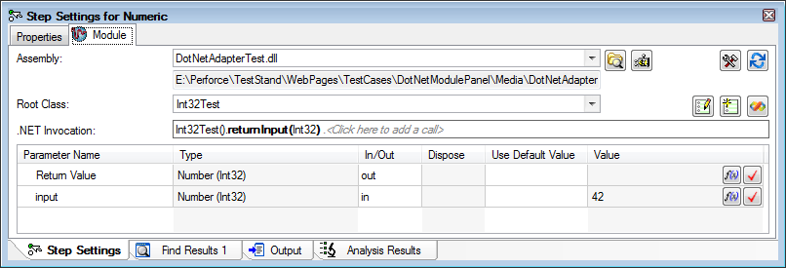

- Verify spelling of labels.
- Verify that controls are aligned and spaced reasonably. Grow and shrink the panel horizontally and vertically.
- Verify that the assembly path control grows horizontally.
- Verify that horizontal and vertical scroll bars appear if the panel shrinks too much.
- Verify that the panel disappears when no steps are selected.
- Verify tab order of controls.
- Verify that tabbing from the last control on the panel returns focus to the Modules tab.
- Verify that you can navigate to each button using tab.
- Repeat above tests with the Step Settings Panel undocked (floating).

Path Control Tests
- Insert a new .NET Action step.
- Type the following path in the control labeled Assembly: DotNetAdapterTest.dll
- Verify that absolute path is displayed.
- Drop-down the relative path combobox and verify that the path you just entered is at the top of the list (the other items will be different). In this case the list would have only one element.
- Press browse button  and verify that the dialog shows the contents of the folder where the assembly is located.
- Verify that the Use Absolute Path button is not checked and that the Files Of Type combobox contains entries for .NET Assemblies (dll’s) and .NET Executables (exe’s).
- Click the Use Absolute Path button and press the Open button to select a file and close the dialog.
- Press browse button again and verify that Use Absolute Path button on the dialog is checked:
- Press the cancel button to close the dialog.
- Delete all text in the path control and verify that the class combo box, invocation control, and parameters grid are all not editable.
- Click on the Browse the GAC button and verify that a list of all assemblies installed to the GAC is displayed (the list of assemblies installed to the GAC is available under C:\Windows\assembly/).

For TestStand 2013 and later (CAR 320127 validation)

- Click on the Browse the GAC button and type ‘m’.
  - Verify that first assembly name starting with ‘m’ is highlighted. And the search match ‘m’ is bold.
  - Type ‘mic’ and verify that prefix ‘Mic’ in the matching assembly name is bold.
  - Verify that matching is case insensitive.
  - Hit Backspace and verify that only ‘Mi’ is bold and most recently typed character-c is removed from matching prefix.
  - Hit Backspace three times and verify it sounds a bell because there are no more character to remove from match.
  - Verify that a bell is sounded if you type a character that does not match any assembly’s name.
  - Selecting a new value using either the mouse or arrow/page-up/page-down/home/end keys resets the prefix.

General Control Tests
- Type in the following path to the Assembly control: DotNetAdapterTest.dll
- Verify that the Class combo box contains a list of classes in alphabetic order.
- Verify that you can type in the Class combobox and it will select the closest match in the dropdown list as you type. Typed text that does not match exactly to something in the list should show in red. Pressing tab or enter should choose the currently selected item from the list.
- Verify that the tag (struct) appears after structs in the list.
- Select the class BoolTest from the list.
- Verify that the invocation control is now enabled and says <Click here to add a call>
- Click on the invocation control and verify that a window pops up with the list of members. Since this is the first call it should only show <Use Existing Object>, constructors, <Create Remote Object>, and static members (in that order).
- Select StaticReturnInput from the member list
- Verify that the parameters control updates immediately to display a Boolean return value and input. Since the input is required, the parameter type name should show in red in the invocation control until it is actually specified.
- Click on <Click here to add a call> at the end of the invocation control to bring up the member list.
- All items that were in the list for the first call should no longer be shown (only instance members should now be shown).
- Verify that base class members such as ToString() are also shown in the list.

Parameter Tests
- Insert a new .Net action step and select the following assembly //TestStand/WebPages/TestCases/DotNetModulePanel/Media/ClassLibraryTest.dll
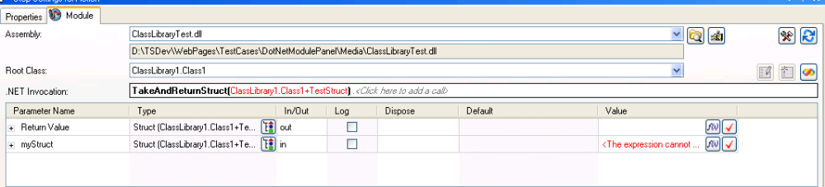
- Select ClassLibrary1.Class1 as the Root class and select, TakeAndReturnStruct as the .Net Incocation.
- Verify that “in” parameters require an expression. Test various types of in parameters to be sure they show as requiring an expression. Specifically test an array of structs as there was a problem with that in the past.
- Verify that “in” parameters that are structs or arrays have the following behavior
  - If the parent has an expression, every child will be disabled and will not show require expression
  - If any child has an expression, the parent will not show require expression
- Verify that you can add/remove elements to array parameters using the buttons in the rows.
- [TS 2010 and later] Verify that you can choose to log any parameter in the panel, and that changes to parameter logging is reflected in the additional results panel (and vice versa). Be sure to verify this for array/struct elements several layers deep.
- [TS 2010 sp1 and later] On a method with a struct parameter, create a type from that struct, then use a variable of that type to specify the parameter. Go back to the assembly and modify the struct definition (change the type of one of the members) and rebuild. Come back to the panel and verify that you get an error on the .NET parameter after you reload the prototype.

Tooltip Tests

Note: As of fixing CAR 627908 in TS 2019, help for parameters shows up in the “XML Help” column at the right of the panel. Help is still in the tool tips for the methods themselves though.

- Choose an assembly that has xml help strings (such as mscorlib). *Note that mscorlib will likely only have the xml help strings if Visual Studio is installed on the machine. If VS is not installed, try adding xml help strings to members of an assembly on your own.
Verify mscorlib.xml exists for 2.0 here: C:\Windows\Microsoft.NET\Framework\v2.0.50727
For 4.0 here: C:\Program Files (x86)\Reference Assemblies\ Microsoft\ Framework\ .NETFramework\v4.0
Or C:\Program Files (x86)\Reference Assemblies\Microsoft\ Framework\ .NETFramework\v4.0\Profile\Client
Note: If by any chance mscorlib.xml happen to be in different location like in a subdirectory ( CAR#335315), you must copy the xml to specified directory, and restart sequence editor to get tooltips.

- Verify that once you choose a class, if you hover over the class control you see the help string for the class as a tooltip.
- Specify a call chain, and verify that hovering the mouse over a specific call shows the help for that member as a tooltip.
- Verify that hovering the mouse over a parameter row shows the help string for that parameter as a tooltip.
- Save and close your sequence file. Reopen it and verify all the tooltips again but don’t respecify anything. The tooltips are obtained dynamically and not stored in the sequence file, so we want to make sure we are getting them even for steps that have just been loaded and nothing has actually been specified on yet.
- Create your own assembly that contains xml comments and verify that they show up in TS.

Prototype Reloading Tests
- You can use the TestClassLibrary solution under the media folder to regenerate the d:\perforce\WebPages\TestCases\DotNetModulePanel\Media\ClassLibraryTest.dll assembly for this test.
- Verify that if you specify a method, and then either add or remove a parameter or change a parameter type in the actual method and rebuild your assembly, that when you come back to the sequence editor you get an error provider saying that the prototype doesn’t match.
- Verify that clicking the error provider will correct the error.
- Verify that clicking the reload button in the upper right corner will also fix up the prototype.
- Verify that if you just change a parameter name or struct field order and rebuild your assembly you will not receive a prototype mismatch error provider.
- Verify that clicking the reload button will update the parameter with the new name or struct with the new order.
- Verify parameter mapping transfers parameter values when reselecting a method.
- Verify that clicking the button to clear unmapped parameters works and doesn’t cause any errors. The button should be located next to the name of the first unmapped parameter.

Layout Tests:
- Change the parameter column widths and exit the sequence editor.
- Restart sequence editor and verify that the layout is the same.

Translation Tests:
- Exit the SequenceEditor.
- Copy the file DotNetModuleTranslation.ini into the <TestStandPublic>\Components\Language\English directory.
- Perform the steps in the Tests sections above.
- Verify that all strings displayed in the panel are identical to what is displayed in the above screenshots, but that they begin with a $ character.
- Verify all labels, checkboxes, tooltips and combobox items.
- Verify the undo description after changing each control.
- Verify button tooltips, multiple values text.

Source Code Panel And Create/Edit Code Buttons
- Without Visual Studio installed:
  - Select the Action step in the SourceCodeSettings sequence
  - Verify that the .NET Source Code Files… button is enabled.
  - Click the button and verify that the dialog that comes up is populated, but all controls are disabled.
  - Verify that the Create/Edit code buttons on the main panel are disabled even if you have a fully specified and valid call selected. Verify they both have a tooltip giving an explanation for why they are disabled.
- Install Visual Studio 2005 or later.
- Create a new sequence file and drop a .net step
- Click the .NET Source Code Files... button and verify that the controls are enabled.
- Verify that the following requirements must be met for the Create Code and Edit Code buttons are enabled (Note that you don’t need to specify source files). In the cases where the buttons are disabled, verify that there is a tooltip giving a reason.
  - Create Code must have the following fields specified to be enabled
    - Assembly Path
    - Class
    - Some text must be entered for the currently selected call in the invocation control.
  - Edit Code should be enabled if there is an invalid/not loadable assembly specified or an invalid root class specified. Edit Code should be disabled if there is a valid assembly/class but the selected call in the invocation control is invalid.
- Verify that selecting multiple .NET steps causes the Create/Edit code buttons to get disabled (even if they would otherwise be enabled). Verify that there is a tooltip saying that they require that only a single step be selected.
- Verify that the Source Code Panel only resizes horizontally and that the text boxes resize with panel
- Verify that if you click the Create or Edit code button without any source files specified, that you are prompted for a project and source file. (You should not get prompted for a solution file if it is unspecified, but you should if you have an invalid or not found file specified)
- Verify that you are prompted to save the selected file to the step. Do this multiple times and test both options and verify that the files does or does not get saved accordingly. Verify that if you check the box to not be asked again, that you don’t get this dialog for that file type on that step, and that files you choose do not get stored to the step.
- Verify that if you have a project/source file specified that you do not get any prompts for files when clicking Create or Edit code.
- Verify that Edit code properly goes to the selected call in Visual Studio, and that Create code properly creates a method with the same name as the selected call, but with parameters that match the code creation template.
  - Verify that Create and Edit Code work when Visual Studio is closed and already open. See also CAR 676657.
- Verify that if you choose Edit code from the context menu on the step that you are prompted for which call to edit, and that it properly goes to that call in VS.

Advanced Settings Panel
- Click the button to open the advanced settings panel
- Select a non-.NET step and then reselect the .NET step
- Verify that the panel was not visible for the non-.NET step and was visible again when the .NET step was reselected.
- Verify that the panel is resizable horizontally but not vertically and that all controls resize appropriately.

Specifying Parameters with Indexers
- In a new step, select the mscorlib assembly in the GAC
- Select the System.Collections.SortedList class
  - Enter the SortedList() constructor in the .Net Invocation control and store the return value in a object reference local variable
- Call Method Add with parameters:
  - key = mykey
  - value = myvalue
.Net Invocation should read: SortedList().Add(System.Object, System.Object)
- Create a second step with the same assembly and class
  - Don’t create instance, but use the instance stored in your local variable by selecting Use Existing Object form the .Net invocation list and entering your local variable as the input parameter.
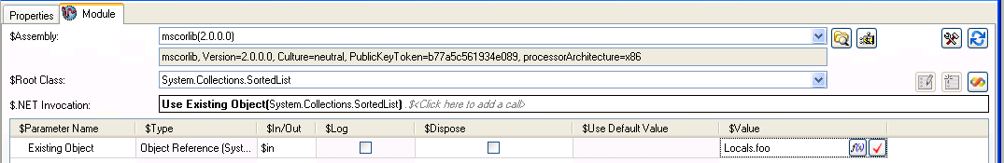

- Select Item[System.Object] – Get from the .net invocation list
- 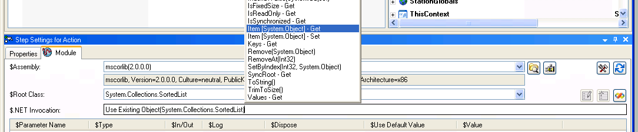
- Verify that the invocation control reads as follows:
Use Existing Object(System.Collections.SortedList).Item [System.Object]
- Verify that you see a return value (Get Property) and a key in the parameters grid (return value will
- Put in your key (mykey) and save the return value to a local variable
- Run the execution and verify that the return value from the get is myvalue

Create Custom Data Type From Struct:

(TestStand 4.0.1 and later)

- Open the ‘StructTest.seq’ file (make sure the file is not marked as read only, or you have allow editing read-only files on)
- Select the Create Type From Struct Step.
- Select the StructMethod call in the invocation control.
- Click on the Create Type From Struct… button located on the input parameter row
- Verify that the Create Custom Data Type From Struct dialog is displayed.
- Clear the type name control and leave it empty.
- Click on the Create button.
- Verify that you get a prompt indicating that the type name is invalid because it is empty.
- Enter @@@ as the type name.
- Click on the Create button.
- Verify that you get a prompt indicating that the type name is invalid.
- Enter ValidNameStruct as the type name.
- Click the Create button.
- Verify a type is created and the type matches the struct .

(TestStand 4.1 and later)

- Click on the Create Type From Struct… button located on the first parameter (Return Value).
- Type ValidNameStruc2 as the type name
- Click on the Create button.
- Verify a type is created and the type matches the struct .
- Click on the Create Type From Struct… button again
- Type ValidNameStruc2 as the type name
- Enter duplicate property names for two of the elements in the struct. For example change the property name of the b property to a
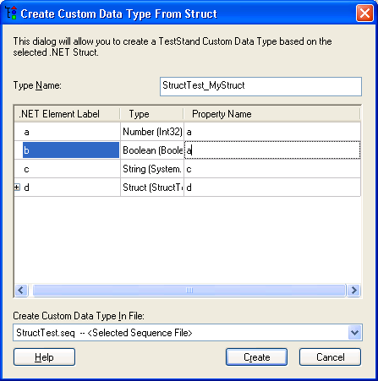
- Click on the Create Button
- Verify that you get prompted indicating that the property name is duplicated.
- Verify that if you click OK the duplicate property name is highlighted.
- Enter invalid names as property names
- Verify you get prompted when trying to create the type.
- Try entering invalid or duplicate names in different levels of the tree.
- Collapse all the tree branches before clicking on the Create button
- Verify that if the property with the problem is in a collapsed branch, the branch is expanded and the correct property is highlighted.
- Validate the dialog in general.
- The names should be always valid and we should not allow duplicate properties within the same level in order to create a valid type.
- Always verify that the type was properly created after clicking the ‘Create’ button.

Floating Behavior
Float the step settings pane and test inserting and configuring steps by treating the step settings pane as a dialog. [CAR 4HABHU54]
- Float the step settings pane and close it.
- Insert a step.
- Right-click on the step and choose Specify Module to display module tab on step settings pane.
- Configure the module.
- Close the step settings pane.
- Repeat steps 2-5 for more steps.
Assembly Load Errors and Warnings
Check improved error messages for two known load errors: legacy mixed mode assemblies (TS2012 feature) and blocked downloaded assemblies [CAR 311308]. Check warning for loading two versions of the same assembly [CAR 226928].
- Download the file from link DownloadedBlockedFile.dll and place it next to DotNetLoadErrors.seq. This will overwrite the existing file, but the newly downloaded one will be marked as blocked from being downloaded.
- Open DotNetLoadErrors.seq
- Open the LoadErrors sequence.
- Click on the C++/CLR 2.0 step.
- Hover over the assembly load error icon and verify that the error message refers to TestStand documentation.
- Click on the Downloaded Blocked File step.
- Hover over the assembly load error icon and verify that the error message describes how to unblock the file.
- Open TwoVersionOfAssembly sequence.
- Run the Sequence Analyzer.
- Verify that there is no such warning about the mscorlib assembly. This warning should never be seen for assemblies requested from the GAC.
- Download the files attached in CAR 226928.
- After downloading unblock the files. To unblock a dll, right click on it and go to properties and click Unblock.
- Open the Sequence File 2.seq sequence.
- Run the Sequence Analyzer.
- Verify that there is a warning informing the user that TestStand loaded a different version of the “ErikDotNetStructTest.dll” assembly than the one requested.
TestStand 2010 New Functionality Tests

Invocation Control Formatting
- Verify that clicking on a call makes that call show in bold and the parameters grid shows the parameters for that call.
- Verify that invalid calls show in red (you can make a call invalid by just typing some characters into it.
- Verify that valid calls are shown in black. Any call that you choose from the member list dropdown should show in black. Parameters might still show in red if they do not contain valid values.
- Verify that if you fully type the signature of a member, it will load the prototype and show the call as being valid. Do this by verifying that:
  - If you just type the name of a method it will still show as invalid and not try and load the prototype.
  - If you type the full signature of a method (including parameter types) it will show the call as valid and properly load the prototype. (you should be able to just type exactly what is shown in the member list dropdown for the signature of any method listed)
  - If you type the name of a property that has both a Get/Set operation or just a Get operation that it will load the prototype for the Get operation and will show the call as valid.
  - If you type the name of a property that has only a Set operation, it will properly load the prototype for the Set operation and show the call as valid.
- Verify that adding/removing dots between calls using the keyboard maintains the correct caret location in the textbox.
- Verify that parameters whose value expression contains errors show in red in the invocation control.
- Verify that parameters whose value expression does not contain errors show in black.
- Verify that clicking on a parameter in the invocation control makes that parameter show in bold and also selects the corresponding row in the parameters grid (but focus should stay in the invocation control). It will not select the row if the parameter is unmapped.
- Verify that typing extra invalid parameters and then selecting them does not cause any errors in the parameters grid, and that no parameter row is selected.
- Verify that clicking on a parameter row in the parameters grid makes the corresponding parameter show in bold in the invocation control but does not take focus away from the parameters grid. It will not bolden a parameter if the parameter is unmapped.
- Verify that clicking on an unmapped parameter row does not cause any errors in the invocation control and that no parameter is shown in bold.
- Test copying and pasting text into and out of the control. Test pasting formatted text (from Word or Visual Studio, etc) into the control and verify that the formatting is changed to match that of the control (you might see a flicker of the old formatting). Verify that you cannot paste images into the control. Be sure to try cut/copy/paste/delete from the TestStand Edit menu.
- Try to break the control. Type lots of invalid characters, calls, large amounts of text, and anything else you can think of. The control may slow down with unusually large text amounts but it should never crash or give error dialogs. Try to cause many changes with a single operation to verify that simultaneous events are being properly handled (highlight many calls and start typing, type some text then click or right click another call before the text gets committed (it happens on a timer callback), etc.
- Test Adding and Removing multiple calls at once. This could be from copy/paste, or highlighting and deleting. Test adding stray characters in the middle of a call chain that would result in calls getting removed (ie any open bracket such as ‘(‘ or ‘[‘ where we are expecting a matching closing one). Make sure that call information is preserved if you then remove those characters and are back in a valid state.
- Change selection between various .NET steps and verify that focus is not stolen by the invocation control and that the member list is not shown. Try steps with both valid and invalid calls.

Member List Behavior
- Verify that clicking on the invocation control for a step with no yet specified shows the member list but does not actually add a call to the step until you select something form the list (Check the Step.SData.Calls array).
- Verify that single-clicking on an invalid or empty call shows the member list. (It should only show if the previous call is valid and has a return value)
- Verify that single-clicking on a valid call does not show the member list box if it is not currently being displayed. If it is currently being displayed, verify that the contents and location are updated to reflect the change in call selection.
- Verify that double-clicking on a valid call shows the member list.
- Verify that right-clicking shows the member list and changes call selection to the call that was right-clicked.
- Verify that pressing ctrl+space shows the member list.
- Verify that pressing escape hides the member list.
- Verify that pressing tab or enter inserts the currently selected item from the member list.
- Verify that typing a character into the invocation control causes the closest match in the member list to become selected and to scroll into view. Try typing a property name followed by “ – Get” or “ – Set” and verify that the appropriate item gets selected in the member list.
- Verify that typing a ‘.’ character with the member list showing inserts the currently selected item from the member list and also inserts a new call on the step.
- Verify that <Click here to add a call> is only shown at the end of the call chain if the last call is valid and has a return value.
- Verify that clicking in the <Click here to add a call> text at the end of the call chain shows the member list but does not insert a call on the step until you select something from the list.
- Verify that double-clicking or right-clicking the <Click here to add a call> text works the same as single-clicking the <Click here to add a call> text. (NOTE: In TS 2010 and later double-clicking selects the previous member call and opens the member list).
- Verify that you can resize the member list both vertically and horizontally, and that whitespace is shown in both directions if going past the items.
- Verify that when the member list shows it grows big enough vertically to show all items (if there is room) and horizontally to show the longest item in the list.
- Verify that the member list shows below the control if there is room.
- Verify that the member list shows above the control if there is not room below.
- Verify that if there is not room above or below the control to show all members, that the member list then shows on whichever side has more room and that it sizes to go to the edge of the screen but does not hang off. (Will need to select a class with many members. Should be some good ones in mscorlib)
- Verify that moving focus away from the invocation control hides the member list.
- Verify that switching tabs, switching documents, or switching to a window outside the sequence editor hides the member list.
- Verify that letting the panel autohide also hides the member list.
- Verify that resizing the panel moves the member list along with it. Try resizing the panel, moving the sequence editor window around, resizing the sequence editor, floating the panel and resizing it. Note that if you try to move the panel by clicking on the panel’s title bar it will hide the member list.

Assemblies
- Specify a multiple call step that uses types in multiple assemblies, both from the GAC and from a normal file. An easy way to do this is to call ToString() on a class and then call some string operation on the return value. Verify that you can specify valid calls with no errors.
- Create 2 assemblies, with one depending on the other. Specify a step using the assembly that depends on the second assembly (make sure you actually use types from the second assembly in the first one). Rename the second assembly so that the one the step uses cannot find it. Verify that when you return to TS you get a clear error provider saying that it could not find the dependent assembly.

Note: you can use class library test.dll and dependonme.dll for this test. The solution is located under:
TestStand\WebPages\TestCases\DotNetModulePanel\Media\TestClassLibrary\TestClassLibrary.sln

Properties
- Verify that properties have an item in the member list for both Get and Set (only if they are public and exist for that property).
- Select a property and verify that the first row in the parameters grid does not show Return Value or Value for the parameter name, but instead shows a combobox with either Get Property or Set Property. Make sure that the one you select from the list is the one shown in the combobox.

Ex: In ClassLibraryTest.dll select “Class1” as the Class and make the invocation as “class1().field1-get”, now the module should be similar to the image
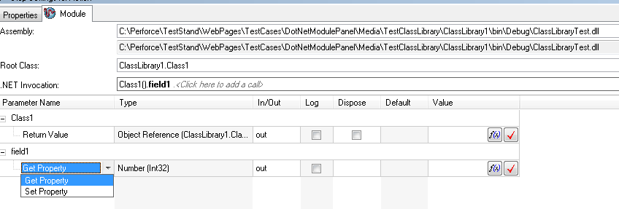
- Change the combobox and verify that everything updates properly. The parameter value should remain in that row. The invocation control should update to reflect the change, for example if you had a property Get with another call after it and you change it to a Set, it should now show the next call as invalid because the Set does not return anything.
To test this you can use the invocation as “Class1().field1.Equals(Int32)” now selecting Set Property from the dropdown should show an error because field1-Set does not return any callable type.
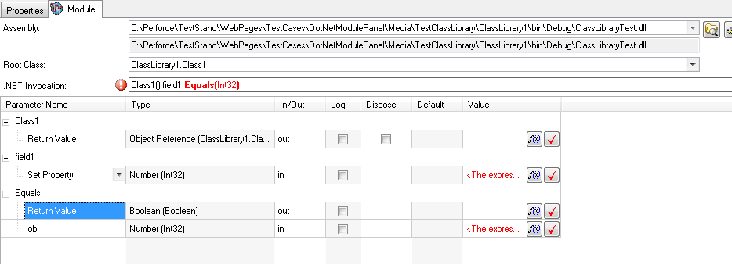

Object Creation
- For the first call on a step, choose <Use Existing Object>. Verify that you get a single row in the parameters grid labeled Existing Object and are allowed to make sequential calls after that.
- For the first call on a step, choose <Create Remote Object>. Verify that you get a row in the parameters grid labeled Remote URI as well as a return value row, and that you are allowed to make sequential calls after that.

Call Text Entry
- Try specifying calls by typing instead of selecting with the mouse.
- Try typing invalid characters, mismatched parentheses, deleting or adding a bunch of text that doesn’t make sense, cutting or pasting a bunch of text. Make sure you don’t get any errors or exceptions and that the text is just shown as invalid with an error provider.

Generics
Generics are supported to a limited capacity. You cannot specify a generic class and specify what you want to fill in for the generic type. However, any generic type that you use in your assembly will appear in the class list for that assembly (even if the type itself is defined elsewhere).
- Verify that generic classes defined in your assembly are filtered out of the class list.
- Verify that if you use a generic type anywhere in your assembly, that it appears in the class list for that assembly (for example, if you use List<string>, then List<string> should appear in the class list).
- Verify that the generic types are at the bottom of the class list and separated by a separator and text from the normal classes in the list.
- Verify that you can select a generic type and call a constructor on it.
- Verify that generic methods are filtered out of the method list (we do not support these).
- Verify that methods that take a fully specified generic type (like List<string>) are not filtered out and can be chosen from the method list.

Member Specification
Create an assembly with various different types of members and parameters and verify that they can all be correctly specified. Types to try:
- Static members
- Multidimensional array parameters
- Enums
  - Specifically test Enums created in a LV built assembly that contain special characters such as spaces, quotes, symbols, etc. You can find a LV built assembly at Media\LVEnums\LVEnumTest.dll
- byref parameters
- struct fields of all of the various types
- regular class parameters
- array of classes and structs as parameters (Note: as of TS 2010 arrays of structs cannot be specified by element, only as an object reference)
- out only parameters
- optional parameters (I believe only VB allows this)
- pointers (should be detected as invalid)
- generic parameters
- NOTE: jagged arrays (arrays where each element is also an array, the datatype of a jagged array in TS is an object reference) are not supported for create and edit code. See rejected CAR 354217.

TestStand 2012 New Functionality Tests

Grouped Parameters Control
Create a new .NET Action step. Select mscorlib as the assembly (from the GAC list).
- Create a step with multiple calls. Verify that each call is initially expanded in the parameters control and that you are able to collapse/expand each one.
- Verify that changing a call to a different member shows the new call as expanded in the parameters control.
- Verify that selecting a new step shows all calls as initially expanded.
- Verify that selecting a step where you had previously collapsed some calls, restores that expansion state when selected.
- Verify that the rows corresponding to each call contain only one column that displays the member name.
- Verify that clicking on a call row will update the bolded call in the invocation control to match the one selected in the parameters control. (and vice versa)
- Verify that clicking on a parameter row will switch the bolded call in the invocation control to match the call containing the selected parameter, and also show the parameter in bold in the invocation control. (and vice versa)
- Verify that clicking on a parameter in the invocation control, whose call is collapsed in the parameters control, will select the collapsed call row (and not expand the call).

Invocation Control Changes
- Verify that dragging something over the invocation control does not change the selected call or parameter.
- Verify that dropping something in the invocation control does nothing.

Auto-Selected Assembly and Class
- Create a .NET step and choose an assembly and class.
- Create a new .NET step. Verify that the assembly and class chosen for the last step are already set in the new step.
- Make sure that this is tested both in the Sequence Editor and in a User Interface, since this dialog is hosted in a dialog in the UIs, and this will result in a different code path.

NET Adapter Debugging
  - Setup
    - Use the Visual Studio that is supported for the release you are testing (3.x - VS.NET 2003, 4.0 VS.NET 2005) to create a C# and/or VB.NET DLL
    - Create both functions and properties
    - Create overloaded functions (this is required to test the majority of the code - without overloads an optimization eliminates most of the token lookup code)
    - Make overloads use various complex data types such as multidim arrays, user defined types, etc. Be creative.
    - Make .NET steps that make multiple sequential calls on the same step.
  - Basic functionality
    - Verify step into and step over work as expected
    - Verify step into followed by step out stops on next step in sequence. If you have more calls on your step, step out will stop on the same step, and then step into should step into the next call.
    - Verify step into followed by continue does not stop on next step in sequence
    - Verify prompt if attempt to stop debugging or exit VS.NET
    - Repeat above with VS.NET debugger already attached to SeqEdit.exe (specify SeqEdit as the debugging .exe for the VS.NET DLL)
    - Verify developing/debugging/rebuilding process works intuitively for VS.NET DLL steps
    - Verify that if you step into a step that first calls an implicitly defined constructor, TS will just skip over the constructor and not give an error. Verify that if you step into a step that first calls an explicitly defined constructor, TS properly steps into the constructor and does not skip it.
    - Things to think about include switching of top level application and performance
    - Verify that you can step through each call on a multi-call step and that none of the calls get skipped.
  - Corner and failure cases
    - Test with .NET debugging disabled in VS.NET
    - Kill VSDebuggingController.exe at various stages of debugged execution
    - Set various types of breakpoints at various places (especially the first line) in the method/property and verify it is not removed
    - Try multiple executions or threads calling different functions and calling the same functions
    - Try stepping into a CVI-created function while debugging from VS.NET
    - Try stepping into a release-compiled VS.NET DLL
    - Move or rename the source file containing the method/property
    - Test throwing an exception from code you stepped into
    - Verify no debugging functionality with version of Visual Studio that is different from the supported version.
    - Test using a class that contains properties with one public accessor and one private accessor. Make sure there are no edit time errors when selecting these properties.
· Open the sequence file found in this zip file and on the .NET step, from the method selection dropdown, select the "get_Abc" method. Verify that there are no errors.

Test Create/Edit code in the .NET adapter
- Test with various combinations of all versions of VS (2003 and newer) installed on the machine.
  - Create and edit code should only work for project/solution files from the supported version of VS (3.x - 2003, 4.0 and 4.1 - 2005). TS 4.2 supported VS 2005 and 2008 and attempted to support future versions as well. TS 2010 supports VS 2005, 2008, 2010 and attempts to support future versions. If there are future versions of VS that are not yet supported by the version of TS you are testing, you should still do some minimal testing to see what does and does not work.
- Create Code
  - Verify that the browse buttons browse for the correct type of file and that the edit controls are correctly updated when a file is selected.
  - Test Create Code using various source, project, and solution files.
  - Verify that if no solution file is provided, an appropriate solution is used.
  - Verify that if the solution file is already open in a Visual Studio environment, that environment is used for code generation.
  - Verify that you browse for the files if they do not exist.
  - Test functionality when the desired function already exists in source.
  - Verify that a replace/insert above/insert below dialog is displayed and that the correct action is taken depending on the user's choice.
  - Verify that the code template is correctly read and that any using statements, parameters types and names, and function body are transferred to the new function.
  - Test with methods that use various parameter types (structs, enums, nested types, etc).
  - Do all tests with both C# and VB as there is completely different code for the code generators for the two languages.
- Edit Code
  - Test Edit Code using various source, project, and solution files
  - Verify that if no solution file is provided, an empty solution is used (TS 3.0 Beta 2 requires a solution).
  - Verify that if the solution file is already open in a Visual Studio environment, that environment is used for code generation.
  - Verify that an error message is displayed if the function does not exist in the source.
  - Verify that the project and source are opened and that the cursor is moved to the first line of the correct function.
  - Test with methods that use various parameter types (structs, enums, nested types, etc).
  - Test with constructors.
  - Do all tests with both C# and VB as there is completely different code for the code generators for the two languages.

Other tests
  - Test Specify Module Dialog for both classes and structs
  - test with all parameter types, with keywords ref and out,
  - Test Specify Constructor Dialog for both classes and structs
  - test with all parameter types, with keywords ref and out,
  - Run automated test to test passing all valid data types

Various CARs

CAR 738286 and BUG 205965

Preparation:
- Build //TestStand/WebPages/TestCases/DotNetModulePanel/Media/CARs/CAR 738286/CAR 738286.sln .

Validation:

- Open //TestStand/WebPages/TestCases/DotNetModulePanel/Media/CARs/CAR 738286/CAR 738286.seq in the TestStand Sequence Editor.
- In the Sequence “Edit Time Tests,” verify that there are no errors in the various adapter steps in the Sequence. (It is OK that the expressions are blank for the parameters. We are looking for errors with an error provider that stem from types not being found, etc.)
  - The Two adapter steps at the top work with PrecisionTimeSpan to test the case specifically from this CAR.
    - Verify that the NationalInstruments.Internal.PrecisionTimeValue is not available in the “Root Class” drop-down even though it is available as a parameter type.
  - The “Probing Example” step works with the provided solution.
- Verify that you can expand the various structures using the “+” buttons in the tree control under “Parameter Name.”
- Verify that you can see the enumerators for the enum parameters in the drop-down for the enum parameter.
- Verify that the Create/Update custom data type buttons function properly. This is just a sanity check. The need to be able to see the various types, members, and enumerators.
- Run MainSequence. The test should pass. This just calls a .Net method that takes a structure with some private members based on internal types and sanity checks things work.
- Verify that TestStand unloads the assemblies. You can do this by deleting Dependency.dll and PublicLibrary.dll. (If they are loaded, Windows will not let you delete them.) You may need to unload all modules from the File menu or using Ctrl-Shift-U.

Summary: As noted, this test included the original case from the CAR. It also includes a contrived case where we have a struct with private members that use internal types. We added this to make sure we covered both the enum and the struct case. We also wanted to make sure we had a test case that did not depend on the presence of NationalInstruments.Common.

