.NET Module Panel – Goto Location
TestStand Version: 4.0

Author: Isaac Squires
Feature: .NET Module Panel
Dependencies: none
Test Category: [ Functional ]

Description
This procedure tests the “Goto Location” functionality of the .NET Module step settings panel. The Goto Location functionality is invoked by the Find and Find-in-Files features.

Preparation
- Launch the TestStand sequence editor.
- Open the sequence files DotNetModuleGotoTest.seq and DotNetModuleLocations.seq.
- If either of the sequence files is read-only, go to the Sequence Editor Options dialog and check the “Allow Editing of Read-Only files” checkbox.
- In Station Options, go to Preferences and enable the “Show hidden Properties” check box.

Validation

Semi-Automatic Test Execution:
The MainSequence sequence in DotNetModuleGotoTest.seq partially automates testing by attempting to go to each of the locations represented by the .NET Module Panel controls. Run the sequence and follow the instructions to verify that the correct control is highlighted. When a control is highlighted, it receives the focus and a thick black rectangle is drawn around the control for about a second.

Find-in-Files Test Execution:
- Type Ctrl-F or press find toolbar button () to find all instances of the text “SearchTarget” in the DotNetModuleLocations.seq file:

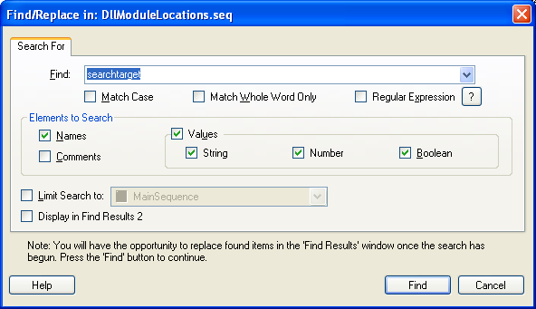

- Verify that there are 60 matches: 19 in each step group (Setup, Main, Cleanup) and 3 Locals.
- Double-click each item in the list of matches and verify that the correct control in the .NET Module Panel is highlighted and that the text “SearchTarget” is selected. Note: as of TS 2010 the Invocation Control will not highlight the searched text.
Goto from Output Window:
- Open file DotNetModuleGotoTest.seq
- Goto Sequence “Goto Location From Output Window”
- Run the sequence and close the execution window
- Goto the Output Message window and double click the “Goto .NET Step” message
- Verify that the step in the step list is selected.

Searching for property names and numbers:

- Type Ctrl-F again and this time find all instances of “thisDir”. Verify that there are 4 matches.
- Double-click each property item in the list of matches and verify that the correct control in the Locals or Module panel is highlighted and that the text “thisDir” is selected.

- Add a local variable of type Numeric and edit its value as “100”. Type Ctrl-F again and this time find all instances of “100”. Verify that there is a match. Verify clicking on the match should display variables view and highlight the text.

