.NET Module Panel – Multiple Selection
TestStand Version: 4.0

Author: Isaac Squires
Feature: .NET Module Panel
Dependencies: none
Test Category: [ Functional ]

Description
This test procedure tests the .NET Module step settings panel when multiple steps are selected.

Preparation
- Launch the TestStand sequence editor.
- Open the sequence file DotNetModulePanel.seq.
- Go to the Sequence Editor Options dialog and check the “Allow Editing of Read-Only files” checkbox.
- Select a step in the file and display the Module step settings panel.

Validation
Multiple Selection
- Open the sequence named MultipleValues.
- Select the first two steps (VariousNumbers and VariousNumbers2).
- Verify that the module panel appears as follows:

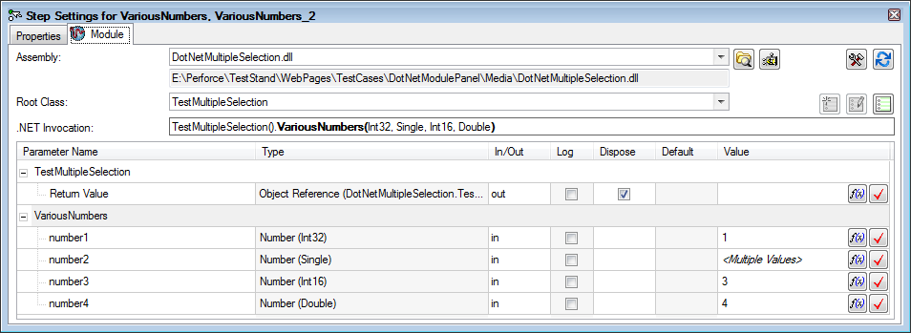

- Select the first and third steps (VariousNumbers and VariousTypes).
- Verify that the module panel appears as follows:

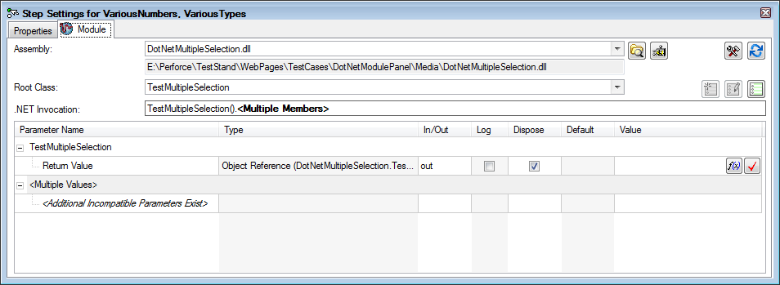

- Select the first and fourth steps (VariousNumbers and DifferentAction).
- Verify that the module panel appears as follows:

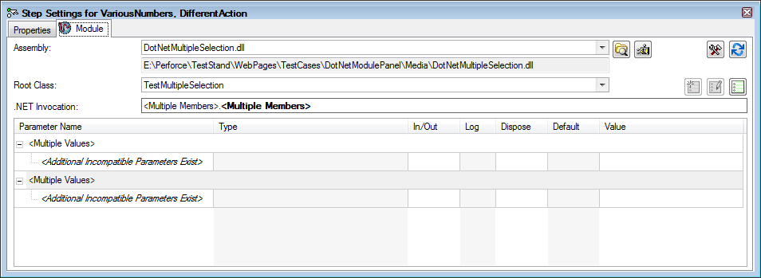

- Select the first and fifth steps (VariousNumbers and DifferentClass).
- Verify that the module panel appears as follows:

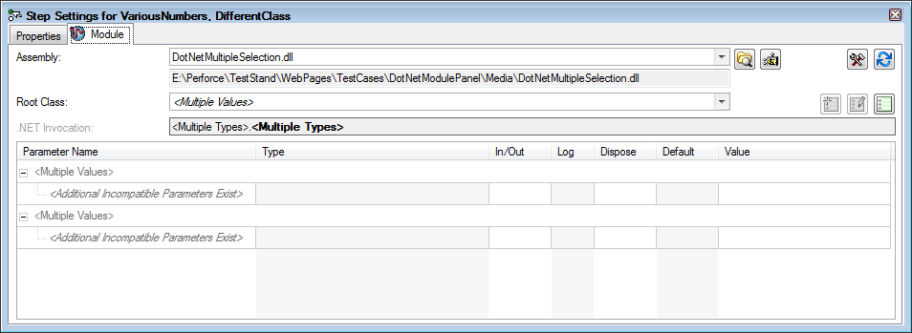

- Select the first and sixth steps (VariousNumbers and DifferentAssembly).
- Verify that the module panel appears as follows:
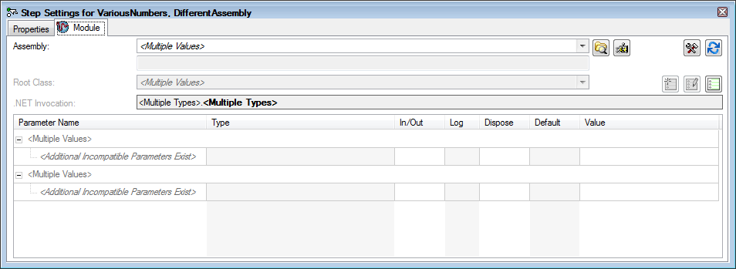

- Select the seventh and eighth steps (DifferentNumCalls and DifferentNumCalls_2).
- Verify that the module panel appears as follows:

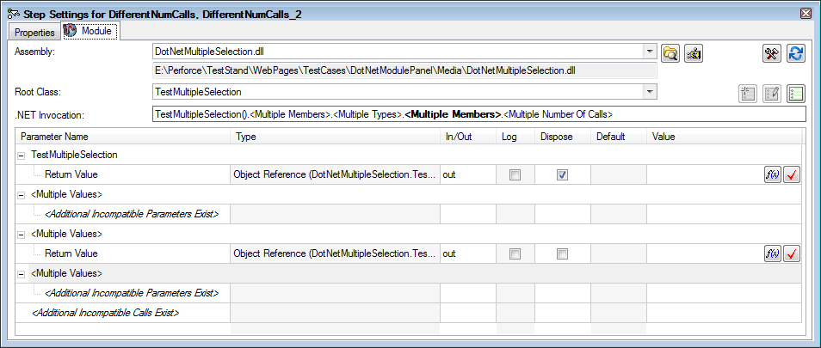

- Select various different combinations of steps and verify that there are no errors and nothing appears broken in the panel.

Incompatible Parameters
When only some parameters of the selected steps are compatible, the panel displays the first set of compatible parameters.

- Open the sequence named IncompatibleParams.
- Each step in the sequence has N numeric parameters, where N is the last letter of the step name. For instance, step named Numeric_6 contains 6 numeric parameters.
- Select combinations of the steps in the sequence and verify that the parameters panel displays N parameters, where N is the minimum number of numeric parameters. For instance, if you select Numeric_3 and Numeric_6, then only 3 parameters should be displayed in the parameters control as shown below:
- Make sure you put mouse over each row to make sure there are no errors from help tooltips. I have added help to this assembly. You will not see help in parameters unless the method is the same for all selected methods.

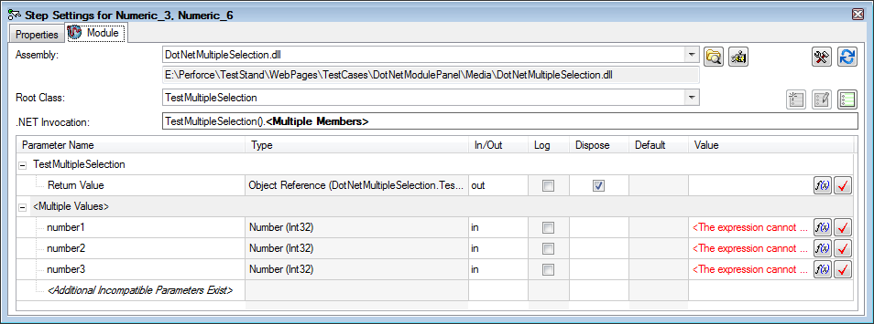

Free Form Editing of Multiple Steps
Select multiple steps and modify the calls in the invocation control. Try both selecting calls using the mouse and the member list, and by typing a portion of the call before pressing tab or clicking the member list. Verify that there are no unexpected errors, and that things generally work similar to how they do when a single step is selected. Try various combinations of steps that have different levels of commonality in their invocation chain.

