.NET Module Panel – Parameter Mapping
Revised: 8/13/2019 12:48 PM
TestStand Version: 4.0

Author: Bapi Mahanta
Feature: .NET Module Panel
Dependencies: none
Test Category: [ Functional ]

Description
This test procedure tests functionality of the module step settings panels when the parameters of the configured step have been updated out of the panel.

Preparation
- Launch the TestStand sequence editor.
- All the examples are present in location //TestStand/WebPages/TestCases/DotNetModulePanel/Media/ParameterMapping/

Validation
For TS 4.2.1 and below

- Open the sequence file ParameterMappingNET.seq.
- Select the AddedParameters step and select the module tab in the Step settings panel.
- Verify that the following is displayed:

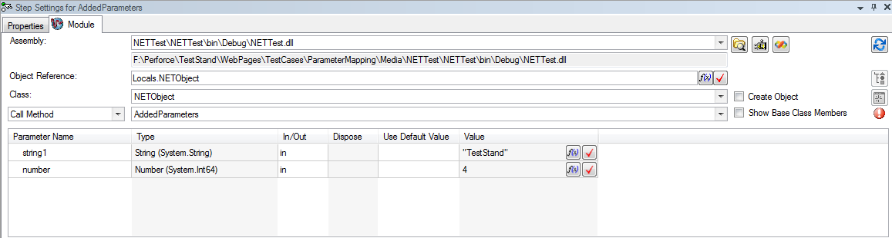

- Notice the red blinking icon close to the buttons. Move the mouse over it, a tooltip should be displayed.
- Select some other method and reselect the AddedParameters method. Verify that the following is displayed:

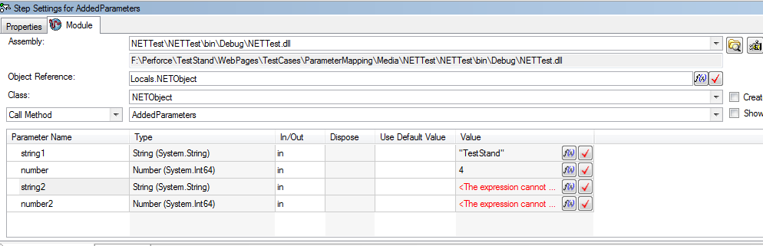

- Notice that the red icon is gone and new parameters have been added.
- Now select the RemovedParameters step.
- Verify that the following is displayed:

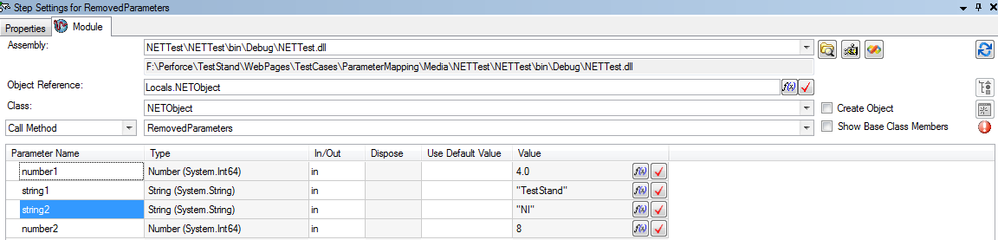

- Select some other method and reselect the method “RemovedParameters”. Verify that the following is displayed:

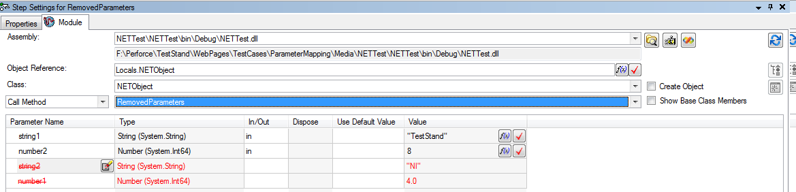

- Notice that the red icon is gone and parameters had been deleted. The deleted parameters are now called unmapped parameters and they will be around to map again for changes of that particular step, unless the “Clear Unmapped Parameters” button is clicked.
- Now select the ChangedParameters step.
- Verify that the following is displayed:

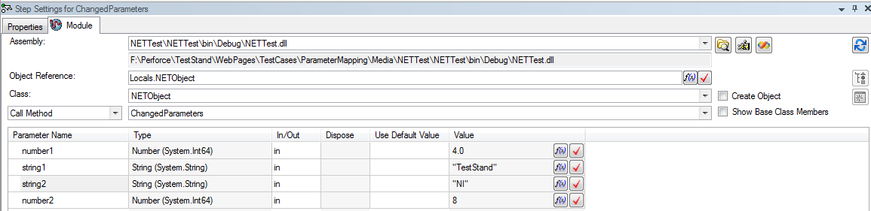

- Select some other method and reselect the method “ChangedParameters”. Verify that the following is displayed:

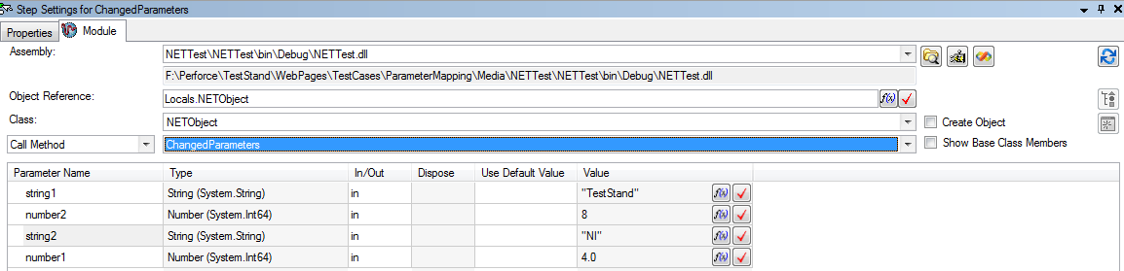

- Notice that the red icon is gone and the values have been moved or mapped.
- Hit “Ctrl-Z” six times to undo all the “Resolve Prototype” operations and verify that the three steps display the red blinking icon
- Now select the three steps.
- Verify that the following is displayed:

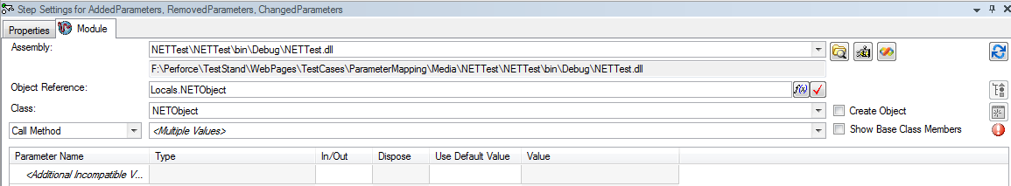

- Now select the RemovedParameters step.
- Verify that the following is displayed:

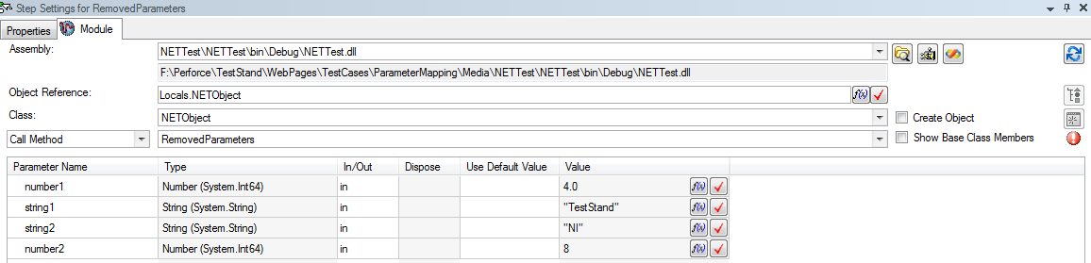

- Select other method and reselect the RemovedParameters method so the prototype can be resolved and then click on the “Clear Unmapped Parameters” button.
- Verify that the following is displayed:

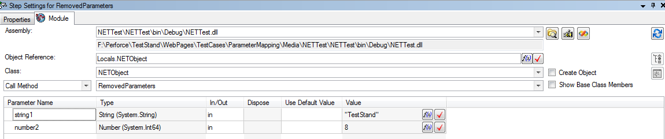

- Hit “Ctrl-Z” twice to undo the “Resolve Prototype” RemovedParameters step.
- Verify that the following is displayed.

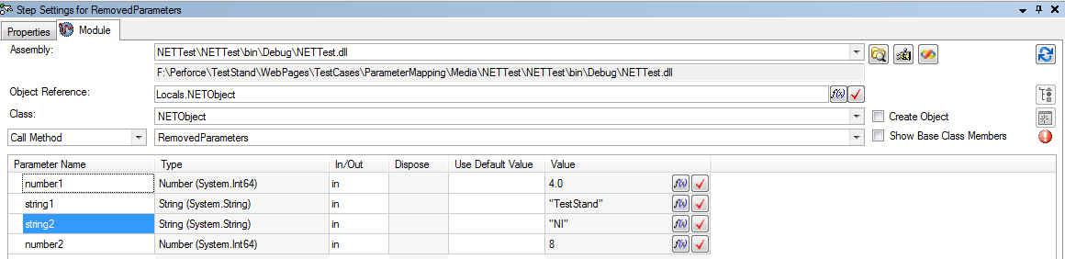

- Now select the ArrayClustersParameters step.
- Verify that the following is displayed:

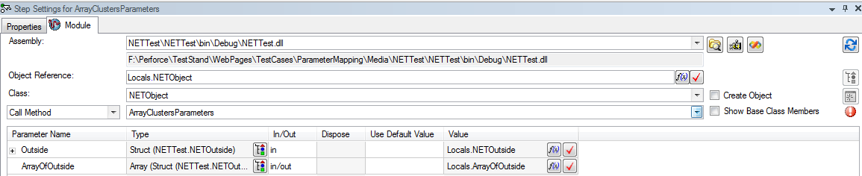

- Select some other method and reselect the method so the prototype can be resolved.
- Verify that the following is displayed:

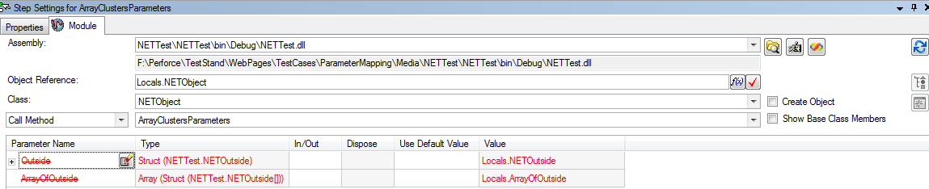

- Verify that all the nodes can be expanded and you’re able to the see the following:

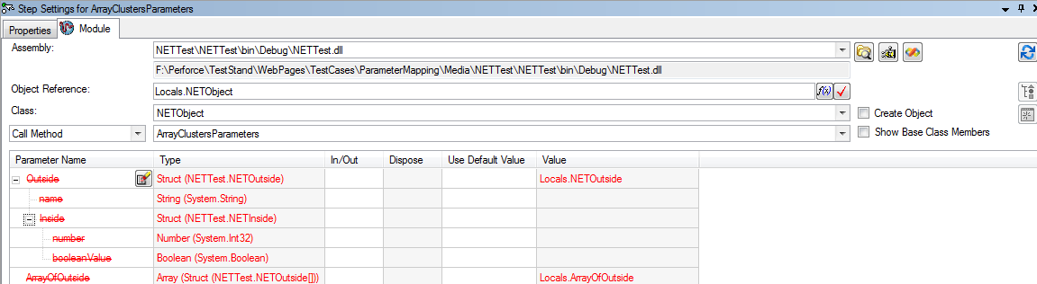

For TS 2010 and above

- Open the sequence file ParameterMappingNET.seq.
- Select the AddedParameters step and select the module tab in the Step settings panel.
- Verify that the following is displayed:

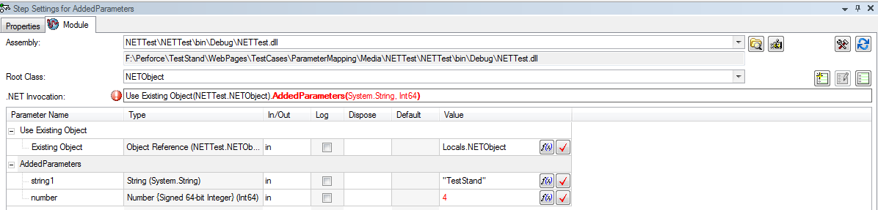

- Notice the red blinking icon close to the buttons. Move the mouse over it, a tooltip should be displayed.
- Reselect AddedParameters method. Verify that the following is displayed:

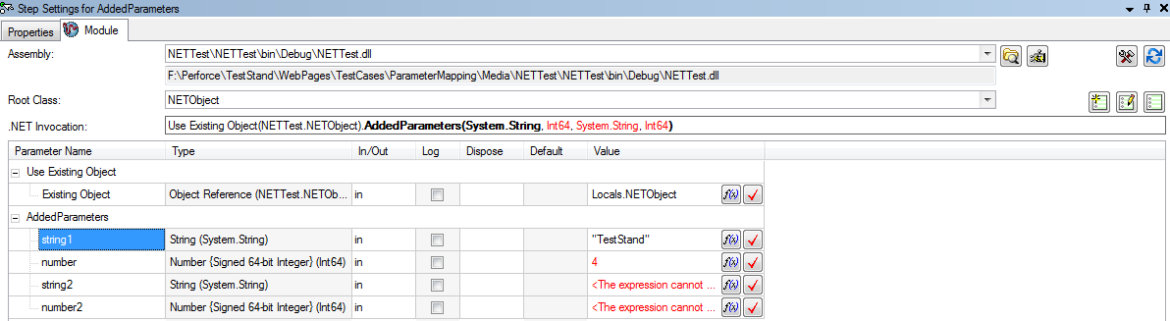

Note : To reselect double click on the added parameters to view the list. Select Added Parameters from the list as shown below:

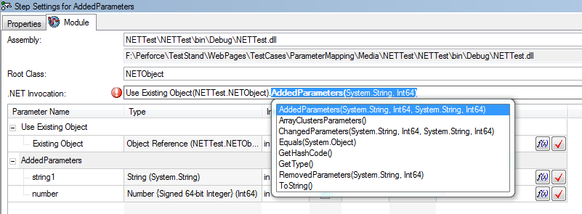

- Notice that the red icon is gone and new parameters have been added.
- Now select the RemovedParameters step.
- Verify that the following is displayed:

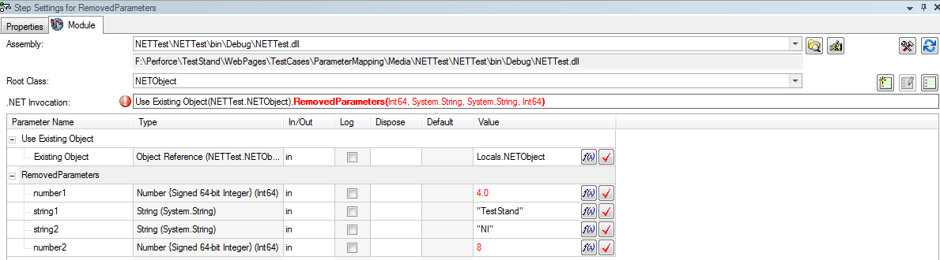

- Reselect the method. Verify that the following is displayed:

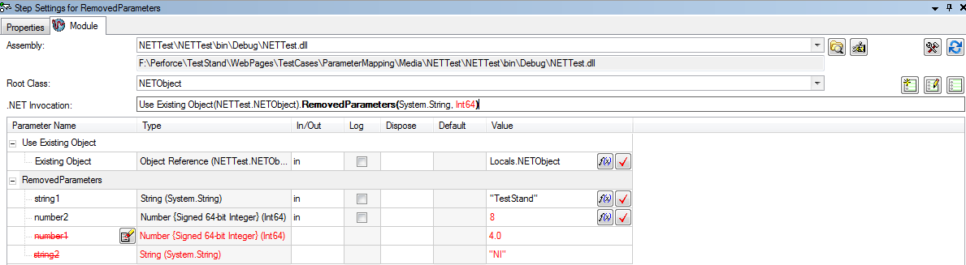

- Notice that the red icon is gone and parameters had been deleted. The deleted parameters are now called unmapped parameters and they will be around to map again for changes of that particular step, unless the “Clear Unmapped Parameters” button is clicked.
- Now select the ChangedParameters step.
- Verify that the following is displayed:

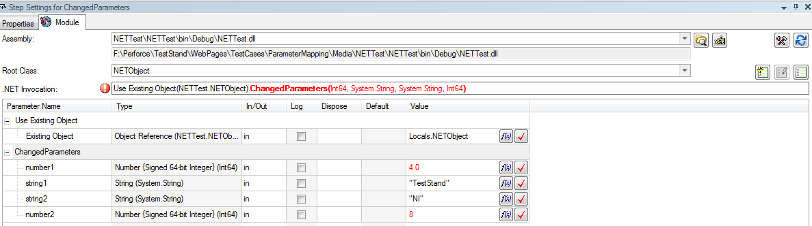

- Reselect the method. Verify that the following is displayed:

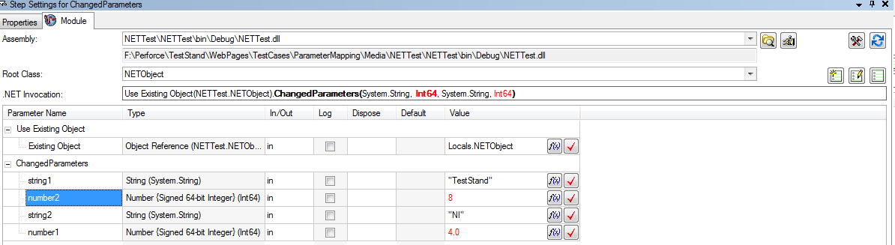

- Notice that the red icon is gone and the values have been moved or mapped.
- Hit “Ctrl-Z” three times to undo all the “Resolve Prototype” operations and verify that the three steps display the red blinking icon
- Now select the three steps.
- Verify that the following is displayed:

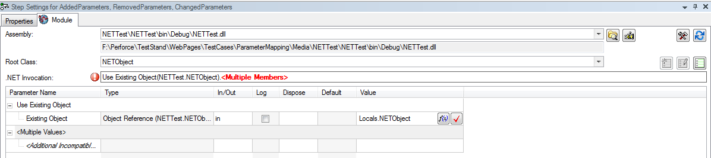

- Now select the RemovedParameters step.
- Verify that the following is displayed:

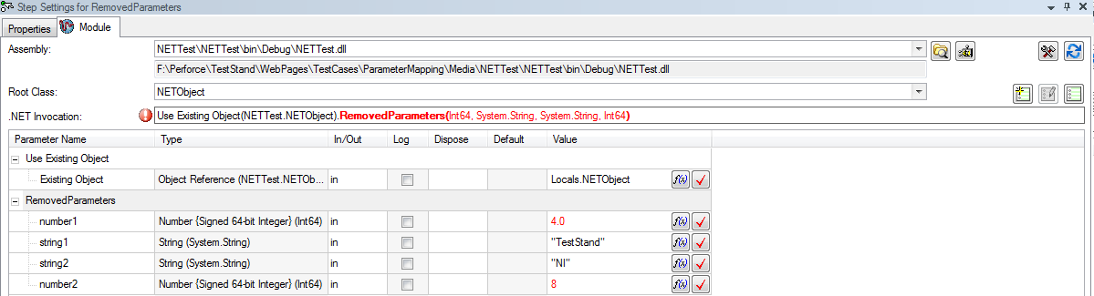

- Reselect the method so the prototype can be resolved and then click on the “Clear Unmapped Parameters” button.
- Verify that the following is displayed:

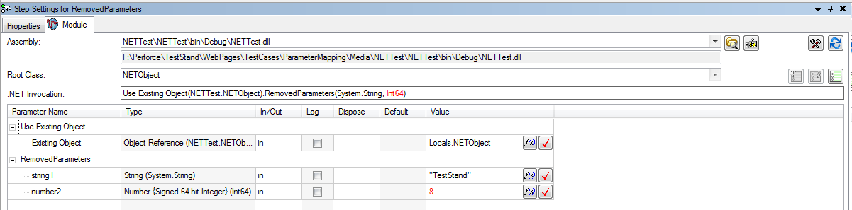

- Hit “Ctrl-Z” one time to undo the “Resolve Prototype” RemovedParameters step.
- Verify that the following is displayed.

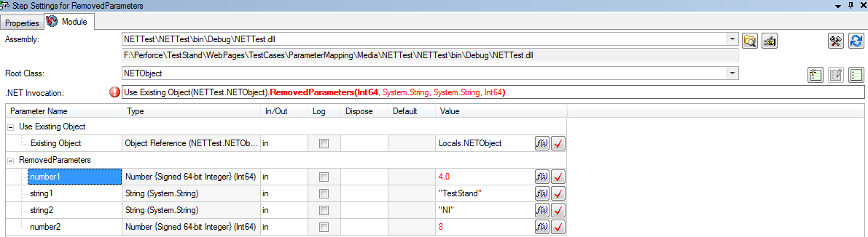

- Now select the ArrayClustersParameters step.
- Verify that the following is displayed:

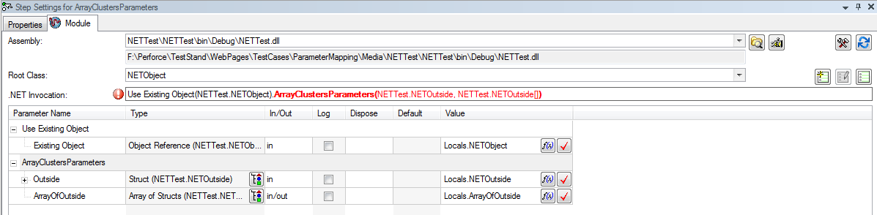

- Reselect the method so the prototype can be resolved.
- Verify that the following is displayed:

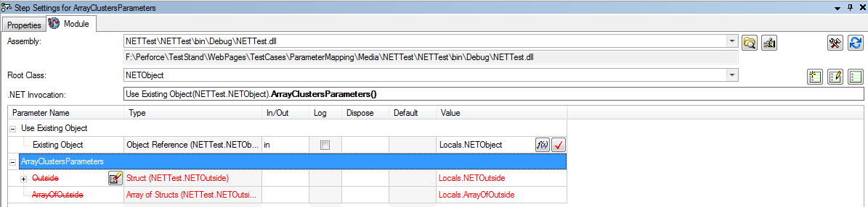

- Verify that all the nodes can be expanded and you’re able to the see the following:

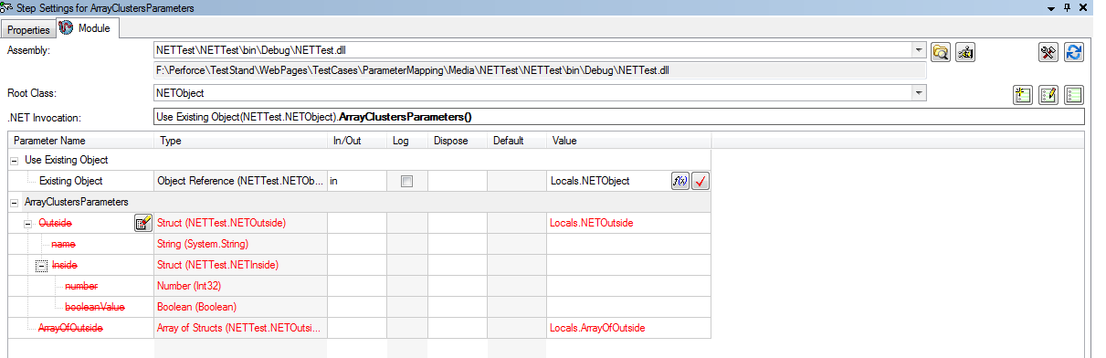

Additional Validation for DotNet Module Panels
- Open the sequence file MultiTest.seq
- Select the 3 DotNet steps.
- In the .NET Module panel, change the method to TestStructPassing2.
Note: To change the method for TS 2010 and above:
- Ensure that the DLL called is from “\TestStand\WebPages\TestCases\DotNetModulePanel\Media\ParameterMapping\DotNetAdapterTest.dll”
- Go to the .net invocation control
- Double click on the TestStructPassing ( in bold)
- Change the method in the drop down box to TestStructPassing2
- Check the image below for more details

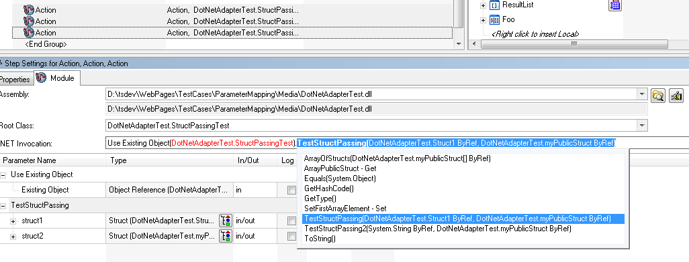

- Verify that there is one unmapped parameter called struct1:

