.NET Module Panel – Undo
TestStand Version: 4.0

Author: Isaac Squires
Feature: .NET Module Panel
Dependencies: none
Test Category: [ Functional ]

Description
This procedure tests the Undo functionality of the .NET Module step settings panel. There is a separate test procedure for testing the basic functionality of the panel. This procedure tests that the Undo command correctly reverts changes made to these step properties.

Preparation
- Make a copy of the file DotNetModulePanel.seq and call it ORIGDotNetModulePanel.seq. Run the sequence editor and open both sequence files.
- Go to the Sequence Editor Options dialog and check the Allow Editing of Read-Only files checkbox.
- If either sequence file appears to be modified (the * character appears in the title bar), save it to disk.

Validation
Ideally, much of this testing would be automated. We don’t yet have a good tool for automating the Sequence Editor GUI, so until then we follow this general approach to validating Undo: Repeat the following sequence of steps, each time varying the set of selected steps, the order in which properties are changed or the values to which properties are set.

- Open MainSequence.
- Select any step or combination of steps. (In subsequent tests, try selecting different sets of steps also.)
- Change the values of the controls on the .NET Module Panel. (In subsequent tests, try changing in different order and use different values. Also, try just a few of the properties.)
- Press Ctrl-Z for each of the changes you made.
- Verify that the document does not appear modified (the ‘*’ character is not displayed next to the title).
- Press Ctrl-Shift-D to display the differ dialog.
- Press OK button to diff the original with the copy and verify that there are no differences. The differ document should appear something like the following:

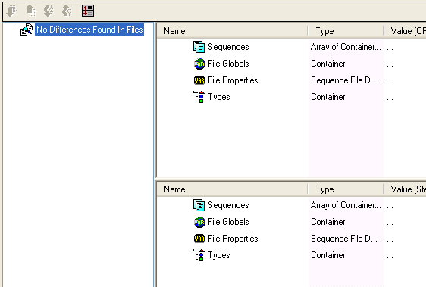

Additional Tests
- After making a change to each control, verify that appropriate text is displayed in the Edit menu for the Undo operation. Note: Testing translation requires editing the SequenceEditorStrings4.ini file, and there is a separate test for general translation.
- Verify that controls that allow typing (edit, expression edit, some combo boxes) commit after each change, but that there is only one Undo item for all the changes.
- Verify that changes made in other places (variables view, expression browser, etc.) mixed with changes to panel properties do not affect undo.
- Verify that if a property had an invalid value prior to the change, the undo operation restores the invalid value.
- Verify that you buttons and checkboxes in the parameter panel restore the state to the previous state and that the undo puts focus on the correct cell.
- Verify that you go to the correct location if you go to a different step before performing the undo.
- Be sure to select steps with enough calls in common that you can add/change/remove some of the calls in the invocation control and thoroughly test undo with that control as that is heavily modifying the step.

