02/07/2012:Changes integrated into help per CAR 301034. DO NOT MAKE ANY CHANGES TO THIS FILE. PLEASE FILE DOCUMENTATION CAR FOR CHANGES.

<Note to tech writer: I included screenshots to help you understand the context of the information. I understand that the screenshots probably do not go in the online help. - James>

Configure>>Result Processing... - This menu item displays the Result Processing Dialog Box.

<Note to tech writer: Configure>>Report Options... and Configure>>Database Options... have been removed>

Result Processing Dialog Box

Use the Result Processing Dialog Box to configure how TestStand processes the results your test sequences generate. You can choose to generate reports, log to databases, or store your results in compact offline result files for later processing. You might have additional options for processing results if you have created or installed additional Result Processing Plug-ins.

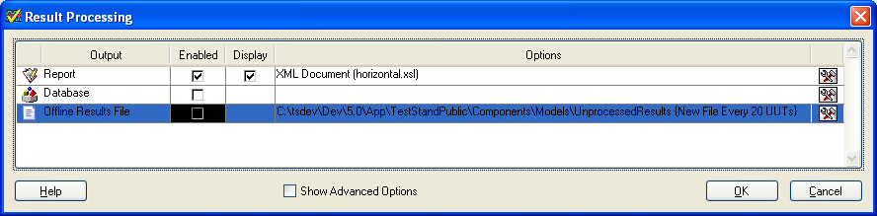

By default, the Result Processing Dialog Box displays without showing its advanced options. In this case it contains only a table with one row in the table for each of the installed Result Processing Plug-ins. You can enable or disable each plug-in, and you can configure the options for how each plug-in processes test results.

If you checkmark the Show Advanced Options checkbox, the dialog displays additional controls.

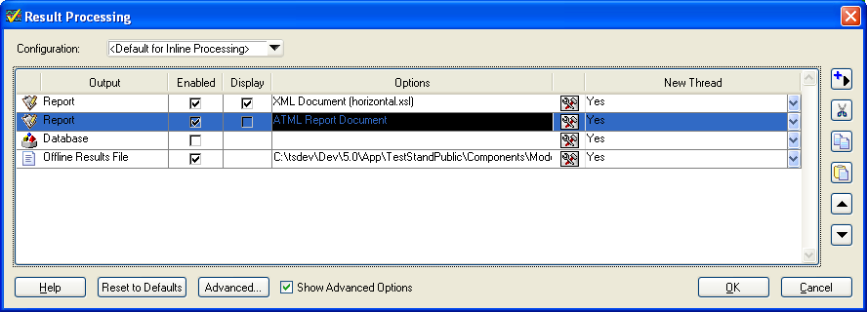

With these additional controls, you can insert or delete Result Process Processing Plug-in instances, change the order in which TestStand invokes them, and specify whether TestStand invokes them serially or in parallel using separate threads. You can also create and manage multiple sets of configured Plug-in instances. Each set is referred to as a Result Processing Configuration.

Configuration - This drop down list selects which Result Processing Configuration is active. The Plug-in Instance Table displays the plug-in instances in the active configuration and TestStand uses the active configuration to process results inline, where inline means at runtime. You can also select the Manage Configurations... item to display the Manage Result Processing Configurations Dialog Box.

Plug-in Instance Table - Each row in this table specifies a result processing plug-in and the options with which to invoke it. You can insert instances of the same plug-in on multiple
rows to invoke the plug-in multiple times with varying options. You might do this to create multiple reports with different formats or to log to multiple databases. Each row in the table has the following columns:

- Output - Indicates the type of output the results processing plug-in creates. You can edit the name to make it more descriptive.
- Enabled - Indicates whether TestStand invokes the plug-in instance when processing results.
- Display - This column only appears if a plug-in instance that uses it is in the table. Of the NI provided plug-ins, only the NI Report Generation plug-in uses the Display column. For multiple instances of the NI Report Generation plug-in, the checkbox in the display column specifies which instance displays its report by default in the TestStand Report View. At run-time, you can still view a report from a different plug-in instance in the Report View by selecting from the Active Report menu from the Report View toolbar. To create reports without the overhead of displaying them in the report view, you can deselect the Display checkbox for all NI Report Generation plug-in instances.
- Options - Displays a summary of the most important option settings for the plug-in instance. Click the Options button to display the options dialog box for the plug-in instance.
- New Thread - Specifies how TestStand invokes the plug-in. The options are:
- Yes - TestStand invokes the plug-in in a new thread. It processes results in parallel with other plug-ins and with the testing of subsequent UUTs.
- No -TestStand waits for the plug-in to complete its processing before invoking the next plug-in in the table, including plug-ins with New Thread set to Yes.
- Yes, But Complete before next UUT -TestStand invokes the plug-in in a new thread but waits for the plug-in to complete before testing begins on the next UUT.

Insert New Plug-in Instance -Displays a menu of the installed result processing plug-ins. Select an item from the menu to insert a new instance of the plug-in into the Plug-in Instance Table.

Cut - Removes the selected plug-in instance and places it on the clipboard.

Copy - Copies the selected plug-in instance to the clipboard.

Paste - Copies the plug-in instance on the clipboard into the Plug-in Instance Table.

Move Up - Moves the plug-instance toward the beginning of the Plug-in Instance Table.

Move Down - Moves the plug-instance toward the end of the Plug-in Instance Table.

Help - Displays the help topic for the Result Processing Dialog Box.

Reset to Defaults - Replaces the contents of the current active configuration with one instance of each installed result processing plug-in. Each instance is configured with its options in their default state. This action prompts you to select whether you intend to use the configuration for inline or offline processing. If you select offline, the action does not insert an instance of the Offline Result Generation plug-in because you already have an offline results file to process.

Advanced... - Displays the Advanced Result Processing Settings Dialog Box.

Show More Options - When unchecked, the dialog hides most of its controls and the user can only edit the options of the plug-in instances that exist in the active configuration.

Advanced Result Processing Settings Dialog Box

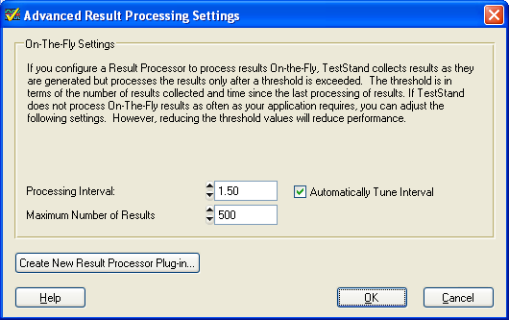

Use the Advanced Result Processing Settings Dialog Box to configure advanced options that apply to result processing for all plug-in instances in all configurations and to create new Result Processing Plug-ins.

Processing Interval - Specifies the duration in seconds since the last processing of on-the-fly results after which a new result will trigger processing of the accumulated on-the-fly results.

Automatically Tune Interval - Specifies that TestStand also initiates processing of the accumulated on-the-fly results when a new result is generated and the number of accumulated results equals or exceeds the number of results that TestStand estimates can be processed within the duration of the value of Processing Interval. This option ensures that large amounts of rapidly generated results do not cause long pauses in test execution during on-the-fly result processing.

Maximum Number of Results - TestStand initiates the processing of accumulated on-the-fly results when a new result is generated and the number of accumulated results meets or exceeds this value. If you want each result to be processed immediately after it is generated, set this value to 1.

Note: TestStand initiates processing of results when it generates a new result and either the Processing Interval or the Maximum Number of Results is exceeded.

Note: If you set the thresholds for processing on-the-fly results so low that only a single result or a very small number of results accumulate before they are processed, it significantly increases the overall time to process your results.

Note: The controls that govern when on-the-fly results are processed apply to the decision of whether to process that TestStand makes after it generates a result. TestStand does not process results for a thread while a code module in the same thread executes, regardless of how long the module takes. In addition, these controls set maximum thresholds that trigger result processing. Depending on the internal requirements of the Result Processing Plug-ins you use, on-the-fly result processing might occur more frequently than these thresholds specify.

Create New Result Processor Plug-in... - Creates a new Result Processor Plug-in sequence file and opens the file. You complete the entry points in the file that your processor requires and delete the ones it does not. You must also update FileGlobals.ResultProcessorComponentDescription in your plug-in according to your requirements. Refer to ???? for more information.

Manage Result Processing Configurations Dialog Box

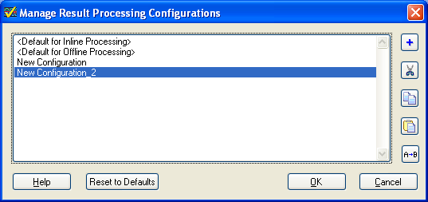

Use the Manage Result Processing Configurations dialog box to create or delete Result Processing Configurations. A Result Processing Configuration is a named set of result processing plug-in instances. Having multiple configurations allows you to quickly change how results are processed by changing the active configuration. It also allows you to specify that offline result files are processed differently than inline results or that offline results files stored in different locations are processed differently. By default the dialog box contains two configurations that can be edited but not deleted or renamed:

- <Default for Inline Processing> - This configuration is the default active configuration for processing results at runtime.
- <Default for Offline Processing> - This configuration is the default configuration used by the Offline Results Processing Utility.

You can create any number of additional configurations. You select the configuration that processes inline results with the Configuration control on the Result Processing Dialog Box. Note that this control is visible only if Show Advanced Options is selected on the Result Processing Dialog Box. You select the configuration that processes offline results files for an Offline Result Processing Profile by editing the profile in the Offline Results Processing Utility. <note to tech writer: see Magus if you want more details, he is working on this part>

Configuration List - Display the list of all Result Processing Configurations.

Insert New - Inserts a new configuration into the Configuration List.

Cut - Removes the selected configuration and places it on the clipboard.

Copy - Copies the selected configuration to the clipboard.

Paste - Copies the configuration on the clipboard into the Configuration List.

Rename - Renames the selected configuration.

Help - Displays the help topic for the Manage Result Processing Configurations Dialog Box.

Reset to Defaults - Deletes all configurations and replaces them with the two default configurations: <Default for Inline Processing> and <Default for Offline Processing>.

Offline Results File Generation Options Dialog Box

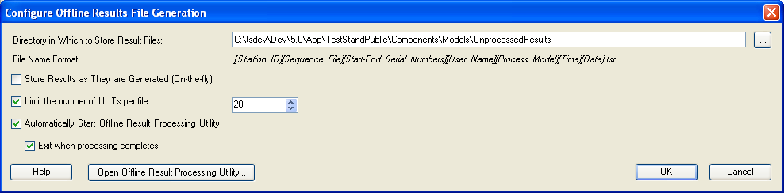

Use the Offline Results File Generation Options Dialog Box to specify the options for an instance of the Offline Results Generation plug-in.

Directory in Which to Store Result Files - Specifies the directory in which the plug-in instance stores offline result files.

Note: If the combination of the result file name and its directory exceed 259 characters, standard Windows functions such as CopyFile() that you might use to manage the file will not function. If this is a problem, you can select a directory with a shorter path, access your directory via a mapped drive letter, or specify the “\\?\” prefix that Windows requires to denote extended length paths (search MSDN for “Naming Files, Paths, and Namespaces for more information).

File Name Format - Indicates how the plug-in chooses the name of the result file. You cannot edit this control. If a file already exists that has the same name as the file name the plug-in selects, the plug-in appends a number to the file name to make it unique.

Store Results as They are Generated (On-the-fly) - Specifies whether the plug-in writes the results to the file after each UUT completes or if it writes the results on-the-fly. If you select to save results on-the -fly, you can control how frequently the plug-in writes results by setting options on the Advanced Result Processing Settings Dialog Box.

Limit the number of UUTs per file - Specifies whether the plug-in stores all the results from an execution in a single file, or whether it creates a new result file whenever the current file contains the results for a specified number of UUTs. The limit is an approximate threshold and might be exceeded for such purposes as keeping the results for all the UUTs in a particular batch within the same results file.

Automatically Start Offline Results Processing Utility - Specifies whether to start the Offline Results Processing Utility when the Offline Result File Generator creates a new results file and the utility is not already running.

Exit When Processing Completes – Specifies whether the Offline Results Processing Utility automatically exits when it completes all processing. This option has no effect when the utility is already launched by the user.

Help - Displays the help topic for the Configure Offline Results File Generation Dialog Box.

Open Offline Results Processing Utility –Launches the Offline Result Processing Utility.

<Note to tech writer: This dialog is the options dialog for the NI Offline Results Generation plug-in. The old Report Options Dialog Box and Database Options Dialog Box are now the options dialog boxes for the NI Report Generation plug-in and the NI Database Logging plug-in respectively. They are no longer invoked directly from items in the Configure menu.>

