Dll Module Panel/Dialog – 64-Bit Integers Support
TestStand Version: 2010

Author: Antonio Lie
Feature Spec: Dll Module Panel / Specify Module Dialog
Dependencies: Visual Studio 2005

Test Category: [ Functional ]

Description
This test validates the interaction of the DLL module panel and dialog with 64-bit parameters.

Preparation
- Install Visual Studio 2005 or later
- Get the latest version of the files under the following perforce location:
//TestStand/WebPages/TestCases/DLLModulePanel/Media/64BitSupport
Mark all the files under the previous directory as writeable.
Note: Do not submit your changes to Perforce.
- Run the sequence editor/UI (2010 or higher) and open the sequence file 64BitIntegersDll.seq
- There are steps in this test plan that only apply to the sequence editor and steps that only apply to the UI (User Interface). Pay attention to the instructions.
- When testing with 64 bit TS use the DLL from : //TestStand/Tests/TS Automated Tests/4.5/cppAdapter/64BitSupport/ . Refer the DLL under respective x64 folder.

Validation
DLL without Type Library
- Select the DLL Without Type Library Sequence
- Insert a new step
- Select 64BitSupport.dll as the module
- Select TestSimple64BitCall as the function
- Verify the module pane/dialog looks as follows:

SeqEdit:
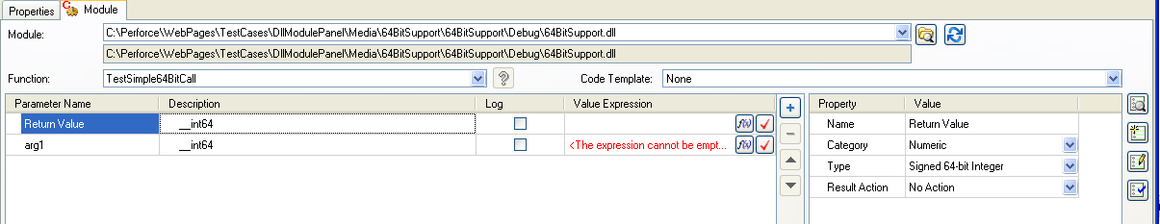

UI:

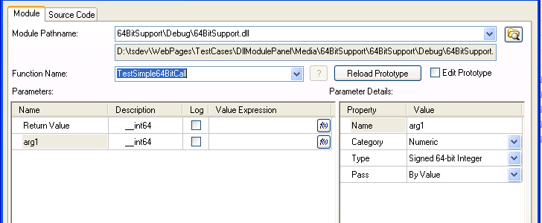

- Click on the Source Code Files button and select the option to create code in text file (Functions Only) from the ring control.
- Enter 64BitSupport.cpp as the source file
- Close the CVI Source Code Files dialog (Sequence Editor Only)
- Click on the Verify Prototype button
- Verify you get the following dialog:
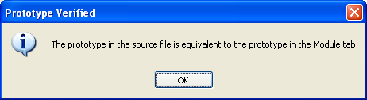
- Click OK
- Change the arg1 type to Unsigned 64-bit Integer
- Verify you get an error provider indicating that the parameter does not match the function prototype
SeqEdit:

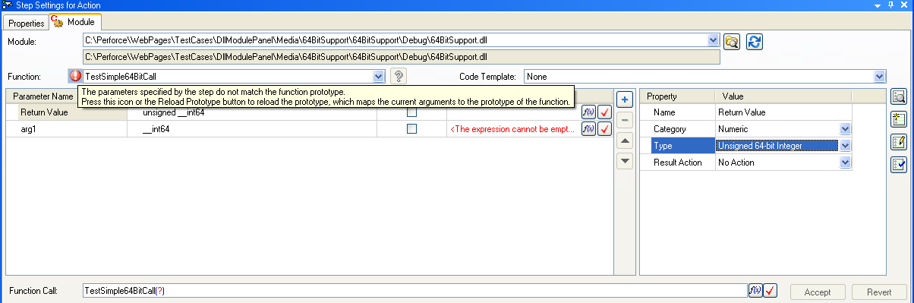

UI:

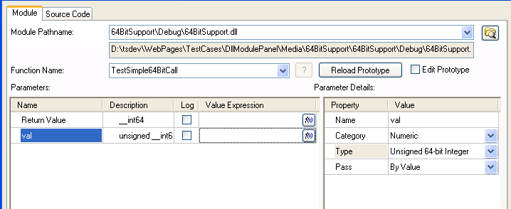
- Click on the Verify Prototype button
- Verify you get the Prototypes Conflict dialog
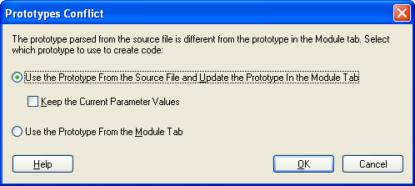
- Select the option to use the prototype from the source file and update the prototype in the module tab and click OK
- Verify that the module pane\dialog looks as follows:
SeqEdit:
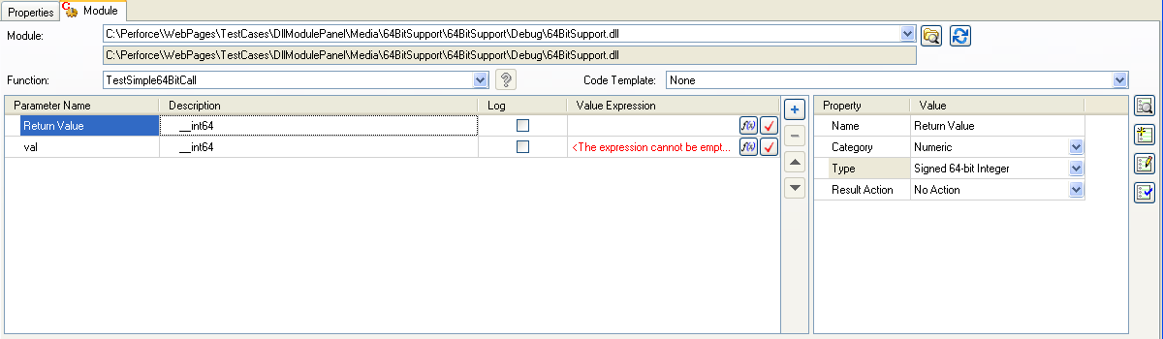

UI:

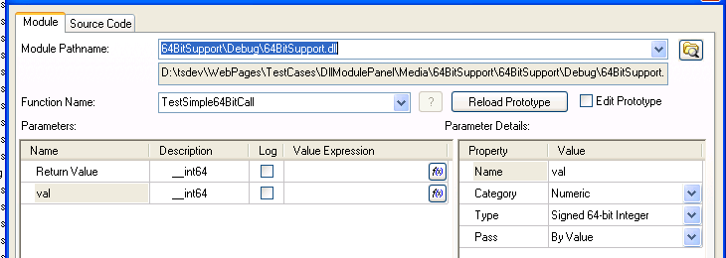
- Click on the Edit Code button
- Verify that the 64BitSupport.cpp file is opened in Visual Studio (Notice that the function is not selected)
- Go back to TestStand
- Click on the Create Code button
- Verify you get the following dialog:

SeqEdit:
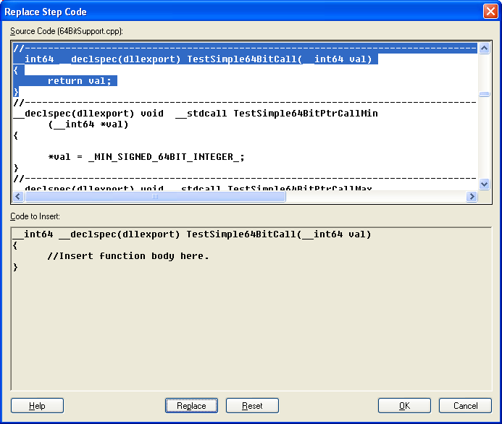

UI:
- You get the Following Dailog:
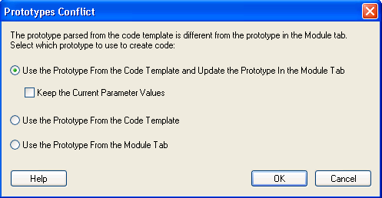
- Click OK.You get the following dialog:
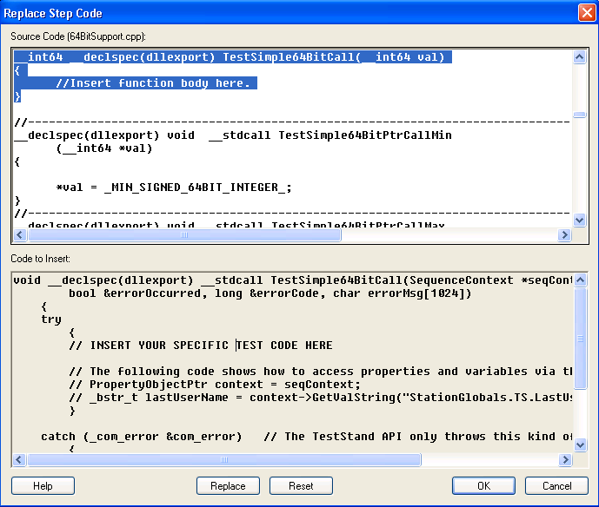
- Click on the Replace button
- Click OK
- Click on the Edit Code button
Verify 64BitSupport.cpp is launched in Visual Studio
Search for TestSimple64BitCall and verify it looks as follows:
SeqEdit:
__int64 __declspec(dllexport) TestSimple64BitCall(__int64 val)
{
//Insert function body here.
}

UI:
void __declspec(dllexport) __stdcall TestSimple64BitCall(SequenceContext *seqContext, char reportText[1024],
bool &errorOccurred, long &errorCode, char errorMsg[1024])
{
try
{
// INSERT YOUR SPECIFIC TEST CODE HERE

// The following code shows how to access properties and variables via the TestStand API
// PropertyObjectPtr context = seqContext;
// _bstr_t lastUserName = context->GetValString("StationGlobals.TS.LastUserName", 0);
}

catch (_com_error &com_error) // The TestStand API only throws this kind of exception
{
_mbsnbcpy((unsigned char *)errorMsg, (unsigned char *)LPCTSTR(com_error.Description()), 1024);
errorMsg[1023] = '\0';
errorOccurred = true;
errorCode = (short)HRESULT_CODE(com_error.Error());
}
}

- Go back to TestStand
- Click on the Source Code Files button
- Select Create Code in Visual Studio from the ring control
- Enter 64BitSupport.cpp as the source file, 64BitSupport.vcproj as the project and 64BitSupport.sln as the solution
- Close the dialog (sequence editor)
- Verify the Verify Prototype button is not displayed anymore
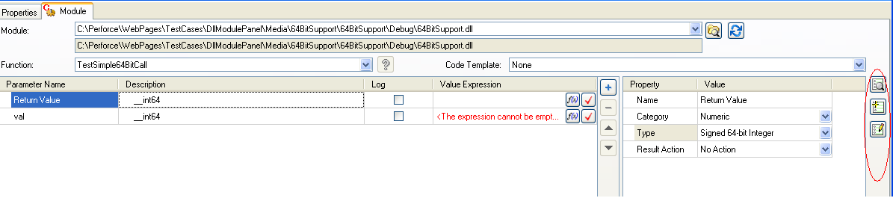
- Click on the Edit Code button
- If you get prompted to specify the version of Visual Studio to use select to use the version that matches the project file
- Verify that 64BitSupport.cpp is opened in Visual Studio and that TestSimple64BitCall function is displayed on the top of the window
- Go back to TestStand and click on the Create Code button
- Verify you get the following dialog:
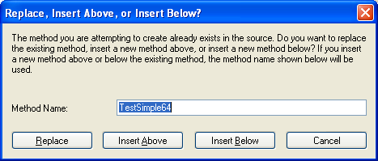
- Clck on the Insert Below button
- Verify a 64BitSupport.cpp is inserted under the existing TestSimple64BitCall function and that the cursor is located in the new function

DLL with Type Library
- Select the DLL Type Library Sequence
- Insert a new C/C++ DLL Action step
- Select 64BitIntegersTestsTl.dll as the module
- Select TestSimpleUnsigned64BitCall as the code function
- Verify the pane\dialog looks as follows:
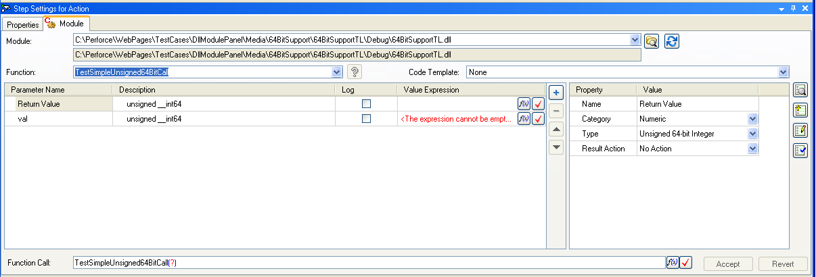
- Notice that the parameter names are Return Value and val.
- Select Unsigned64BitIntegersSingleArrayValues as the function
- Verify the pane\dialog looks as follows:
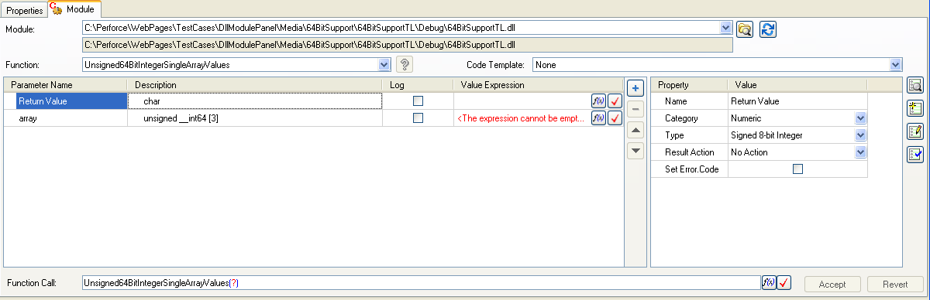
- Verify the Function List contains the following functions:
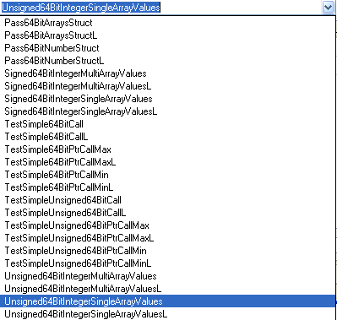

Note: Execute the previous steps with the Sequence Editor and with one of the UI’s so you can validate the panel and the dialog works properly. Remember to get the latest version of the files from perforce while switching from the Sequence Editor to the UI or vice versa.

