DLL Module Panel – DLL Type Information
TestStand Version: 4.0

Author: Erik Crank
Feature: DLL Module Panel
Dependencies: CVI 7.1 or greater, VS 2005, Measurement Studio
Test Category: [ Functional ]

NOTE: The DLL and CVI Module panels share a significant amount of source code and functionality. Consequently, a failure in one panel is likely to correspond with a failure in the other panel. In addition, tests performed for each panel are very similar. If you add a specific items to this test procedure, consider adding it to the other panel as well.

Description
This procedure tests the reading of type information from DLLs and type libraries by the DLL Module step settings panel.

DLL Type information is that information TestStand obtains about the functions declared in a DLL. There are three different sources for type information:
- Type library. This can be embedded in the DLL or it can be in a separate file in the same directory as the DLL with the same base file name and the TLB file extension.
- CVI resource. When creating a DLL, CVI 7.1 and greater generates a resource section in the DLL file that contains type information for every exported function.
- Decorated names. Compilers such as Visual Studio (all versions) decorate the names of exported symbols to support linking of C++ types. A decorated name encodes a symbol’s type.

When user changes the DLL module path, the DLL Module panel obtains the list of exported symbols from the DLL. It also obtains type information for each exported symbol and if the symbol is a function and has parameter types supported by TestStand, the undecorated function name is added to the Function combobox control. When the user selects a function in the combobox control, the panel sets the parameters to match the DLL type information.

Validation
Old DLL Using Type Library
- Open the sequence file flexc_parameter_tests.seq. This is a TS 2.0 sequence file that contains sequences to test the DLL adapter. Tests in this sequence file use a CVI DLL that has a type library.
- Select DLL steps in each of the sequences and verify that the type information appears correct. Note: There are a number of functions in the DLL with incorrect type description in the type library. As a result, if you select a step that calls one of these functions, the DLL module panel will display an error icon indicating the incompatibility. The functions that have incorrect type information are generally called VerifyArray. Also, the following steps are specified incorrectly and will display the error icon. This is expected: Test Passing char Reference and Test Passing and Returning char and PassAStruct and PassAStructPtr.

- Create a new sequence file and insert a DLL step.
- Set the module path to the flexctests.dll file in the FlexC2.0 folder.
- Verify that the function combobox contains the following:

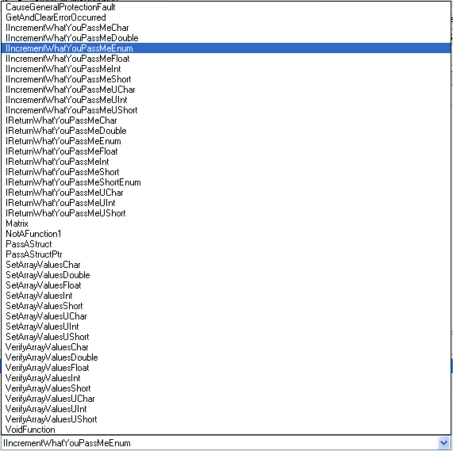

- Select each function in the list one-at-a-time and verify that the parameters control is updated correctly with the expected types. Most types should be apparent from the name of the functions. IncrementWhatYouPassMeEnum should appear as follows. Make sure you try setting to the Int function immediately after setting to the Enum function and verify Enum info is cleared. Do the same with Short and ShortEnum functions.

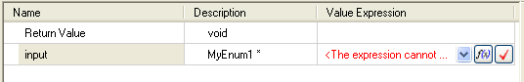
IReturnWhatYouPassMeEnum should appear as follows:
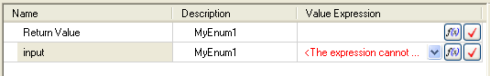
IReturnWhatYouPassMeShortEnum should appear as follows:
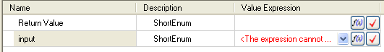

- Functions that take arrays will have an error icon next to the array parameter indicating that the array size is not specified. For instance, SetArrayValuesChar displays the following:
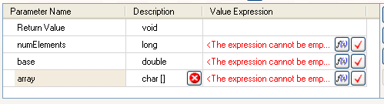

Old VS C++ Tests
- Open the sequence file CppTest1.seq in the Tests\3.0\CppAdapter\CppTest folder.
- This is a 3.0 sequence file that contains sequences to test the 3.0 features of the DLL adapter. Tests in this file use a VS 2003 DLL and type information is obtained via decorated symbol names.
- Select each DLL step in all sequences and verify that the DLL Module panel contains the correct information (there’s too much to include here, so you may have to examine source code if you can’t figure out the prototype from the function name. Source code is in Tests\3.0\CppAdapter\CppTest\Shared\AdapterTest1.h).
- Open the sequence file Tests\3.0\CppAdapter\CppTest\CppTest2.seq.
Repeat step 3 above for this file also. Source code is in Tests\3.0\CppAdapter\CppTest\Shared\AdapterTest3.h
- Open the sequence file Tests\3.0\CppAdapter\CppTest\CppTest4.seq. Select the sequence TestTSObjects. Select each step in the sequence and verify that the parameters control has the correct contents.
- Create a new sequence file and insert a DLL step.
- Configure the step to use the CppTestMFC.dll in the Tests\3.0\CppAdapter\CppTest\Dlls folder. Verify that the function combobox should contain the following items:

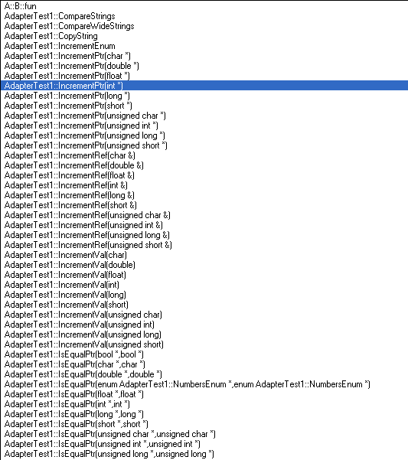
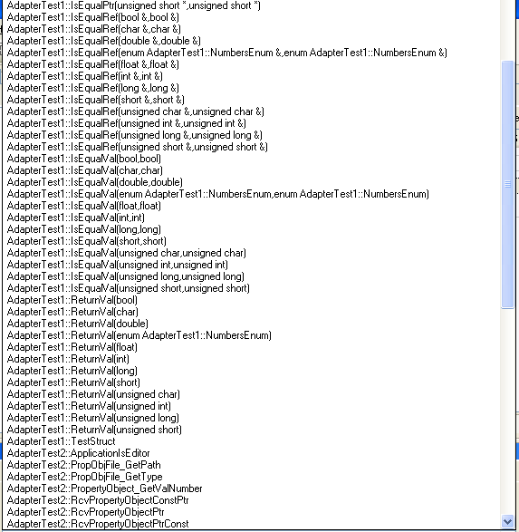
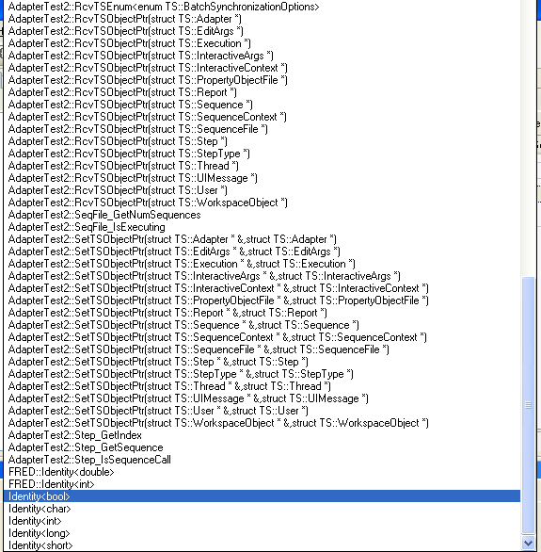

- Select each function and verify that the parameters panel is updated correctly.
- Configure the step to use the CppTestMeasStudio.dll in the Tests\3.0\CppAdapter\CppTest\Dlls folder. Verify that the function combobox lists definitions of static methods Add, Assign and Equals for each Measurement Studio data type.
- Select each function and verify that the parameters panel is updated correctly.

New VS C++ Tests
TestStand obtains DLL information from symbol decorations in DLLs created by VS 2003/2005.

- Create a DLL project in Visual Studio 2005.
- Add and export functions that use various types supported by TestStand.
Note: Use __declspec(dllexport) to export a function or a class. For class members, TestStand supports only public static methods. Read the TestStand help for more info.
- Create a new sequence file and DLL step.
- Configure the step to use the DLL you created.
- Verify that the list of functions in the function combobox matches the functions you added to the DLL.
- Select each function and verify that the parameters control updates correctly.

New CVI Tests
TestStand obtains DLL information directly from CVI DLLs created with CVI 7.1 and greater.

- Using CVI 7.1 or greater, create a DLL project.
- Add and export functions that use various types supported by TestStand.
- Create a new sequence file and DLL step.
- Configure the step to use the CVI DLL you created.
- Verify that the function combobox has the list of functions that you exported from the DLL.
- Select each function and verify that the parameters control updates correctly.

CVI Type Library Tests
- Open the sequence file DLLModulePanel.seq.
- Open the CVI Type Library sequence.
- Select the step in the sequence.
- In the Function control, select the ArrayTest function.
- Verify that the panel appears as follows:
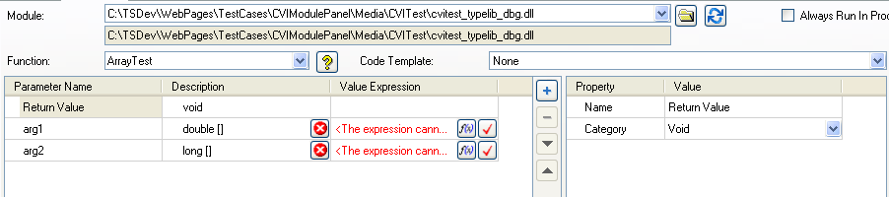
- Select the PtrTest function in the Function control:
- Verify the panel appears as follows:
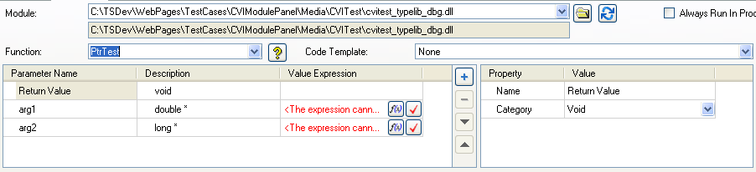
- Select the EnumTest function in the Function control:
- Verify the panel appears as follows:
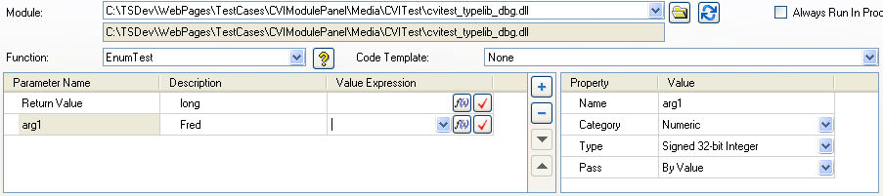
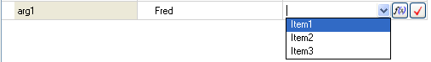

New Type Library Tests

- Create a type library with 3rd party tool (IDL and MIDL compiler)
- Verify that type library with same name as dll is found correctly.
- Verify that array sizes are obtained correctly.

Measurement Studio Tests
- Create a Measurement Studio C++ MFC project in Visual Studio 2005:
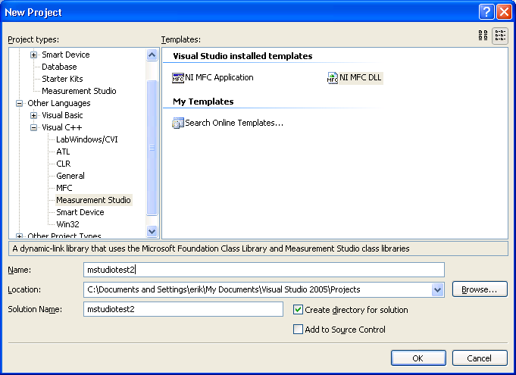
- Be sure to check the TestStand Support checkbox in the Class Library wizard when you create the project:
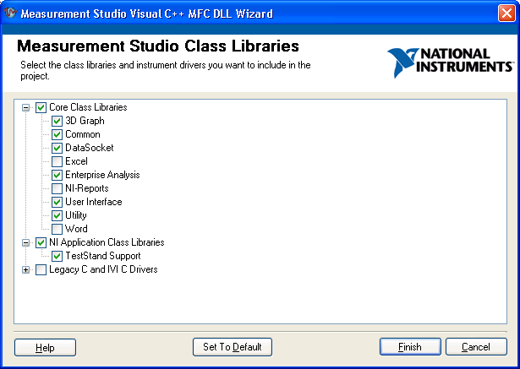
- Create a new class with static methods that are exported from the DLL (use the __declspec(dllexport) directive for the class). Use Measurement Studio datatypes for the method parameters, such as CNiString, CNiVector and CNiStringVector. Also, use MFC data types CString and _bstr_t.
- Build the DLL in Visual Studio.
- Create a DLL step and configure it to use the DLL you created.
- Verify that the list of functions includes the methods you created.
- Select each function and verify that the parameters match the parameters you specified in the DLL.

