DLL Module Panel – Editability
TestStand Version: 4.0

Author: Erik Crank
Feature: DLL Module Panel
Dependencies: none
Test Category: [ Functional ]

NOTE: The DLL and CVI Module panels share a significant amount of source code and functionality. Consequently, a failure in one panel is likely to correspond with a failure in the other panel. In addition, tests performed for each panel are very similar. If you add a specific items to this test procedure, consider adding it to the other panel as well.

Description
This procedure tests how the DLL Module Panel handles situations in which properties cannot be edited for some reason. Factors that affect whether properties can be edited include:
- Sequence file read-only status
- Sequence file source control status
- Current user privileges
- Specific property object flags
- Sequence file execution status
Preparation
- Launch the TestStand sequence editor.
- Open the file: DllModulePanel.seq

Validation
Read-Only
- Mark the file on disk as read-only. Uncheck the sequence editor option of Allow Editing of Read-Only files.
- Open the MainSequence sequence.
- Sequentially select each step in the sequence. After selecting a step, verify that all text and combobox controls are read-only and that checkboxes are disabled.

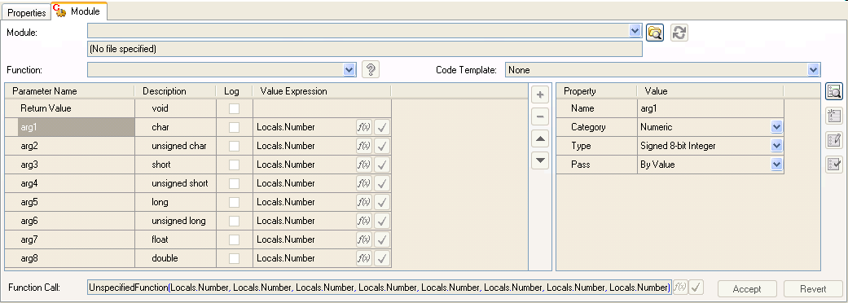

Allow Editing of Read-Only Files Option
- Open the sequence editor options dialog and check the Allow Editing of Read-Only files checkbox.
- Follow steps 2-3 in the Read-Only section above, but verify that controls are NOT read-only.

Executing
- In the Execute menu, set the “Break At First Step” option to true.
- Run the MainSequence sequence.
- With the execution suspended, follow steps 2-3 in the Read-Only section above.
- Verify that the controls are read-only.

NotEditable Flags
- You cannot make module properties not-editable without editing the module type - nothing to test here.

CanEditCode
- Open the PrototypeEditing sequence.
- Select the step “CannotEditCode”.
- Verify that the Edit Code and Create Code buttons are disabled.
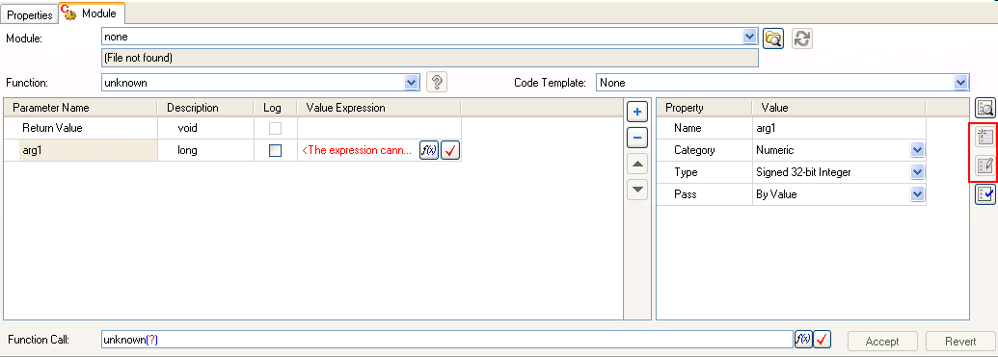

CanEditModulePrototype Property
- Open the PrototypeEditing sequence.
- Select the step “CannotEditPrototype”.
- Verify that the add/remove/move parameter buttons are disabled.
- Select the second parameter and verify that the Category and other rows in the right-hand-side control are disabled as in the image below:

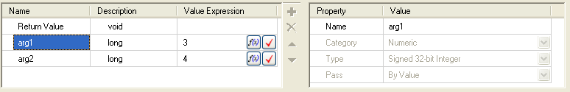

- Verify that other controls (Module, Function name) are enabled and not read-only.
- Select steps CannotEditPrototype and CanEditPrototype at the same time.
- Repeat steps 3 and 4 above.

CanSpecifyModule
- Open the PrototypeEditing sequence.
- Select the step “CannotSpecifyModule”.
- Verify that the DLL module panel is not visible.
- Open the General properties panel and verify that the step’s adapter is C/C++ DLL:

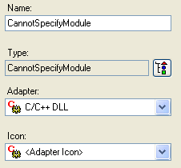

- Select steps CannotSpecifyModule and CannotEditPrototype.
- Verify that the DLL module panel is still not visible.

Source Control
- Check the following options under the Source Control tab of the Station Options dialog.

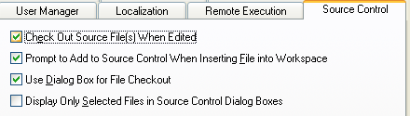

- Open workspace file DllModuleEditability.tsw.
- If the sequence file DllModulePanel.seq is checked out of Perforce, check it in and make sure the file is read-only on disk.
- In the sequence editor options, uncheck the “Allow Editing of Read-Only Files” option.
- Follow steps 2-3 in Read-Only section, except this time all controls should NOT appear read-only.
- For each step, attempt to change each step setting on the DLL Module Panel.
  - Verify that a check-out dialog similar to the one below is displayed.
  - Press the No button for each edit.

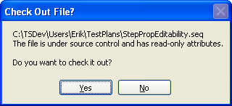

- Perform the same test again, but press the Yes button on the above dialog, and press Cancel on the source control dialog that appears afterwards:

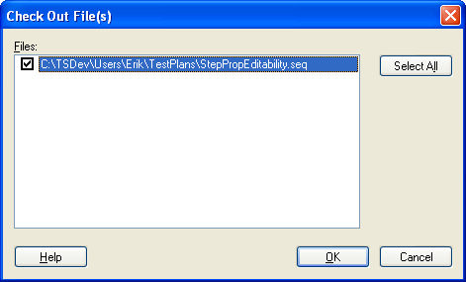

- At this point, all controls should still appear editable and any attempt to edit should cause the “Check Out File?” dialog to appear.
- Finally, go ahead and check out the file and verify that the file is editable again.

User Privileges
- Create an operator account that does not have the EditSequenceFiles privilege.
- Open the sequence file DllModulePanel.seq and make sure that it is NOT read-only on disk.
- While logged in as administrator, verify that controls are NOT read-only.
- Login as an operator.
- Follow steps 2 and 3 in the Read-Only section above to verify controls are read-only.

