DLL Module Panel – General Tests
TestStand Version: 4.0

Author: Erik Crank
Feature: DLL Module Panel
Dependencies: none
Test Category: [ Functional ]

NOTE: The DLL and CVI Module panels share a significant amount of source code and functionality. Consequently, a failure in one panel is likely to correspond with a failure in the other panel. In addition, tests performed for each panel are very similar. If you add a specific items to this test procedure, consider adding it to the other panel as well.

Description
This test procedure tests the basic functionality and cosmetics of the DLL Module step settings panel. This test does not include testing multiple selection, Undo or Goto Location features.

The DLL Module step settings panel allows the user to configure the module for C/C++ DLL steps. In this test, you will verify that the panel properly configures and displays module information for C/C++ DLL steps.

Preparation
- Run the sequence editor and open the sequence file DllModulePanel.seq.
- Go to the Sequence Editor Options dialog and check the “Allow Editing of Read-Only files” checkbox.
- Select a step in the file and display the Module step settings panel by selecting the menu item from the View menu.

Validation
General Tests
- Select step Numeric ByValue in the MainSequence.
- Verify that the DLL Module panel appears as below :
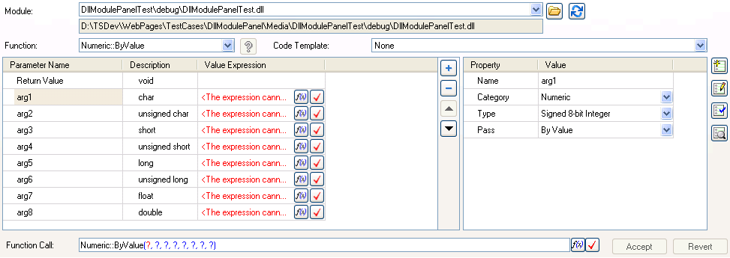

- Verify spelling of labels.
- Verify that controls are aligned and spaced reasonably. Grow and shrink the panel horizontally and vertically.
- Verify that the Module Pathname and the Code Template controls grow horizontally
- Verify that the left parameters control grows vertically and horizontally and that the right-hand-side parameters control grows vertically.
- Verify that the Function Call expression edit control is anchored to the right side of the panel and that it grows and shrinks with the panel.
- Verify that horizontal and vertical scroll bars appear if the panel shrinks too much.
- Use the splitter between the parameters controls to resize the both parameters controls.
- Verify that the panel disappears when no steps are selected.
- Verify tab order of controls.
- Verify that tabbing from the last control on the panel returns focus to the Modules tab.
- Verify that you can navigate to each button using tab.
- Repeat above tests with the Step Settings Panel undocked (floating).
- Disable XP Themes on your computer, restart the Sequence Editor and review the DLL Module panel for cosmetic problems.
- Change the DPI setting on your display to Large (120DPI), restart the Sequence Editor and review the DLL Module panel for cosmetic problems.

Path Control Tests
- Type the following path in the control labeled Module Pathname: CommonCModule\PrototypeCompatibility\Debug\PrototypeCompatibility.dll
- Verify that absolute path is displayed:

- Drop-down the relative path combobox and verify that the path you just entered is at the top of the list (the other items will be different):

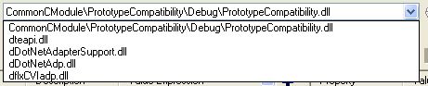

- Press browse button and verify that the dialog shows the contents of the Debug folder.

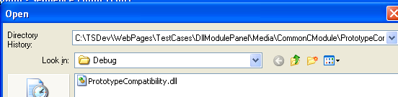

- Verify that the Use Absolute Path button is not checked and that the Files Of Type combobox contains only DLL Files:

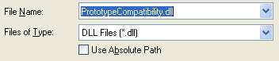

- Click the Use Absolute Path button and press the Open button to select the file and close the dialog.
- Press browse button again and verify that Use Absolute Path button on the dialog is checked:

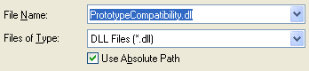

- Press the cancel button to close the dialog.
- Verify that the Function combobox dropdown list contains the list of functions in the PrototypeCompatibility DLL, some of which are shown below:

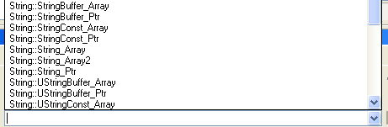

- Delete all text in the path control and verify that the Function combobox dropdown list has no items.
- Type the following invalid path in the path control: badpath\\\\
- Verify that the path control appears as follows:

- Copy the Dll (WebPages\testcases\DllModulePanel\Media\ CommonCModule\PrototypeCompatibility\Debug\PrototypeCompatibility.dll) to the \\Nirvana\Temp folder.
- Type the following path in the path control: \\nirvana\temp\PrototypeCompatibility.dll
- Verify that the path control displays the correct absolute path:
- Click on the dropdown button on the path control and verify that the first three items match the items shown below:
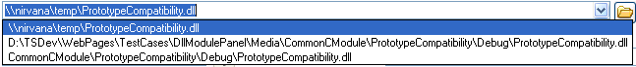

- Make a note of the items in the history list. Exit and restart the sequence editor.
- In the unnamed sequence file, insert a DLL step and display the DLL Module panel.
- Verify that the path control history list matches the list you recorded in step 17.

Function Control Tests
- Select step Numeric ByValue in the MainSequence.
- Type in the following path to the Module Pathname control: CommonCModule\PrototypeCompatibility\Debug\PrototypeCompatibility.dll
- Verify that the Function combobox contains a list of functions in alphabetic order.
- Verify that overloaded symbols display prototype.
- Verify that the following appear in the combobox:
Overloads::Function(int)
Overloads::Function(void)
- Verify that none of the symbols appear decorated (a decorated symbol is one with type information embedded in it like ?String_Array@String@@YAXQAPAD@Z)
- Select the symbol Overloads::Function(int).
- Verify that the parameters control updates immediately to display the single integer argument after you select the function from the combobox.
- Delete the text in the Function combobox and type in the text Overloads::Function(void).
- Verify that the parameters control removes the integer parameter shortly after you typed the last character of the text.
- Cut the text in the Path control and verify that the function name changes to “Overloads::Function”.
- Paste the text back into the Path control and verify that the function names changes to Overloads::Function(int) and that an error icon appears indicating a change in prototype:
- Use Undo to undo the changes and verify that changes undone properly.

Parameters Control Tests
- Select the step NumericByValue.
- Select different parameters in the parameters control and verify that the right-hand-side control displays the correct name for the currently selected parameter.
- Select the Return Value row in the parameters control.
- Click on the Category combobox in the right-hand-side of the parameters control and verify the contents of the combobox:

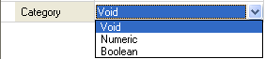

- Select the parameter named “arg1” and verify the contents of the comboboxes on the right-hand-side control:

Category combobox:
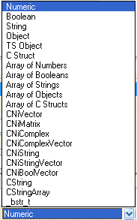

Type combobox:
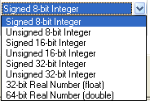

Pass combobox:
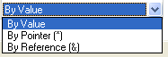

- Select step named NumericByPtr and select the parameter named “arg1”. Verify that the right-hand-side control contains the Result Action and Set Error.Code rows:

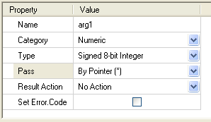

- Repeat step 6 with the step named NumericByRef.
- Verify the contents of the Result Action combobox:

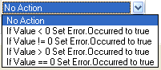

- Change the value of the Result Action combobox to anything other than “No Action”.
- Verify that the left-hand-side control displays an icon in the description column of the parameter.

- Check the Set Error.Code checkbox and verify that the left-hand-side control displays a different icon:

- Change the value of the Result Action combobox back to “No Action”. Verify that the icon displayed is updated:

- Select the Return Value row and change the Category combobox to Numeric. Verify that the right-hand-side control contains the Result Action and Set Error.Code rows:

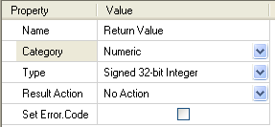

- Select the Return Value row and change the Category combobox to Boolean. Verify that the right-hand-side control does NOT contain Result Action and Set Error.Code rows:
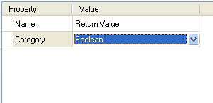
- Select the following steps and parameters and verify that the right-hand-side control appears as shown in the images below:

Step: BoolAndObjectByValue
arg1:
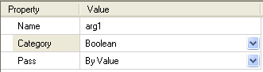

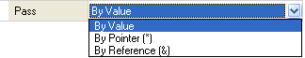

arg2:
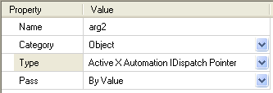
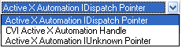

Step: String
arg1:
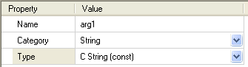
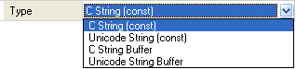
arg3:
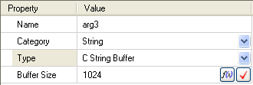

Step: TSObjectByValue
arg1:
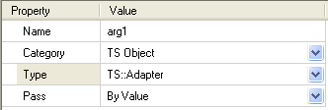

Step: Struct
arg1:
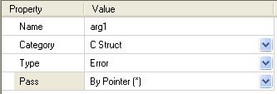
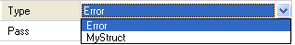

Step: NumericArray1D
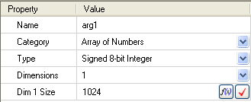
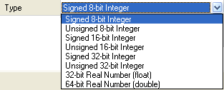
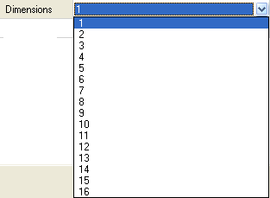

Step: NumericArray2D
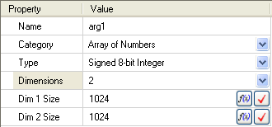

Step: BoolAndObjectArray1D
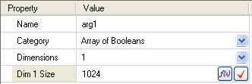
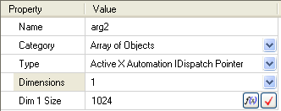

Step: StringArray1D
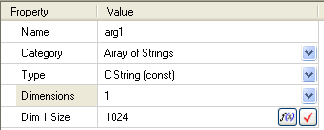
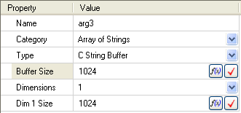

Step: StructArray
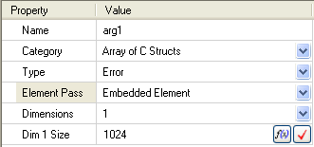
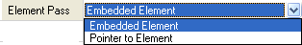

Step: CNiVectorByValue
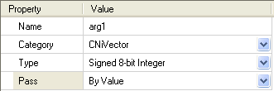
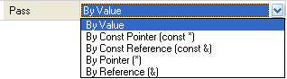

Step: CNiMatrixByValue, CNiComplexByValue, CNiComplexVectorByValue
Same as CNiVectorByValue, except replace CNiVector with the appropriate type.

Step: CNiString
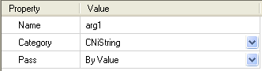

Step: CNiStringVector, CNiBoolVector,CString, CStringArray, _bstr_t
Same as CNiString, except replace CNiString with appropriate type.

Result Actions and Set Error.Code Tests
- Open the sequence “ResultActions” and select None.
- Verify that Description column in the parameters control appears as shown below:
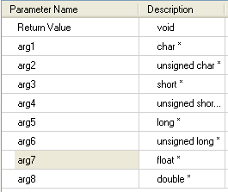
- Select step “ResultAction Set If Value < 0” and verify that Description column has checkbox icons as shown below:
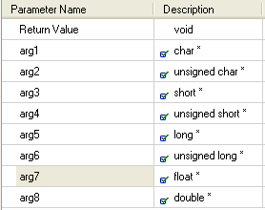
- Select step “Set Error.Code” and verify that Description column has icons as shown below:
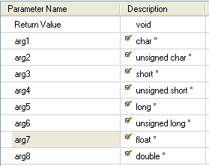
- Select step “Set Error.Code AND ResultAction IF Value < 0” and verify that Description column has icons as shown below:
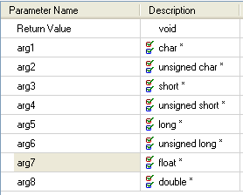
- Select 2 steps: “ResultAction Set if Value < 0” and “ResultAction Set if Value != 0” and verify Description column:
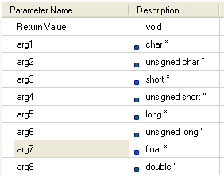
- Select 2 steps: “None” and “Set Error.Code” and verify Description column icons:
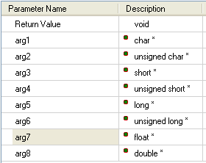
- Select 2 steps: “ResultAction Set If Value < 0” and “Set Error.Code” and verify Description column icons:
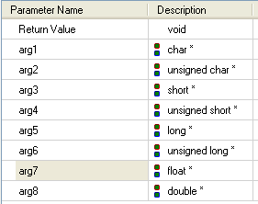

Expression Context Test
- Open the sequence named ExpressionContext and select the Custom step.
- Press the browse button on the parameter argument value expression control.
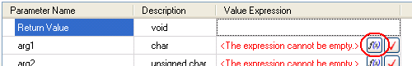

- Verify that the CUSTOM_FIELD property appears under the step in the treeview:
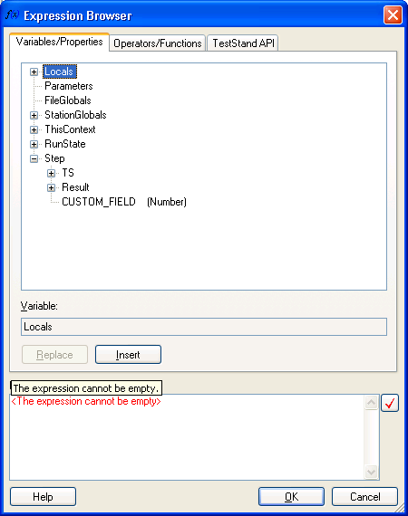

Parameters Error Tests
- Open the sequence “ParameterErrors” and select ArraySizeExpr.
- Verify that the parameters control has error icon buttons as shown below:

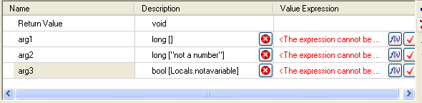

- Click on each of the buttons and verify that focus changes to the Dim 1 Size control. A thick rectangle is drawn around the control for a second:

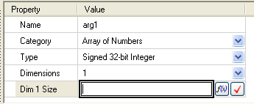

- Change the type of the arg1 parameter to Array of Booleans, Array of Strings, Array of Struct and Array of Objects and verify that the error icon buttons remain visible.
- Select the step StructType and verify the error icon:

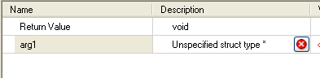

- Click on the error button and verify that focus changes to the Type control:
- Select the StringBufSize step and verify the error icon buttons:

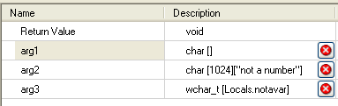

- Click on each button and verify that focus changes to the Buffer Size control:

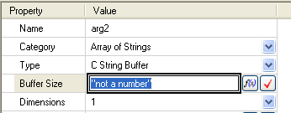

- Select step AmbiguousPtr. This step is configured to use a DLL, but the function has not been selected yet.
- Type in or select the following function in the Function Combobox: Numeric::ByPtrWithBool.
- Verify that the parameters control appears as follows:

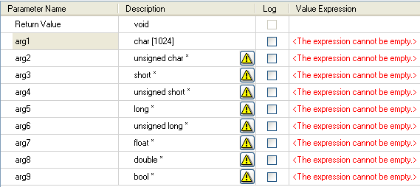

- Click on each warning icon button and verify that the following dialog displays:

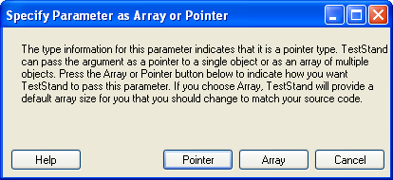

- Choose Pointer for some and verify that the warning icon is hidden and the type remains as a pointer type.
- Choose Array for some and verify that the warning icon is hidden and the type converts to an array type.
- Choose Cancel and verify that the warning icon remains visible.

Add/Remove/Move Parameters Tests
The buttons between the two parameters controls are used to add, remove, and move parameters up and down in the list:



- Open sequence “MainSequence” and select the step NumericByValue.
- Hover the mouse over each button and verify that a tooltip appears.
- Select the first parameter (Return Value).
- Verify that the only the add button is enabled.
- Select the second parameter (arg1).
- Verify that only the move up button is disabled.
- Select the third parameter (arg2).
- Verify that all buttons are enabled.
- Select the last parameter (arg8).
- Verify that only the move down button is disabled.
- Press the remove button ().
- Verify that the parameter is removed and that the eighth parameter is now selected (arg7).
- Press the move up button ().
- Verify that the parameter moves up one position and is still selected. Note: the parameter name will change to arg6 unless you explicitly rename it before the move.
- Press the add button ()
- Verify that a new numeric parameter (arg7) is created at the 8th line and that it is selected.

Splitter Tests
- Move the splitter between the parameters controls to resize.
- Verify that scrollbars appear when columns are not completely visible.

Help Button Tests
- Verify that the help button works only with DLLs that have type library. Use the dll flexc_parameter_tests.dll and specify the function CauseGeneralProtectionFault. The Help button should appear undimmed:
- Click on the button and verify that it displays the help topic.
- Verify it works with both CHM and HLP files. [You’ll need to create a type library with a help file.]

Reload Prototype Button Tests
- Verify disabled for read-only file and when step type disables prototype editing
- Verify that it correctly reloads the DLL parameter information.

TS 2013 and Later
- You can use the //TestStand/WebPages/TestCases/DllModulePanel/Media/DllModulePanelTest/DllModulePanelTest.sln solution under the media folder to regenerate the dll for this test.
- Verify that if you specify a method, and then either add or remove a parameter or change a parameter type in the actual method and rebuild your assembly, that when you come back to the sequence editor you get an error provider saying that the prototype doesn’t match. The Reload prototype button will be disabled.
- Verify that clicking the error provider will correct the error and reload the prototype. Navigate away from the step and select it again. Verify the Reload Prototype button is now enabled.

Other Tests
- Modify the DLL outside of sequence editor.
- Return to sequence editor and verify that the function combobox has the new list of functions.
- Complex data types: verify expandable rows in parameters control.
- Backwards Compatibility: Verify that we handle older sequences correctly by editing DLL steps in TS 3.5 and then opening in TS 4.0 to check consistency of data.

Layout Tests:
- Change the layout of the panel and exit the sequence editor.
- Restart sequence editor and verify that the layout is the same. Layout includes the widths of the columns in the parameters controls as well as the width of the right-hand side control.

Translation Tests:
- Exit the SequenceEditor.
- Run the application GenLangFiles.exe to generate new language files into a new language directory (e.g. Components\User\Language\Test).
- Go to station options dialog, select the localization tab and choose the new language directory you created above:
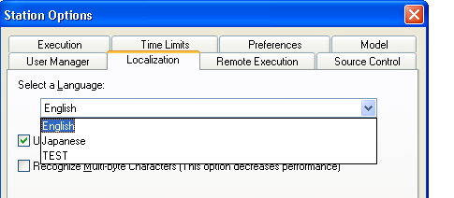
- Restart sequence editor for changes to take effect.
- Perform the steps in the General Tests sections above.
- Verify that all strings displayed in the panel are identical to what is displayed in the above screenshots, but that they end with >>>> characters.
- Verify all labels, checkboxes, tooltips and combobox items.
- Verify the undo description after changing each control.
- Verify there is enough room for the text.

Help Integration Tests:
- With the step settings pane active, press the F1 key.
- Verify the context sensitive help is launched and that it opens the DLL Module Tab topic.
- Close the help application.
- Repeat steps 1-3 with the step settings pane floating.
- With the step settings pane active, verify that the Help Topic toolbar button ( ) is enabled.
- Click on the Help Topic toolbar button to verify that the same topic as for F1 help is opened.
- Close the help application.
- Repeat steps 5-7 with the step settings pane floating.

Step Insertion Tests
- The purpose of these tests is to verify that the module path is initialized to the most-recently-used module path when new steps are inserted in the sequence.
- Insert a DLL step clear the module path if it has one. Copy that step to the Templates and name it Uninitialized.
- Configure the DLL step to a module path that is found on disk.
- Copy that step to the Templates and name it Initialized.
- Insert and configure another DLL step to a different module path that is found on disk. This is the MRU path.
- Insert new steps using all methods: Step Types in Insertion palette – drag, double-click, context menu; steps list – context menu. Also insert the Uninitialized step from the Templates.
- Verify that the inserted steps have the module path initialized to the MRU path.
- Insert the Initialized step you added to the Templates view (using all methods: drag, double-click, context menu).
- Verify that the inserted step has the first module path you used in step 3.
- Copy the step you configured in step 3 (using Ctrl-C).
- Paste the step and verify that the module path is the same as the original.

Floating Behavior
Float the step settings pane and test inserting and configuring steps by treating the step settings pane as a dialog. [CAR 4HABHU54]
- Float the step settings pane and close it.
- Insert a step.
- Right-click on the step and choose “Specify Module” to display module tab on step settings pane.
- Configure the module.
- Close the step settings pane.
- Repeat steps 2-5 for more steps.

CARs
Revalidate CARs listed in this section per notes.

CAR 379299, “CVI step Set Error Code and Result Action property values incorrectly set to default in some cases when selected function or prototype is changed.” There were two key elements to the fix for this CAR. The first was preserving the result action and set error code values. The second was preserving values for mapped parameters even when there is no value specified yet in the module UI. In what follows validate with both the C/C++ and CVI adapters.

Verify using the example project and steps to reproduce attached to CAR 379299.

Verify that the values of “Set Error.Code” and “Result Action” are preserved for parameters (including return values) when refreshing the prototype as well as changing the function to a different name with matching parameters. When refreshing the prototype, try some cases where parameters have been added and deleted. Note that these settings will not be preserved if you manually change the type of a parameter and then change it back. For example, if you change the return value to void in the UI by manually adjusting the setting and then change it back to numeric, settings will be lost. This is because the action of updating these values in the UI sets these values to their defaults. This is true for parameters as well as return values. Note, however, that if you change the return type implicitly by changing the selected function to a function that returns void and then change back, the settings for “Result Action” and “Set Error.Code” should be retained.

Verify that the additional results settings as well as “Result Action” and “Set Error.Code” are maintained when switching between prototypes even when no value expression has been entered. (Before the CAR, parameters were not mapped if the value expression was empty.)

