DLL Module Panel – Goto Location
TestStand Version: 4.0

Author: Erik Crank
Feature: DLL Module Panel
Dependencies: none
Test Category: [ Functional ]

NOTE: The DLL and CVI Module panels share a significant amount of source code and functionality. Consequently, a failure in one panel is likely to correspond with a failure in the other panel. In addition, tests performed for each panel are very similar. If you add a specific items to this test procedure, consider adding it to the other panel as well.

Description
This procedure tests the “Goto Location” functionality of the DLL Module step settings panel. The Goto Location functionality is invoked by the Find and Find-in-Files features.

Preparation
- Launch the TestStand sequence editor.
- Open the sequence files DllModuleGotoTest.seq and DllModuleLocations.seq.
- If either of the sequence files is read-only, go to the Sequence Editor Options dialog and check the “Allow Editing of Read-Only files” checkbox.

Validation

Semi-Automatic Test Execution:
The MainSequence sequence in DllModuleGotoTest.seq partially automates testing by attempting to go to each of the locations represented by the DLL Module Panel controls. Run the sequence and follow the instructions to verify that the correct control is highlighted. When a control is highlighted, it receives the focus and a thick black rectangle is drawn around the control for about a second as shown in the image below:
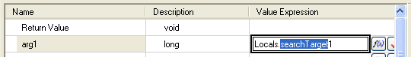

Find-in-Files Test Execution:
- Type Ctrl-F or press find toolbar button ()to find all instances of the text “SearchTarget” in the DllModuleLocations.seq file:

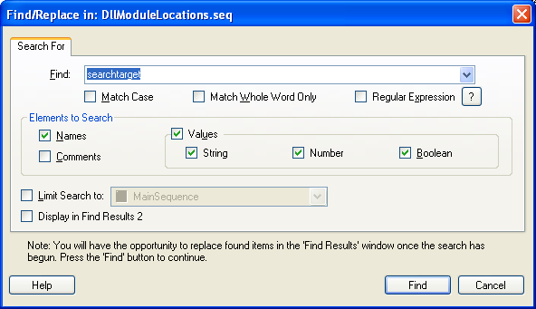

- Verify that there are 27 matches: 9 in each step group (Setup, Main, Cleanup).
- Double-click each item in the list of matches and verify that the correct control in the DLL Module Panel is highlighted and that the text “SearchTarget” is selected.

Additional Tests:
Verify that searching for property names, comments, attributes, numeric format do NOT go to the CVI Module panel.
NOTE: All the below steps should be done in the “FindFunctionTesting” subsequence of the DllModuleGotoTest.seq.

Tests For Property Names

- Type Ctrl-Shift-F or press find toolbar button ()to find all instances of the text “Check”.In the filter tab check in locals in variables section.

- Verify that there are 5 matches and they are property names in the variables panes.

- Double-click each item in the list of matches and verify that the correct control in the DLL Module Panel is highlighted and that the text “Check” is selected.

Tests For Comments

- Type Ctrl-F or press find toolbar button ()to find all instances of the text “FindFunction Testing”.In the Elements to Search section check in Comments box.

- Verify that there are 4 matches and they are Comments.

- Double-click each item in the list of matches and verify that the correct control in the DLL Module Panel is highlighted and that the text “FindFunction Testing” is selected.

Tests For Attributes

- Type Ctrl-F or press find toolbar button ()to find all instances of the text “NullAttribute.In the Elements to Search section check in Name and Attributes box.

- Verify that there are 4 matches and they are Attributes but categorized under Name.

- Double-click each item in the list of matches and verify that the correct control in the DLL Module Panel is highlighted and that the text “NullAttribute” is selected.

Tests For Numeric Format

- Type Ctrl-F or press find toolbar button ()to find all instances of the value “-5”.In the Elements to Search check in the Values box.

- Verify that there are 2 matches and they are categorized under Value.

- Double-click each item in the list of matches and verify that the correct control in the DLL Module Panel is highlighted and that the text is highlighted.

- Repeat steps 1-3 for the value of “0x78”.

- Repeat steps 1-3 for the value of “0b01101”.

- Repeat steps 1-3 for the value of “0c56”.

