DLL Module Panel – Multiple Selection
TestStand Version: 4.0

Author: Erik Crank
Feature: DLL Module Panel
Dependencies: none
Test Category: [ Functional ]

NOTE: The DLL and CVI Module panels share a significant amount of source code and functionality. Consequently, a failure in one panel is likely to correspond with a failure in the other panel. In addition, tests performed for each panel are very similar. If you add a specific items to this test procedure, consider adding it to the other panel as well.

Description
This test procedure tests the DLL Module step settings panel when multiple steps are selected.

Preparation
- Launch the TestStand sequence editor.
- Open the sequence file DllModulePanel.seq.
- Go to the Sequence Editor Options dialog and check the “Allow Editing of Read-Only files” checkbox.
- Select a step in the file and display the Module step settings panel.

Validation
Module and Function Controls
The Module Pathname and Function controls display <Multiple Values> text when the selected steps have different modules or functions.
- Open the sequence named MultipleValues.
- Select the first two steps (NumericByValueDebug and NumericByValueDebug2).
- Verify that the parameters control appears as follows:

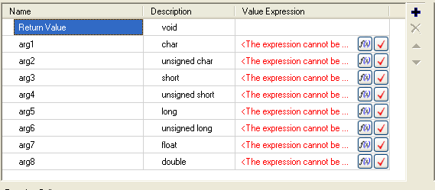

- Verify that the module and function controls appear as follows:

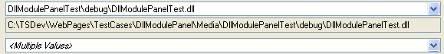

- Select the steps NumericByValueDebug and NumericByValueRelease.
- Verify that the module and function controls appear as follows:

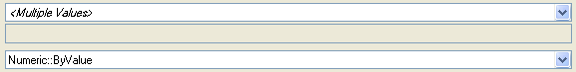

- Verify that the parameters control appears as in step 3 above.
- Select the steps NumericByValueDebug, NumericByValueRelease, and NumericByValueDebug2
- Verify that the controls appear as follows:

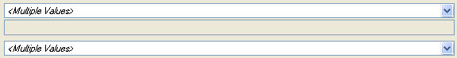

- Verify that the parameters control appears as in step 3 above.
- Select the steps Enum1 and Enum2.
- Verify that the parameters control appears as follows:
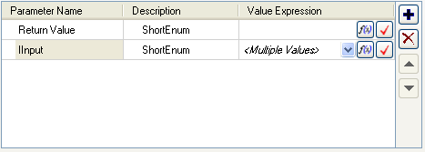
- Drop down the Value Expression combobox for the IInput parameter and verify it contains the enumeration information:
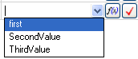
- Select the first item in the combobox and verify that the text is black (no errors).

Compatible Parameters
When all parameters of the selected steps are compatible, the panel displays all the parameters putting the text <Multiple Values> in those controls where the parameters differ.

- Open the sequence named CompatibleParams. This sequence contains groups of steps that have compatible parameters. Steps that have the same base name have compatible parameters.
- Sequentially select each group of steps in the sequence and verify that all parameters are displayed in the parameters control. For instance, select the steps NumericType1 and NumericType2.
NOTE: Due to a bug fix in TS 2010 SP1, the parameters passed by pointer are not compatible with parameters passed by value (because the constant Nothing is valid for pointers, but not for values). Do not select the steps with pass-by-value parameters because they will not be compatible with the other steps in the same group.
- Verify that the parameters panel appears as follows:

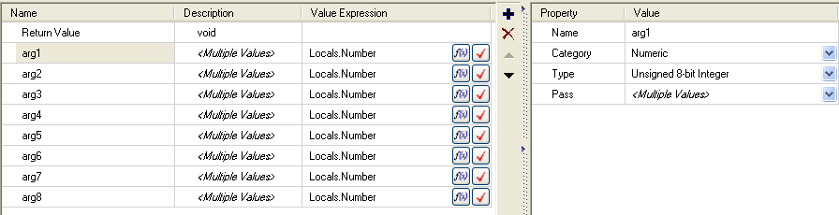

- Select each parameter verify that there is just one property that displays <Multiple Values> in the right-hand-side control (or the Value Expression in the left-hand-side).
- Select the steps NumericName1 and NumericName2. Verify that the parameters panel appears as follows:
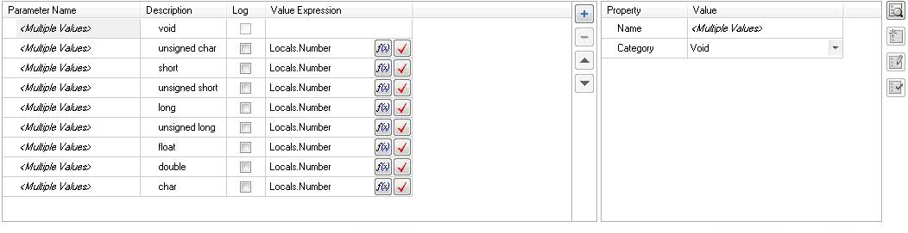
- Select the steps NumericValue1 and NumericValue2. Verify that the parameters panel appears as follows:

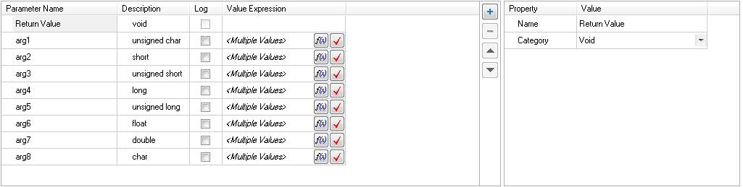

Incompatible Parameters
When only some parameters of the selected steps are compatible, the panel displays the first set of compatible parameters.

- Open the sequence named IncompatibleParams.
- Each step in the sequence has N numeric parameters followed by several non-numeric parameters, where N is the last letter of the step name. For instance, step named Numeric7 contains 7 numeric parameters followed by 0 or more non-numeric parameters.
- Select combinations of the steps in the sequence and verify that the parameters panel displays N parameters, where N is the minimum number of numeric parameters. For instance, if you select Numeric3 and Numeric8, then only 3 parameters should be displayed in the parameters control as shown below:
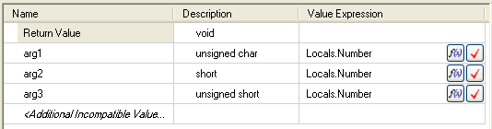

Additional Function Control Tests

When multiple steps are selected, the dropdown list for the Function control displays the intersection of the functions defined by the modules of the selected steps. We need to verify that the intersection is correct and that the computation doesn’t take too long.

- Open sequence MultipleValues.
- Select all the steps named Kernel32 and verify that step selection does not take too long. (These steps call into the Windows dll Kernel32.DLL which has over 900 functions.)
- Drop down the function combobox and verify that it does not take too long.
- Select step named Many 1.
- Drop down the function combobox and verify that there are 1000 functions and that it doesn’t take too long to drop it down.
- Select both Many 1 and Many 2 steps and verify that selection does not take too long.
- Drop down the function combobox and verify that the functions named Test900 through Test999 do NOT appear in the list.

