DLL Module Panel – Parameter/ DLL Compatibility
TestStand Version: 4.0

Author: Erik Crank
Feature: DLL Module Panel
Dependencies: none
Test Category: [ Functional ]

NOTE: The DLL and CVI Module panels share a significant amount of source code and functionality. Consequently, a failure in one panel is likely to correspond with a failure in the other panel. In addition, tests performed for each panel are very similar. If you add a specific items to this test procedure, consider adding it to the other panel as well.

Description
This test procedure tests how the DLL Module panel compares TestStand parameter types to the DLL parameter type information.

Parameter/DLL Compatibility is a relationship between a TestStand parameter and the parameter description obtained from the DLL type information. Generally, the DLL type information will contain less information about the parameter type than the TestStand parameter. A TestStand parameter is said to be compatible with a DLL parameter if the user can reasonably expect to pass the parameter as it is configured to the function parameter as it is described in the DLL type information. For example, a TestStand parameter configured as an Array of Int8 could reasonably be passed to a parameter declared as “char *” in the DLL.

Note: This test has been partially ported to 64-bit for TestStand 2014. The supporting C++ solution can now build both the original 32-bit DLL as well as a 64-bit DLL. To test 64-bit use the sequence files PrototypeCompatibility_x64.seq and PrototypeIncompatibility_x64.seq instead of their non-“_x64” counterparts. Once we have a feature allowing the same sequence file to work on multiple platforms, the “_x64” versions of the files can updated to work for both 32-bit and 64-bit. These can then be renamed to overwrite and replace the original sequence file.

Preparation
- Launch the TestStand sequence editor.
- If the file is read-only in disk, make it writable.
- If the file appears to be modified (the * character appears in the title bar), save it.

Validation
Expected Behavior
- When the DLL Module panel refreshes, it checks for parameter/DLL compatibility of each parameter of the currently selected steps. If any TestStand parameter is not compatible with the DLL parameter, the DLL Module panel displays an error icon.

- The error message associated with the error icon instructs the user to press the Reload Prototype button or the same error icon. Pressing the Reload Prototype button or the icon will re-configure all the parameters to match the DLL type information. (Parameter values will be mapped appropriately.)

Test Compatible Parameters
- Open sequence file CommonCModule\PrototypeCompatibility.seq.
- Select a step in any of the sequences in the sequence file.
- Display the DLL Module Panel.
- Verify that the DLL Module panel does NOT display error icon.
The following image shows an error icon in the red circle. This icon should never appear for steps in this sequence file.
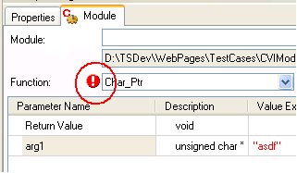

- Repeat steps 2 and 4 for all steps in the sequence file.

Test Incompatible Parameters
- Open sequence file CommonCModule\PrototypeIncompatibility.seq.
- Select a step in any of the sequences in the sequence file.
- Display the DLL Module Panel .
- Verify that the DLL Module panel does display error icon.
The following image shows an error icon in the red circle. This icon should always appear for steps in this sequence file.
- Hover the mouse over the icon and verify that a tooltip is displayed.
- Click on the icon and verify that the parameters are fixed up and the icon disappears.
- Repeat steps 4-6 for all steps in the sequence file.

Parameter Mapping
- Open the sequence file ParameterMappingDLL.seq.
- Select the AddedParameters step and select the module tab in the Step settings panel.
- Verify that the following is displayed:

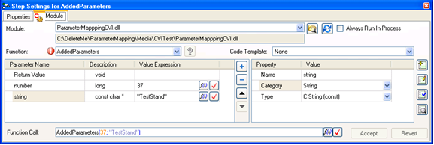

- Notice the red blinking icon close to the buttons. Move the mouse over it, a tooltip should be displayed. Make sure the error icon can be tabbed into.
- Click on the error icon. Verify that the following is displayed:

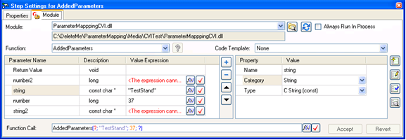

- Notice that the red icon is gone and new parameters have been added.
- Now select the RemovedParameters step.
- Verify that the following is displayed:

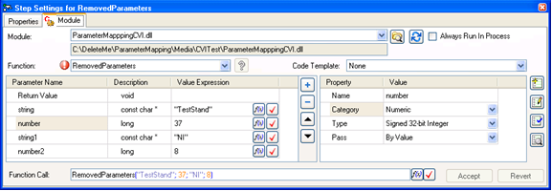

- Click on the error icon. Verify that the following is displayed:

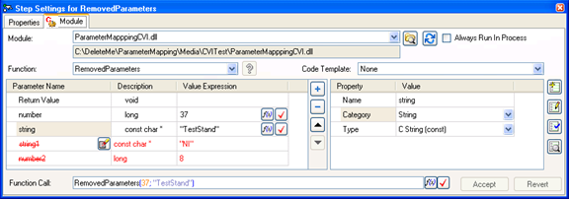

- Notice that the red icon is gone and parameters had been deleted. The deleted parameters are now called unmapped parameters and they will be around to map again for changes of that particular step, unless the “Clear Unmapped Parameters” button is clicked.
- Now select the ChangedParameters step.
- Verify that the following is displayed:

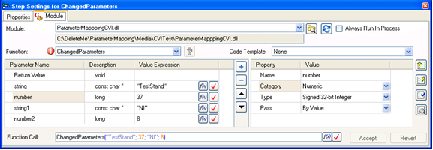

- Click on the error icon. Verify that the following is displayed:

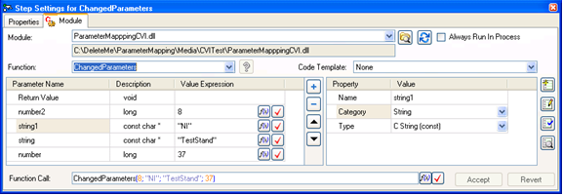

- Notice that the red icon is gone and the values have been moved or mapped.
- Hit “Ctrl-Z” three times to undo all the “Resolve Prototype” operations and verify that the three steps display the red blinking icon
- Now select the three steps.
- Verify that the following is displayed:

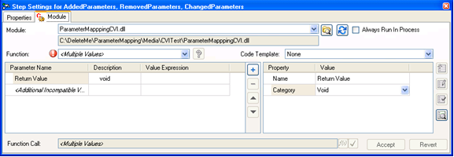

- Click on the error icon. Verify that the following is displayed:

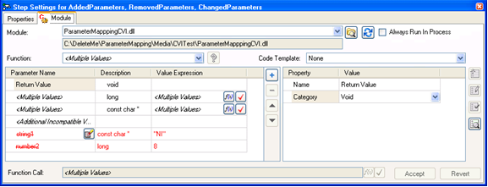

- Now select each step individually and verify that all have been resolved as before.
- Hit “Ctrl-Z” one time to undo the “Resolve Prototype” operation for multiple selection and verify that the three steps display the red blinking icon
- Now select the RemovedParameters step.
- Verify that the following is displayed:

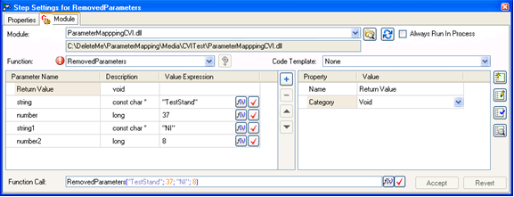

- Click on the error icon so the prototype can be resolved and then click on the “Clear Unmapped Parameters” button.
- Verify that the following is displayed:

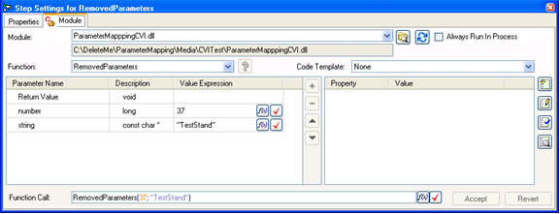

- Hit “Ctrl-Z” one time to undo the “Clear All Unmapped Parameters” operation.
- Verify that the following is displayed.

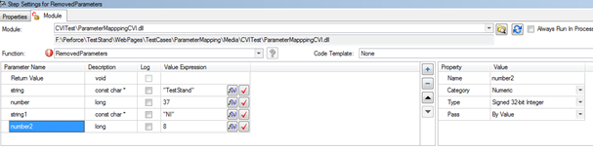

Other Tests
- Open sequence file CommonCModule\PrototypeCompatibility.seq.
- Select Int8 Pointer step in Strings sequence.
- Display Module panel and change the category form Numeric to Boolean.
- Verify the error icon appears in TS 2010 or older. Hover over the icon and verify the tooltip showing “parameters do not match”.
- Press Ctrl-Z, Verify the error icon disappears and category changes back to Numeric.

Note:
In TS 2010 SP1 or later, the above mentioned error is not displayed. This is an expected behavior. Press Ctrl-Z, Verify the category changes back to Numeric.
Refer CAR #402734

- Change the value of the expression as 10 and check for errors. Verify that there are no errors.
- Change the Type to Unsigned 8-bit Integer and verify the error icon appears.
- Click on the error icon and verify the parameters changed as displayed below.
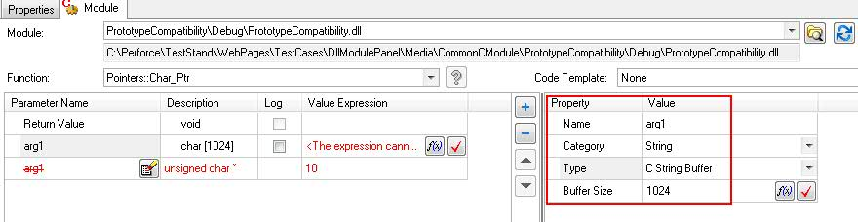

- Click Ctrl-Z, Verify the Category is changed back to Numeric.
- Select String Buffer[1024] step and edit the value of Expression with a string.
- Verify that an array of char is treated as a string with default buffer size 1024.
- Change the buffer size as 100 and verify that there are no errors.
- Delete the buffer size and verify you get an error in the description column of the parameters tab.
- Click on the error icon and verify the buffer size is set to focus.
- Select StringArray[1024] step in StringArray sequence.
- Change the Type as C String Buffer and verify the error icon appears.
- Click on the error icon and verify the type is changed back to C String(const).
- Change the value of dimensions to 2 and verify the error icon appears.
- Also verify that new dimension size property is added to the parameter.
- Delete the value of Dim 1 Size and verify the description of the parameter shows an error.
- Click on the error should set the focus to Dim 1 Size.

Valid Parameter Expressions
- Open the sequence named ValidParameterExprType.
- Sequentially select each of the steps in the sequence.
- For each step that you select, verify that the DLL Module panel displays all the parameter value expressions in the normal, black text (indicating no error):

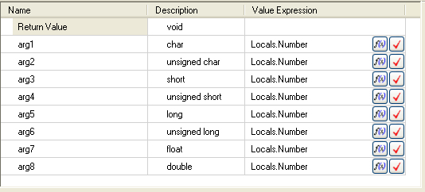

Invalid Parameter Expressions
- Open the sequence named InvalidParameterExprType.
- Sequentially select each of the steps in the sequence.
- For each step that you select, verify that the DLL Module panel displays all the parameter value expressions in the red text (indicating semantic error):

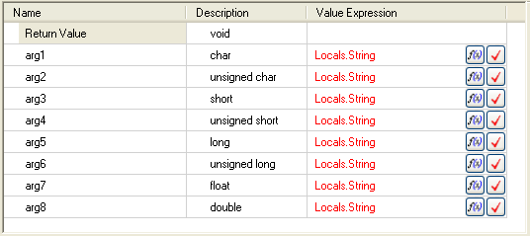

- Hover the mouse pointer over the value expressions and verify that a tooltip appears that displays the error as in the following image:

