DLL Module Panel – Parameter Value Type Checking
TestStand Version: 4.0

Author: Erik Crank
Feature: DLL Module Panel
Dependencies: none
Test Category: [ Functional ]

NOTE: The DLL and CVI Module panels share a significant amount of source code and functionality. Consequently, a failure in one panel is likely to correspond with a failure in the other panel. In addition, tests performed for each panel are very similar. If you add a specific items to this test procedure, consider adding it to the other panel as well.

Description
This test procedure tests the type checking of parameter value expressions in the DLL Module step settings panel. The DLL Module panel compares the type of the parameter value expression to the type of the parameter and displays semantic errors for expressions of incompatible types. This test procedure verifies that the DLL Module panel correctly identifies these types of errors.

Preparation
- Launch the TestStand sequence editor.
- Open the sequence file DllModulePanel.seq.
- Go to the Sequence Editor Options dialog and check the “Allow Editing of Read-Only files” checkbox.
- Select the ValidParameterExprType sequence and select the first step in the sequence.

Validation
Valid Parameter Expressions
- Open the sequence named ValidParameterExprType.
- Sequentially select each of the steps in the sequence.
- For each step that you select, verify that the DLL Module panel displays all the parameter value expressions in the normal, black text (indicating no error):

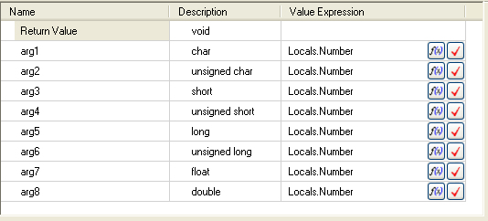

Invalid Parameter Expressions
- Open the sequence named InvalidParameterExprType.
- Sequentially select each of the steps in the sequence.
- For each step that you select, verify that the DLL Module panel displays all the parameter value expressions in the red text (indicating semantic error):

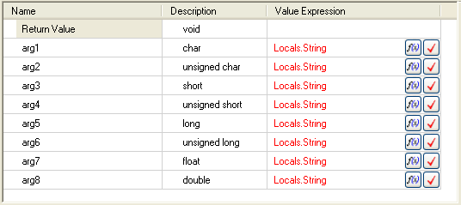

- Hover the mouse pointer over the value expressions and verify that a tooltip appears that displays the error as in the following image:

