Dll Module Panel – Suppress Array/Ptr Ambiguity Prompt
TestStand Version: 2017

Author: Michael Harrison
Feature: Dll Module Panel
Dependencies: none
Test Category: [ Functional ]

NOTE: The DLL and CVI Module panels share a significant amount of source code and functionality. Consequently, a failure in one panel is likely to correspond with a failure in the other panel. In addition, tests performed for each panel are very similar. If you add a specific item to this test procedure, consider adding it to the test procedure for the other panel as well.

Description
This procedure tests that when CVI embeds /*OUT*/ in front of a function prototype pointer argument that TS will not show the Unknown Info (Pointer/Array) button/dialog.

Validation

- Open new sequence in Sequence Editor.
- Add C/C++I Action step
- Set ‘P4:\TestStand\WebPages\TestCases\CVIModulePanel\Media\OutTag\Dynamic-Link Library.dll’ as the Module for the step.
- Set ‘FunctionWithoutOutTag’ as the Function.
- Verify parameter x has Specify parameter as array or pointer button. 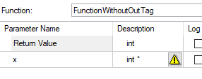
- Add new C/C++ Action step
- Set ‘P4:\TestStand\WebPages\TestCases\CVIModulePanel\Media\OutTag\Dynamic-Link Library.dll’ as the Module for the step.
- Set ‘FunctionWithOutTag’ as the Function.
- Verify parameter x does not have Specify parameter as array or pointer button. 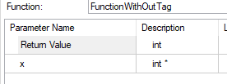
- Open in new sequence in CVI Full Featured Editor User Interface
- Add C/C++Action step
- Set ‘P4:\TestStand\WebPages\TestCases\CVIModulePanel\Media\OutTag\Dynamic-Link Library.dll’ as the Module for the step.
- Set ‘FunctionWithoutOutTag’ as the Function.
- Select Yes to use the parameter information
- Verify Problem Reading Function Parameter List dialog appears 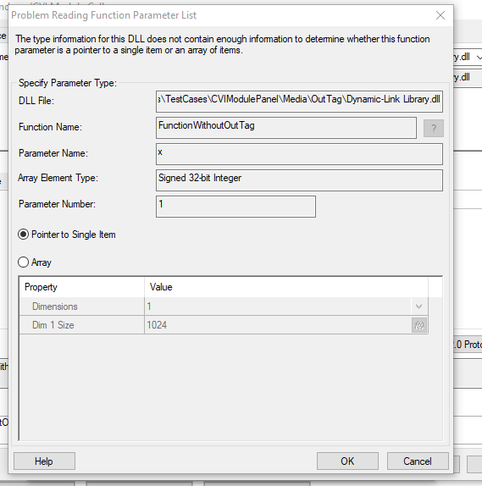
- Dismiss the dialogs.
- Add new C/C++ Action step
- Set ‘P4:\TestStand\WebPages\TestCases\CVIModulePanel\Media\OutTag\Dynamic-Link Library.dll’ as the Module for the step.
- Set ‘FunctionWithOutTag’ as the Function.
- Verify the Problem Reading Function Parameter List dialog does not appear.

