DLL Module Panel – Undo
TestStand Version: 4.0

Author: Erik Crank
Feature: DLL Module Panel
Dependencies: none
Test Category: [ Functional ]

NOTE: The DLL and CVI Module panels share a significant amount of source code and functionality. Consequently, a failure in one panel is likely to correspond with a failure in the other panel. In addition, tests performed for each panel are very similar. If you add a specific items to this test procedure, consider adding it to the other panel as well.

Description
This procedure tests the Undo functionality of the DLL Module step settings panel. There is a separate test procedure for testing the basic functionality of the panel. This procedure tests that the Undo command correctly reverts changes made to these step properties.

Preparation
- Make a copy of the file DllModulePanel.seq and call it ORIGDllModulePanel.seq. Run the sequence editor and open both sequence files.
- Go to the Sequence Editor Options dialog and check the Allow Editing of Read-Only files checkbox.
- If either sequence file appears to be modified (the * character appears in the title bar), save it to disk.

Validation
Ideally, much of this testing would be automated. We don’t yet have a good tool for automating the Sequence Editor GUI, so until then we follow this general approach to validating Undo: Repeat the following sequence of steps, each time varying the set of selected steps, the order in which properties are changed or the values to which properties are set.

- Open MainSequence.
- Select any step or combination of steps. (In subsequent tests, try selecting different sets of steps also.)
- Change the values of the controls on the DLL Module Panel. (In subsequent tests, try changing in different order and use different values. Also, try just a few of the properties.)
- Press Ctrl-Z for each of the changes you made.
- Verify that the document does not appear modified (the ‘*’ character is not displayed next to the title).
- Press Ctrl-Shift-D to display the differ dialog that appears as follows:

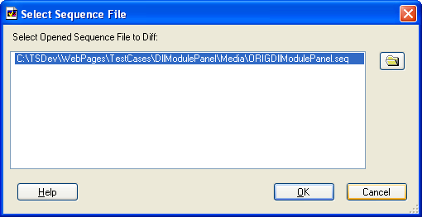

- Press OK button to diff the original with the copy and verify that there are no differences. The differ document should appear something like the following:

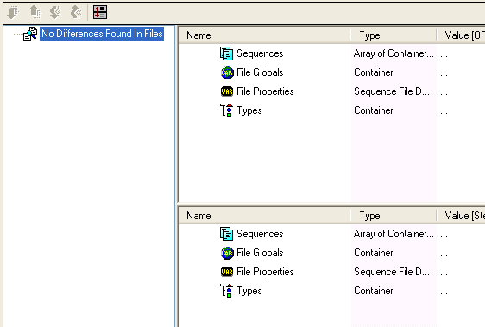

Additional Tests
- After making a change to each control, verify that the text displayed in the Edit menu for the Undo operation is correct and is translatable. Note: Testing translation requires editing the SequenceEditorStrings4.ini file, and there is a separate test for general translation.
- Verify that controls that allow typing (edit, expression edit, some combo boxes) commit after each change, but that there is only one Undo item for all the changes. For example, type text in path control, wait 1 second, type again, wait 1 second, type again. The path is committed 3 times, but there should be a single Undo item. Use Ctrl-Z to verify that the 3 changes are reverted in a single operation. Use Ctrl-Y to verify that the 3 changes are redone in a single operation. Repeat this test with Function combobox, the parameter name textbox and the argument value expressions.
- Verify that changes made in other places (variables view, expression browser, etc.) mixed with changes to panel properties do not affect undo. For example, type text in a expression edit for parameter argument value, create a variable with with expression edit context menu and change text again in expression edit. Use Undo to verify that the 3 operations are undone separately.
- Verify that if a property had an invalid value before the change, the undo operation restores the invalid value. For example, using the variables vew you can change the value of the Parms[1].NumType property to an invalid value like 765. The module panel will display this value in red as shown below.
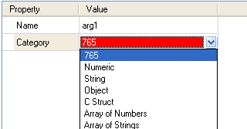
Now, if you change the Category to Numeric and then use Ctrl-Z to undo the change, it should return to 765.
- After making many changes, type Ctrl-Z many times quickly to undo all changes.
- After undoing many changes, type Ctrl-Y many times quickly to redo the changes.
- Create a StepType that has an edit substep and that can use a CVI module. Create an instance of the step type and edit the step as follows:
  - Specify the DLL on the CVI Module Panel.
  - Run the edit substep
  - Specify the function on the CVI Module Panel.
  - Run the edit substep
  - Specify parameters on the CVI Module Panel.
  - Run the edit substep
  - Undo all of the previous changes
  - Redo all of the previous changes
  - Verify that the step is the same
- Try redo - Ctrl+Y.

Note: Add more steps with different step property values to the sequence file DllModulePanel.seq if you need to test with different initial values. Do not modify the existing steps because there are other test procedures that require that those steps have certain values.

