TestStand AutoTest System
This document describes the details of how TestStand performs automatic testing. The TestStand group owns a number of test computers for running tests. Multiple Ghost images for these computers are managed by a dedicated computer (ts-console) running Symantec Ghost Console. The TestStand AutoTest system consists of the following components:
- A set of Ghost images configured for automatic testing.
- A set of Ghost tasks configured to clone Ghost images, to download files and to run tests on specific test computers.
- A Windows service that runs on the console computer that submits commands to the Ghost Console to initiate Ghost tasks.
- A client program (AutoTestClient) that runs on development computers that communicates with the Windows service on the console computer to initiate Ghost tasks.
- A set of batch files and applications that install TestStand, that get the test suite from source control (Perforce) and that execute sequence files.
- A set of sequence files that perform specific tests.
I’ll discuss each of these components in detail in subsequent sections.

Ghost Images
There are two types of images used for automatic testing: Clean and Full. The Clean images contain only Perforce and the .NET 2.0 Framework installed. The AutoTest system uses Perforce to get the latest versions of the test suite from source control. The Full images include many other applications that are used by the test suite. We test with both types of images to represent different customer scenarios. We have both a Clean and a Full image for each of the operating systems TestStand supports (currently 2000, XP and Vista).
The complete list of software in a Full image is listed below. This list changes as older software becomes obsolete and new versions are released. Some images have multiple versions of software (e.g. LabVIEW 7.1.1, 8.2, 8.5) because we add on to existing images.
Perforce (command line component p4.exe is required, install both P4V and P4 win)
Microsoft Office 2007
Microsoft Visual Studio 6 SP6
Microsoft Visual Studio 2005 SP1
Measurement Studio 8.1 Enterprise edition (or later) for VS2005
LabVIEW 8.5 (or later)
CVI 8.5.0 (or later)
NI Switch Executive
IVI Compliance Package
IVI Drivers arpps, hp33120a, hp34401a, hpe1463a, tkds30xx
IVI Logical Names: SamplePowerSupply, SampleFGen, SampleDmm, SampleSwitch, SampleScope
HTBasic
See the Appendix for more information about installing and configuring this software. Instructions for creating Ghost images in general are available on the console computer at http://ts-console/TestMachineInfo/. That document is currently stored in Perforce at //TestStand/Users/Erik/TSConsole/TestCompInstr/Index.htm.

Ghost Tasks
For each computer that supports automatic testing, there are Ghost tasks defined in the Ghost Console named Computer/AutoTest and Computer/AutoTest-Image, where Computer is the name of the computer and Image is the name of one of the Ghost images for that computer that supports automatic testing. The Image name must be one of the following: XP-Clean, XP-Full, 2K-Clean or 2K-Full (eventually we’ll add Vista-Clean, Vista-Full). Each of these tasks performs the same set of actions except that they clone different ghost images. The actions include the following:
- Clones a ghost image (except for AutoTest task)
- Downloads a self-extracting zip file (GhostAutoTest.exe) that contains batch files and executables to run tests.
- Downloads activated license files for the particular machine to activate TestStand
- Downloads a batch file (EnvVars.bat) that contains settings related to type of testing to perform.
- Extracts the zip file, which then runs a batch file that initiates the testing.
All files used by the Ghost tasks are stored in the //TestStand/Tests/Utils/Ghost folder in Perforce (C:\TSDev\Tests\Utils\Ghost folder on ts-console). License files for the test computers are stored in separate folders within the Ghost folder. The complete set of files that are downloaded is described in the Batch Files and Executables section of this document.

Windows Service and Client Program
There is a Windows service named LaunchAutoTestUI running on the ts-console computer which is accessed remotely by a client program named LaunchAutoTestClient running on development computers. Development of this system was performed in stages by different people for various reasons with little planning so it is just several components glued together. I’ll discuss each component below.

AutoTestUI
The AutoTestUI application runs on ts-console and is used to execute Ghost tasks. Originally, it was just a dialog box application that allowed you to select computer, email address, installer to run, image, etc. and when you pressed OK button, it replaces text in the EnvVars.bat file and then initiates the Ghost task by passing parameters to the Ghost console. The problem with this system was that you have to run the application on the ts-console computer. To make it accessible from developer computers, we added a command line interface and implemented a service to call it.
The AutoTestUI application is an MFC application with source code in Tests/Utils/Ghost/AutoTestUI.

LaunchAutoTestUI
The LaunchAutoTestUI application is a Windows service that runs on the ts-console. It is a .NET application that implements a remotely accessible object that launches the AutoTestUI application passing command line parameters to initiate Ghost tasks. The client program LaunchAutoTestClient accesses the service remotely from other computers.
Source code for the LaunchAutoTestUI application is in Tests/Utils/LaunchAutoTestUI.

LaunchAutoTestClient
The LaunchAutoTestUI application is a .NET Forms application that runs on developer computers and appears as follows:
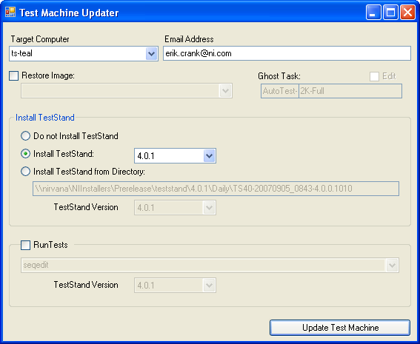
When you press the Update Test Machine button, the application connects to the LaunchAutoTestUI Windows service on ts-console and passes to it the parameter values corresponding to the settings from the dialog. The LaunchAutoTestUI application then executes the AutoTestUI application on the ts-console passing parameters on the command line. Finally, the AutoTestUI application starts the Ghost tasks by calling the Ghost console application.
Source code for the LaunchAutoTestClient application is in Tests/Utils/Ghost/LaunchAutoTestClient.

Batch Files and Executables
This section describes the files in the //TestStand/Tests/Utils/Ghost folder that are downloaded to the test computers and that are used to automatically install TestStand and run tests.
- EnvVars.bat
All batch files call this batch file to setup the environment variables that are needed to install and run tests. These variables include the path to the installer, the version of TestStand, the email address to send notifications, the test program name and others. The AutoTestUI application edits this batch file to set the correct values before it is downloaded to the test computer.
- License files: (TestStand_DevSystem_Pkg_NNNNNN.lic)
These files are activated license files for TestStand on the destination computer. The Install_2.bat batch file copies them to the NI License file folder so that we don’t have to activate TestStand to run tests. (Note: as of 11/2007 a program called autolicense.exe is used to license teststand)
- GhostAutoTest.exe
This file is a self-extracting zip file containing the following files. When it is extracted, it runs the Start.bat batch file. See Appendix B for information on how to create the self-extracting zip file.
  - AutoLoginFrontEndCallbacksNN.seq
To avoid the login dialog when TestStand starts, the Install_2.bat file copies this sequence file into UserComponents folder after installing TestStand on the test computer. The LoginLogout sequence logs in the administrator user without displaying a dialog.
  - Start.bat
This batch file is run immediately after all files are extracted from the zip file. It copies the appropriate batch file (Install_1Startup.bat or RunTests_1Startup.bat, based on the values of the environment variables in EnvVars.bat) into the Startup folder, sends an email message and restarts the computer.
  - Install_1Startup.bat, Install_2Startup.bat, RunTests_1Startup.bat
These batch files run from the Startup folder. They simply call Install_1.bat, Install_2.bat or RunTests_1.bat and delete themselves.
  - Install_1.bat
This batch file installs TestStand, copies Install_2Startup.bat to the Startup folder and reboots the computer.
  - Install_2.bat
This batch file copies license files to the NI License file folder, copies the AutoLoginFrontEndCallbacks sequence file to the User Components folder, sends email message and calls RunTests_1.bat if requested.
  - RunTests_1.bat
This batch file gets the latest test files from Perforce and executes all tests.
  - RunTests.bat
This batch file is not part of the automatic test, but you can call it directly after installing TestStand using the AutoTest system to run tests.
  - NetUse.bat
Issues the “net use” command to access network resources.
  - Psshutdown.exe
Shuts down the computer and restarts it. This is a systinternals tool.
  - SendEmail.bat, SendEmail.exe
Sends email. Source code in is //TestStand/Tests/Utils/SendEmail.
  - SetDecimalPointToComma.exe
Sets the system decimal point to comma. (Currently not used.) Source code is in //TestStand/Tests/Utils/SetDecimalPointToComma.
  - TS_Setup.ini
Configuration file passed to the TestStand installer.
m. Autolicense.exe and autolicenselibu.dll
Licenses all national instruments software that is installed on the test machine.

There are other files that we used for installing CVI, LabVIEW and the device driver CD. It is a lot of work to keep all of these files updated, so we no longer use them, but I haven’t taken the time to remove them from the ZIP file that is downloaded.

Some other notes about these files and how they work:
- We pass the /noFirstLaunchDialog flag to the Sequence Editor to avoid the dialog that is normally displayed the first time you run it after installation.
- All files are downloaded to the C:\TestStandAutoTest folder on the test computer.
- The batch files direct all output to the log.txt file in the TestStandAutoTest folder.
- The EnvVars.bat file contains environment variables for the Perforce client spec and user. As we add computers, we have to update that file. It would be better to standardize our test computers so that we use a single Perforce client spec. I started doing this by creating the TestStand_TestComputer_D client spec that maps the Tests folder to the D: drive.

Sequence Files
All sequence files used in automatic testing are stored in the //TestStand/Tests folder (generally D:\TSDev\Tests on test computers). The tests are organized by the version of TestStand for which the test was initially added to the suite. Within the Tests folder there are folders for each version of TestStand (2.0, 2.0.1, 3.0, etc.). Within each of these folders is a sequence file called AllTests.seq which runs all the automated tests for that version. Developers add sequence files to the test suite and insert a sequence call step in the AllTests.seq sequence file. Information about writing automated tests can be found in //TestStand/Tests/Writing Automated Tests For TestStand.doc.

The top-level sequence file used to execute tests for the AutoTest system is called AutoTestNN.seq, where NN is the current version of TestStand. The MainSequence in this sequence file runs all the automated tests from 2.0 until that particular version. We generally do not run the MainSequence in the AutoTestNN.seq sequence file because that requires too much memory and errors that occur in early tests can cause problems for later tests. The AutoTestNN.seq file contains a TestNN sequence for each version of TestStand. The AutoTest system (RunTests_1.bat) runs each of these sequences in separate instances of TestStand.

Each test step in the AllTests.seq sequence files is annotated the test owner’s name (e.g. by adding text “owner=erik” to the step comment). The sequence file automatically sends an email to the test owner and the “test coordinator” (currently erik) if the test fails. In addition, some report tests are run (see TestReportCallback in TSTestUtil_3.5.seq) which send email to “anand” on failure. The mechanisms that implement this feature are beyond the scope of this document. You can temporarily disable the email feature by creating a Boolean variable StationGlobals.SendEmail and setting it to false.

Appendix A: Creating a Full Image
This section describes how to set up a Full Ghost image.

Obtain latest versions of NI software at \\nirvana\niinstallers\current\NI.
Obtain other software from \\nirvana\software\apps.
Obtain VS2005 SP1 at \\nirvana\teststand\VS 2005 SP1.
Obtain HTBasic from Scott (network copy at \\nirvana\TestStand\Software\HTBasic CD\90win. )

After installing LabVIEW and CVI, you must run these applications once to initialize them. Just start them up and then exit.

IVI drivers are available at \\nirvana\teststand\ivi folder.

After installing IVI drivers and the Switch Executive, you must create IVI logical names in MAX. Right-click on the Logical Names section in the configuration tree and choose Create New:
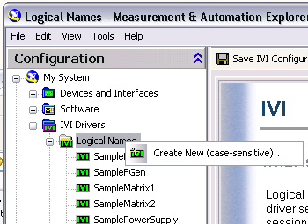

Type in one of the sample (case-sensitive) names and assign the appropriate driver session according to the following table:
SampleDmm | hp34401a
SampleFGen | hp33120a
SamplePowerSupply | arpps
SampleScope | tkds30xx
SampleSwitch | hpe1463a

Some Images need DataBase clients installed from the following locations:

Oracle (Vista)
\\nirvana\teststand\Software\Oracle Client 11g\
Oracle(XP)
\\nirvana\Software\Apps\Win\Oracle\Oracle 10g Client
Choose: 'Custom' then choose:
Oracle SQLJ 10.2.0.1.0
Oracle Windows Interfaces 10.2.0.1.0
>Oracle Objects for OLE 10.2.0.1.0
>Oracle ODBC Driver 10.2.0.1.0
>Oracle Provider for OLE DB 10.2.0.1.0
>Oracle Data Provider for .NET 10.2.0.1.0
Oracle Net 10.2.0.1.0
Accept defaults

After installing Oracle client you need to run the Oracle - OraClinet10g_home1>>Configuration and Migration Tools>>Net Configuration Assistant application and use the following options to create the ORCL net service name(run as admin in Vista):
1. Select "Local Net Service Name configuration" and click Next
2. Select "Add" and click Next
3. Enter "orcl" as the service name and click Next
4. Select "TCP" and click Next
5. Enter "xfiles2000" as the host name using standard port number 1521 and click Next
6. Select :Yes, perform a test" and click Next
7. Verify that details is "Connecting...ORA-01017: invalid username/password; login denied".
8. Click Change Login and enter "tester" and "teststand" as the username and password and click OK
9. Verify that details is "Connecting...Test successful" and click Next
10. Enter "orcl" as the net service name and click Next.
11. Select No for configuring another net service name and click Next twice
12. Select Finish to close application.

MySQL
\\nirvana\TestStand\Software\MySQL\odbc
mysql-connector-odbc-3.51.21-win32.msi
Accept defaults

SyBase
\\nirvana\TestStand\Software\SyBase
SQLAnywhere10_Windows_Developer_10.0.1.exe
JEPDE-EJ96Q-AM002-74930-10531
Accept defaults

The clients can be tested by double clicking on the corresponding UDL file in the \TSDev\Tests\TS Automated Tests\4.1\Database\UDL Files directory and clicking the "Test Connection" button on the Connection tab. If you get a "Test connection succeeded" prompt, you should be OK.

Appendix B: Creating the Self-Extracting Zip File
This section describes how to create the self-extracting GhostAutoTest.exe file. You must update this file whenever you make changes to one of file files contained in the GhostAutoTest.zip file. A batch file in perforce under \Tests\Utils\Ghost called ‘P4 to Self Extractor.bat’ automatically performs the following steps EXCEPT for checking in GhostAutoTest.*. A shortcut to this batch file is on the desktop of the console.

- Check out the following files from Perforce on TS-Console:
//TestStand/Tests/Utils/Ghost/GhostAutoTest.exe
//TestStand/Tests/Utils/Ghost/GhostAutoTest.zip

- Run WinZip to update the zip file GhostAutoTest.zip with changes. After opening the zip file in WinZip, click Add button and change Action to “freshen” existing files and press the “Freshen with wildcards” button:
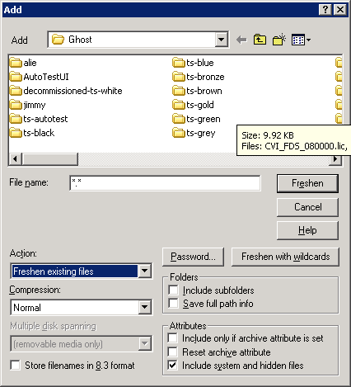

- Exit WinZip and run WinZip Self-Extractor on TS-Console.
- Select Standard:
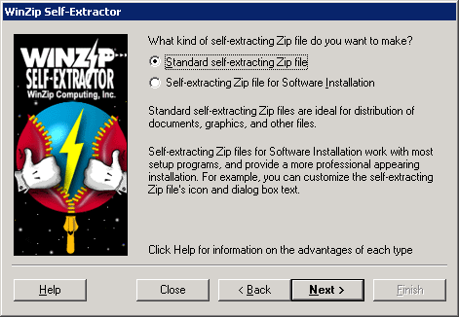
- Do not Span multiple disks:
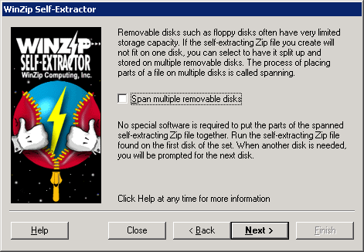
- Choose the GhostAutoTest zip file:
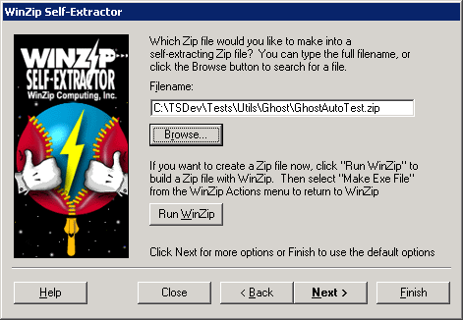
- Choose to replace existing:
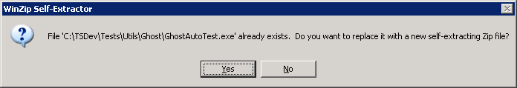
- Leave messagebox blank:
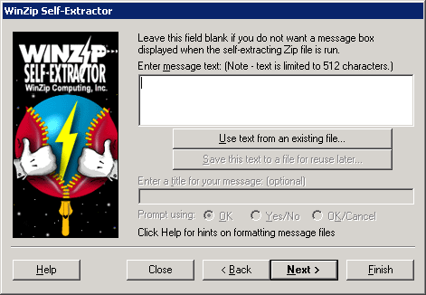
- Type in C:\TestStandAutoTest for the folder to unzip to:
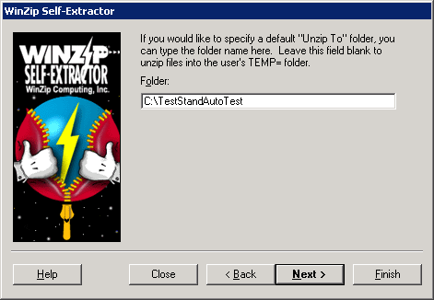
- Type in .\Start.bat for the command to execute:
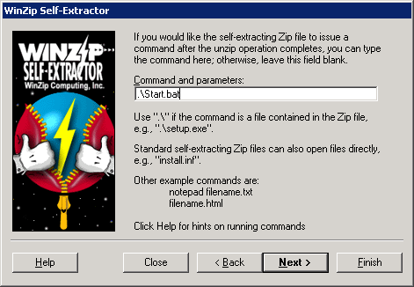
- Leave about box empty:
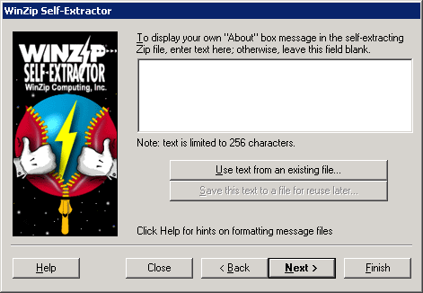
- Leave icon empty:
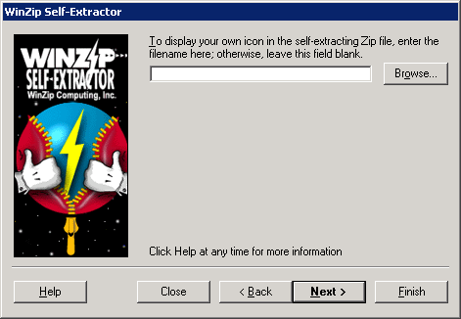
- Check the Unzip automatically checkbox:
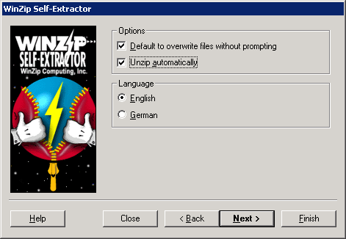
- Confirm dialog:
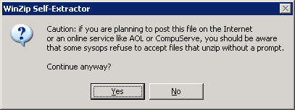
- Create the EXE file and finish. No need to test it.
- Submit your changes to Perforce.

