LabVIEW Adapter: Calling Express VIs
TestStand Version: 4.0

Author: Jose A. Hernandez
Feature Spec: Calling Express VIs (Link To Proposal)
Dependencies: LabVIEW versions 7.1 and Later

Test Category: [Acceptance]

Description
Test calling LabVIEW Express VIs from TestStand. TestStand cannot call Express VIs directly, a wrapper VI is created to call the Express VI. This wrapper VI is embedded in the step.

Preparation
- This test assumes familiarity with the LV adapter. If you are not familiar with the LV adapter, I recommend reading the bookshelf document titled “Using LabVIEW with TestStand”.
- The LabVIEW installers can be found at \\nirvana\NISoftwareReleased\Windows\Distributions\LabVIEW. If testing a pre-release version of LV, you can find it at \\nirvana\NISoftwarePrerelease\LabVIEW.
- Install the latest DIAdem installer from \\nirvana\NISoftwarePrerelease\DIAdem.

Validation
Express VIs are supported with 7.1 or later versions of LabVIEW. You need the LabVIEW Development System to be able to specify Express VIs. To run them, you can either use the Development System or the LabVIEW Run-Time Engine (RTE).
The test sequence files that test Express VIs can be found in Perforce under “//TestStand/Tests/LV Automated Tests/ExpressVIs/<LV VERSION>/TestStand Sequence/Call All Non-Hardware Express VIs.seq”. Run the sequence under the version of LabVIEW being tested.
Independent section
Duration: 20 min
Express VI Popup Menu

- Goto Configure>>Adapters, select LabVIEW adapter and click Configure.
- Select Development System as the LabVIEW server.
- Create a sequence and insert a LabVIEW step.
- Select an Express VI by clicking on the button in the LV module panel
Note: In a UI, you can select an Express VI by going to the Specify Module dialog and selecting “Express VI” from the combo box below the path control.
- In the Sequence Editor, clicking on the button will generate a popup menu with all the Express VIs found in the current selected LabVIEW functions palette view. Building the menu can take a while, just be patient.
- Verify that after a menu is generated, it is not recreated unless you select Refresh from the menu or change LabVIEW versions.
- In an UI in the Specify Module dialog of a VI step, select Express VI from the combo box. At this point, the file browse button icon should change to a LabVIEW icon. Clicking on the button will generate the Express VI menu.
- Check that the icons and names in the menu are the same as the LabVIEW palette. You do not need to do this for all the Express VIs. A few will suffice.
- Check that the Express VI you selected in the menu is the Express VI you expect. For example, if you select the Formula Express VI from the menu, you should see the Formula configuration dialog and the name displayed in the Path control should say “Formula Express VI”.
- Make sure that selecting Refresh from the popup menu actually refreshes the menu.
Independent section
Duration: 30 min
Selecting and Configuring an Express VI
Most of the Express VIs have Dynamic Data types as inputs and outputs. This is special data type that LabVIEW created specially for Express VIs. A Dynamic Data type can take a number, Boolean, an array of numbers and Booleans, a waveform, or another Dynamic Data type. This was done to avoid specifying an input for each possible data type.
- Goto Configure>>Adapters, select LabVIEW adapter and click Configure.
- Select Development System as the LabVIEW server.
- In the Sequence Editor or a UI, Create a sequence and insert a LabVIEW step.
- Select Express>>Arithmetic and Comparison>>Formula VI from the Express VI popup menu.
- Configure the Formula VI to add two numbers.
- Specify 2 and 3 as the inputs and a local variable as the output. Run the step.
- Verify that the result is 5.
- Since the Formula VI takes dynamic data types arguments, you can pass any of the data types mentioned above and they should be added. Test this is the case. This will also test that TestStand is able to handle all those types as inputs to a Dynamic Data type.
NOTE: This is not supported for array of dynamic data types and array of clusters with dynamic data types.
- Try reconfiguring the Express VI to have more inputs by pressing the button.
- Verify that the dialog updates the number of parameters. Verify all new parameters are set to use their default value and have the string <using configured value>.
- Copy and paste the LV Step.
- Configure the new step and modify the formula.
- Open the original step and verify that the formula has not changed( Each step has its own instance of the Express VI, Configuring one instance should not affect another instance).
- Test other Express VIs. Make sure you run them and they have the expected output.
- Every time an Express VI is configured, you will get a prompt that will tell you which parameters were added and deleted as well as their arguments. Make sure the information is correct.( You can easily test this with the Formula Express VI, but you should try other such as the Simulate Signal Express VI).

Independent section
Duration: 20 min
XNode-Based Express VIs (TestStand 4.1 and later)
In LabVIEW 8.5, some of the Express VIs were modified to use XNodes instead of subVIs. TestStand 4.1, was modified to handle these types of VIs. Make sure you test all of them. Try to run them if possible. You should at least test that you can configure all of them and they maintain their configuration the next time you reconfigure them. Here is the list of the known XNode-based Express VIs since 8.5.
- Formula Express VI (Express->Arithmetic and Comparison->Formula)
- Spectral Measurement Express VI (Express->Signal Analysis->Spectral Measurement)
- Group Digital Signals (Express->Signal Manipulation-> Group Digital Signals)
- LV Storage Express VIs (Programming->File I/O->Storage)
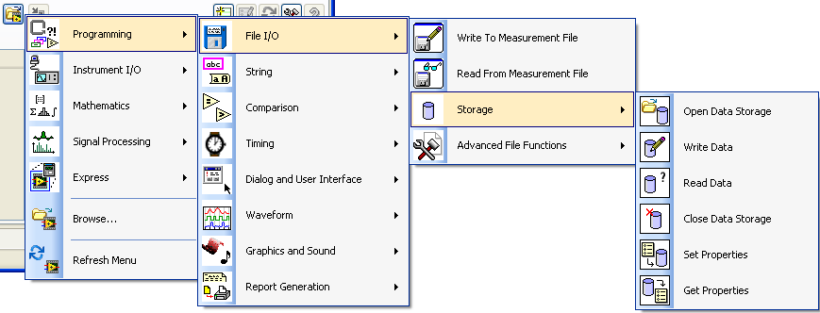

Independent section
Duration: 15 min
Diadem Express VI Test

[If not already installed] Install the latest DIAdem installer .

- Launch TestStand and create a new sequence file.
- Goto Configure>>Adapters, select LabVIEW adapter and click Configure.
- Select Development System as the LabVIEW server.
- Add three LabVIEW Action steps.
- Create 2 local variable “Locals. Signal” and “Locals.Signal1” of type LabVIEWDynamicData.(Insert Local >>Type>>LabVIEW>> LabVIEWDynamicData)
- In the first action step, select Express VI – Simulate Signal
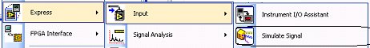
- Use default settings. Set the Sine output to be received in “Locals. Signal”
- In the second step, select Express VI – Simulate Signal
- Change the signal type to anything other than Sine. Set the output signal of the step two, to be received in “Locals.Signal1”
- In the third step, select DIAdem Report
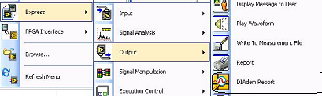
- In the configuration page, change the target output to HTML file. Click OK.
- In the Module settings, change the input Signals 1 to “Locals. Signal” instead of default. And Signals 2 to “Locals.Signal1”.
- Run the sequence in Single Pass.
- Verify that you get an html report with the respective signals drawn.
- <Optional> Play around with the settings of the three express VIs and see if you get expected results.
Test Impact for CAR 338234 (TestStand 2012 with LabVIEW 8.5.1 or later)
Do the following after finishing your Express VI testing
- Unload all modules
- Close all VIs in LabVIEW
- Exit LabVIEW without exiting TestStand
- Verify that you don’t get a prompt to save any VIs found in the TestStand support directory

National Instruments Confidential
Copyright © 2005 National Instruments Corporation

