LV Adapter : Specify Module Dialog and Execution
TestStand Version: 3.5

Author: Jose A. Hernandez
Feature Spec: LV Adapter
Dependencies: Previous, Current, and pre-release LabVIEW versions

Test Category: [Acceptance]

Description
Test that the LabVIEW adapter integration with a LabVIEW version.

Preparation
- This test assumes familiarity with the LV adapter. If you are not familiar with the LV adapter, I recommend reading the bookshelf document titled Using LabVIEW with TestStand.
- The LabVIEW installers can be found at \\nirvana\NISoftwareReleased\Windows\Distributions. If testing a pre-release version of LV, you can find it at \\nirvana\NISoftwarePrerelease.
- Mass compile the VIs under <LabVIEW>\vi.lib\addons\TestStand to make sure the run-time engine can load them. You must run the Sequence Editor to create this folder.
- The test assumes you are using the Specify Module dialog. Testing of the LV Adapter panel will be done in a separate test.
- Turn off the Windows Firewall protection. This is to avoid configuring the firewall. Some of the automated test will fail if the Windows Firewall is turn on. It can be configured to work correctly, but it is not the purpose of this test to test that functionality.
- Make sure you have the .NET framework installed because some of the automated tests use it.

Validation
LabVIEW Development Only
Configure the LV Adapter to use the LabVIEW Development System. The active version will be the last LV version ran. However, test with all the LV versions we support.
- Create a new VI using one of our templates by clicking on the Create VI button on the Specify Module dialog.
- When clicking on the Edit VI button in the Specify Module dialog, make sure you the VIs are opened in LV.
- Debugging
- Test step into LV code from TestStand, step out of back to TestStand.
- When stepping into test changing the values of LabVIEW controls and see you get the appropriate values when you step out.
  - Note: In order for this to work, the VI must change the value of the wire along the way from input to output.
- Test with Highly Execution and Retain Wire values on.
  - Test for CAR 278697. Abort the VI, it shouldn’t continue execution, if the execution had hit a breakpoint.
- Do single stepping, use return to caller.
- Select Show VI Front Panel When Called and make sure the front panel is shown when running LV step.
Do the rest of the tests using all versions of LV Development System and RTEs
- For LV 8.0 or later, run the sequence //TestStand/Tests/LVBuildValidation/<LV Version>/Automated /AllLVBuildValidation.seq. This will test the LV adapter using the Sequence Editor and the OIs. The test sequence includes the sequences used to test 7.x mentioned above. When you run the sequence, select small testing. Also, make sure you also get //TestStand/Tests/Utils/TSTestUtil/TSTestUtil.dll since the test uses it.
- If the folder with the LV version you are trying to test does not exists, do the following:
- Copy the latest LV version folder from perforce.
- Rename the folder with the new version of LabVIEW which you are testing.
  - For example, copy all files under LVBuildValidation\8.5 from perforce and rename the folder name to LVBuildValidation\9.0.
- Make all the files under the new folder as writable. (i.e LVBuildValidation\9.0 folder)
- Mass compile all the VIs in the new folder.
- Open the Find In Files dialog in Edit menu, type the LV version of the folder you originally copy all the files (for example 8.5) in the Find control. Select All Sequence Files Under Directory and select the path to the new LVBuildValidation\<Version> folder. Click OK.
- Replace (click on Replace Found Text button) in teststand Find Results palette, the 3 first instances of the string you were searching for (for example 8.5) with the LV version you are going to be testing within the Find control such as 9.0. Do not use 8.2.1 or 8.0.1. Use only the major and minor version numbers. Make sure you don’t modify any matches found in the file LVRefnumsTests.seq.
- Save all modified Sequence files.
- Build all build specs in the following projects
  - //TestStand/Tests/LVBuildValidation/<Version>/Automated /LVDLL/LVDLL.lvproj
  - //TestStand/Tests/LVBuildValidation/<Version>/Automated/FlexLVAdapter30/LabVIEWPackedLibraries/Base/CreatePackedLibrary/TestLVPackedLibrary.lvproj
  - //TestStand/Tests/LVBuildValidation/<Version>/Automated/MiscVIs/BlockDiagramRemoved/RemoveBlockDiagram.lvproj
  - //TestStand/Tests/LVBuildValidation/<Version>/Examples/StructPassing/LabVIEW/dll_bld_script.lvproj
  - //TestStand/Tests/LVBuildValidation/<Version>/Automated/FlexLVAdapter30/LabVIEWPackedLibraries/StepTypes/StepTypeInLVPackedLibrary/StepTypeInLVPackedLibrary.lvproj
    - Note: Copy the resulting PPL to //TestStand/Tests/LVBuildValidation/<Version>/Automated/FlexLVAdapter30/LabVIEWPackedLibraries/StepTypes/StepTypeInLVPackedLibrary/
- Open //TestStand/Tests/LVBuildValidation/<Version>/Automated/AllLVBuildValidation.seq and change the step Create/Update Station Global Variables with the value of the LabVIEW version you are testing (use year based version for LabVIEW 2009 or later).
- For TS 4.1 or later, Run Update VI Calls tool in the following sequences (Tools -> Update VI Calls, then select update if required for both combo boxes).
  - //TestStand/Tests/LVBuildValidation/<Version>/Automated/PartialClusterTesting/partial cluster passing/Partial Cluster Passing2.seq
  - //TestStand/Tests/LVBuildValidation/<Version>/Automated/Express VIs/Call All Non-Hardware Express VIs.seq
    - Note: The “Sensor Source” step might display an error indicating a VI reference is invalid. This error is expected if DAQ drivers were not installed. This step is actually skipped in the sequence, but the VI update tool doesn’t skip steps.
  - //TestStand/Tests/LVBuildValidation/<Version>/Automated/Express VIs/ValidateExpressVIs.seq

    - Note: Feel free to submit the files in perforce for the newer versions of LV if you have done the above steps.
    - Note: For TS 4.0, Sync //TestStand/Tests/LV Automated Tests/Framework Files/RefreshExpressVIs/ and //TestStand/Tests/LV Automated Tests/Framework Files/Set File Read Only.vi, mass compile the files with the LV you are using.
Open Refresh Express VIs.seq, Specify the path of the sequences you need to update the vi calls in the SequenceFilePath parameter in Variables pane. Run the Refresh Express Vis.seq.

NOTE: TS 2010 has a bug that prevents it from loading DLLs built in LV versions 2011 and later. It tries to load the DLL using the LV 2010 RTE (CAR 257200) which might fail. This behavior has been fixed in TS 2010 sp1. Please do not file a CAR for this known issue ONLY IF you are testing with TS 2010.
- Make sure the adapter is set to use the Development System.
- Make sure the windows firewall is off since it will prevent some test from running
- Create a TestStand user with the same name as the windows user (usually tester), give it administrative privileges, and check the station option Automatically Login Windows System User. Make sure you save the changes before running test.
- Before running the test sequence, make sure to set the adapter to the current version of LabVIEW you are testing and restart TestStand; new instances of the Sequence Editor will read the adapter configuration from disk and the Sequence Editor only writes the adapter configuration when closing.
- If you have any of the following installed and configured: DAQ board, Fieldpoint, IVI and VISA, try running the test for those I/O references. The tests are found under the folder //TestStand/Tests/LVBuildValidation/<version>/Automated/FlexLVAdapter30. Note: I/O references are broken in 8.0. You need 8.0.1.

- Create VIs with different connector panes and different LabVIEW data types. Make sure the Specify Module dialog can read them and the parameters are editable. Include in your test the following data types: Waveform, path controls, enums, I/O references such as DAQmx.
- Many of these data types are tested in the automated test. You can use that as a starting point.
- Test binary strings. The combobox in the type column indicates whether a string is binary or not.
- Select a VI that has the TestData clusters. The TestData cluster should not be editable.
- Call VIs that are part of an llb. Call a VI that uses a VI that is part of an llb.
- In the advanced dialog of the Specify Module dialog, select the option in the Always Run VI in LabVIEW Run-Time Engine and test it. To do this, you will need two versions of LabVIEW and the run-time engine.
- Make sure the help picture in the Specify Module dialog looks the same as in LV. Make sure the connector that blinks matches the selected parameter.
- Run the sequences with the parallel and batch models using reentrant and non-reentrant VIs. To make a VI reentrant, in LV, select File->VI Properties…. In the properties dialog, select Execution from the Categories combo box. Check the Reentrant execution checkbox. Make sure all VIs execute correctly. For 7.x reentrant VIs, the Front Panel is not shown so make sure your tests don’t expect a user input.
Arrays and Clusters
- Select a VI with an array. In the Type column, click on the "+" button to add new items to the bottom of the array. Click on the "-" button to delete some of the items. Make sure the array elements are passed correctly. Include arrays of the following type: number, strings, boolean, Waveform, path controls, enums, and simple clusters.
- Also, use TestStand typed arrays when passing array of clusters.
- When the type of the parameter is a cluster, create a custom data type that has the same structure as the cluster by clicking on the button on the type column. Verify that a custom data type is created in the file you specified and that cluster mapping is set correctly. In the Specify Module dialog, verify that specifying an instance of this data type as the cluster automatically maps the cluster elements to the properties of the data type. Run the VI.

LabVIEW 8.0 or Later
- Test the new data types RealMatrix and ComplexMatrix.
- Call VIs that are not part of a LV project library.
- Call VIs that are part of a LV project library.
- Call a VI that uses a subVI from a project library, e.g. analysis library.
Substeps Using LV Modules (This only applies to TestStand 4.0 and later)

- Open the Sequence File LVModulePanel.seq.
- Open the Substeps sequence.
- Insert an instance of the step type Test LV Substeps.
- Verify that you get the VI below when the step is inserted and that the VI is modal to the Sequence Editor. Note that you will still be able to activate the Sequence Editor by clicking on it, but the Sequence Editor will be disabled.
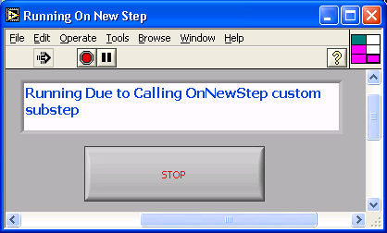

- Click the STOP button.
- Press Ctrl+E and verify that you get the VI below and that it is modal to the Sequence Editor.
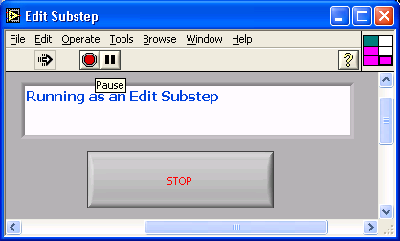

- Click the STOP button.
- Run the Substeps sequence and verify that you get the VIs below in the same order they appear in this document and that they are modal to the Sequence Editor. Click the STOP button on each VI.
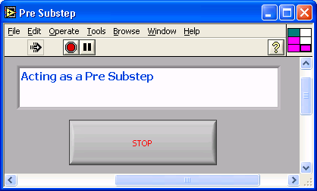

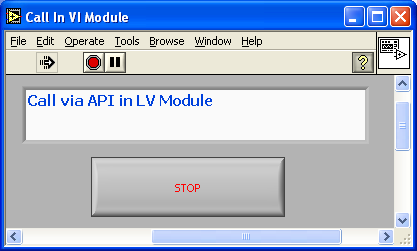

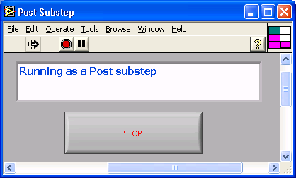

- Repeat the steps 1 – 7 using all the Full-Featured User Interfaces in Edit Mode.

VI Namespaces (This only applies to TestStand 4.2 and later)

In LabVIEW, a namespace is defined by a LV project library. If a VI belongs to a project library, then the VI namespace will be the name of the project library.
Create a LV project and create several LV project libraries and them to the LV project. Make sure some of those libraries more than 2 levels deep. Add VIs to those libraries.
Call the VIs from TestStand. Make sure the load without any errors.
Change the names of the libraries or move the VIs from one library to another. Try to run those VIs in TestStand. You should get an error that the VI’s namespace has change and they will not load. Check that the error message has correct syntax and is accurate. To update them, run the Update VI Calls tool from the Tools menu. Select Force Prototype Reload. Run the VIs again and this time they should run without any errors.
Note: VI namespace error is not observed when calling VIs under project context. Refer CAR 446789
Now, move one or more VIs out of the project libraries. Make sure the VIs don’t belong to any. Run the VIs and you should get an error. Check that the error message has correct syntax and is accurate. Now, reload the prototype of those VIs and rerun them. They should run without errors.

National Instruments Confidential
Copyright © 2005 National Instruments Corporation

