LabVIEW Adapter: Calling Express VIs
TestStand Version: 3.5

Author: Jose A. Hernandez
Feature Spec: Calling Express VIs (Link To Proposal)
Dependencies: LabVIEW versions 7.1 and Later

Test Category: [Functional]

Description
Test calling LabVIEW Express VIs from TestStand. TestStand cannot call Express VIs directly; a wrapper VI is created to call the Express VI. This wrapper VI is embedded in the step.

Preparation
- This test assumes familiarity with the LV adapter. If you are not familiar with the LV adapter, I recommend reading the bookshelf document titled “Using LabVIEW with TestStand”.
- If testing TestStand 2010 SP1or later, install the minimum version of LV supported.
- The LabVIEW installers can be found at \\nirvana\NISoftwareReleased\Windows\Distributions\LabVIEW. If testing a pre-release version of LV, you can find it at \\nirvana\NISoftwarePrerelease\LabVIEW.
- Install the latest DIAdem installer from \\nirvana\NISoftwarePrerelease\DIAdem.
- The test assumes you are using the Specify Module dialog so you will need to use a UI for this test if you are testing with 4.0 or later.

Validation
Express VIs are supported with 7.1 and later versions of LabVIEW. You need the LabVIEW Development System to be able to specify Express VIs. To run them, you can either use the Development System or the LabVIEW Run-Time Engine (RTE).
The test sequence files that test Express VIs can be found in Perforce under “//TestStand/Tests/LV Automated Tests/ExpressVIs/<LV VERSION>/TestStand Sequence/Call All Non-Hardware Express VIs.seq”. Use the sequence under the version of LabVIEW being tested.
Independent section
Duration: 15 min
Express VI Popup Menu

- Configure the LabVIEW adapter to use Development System as the LabVIEW server: goto Configure >> Adapters >>LabVIEW and click Configure, select LabVIEW Development System and click “Done”.
- Place an action step and in the Specify Module dialog and selecting “Express VI” from the combo box below the path control
- Verify at this point, the file browse button icon changed to a LabVIEW icon.
- If you click on the button, it should generate a popup menu with all the Express VI found in the current selected LabVIEW functions palette view. Building the menu can take a while, just be patient. After a menu is generated, it should not be recreated unless you select Refresh from the menu or change LabVIEW versions.
- Check that the icons and names in the menu are the same as the LabVIEW palette. You do not need to do this for all the Express VIs. A few will suffice.
- Check that the Express VI you selected in the menu is the Express VI you expect. For example, if you select the Formula Express VI from the menu, you should see the Formula configuration dialog and the name displayed in the Path control should say “Formula Express VI”.
- Change the active LabVIEW version, ie. if you are using 7.1, close it and launch 8.0. Reopen the Specify Module dialog and try to select a new Express VI; the menu should be recreated.
- [Optional] If you want to be thorough, you can verify that all Express VIs found in the LabVIEW palette appear in the TestStand Express VI menu.
- Make sure that selecting Refresh from the popup menu actually refreshes the menu.
- Select from “Browse…” from the popup menu and select an Express VI block. You can find one under LabVIEW\vi.lib\express. An example of an Express VI block is LabVIEW\vi.lib\express\express arith-compare\ComparisonBlock.llb\Ex_Inst_Comparison.vi. After you select the Express VI block, TestStand should detect it is an Express VI and will show its configuration dialog.
- Now, select “Browse…” again from the popup menu and this time select a regular VI. You should get a prompt indicating that the VI you selected is a standard VI. If you go ahead and accept, the Specify Module dialog should not switch to “Standard VI” mode (the combo box should be set to “Standard VI”).

Independent section
Duration: 20 min
Selecting and Configuring an Express VI
Most of the Express VIs have as inputs and outputs Dynamic Data types. This is special data type that LabVIEW created specially for Express VIs. A Dynamic Data type can take a number, Boolean, an array of numbers and Booleans, a waveform, or another Dynamic Data type. This was done to avoid specifying an input for each possible data type.
- Configure the LabVIEW adapter to use Development System as the LabVIEW server: goto Configure >> Adapters >>LabVIEW and click Configure, select LabVIEW Development System and click “Done”.
- Create a new LV step (LabVIEW action step).
- In the Specify Module dialog, select “Express VI” from the combo box and select the Express>>Arithmetic and Comparison >> Formula VI.
- Configure the Formula VI to add two numbers.
- Uncheck Default checkbox for both the inputs(x1 and x2) and in value specify 2 and 3 and a local variable as the output.
- Place a break point at the <end group> and run the step(right click >> run selected steps). While the sequence is still paused verify that the result is 5 (value of local variable storing the result in variable pane is 5).
- Since the Formula VI takes dynamic data types arguments, you can pass any of the data types mentioned above and they should be added. Test this is the case. This will also test that TestStand is able to handle all those types as inputs to a Dynamic Data type. This is not supported for array of dynamic data types and array of clusters with dynamic data types.
- Try reconfiguring the Express VI to have more inputs (select Configure VI button next to VI path). Verify that the dialog updates the number of parameters. All new parameters are set to use their default value and have the string <using configured value>.
- Copy and paste the LV Step. Configure the new step and modify the formula. Open the original step and verify that the formula has not changed. Each step has its own instance of the Express VI. Configuring one instance should not affect another instance.
- Make sure that every time you open the Express VI’s configuration dialog it saves the previous configuration. For example, if you configure a Simulate Signal Express VI to generate a Sawtooth wave signal, the next time you open the configuration dialog it should have its Signal Type set to Sawtooth and any other values you set in last time you configured the Express VI.
- If you have a DAQ board, try testing the DAQ Assistant Express VI to collect data.
- Save your Sequence Files that contain Express VIs. Exit TestStand then copy the Sequence Files to another directory. Load and run them to verify they still work. Since the Express VIs are embedded in the TestStand step, moving the Sequence Files should not affect loading and running the Express VIs.

- Test other Express VIs. Make sure you run them and they have the expected output.

Independent section
Duration: 20 min
XNode-Based Express VIs (TestStand 4.1 and later)
In LabVIEW 8.5, some of the Express VIs were modified to use XNodes instead of subVIs. TestStand 4.1, was modified to handle these types of VIs. Make sure you test all of them. Try to run them if possible. You should at least test that you can configure all of them and they maintain their configuration the next time you reconfigure them. Here is the list of the known XNode-based Express VIs since 8.5.
- Formula Express VI (Express>>Arithmetic and Comparison>>Formula)
- Spectral Measurement Express VI (Express>>Signal Analysis>>Spectral Measurement)
- LV Storage Express VIs (Programming>>File I/O>>Storage)
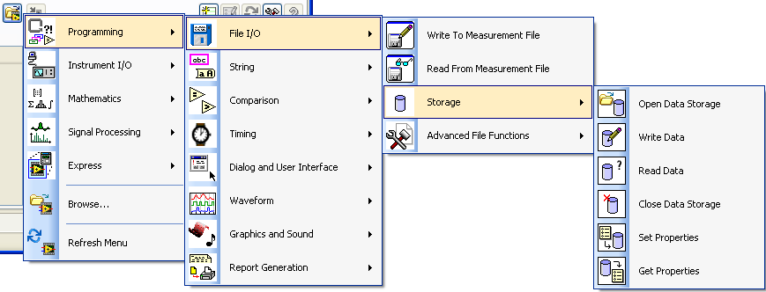
Independent section
Duration: 15 min
Express VI Type Combo Box
- Configure the LabVIEW adapter to use Development System as the LabVIEW server: goto Configure >> Adapters >>LabVIEW and click Configure, select LabVIEW Development System and click “Done”.
- Place an action step and configure it to use an Express VI.
- Take above created Express VI step and try switching to a Standard VI by selecting “Standard VI” from the combo box. At this time, you should get dialog prompting you what action do you want to take. You can either save the Express VI, clear the dialog contents, or cancel. Try cancelling. Make sure nothing happens.
- Now, do it again, but save the VI this time. You should be prompted for the location to save the VI. After the VI is saved, the combo box should be set to “Standard VI”. Make sure the VI is saved on disk with the path you specified.
- Switch again, but this time say No. The contents of Specify Module dialog should be cleared and the combo box should be set to “Standard VI”.

Miscellaneous
If you configure the LabVIEW adapter to use the 7.1 or later run-time engine, you will not be able to configure Express VIs. However, you will still be able to run them. Verify this.

Independent section
Duration: 10 min
Parameter Mapping
To check parameter mapping you have to create a new Step Type. Do the following:
- Configure the LabVIEW adapter to use Development System as the LabVIEW server: goto Configure >> Adapters >>LabVIEW and click Configure, select LabVIEW Development System and click “Done”.
- Create a new step type: Open sequence editor, View>> Types(ctrl+T), select your sequence file and create a new step type
- Open its properties page: right click >> Properties..
- Check “Designate an Adapter” in General tab and select the LabVIEW adapter.
- Click on the “Default Module…” button. This will bring the LabVIEW Specify Module dialog.
- On the Specify Module dialog, select Express VI from the combobox below VI Path as the default VI. Select an Express VI, I recommend the Formula Express VI since it is easy to add, rename, and remove parameters. Configure it anyway you want.
- Now, click on button labeled “Parameter Mapping…” (it is at the bottom of the dialog next to the “VI Help…” button). You should now see the “Parameter Name/Value Mappings” dialog.
- In the dialog, specify some mapping: you can for instance Click Add, map Parameter Name X1 to value 5 or to an expression. When you are done, click OK on all the dialogs.
- Save the sequence, close sequence editor and open the sequence in UI.
- Insert an instance of the type, right click on the step, and select “Configure VI”. Depending on how you configure your VI, you will get different parameters. When you click OK, the prototype will be updated and the arguments will be set as follows:
- Any matching parameters will be kept. Matching is done as follows in the order specified:
    - By name and type first.
    - By position and type.
    - By matching prefixes.
- The parameter mapping will be used with all unspecified parameters
- All unspecified non-required input parameters left will have “Use Default” set
- You will get a prompt every time you configure an Express VI if prototype is changed. The prompt will have the number of parameters added or deleted and their arguments.

Independent section
Duration: 10 min
Diadem Express VI Test
- Configure the LabVIEW adapter to use Development System as the LabVIEW server: goto Configure >> Adapters >>LabVIEW and click Configure, select LabVIEW Development System and click “Done”.
- Launch TestStand and create a new sequence file
- Add three LabVIEW Action steps.
- In the first one, select Express VI – Simulate Signal (Express VI>>Input>>Simulate Signal)
- Use default settings. Create a local variable Locals.Signal of type LabVIEWDynamicData.
- Set the Sine output to be received in Locals.Signal
- In the second step, select Express VI – Simulate Signal (Express VI>>Input>>Simulate Signal)
- Change the signal type to anything other than Sine. Create a local variable Locals.Signal1 of type LabVIEWDynamicData.
- Set the output signal of the step two, to be received in Locals.Signal1
- In the third step, select DIAdem Report (Express VI>>Output>>DIAdem Report)
Note: Starting from LV 2015, “DIAdem Report” express VI has been removed from the palette. Please see CAR 372283. Use Report Express VI instead (Express >> Output >> Report)
- In the configuration page, change the target output/Destination to HTML file. Click OK.
- In the Module settings, change the input Signals 1 to Locals.Signal instead of default. And Signals 2 to Locals.Signal1. Copy the path from Path to save report control.
- Run the sequence in Single Pass.
- Verify that you get an html report with the respective signals drawn is saved at the above copied location.
Independent section
Duration: 10 min
Deployment
- Create a Workspace that references the Sequence file “//TestStand/Tests/LV Automated Tests/ExpressVIs/<lv version>/TestStand Sequence/Call All Non-Hardware Express VIs.seq
- Run the Deployment Utility (Tools >> Deploy TestStand System…) and select your workspace.
- In the Installer Options check Install TestStand Engine; in the Engine Options… dialog check an operator interface to run your sequences. Build the installer and try installing it onto a clean system.
- Ensure all the express VI steps run correctly.
Independent section
Duration: 5 min
Test Impact For CAR 114067 (test with TS 2010 SP1 and later)
- Delete the file <TestStand>\Cfg\ExpressMenu<LV Version> where <LV Version> is the version you are using.
- Restart the Sequence Editor and make sure the LV adapter is set to use the LV Dev system
- On a new sequence file, insert a LV step and type Formula Express VI in the VI Path control. Verify that you don’t see the VI that builds the Express VI menu and verify that no file is found.
- Click on the Select Express VI button to build the Express VI menu.
- On the VI Path control, retype Formula Express VI and verify that the Formula Express VI is found.
Independent section
Duration: 10 min
Test Impact For CAR 51881 (test with TS 2010 SP1 and later)
- Make LV 8.01 active by running it. Run the sequence file //TestStand/Tests/LV Automated Tests/ExpressVIs/8.0/TestStand Sequence/Call All Non-Hardware Express VIs.seq and make sure it passes.
- Manually reconfigure all Express VIs in sequence file //TestStand/Tests/LV Automated Tests/ExpressVIs/8.0/TestStand Sequence/Call All Non-Hardware Express VIs.seq and run it and make sure it passes.
- Repeat the above steps with the LV version you are testing or the latest LV version available.
- Sync all the files under //TestStand/WebPages/TestCases/Adapters/LabVIEW/Media/.
Note: If you are testing with a LV version older than 8.6.1, skip the rest of the steps.
- Open sequence file //TestStand/WebPages/TestCases/Adapters/LabVIEW/Media/UserExpressVIs/ScriptingProblems.seq.
- Configure the LV step “Invalid Config VI Prototype” and verify that you get the error that the configuration VI does not have the expected prototype.
- Configure the LV step “Failed To Find Configuration VI” and verify that you get a prompt to find the configuration VI “Configure MathSample – Error1.vi”. Verify that clicking the cancel button cancels the whole operation.
- Configure the LV step “Failed To Find Configuration VI” again and this time browse for the configuration VI. The relative path to the location in the dialog should be ..\ MathSampleConfig.llb\ Configure MathSample - Error1_RENAMED.vi.
- Verify that the configuration dialog opens. Select a different operation other than the one currently selected and click the OK button.
- Verify that you get a dialog informing you that a parameter was. Click OK.

Independent section
Duration: 7 min
Test Impact For CAR 51881 (test with TS 2012 and later)
- For this test, use a LV version newer than 8.2.1.
- Make sure LV is not running.
- After configuring an Express VI, exit the Sequence Editor or UI.
- Verify that you do not get the following prompt:
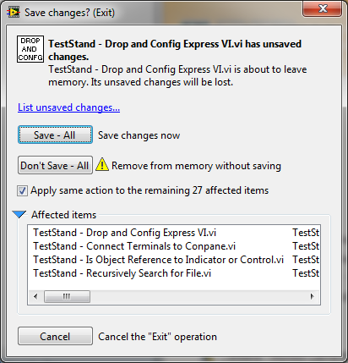
- Launch LV manually and restart the Sequence Editor or UI
- After configuring an Express VI, exit the Sequence Editor or UI.
- Exit LV and verify you do not get the above dialog.
- Restart the Sequence Editor or UI and configure an Express VI.
- Exit LV and, if you get the above dialog, click on the “Don’t Save – All” button.
- Once LV shuts down, reconfigure an Express VI and verify that you do not get any errors.
Independent section
Duration: 15 min
Test Impact For CAR 336372 (test with TS 2012 and later)
- Set the LabVIEW adapter to use the LabVIEW Development System.
- Insert a new LabVIEW Action step on a new sequence
- On the LabVIEW Module panel, click on the Select Express VI button
- In the menu, select the Time Delay Express VI.
- In the configuration dialog, click on the Cancel button
- Verify that the whole operation is cancel
  - The VI Path combo box control in the panel is still empty
  - Click on the Edit menu and verify there is no menu item called “Undo VI Module Pathname”
- Click on the Select Express VI button and select the Time Delay Express VI again
- On the configuration dialog, click OK
- Verify that the VI Path combo box control in the panel now shows Time Delay Express VI
- Press Ctrl+Z to undo the change and verify the panel is cleared
- Press Ctrl+Y to redo the change and verify the information about the Time Delay Express VI is restored and the configuration VI dialog is not shown
- Click on the Select Express VI button again and select the Formula Express VI
- In the configuration dialog, set the formula to X1+X3+X5 and click OK
- Verify that you get a dialog showing the parameter changes. Click OK on the dialog.
- Press Ctrl+Z and verify the panel shows the Time Delay Express VI
- Press Ctrl+Y and verify the panel shows the Formula Express VI
- Click on the Configure VI… button
- In the Configure Formula dialog, change the Formula to just have X2
- Click the Cancel button and verify the prototype shown in the module panel does not change
- Press Ctrl+Z and verify the panel shows the Time Delay Express VI
- Press Ctrl+Y and verify the panel shows the Formula Express VI
- Click on the Configure VI… button
- In the Configure Formula dialog, change the Formula to X2+X4+X5 and click OK
- Verify that you get a dialog showing the parameter changes. Click OK on the dialog.
- Press Ctrl+Z and verify that the panel is showing the old prototype (it should include the parameters X5, X3, and X1).
- Press Ctrl+Y and verify that the panel is showing the new prototype (it should include the parameters X5, X4, and X2)
- Verify that the configuration dialog did not appear and you did not get a dialog that shows the parameter differences when you undo and redo the changes.
- Click on the Browse For VI button and select an existing VI
- Verify that panel is showing the prototype for the new VI
- From the VI Path combo box, select Time Delay Express VI
- In the configuration dialog, click the cancel button
- Verify that he panel is still shows the VI you selected in step 28
- From the VI Path combo box, select Time Delay Express VI again and this time click OK on the configuration dialog
- Verify that you get a dialog showing the parameter changes. Click OK on the dialog.
- Press Ctrl+Z to undo the change and verify the information about the VI you selected on step 28 is shown
- Press Ctrl+Y to redo the change and verify the configuration dialog is not shown and the panel is showing the Time Delay Express VI

Independent section
Duration: 15 min
Test Impact For CAR 337075 (test with TS 2013 and later and LV 2010 or later)
- Sync all the files under //TestStand/WebPages/TestCases/Adapters/LabVIEW/Media/CustomExpressVI.
- Compile the files in LV Version being used.
- Set the LabVIEW adapter to use the LabVIEW Development System.
- Insert a new LabVIEW Action step on a new sequence
- On the LabVIEW Module panel, click on the Select Express VI button
- In the menu, select Browse...
- Browse for the VI CustomExpressVI\MyOwnExpressVISource.llb\MyOwnExpressVI Source.vi
- Select to use the absolute path of the VI
- Verify that you get the dialog with the title "Please find the VI named 'ConfigureMyOwnExpressVI.vi'"
- Click the Cancel button
- In LabVIEW, create a new blank VI and go to its block diagram
- Right click on the block diagram and select the option “Select a VI…”
- In the “Select the VI to Open” dialog, browse for the VI CustomExpressVI\MyOwnExpressVISource.llb\MyOwnExpressVI Source.vi and drop it in the block diagram
- Verify that you get the message “Unable to view properties.”
- Close the dialog by clicking on the OK button
- Modify LabVIEW's search paths to include the location of the configuration VI
  - Tools->Options
  - In the Options dialog, select Paths
  - In the combo box, select VI Search Path and uncheck the Use Default checkbox
  - In the text control (to the right of the Browse button), specify the location of the llb file _MyOwnExpressVIConfig.llb. Make sure you end the path with "\*" to specify that subfolders need to be searched.
  - Added as the last path by selecting the last path and clicking on the Insert After button
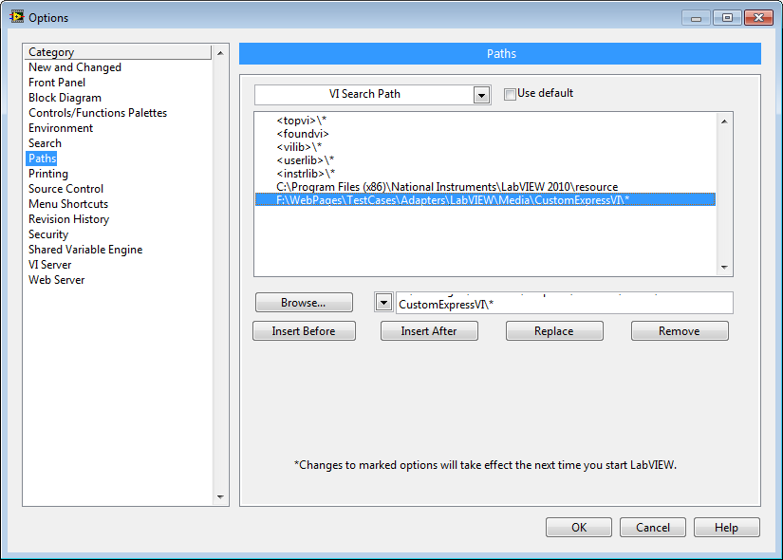
  - Click OK
- Double click on Express VI you dropped in step 12 and this time you should be able to see the configuration VI
- Click OK on the configuration dialog
- In TestStand once again in the LabVIEW Module panel, click on the Select Express VI button
- In the menu, select Browse...
- Browse for the VI CustomExpressVI\MyOwnExpressVISource.llb\MyOwnExpressVI Source.vi
- Select to use the absolute path of the VI
- Verify that you get the same configuration dialog you got when you double click on the Express VI in LV
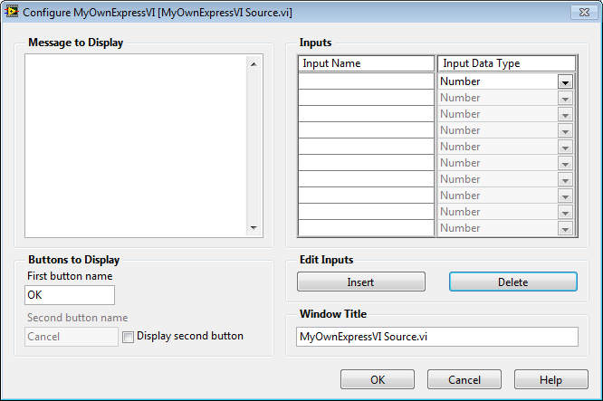
- Click OK and verify you don’t get any errors
- Click on the Configure VI… button and verify that the configuration dialog is shown again

Independent section
Duration: 10 min
Test Impact For CAR 381698 LabVIEW crashes when running Update VI tool on an express VI step that hasn't been saved (test with TS 2012 SP1 and later)

- Create a new sequence
- Drop a LabVIEW step and configure to call a Express VI. Any will do.
- After that launch the VI update tool to update the unsaved sequence
- Make sure you select the option to force the prototype reload
- Run the tool
- At this moment you shouldn’t see a LabVIEW crash.
Detect Express VIs- Test this using panel and Specify module dialog.
  - Add a new Action step and browse to an express VI (you can find one under LabVIEW\vi.lib\express directory).
  - TestStand should automatically detect it is an Express VI and ‘Convert to standard VI’ button should be enabled.
  - Verify that the path has only vi name.
  - Click on Select Express VI button. In the context menu that appears, select the “Browse…” menu item and select a regular VI. ‘Convert to standard VI’ button should be disabled and path should contain absolute or relative path of VI.

[Independent Section]Calling Call All Non-Hardware Express VIs.seq in interactive mode.

- Download \Tests\LVBuildValidation\a.b\Automated\Express Vis\Call All Non-Hardware Express VIs.seq ( a.b = select the labview folder used for testing)
- Make the folder writeable and mass compile it
- Run update VI tool and select reload prototype for both standard and express vi options.
- Run the sequence in interactive mode for both development and run time environment. Check it passes.

National Instruments Confidential
Copyright © 2005 National Instruments Corporation

