LV Adapter : VI Namespace Support
TestStand Version: 2013
Author: Jose A. Hernandez
Feature Spec: CAR 133550
Dependencies: LV 2011 SP1 and LV 2012 or later
Test Category: [Acceptance]

Description
Test VI namespace support in the LabVIEW adapter.

Preparation
- Install LabVIEW 2011 SP1 and LV 2012 or later. The LabVIEW installers can be found at \\nirvana\NISoftwareReleased\Windows\Distributions. If testing a pre-release version of LV, you can find it at \\nirvana\NISoftwarePrerelease.
- The media files are located at http://teststand.ni.com/testcases/Adapters/LabVIEW/Media/Namespaces. Make all the files writeable.
- Configure the LV Adapter to use the LabVIEW Development System. The active version will be the last LV version ran.
- Modify the station options to show hidden properties
  - Configure->Station Options…
  - Select the Preferences tab
  - Check the option “Show Hidden Properties”

Validation
In LabVIEW, a namespace is defined by a LV project library. If a VI belongs to a project library, then the VI namespace will be the name of the project library.

LabVIEW Module Panel

- Open the sequence file Namespace.seq and save it so it is not marked as modified
- Run the sequence file.
- Verify that you get the Find dialog because the VI cannot be found. Click Cancel on the dialog and click OK on the second dialog.
- Select each step and verify that you get the error provider with the message that the VI cannot be found
- Add the locations of the VIs to the TestStand search paths
  - Select Configure->Search Directories…
  - In the Edit Search Directories dialog, add at the bottom of the list the locations of the VIs as shown in the screenshot below
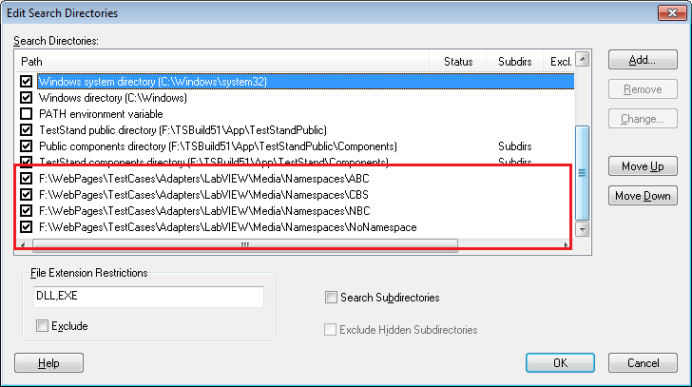

- Select the first step and, in the Variables control, expand Step.TS.SData.ViCall and scroll to show the properties VIPath and Namespace
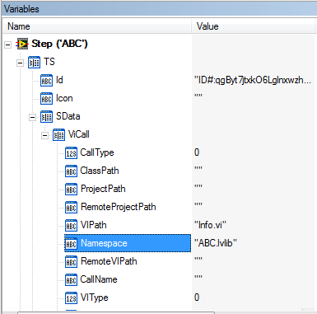
- Now, select each step again and verify the following:
  - Step ABC absolute path contains Namespaces\ABC\Info.vi, the VI help picture has a green square and has the name ABC.lvlib:Info.vi, and the Namespace property of the step has the string value ABC.lvlib
  - Step CBS absolute path contains Namespaces\CBS\Info.vi, the VI help picture has a red square and has the name CBS.lvlib:Info.vi, and the Namespace property of the step has the string value CBS.lvlib
  - Step NBC absolute path contains Namespaces\NBC\Info.vi, the VI help picture has a blue square and has the name NBC.lvlib:Info.vi, and the Namespace property of the step has the string value NBC.lvlib
  - Step NoNamespace absolute path contains Namespaces\ABC\Info.vi, the VI help picture has a green square and has the name ABC.lvlib:Info.vi, and the Namespace property of the step has an empty string value.
- Make sure you have the NoNamespace step selected
- Modify the search directories by moving the directory ABC below CBS
- Verify that after you close the Edit Search Directories dialog, the information of the NoNamespace is automatically updated as follows
The absolute path contains Namespaces\CBS\Info.vi, the VI help picture has a red square and has the name CBS.lvlib:Info.vi, and the Namespace property of the step has an empty string value.
Note: When the VI has no associated namespace, it will be assumed that the first VI found will be the VI you want. This is done to keep backwards compatibility.
- Verify the sequence file is not marked as modified.
- Modify the search directories by moving the directory NoNamespace above CBS as seen in the screenshot below
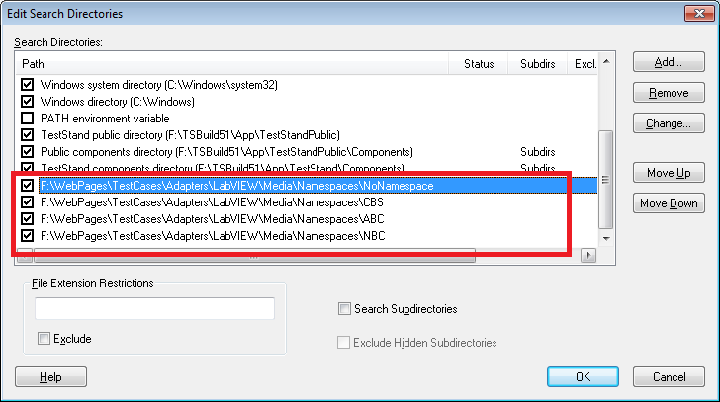

- Verify that the NoNamespace step now shows the VI in the NoNamespace directory and the sequence file is not marked as modified.
- Run the sequence file and verify that is runs successfully. Close the execution dialog and unload all the modules.
- Select the ABC step and click on the “Reload VI Prototype” button
- Verify that it reloads successfully and the file is not marked as modified (the path and the namespace did not change)
- Repeat the two previous steps with the CBS, NBC, and NoNamespace LV steps
- Modify the search directories and move the NoNamespace directory below the CBS directory
- Select the NoNamespace directory and click the “Reload VI Prototype” button
- Verify that the sequence file is marked as modified and that the step property Namespace now has the string value CBS.lvlib.
Note: When the property Namespace is empty, reloading a prototype assumes that the selected VI is the VI you want so the LV adapter just records the VI prototype information.
- Save the sequence file.
- Select the ABC step
- Modify the search directories by unchecking the ABC directory so it is disabled.
- Verify that the VI for the ABC step is no longer found.
Note: The namespace is part of the VI path information. If the namespace of any found VI does not match the namespace in the Namespace step property, the VI is considered different.
- Run the sequence file
- Verify that you get the Find File dialog because the VI cannot be found. Click on the Cancel button.
- Modify the search directories by checking the ABC directory so it is enabled. Also, move the NoNamespace directory above the CBS directory. The search directories should look similar the screenshot below.
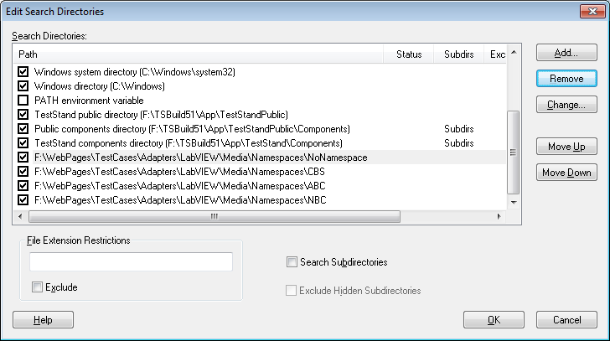
- Add a new LV step to MainSequence and select it.
- Click on the “Browse for VI…” button and browse for info.vi under the ABC folder
- Verify that the help picture of the VI says ABC.lvlib:info.vi and it has a green rectangle. Also, verify that the Namespace property has the value ABC.lvlib.
- Click on the “Browse for VI…” button again and browse for info.vi under the CBS folder
- Verify that the help picture of the VI says CBS.lvlib:info.vi and it has a red rectangle. Also, verify that the Namespace property has the value CBS.lvlib.
- Click on the “Browse for VI…” button again and browse for info.vi under the NBC folder
- Verify that the help picture of the VI says NBC.lvlib:info.vi and it has a blue rectangle. Also, verify that the Namespace property has the value NBC.lvlib
- Click on the “Browse for VI…” button again and browse for info.vi under the NoNamespace folder
- Verify that the help picture of the VI says info.vi and it has a clear rectangle. Also, verify that the Namespace property has an empty string.
- Close Namespaces.seq
- Modify the search directories as follows
Uncheck the locations for ABC, CBS, NBC, and NoNamespace
Add the directory <Media>\Namespaces and check the option “Search Subdirectories” as shown in the screenshot below
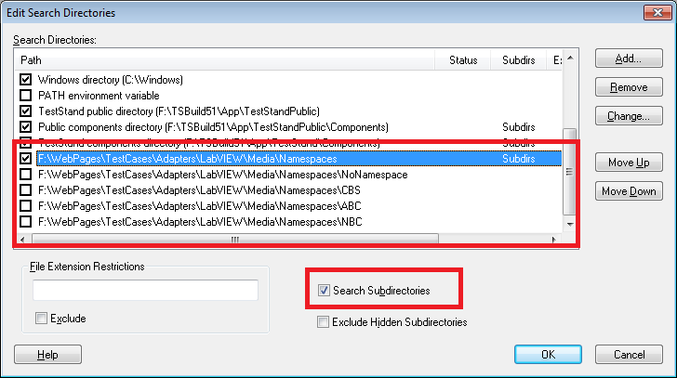
- Get a new copy of Namespace.seq and open it
- Select each step and verify the following
  - Step ABC absolute path contains Namespaces\ABC\Info.vi, the VI help picture has a green square and has the name ABC.lvlib:Info.vi, and the Namespace property of the step has the string value ABC.lvlib
  - Step CBS absolute path contains Namespaces\CBS\Info.vi, the VI help picture has a red square and has the name CBS.lvlib:Info.vi, and the Namespace property of the step has the string value CBS.lvlib
  - Step NBC absolute path contains Namespaces\NBC\Info.vi, the VI help picture has a blue square and has the name NBC.lvlib:Info.vi, and the Namespace property of the step has the string value NBC.lvlib
  - Step NoNamespace absolute path contains Namespaces\ABC\Info.vi, the VI help picture has a green square and has the name ABC.lvlib:Info.vi, and the Namespace property of the step has an empty string value.
- Run the sequence file and verify that the first three steps passed. The fourth one will failed because it expects the loaded VI to not have a namespace.
- Close the execution window and unload all modules

Update VI Calls Tool

- Run the Update VI Calls tool (Tools->Update VI Calls…)
- Verify that the Files To Update section has the option Active Sequence File selected and it has the name Namespaces.seq in the text field.
- Using all the default settings click on the Update Calls button
- Verify that the status control says that the first three steps are up to date. The last one will say that the namespace is different because the info.vi is found under the ABC folder instead of the NoNamespace folder. You can see this by looking at the Found VI Path field of the last step in the status control.
- Select the Files To Update tab and now check the Ignore VI Namespace check box
- Click the Update Calls button
- Verify that Info.vi is found under the ABC folder for all the steps since the namespace is being ignored when finding Info.vi. For this reason, the log will say that the namespace is different for all the steps except the first one.
- Select the Files to Update tab and under the Process Standard VI Calls option select Force Prototype Reload from the combo box and uncheck Ignore VI Namespace.
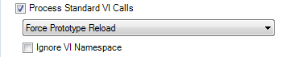

- Click on the Update Calls button and verify that the prototype of all the steps is reloaded successfully. The log should not have the text “VI call was updated to use the new prototype” for all the steps.
- Close the Update VI Calls dialog by clicking on the Close button
- Select each step and verify the following
  - Step ABC absolute path contains Namespaces\ABC\Info.vi, the VI help picture has a green square and has the name ABC.lvlib:Info.vi, and the Namespace property of the step has the string value ABC.lvlib
  - Step CBS absolute path contains Namespaces\CBS\Info.vi, the VI help picture has a red square and has the name CBS.lvlib:Info.vi, and the Namespace property of the step has the string value CBS.lvlib
  - Step NBC absolute path contains Namespaces\NBC\Info.vi, the VI help picture has a blue square and has the name NBC.lvlib:Info.vi, and the Namespace property of the step has the string value NBC.lvlib
  - Step NoNamespace absolute path contains Namespaces\ABC\Info.vi, the VI help picture has a green square and has the name ABC.lvlib:Info.vi, and the Namespace property of the step has the string value ABC.lvlib.
- Run the Update VI Calls tool again
- Under the Process Standard VI Calls option select Force Prototype Reload from the combo box and check Ignore VI Namespace.
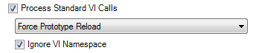
- Click on the Update Calls button and verify that the prototype of all the steps is reloaded successfully by using info.vi under the ABC folder. The log should not have the text “VI call was updated to use the new prototype” for all the steps.
- Close the Update VI Calls dialog by clicking on the Close button.
- Select each step and verify that all steps call Info.vi under the ABC folder.
- Close Namespace.seq and get a new copy and open it
- Update the search paths as seen in the screenshot below. Disable the Namespaces folder and enable the NoNamespace, CBS, ABC, and NBC folders
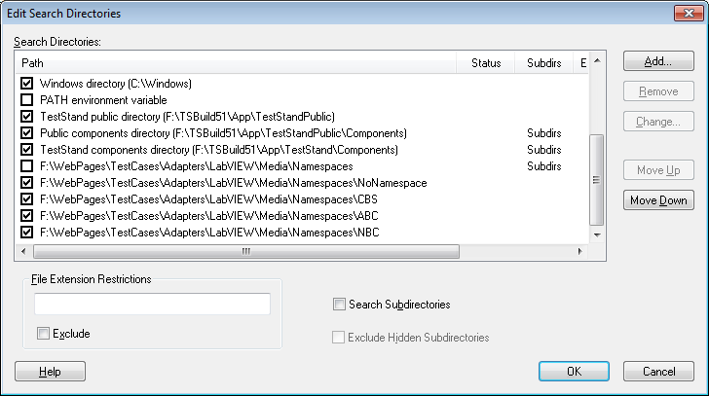
- Run the Update VI Calls tool again
- Using the default settings click on the Update Calls button
- Verify that all the steps are up to date and you don’t get any messages about the namespace being different in any of the steps.
- Select the Files To Update tab and check the checkbox Ignore VI Namespace and click on the Update Calls button
- Verify that the first three steps have a message about the namespace being different. The fourth one should be fine.
- Select the Files To Update tab and uncheck Ignore VI Namespace and select Force Prototype Reload under the Process Standard VI Calls.
- Click on the Update Calls button and verify that the prototype is reloaded successfully.
- Close the Update VI Calls dialog
- Select each step and verify the following
  - Step ABC absolute path contains Namespaces\ABC\Info.vi, the VI help picture has a green square and has the name ABC.lvlib:Info.vi, and the Namespace property of the step has the string value ABC.lvlib
  - Step CBS absolute path contains Namespaces\CBS\Info.vi, the VI help picture has a red square and has the name CBS.lvlib:Info.vi, and the Namespace property of the step has the string value CBS.lvlib
  - Step NBC absolute path contains Namespaces\NBC\Info.vi, the VI help picture has a blue square and has the name NBC.lvlib:Info.vi, and the Namespace property of the step has the string value NBC.lvlib
  - Step NoNamespace absolute path contains Namespaces\NoNamespace\Info.vi, the VI help picture has a clear square and has the name Info.vi, and the Namespace property of the step has an empty string.
- Modify the search paths by disabling the CBS and ABC folders
- Run the Update VI Calls tool
- Using the default settings click on the Update Calls button
- Verify that the VIs for steps ABC and CBS are not found because the namespace does not match any of the namespaces for Info.vi in the current enabled search paths.
- Select the Files To Update tab and check the option Ignore VI Namespace and click on the Update Calls tool
- Verify that Info.vi for all the steps is found under the folder NoNamespace and the first three steps have a message that the namespace is different.
- Select the Files To Update tab and uncheck Ignore VI Namespace and select the option Force Prototype Reload under Process Standard VI Calls
- Click on the Update Calls button and verify that the first two steps are not updated because the VI is not found
- Select the Files To Update tab and check the option Ignore VI Namespace and click on the Update Calls tool
- Verify that all the steps are updated to use Info.vi from the NoNamespace folder
- Close the Update VI Calls tool
- Select each step and verify that all of them are calling Info.vi from the NoNamespace folder

LV 2012 Run-Time Engine Is Not Installed
Supporting finding VIs with the correct namespace is only supported when the LV 2012 RTE is installed. If it is not installed, the behavior should be the same as TestStand 2012 and earlier which is to always ignore the namespace when finding a VI.

- Close the Sequence Editor
- Get a new copy of Namespaces.seq
- Simulate not having the LV 2012 Run-Time Engine (RTE) installed by doing the following
- Open the Registry Editor window. You can do this by clicking on the Start Windows menu and search for regedit and run it.
- Navigate to the registry key HKEY_LOCAL_MACHINE\SOFTWARE\Wow6432Node\National Instruments\LabVIEW Run-Time. It might be slightly different when a 32-bit OS.
- Rename the 12.0 folder to and old version like 6.1
- Run the Sequence Editor and open Namespace.seq
- Select each step and verify that each step calls the VI Info.vi under the NoNamespace folder.
- Run the sequence and verify that you get a loading error due to the namespace of the loaded VI does not match the expected namespace ABC.lvlib.
- Disable the NoNamespace search directory and enable the directories CBS, ABC, and NBC
- Select each step and verify that now all each step is calling the VI Info.vi under the CBS folder.
- Run the Update VI Calls tool
- Verify that the option “Ignore VI Namespace” is disabled and checked because the option cannot be modified since the LV 2012 RTE (or later) is not installed.
- Verify that checking and unchecking the option Process Standard VI Calls does not enabled the “Ignore VI Namespace” checkbox
- Click on the Update VI Calls button (make sure the Process Standard VI Calls checkbox is checked).
- Verify that the Found VI Path for all the steps have the path to the Info.vi under the CBS folder and all the steps except for the CBS step have the message that the namespace is different.
- Close the Update VI Calls tool
- Try modifying the search directories and verify that the first Info.vi found is always used. This is how TestStand 2012 or earlier behave.

At the end of this test, rename the registry key back to 12.0 and restart the Sequence Editor because the LV adapter caches all the RTEs installed.

Free Form
Now that you are familiar with the behavior of finding VIs using their namespace, try the following test cases
- Calling VIs in the context of a project with different namespaces. All the folders have projects that you can use.
- Run the Update VI Calls tool and try to the steps you created in above
- Browse for VIs in different locations and verify the namespace of the VI is stored in the Namespace property
- Manually type the name of the VI
- Use relative paths to the VIs
- Configure VIs called by instances of the Run VI Asynchronously step type
- Undo and redo some of the changes
- On a new VI step, create a new VI by pressing on the Create VI… button.
- Configure VI calls using a User Interface. You don’t need to spend a lot of time doing this. Just a few cases will do.

National Instruments Confidential
Copyright © 2005 National Instruments Corporation

