LabVIEW Adapter: Ring Controls
TestStand Version: 2012

Author: Jose A. Hernandez
Feature Spec: Ring Control Support For LabVIEW
Dependencies: LabVIEW 2012 or later

Test Category: [ Functional ]

Description
Test that the string values for a ring control are shown in the LabVIEW Module panel. Also, test that mapping an enum control value behaves the same as in LabVIEW.

Preparation
- Install LabVIEW 2012 or a later version from \\nirvana\NISoftwareReleased\Windows\Distributions\LabVIEW or \\nirvana\NISoftwarePrerelease\LabVIEW
- Install TestStand 2010 SP1 or TestStand 4.2.1
- The media files are located at http://teststand.ni.com/testcases/Adapters/LabVIEW/Media/RingControls
- Make all the files writeable and mass compile them with the installed version of LV
- Set the LV adapter to use the LabVIEW Development System

Validation
Ring Controls
As of LabVIEW 2012, all ring controls are found in the Ring & Enum palette which is shown in the screenshot below.
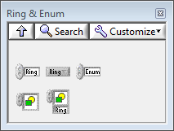
- Open RingControls.seq in the Sequence Editor
- Select the step Top-Level Ring Controls - No Type Def and specify for its module the VI “RingControls - NoTypeDefs.vi”
In the LabVIEW Module panel, click on the Browse for VI… button.
In the Open dialog, browse for the VI RingControls - NoTypeDefs.vi
Click the Open button to select the VI
- Verify that each parameter except for Pict Ring Control has a combo box in the Value column.
- Click on the Edit VI button to open the VI in LabVIEW
- For each ring control (except for Pict Ring Control), do the following:
  - Verify that the default value shown in the LabVIEW module panel for each parameter is the same value as the value shown in the corresponding control in the VI
  - Verify that all the string values defined in the ring control appear in the combo box for that control in the LabVIEW Module panel. For example, verify that the control Enum has the following string values in both the VI and the LabVIEW Module panel and they appear in the same order:
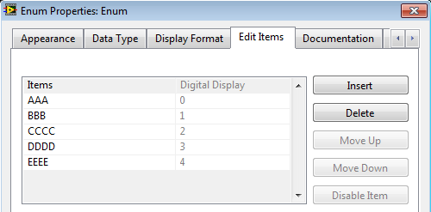
To open the dialog above, right click on the ring control in the VI and select Edit Items…

I recommend writing down the string and numeric values for each ring control since you will be referring to them throughout the test plan.

  - Uncheck the checkbox under the Default column in the LabVIEW Module panel.
  - Verify that the value in the Value column does not change
  - Verify that selecting an item from the combo box sets the corresponding numeric value in the ArgVal property and the string value in the ArgDisplayVal property for that parameter.

To do this, modify TestStand to show hidden properties.
Select Configure->Station Options…
In the Station Options dialog, select the Preferences tab and check the option Show Hidden Properties
Click OK on the dialog
In the Variables View control under Step.TS.SData.ViCall.Parms, expand to each parameter so you can see the properties ArgVal and ArgDisplayVal.
In the LabVIEW Module panel, select a value from the combo box and verify that the properties are modified with the numeric and string values for that selection.

For example, to show the properties for the Enum parameter, expand all the way to Step.TS.SData.ViCall.Parms["Enum"]. In the LabVIEW Module panel, select “EEEE” from the combo box in the Value column for the Enum parameter and verify that the property ArgVal has the value 4 and ArgDisplayVal has the value “EEEE”.
- Verify that after entering a numeric value that matches one of the ring control numeric values displays the corresponding string value.
For example, after entering the value 8.314472 in the Value column for the Numeric Constants parameter, the display value will be MolarGasConstant. If you enter Inf, the display value will be PositiveInfinity.
- Right-click on the step and select Run Selected Steps from the context menu and verify that the controls in the VI show the same values specified in the parameters in the step
- Reload the VI prototype by clicking on the Reload VI Prototype button in the LabVIEW panel.
- Verify that the values under the Value column do not change
- Select the step Top-Level Ring Controls - Type Def and specify for its module the VI “RingControls – Type Defs.vi”
- Repeat the steps 3 to 7.

- Select the step Rings In A Cluster and specify for its module the VI “Rings In A Cluster.vi”
- Select the Cluster parameter and press the numeric key ‘*’ to expand all cluster items
- Click on the Edit VI button to open the VI in LabVIEW
- For each ring control in the cluster parameter, verify the following
  - The default value of all the cluster elements shown in the LabVIEW module panel is the same value as the value shown in the VI
  - Verify that all the string values defined in a ring control appear in the combo box for that control in the LabVIEW Module panel and they are in the same order
  - Uncheck the checkbox under the Default column in the LabVIEW Module panel and verify that the value in the Value column does not change
  - Verify that selecting an item from the combo box sets the corresponding numeric value in the ArgVal property and the string value in the ArgDisplayVal property for that element.
- Verify that after entering a numeric value that matches one of the ring control numeric values displays the corresponding string value.
- Right-click on the step and select Run Selected Steps from the context menu and verify that the controls in the VI show the same values specified in the parameters in the step
- On the last element of the array Array Of Enums, click on the button Add Array Item and verify that the newly inserted array element has a combo box and it has the same enum strings as the other array elements.
Repeat the same steps as described in step 13 for the newly inserted array element.

- Select the step Rings In A Cluster – No Type Defs and specify for its module the VI “Rings In A Cluster – No Type Defs.vi”
- Repeat the steps 11 to 14.

- Select the step Output Rings and specify for its module the VI “Output Rings.vi”.
- Verify that the Value column has not combo boxes

- Select the step Array Of Enums and specify for its module the VI “Array With Enums.vi”.
- Select all the parameters and press the numeric key ‘*’ to expand all of them
- Click on the Edit VI button to open the VI in LabVIEW
- Repeat the steps described in step 13 for each ring control element
- Collapse all the parameters and expand the parameter Array Of Clusters With Enums 2
- On the last element of the array Array Of Clusters With Enums 2, click on the button Add Array Item
- Select the newly inserted array element and press the numeric key ‘*’ to expand all the elements of the cluster. Note: The element named Array will not be expanded.
- Verify that all the ring controls in the cluster have combo boxes and their values match the values in the VI for those ring controls.
- Verify that selecting an item from the combo box sets the corresponding numeric value in the ArgVal property and the string value in the ArgDisplayVal property for that element
- Add a new element to the Array element by clicking on the button Add Array Item
- Expand the newly inserted array element. It should look similar to the screenshot below.
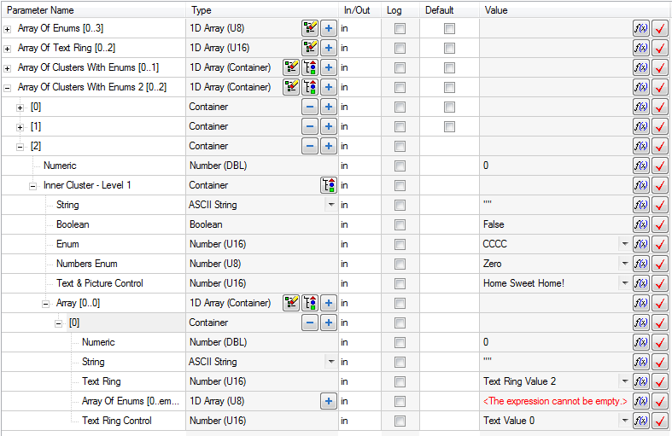
- Repeat steps 25 and 26 with the newly inserted array element
- Add a new array element to the element Array Of Enums by clicking on the button Add Array Item
- Verify that the new element has a combo box and verify that its values match the values in the VI for that array enum control.
- Verify that selecting an item from the combo box sets the corresponding numeric value in the ArgVal property and the string value in the ArgDisplayVal property for that element

- Select the step Array Of Enums – No Type Defs and specify for its module the VI “Array With Enums – No Type Defs.vi”.
- Repeat steps 20 to 33

- Configure the LabVIEW adapter to run VIs in the Run-Time Engine.
Configure->Adapters
Double click on the LabVIEW adapter
Select LabVIEW Run-Time Engine
In the Version combo box, select Auto detect using VI version
Close all the dialogs by clicking OK and Done
- Clear the module information for all the steps. If you see the button Clear All Unmapped Arguments, click on it to clear all the old parameter information.
- Repeat the steps 2 to 35 using the LabVIEW Run-Time Engine

Enum Parameter Mapping

When reloading a prototype of a VI and the VI has ring control including enums, TestStand 2012 tries to behave like LabVIEW when remapping the ring controls. This is the expected behavior:
For strict type def enum controls, applying changes to instances of the control will keep the enum display value and update the numeric value to match the display value. If the enum is renamed or deleted and the value is still in range, the numeric value is kept. If the enum no longer exists and the numeric value is out of range, the last enum is selected.
For regular enum controls (non type def controls), the numeric value is kept and display value is updated to match the numeric value. If the enum is deleted, the last enum is selected.
For other ring controls (not enums), the numeric value is always kept regardless if it is in range or not. The string display value will always be updated to match the numeric value if one is found.

- Configure the LabVIEW adapter to run VIs in the LabVIEW Development System
- Close all VIs opened in LabVIEW
- Select the MapEnumValues sequence and select Ring Control Mapping
- Click on the Edit VI… button
- Verify that the properties ArgVal and ArgDisplayVal for each parameter match the selected ring values which should be as follows:
 | ArgVal | ArgDisplayVal
Enum (Not Using Type Def) | 2 | "Value - 2"
Enum (Using Type Def) | 3 | "Three"
Text Ring (Not Using Type Def) | 78 | "Text Ring Value - 78"
Text Ring (Using Type Def) | 3 | "Text Value 3"
- Reload the prototype and verify that the parameters do not change
- For the parameter Enum (Not Using Type Def) in the Value column, enter the value 11
- For the parameter Enum (Using Type Def) in the Value column, enter the value 45
- For the parameter Text Ring (Not Using Type Def), enter the value 1990
- For the parameter Text Ring (Using Type Def), enter the value 2011
- Click on the Reload VI Prototype button and verify that the parameters have the following value:
 | ArgVal | ArgDisplayVal
Enum (Not Using Type Def) | 4 | "Value - 4"
Enum (Using Type Def) | 5 | "Five"
Text Ring (Not Using Type Def) | 1990
Text Ring (Using Type Def) | 2011
No matches for the values in the enum parameters were found so that last item was used.
- For the parameter Text Ring (Not Using Type Def), select the value Text Ring Value - 11
- For the parameter Text Ring (Using Type Def), select the value Text Value 5
- Verify the value for the parameters are as follows:
 | ArgVal | ArgDisplayVal
Enum (Not Using Type Def) | 4 | "Value - 4"
Enum (Using Type Def) | 5 | "Five"
Text Ring (Not Using Type Def) | -11 | "Text Ring Value - 11"
Text Ring (Using Type Def) | 4 | "Text Value 5"
- In the EnumParameterMapping.vi, right click on the Enum (Not Using Type Def) control and select Edit Items…
- In the properties dialog, move item Value – 4 up two rows. Item Value – 3 should now be the last item and Value – 4 should have the numeric value 2.
- Click OK on the dialog
- Right-click on Enum (Using Type Def) and select Open Type Def.
- In the EnumTypeDefControl.ctl control file, right-click on the enum control Numbers Enum and select Edit Items…
- In the properties dialog, move the item Five up three rows. Item Five should have the value 2.
- Click OK on the dialog
- In the EnumTypeDefControl.ctl control file, select File->Apply Changes
- In the EnumParameterMapping.vi, right-click on Text Ring (Not Using Type Def) and select Edit Items…
- Change the value for item Text Ring Value – 11 to -345 and click OK on the dialog
- Right-click on Text Ring (Using Type Def) and select Open Type Def.
- In the TextRingTypeDefControl.ctl control file, right-click on the control Text Ring Control and select Edit Items…
- In the properties dialog, move the item Text Value 5 up two rows. Item Text Value 5 should have the value 2 and the numeric value 4 is now associated with Text Value 3.
- Click OK on the dialog
- In the TextRingTypeDefControl.ctl control file, select File->Apply Changes
- Go back to the LV module panel and reload the prototype of the VI
- Verify that the parameters have the following value:
 | ArgVal | ArgDisplayVal
Enum (Not Using Type Def) | 4 | "Value - 3"
Enum (Using Type Def) | 2 | "Five"
Text Ring (Not Using Type Def) | -11
Text Ring (Using Type Def) | 4 | "Text Value 3"
The enum that is not an instance of a type def control kept its numeric value and the display value was modified to match the numeric value. The other enum which is an instance of a type def control kept its display value and the numeric value was modified to match the display value.
For the Text Ring controls, the numeric value was kept and the display value was modified if a match was found.
- Modify the values for the parameters as shown below (modify the values by selecting the item from the combo box):
 | ArgVal | ArgDisplayVal
Enum (Not Using Type Def) | 2 | "Value - 4"
Enum (Using Type Def) | 2 | "Five"
Text Ring (Not Using Type Def) | 78 | "Text Ring Value - 78"
Text Ring (Using Type Def) | 4 | "Text Value 3"
- In the EnumParameterMapping.vi, right click on the Enum (Not Using Type Def) control and select Edit Items…
- In the properties dialog, move item Value – 4 up two rows. Item Value – 4 should now have the numeric value 0 and Value – 1 should now have the numeric value 2.
- Rename item Value – 4 to Value – 4 Renamed.
- Click OK on the dialog
- Right-click on Enum (Using Type Def) and select Open Type Def.
- In the EnumTypeDefControl.ctl control file, right-click on the enum control Numbers Enum and select Edit Items…
- In the properties dialog, move the item Five down two rows. Item Five should have the value 4 and Item Two should have the numeric value 2.
- Rename item Five to Five – Renamed.
- Click OK on the dialog
- In the EnumTypeDefControl.ctl control file, select File->Apply Changes
- In the EnumParameterMapping.vi, right-click on Text Ring (Not Using Type Def) and select Edit Items…
- Rename item Text Ring Value – 78 to Text Ring – 78 Renamed and click OK on the dialog
- Right-click on Text Ring (Using Type Def) and select Open Type Def.
- In the TextRingTypeDefControl.ctl control file, right-click on the control Text Ring Control and select Edit Items…
- In the properties dialog, rename item Text Value 3 to Text Value 3 – Renamed.
- Click OK on the dialog
- In the TextRingTypeDefControl.ctl control file, select File->Apply Changes
- Go back to the LV module panel and reload the prototype of the VI
- Verify that the parameters have the following value:
 | ArgVal | ArgDisplayVal
Enum (Not Using Type Def) | 2 | "Value - 1"
Enum (Using Type Def) | 2 | "Two"
Text Ring (Not Using Type Def) | 78 | "Text Ring Value – 78 Renamed"
Text Ring (Using Type Def) | 4 | "Text Value 3 - Renamed"

Save As Previous
- Open the file ForSaveAsPrevious\ConfiguredWithTS2012.seq
- Run the sequence and verify that it runs successfully
- Open the type palette document (Ctrl+T)
- Right click on the step type TypeWithEnumParameters and select Properties…
- Click on the Default Module button
- Find the VI EnumControls-OutOfRange.vi. The VI is under the folder ForSaveAsPrevious.
- Select the option “Add the directory containing the file you selected to the list of search directories” when prompt to resolve the path
- Due to a problem with the dialog, you will need to reopen it so the information with the new path is refreshed. (Problem has been reported in CAR 346456).
- Verify you don’t have any problems opening the dialog
- Close the dialog
- Select the Substeps tab and select the Post substep
- Click on the Specify Module… button
- Verify that you can open it without any problems
- Close all the dialogs and go back to the sequence file ConfiguredWithTS2012.seq
- Select File->Save As and, in the Save As dialog, select the TestStand version you installed in step 2 in the preparation section above in the Files of Type control
- Add the TS version as the suffix for the new file. For example, if you installed TS 4.2.1, name the new file ConfiguredWithTS2012-421.seq.
- When you get prompt to view the log file, click the Yes button
- Verify that the you get five messages about the steps using enums parameters and that their values will not be normalized in older versions of TestStand.
- Version switch to the old TestStand version and open the new sequence file
- Run the sequence in the old TestStand version and verify that it runs without any errors. Note that the sequence will fail, but should not error.
- Close the execution and press Ctrl+T to open the Type palette document
- Select the sequence file and right click on the TypeWithEnumParameters and select Properties…
- Click on the Default Module... button and verify that you don’t get any errors (browse for the VI if it is not found)
- Select Array Of Clusters and press the ‘*’ in the numeric keypad to expand all items
- Verify you don’t get any errrors
- Close the dialog and switch to the substeps tab
- Click on the Specify Module… button and verify you don’t get any error opening the dialog
- Select Array Of Clusters and press the ‘*’ in the numeric keypad to expand all items
- Verify you don’t get any errors
- Close all the dialogs
Test Impact For CAR 351926 (Validate after CAR 352446 is fixed)
- Set the LV adapter to use the LV Development System
- Open the file All Ring Control Representations.seq
- Select the LV step and click on the Edit VI… button to open the VI LV
- For each parameter, select each ring value and verify that the ArgVal and ArgDisplayVal values match the values in the VI ring control. Note that the values for Single
- Run the VI after changing some of the values and verify the value specified in TestStand is passed to the VI. You don’t need to run the VI every time you change a value. Just make sure to run it a few times to verify that the values are passed correctly.
- Repeat steps 4 and 5 with the LabVIEW run-time engine

National Instruments Confidential
Copyright © 2011 National Instruments Corporation

