LabVIEW Adapter: Show Front Panel of a VI
TestStand Version: 4.1

Author: Jose A. Hernandez
Feature Spec: LabVIEW Adapter
Dependencies: Current LabVIEW

Test Category: [ Functional ]

Description
Test the behavior of showing a VI’s front panel from TestStand.

Preparation
- Install LabVIEW 8.0 or later from \\nirvana\NIInstallers\Current\NI\LabVIEW.
- Mass compile VIs under TestCases\Adapters\LabVIEW\Media\ShowVIFrontPanel
- Set the LabVIEW adapter to use the LabVIEW Development System

Validation

Each test VI will test each setting found in the Window Appearance section of the VI properties dialog. 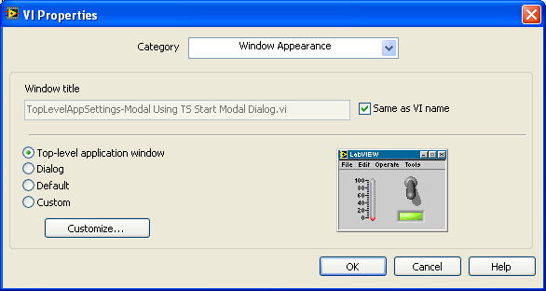

The VIs named TopLevelAppSettings.vi and “TopLevelAppSettings-Modal Using TS Start Modal Dialog.vi” will test the “Top-level application window” setting.
Note: When a VI is modal to TestStand, TestStand will ignore any user input, but it can still come to the front of the VI. The VI is not really modal in the sense that you cannot select TestStand without first dismissing the VI. The VI and TestStand can be selected independently.

The VIs named DialogSettings.vi and DialogSettings-Modal Using TS Start Modal Dialog.vi will test the Dialog setting.

The VIs named DefaultWindowSettings.vi and DefaultWindowSettings-Modal Using TS Start Modal Dialog.vi will test the Default setting.

We are not testing every setting under Custom settings since some of the settings do not affect the interaction with TestStand. The Custom settings dialog has the following default options:

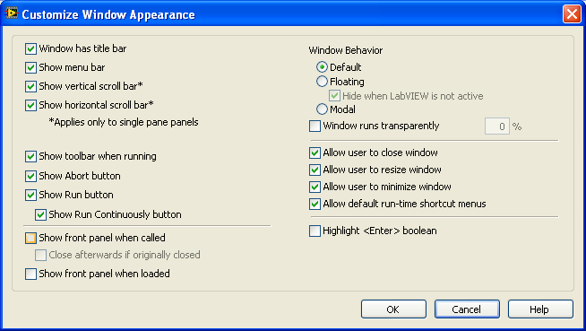

The setting “Show front panel when loaded” is ignored when you use the VI Server to load the VI. TestStand uses the VI Server to load the VI so this option is completely ignore so we are not testing.

The VIs named Custom-SFPWhenCalled.vi and Custom-SFPWhenCalled-Modal.vi have the settings below. They test the “Show front panel when called” setting using the Default Window Behavior.

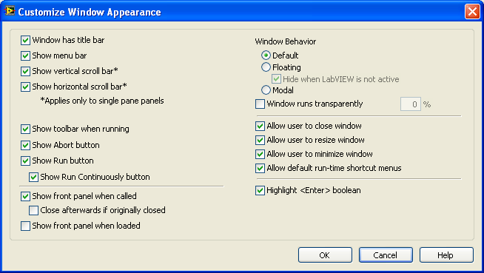

The VIs named Custom-SFPWhenCalled Floating.vi and Custom-SFPWhenCalled Floating-Modal Using TS Start Modal Dialog.vi have the settings below. They test the “Show front panel when called” setting using the Floating Window Behavior.

Note: When running “Custom-SFPWhenCalled Floating-Modal Using TS Start Modal Dialog.vi” in the LV UI when running in LV or as an executable, the VI’s front panel will not be visible. The front panel will flash when you select the LV UI. The VI will be visible only if LV is active. However, since the VI’s parent is the hidden TestStand modal window, LV will never be active so the VI’s front panel will not be visible. This is just expected behavior. If you hit this problem, just press Alt+F4 to display the window.

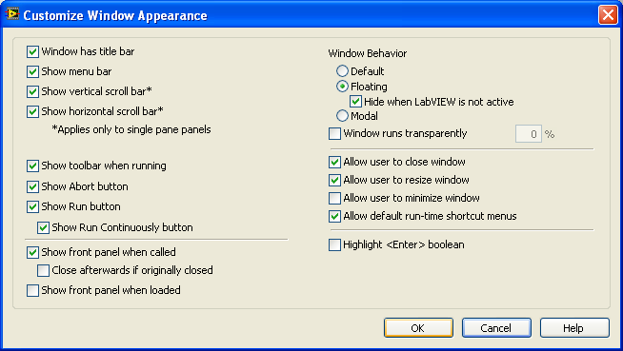

The VIs named Custom-SFPWhenCalled ModalWindow.vi and Custom-SFPWhenCalled ModalWindow -Modal Using TS Start Modal Dialog.vi have the settings below. They test the “Show front panel when called” setting using the Modal Window Behavior.

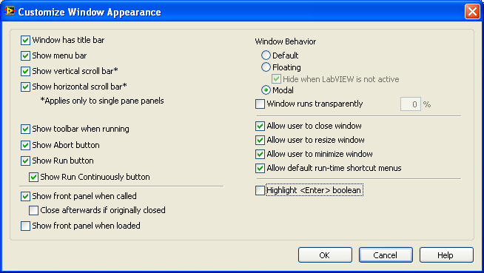

The VIs named Custom-SFPWhenCalledCloseAfter.vi and Custom-SFPWhenCalledCloseAfter-Modal Using TS Start Modal Dialog.vi have the settings below. They test the “Show front panel when called” and “Close afterwards if originally closed” settings using the Default Window Behavior.

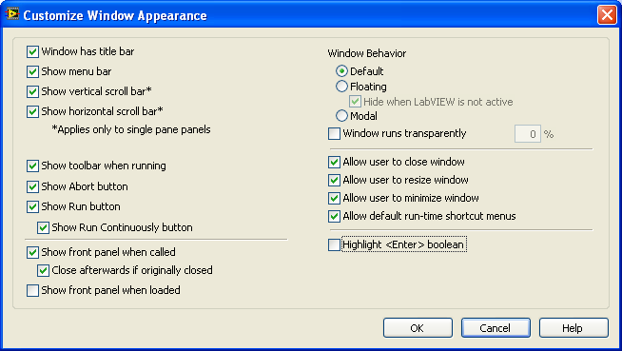

The VIs named Custom-SFPWhenCalledCloseAfter ModalWindow.vi and Custom-SFPWhenCalledCloseAfter ModalWindow-Modal Using TS Start Modal Dialog.vi have the settings below. They test the “Show front panel when called” and “Close afterwards if originally closed” settings using the Modal Window Behavior.

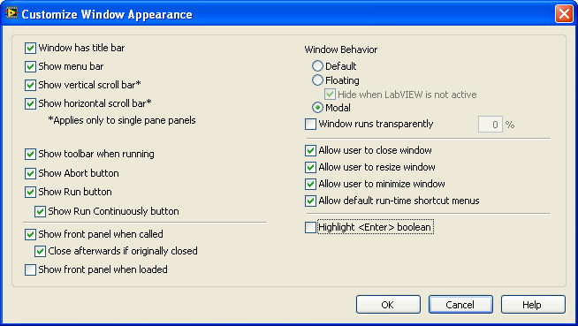

The VIs named Custom-Floating.vi and Custom-Floating-Modal Using TS Start Modal Dialog.vi have the settings below. They test the Floating Window Behavior.

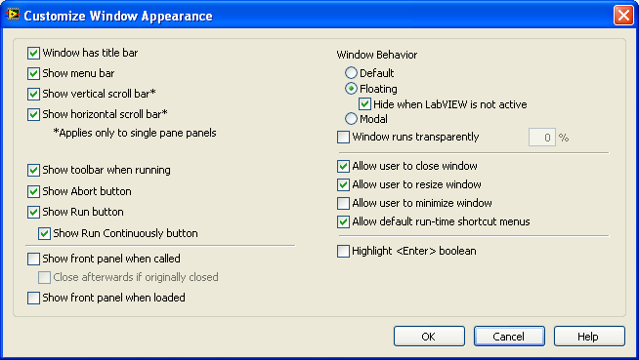

The VIs named Custom-Modal.vi and Custom-Modal-Modal Using TS Start Modal Dialog.vi have the settings below. They test the Modal Window Behavior.

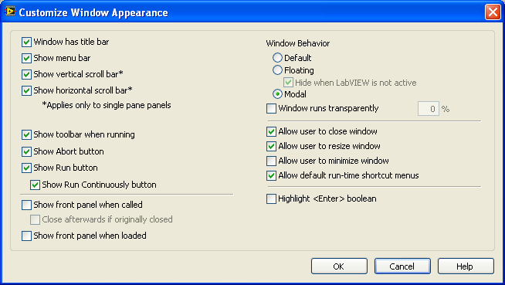

- Open “Blank VI.vi” in LabVIEW so you can check when a VI is modal to LabVIEW.
- Open sequence file TestCases\Adapters\LabVIEW\Media\ShowVIFrontPanel.seq.
- The sequence has a load callback so it will call some VIs.
- Verify that the behavior of the VI is as described in its front panel
- Verify that all front panels are closed.

- Set the option Execute->Break on First Step.
- Run MainSequence and single step through each step in the sequence so you can see the behavior of each VI call.
- It first calls the sequence ShowFrontPanelStepSettingSet. All the LV steps have the setting “Show Front Panel When Called “ set.
- Verify that the behavior of the VI is as described in its front panel
- Verify that all front panels are closed.

- It then calls ShowFrontPanelStepSettingNotSet. All the LV steps have the setting setting “Show Front Panel When Called “ not set.
- Verify that the behavior of the VI is as described in its front panel. Some of the front panels will not close after they are executed.

- The third sequence SetShowFrontPanelPropertyOnVI called should show the front panel of a VI by setting its property Front Panel Window.Open to true.

- The fourth sequence Centered called should show the front panel centered to the computer screen.

- The fifth sequence “Run Edit Substeps” should run some VIs as Edit Substeps.

After the sequence finishes running, go to the sequence HasStepWithEditSubsteps and select the step named “Has LabVIEW Substeps”. Click on each edit substep button and verify that the behavior of each VI is as described in the VI’s front panel. In a UI, select the Edit Substep from the step context menu.

Rerun the sequence in the LV User Interface when running in LV and as an executable.

Test for CAR #284748. VI exists when done running, when opened through TestStand and “Show VI Front Panel When Called” is checked.
- Launch the version of LabVIEW you’re testing and create a VI with a two second wait. Save it as wait.vi.
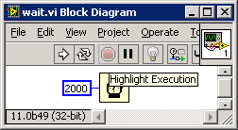
- Close LabVIEW.
- Open TestStand and create a new sequence. Add a LabVIEW action step and configure it to call the wait.vi. Check the “Show VI Front Panel When Called check box. Save the sequence as wait.seq
- Configure the LabVIEW adapter to use LabVIEW development environment and execute the sequence using Single Pass.
- The front panel of the VI should appear for two seconds and then disappear.
- Click on the Edit VI button. The VI should open in LabVIEW.
- Now run the VI in LabVIEW. The VI should run and the VI window should remain open.
  - With LV 2010 SP1. The VI closes.

National Instruments Confidential
Copyright © 2005 National Instruments Corporation

