LabVIEW Adapter: Partial Clusters And Arrays
TestStand Version: 3.5

Author: Jose A. Hernandez
Feature Spec: Specifying Partial LabVIEW Clusters (Link To Proposal)
Dependencies: LabVIEW versions 7.0 and later. There is a section that requires LV 2012 or later.

Test Category: [Functional]

Description
Test specifying some arguments for some elements of a cluster and an array while passing the default value for the rest.

Preparation
- This test assumes familiarity with the LV adapter. If you are not familiar with the LV adapter, I recommend reading the bookshelf document titled “Using LabVIEW with TestStand”.
- I strongly recommend reading the proposal for this feature.
- The LabVIEW installers can be found at \\nirvana\NISoftwareReleased. If testing a pre-release version of LV, you can find it at \\nirvana\NISoftwarePrerelease\LabVIEW.
- Force sync all the files from //TestStand/WebPages/TestCases/Adapters/LabVIEW/Media/ because you are going to need some of them

Validation
For this test, you can use any LabVIEW version including any version of the LabVIEW Run-Time Engine. The behavior should be the same in all versions. Verify this is the case as you work through the test plan.
Independent section
Duration: 1 min
Conversion
In TestStand 3.0 and 3.1, you can only specify to use the default value for the whole cluster or array parameter. You could not specify default values for their elements. So, you will only get a single checkbox for each parameter. In 3.5 and later, the checkbox is propagated to the sub-elements of a cluster and an array.
- Make sure that opening old Sequence file versions (3.0 and 3.1) get converted properly. You should not get a type conflict dialog. The Sequence files should be marked as modified due to type conversion.
- For arrays and clusters using default values, the "use default value" value should be propagated to their elements. If you open the Specify Module dialog, all the parameters using a default value should have its checkbox still check along with all its sub elements.
Independent section
Duration: 3 min
Specify Module Dialog and LabVIEW Module Panel
Create a VI with a simple cluster (cluster with a string and number for example) and with a numeric array with 2 default values. Wire them to the connector pane. The VI will be used to the test the state of the checkboxes.
- Create a sequence and insert a LabVIEW action step.
- In Specify Module Tab brows for //TestStand/WebPages/TestCases/Adapters/LabVIEW/Media/Controls With Default Values/<lv version>/Cluster And Array Of Numbers.vi
- By default when you select a VI, all the checkboxes of input parameters will be checked.
- Verify if you uncheck the checkbox of one of the cluster elements, the parent checkbox should be in the state (This state tells you that some of the elements of this cluster are using default values and some are not).
- Go to the deepest cluster and partially specify it. The state should propagate all the way up to the top most cluster.
- Checking a checkbox in the state should change to uncheck. See proposal for the states of the checkboxes.
- For array parameters, see section " Specifying Partial Arrays".
- As mentioned before, by default, all the input parameters would be checked. If you unchecked the checkbox, notice that the default value now becomes the default argument of the parameter. For example, if you have a numeric control with the default value of 5, the argument to the numeric control will still be 5 if you uncheck the use default checkbox. By default, all the parameters will have as their default argument the default value of the control.
Independent section
Duration: 30 min
Specifying Partial Clusters
- Create VIs that contain clusters(you can use files under //TestStand/WebPages/TestCases/Adapters/LabVIEW/Media/Clusters and Arrays/). You can make them as complicated as you want. Make sure some of the clusters elements are specified as
  - binary strings and array of binary strings.
  - waveform data types (Analog, Digital, and Dynamic Data).
  - waveforms which are partially specified .
  - partially specify clusters of timestamps, paths, ASCII, and binary strings.
  - complex number in one of the clusters
Note: We have discovered several problems in the past with waveforms so make sure you test them before passing this test.
- Create a cluster several levels deep and partially specify it.
- Create a sequence that calls these VIs through action step(make sure you show the front panel of the VI and have a stop button so you can see the front panel)
- Run the sequence and check that all the elements using default values actually have the default values in the VI when called and the other elements should have the values you specify to pass.
- Make sure the checkboxes show the correct state (partially specified , use default value , don't use default value ).
- Make sure the state of the checkbox gets propagated to the parent. For example, if you uncheck all the checkboxes of the cluster elements, then all the checkboxes should be unchecked. Checking all the checkboxes of all the elements should behave the same way.
- For some of the elements, don't use the default value and don't specify an argument.
- On the LV module panel, you should see an error message on the element saying that the value cannot be empty.
- On the specify module dialog, you should get an error when clicking the OK button.
- Make sure errors on unspecified arguments still get reported correctly. You might even ignore the error and try to run to make sure you get a run-time error because there are missing arguments.
- Create a custom data type that has the same structure as the LV cluster: You can click on the button found in the type column (see below). Specify an instance of the custom data type as the argument of the cluster. Partially specified some of the elements.

- 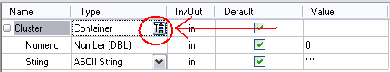

- Make some of the VI inputs required. You should not be able to pass a default value for required parameters.
- Try to partially specify a complex number. You should not be able to. The same goes for LabVIEW IO controls such as IVI and VISA.
- Close and open the Sequence files that have steps with partially specify clusters and, without opening their Specify Module dialog, run them. This is to make sure nothing is cached in TestStand. You might even want to close LabVIEW before running.
- Try to partially specify cluster with strings and array of strings set to be passed as binary strings. Make sure some of the strings and arrays are set to use their default value. Verify that the default values for the elements set to use their default value are actually passed to the VI.

Independent section
Duration: 45 min
Specifying Partial Arrays
Create VI that has array controls and a cluster with several elements including arrays(as deep and complex as you want. The more complex the better chances you have to find a problem so go wild, You can use files under //TestStand/WebPages/TestCases/Adapters/LabVIEW/Media/Clusters and Arrays/). Some of these array elements could be
- array of clusters and these cluster array elements could even have more array elements in them.
- (some of the arrays) multi-dimensional arrays.
- complex numbers and array of strings.
- (some of the arrays) array of strings and the strings are set to be passed as binary strings.
- partially specified arrays of timestamps, paths, ASCII, and binary strings.
- Verify that only the array elements that have default values will have a checkbox. For example, if you have an array with two default values, when you expand the array, you should see by default two array elements and they should have a checkbox.
- Insert a third element (by clicking the '+' button) at the bottom, this third element should not have a checkbox since it has no default value.
- This third element should be pre-filled with some default value.
- This default value is the default value that you will get when you insert a new array element in LabVIEW. For example, if you already have two default values in the array and you go to the 5th element and modify it, the 3rd and 4th array elements will be filled with some default value. This default value is the one we use in TestStand when you insert a new array element.
- Insert a new element at index 0 and verify the array has default values, then the new inserted element will have the same default value as the first element in the array in the VI's front panel. All the other array elements using a default value will be updated.
  - Try inserting array elements at the beginning, middle, and end. Have some element use default values and some not. Make sure everything is updated correctly.
  - Also, test the same array behavior when the array is part of a cluster. It should behave the same way. Try an array within an array of clusters. The arrays could be very deep, but they still should behave like top most arrays. Try it.
- Choose the default value for the entire array
- Verify all the array elements are deleted when you click OK on the dialog since these array elements will never be used at run-time. For example, if you have an array that has two default array elements, you can add two additional elements in the dialog and specify some arguments for them. So, you will have 4 array elements and the first two are using default values and the last two have argument specified. If you select to use the default value for the entire array, clicking OK on the dialog will delete these 4 array element. The next time you open the dialog and expand the array it will only show the 2 default array elements. Keeping any extra elements will just use extra space since they will never be used.
- Verify this feature with arrays inside clusters.
- If the number of default value array elements changed since the last time the prototype of the VI was read (the VI changed and you have not opened the Specify Module dialog) and the array is using the default value for some but not all elements, the next time the VI is loaded for execution a message will appear telling you that the default value changed and it asks you to open the Specify Module dialog. If the number of default values changed, we don't know if we should use these new default values.
- If the number of default array elements decreased from 2 to 0 for example, then we don't know what values to pass for the first two array elements if this array has been partially specified. For now, I just check if the number of default array elements changed without checking if the number increased or decrease. I only do this check if the array has been partially specified.
- Pass the default value for a multi-dimensional array that is an element of a cluster. Do you get any errors?
- Make some of the VI inputs required. You should not be able to pass a default value for required parameters.
- Close and open the Sequence files that have steps with partially specify clusters and, without opening their Specify Module dialog, run them. This is to make sure nothing is cached in TestStand. You might even want to close LabVIEW before running.

Independent Section
Duration: 5 min
Test for invalid time stamps values on waveforms (See CAR #292116) For TestStand 2010 SP1 and later
  - Create a VI that has a LabVIEW waveform as an input (You can use files under //TestStand/WebPages/TestCases/Adapters/LabVIEW/Media/Clusters and Arrays/).
  - Call the VI from TestStand and configure the VI waveform t0 value with an invalid date as follows:
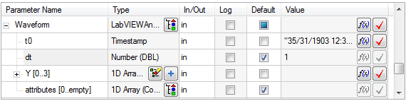
  - Execute the VI and you should see an Run-Time Error dialog with the following information:
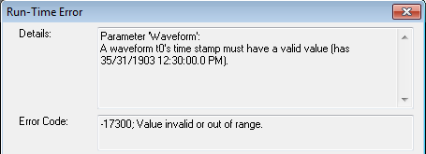

Independent Section
Duration: 5 min
Test impact for CAR 366452 (TestStand 2010 SP1 or later)
If you’re not testing with TestStand 20210 SP1 or later skip this section

- Make sure LabVIEW 2012 is the active LabVIEW version
- On a new sequence file, insert a LV action step
- Specify the VI Media\Controls With Default Values\12.0\Cluster And Array Of Numbers.vi as the module for the LV step
- Check the checkbox under the Log column for both parameters
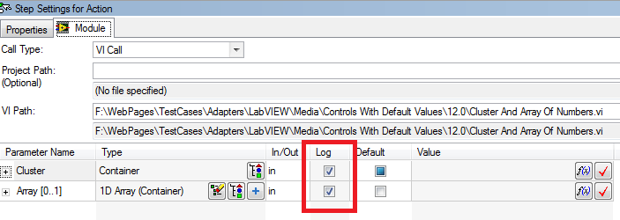
- Expand Cluster and then the Array Element. It should look the screenshot below.
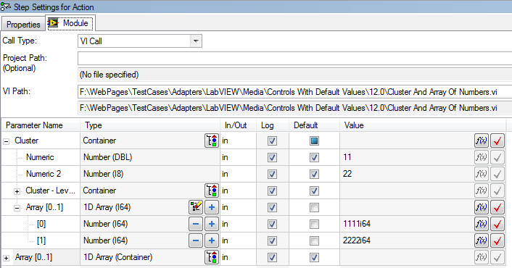
- Verify that you don’t get any errors when you expand Cluster.Array.
- Now, expand the second parameter Array and verify that it expands successfully.

Independent Section
Duration: 5 min
Test impact for CAR 51578 (Create Custom Data Type dialog appears multiple times when there are multiple steps selected) For TestStand 2013 or later
If you’re not testing with TestStand 2013 or later skip this section

- Create a new sequence and add one LabVIEW action step. Configure the step using one of the VIs you already worked with that use clusters or just create a new VI with a simple cluster.
- Copy the step more than two times and select all of them.
- Click on the “Create Custom Data Type …” button:
- Cancel the dialog that appears and validate that only one dialog appeared.

Independent Section
Duration: 45 min
Test impact for CAR 365626 (TestStand 2013 or later)

- Open the sequence file ClusterMapping.seq from the media folder
- Select the step Action1
- Verify that the argument Locals.ComplexCluster for parameter Cluster is not in red and no errors are shown when you hover the expression
- Select the step Action2
- Verify that the argument Locals.ComplexCluster for parameter Cluster is red and, when you hover over it, a tooltip is shown displaying the error with the cluster mapping.
- Verify that the cluster mapping is reported correctly by checking the type definition and the VI
- Verify steps Action3, Action 4, and Action 7 do not report any errors
- Verify steps Action 5 and Action 6 report an error and verify the error is correct
- Analyze the sequence file and verify the analyzer reports the same errors
- Run the sequence and verify that you get a run-time error for steps Action2, Action 5 and Action 6 (you will have to ignore the run-time errors to continue execution)
- Run the Update VI Calls tool and, using all the defaults in the dialog, click on the Update Calls button and verify that the log includes the cluster mapping errors.

[TS 2020 and later] Test the Arrays match LV Array Dimensions feature (CAR# 161523)

- Sync //TestStand/Tests/LV Automated Tests_New/TestVIs/CAR#161523
- Drop a LV step and select MultiDimArray.vi from the folder.
- Note the dimensions of the “Array” parameter in the input value. They should be [0..3][0..1] indicating that the default values are of 4 rows and 2 columns.
- In the Advanced settings dialog, enable the “Arrays match LV Array dimensions” checkbox and close the dialog.
- Verify that an error provider is shown and the error indicates that the value of the “Arrays match LV Array dimensions” setting might have changed.
- Click on the provider to reload the step.
- Verify that the dimensions of the “Array” parameter update to [0..1][0..3] which matches the actual dimensions of the array in LV.
- Execute the VI and verify there are no errors.
- Change the “Arrays match LV Array dimensions” setting to disabled again and verify that the error provider comes up.
- Verify that the step can not be executed in this state.

Unload default values
The following test verifies that the LV module is unloaded when setting a parameter to use its default value. If a parameter is modified to use a default value after the step has been run, the default value will not be loaded because default values are loaded when the step’s module is loaded.
- Open Sequence File //TestStand/WebPages/TestCases/LabVIEWModulePanel/Media/LVModulePanel.seq and run the step PartialCluster in MainSequence.
- Go back to the Sequence File and expand the parameter cluster of the PartialCluster step.
- Check the Default checkbox of the cluster element Waveform.
- Rerun the step.
- Verify that the step runs successfully.

Test Impact for CAR 497072 (TestStand 2014 SP1 and later)
- Launch the Sequence Editor and open the sequence file //TestStand/WebPages/TestCases/LabVIEWModulePanel/media/confirmNoDialog.seq
- Click the step “Contains cluster with empty label”
- Uncheck the “Default” checkbox for the VI’s container parameter (the parameter has no label)
- Expand the container parameter
- Uncheck the “Default” checkbox for the Array sub-element
- Verify that no dialog appears.
- Click the “Add Array Item” button for the array
- Verify that no dialog appears.
- Click on the step “Step passes to variant”
- Open the Module tab for the step settings if not already open
- Verify that no dialog appears.
- Uncheck the “Default” checkbox for the parameter “Variant without default”
- Verify that no dialog appears.

Free form
Update the cluster mapping and/or modify the cluster control in LabVIEW and verify that the LabVIEW module panel and the analyzer detect the errors. Also, verify that you don’t get any run-time errors when the mapping is reported to be correct.
Create your own clusters and your own type definitions and verify any problems with the cluster mapping is detected.
Do not forget to run the Update VI Calls tool against the sequence file and verify that the tool reports any cluster mapping errors.

National Instruments Confidential
Copyright © 2005 National Instruments Corporation

