PB Manager — Project Documentation
MB Groups
Table of Contents

PB Manager — Project Documentation
PB Manager (branded MB Groups) is an internal web application for running a grain/maize trading business. It tracks the full cycle of the business: buying grain from farmers, moving it via transport (bilty), selling it to buyer companies, generating bills and tax-style invoices, recording expenses, and managing gunny-bag (jute sack) purchases — all with payment tracking and Excel import/export.
This document is the single, complete reference for the project: what it does, how it's built, the data model, the main flows, and how to run and extend it. Every diagram is a rendered image so it displays in any viewer. A more focused architecture-only doc lives at ARCHITECTURE.md.

Table of contents
- What the system does
- Technology stack
- Module map
- Modules in detail
- System architecture
- Feature-slice layering
- Request lifecycle
- Authentication & authorization
- Route map
- Data model (ERD)
- Key domain flows
- Dashboard & financial-year logic
- Setup & running
- Testing & quality
- Known limitations / hardening backlog
- Glossary
- Regenerating the diagrams

1. What the system does
The business buys grain, transports it, and resells it. PB Manager digitizes that pipeline:
- Purchases — record grain bought from farmers/suppliers (weight, rate, deductions, payment).
- Bilty — record transport consignments (similar shape to purchases, tied to a transport party).
- Sales — record grain sold to buyer companies, with pending-amount tracking.
- Bills — generate a bill from a purchase or bilty (idempotent, one source → one bill).
- Sales invoices — generate numbered, company-branded invoices from one or more sales, with a frozen snapshot for stable printing.
- Companies — manage issuer (own) and buyer company profiles, including bank/GST details.
- Gunny bags — track jute-sack purchases from sellers and the payments against them.
- Expenses — record operating costs by category (salary, vehicle, hamali, other).
- Dashboard — KPIs and trends, scoped to the current Indian financial year.

2. Technology stack
Concern | Choice
Framework | Next.js 16 (App Router)
UI runtime | React 19
Language | TypeScript
Database | Supabase (Postgres) — accessed server-side with the service-role key
Validation | Zod (schemas are the source of truth for types)
Forms | React Hook Form + @hookform/resolvers
UI kit | shadcn-ui + Tailwind CSS v4, @tanstack/react-table
Auth | jose (JWT) + bcryptjs (password hashing)
Excel | xlsx (SheetJS) for import/export
Dates | date-fns
Tests | Vitest

3. Module map
How the business modules relate. Core data-entry modules feed billing/invoicing and the dashboard; auth guards everything; Excel seeds and reports on the data.
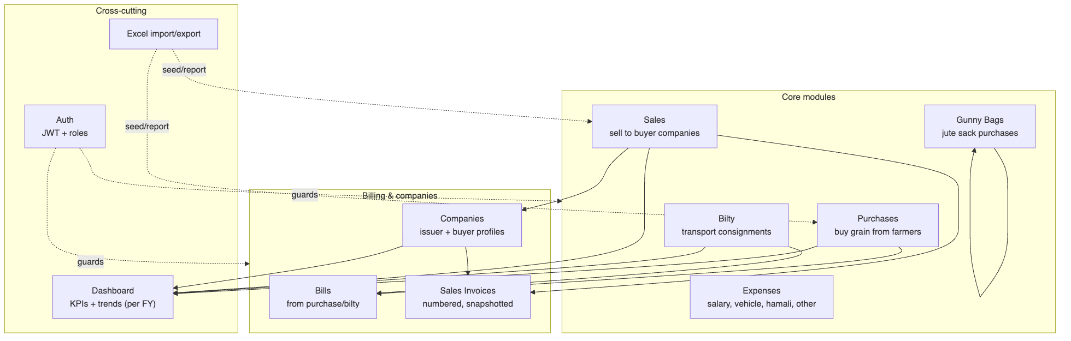

4. Modules in detail
Each module is a self-contained slice under src/features/<domain>/ with matching routes under src/app/<domain>/.

Purchases (features/purchases, app/purchases)
Buying grain. The form captures weight, less_percent, rate, plus deductions (bag_less, cash_paid, upi_paid) and additions (add_amount). Derived values (less_weight, net_weight, amount, final_total, bag_avg) are computed by a pure function and recomputed on every write. Rows imported from the legacy Excel are marked source = 'manual' and are protected from edit/delete. Bill numbers are sequenced per financial year.

Bilty (features/bilty, app/bilty)
Transport consignments. Same numeric shape as purchases, but tied to a party (transport agent), managed under /bilty/parties with their own party-level payment ledger (bilty_party_payments).

Sales (features/sales, app/sales)
Selling grain to buyer companies. Tracks bill_number (unique), dispatch details (truck/tractor, lorry number, destination), amounts, and pending_amount. Sales can be imported from an Excel BILL sheet (admin-only) and are the input to invoice generation.

Bills (features/bills, app/bills)
A bill is generated from a purchase or bilty with a deterministic id (PUR_BILL_<id>), making generation idempotent. Stores bill_date, net_weight, rate, freight, payment_term_days, and a computed due_date. Has a printable A4 layout.

Companies & Sales Invoices (features/companies, features/sales invoices)
Companies are either issuer (your own trading entities, with bank/GST/invoice_prefix) or buyer. Sales invoices bundle one or more sales into a numbered document (PREFIX-0001), using an atomic Postgres counter per issuer, and freeze a snapshot_json of all parties and line items so reprints never change. Company payments are recorded and allocated across sales (company_payment_allocations).

Gunny Bags (features/gunny, app/gunny)
Jute-sack purchases from sellers. Each gunny_bags row has bags/rate/amount and a paid_amount; seller-level payments (gunny_seller_payments) are allocated across multiple gunny records (gunny_payment_allocations) — the allocation pattern that mirrors company payments.

Expenses (features/expenses, app/expenses/[tab])
Operating costs in four categories — salary, vehicle, hamali, other — with an optional linked employee (expense_employees). Tabbed UI: overview, salary, vehicle, hamali, other.

Dashboard (features/dashboard, app/dashboard)
Aggregates purchases, bilty, sales, and buyer companies into KPIs and a purchase-trend chart, scoped to the current financial year (see §12).

Auth (features/auth)
Login/logout, JWT session, role guards. See §8.

5. System architecture
There is no separate backend service. Next.js is the backend. The browser never talks to Supabase directly — every read/write goes through the server (a Server Action or a Route Handler) using the service-role key, which never ships to the client bundle.
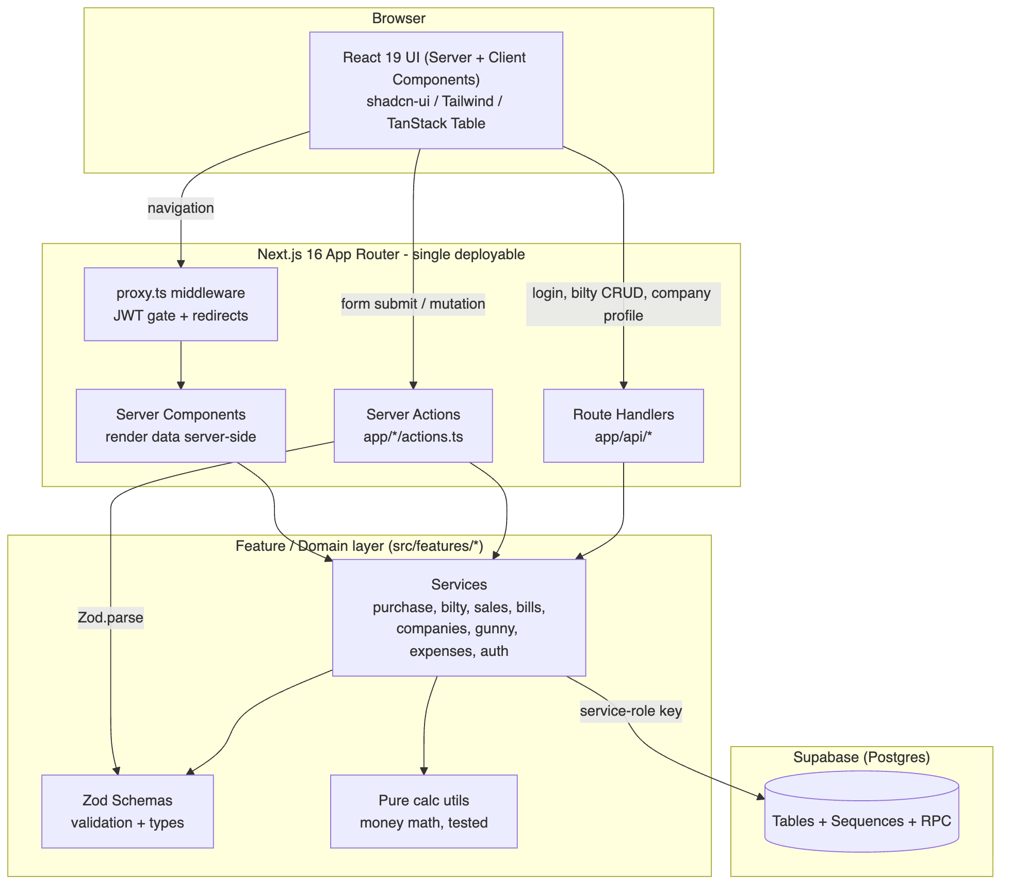

6. Feature-slice layering
Every domain follows the same four-part shape, which is the backbone of the codebase.
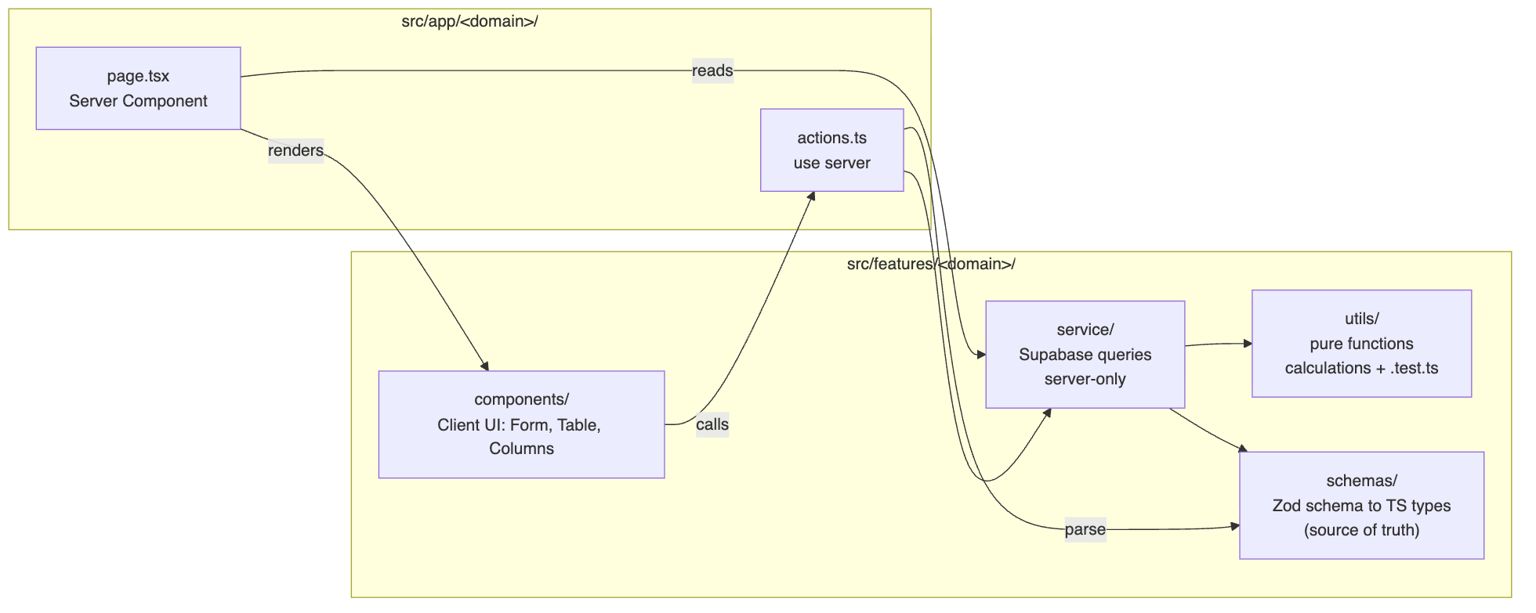
Layer | Responsibility | Rule
schemas/ | Zod validation + inferred types | Single source of truth for shape
utils/ | Pure derivations (net weight, totals) | No I/O, unit-tested
service/ | All Supabase reads/writes + auth guards | Server-only; recomputes derived fields
components/ | Forms & tables | Client; call Server Actions
app/.../actions.ts | Thin RPC boundary | parse() then delegate to the service

7. Request lifecycle
A write flows: UI → Server Action → Zod parse → service (auth + calc) → Postgres. Validation happens twice on the server (Zod, then DB constraints); auth is enforced inside the service for defense in depth.
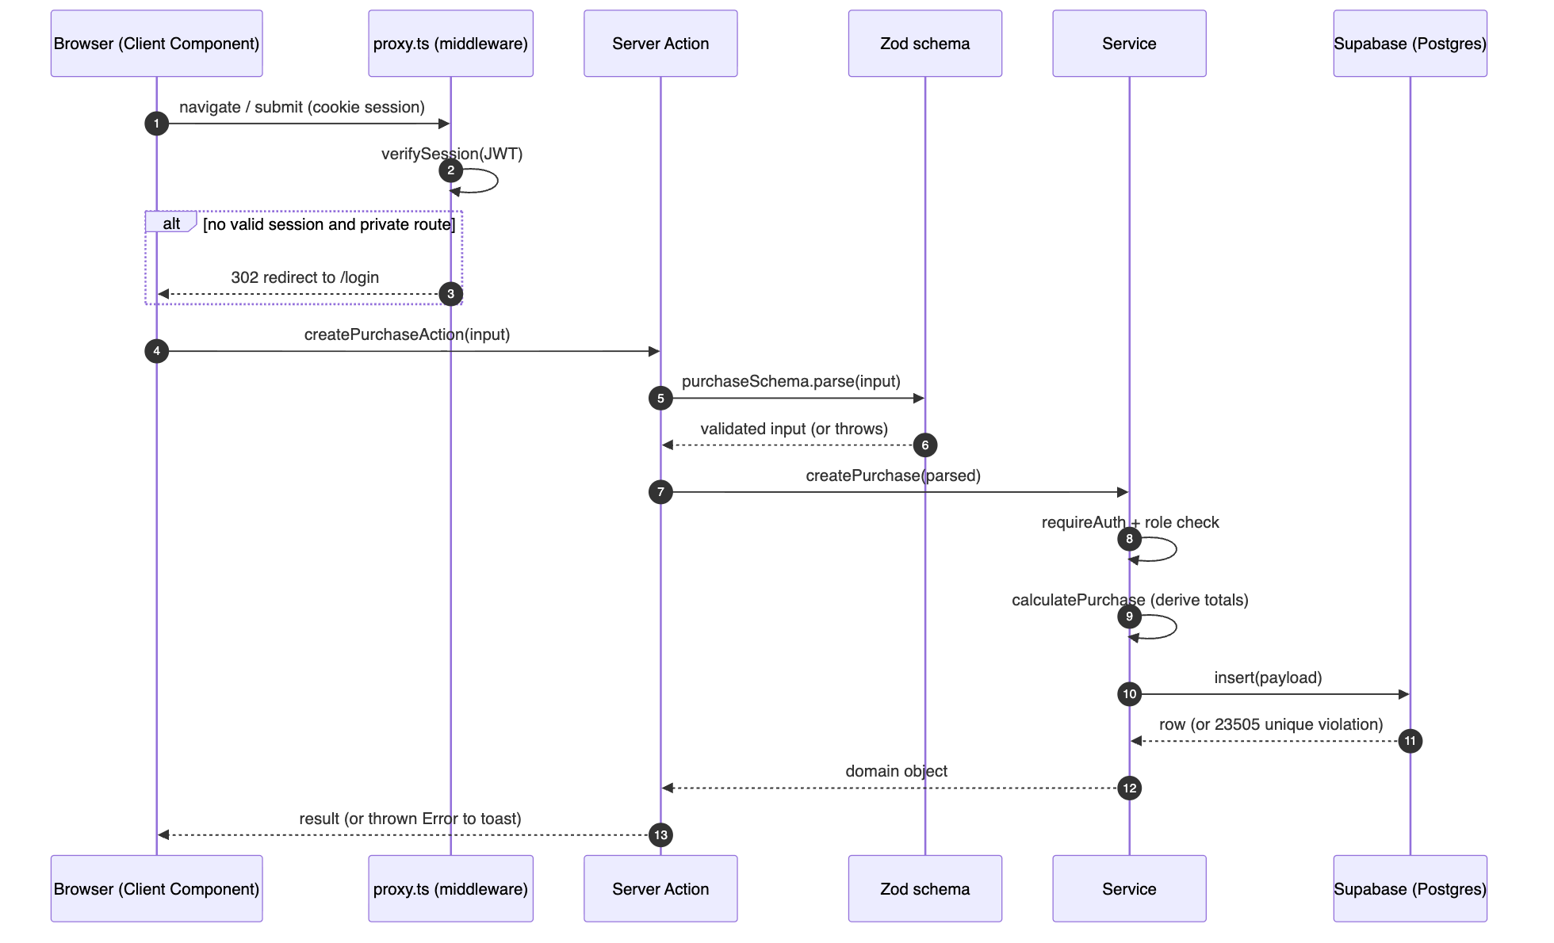

8. Authentication & authorization
- Sessions are stateless JWTs signed with SESSION_SECRET (HS256, 24h), stored in an httpOnly, sameSite=lax cookie. No server-side session store.
- Passwords are bcrypt hashes in the users table.
- proxy.ts middleware gates every route: unauthenticated users → /login, authenticated users on /login → /dashboard, / → dashboard-or-login.
- Roles are admin and operator; services call requireAuth() / requireRole([...]).
- Public routes: /login, /api/auth/login.
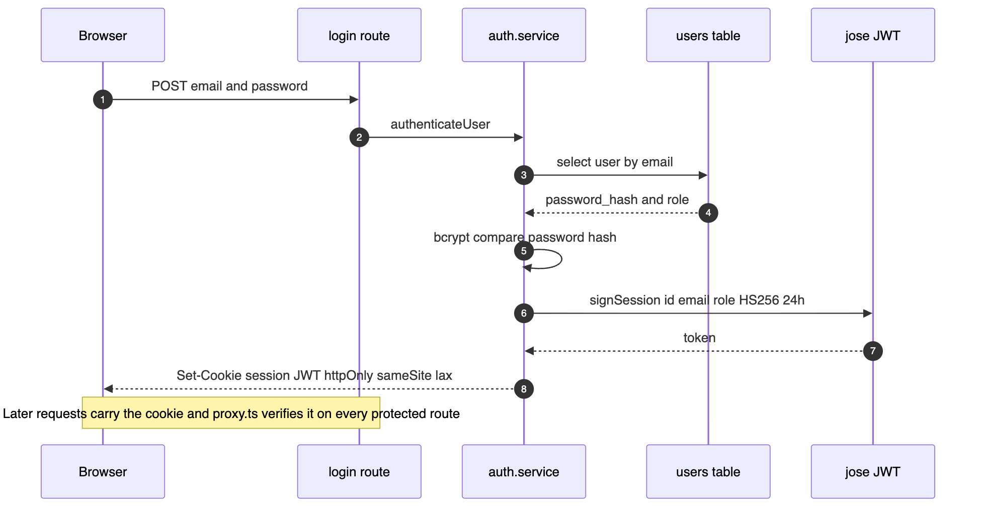

9. Route map
Navigation is defined in src/components/layout/Sidebar.tsx.
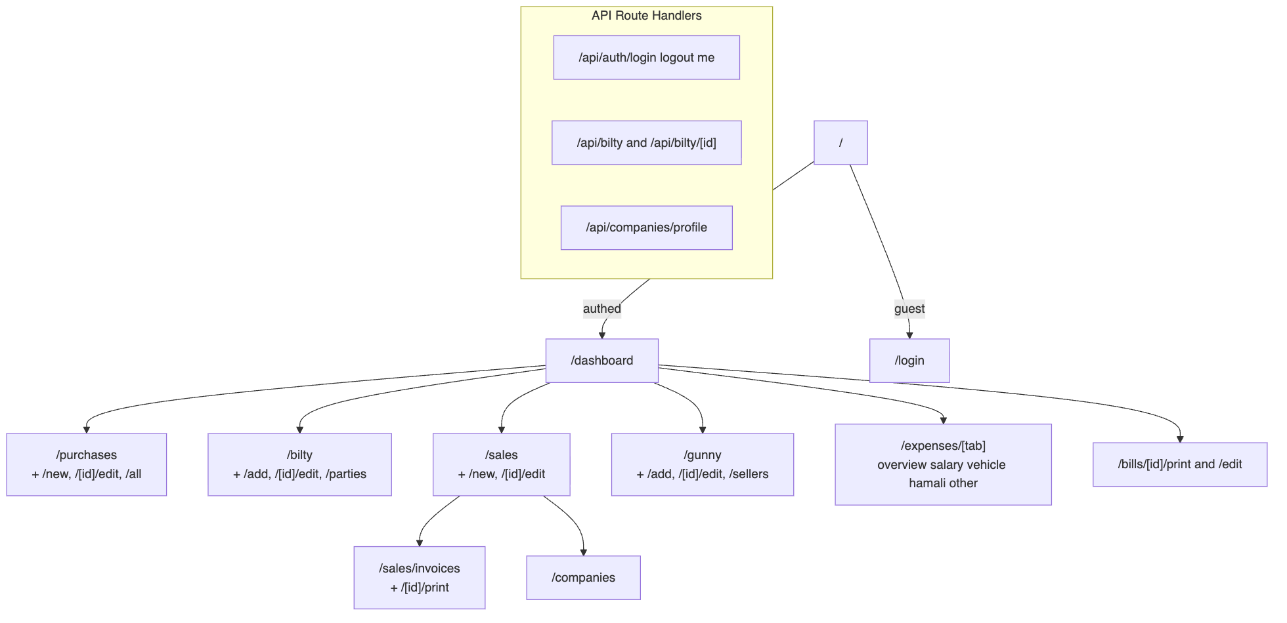

10. Data model (ERD)
18 tables (+ sequences and one RPC) defined in supabase/schema.sql.
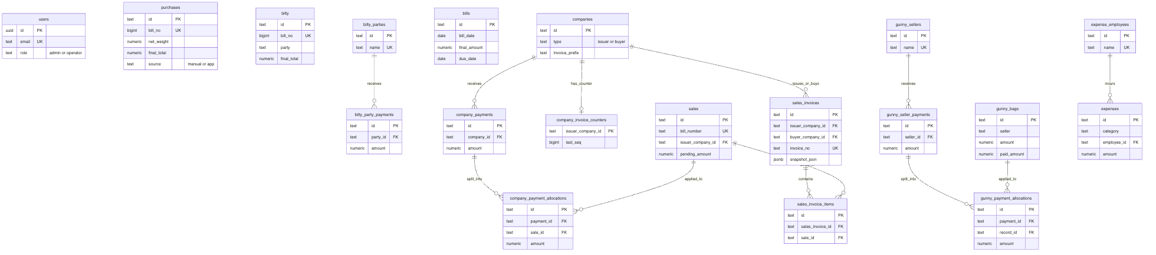
Modeling notes
- purchases / bilty carry denormalized name / place / mob rather than a hard FK to a party table.
- gunny_bags.seller is a free-text name (matched to gunny_sellers by name, not by FK).
- The three *_payment_allocations tables (company_, gunny_, plus the bilty_party_payments ledger) implement the "one payment, many records" split.
- Money columns are numeric; some are read back as strings and coerced server-side (n() helper).

11. Key domain flows

11.1 Bill generation (idempotent)
purchase → bill id = "PUR_BILL_<purchaseId>" → upsertBillById(...)
Because the id is derived from the source row, the upsert makes generation idempotent — one purchase always resolves to exactly one bill.

11.2 Sales invoice numbering (concurrency-safe)
Per-issuer invoice sequence uses an atomic Postgres RPC (next_company_invoice_seq) — an INSERT ... ON CONFLICT DO UPDATE ... RETURNING — so concurrent generation cannot collide. The invoice stores a snapshot_json of issuer/buyer/items so reprints stay stable.

11.3 Payment allocation (gunny & companies)
A single payment is recorded once and split across multiple records:
seller_payment (₹50,000)
├─ allocation → gunny_bags A : ₹30,000
└─ allocation → gunny_bags B : ₹20,000

12. Dashboard & financial-year logic
The Indian financial year runs April 1 → March 31. getFinancialYearBounds() (lib/financial-year.ts) computes the bounds for any date, and the dashboard evaluates "now" in IST before filtering. Bill numbering and dashboard stats are both FY-scoped, so counters reset each year.
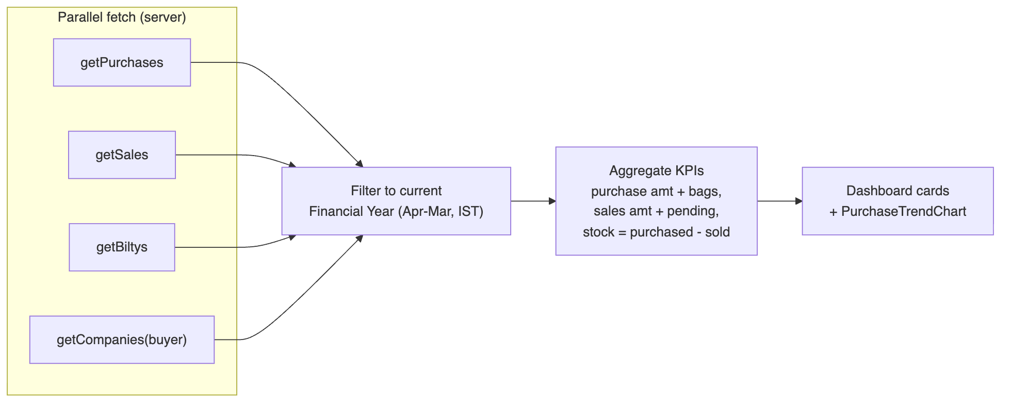
KPIs include total purchase amount (purchases + bilty), purchased bags, total sales amount and pending, and stock (purchased − sold), plus a purchase-trend chart.

13. Setup & running

Environment variables (.env / .env.local)
SESSION_SECRET=replace_with_at_least_32_chars
NEXT_PUBLIC_SUPABASE_URL=https://YOUR_PROJECT.supabase.co
SUPABASE_SERVICE_ROLE_KEY=YOUR_SERVICE_ROLE_KEY
lib/env.ts validates these at boot with Zod and throws if invalid.

Database
Run supabase/schema.sql in the Supabase SQL editor. It creates all tables, sequences, the invoice-counter RPC, and seeds admin@gmail.com / operator@gmail.com.

Install & run
npm install
npm run dev # http://localhost:3000
npm run build && npm run start # production

Scripts
Command | Purpose
npm run dev | Dev server
npm run build / start | Production build / serve
npm run lint | ESLint
npm run test | Vitest (run once)
npm run verify | lint + test + build

14. Testing & quality
- Unit tests (Vitest) cover the pure calculation utilities and number formatting: features/bilty/utils/calculations.test.ts, features/sales/utils/calculations.test.ts, lib/number-format.test.ts.
- Type safety: TypeScript throughout, with zero as any casts across the codebase.
- Validation: Zod at every Server Action boundary, plus DB constraints.
Gaps: services, Server Actions, and auth are not yet covered by tests (see §15).

15. Known limitations / hardening backlog
Documented so the trade-offs are explicit. None block a small, trusted-user deployment; they matter at scale.
- No Row-Level Security. All access uses the service-role key; protection is app-layer only. Add RLS + anon key for defense in depth.
- Read-modify-write bill numbers for purchases/bilty (race-prone; relies on a unique-constraint error). Move to atomic sequences like next_company_invoice_seq.
- No multi-table transactions. Invoice header+items uses a best-effort compensating delete; gunny payment+allocations can orphan a payment row on partial failure. Wrap in Postgres functions.
- No cache revalidation (revalidatePath/revalidateTag unused) — freshness relies on refetch.
- Thin tests — only pure calc functions are covered.
- Inconsistent error surfacing — most actions throw raw DB error strings to the client.
- SESSION_SECRET has a dev fallback default — must hard-fail in production.

16. Glossary
Term | Meaning
Bilty | A transport consignment / goods-receipt note for moving grain.
Gunny | Jute sacks used to hold grain; bought from sellers as a separate line of business.
Hamali | Manual loading/unloading labor charges (an expense category).
Bag avg | Net weight ÷ number of bags.
Less % | Percentage weight deduction applied before computing amount.
Issuer company | Your own trading entity that issues invoices.
Buyer company | A customer company that buys grain.
Allocation | Splitting one payment across multiple records (bills/sales/gunny rows).
Financial year | April 1 → March 31 (India); resets bill counters and dashboard scope.
Source = manual | A row imported from legacy Excel; protected from in-app edit/delete.

17. Regenerating the diagrams
Diagram sources are the .mmd files in diagrams/; the committed .svg files are rendered output (@mermaid-js/mermaid-cli is a devDependency).
for f in docs/diagrams/*.mmd; do
npx mmdc -i "$f" -o "${f%.mmd}.svg" \
-c docs/diagrams/mermaid-theme.json -b transparent
done
On macOS the renderer uses the system Chrome via a Puppeteer config (executablePath → /Applications/Google Chrome.app/...). Adjust for your OS if needed.

Diagram index
File | Shows
diagrams/01-high-level.svg | System architecture
diagrams/02-feature-slice.svg | Per-domain layering
diagrams/03-request-lifecycle.svg | Mutation end-to-end
diagrams/04-auth.svg | Login / session
diagrams/05-route-map.svg | All routes
diagrams/06-erd.svg | Data model
diagrams/07-invoice-flow.svg | Invoice generation
diagrams/08-module-map.svg | Business module relationships
diagrams/09-dashboard.svg | Dashboard aggregation

