|  |  |  |  |  |
| --- | --- | --- | --- | --- |
| Mr. C K Srinivas *Ballari Institute of Technology & Management srinivasck9@gmail.com* | D Priyanka *Ballari Institute of Technology & Management priyankachowdary20378@gmail.com* | Mundergi Sandeep *Ballari Institute of Technology & Management sandeepmundergi13@gmail.com* | Thimmalapuram Srujana *Ballari Institute of Technology & Management srujanadharanesh@gmail.com* | Tushar Santosh Telkar *Ballari Institute of Technology & Management ttushartelkar@gmail.com* |

A METHODOLOGY TO GENERATE A FUNSIZE URL USING DJANGO FRAME WORK

***Abstract—*** **A proposed system used for building a web-based system using Django framework that shortens the URL provided by the user. By using this system user can use the services by just visiting the shrinky.in website. There are two types of users Guest users and Authorised users. The Guest users can visit to the website any time and can short their required URLs and the shortened URLs are valid for 24Hrs. The Authenticated users can Register/Login to their account and can use some additional services such as Generating QR code for**

**the URLs, end-to-end access for the URLs, create custom URLs and a fully functioning Dashboard for the Users where the user can keep track the URLs.**

**The Dashboard contains a graph which tells the user the total number of URLs present in his/her account, total number of clicks and URLs actively used at that day.**

**Keywords: URLs, Short URL, Guest, Authenticated, User, Dashboard, Custom, Public,**

**Private, Account, Link, Long URL**

# INTRODUCTION

Shortening URLs is a widely used process nowadays. With the presence of social media channels where the text is needed to adapt to a restricted number of characters usually 140 characters as per the study, therefore shortening URLs became more crucial. So, to short the long URLs, a greater number of URL-shortening resources are being used [1]. When someone needs to shorten their unpleasantly long URL, they go to a URL shortening resource and submit the long URL meant to get shortened [2]. Short URLs are usually no longer than 10 to 15 characters. Instead of using long URLs, users can visit these shortened URLs. This resource handles the connection between the original, long link and the new shortened link, which gives the user a simple link of about 5 to 10 characters instead of the lengthy one. Further, URL shortening services also incorporate link tracking for analytic to track clicks and users. Docked links permits link masking. Link masking is the consequence of the URL shortening where the long URL changes into a short bone. Masked links are better to track where links appear. This operation can be further enforced to check whether the diverted URL website is secure or not.

There are three sections in this URL shortening service public, private and custom. First section is public section where the link can be shorted and no security is provided as private section, this is created when user don’t want to restrict the link to specific persons. The link can be used by everyone and the detailed report of which can be seen in the dashboard. Second section is private section, the user can enter the desired link that needs to be shorted and then set a unique password to that link. After doing this, whenever someone wants to use that link, they must enter a valid password that was created during link creation, this private section is provided to the user to give additional security so that one cannot access the link without entering a valid password. This is helpful for the user who wish to share the link to specific person who wants to use the link and if any other person gets the link, he/she should not be able to access it. The third section is custom section where the user can create his own link, as in the public or private section the link is randomly shorted by the system by a default character limit of 5, but in custom section the user is given full access to customize the link. In this section the user can create his desired link which is easily remembered by the user rather than the system generated link.

1. LITERATURE SURVEY

In article [1], the author offered a URL shortening resource that will take a long URL/Web address and create a shorter one. The Short URL that won’t break when we share it across different platforms and make them more manageable using flask framework base62 algorithm.

In article [2], the author is discussing the advantages of QR codes over conventional barcodes. QR codes can store information both horizontally and vertically, allowing them to store a much greater amount of information than traditional bar-codes. The information encoded in a QR code can be text, a URL, or other data and can be read by mobile device cameras. The popularity of smartphones has expanded the applications of QR codes, which are now used in various industries such as commercial tracking, entertainment and transport ticketing, product marketing, and in-store product labelling.

In article [3], the author offered a composite and vigorous nature of information flow is based on computer server technologies and makes the Web hard to conserve. With this reference this application checks the status code of the website to confirm it is valid or not. There are many status codes available, but status code 404 is the one which will give the information that the site cannot be reached.

In article [4], the author has discussed the fact that link shortening services save space and make manual URL entry cheaper. Although, they create output which is poorly look right on to entry on mobile devices. We identified the issue with the output of a link-shortening service, bit.ly, and presume that longer links that are shortened for input on mobile keyboards would enhance link entry speeds. We conducted a human performance study that confirmed this thesis and applied our method to a selection of different non-word mobile data-entry tasks. This work demonstrates the need for resource design which is suitable for the limitations of the devices public use to consume resources.

In article [5], the author has analysed the habit of using shortened URLs from creating them to sharing, by using a large-scale dataset of 4.2 B require for 80M URLs created past by Bit.ly. It finds the content URLs that are unknown, making them tough to comprehend. One of the best ways to produce and share online content is using a URL shortening resource, this provides a shortened URL that is redirected to an original URL of content, this application comprehensively analysis the habit of using shortened URLs from their creations to publishing to sharing.

In article [6], the author introduces a steganographic system that uses fast response (QR) code as a holder to the opponent while transferring its usual message and payload. The QR code which is generated is a normal QR code, making it less open to a holder’s attack. The proposed system is space-saving, has a bearable level of noise release, and is subjected to cryptographic attacks. The QR code, which is generated for the link, by scanning it will redirect to the original link.

In article [7], the author has discussed the importance of URL previewing to ensure user confidence when using shortened URLs. It then presents Bit.ly as a freeware and sophisticated URL shortcut resource that not only shorts URLs and provides real-time follow-up, but also offers variety of features, such as a history of shorter URLs, a bookmarklet, a Firefox plugin for previewing, a spreadsheet template, a Gmail gadget, and an API for different applications.

In article [8], the author has discussed the use of short URL services to convey information easily when a long URL with special characters is difficult to share. However, attackers can abuse short URLs to distribute malicious code and launch phishing attacks. The proposed method suggests writing destination information when generating short URLs to permit users to inspect if it is a web document or file. URL shortening resource providers keep track of the risk of target URLs and decide to provide service or not. They assess the risk of web pages and may block short URLs to prevent attacks like” drive-by download.”

In article [9], the author has discussed the Status codes are three-digit numerical codes returned by web servers to web browsers to indicate the status of an HTTP transaction. They are categorized into five groups based on the first digit of the code, with the second and third digits providing more specific information. Some status codes include 200 OK, 301 Permanent Redirect and 404 Not Found. These codes are crucial for troubleshooting and debugging web applications, providing information on errors and diagnosing problems with a website’s performance. Developers can optimize their websites and enhance user experiences by understanding the different types of status codes.

In article [10], the author has discussed that a URL redirector service is a web-based tool that takes a long URL and converts it into a shorter, more manageable link. When a user clicks the shortcut URL, they automatically move to the original long URL. The process of using a URL-redirector service is straight forward. First, the user enters the long URL they want to shorten into the service’s interface. The redirector service then assigns a unique identifier to the URL and stores it in its database. The service then returns the shortened URL to the user, which they can share or post online. The redirector resource uses the unique identifier assigned to the shortened URL to locate the corresponding lengthy URL in its database and then forwards the user to that URL.URL-redirector services are commonly used to create shorter, more manageable links that are easier to share on social media and in other online contexts. Additionally, they allow users to track clicks and other metrics associated with the URLs they have shortened. This information can be used to measure the effectiveness of marketing campaigns, among other things.

1. PROPOSED METHODOLOGY

The proposed methodology for shortening the URL is carried out in the steps shown below.

**Step 1: User (Register/Login)**

In this the user is allowed to register to create a new account or login to an

existing account. After login the user is allowed to input the long URL that need to

short.

**Step 2: Check Status Code**

In this step the long URL is sent to server which then checks the status code of the long URL. Here a python library urllib takes the URL and checks the status code of that link and gives the output. If the status code of Long URL is 404 then the Server does not convert the long URL into shorter one, it just gives the output as Error:404 page not found for the provided Input URL. If the status code of Long URL is other than 404 then the server converts the long URL into shorter one and stores the original and shorted URL in the database. It also checks for Secure socket layer (SSL) certificate if the URL is SSL certified then only it will short the URL. While checking for status code if the provided URL takes much time to fetch the website, then it will return as Failed page even if it is reachable. Output the Short URL to the user. The outputted short URL is ready to use.

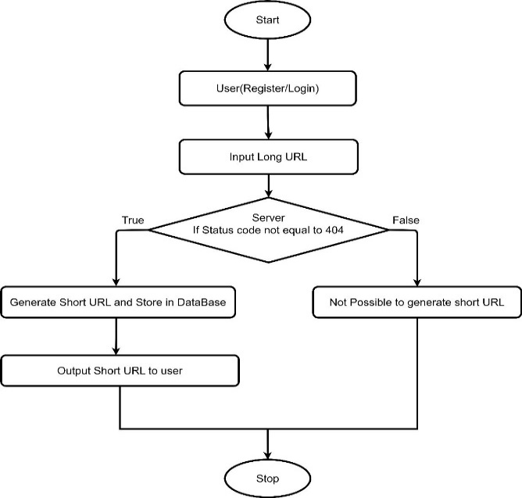

*Figure 3.1 Process workflow of URL shortening service.*

1. CASE STUDY

Following the necessary requirement gathering, the proposed system is demonstrated by considering two users like the guest user and authenticated user. The execution is based on those who want to use only the most basic features and those who want more information about the link’s functionality.

**1. Guest Users:**

The Fig:4.1 depicts the visibility for guest user, the user can short the URL by pasting the link in the specified field and should click on the generate button, if the link is valid then the short link is generated in the field, user can copy the link by clicking on copy URL button, the link will be copied to the clipboard. This link is now ready to use and is valid for 24hrs.

*****Figure 4.1 Home page for guest user*

**2. Authenticated Users:**

**Register page:**

The Fig:4.2 shows the visibility for authenticated user, the authenticated users can Register to create an account by filling up the below form.

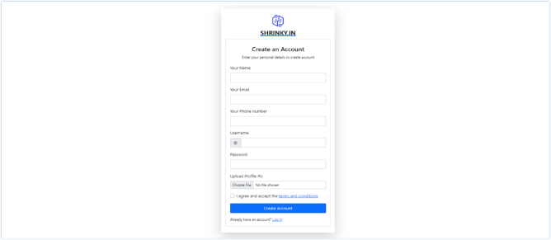

*Figure 4.2 Register page for authenticated user*

**Login page:**

The Fig:4.3 shows the visibility for authenticated user, the authenticated users can login by providing the credentials in the login form.

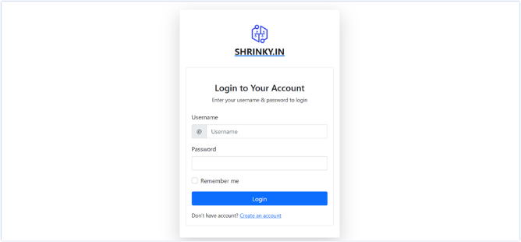

*Figure 4.3 Login page for authenticated user*

**Dashboard:**

The Fig:4.4 shows the visibility for authenticated user. this is the window where the user can start working with the features of the application.

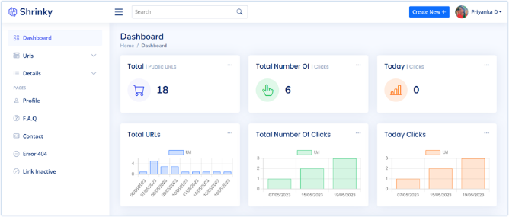

*Figure 4.4 Dashboard for authenticated user*

**Public Section:**

The Fig:4.5 shows the visibility for authenticated user, in this section, the link can be shortened, and no security is provided for the link.

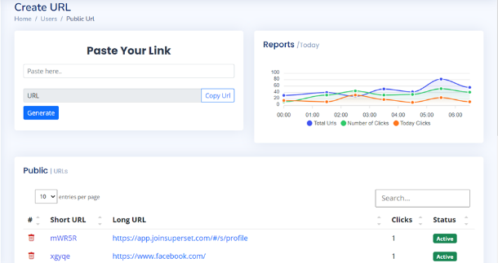

*Figure 4.5 public section for authenticated user*

**Private Section:**

The Fig:4.6 shows the visibility for authenticated user, in this section, the user can enter the desired link that needs to be shorted and then set a unique password to that link.

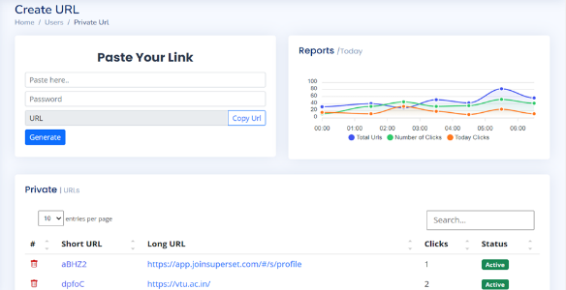

*Figure 4.6 Private section for authenticated user*

**Custom Section:**

The Fig:4.7 shows the visibility for authenticated user, in this section, the user can customize his own link, which is easily remembered by the user rather than the system generated link.

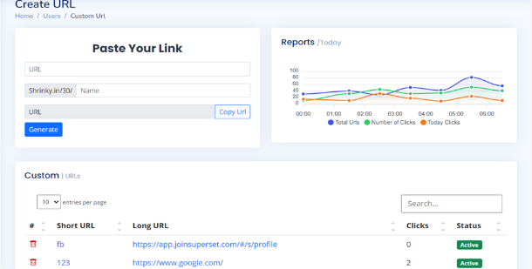

*Figure 4.7 Custom section for authenticated user*

**QR Code:**

The Fig:4.8 shows the visibility for authenticated user, in this module the user can generate a QR code for the shortened URL which when scanned, redirects to the original URL.

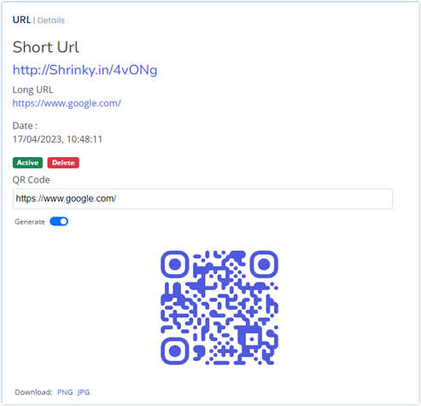

*Figure 4.8 QR Code for authenticated user*

**Graph:**

The Fig:4.9 shows the visibility for authenticated user, in this module the user can view the total number of URL’s generated till date, total number of clicks on those URLs till date and total number of URL’s used on that day.

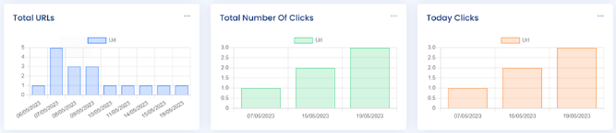

*Figure 4.9 Graph for authenticated user*

CONCLUSION

It is concluded that the service provided works well and satisfy the end users. This web application is user friendly so that everyone can use easily. Creating a short URL for an existing long URL can be a useful tool for making links easy to manage and easier to share. With a shorter URL, it becomes easier to share. Links on social media platforms, messaging apps, and other online channels with character limits. Shortened URLs can also help to track the number of clicks and analyse user behaviour. However, it is essential to use a trustworthy URL shortening service to avoid potential security risks like phishing scams or malware attacks associated with shortened links. Overall, creating a short URL for an existing long URL can be a quick and effective way to simplify links, making them more accessible and user-friendly. Further changes can be made to the existing application to make it more attractive and give some more advanced features than the present one.

1. REFERENCES
2. Rohit Sankhala, Manan Kharbanda, Ankit Yadav, Pardeep Suthar, Parampreet Kaur, A URL Shortening Service Project in 2022.
3. Coleman, J. and. (2013), "Putting QR codes to the test", New Library World, Vol. 114 No. 11/12, pp. 459-477. <https://doi.org/10.1108/NLW-05-2013-0044>
4. Michael A. Veronin,‘URL 404 File Not Found’ in 2009.
5. Sandy J.J. Gould a,n , Anna L. Cox a , Duncan P. Brumby a , Sarah Wiseman, A systematic exploration of design trade-offs in link shortening services in 2016.
6. Daejin Choia,1 , Jinyoung Hanb, Selin Chuna, Efstratios Rapposc , Stephan Roberts , Ted Taekyoung Kwona, Bit.ly:Uncovering content publishing and sharing through URL shortening services in 2018.
7. M. Alajmi, I. Elashry, H. S. El-Sayed and O. S. Farag Allah, "Steganography of Encrypted Messages Inside Valid QR Codes," in IEEE Access, vol. 8, pp. 27861-27873, 2020, doi: 10.1109/ACCESS.2020.2971984.
8. Gibbs, M. (2009). URL shortening: * A list of URL shorteners worth checking out. Network World (Online), Retrieved from <https://www.proquest.com/trade-journals/url-shortening/docview/223738160/se-2>
9. Hyung-Jin, M., & Li, Y. (2017). Secure short URL generation method that recognizes risk of target URL. Wireless Personal Communications, 93(1), 269-283. doi: <https://doi.org/10.1007/s11277-016-3866-8>
10. Server status codes. (1998). Active Server Developer's Journal, 2(10), 15. Retrieved from <https://www.proquest.com/trade-journals/server-status-codes/docview/206872841/se-2>
11. Munro, J. (2004, Dec 28). Cut URLs down to size; long URLs can be unwieldy. here's how to make them easy to use.: The independent guide to IBM personal computers. PC Magazine, 23, 84. Retrieved fromhttps://www.proquest.com/magazines/cut-urls-down-size-long-can-be-unwieldy-heres-how/docview/203815144/se-2
12. Nikiforakis, N., Maggi, F., Stringhini, G., Rafique, M.Z., Joosen, W., Kruegel, C., Piessens, F., Vigna, G., Zanero, S., 2014. Stranger danger: exploring the ecosystem of ad-based URL shortening services. In: Proceedings of the 23rd International Conference on World Wide Web Conference (WWW 2014).
13. Gupta, N., Aggarwal, A., Kumaraguru, P., 2014. bit.ly/malicious: Deep dive into short URL based e-crime detection. CoRR abs/1406.3687.
14. Newman, A., 2014. Bitly helps the red cross get to hope.ly – 2014
15. Alexander Neumann, Johannes Barnickel, Ulrike Meyer, Security and Privacy Implications of URL Shortening Services in 2011.
16. Chhabra, S., Aggarwal, A., Benevenuto, F., Kumaraguru, P., 2011. Phi.sh/social: The phishing landscape through short URLs. In: Proceedings of the 8th Annual Collaboration, Electronic Messaging, Anti-Abuse and Spam Conference.
17. Choi, D., Han, J., Chung, T., Ahn, Y.Y., Chun, B.G., Kwon, T.T., 2015. Characterizing conversation patterns in reddit: From the perspectives of content properties and user participation behaviours. In: Proceedings of the 2015 ACM on Conference on Online Social Networks (COSN 2015).
18. DGTraffic, 2012. Indonesia internet users. Online, accessed 20-Oct-2016. Gelley, B., John, A., 2015. Do i need to follow you? Examining the utility of the Pinterest follow mechanism. In: Proceedings of the 18th ACM Conference on Computer Supported Cooperative Work (CSCW 2014).
19. Goel, S., Watts, D.J., Goldstein, D.G., 2012. The structure of online diffusion networks. In: ACM Conference on Electronic Commerce (EC 2012).
20. Han, J., Choi, D., Choi, A.Y., Choi, J., Chung, T., Kwon, T.T., Rha, J.Y., Chuah, C.N., 2015. Sharing topics in Pinterest: Understanding content creation and diffusion behaviours. In: Proceedings of the 2015 ACM on Conference on Online Social Networks (COSN 2015).
21. Han, J., Choi, D., Chun, B.G., Kwon, T., Kim, H.C., Choi, Y., 2014. Collecting, organizing, and sharing pins in Pinterest: Interest-driven or social-driven? In: Proceedings of the 2014 ACM International Conference on Measurement and Modelling of Computer Systems (SIGMETRICS 2014).
22. Klien, F., Strohmaier, M., 2012. Short links under attack: geographical analysis of spam in a URL shortener network. In: Proceedings of the 23rd ACM Conference on Hypertext and social media (HT 2012).
23. Maggi, F., Frossi, A., Zanero, S., Stringhini, G., Stone-Gross, B., Kruegel, C., Vigna, G., 2013. Two years of short urls internet measurement: Security threats and countermeasures. In: Proceedings of the 22nd International Conference on World Wide Web (WWW 2013).
24. shortening services. In: Proceedings of the 23rd International Conference on World Wide Web Conference (WWW 2014).
25. Rodrigues, T., Benevenuto, F., Cha, M., Gummadi, K., Almeida, V., 2011. On word-of-mouth-based discovery of the web. In: Proceedings of the 2011 ACM SIGCOMM Conference on Internet Measurement Conference (IMC 2011).
26. Wang, C., Ye, M., Huberman, B.A., 2012. From user comments to on-line conversations. In: Proceedings of the 16th ACM SIGKDD International Conference on Knowledge Discovery and Data Mining (KDD 2012).
27. Wang, D., Navathe, S.B., Liu, L., Irani, D., Tamersoy, A., Pu, C., 2013. Click traffic analysis of short URL spam on twitter. In: Proceedings of the 9th IEEE International Conference on Collaborative Computing: Networking, Applications and Work-sharing.