Health Index of Transformer

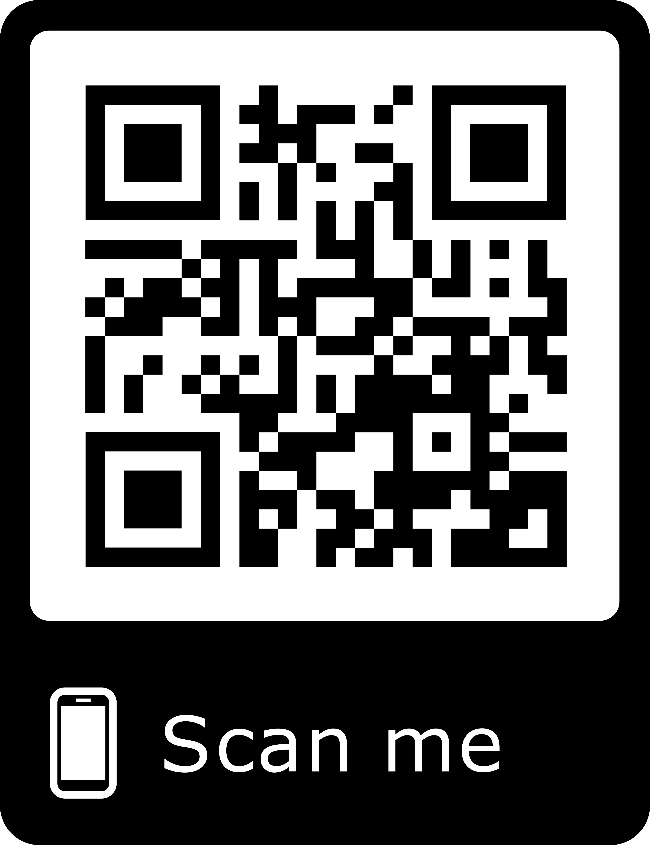

Anupama, Rakesh, Pallavi, Charan, Ramya

Customer Stories:

“There are no health monitoring system online for transformers”

Technology:

We have used Java Server Pages to develop our webpage and IOT to keep sensors on the transformers .

Business:

Talked with linemen about the existing health monitoring system.

It would cost around two lakhs for online monitoring.

Market Strategy is to propose idea to TSSPDCL.

Progress:

* Week1 – Started formulating product scope
* Week2 – Assembled individual sensors
* Week3 – Created an online webpage for monitoring transformer
* Week4 – Talked with linemen and found out the existing system
* Week5 – Added a new parameter i.e. temperature
* Week6 – Converted the breadboard model into PCB

Initial Prototype:

A PCB model with a 12-0-12 V transformer having three sensors

i.e. voltage, current, temperature

Problem: Inefficient maintenance of transformer by linemen resulting in reduced service life and increased transformer failure.

Product: A device which enables online monitoring of transformer using sensors .

Contributors:

Dr. Santosh Kumar (BVRIT Hyderabad College of Engineering for Women – EEE Project Head)

Guided us in hardware part

Mr. Naresh (BVRIT Hyderabad College of Engineering for Women – CSE Professor)

Guided us in creating the webpage