Initial Prototype: We initially started with Arduino ADXL 335 and GSM which sends SMS to the caretaker.

Customer Stories: We visited an old age home at Nizampet and tested on senior people by which we found some drawbacks in product and improvised it by using voice assistant.

Business:

* We approached senior citizens and got valuable responses from them.
* The product will be sold at 15000/- and expected revenue is

50,000/-

* The targeted customers are Old age Homes, Caretakers for senior people and Hospitals.

Technology:

Our technologies involved in our product are Internet of things

and Machine Learning.

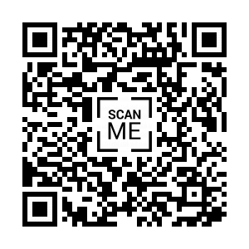

Contributors:

* Dr. Vijaya Kumari helped us in finding the competitors in market.
* Mr. Sandeep has been assisting us in IOT & ML since beginning and helped us in finding proper channel to sell the product.
* Mr. Badrinath helped us in establishing the business model in practical world.
* All the sessions and external reviews helped us in building our product more efficiently.

Problem: Continuous monitoring and assistance for senior citizens is difficult which results in improper healthcare.

Product: A gesture based band that notifies the needs to the care taker and also detects and alerts the fall of senior citizen.

Progress:

* Week1: Replaced ADXL with MPU 6050 to get accuracy in gestures.
* Week2: Based on reviews, we added ML to our product and replaced Ardunio with Raspberry Pi.
* Week3: Visited an old age home. Based on the feedback, reduced the weight of the band.
* Week4: Included voice assistant to the product.
* Week5: Remodified design to a compact form
* Week6 : Implemented final set of features for the product.