iNethra

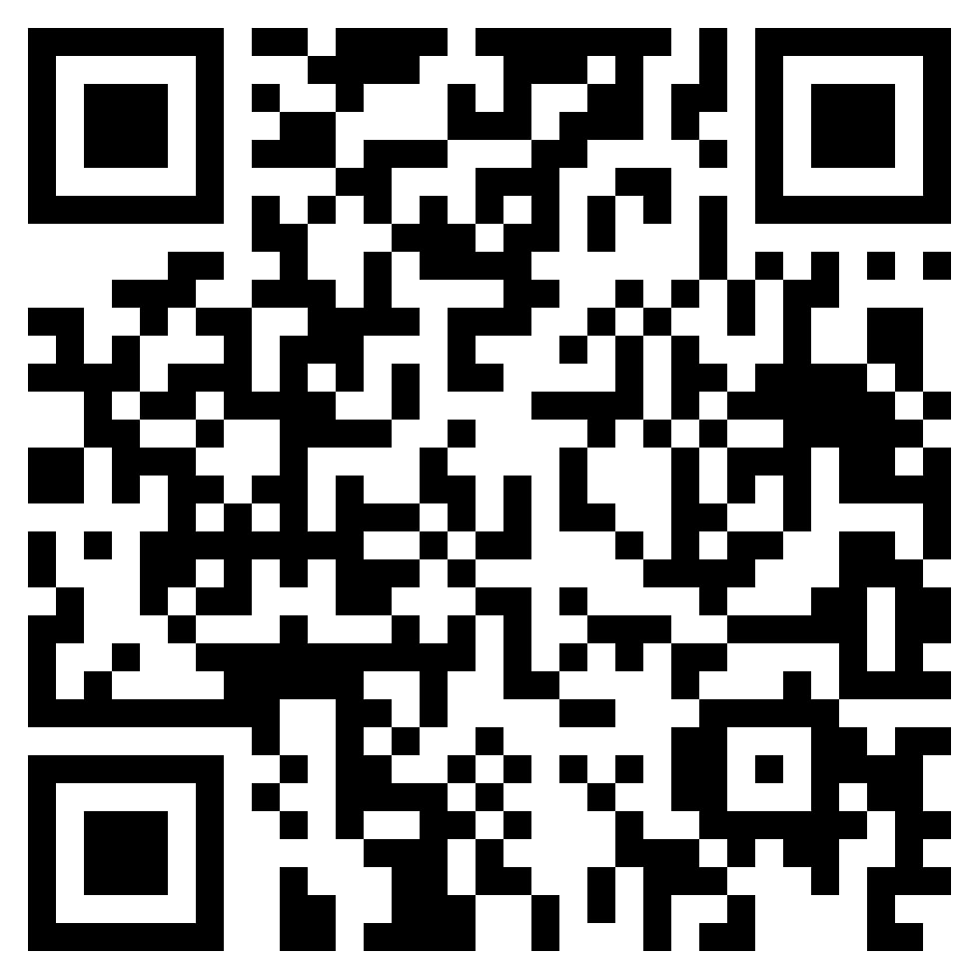QR CODE TO Your Product site/Presentation/Video

M. Srija, D. Sai Sowmya, K. Bhavya Sri, D. Neelima

Progress:

* Week1 – Improvement in the technology after the review
* Week2 – Approached Eye hospitals ,Optical centers and got feedback
* Week3 – Made a viable product with less number of lenses
* Week4 – Tested our prototype and took feedback from doctors
* Week5 – Made changes in prototype and tested on patients
* Week6 – Product building using 3D printer & improvements to mobile app

Contributors:

Dr.Vijaya Kumari supported us in doing market research by referring to Dr.Madhavi Latha in Maxi Vision Eye Superspeciality Hospital

Mentor Badrinath supported us in doing market research by referring to Dr.PadmaSri Sai Baba Goud in Sai Jyothi Hospital

Mentor Sandeep suggested us to use single lens for capturing retinal image and to use OpenCV for image enhancement

MBA interns M.Sushma and D.Rashmika helped us in business model

Initial Prototype:

Device consisting of 1

Concave, 2 convex and 1 Plano lens

Image Processing using Matlab

Business:

Approached to Sai Jyothi Hospital, Pushpagiri retina institute

Product Cost Rs.15,000/- and Revenue Rs.15,00,s000/-

Our marketing channels – Health care centers and through online websites

Customer Stories:

- Dr. Vijay Kiran in Pushpagiri eye hospital assigned one RNT to help us in testing our prototype and suggested us to enhance the image. - Ram Reddy (Sai Opticals) showed interest in buying our product if it is ready and suggested us to reshape the business model.

Technology:

- Android Studio

- Fire Base

- Image Processing

- Indirect ophthalmoscopy

Problem: Inability to detect eye diseases in rural areas, Lack of access to ophthalmologists and diagnostic resources

Product: A device that captures retinal images of patients and makes it available for the remote expert to diagnose