Reinforcement Learning Foundations — Session 1
Industry-aligned training material (2–3 hours) • Experienced audience (4–5 years)
VS Code lab + Python file-aligned chapters • Includes math + CPG/Retail cases

How to use this document: Each chapter contains (1) theory, (2) key math, and (3) a hands-on section mapped to a Python file in the lab repo.

0. Lab Repository + VS Code Setup
Repository folder: rl_foundations_hands_on

0.1 VS Code setup (one-time)
Open VS Code → File → Open Folder… → ~/rl_foundations_hands_on, then open Terminal → New Terminal.
Create and activate the environment (recommended Python 3.11):
conda create -n rltrain python=3.11 -y
conda activate rltrain
pip install -r requirements.txt
# In VS Code: Cmd/Ctrl+Shift+P → Python: Select Interpreter → rltrain
python -c "import sys; print(sys.executable); print(sys.version)"
Run the health check (must PASS before training):
python scripts/lab_check.py

1. RL in Industry: what it is and when it fits
Reinforcement Learning (RL) learns a decision policy that maximizes long-term value by interacting with an environment and receiving feedback (rewards). The key difference from supervised ML is that actions change the future state and future data (feedback loop). RL becomes relevant when decisions are sequential, delayed effects matter, and constraints must be respected.

1.1 Decision checklist: RL vs other approaches
- Immediate reward + no long-term coupling → start with (contextual) bandits or supervised ranking.
- Actions influence future (fatigue, retention, inventory dynamics) → RL candidate.
- Hard constraints dominate (budget, SLAs, fairness) → RL must be constrained/guardrailed.
- No safe exploration in production → use simulation + offline evaluation + gradual rollout.

1.2 Math: return (what RL optimizes)
Expected discounted return:
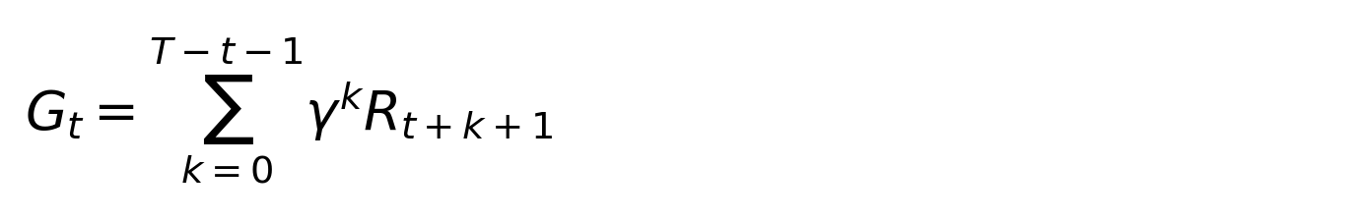
γ ∈ [0,1] controls long-term vs short-term preference. Higher γ is typical for retention/LTV or multi-week supply chain cycles.

2. The Agent–Environment–Reward–Policy loop as an MDP
Most RL problems are formalized as a Markov Decision Process (MDP):
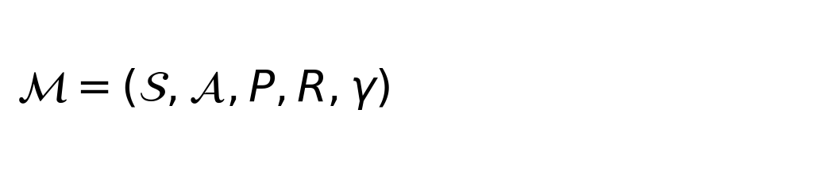

2.1 Practical mapping (CPG/Retail examples)
- State: customer segment + basket features + inventory + seasonality + competitor index
- Action: coupon choice, price move, reorder quantity, routing decision, service level choice
- Reward: margin/service level/on-time delivery minus penalties (discount spend, stockouts, volatility, returns)
- Episode/horizon: session, promo cycle (2–4 weeks), replenishment cycle (weeks), daily ops window

2.2 Math: value functions and Bellman recursion
Value under a policy π:
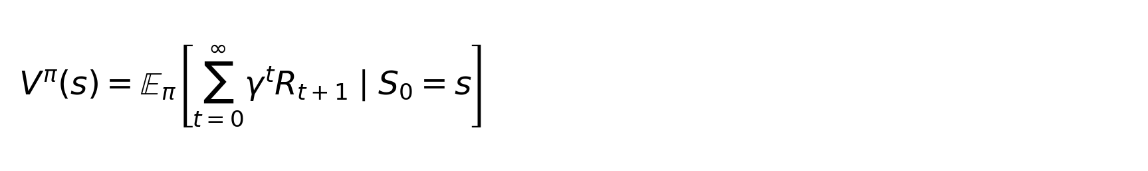
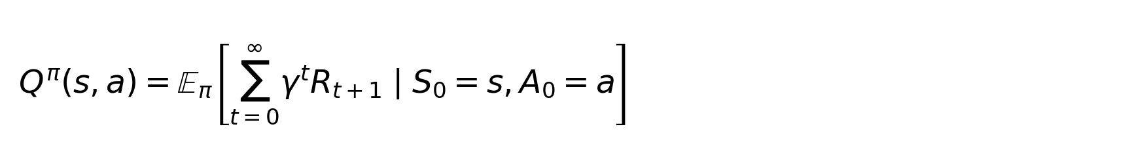
Bellman expectation (policy evaluation):
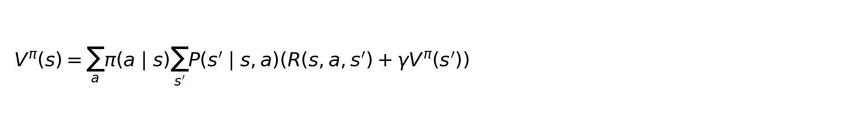
Bellman optimality (control):
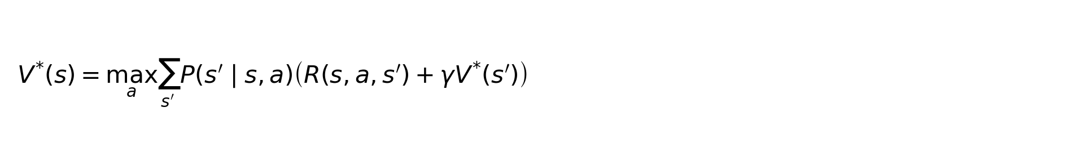

Hands-on A — RL loop demo [scripts/cartpole_random_agent.py]
Objective: make the loop concrete: reset → act → step → reward → terminate → repeat.
python scripts/cartpole_random_agent.py
- Interpretation (experienced):
- Episode termination is a constraint violation signal. Map it to churn/stockout/SLA breach in business.
- A random policy is your baseline; RL is about improving policy using feedback.

3. Trial-and-error optimization: exploration vs exploitation (Bandits)
Bandits model 'choose one of K actions and immediately observe reward'. This is highly relevant to offer selection and promo testing when the main effect is immediate.

3.1 Epsilon-greedy (math + interpretation)
Epsilon-greedy chooses the current best action with probability (1 − ε), otherwise explores a random action with probability ε. In industry, ε corresponds to an exploration/experiment budget and must be governed by risk appetite.

Hands-on B — Bandits [scripts/bandit_epsilon_greedy.py]
python scripts/bandit_epsilon_greedy.py
- Run recommendations:
- Edit epsilon in the script (0.0, 0.1, 0.2). Compare avg_reward and stability.
- Map arms to offers (5%, 10%, bundle, free shipping). Use reward as incremental margin.

4. Supervised vs RL: delayed rewards and feedback loops
Supervised learning optimizes predictive performance on a target label. In many business systems, labels are proxies (CTR, open-rate, add-to-cart). When decisions affect future outcomes (fatigue, retention, inventory), optimizing a proxy can reduce long-term value.

4.1 Why proxies break (experienced lens)
- Goodhart’s law: optimizing a metric changes behavior, making it less representative.
- Policy-induced distribution shift: model changes user behavior and future data.
- Delayed effects: promos can pull demand forward; short-term lift hides long-term erosion.

Hands-on C — Delayed reward environment [envs/delayed_reward_env.py]
This toy environment encodes a 'fatigue' effect: one action gives higher immediate reward but increases fatigue, reducing future reward. Analogous to promo fatigue / notification fatigue / brand trust erosion.
Open and read in VS Code: envs/delayed_reward_env.py

Hands-on D — Supervised baseline vs Q-learning [scripts/train_supervised_policy.py + scripts/train_q_learning.py]
Run both and compare long-term return:
python scripts/train_supervised_policy.py
python scripts/train_q_learning.py

4.2 Q-learning update (math)
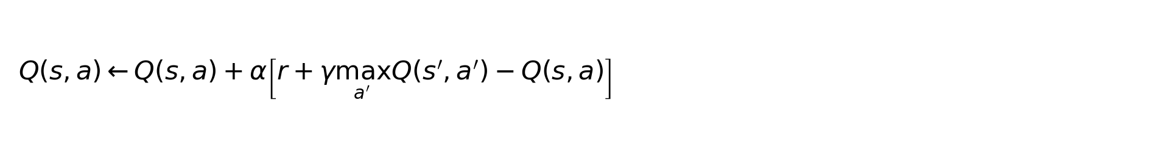
Interpretation: Q-learning learns long-term value via TD error; α controls update size; γ controls long-term preference.

5. PPO: practical policy optimization (why it is popular)
PPO (Proximal Policy Optimization) is an on-policy method that is widely used because it is stable and easy to operationalize in many settings. It improves policies cautiously to avoid destructive updates.

5.1 Policy gradients (math)
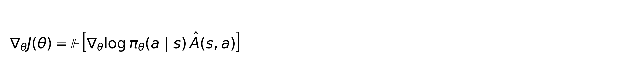
Â(s,a) is an advantage estimate: how much better action a is than a baseline in state s.

5.2 PPO clipping (math)
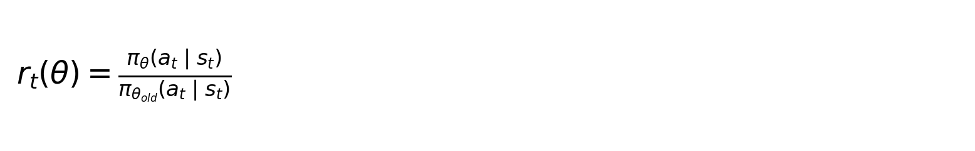
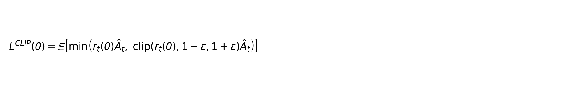
Intuition: if the new policy differs too much from the old policy, the objective is clipped to keep updates small.

Hands-on E — PPO smoke run (CPU) [scripts/ppo_cartpole_smoke.py]
Run PPO quickly to validate the full stack (also used as an infra check).
python scripts/ppo_cartpole_smoke.py

6. Reward design, shaping, and constraints (common failure modes)
Reward is your specification. In real programs, reward design and constraints matter more than algorithm choice. Use penalties and guardrails to enforce budget, SLAs, and brand-safety requirements.

6.1 Common pitfalls (experienced)
- Reward hacking (loopholes): agent maximizes the metric but harms the business.
- Sparse reward: feedback comes too late → slow learning.
- Ignoring constraints: policies violate budgets/SLAs/fairness.
- Wrong horizon: optimizing daily conversions can harm weekly retention or supply stability.

Hands-on F — Reward shaping demo [scripts/reward_shaping_cartpole_wrapper.py]
This wrapper adds a penalty to shape behavior (illustrates how reward changes learned behavior).
python scripts/reward_shaping_cartpole_wrapper.py

7. CPG & Retail Use Cases (MDP mapping + reward examples)

7.1 Promo/Coupon Optimization (CPG + Retail)
Goal: maximize incremental margin and long-term value while controlling discount spend and fatigue
- MDP mapping:
- State: segment, basket value, prior promo exposure, channel, inventory, seasonality
- Action: coupon type/value/timing (5%, 10%, bundle, free shipping)
- Episode: customer journey window (2–4 weeks)
- Constraints: budget cap, min margin, fairness by segment
Illustrative reward (pseudo-code):
reward = incremental_margin - discount_cost - 0.5*returns_cost - 0.2*fatigue_penalty
if total_discount_spend > B: reward -= 5.0 # hard penalty / guardrail

7.2 Guardrailed Dynamic Pricing
Goal: optimize price while balancing conversion, margin, competition, and trust
- MDP mapping:
- State: price, inventory, demand trend, competitor index, season/time, elasticity estimate
- Action: bounded price delta (±1–2%)
- Episode: daily/weekly cycle aligned to replenishment
- Constraints: price volatility cap, legal/brand constraints
Illustrative reward (pseudo-code):
reward = profit - 2.0*stockout_penalty - 0.5*price_volatility_penalty
if abs(price_delta) > 0.02: action = clip(action) # safe action space

7.3 Inventory Replenishment / Ordering
Goal: reduce stockouts and waste while minimizing holding costs
- MDP mapping:
- State: on-hand, forecast, lead time, promo calendar, shelf-life, supplier reliability
- Action: reorder quantity / safety stock / expedite
- Episode: multi-week replenishment horizon
- Constraints: capacity, MOQ, shelf-life, cash
Illustrative reward (pseudo-code):
reward = +3.0*service_level - 1.0*holding_cost - 2.0*spoilage_cost - 1.5*expedite_cost
if spoilage_risk_high: reward -= 3.0

7.4 Fulfillment Prioritization (Omnichannel)
Goal: maximize on-time delivery and minimize shipping cost
- MDP mapping:
- State: backlog, promised windows, node capacity, labor, carrier SLA performance
- Action: choose node + priority + carrier
- Episode: daily ops window
- Constraints: SLA targets, capacity limits
Illustrative reward (pseudo-code):
reward = 1.0*on_time - 0.3*shipping_cost - 0.4*late_penalty - 0.2*cancel_penalty

8. Evaluation & rollout (what infra/product teams must support)
- Offline evaluation: logged data is biased because actions were chosen by an old policy.
- Shadow mode: log recommended actions without affecting production decisions.
- Online rollout: staged ramp with hard guardrails (safe action spaces, budget caps).
- Observability: log (state, action, reward, next_state, policy_version).
- Monitoring: constraints and safety metrics are as important as reward.

Appendix — Run order (recommended)
python scripts/lab_check.py
python scripts/cartpole_random_agent.py
python scripts/bandit_epsilon_greedy.py
python scripts/train_supervised_policy.py
python scripts/train_q_learning.py
python scripts/ppo_cartpole_smoke.py
python scripts/reward_shaping_cartpole_wrapper.py

