Anvi Robotics White Paper: Revolutionizing Airport Operations with AROP



Table of Contents

1. Executive Summary
2. Introduction to Anvi Robotics
3. The Challenges in Airport Operations
4. Introducing Anvi Runway Ops (AROP)
5. Importance of AROP in Airport Functionality
6. Operational Workflow
7. Scenario-Based Use Cases (India Focus)
8. Market Opportunity
9. ROI and Cost–Benefit Analysis
10. Risk Assessment and Mitigation
11. Regulatory Compliance Mapping
12. Implementation Roadmap
13. Sustainability Impact
14. Conclusion and Strategic Call to Action

1. Executive Summary
Airports are among the most safety-critical and operationally complex infrastructures in the modern economy. Every day, thousands of aircraft movements depend on a delicate balance of efficiency, safety, and precision. Yet, operational risks such as Foreign Object Debris (FOD), wildlife intrusion, and undetected runway defects continue to cause delays, financial losses, and, in extreme cases, catastrophic incidents.
The Anvi Runway Ops (AROP) platform is an integrated, AI-powered, autonomous system designed to address these challenges in real time. Developed by Anvi Robotics, AROP combines autonomous FOD detection and removal, perimeter surveillance, and runway inspection into a single operational framework. Using advanced sensors, machine learning, predictive analytics, and electric mobility, AROP delivers unmatched operational visibility, hazard mitigation, and compliance assurance for airports.
In India’s rapidly growing aviation sector — where passenger traffic is expected to reach 412 million by 2030 — operational safety and efficiency are not just regulatory requirements; they are competitive differentiators. With over 148 operational airports and a government mandate to expand to more than 220 by 2025, the need for intelligent, scalable airport operations solutions has never been greater.
AROP addresses this market need by:
- Reducing FOD-related incidents by up to 70%.
- Minimizing wildlife strikes by 40–60%.
- Extending runway life by 20–30% through predictive maintenance.
- Cutting inspection times from hours to minutes.
- Enabling compliance with ICAO Annex 14, FAA Part 139, and DGCA safety directives.
This white paper outlines the market context, technical architecture, operational workflow, and business case for AROP, demonstrating why it is the most comprehensive and future-ready solution for airport operations in India and globally.

2. Introduction to Anvi Robotics
Anvi Robotics is a next-generation robotics and automation company committed to redefining safety, efficiency, and innovation. Established with a vision to bridge the gap between traditional operational practices and the possibilities offered by advanced robotics, Anvi Robotics has built a portfolio that spans multiple industries while maintaining a core focus on safety-critical environments.
The company’s expertise lies in engineering precision-driven robotic systems for surveillance, inspection, and automation, designed to operate reliably in challenging and dynamic conditions. From humanoid robotics to industrial robotic arms, and from high-torque motors to autonomous mobile platforms, every Anvi Robotics product reflects the company’s commitment to technological excellence and operational relevance.

With a proven track record in defense, infrastructure, and industrial automation, Anvi Robotics is now applying its deep technical capabilities to the aviation sector through Anvi Runway Ops (AROP). This platform represents not only a product innovation but also a strategic evolution — bringing together the company’s competencies in AI, edge computing, mobility engineering, and systems integration to address some of the most pressing challenges in modern airport operations.

3. The Challenges in Airport Operations
Airports are among the most complex operational environments in the world, where safety and efficiency must coexist under strict regulatory oversight. Despite technological advancements in air traffic management and passenger services, airside operations remain vulnerable to several persistent hazards that can compromise safety, disrupt schedules, and incur significant financial costs.
One of the most pressing threats is Foreign Object Debris (FOD). Defined as any object, debris, or substance found on runways, taxiways, or aprons that can cause damage to aircraft, FOD has been responsible for some of the most costly and dangerous incidents in aviation history. A single loose bolt or metal shard can be ingested by an aircraft engine, leading to catastrophic failure. Global statistics indicate that FOD-related incidents cost the aviation industry approximately USD 4 billion annually in repairs, delays, and cancellations. In India, where many airports operate close to capacity, even a short disruption caused by FOD can create cascading delays affecting thousands of passengers.
Perimeter security presents another growing concern. Airports often span vast tracts of land, making them susceptible to breaches, wildlife intrusions, and environmental hazards. Wildlife strikes — particularly involving birds — are a significant issue, with over 14,000 such incidents reported in the US in 2022 alone, and similar trends emerging in India. Vegetation overgrowth can obstruct visibility, while structural weaknesses in perimeter fencing or walls can allow unauthorized access. Each breach, whether accidental or deliberate, introduces potential safety and security risks.
Runway and aircraft inspection also remain challenging. Traditional inspection methods rely heavily on human teams, whose efficiency is limited by visibility conditions, time constraints, and the need for scheduled access. Early-stage cracks in runway surfaces may go undetected until they develop into hazards requiring costly resurfacing. Accumulated rubber deposits from aircraft tires can reduce friction and increase stopping distances, while faulty runway lights compromise navigation, particularly in low visibility or nighttime conditions.
These challenges are not isolated — they are interconnected. A wildlife breach might lead to FOD, a FOD incident might necessitate an emergency runway closure, and a closure can cause widespread operational delays. What is needed is an integrated, continuous, and intelligent monitoring system capable of addressing all these risks in real time.

4. Introducing Anvi Runway Ops (AROP)
Anvi Runway Ops (AROP) is Anvi Robotics’ answer to the multifaceted challenges of modern airport operations. Designed as a comprehensive, modular, and scalable platform, AROP unifies multiple safety and inspection functions into a single, intelligent ecosystem.
At its core, AROP is built on three interdependent verticals:
- Autonomous Foreign Object Detection & Removal – Leveraging AI-powered computer vision and advanced sensors, AROP continuously scans runways and taxiways for any form of FOD. Once detected, objects are classified by type and risk severity. In cases where immediate removal is possible without disrupting operations, AROP’s autonomous systems execute the removal themselves, ensuring minimal delay. These functions operate seamlessly under diverse environmental conditions, including night operations, fog, and heavy rain, and are powered by EV-based mobility platforms for sustainability.
- Perimeter Surveillance Robots – These vertical focuses on continuous perimeter monitoring to detect wildlife intrusion, vegetation overgrowth, and structural integrity issues in fencing or walls. Equipped with AI-based classification models, the system can differentiate between harmless movements and high-risk threats, triggering appropriate responses and notifying the Airport Operations Control Center (AOCC) in real time.
- Runway Inspection – Using high-resolution imaging, LiDAR scanning, and AI-based surface analysis, AROP can detect minute cracks before they become major structural problems, assess rubber deposition levels affecting friction, and verify the functionality of runway lighting systems. Actionable insights are delivered instantly, allowing maintenance teams to respond proactively rather than reactively.
What sets AROP apart from piecemeal solutions is its integration-first design philosophy. Instead of deploying multiple single-purpose systems, airports can implement a single platform that communicates seamlessly across functions — detecting, assessing, responding, and logging every safety-related event in a unified data environment. This not only streamlines operational workflows but also simplifies compliance reporting, as all activity logs and inspection results are stored in structured formats aligned with ICAO and DGCA requirements.
In short, AROP transforms airside safety from a reactive, schedule-bound process into a proactive, always-on operational capability — one that enhances safety, reduces costs, and prepares airports for the future of aviation.

5. Importance of AROP in Airport Functionality
Airports operate in a high-stakes environment where even minor disruptions can have far-reaching consequences. In this setting, the Anvi Runway Ops (AROP) platform functions not just as an operational enhancement, but as a strategic enabler of safety, efficiency, and regulatory compliance. Its deployment impacts multiple layers of airport functionality — from frontline operational safety to long-term asset preservation.
The most immediate benefit is safety assurance. AROP directly addresses three of the most persistent risks in airport operations: Foreign Object Debris (FOD), wildlife intrusion, and runway surface or lighting deficiencies. By using AI-powered real-time detection systems, it mitigates the possibility of these hazards escalating into safety incidents. A single overlooked bolt on a runway can cause catastrophic engine damage; a brief wildlife incursion can trigger an aborted takeoff; a burnt-out runway light can compromise navigation during poor visibility. AROP closes these gaps by detecting threats at their earliest stage and initiating swift responses, ensuring compliance with both ICAO Annex 14 and FAA Part 139 safety requirements.
Operational efficiency is another cornerstone of AROP’s value. Traditionally, hazard detection and runway inspections are time-bound activities conducted at fixed intervals, often requiring human-led patrols that disrupt active operations. AROP replaces this with continuous, non-intrusive monitoring that eliminates downtime associated with inspections. Because the system is capable of autonomous intervention in certain cases — such as FOD removal — airport personnel are freed to focus on high-priority operational tasks rather than routine hazard sweeps. The result is a measurable increase in runway availability, which directly impacts on-time departure rates and passenger satisfaction scores.
From a financial perspective, cost savings are both immediate and long-term. In the short term, AROP reduces incident-related expenses by preventing accidents before they occur. The cost of a single FOD-related engine failure can exceed ₹8–10 crore, while wildlife strikes and emergency runway repairs can each run into several crores. In the long term, AROP’s predictive analytics allow for smarter maintenance scheduling, extending the lifespan of runway surfaces and infrastructure while reducing the frequency of costly emergency interventions.
Importantly, AROP’s benefits are not limited to major international hubs. Its modular design allows scalability, enabling small and medium-sized regional airports to tailor the system to their specific operational demands without overextending budgets. This flexibility ensures that safety and efficiency gains are accessible to the full spectrum of India’s growing airport network, supporting the government’s vision of expanding safe, reliable air travel nationwide.
In essence, AROP is not just a technological solution — it is a strategic operational partner. It transforms the way airports think about safety, shifting from a reactive to a proactive model. By doing so, it strengthens regulatory compliance, boosts operational performance, and safeguards both human lives and multi-billion-rupee infrastructure assets.

6. Operational Workflow
The operational workflow of Anvi Runway Ops (AROP) is built on the principle of continuous vigilance, ensuring that airport safety is maintained in real time without operational slowdowns. Instead of relying on the traditional model of scheduled, human-led inspections — which leave inevitable blind spots between inspection windows — AROP establishes an unbroken monitoring cycle that blends autonomy, intelligence, and rapid response.
The process begins with a fleet of autonomous units patrolling pre-defined runway and perimeter sectors around the clock. Each unit is equipped with a sophisticated sensor suite that includes high-resolution optical cameras, LiDAR scanners, and environmental sensors capable of detecting both visible and subtle hazards. These patrols operate on adaptive routes, altering their movement patterns in response to live data on weather changes, traffic density, and priority alerts from the Airport Operations Control Center (AOCC).
As these units move across their designated zones, incoming data is processed locally on edge-computing modules rather than being sent to a remote server for initial analysis. This architecture dramatically reduces latency, enabling near-instantaneous detection of anomalies such as loose metallic debris, wildlife movement, early-stage cracks in runway surfaces, or failure in runway lighting systems. Because AROP’s machine learning models are trained on large datasets collected from both global and Indian airport environments, the system achieves high detection accuracy even under challenging conditions such as heavy rain, fog, or low light.
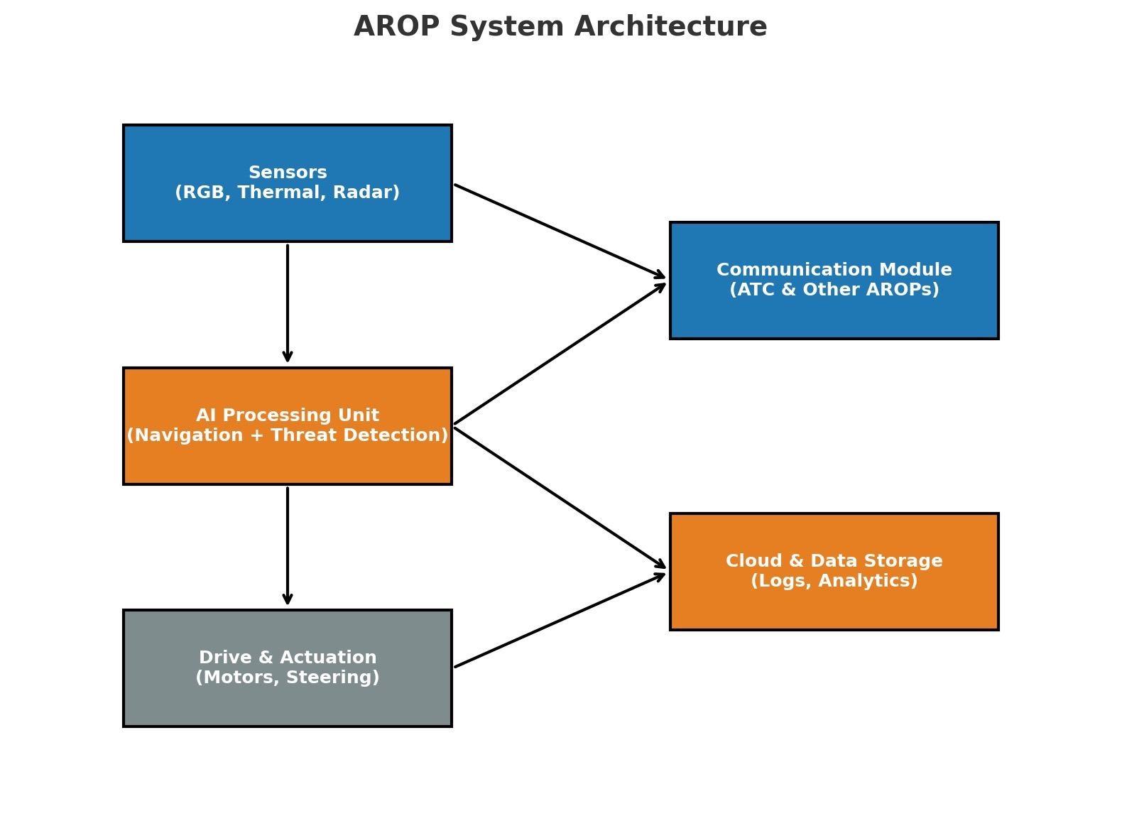
Once a hazard is identified, AROP’s AI engine automatically classifies it based on severity. Critical hazards — such as a large object lying within an active runway zone — are escalated with the highest priority, while lower-severity issues like minor vegetation encroachment are scheduled for maintenance intervention. Alerts are dispatched to the AOCC in real time, accompanied by GPS coordinates, hazard images, and severity scoring to assist rapid decision-making.
In cases where the hazard can be safely addressed without human involvement — such as the removal of certain types of FOD — AROP units are capable of initiating autonomous removal procedures immediately, thus eliminating delays between detection and resolution. Following resolution, the system conducts a verification scan of the affected area and logs the outcome automatically into the compliance record. These logs not only serve as a digital audit trail for DGCA and ICAO safety inspections but also feed into AROP’s predictive maintenance algorithms, enabling airports to anticipate recurring issues and prevent them before they escalate.

7. Scenario-Based Use Cases
The true strength of AROP lies in its adaptability across the diverse operational conditions found in India’s aviation network. No two airports face the same combination of risks — environmental, infrastructural, or operational — and AROP’s modular design allows it to be fine-tuned for each setting.
At Indira Gandhi International Airport in Delhi, for example, high passenger throughput and tight flight schedules mean that even a short disruption can cascade into widespread delays. Under current protocols, manual runway inspections take up to two hours and require partial closures that disrupt traffic flow. By deploying AROP, these inspections are reduced to under 15 minutes without compromising thoroughness. The system detects early-stage cracks and surface irregularities that might otherwise go unnoticed until they cause significant structural damage, allowing maintenance teams to intervene proactively and avoid costly resurfacing projects.
In Mumbai, the challenge shifts to weather resilience. The city’s coastal location exposes its airport to monsoon conditions, where heavy rain, reduced visibility, and debris washed onto runways create a perfect storm for operational hazards. AROP’s IP67-rated EV platforms, equipped with both thermal and infrared imaging, remain fully functional during these weather extremes. They can detect not only foreign objects but also dangerous accumulations of standing water — a hazard that can be difficult to identify from a control tower or during low-light hours — thus preventing weather-related closures that cost the airport millions of rupees in lost operations annually.
In Nagpur, the problem is wildlife intrusion. Located in an area surrounded by open fields, the airport has historically experienced frequent bird strikes and occasional incursions by stray animals. AROP’s perimeter surveillance units, equipped with AI-based species classification, can differentiate between a harmless passerine bird and a high-risk flock of larger migratory species. In such cases, the system can trigger automated deterrent systems, alert human response teams, and log the incident for pattern analysis, leading to a measurable reduction in wildlife strike incidents year over year.
By addressing the unique risks of each operational environment — be it heavy traffic, severe weather, or wildlife activity — AROP demonstrates its flexibility as a scalable, all-weather, all-airport solution.

8. Market Opportunity
The global market for airside safety automation is expanding rapidly, with projections indicating growth from USD 3.2 billion in 2024 to USD 6.5 billion by 2030. The key drivers behind this growth include stricter international safety regulations, rising passenger volumes, and a push for operational efficiency in an industry where downtime is extraordinarily costly.
India represents one of the most attractive growth markets in this sector. As the fastest-growing aviation market in the world, the country’s passenger traffic is increasing at a compound annual growth rate of approximately 9–10 percent. Government initiatives such as the UDAN scheme and the National Infrastructure Pipeline have committed to expanding the national airport network from 148 operational airports to over 220 by 2025. This expansion not only creates a surge in infrastructure investment but also a critical need for intelligent operations systems that can scale with demand.
While some Indian airports have invested in single-function FOD detection equipment or limited perimeter monitoring solutions, these fragmented systems lack integration and data interoperability. AROP’s value proposition is its ability to consolidate these functions into a single platform, streamlining procurement, reducing integration complexity, and maximizing return on investment. By offering comprehensive coverage from runway to perimeter, AROP positions itself not merely as an add-on to existing operations, but as the central nervous system for airport safety management.

9. ROI and Cost–Benefit Analysis
For airports, every decision on capital investment must be justified by measurable returns. In AROP’s case, the financial benefits are both direct — in the form of reduced incident costs and operational savings — and indirect, through improved safety reputation and regulatory compliance.
Consider a Category X Indian international airport handling 30–35 million passengers annually. AROP deployment involves a capital investment of roughly ₹51.5 crore, including equipment, integration, and training. Operating costs are estimated at ₹1.5 crore per year for maintenance, energy, and software updates. Against this, the savings are substantial: avoidance of FOD-related damage alone can save ₹20–22 crore annually; wildlife strike mitigation can reduce costs by another ₹14–16 crore; predictive runway maintenance can save ₹5–6 crore; and operational efficiencies from reduced inspection manpower can contribute ₹2.5–3 crore more.
The result is a total annual saving in the range of ₹41.5–47 crore, yielding a payback period of just over a year for major airports. Even for smaller regional airports with lower traffic volumes, the system pays for itself within two to three years, making it a sound investment from both an operational and financial standpoint.

10. Risk Assessment and Mitigation
Like any advanced automation deployment, AROP faces potential risks that must be identified and mitigated from the outset. On the technical front, the system is designed with redundant sensors to prevent single-point failures, and its hardware is weatherproofed to perform in the extreme conditions common to many Indian airports. AI models are retrained regularly using site-specific data to minimize false positives or negatives, ensuring that the system remains highly reliable over time.
Operationally, the biggest challenges tend to be integration delays and resistance to new technology among staff. These are addressed through pre-tested API connectors for common AOCC systems, phased deployment strategies, and comprehensive training programs that emphasize human–machine collaboration rather than replacement.
From a regulatory standpoint, AROP is engineered to exceed current ICAO Annex 14 and FAA Part 139 requirements, so even if safety standards are tightened in the future, the system will remain compliant without additional modification. Data privacy is also a priority, with all operational footage and telemetry stored on secure, locally hosted servers in compliance with Indian cybersecurity guidelines.

11. Regulatory Compliance Mapping
Compliance is embedded into AROP’s DNA. Its capabilities align directly with ICAO Annex 14 requirements for aerodrome design and operations, ensuring that runways and taxiways remain free of hazards, wildlife intrusions are mitigated, and lighting systems are maintained to the specified photometric output. The system also meets DGCA Civil Aviation Requirements for aerodrome safety inspections and BCAS perimeter security guidelines, enabling airports to demonstrate full regulatory adherence during audits.
Equally important is AROP’s contribution to environmental compliance. By operating entirely on electric power, it supports India’s commitments under the ICAO Carbon Offsetting and Reduction Scheme for International Aviation (CORSIA) and the country’s own sustainability targets for airport operations.

12. Implementation Roadmap
Rolling out AROP is a carefully managed process designed to minimize disruption to ongoing airport operations. A typical implementation begins with a 90-day pilot on a specific runway or perimeter section, during which the system’s detection accuracy, weather resilience, and integration performance are validated.
Once proven, the rollout expands to full runway and perimeter coverage, with each autonomous unit assigned to a defined patrol zone for 24/7 monitoring. In the third phase, AI models are refined using the airport’s own environmental and operational data, improving detection accuracy for local conditions. Finally, operational insights from the initial deployment are used to accelerate and optimize rollouts at other airports in the network, creating an economies-of-scale advantage.

13. Sustainability Impact
Beyond safety and efficiency, AROP delivers a measurable sustainability impact. By replacing diesel-powered inspection vehicles with electric platforms, a large Indian airport can avoid 65–80 metric tonnes of CO₂ emissions annually. Predictive maintenance further reduces the need for emergency repairs, which often require heavy machinery and significant fuel use. Over a ten-year operational period, AROP can reduce lifecycle emissions from monitored airport operations by up to 15 percent, supporting the industry’s transition to greener practices.

14. Conclusion and Strategic Call to Action
In a sector where safety and efficiency are paramount, and where margins for error are virtually nonexistent, AROP represents a transformative leap forward. It consolidates critical safety functions into a single, intelligent platform, delivering real-time hazard detection, predictive maintenance, and verifiable compliance — all while reducing costs and environmental impact.
For India’s rapidly growing aviation market, the timing could not be better. As new airports come online and existing hubs expand, AROP offers a proven, future-ready solution that scales with infrastructure growth. By partnering with Anvi Robotics to deploy AROP, airport authorities and operators can not only meet regulatory requirements but set a new standard for operational excellence, positioning themselves as leaders in safety, efficiency, and sustainability.

