STREAMFLIX
Architecture, service design
and deployment guide
Version 2.0 • Prepared 10 October 2026
A streaming engineering project with an original Netflix-inspired experience, independently deployable services, Kubernetes controls and a staged GitHub Actions → Argo CD delivery path.

Read this first
This document explains the implemented v2 repository and its deployment prerequisites. The old devops kind cluster was deleted following the requested reset on 2026-10-10. A fresh three-node streamflix-v2 learning cluster now runs version-pinned platform controllers and observability. All 28 Prometheus targets passed, logs were collected from all active platform namespaces, a synthetic trace was retrieved from Tempo, and HTTPS and cross-node policy enforcement passed. Application releases still await GitHub Actions; no production cloud provisioning or Argo CD sync has been performed.
Production readiness is a property of the deployed system and its operating practices. The production profile validates required configuration and uses external resilient data services. Real payment capture, adaptive video encoding, content entitlements/DRM, commercial media rights, an account recovery system and multi-region operations remain explicit boundaries.
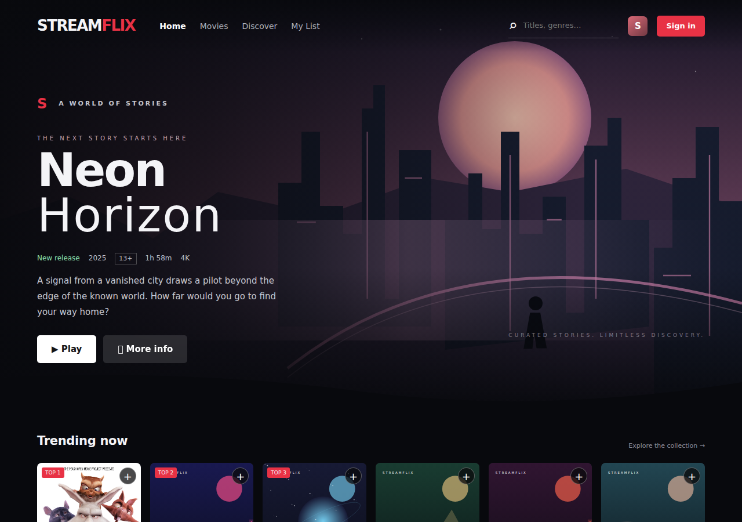

1. System overview and how to read the repository
Start with the browser. It loads same-origin static assets from frontend. Every data action uses a relative /api path, routed by the HTTPS ingress to api-gateway. The gateway verifies a session and selects its upstream from a ConfigMap. Each Kubernetes Service selects the current ready Pods; DNS and EndpointSlices track changing Pod addresses. Application code does not contain a fallback Kubernetes hostname or demo database password.
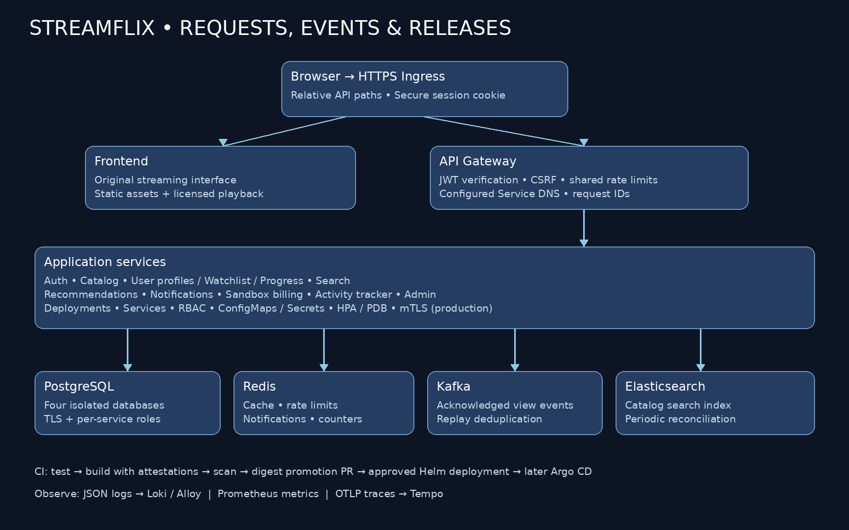
Location | Purpose
app/*/src | Service implementations; Node services share app/shared
app/shared | HTTP security, config validation, DB pool, tracing, password hashing, migrations, rate limiting
app/frontend/src/public | Responsive interface, assets and browser behavior
gitops/charts/streamflix | Authoritative v2 consolidated chart
gitops/environments | Learning/production configuration and promoted image digests
gitops/platform | CA/trust and versioned log-stack configuration
.github/workflows | Active CI/publication and deployment jobs
scripts/v2 | Bootstrap, deploy, validation, promotion, smoke, integration and documentation tooling
tests | Node security, Python service and Playwright desktop/mobile tests
gitops/charts/<old-service>, ci/github-actions | Historical v1 examples; do not deploy current v2 service code using them

2. User journeys and connection flows

Browse and search
Browser GET /api/catalog/titles → ingress → gateway → catalog-service → catalogdb. Search GET /api/search/search?q=... → gateway → search-service → authenticated Elasticsearch index. Search periodically reconciles from the catalog rather than maintaining a second independently seeded title list.

Register and sign in
Browser POST /api/auth/register → gateway → auth-service. Input is bounded, email normalized and passwords hashed using scrypt with per-password random salt. Login verifies the hash and returns an HttpOnly, SameSite=Strict session cookie. RS256 JWTs enforce algorithm, issuer, audience, subject and expiry. Authentication failures use a generic response; passwords are never returned.

Save a title
Browser PUT /api/users/my-list/:id with its session cookie → gateway verifies JWT → user-service verifies JWT again and uses the subject email for its SQL row. The request does not choose another user’s identity. Watchlist state lives in userdb, so replicas do not share a writable local disk.

Play and resume
Licensed media URLs are catalog metadata. The player accepts HTTPS files from the approved sample host, plays the whole film including credits and periodically stores progress in user-service. Gateway traffic records the view through catalog-service; browser playback remains available if the view-tracking request temporarily fails.

Track viewing asynchronously
Catalog waits for Kafka producer acknowledgement before reporting eventPublished=true. A unique event ID accompanies each event. Activity-tracker consumes the topic and uses one Redis Lua operation to deduplicate the ID and increment a title count. The deduplication window is seven days; this is not a claim of permanent exactly-once processing.

Subscription demonstration
Browser selects a named plan and sends an idempotency key. Billing calculates a fixed amount server-side, persists the response in a transaction, and returns the same response for a repeated user/key pair. It is a sandbox subscription model; no payment provider call or real charge occurs.

Administration
/api/admin/pods requires a valid JWT plus an explicit admin email allowlist. The service uses an in-cluster ServiceAccount and a namespace-scoped Role granting Pod get/list only. There is no public ingress route bypassing the gateway to the old /pods endpoint.

3. Kubernetes components and why they are used
Component | Role in this project | Operational detail
Namespace | Scopes application resources in the fresh learning cluster | Learning namespace labels enable restricted Pod Security and public CA distribution.
Deployment / ReplicaSet / Pod | Runs stateless HTTP services | Deployment owns rollout history; ReplicaSets own replacement Pods. State moves into datastores.
Service / DNS / EndpointSlice | Stable service discovery | ClusterIP/headless Services select ready endpoints; ConfigMap URLs derive namespace and cluster domain.
Ingress | Same-origin browser routing and TLS termination | / goes to frontend, /api goes to gateway; TLS certificate lives in a Secret.
ConfigMap | Non-secret environment configuration | Service URLs, DB names, ports, public origin and trace endpoint; checksum triggers application rollout.
Secret / ExternalSecret | Credential injection | Secrets are referenced by key. External Secrets fetches provider values; workloads cannot list Secrets.
Issuer / ClusterIssuer / Certificate / Bundle | Certificate issuance and CA trust | Learning CA private key stays in cert-manager; trust-manager distributes the public CA only.
ServiceAccount / Role / RoleBinding | Workload identity and least privilege | Most workloads disable token mounting. Admin has Pod reads only; platform identities are separate.
StatefulSet / PVC / PV / StorageClass | Learning datastore identity and persistence | Four single-node StatefulSets own storage claims. Production uses external resilient datastores.
HPA | Scales eligible application Deployments | CPU percentage is relative to requests. Requires metrics-server; scale-down stabilization is five minutes.
VPA | Learning resource recommendations | Update mode Off avoids competing CPU adjustments with HPA; requires VPA CRDs.
PodDisruptionBudget | Controls voluntary disruption | Multi-replica apps permit one unavailable Pod; single replicas block voluntary eviction.
Startup / readiness / liveness probes | Controls startup and routing | Readiness checks dependencies/schema, liveness checks the process; startup avoids premature restarts.
Job | Database schema migrations | Versioned SQL and advisory locks; bounded retries/deadline; deployment waits for completion.
CronJob | Digest, encoding exercise and DB backup | Forbid overlapping runs, bounded history/deadlines; backup learning PVC retains seven days.
NetworkPolicy | Restricts service/data communication | Default deny plus DNS, ingress, metrics and explicit edges. Enforcement requires a compatible CNI.
ResourceQuota / LimitRange | Bounds resource consumption | Namespace CPU/memory/Pod/PVC limits plus defaults for containers.
SecurityContext / Pod Security | Limits container privileges | Non-root, RuntimeDefault seccomp, all capabilities dropped, no privilege escalation; apps have read-only roots.
TopologySpreadConstraint / toleration | Placement and scheduling | Application Pods spread across hostnames; learning datastore Pods tolerate the datastore taint.
ServiceMonitor / PrometheusRule | Scraping and alerts | Metrics endpoint discovery, error-rate/restart/unavailable alerts; requires operator CRDs.
PeerAuthentication / DestinationRule | Production service mesh | Strict mTLS and bounded connections require running Istio proxies, CNI and an ingress mesh integration.

4.1 Service: frontend
Property | Implementation
Runtime | Node / Express
API / trigger | /
Dependencies | No private data store
Source | app/frontend/src
Deployment | Deployment + Service + service account

Responsibility and request/data flow
Public static application; three licensed movies and original concept artwork. Browser API calls are relative paths, not configurable user inputs.

Configuration, identity and security
No credential Secret is injected. Security headers and CSP restrict script/style/image sources to the application. Movies use an explicit HTTPS host allowlist.

Kubernetes operation and observability
Readiness reports the static server is available. Browser tests cover rendered catalog, dialogs, registration/sign-in UI, search, watchlist and sandbox plans on desktop and mobile.
The common application template applies non-root UID/GID 1000, RuntimeDefault seccomp, a read-only root filesystem, dropped capabilities, disabled privilege escalation and a size-limited writable /tmp. Dedicated Services, probes, resource limits, topology spreading and disruption budgets are generated from the service map. Multi-replica services receive CPU HPAs. Only admin-dashboard mounts a Kubernetes API token.

Scope and production extension
Static originals and licensed poster assets are shipped in its image. /lab and the legacy public operational console are not exposed.

4.2 Service: api-gateway
Property | Implementation
Runtime | Node / native Fetch
API / trigger | /api/{service}/*
Dependencies | Redis for shared rate counters
Source | app/api-gateway/src
Deployment | Deployment + Service + service account

Responsibility and request/data flow
Selects a validated environment-configured origin for each upstream. Removes user-controlled identity headers by forwarding a minimal header set. Preserves session Set-Cookie and idempotency headers. JSON bodies are reconstructed after parsing; requests have timeouts.

Configuration, identity and security
JWT is verified before private routes. Public catalog/search/activity reads are explicit. Redis-backed limits work across replicas. CSRF validates the exact public browser origin for cookie-authenticated mutations.

Kubernetes operation and observability
Readiness checks its rate-limit Redis connection. Standard HTTP counters/histograms, request IDs and automatic tracing cover upstream requests.
The common application template applies non-root UID/GID 1000, RuntimeDefault seccomp, a read-only root filesystem, dropped capabilities, disabled privilege escalation and a size-limited writable /tmp. Dedicated Services, probes, resource limits, topology spreading and disruption budgets are generated from the service map. Multi-replica services receive CPU HPAs. Only admin-dashboard mounts a Kubernetes API token.

Scope and production extension
The gateway is application-level routing. It does not replace Kubernetes Ingress, Service DNS or NetworkPolicies.

4.3 Service: auth-service
Property | Implementation
Runtime | Node / Postgres / scrypt / JWT
API / trigger | POST /register, POST /login, GET /me, POST /logout
Dependencies | authdb using auth_app
Source | app/auth-service/src
Deployment | Deployment + Service + service account

Responsibility and request/data flow
Owns identity records and password hashes. Login performs equivalent password-hash work for unknown accounts, signs a one-hour JWT and sets a Secure HttpOnly SameSite cookie. No JWT is returned for browser storage.

Configuration, identity and security
Receives DB credentials, JWT private signing key (auth only), public verification key and Redis password through Secrets. Input bounds and shared rate limiting protect expensive hashing. SQL uses parameters. Generic registration response avoids disclosing duplicate email existence.

Kubernetes operation and observability
Readiness requires users table and Redis. Startup schema work is performed by a migration Job; no app startup DDL.
The common application template applies non-root UID/GID 1000, RuntimeDefault seccomp, a read-only root filesystem, dropped capabilities, disabled privilege escalation and a size-limited writable /tmp. Dedicated Services, probes, resource limits, topology spreading and disruption budgets are generated from the service map. Multi-replica services receive CPU HPAs. Only admin-dashboard mounts a Kubernetes API token.

Scope and production extension
Logout clears the browser cookie. It does not revoke every already-issued JWT. Short expiry limits exposure; a production account platform should add revocation, recovery, verification, MFA and audited signing-key rotation.

4.4 Service: catalog-service
Property | Implementation
Runtime | Node / Postgres / KafkaJS
API / trigger | GET /titles, GET /titles/:id, POST /titles/:id/view
Dependencies | catalogdb using catalog_app; Kafka topic
Source | app/catalog-service/src
Deployment | Deployment + Service + service account

Responsibility and request/data flow
Authoritative title metadata includes posters, duration, rating, genre, licensed playback URL and descriptions. Kafka events have unique IDs and acknowledgements; reads are separate from event publication.

Configuration, identity and security
Reads are public catalog data; recording a view requires a JWT. IDs are validated and SQL is parameterized. Database SSL verifies the trusted CA and host.

Kubernetes operation and observability
Readiness requires title schema and connected event producer. HTTP metrics/traces expose latency, failures and DB calls.
The common application template applies non-root UID/GID 1000, RuntimeDefault seccomp, a read-only root filesystem, dropped capabilities, disabled privilege escalation and a size-limited writable /tmp. Dedicated Services, probes, resource limits, topology spreading and disruption budgets are generated from the service map. Multi-replica services receive CPU HPAs. Only admin-dashboard mounts a Kubernetes API token.

Scope and production extension
Producer retries and idempotence improve reliability, but there is no transactional DB outbox. A browser/client retry may represent a new view event; add request-id deduplication/outbox if durable business events are required.

4.5 Service: user-service
Property | Implementation
Runtime | Node / Postgres
API / trigger | GET/PUT /profile, GET/PUT/DELETE /my-list, GET/PUT /progress
Dependencies | userdb using user_app
Source | app/user-service/src
Deployment | Deployment + Service + service account

Responsibility and request/data flow
Profiles, watchlist entries and per-title progress are persisted in SQL. Every lookup and mutation derives the user email from a verified session; email is not accepted as a target identity.

Configuration, identity and security
Receives its own DB credentials and JWT public verification key. Titles and progress are bounded. Replaces the old path-derived note filename and shared ReadWriteOnce avatar volume to support horizontal replicas safely.

Kubernetes operation and observability
Readiness checks profiles schema; standard HTTP metrics and Postgres tracing apply.
The common application template applies non-root UID/GID 1000, RuntimeDefault seccomp, a read-only root filesystem, dropped capabilities, disabled privilege escalation and a size-limited writable /tmp. Dedicated Services, probes, resource limits, topology spreading and disruption budgets are generated from the service map. Multi-replica services receive CPU HPAs. Only admin-dashboard mounts a Kubernetes API token.

Scope and production extension
This is one profile per account. Household profiles, uploads/object storage and cross-service catalog referential checks remain extension work.

4.6 Service: search-service
Property | Implementation
Runtime | Node / Elasticsearch client
API / trigger | GET /search?q=...
Dependencies | Elasticsearch index; catalog API
Source | app/search-service/src
Deployment | Deployment + Service + service account

Responsibility and request/data flow
Periodically reconciles catalog documents into Elasticsearch with stable title IDs. Search matches name, genre and description, returns bounded results and validates query length.

Configuration, identity and security
Credentials are Secret-backed. Production uses a least-privilege indexing/search account and HTTPS. Learning uses the bootstrap elastic account in an isolated single-node environment.

Kubernetes operation and observability
Readiness checks Elasticsearch connectivity. Periodic failure logging does not invent results or leak endpoint credentials.
The common application template applies non-root UID/GID 1000, RuntimeDefault seccomp, a read-only root filesystem, dropped capabilities, disabled privilege escalation and a size-limited writable /tmp. Dedicated Services, probes, resource limits, topology spreading and disruption budgets are generated from the service map. Multi-replica services receive CPU HPAs. Only admin-dashboard mounts a Kubernetes API token.

Scope and production extension
Index freshness is eventually consistent with a one-minute reconciliation interval. Deletes are not reconciled yet; use an event-driven indexing pipeline or full reconciliation when catalog administration is added.

4.7 Service: recommendation-service
Property | Implementation
Runtime | Python / Flask / Gunicorn
API / trigger | GET /recommendations/:user
Dependencies | Redis cache; catalog API
Source | app/recommendation-service/src
Deployment | Deployment + Service + service account

Responsibility and request/data flow
Retrieves full catalog objects, produces a deterministic user-seeded ordering and caches structured JSON for two minutes. It never falls back to invented title names on dependency failure.

Configuration, identity and security
Redis authentication comes from a Secret; URLs are required environment configuration. Recommendations contain public title data only. Private identity/state remains in user-service.

Kubernetes operation and observability
Readiness checks Redis; errors return 503. Flask/Requests/Redis OpenTelemetry tracing and HTTP metrics are wired; Gunicorn runs non-root workers.
The common application template applies non-root UID/GID 1000, RuntimeDefault seccomp, a read-only root filesystem, dropped capabilities, disabled privilege escalation and a size-limited writable /tmp. Dedicated Services, probes, resource limits, topology spreading and disruption budgets are generated from the service map. Multi-replica services receive CPU HPAs. Only admin-dashboard mounts a Kubernetes API token.

Scope and production extension
This is deterministic content discovery, not a trained recommendation model. Behavioral ranking and privacy-aware feature pipelines can be added later.

4.8 Service: notification-service
Property | Implementation
Runtime | Node / Redis
API / trigger | POST /notify, GET /notify
Dependencies | Redis per-subject queue
Source | app/notification-service/src
Deployment | Deployment + Service + service account

Responsibility and request/data flow
Each authenticated user owns a bounded list of 50 in-app notifications, with a 30-day expiry. The digest CronJob scans queue names without logging user messages.

Configuration, identity and security
JWT and Redis password are injected by Secret reference. Message input is bounded. Redis keys use the token subject; another user cannot select the target account.

Kubernetes operation and observability
Readiness returns 503 if Redis is unavailable; metrics and Redis spans are collected.
The common application template applies non-root UID/GID 1000, RuntimeDefault seccomp, a read-only root filesystem, dropped capabilities, disabled privilege escalation and a size-limited writable /tmp. Dedicated Services, probes, resource limits, topology spreading and disruption budgets are generated from the service map. Multi-replica services receive CPU HPAs. Only admin-dashboard mounts a Kubernetes API token.

Scope and production extension
No email/SMS/push provider is configured. Durable delivery needs provider integration, retry/dead-letter handling and user preferences.

4.9 Service: billing-service
Property | Implementation
Runtime | Node / Postgres
API / trigger | GET /subscription, POST /subscribe
Dependencies | billingdb using billing_app
Source | app/billing-service/src
Deployment | Deployment + Service + service account

Responsibility and request/data flow
Calculates plan prices server-side and uses a user-scoped idempotency key plus a SQL transaction. Replays return the original stored response. Subscriber identity comes from JWT.

Configuration, identity and security
Receives DB/JWT/payment Secret references. The provider key is required and never logged, but no provider call is performed. No card input is collected.

Kubernetes operation and observability
Readiness checks subscription schema; failure handling rolls back transactions and returns sanitized errors.
The common application template applies non-root UID/GID 1000, RuntimeDefault seccomp, a read-only root filesystem, dropped capabilities, disabled privilege escalation and a size-limited writable /tmp. Dedicated Services, probes, resource limits, topology spreading and disruption budgets are generated from the service map. Multi-replica services receive CPU HPAs. Only admin-dashboard mounts a Kubernetes API token.

Scope and production extension
All responses clearly identify sandbox mode. Production billing requires a provider checkout/webhook signature flow, entitlement state, reconciliation, refunds and applicable compliance review.

4.10 Service: activity-tracker
Property | Implementation
Runtime | Node / KafkaJS / Redis
API / trigger | GET /views/:title
Dependencies | Kafka consumer group; Redis counters
Source | app/activity-tracker/src
Deployment | Deployment + Service + service account

Responsibility and request/data flow
Consumes view events and atomically deduplicates event IDs while incrementing counters with Lua. Deduplication survives replay/consumer restarts within the seven-day retention window.

Configuration, identity and security
Redis authentication is Secret-backed. Production Kafka supports TLS/SASL credentials and topic ACLs. It does not expose an event mutation API.

Kubernetes operation and observability
Readiness tracks Kafka consumer startup and Redis state. A dedicated accepted-event counter supports throughput monitoring.
The common application template applies non-root UID/GID 1000, RuntimeDefault seccomp, a read-only root filesystem, dropped capabilities, disabled privilege escalation and a size-limited writable /tmp. Dedicated Services, probes, resource limits, topology spreading and disruption budgets are generated from the service map. Multi-replica services receive CPU HPAs. Only admin-dashboard mounts a Kubernetes API token.

Scope and production extension
Consumer groups allow scaling, but the learning profile starts one replica. Invalid poison events stop processing until addressed; dead-letter handling and durable analytics are future requirements.

4.11 Service: admin-dashboard
Property | Implementation
Runtime | Node / Kubernetes client
API / trigger | GET /pods through /api/admin/pods
Dependencies | Kubernetes API, current namespace only
Source | app/admin-dashboard/src
Deployment | Deployment + Service + service account

Responsibility and request/data flow
Loads in-cluster credentials and lists a bounded view of Pod name/phase/node. Uses the current client API shape and a namespace supplied through the downward API.

Configuration, identity and security
Requires JWT plus configured admin email allowlist. Its ServiceAccount Role permits Pod get/list, with no Secret access or resource mutations. API egress must be allowed explicitly.

Kubernetes operation and observability
Readiness reports process availability. Requests have sanitized errors and standard metrics.
The common application template applies non-root UID/GID 1000, RuntimeDefault seccomp, a read-only root filesystem, dropped capabilities, disabled privilege escalation and a size-limited writable /tmp. Dedicated Services, probes, resource limits, topology spreading and disruption budgets are generated from the service map. Multi-replica services receive CPU HPAs. Only admin-dashboard mounts a Kubernetes API token.

Scope and production extension
Leave adminEmails empty to deny all administrative users. Administrative authorization should move to a role/claim or identity-provider policy for a real organization.

4.12 Service: video-encoder-job
Property | Implementation
Runtime | Node batch process
API / trigger | CronJob; no public HTTP endpoint
Dependencies | No external provider in this iteration
Source | app/video-encoder-job/src
Deployment | CronJob/Job

Responsibility and request/data flow
Runs the existing seven-step simulated encode exercise as a scheduled non-root container with bounded resources and deadline. Demonstrates CronJob/Job behavior and completion status.

Configuration, identity and security
No database, payment or signing secrets are injected into the encoder.

Kubernetes operation and observability
Job success/failure is observed through Kubernetes job state and logs.

Scope and production extension
It is a simulation, not an FFmpeg transcoder. Production media work requires upload storage, a durable job queue, FFmpeg workers, HLS/DASH packaging, thumbnails and CDN delivery.

5. Datastores, migration safety and scheduled work

PostgreSQL
Learning PostgreSQL runs one StatefulSet with a headless Service and PVC. Bootstrap SQL creates four databases and separate login roles, revokes public database connection and grants access only to the owning role. The superuser Secret is available to bootstrap/backup, not application Deployments. TLS server certificates are issued by cert-manager and verified by Node clients using the public CA ConfigMap. Production databases/roles must be provisioned through the managed provider before migration Jobs run.

Redis
Learning Redis runs one StatefulSet with append-only persistence and an authenticated configuration file written into /tmp. Generated learning passwords are alphanumeric; the password is not placed in Helm values or startup arguments. Applications receive it by Secret key. Production expects rediss:// with provider CA validation. Redis contains derived/non-authoritative data but rate limiting and event counts still need an appropriate availability/backup design.

Kafka
Learning Kafka uses one broker/controller in KRaft mode, a headless Service and PVC. Internal PLAINTEXT is restricted by namespace network policies; this learning arrangement is not accepted by the production profile. Production requires external TLS/SASL brokers, configured topic replication/retention and service-specific ACLs. The broker advertised address must be routable from client Pods; DNS configuration is part of deployment configuration.

Elasticsearch
Learning Elasticsearch runs one authenticated single-node StatefulSet, not a production cluster. A periodic catalog synchronization builds its index. Production uses HTTPS, restricted credentials, resilient storage/replicas and a capacity policy. Index data can be rebuilt from the catalog; protect credentials and monitor index freshness.

Migration Jobs
Each database service has ordered SQL files and a schema_migrations table. A PostgreSQL advisory lock serializes schema changes for that database. Each file runs in a transaction and is recorded only after commit. Job names incorporate the release version, have retry/deadline limits and run before application wave 2 in Argo CD. Readiness checks the service table so traffic is not served against an absent schema.

CronJobs
Notification digest counts queues with SCAN, avoids KEYS and does not print messages. Video encoding remains a bounded simulation. Learning PostgreSQL backup writes a full SQL dump with restrictive permissions, retains seven days and requires a restore exercise. A production backup must live outside the cluster failure domain, be encrypted and support documented RPO/RTO.

6. Security, TLS and dynamic configuration
Service discovery is dynamic at the Kubernetes level: stable Service DNS names are rendered from release namespace and cluster domain, while endpoint Pod IPs change automatically. External managed endpoints and the public hostname still need environment configuration once. The browser never asks a viewer to enter a service URL, password, database host or token.
The learning secret bootstrap generates cryptographically random credentials and sends Secret JSON through kubectl stdin. It does not print secret values, persist a plaintext .env file in the repository or rotate existing database passwords unexpectedly. Production uses External Secrets backed by provider workload identity. Base64 is not encryption; API/etcd encryption, audited access, backup protection and cluster policy remain platform responsibilities.
TLS is implemented in separate layers: ingress certificates protect browser transport; verified PostgreSQL SSL protects DB connections; production external Redis/Elasticsearch/Kafka use TLS; Istio STRICT mTLS protects application service traffic when mesh proxies and CNI are actually installed. A Certificate object or a PeerAuthentication object alone cannot prove encrypted transport.
The learning root CA private key remains in cert-manager. trust-manager reads that source in its configured trust namespace and propagates only public CA bytes into labeled namespaces. Application containers mount the public ConfigMap; they cannot request or list Secrets through their ServiceAccounts. Import the public learning CA into Windows/browser trust for HTTPS; a real domain should use ACME or organizational PKI.
NetworkPolicies model explicit request edges, DNS, ingress and metrics. Use Calico/Cilium to enforce them; kindnet does not enforce the network policy contract. External provider IP/CIDR changes and Kubernetes API DNAT behavior need environment-specific rules and tests. Mesh ingress must be configured so the ingress controller reaches strict backends over mTLS.
Secret updates in environment variables require Pod restart. External Secrets refresh alone does not hot-reload DB credentials or signing keys. Plan database role updates, dual-key verification for JWT rotation, coordinated rollouts and CA rotation. This iteration fails closed on missing configuration but does not implement an automated end-to-end key-rotation system.

7. Observability: logs, metrics, traces and alerts
Node services emit structured request logs containing timestamp, level, service, request ID, normalized route and response status. They avoid passwords, raw cookies, authorization tokens and SQL contents. HTTP route labels avoid unbounded user/title cardinality. Prometheus client metrics include process counters, request totals and duration histograms; Python provides matching HTTP metrics and its recommendation counter.
ServiceMonitors select application Services and scrape /metrics. PrometheusRule resources cover HTTP error fraction, repeated restarts and Deployments with zero available replicas. Resource dashboards rely on kube-state-metrics, node exporter and kubelet/cAdvisor. metrics-server supplies HPA and kubectl top, not Prometheus historical dashboards; these are different data paths.
Node auto-instrumentation runs before service imports and traces HTTP/Express/Postgres/Redis/Kafka-supported libraries through OTLP HTTP. Python explicitly instruments Flask, Requests and Redis. Tempo must expose its OTLP receiver on the configured port and the NetworkPolicy must allow export. A realistic verification is a request trace across gateway → service → datastore, not merely a successful synthetic trace upload.
The old cluster used Fluent Bit and Promtail with an older Loki instance. That cluster and its node-local data were deleted following the requested reset. The fresh cluster uses Loki 3 TSDB v13 filesystem storage and Grafana Alloy; Fluent Bit and Promtail are not installed in the new cluster. Log ingestion from all six active platform namespaces has been verified.
Alloy API discovery labels namespace, Pod, container and service. A single API collector does not need hostPath access or placement on every tainted worker. Production uses scoped RBAC, clustered collectors, authenticated Loki access/object storage and retention/capacity/recovery controls. Platform checks passed all 28 Prometheus targets, Grafana HTTPS trust and synthetic trace retrieval from Tempo. Real application traces and external Alertmanager notification delivery still need verification after application deployment.
{namespace="streamflix-v2", service="catalog-service"}
sum(rate(http_requests_total{namespace="streamflix-v2"}[5m]))
histogram_quantile(0.95, sum by(le,service)(rate(http_request_duration_seconds_bucket{namespace="streamflix-v2"}[5m])))

8. GitHub Actions, artifact promotion and deployment
Active workflows now live in .github/workflows. Actions are pinned to verified commit SHAs, with the source version retained in comments. Pull-request validation has read-only permissions. Image publication uses Docker Hub with repository Actions secrets DOCKERHUB_USERNAME and DOCKERHUB_TOKEN. The namespace is derived from that username and the release SHA from the workflow context. BuildKit attaches SBOM and provenance metadata. The built-in GITHUB_TOKEN is used separately to propose the digest promotion PR; enable repository permission for Actions to create pull requests. The first source push publishes images; deployment is triggered separately after promotion and runner setup.
Validation gates cover Node security/HTTP tests, Python dependency behavior, chart rendering, Secret references, production configuration failure, real Docker Postgres/Redis integration and desktop/mobile browser tests. Docker contexts are repository-root because each Node service uses the shared runtime and root lockfile. Images are scanned, accompanied by SBOM/provenance and recorded by digest.
A single promotion job requires the complete twelve-image digest set, updates one image manifest and opens a reviewable pull request. This avoids parallel service jobs racing to update the same Git branch. Promotion-only changes do not trigger a new image publication loop. Failed validation/image scans prevent promotion.
Deployment is a separately triggered, approved environment workflow on a dedicated self-hosted runner that can reach the cluster. GitHub-hosted runners cannot reach the local kind API. The runner should use a restricted short-lived identity; do not commit or upload a cluster-admin kubeconfig. Helm waits for workloads and Jobs, times out, rolls back failed resource upgrades and limits release history.
Production environments need protected branches, reviewed workflow changes, required checks, environment approvals and controlled runner access. Dependency updates are prepared through Dependabot. The workflows have been statically validated and action references checked, but have not been executed on GitHub as part of this local change.

9. Later Argo CD ownership
The Argo CD generator creates a scoped AppProject and a single Application for the v2 chart and environment/image overlays. Source repository and destination namespace are explicit configuration. Cluster resource creation is not granted. Platform controllers, CA/Bundle resources, namespaces and secret-provider identity are prepared separately by platform administrators.
The application uses sync waves: Secret/configuration prerequisites before datastores; migrations after datastores; application Deployments after successful migrations. HPA-controlled replica counts are ignored for Git drift. Automatic prune/self-heal restores the desired release configuration; it is not a database recovery mechanism.
After enabling Argo CD, retire the direct Helm deployment writer for the same namespace/release. GitHub Actions should test/build/scan and propose digest promotion; Argo CD should reconcile the reviewed Git state. Two controllers continuously writing the same release create ownership and drift conflicts.
python3 scripts/v2/render-argocd.py --repo https://github.com/YOUR_ORG/YOUR_REPO.git --namespace streamflix-v2 --profile learning > /tmp/streamflix-argocd.yaml

10. Deployment runbook and verification
The detailed executable setup sequence is maintained in docs/v2/DEPLOYMENT.md. This guide records how the deployment is designed; it does not claim v2 was already deployed. The v1 cluster has been retired; deploy the v2 application through the reviewed CI release process.

Prepare platform
Install/version-pin a policy-enforcing CNI, ingress, metrics-server, cert-manager/trust-manager, monitoring CRDs and VPA. Prepare learning CA/trust or production organizational/ACME issuer. Set namespace Pod Security and quota policy.

Prepare identities
Learning uses the isolated credential generator. Production connects a workload-identity SecretStore to the provider and provisions DB roles/databases, Kafka topic/ACLs and least-privilege search credentials. Test RBAC and secret readiness.

Publish reviewed images
Push reviewed source through GitHub Actions, verify checks/scans/attestations and merge the complete digest promotion PR. Keep production profile input in an approved environment overlay.

Deploy
Run the approved deployment workflow against the configured namespace. Wait for TLS Secret/trust bundle, datastores, transactional migrations and Deployment readiness. Inspect rollout status and failed Pod events; image-pull DNS must work on every scheduled node.

Open the browser
Learning HTTPS is https://streamflix-v2.local:9443 through the ingress port-forward. Trust the public learning CA, keep the exact public origin configured and verify Secure session cookies. Production uses a real DNS/load-balancer hostname.

Verify distributed flows
Run live-smoke.mjs with trusted TLS. Verify registration/login, ownership, catalog, list/progress persistence, acknowledged Kafka → Redis count, search, recommendation caching and logout. Inspect a real trace, matching request logs, ServiceMonitor targets and HPA metrics.

Rollback/recover
Rollback application resources only if the old version is compatible with current schema. SQL/data changes require migration strategy or restore. Test the backup restore procedure in a separate environment before depending on it.

11. Evidence, boundaries and next acceptance gates
# Validation record — 10 October 2026
Implemented source and manifests have been checked locally. The old `devops` cluster was deleted at the user's request on 2026-10-10 and replaced with a fresh three-node `streamflix-v2` cluster. The platform setup is recorded separately; application release validation still awaits CI deployment.
## Fresh learning platform — verified 2026-10-10
- Three Kubernetes 1.34.0 nodes Ready; context `kind-streamflix-v2`.
- Ten Helm releases deployed: Cilium, Traefik, metrics-server, cert-manager, trust-manager, kube-prometheus-stack, Tempo, Loki, Alloy and VPA recommender.
- `kubectl top nodes` succeeds; all 28 discovered Prometheus scrape targets are healthy, including controller-manager, scheduler, etcd and kube-proxy.
- Cross-node NetworkPolicy test passed initial access, denied access and explicit allowed access. Its temporary namespace was removed.
- Learning CA/ClusterIssuer/Bundle and Grafana leaf certificate are Ready/Synced. Grafana HTTPS health passed using the public CA and hostname verification.
- Loki contains namespace/pod/container/service labels and logs from all six active platform namespaces.
- A synthetic OTLP span was accepted and retrieved from Tempo. Alertmanager readiness passed.
- Application Secrets were bootstrapped directly in the new namespace; values and signing keys were withheld from logs.
Application images/releases, application distributed traces and application alerts still await GitHub Actions deployment. Alertmanager has no external notification receiver configured. Learning storage is node-local and single-instance data services do not provide production HA. The pinned legacy Tempo chart reports deprecation; migration to the maintained community chart requires a separately validated Tempo/configuration upgrade.
- Node 22 security/HTTP tests: 7 passed (password hashing/salts, input boundaries, required config, JWT verification, anonymous access, CSRF/sanitized async errors/security headers, real HTTP gateway forwarding with rate-limit dependency stubbed).
- Python recommendation tests: 4 passed (health, readiness failure, structured cache response, dependency failure).
- Playwright: 6 passed across desktop Chromium and mobile Pixel 7 profiles. Covers catalog/details, login/watchlist/sandbox subscription, search and failure states. APIs are mocked; screenshots are stored alongside this record.
- Helm/local code validation: passed for the v2 application chart, including Secret references, namespace-derived DNS, workload security, migrations/CronJobs, production fail-closed and shell/workflow syntax.
- Node production dependency audit: zero known vulnerabilities at validation time.
- Python service dependency audit: no known vulnerabilities at validation time.
- Production overlay: complete synthetic environment inputs render successfully; learning datastores are absent and application images are digest-pinned. Missing required production inputs fail closed.
- Loki chart 18.3.0 and Alloy chart 1.13.1: rendered and deployed successfully, using Loki 3.7.0 and Alloy v1.20.1. Live log ingestion was verified as recorded above.
- GitHub Actions references: resolved to immutable commit SHAs using the upstream tag references.
- Isolated real-service integration harness: passed against temporary real Postgres and Redis instances. Verified migrations, hashed passwords, authenticated gateway proxying, secure cookies, user ownership, persisted watchlist/progress, numeric title IDs and invalid-ID rejection, idempotent sandbox billing, CSRF and logout. The earlier image-pull blocker is resolved. This remains an explicit CI gate.
- Application image builds/scans, actual GitHub CI run, application rollout/live smoke, application DB TLS, production mTLS, Argo CD sync, load testing, backup restore and secret rotation remain unverified. Platform rollout, cross-node NetworkPolicy enforcement and Grafana HTTPS trust passed the checks above.
These results describe a hardened implementation and reviewable deployment path. Production acceptance still depends on the supplied infrastructure, identities and successful staging verification.
Browser tests use mock APIs to test UI behavior. The real service integration harness and the post-deployment smoke harness test different boundaries. Passing static Helm checks does not prove scheduling, CNI enforcement, certificate trust, runtime database permissions, DNS connectivity or workload health in the actual cluster.
Before a production release, require a passing real integration/CI run, successful staging deployment, cross-user authorization tests, TLS/mTLS verification, failure/recovery testing, load tests and documented capacity. Run restore drills, signing-key/credential rotation drills and policy-denial tests. Add content provider/CDN, adaptive media processing and payment entitlements before selling subscriptions.
Known extension work includes persistent analytics beyond Redis deduplication retention, dead-letter handling, catalog administration/delete indexing, email verification/password recovery/MFA, revocable sessions, durable provider notifications, payment webhooks, real transcoding and media rights. These are documented so a reader can distinguish implemented safeguards from future integrations.

12. Reference sources and regeneration
Kubernetes security checklist: https://kubernetes.io/docs/concepts/security/security-checklist/
cert-manager CA issuer: https://cert-manager.io/docs/configuration/ca/
trust-manager: https://cert-manager.io/docs/trust/trust-manager/
Docker BuildKit attestations in GitHub Actions: https://docs.docker.com/build/ci/github-actions/attestations/
Grafana Loki monolithic Helm deployment: https://grafana.com/docs/loki/latest/setup/install/helm/install-monolithic/
Alloy Kubernetes log collector: https://grafana.com/docs/alloy/latest/reference/components/loki/loki.source.kubernetes/
Blender Big Buck Bunny license: https://peach.blender.org/about/
Trivy action: https://github.com/aquasecurity/trivy-action
Regenerate this Word document and the architecture diagram from repository facts after implementation changes:
python3 scripts/v2/build-guide.py
Primary implementation sources: gitops/charts/streamflix, app/shared, individual service source/migrations, .github/workflows and scripts/v2. Full desktop/mobile screenshots and the diagram are stored under docs/v2. No deployment credentials are embedded in this document.

