AI Smart Attendance and Engagement Application.

Tavva Sandeep Kumar Reddy

24955A66H0

AI Smart Attendance and Engagement Application.

A Project Report
submitted in partial fulfillment of the
requirements for the award of the degree of

Bachelor of Technology in
CSE (Artificial Intelligence & Machine Learning)

by

Tavva Sandeep Kumar Reddy
23951A66H0



Department of
CSE (Artificial Intelligence & Machine Learning)

INSTITUTE OF AERONAUTICAL ENGINEERING
(Autonomous)

Dundigal, Hyderabad – 500 043, Telangana

January, 2026

© 2025, Tavva Sandeep Kumar Reddy. All rights reserved.

DECLARATION
I certify that
- The work contained in this report is original and has been done by me under the guidance of my supervisor(s).
- The work has not been submitted to any other Institute for any degree or diploma.
- I have followed the guidelines provided by the Institute for preparing the report.
- I have confirmed the norms and guidelines given in the Ethical Code of Conduct of the Institute.
- Whenever I have used materials (data, theoretical analysis, figures, and text) from other sources, I have given due credit to them by citing them in the text of the report and giving their details in the references. Further, I have taken permission from the copyright owners of the sources, whenever necessary.

Place: Signature of the Student
Date: Roll No.

CERTIFICATE
This is to certify that the project report entitled AI Smart Attendance And Engagement Application submitted by Mr. Tavva Sandeep Kumar Reddy of Aeronautical Engineering, Hyderabad in partial fulfillment of the requirements for the award of the Degree Bachelor of Technology in CSE (Artificial Intelligence & Machine Learning) is a Bonafide record of work carried out by him/her under my guidance and supervision. The contents of this report, in full or in parts, have not been submitted to any other Institute for the award of any Degree.

Supervisor Head of the Department
Date:

APPROVAL SHEET

This project report entitled AI Smart Attendance And Engagement Application by Tavva Sandeep Kumar Reddy is approved for the award of the Degree Bachelor of Technology in CSE (Artificial Intelligence & Machine Learning).

Examiners Supervisor

Principal

Date:
Place:

ACKNOWLEDGEMENT

The satisfaction that accompanies the successful completion of any task would be incomplete without acknowledging the people who made it possible and whose constant guidance and encouragement crowned all efforts with success.

I express my sincere gratitude and profound indebtedness to my project guide, Dr. Shaik Jakeer Hussain, Professor, Department of Computer Science and Engineering (Artificial Intelligence & Machine Learning), for his valuable guidance, constant support, and constructive suggestions throughout the course of this project work.

I express my sincere gratitude to Mr. M. Rajashekar, Project Coordinator, for his effective coordination, constant encouragement, and timely guidance throughout the course of this project. His valuable suggestions, systematic monitoring, and readiness to clarify doubts played a crucial role in the smooth progress and successful completion of this work.

I am grateful to Dr. M. Purushotham Reddy, Professor and Head of the Department, Department of Computer Science and Engineering (Artificial Intelligence & Machine Learning), for his encouragement and support in carrying out this project successfully.

I express my sincere thanks to Dr. L. V. Narasimha Prasad, Professor and Principal, for being a great source of inspiration and for providing the necessary facilities to accomplish this work.

I also thank the college management and Sri M. Rajashekar Reddy, Chairman of the Institute of Aeronautical Engineering (IARE), Dundigal, for providing the necessary infrastructure and resources to complete this project.

Finally, I take this opportunity to express my heartfelt gratitude to all those who directly or indirectly supported and helped me in bringing this project to its present form.

ABSTRACT
In the rapidly evolving landscape of modern higher education, traditional institutional management faces severe operational bottlenecks due to antiquated, manual administrative processes. Current roll-call methods are not only excessively time-consuming—often consuming up to 15% of instructional time—but are also highly susceptible to human logging errors and the pervasive issue of proxy entries. This project introduces the "Ai Smart Attendance And Engagement Application," a comprehensive, multi-role digital platform (Admin, Faculty, Student) engineered to modernize institutional administration and significantly enhance student engagement through data-driven insights. The core of this ecosystem is a Hybrid Attendance Engine that prioritizes security and efficiency. It utilizes dynamic, time-limited, and encrypted QR scanning to facilitate high-speed logging while virtually eliminating the "buddy punching" phenomenon associated with static digital codes. To ensure total operational reliability, the system provides a streamlined manual interface for faculty to handle technical exceptions and bulk attendance adjustments. Unlike existing reactive logbooks, this ecosystem synchronizes attendance timestamps directly with a centralized Master Timetable, ensuring 100% subject-wise record integrity and providing a unified "360-degree" view of institutional operations. To move beyond passive administration, the Interactive Learning Ecosystem integrates a Gamified Coding Leaderboard. This module aggregates student technical performance metrics into real-time rankings, fostering a healthy competitive environment and motivating technical competency. Technically, the platform is architected on a decoupled, high-performance stack utilizing React.js for responsive, role-specific dashboards and Node.js (Express.js) for a robust backend capable of handling high-speed concurrent scans. MongoDB provides a flexible persistence layer for real-time synchronization of schedules and performance data. By unifying administrative oversight, automated tracking, and student motivation, this ecosystem aims to reduce attendance marking time by over 80% while establishing a single, transparent source of truth for all institutional data.
Keywords: AI Smart Attendance, Interactive Learning Ecosystem, Dynamic QR Scanning, Gamification, Real-time Analytics, Institutional Management, Node.js, MongoDB, Role-Based Access Control (RBAC).

CONTENTS

Title Page |  | i
Certificate by the Supervisor |  | ii
Declaration |  | iii
Acknowledgement |  | iv
Abstract |  | v
Contents |  | vi
List of Figures |  | vii
List of Tables |  | vii
List of Symbols |  | ix
Abbreviations |  | x
Abstract |  | xi
Chapter 1 | Introduction | 1-7
 | 1.1 Introduction | 1-2
 | 1.2 Objectives | 2-3
 | 1.3 Feasibility | 3-5
 | 1.4 Existing Methodologies | 5-7
Chapter 2 | Review of Relevant Literature | 8-21
Chapter 3 | Methodology | 22-35
Chapter 4 | Results and Discussions | 36-52
Chapter 5 | Conclusions and Future Scope of Study | 53-54
References |  | 55-56

LIST OF TABLES
Table No | Name of the Table | Page No.
4.1 | Operational Efficiency and Latency Comparison | 51
4.2 | Comparative Analysis of Institutional Management Solutions | 52

LIST OF FIGURES

Figure No.  3.1 | Name of the Figure  System Architecture | Page No.  21
4.1 | Multi-Role Login Interface | 37
4.2 | Student Dashboard Interface | 38
4.3  4.4 | Student Profile Interface  Leaderboard Interface | 39  40
4.5 | Student Logs Interface | 41
4.6 | Faculty Dashboard Interface | 42
4.7 | Faculty Attendance Interface | 43
4.8  4.9  4.10  4.11 | Faculty Report Download Interface  Student Attendance Logs Interface in Faculty  Admin Dashboard Interface  Admin Attendance Updation Interface | 44  45  47  48

LIST OF ABBREVIATIONS

ABBREVIATION | DEFINITION
QR | Quick Response Code
JWT | JSON Web Token
RBAC | Role-Based Access Control
MERN | MongoDB, Express.js, React.js, Node.js
API | Application Programming Interface
JSON | JavaScript Object Notation
CRUD | Create, Read, Update, Delete
SPA | Single Page Application

CHAPTER 1 INTRODUCTION

1.1 Introduction
The landscape of modern higher education is currently navigating a period of profound digital evolution, transitioning from traditional, paper-based administrative workflows to integrated, intelligent ecosystems. For decades, the cornerstone of institutional management has been the manual roll-call process—a method that is increasingly viewed as an obsolete bottleneck in the 21st-century classroom. In a typical professional college setting, manual attendance marking consumes a substantial portion of instructional time, leading to a cumulative loss of teaching hours and introducing significant human logging errors. This inefficiency is compounded by severe data fragmentation, where class schedules, attendance logs, and student performance metrics are stored in disconnected silos, preventing a unified, "360-degree" view of student progress and institutional operations.
Beyond the loss of time, traditional infrastructure relies on static digital attendance methods that are fundamentally inefficient and vulnerable to manipulation. While some institutions have adopted basic digital solutions like static QR codes, these have introduced the "buddy punching" phenomenon, where students bypass physical presence requirements by sharing screenshots of codes with absent peers. Furthermore, existing systems are largely "reactive" and siloed; they act as simple digital logbooks that record data without providing actionable insights into student disengagement or providing immediate learning support after the attendance is marked. There is a critical lack of interoperability between attendance logs and technical performance metrics, leaving educators without a unified view of classroom health.
The AI Smart Attendance and Interactive Learning Ecosystem is proposed to bridge these gaps by creating a proactive, unified, and secure platform. This system is not merely an administrative tracker; it is a comprehensive management and engagement hub designed to modernize institutional administration while simultaneously enhancing student technical competency. By utilizing dynamic, time-sensitive QR authentication that refreshes periodically, the system eliminates the possibility of proxy entries and ensures that students are physically present during the scan.
The core philosophy of this Interactive Ecosystem is the integration of administrative oversight with motivational analytics. Unlike traditional systems that act as passive repositories, this ecosystem synchronizes a centralized Master Timetable with live student performance analytics. This ensures that every attendance record is mapped directly to the correct scheduled hour, providing 100% data integrity and allowing for real-time synchronization of the timetable across Admin, Faculty, and Student views.
Furthermore, the platform addresses the "engagement gap" by embedding a Gamified Coding Leaderboard. This module aggregates student technical performance metrics—such as daily coding scores integrated from internal and external platforms—into real-time rankings. This fosters a healthy competitive environment and motivates students to improve their technical skills, as their rank is visible on their daily dashboards. By bridging the gap between administrative monitoring and student success, this ecosystem represents a necessary evolution in institutional management, shifting from simple tracking to active institutional improvement.
This project prioritizes a Hybrid Attendance Engine, combining the speed of QR scanning with a streamlined manual interface for faculty to handle exceptions and bulk adjustments. This ensures that the system remains functional even if technology glitches occur, addressing the "single-mode failure" common in existing solutions. By providing administrators with a "Master Control" dashboard to manage schedules and records, the ecosystem establishes a single, transparent source of truth for all institutional data.

1.2 Objectives
The primary goal of SIMES is to provide a cohesive, transparent, and affordable management platform for all stakeholders. The specific SMART objectives are:
- To design a hybrid-mode attendance engine: Creating a system that combines dynamic QR scanning with a streamlined manual interface to reduce attendance marking time by over 80%.
- To implement a Real-Time Synchronization Engine: Mapping student presence directly to the Master Timetable to ensure every attendance record is accurate and time aligned.
- To integrate Gamified Learning Analytics: Developing a live leaderboard that aggregates student coding scores to drive technical competency and engagement.
- To provide Tiered Administrative Control: Equipping administrators with a "Master Control" dashboard to manage user credentials, modify records, and oversee global schedules.

1.3 Feasibility
The feasibility of the AI Smart Attendance and Interactive Learning Ecosystem has been rigorously analyzed across four critical dimensions—Technical, Operational, Economic, and Legal—to ensure that the project is not only viable for development but also sustainable for long-term campus-wide deployment.

1.3.1 Technical Feasibility
The technical feasibility evaluates whether the current technology stack is capable of delivering the proposed high-performance ecosystem. This project is built upon an industry-standard, "Best-in-Class" open-source stack that prioritizes real-time synchronization and scalability:
- Backend (Node.js & Express.js): The backend serves as the brain of the ecosystem, utilizing Node.js due to its non-blocking I/O and asynchronous nature. This is critical for handling the high-speed processing of simultaneous attendance scans from hundreds of students during peak class hours without data collisions. This is about the backend.
- Frontend (React.js): The user interface is developed using React.js, allowing for the creation of responsive, role-specific dashboards. This component-based architecture ensures that elements like the Live Leaderboard and Today’s Schedule update instantly via hooks without requiring a full-page refresh, maintaining a seamless user experience.

- Database (MongoDB): To handle the varied data shapes of student profiles, master timetables, and attendance logs, MongoDB was selected for its flexible, JSON-based document storage. Its ability to scale horizontally ensures that the system can manage thousands of logs across a large institution.
- Security & Integration: The system employs JSON Web Tokens (JWT) for secure, role-based authentication, ensuring that data flows are restricted to authorized users. Libraries such as qrcode are used to generate dynamic, time-sensitive hashes, while axioms facilitates the integration of external coding scores for the leaderboard.

1.3.2 Operational Feasibility
Operational feasibility examines if the system can be effectively utilized by the target audience and if it solves existing classroom challenges.
- Hardware Accessibility: By prioritizing QR code-based attendance over biometric systems, the project eliminates the need for expensive hardware or specialized maintenance. It leverages the student's own smartphone, ensuring a zero-cost hardware barrier and a near-zero learning curve for the digital-native student body.
- Role-Specific Workflows: The system is designed with a three-role hierarchy (Admin, Faculty, Student), each with a tailored dashboard that addresses their specific pain points. For example, faculty are provided with a streamlined manual interface to handle exceptions, while administrators gain a "Master Control" view for record modification.
- Maintenance & Scalability: The system architecture is modular, allowing for easy updates. If the institutional schedule changes, the admin can modify the Master Timetable through the editor, which then propagates the updates across the entire ecosystem instantly.

1.3.3 Economic Feasibility
This analysis determines the cost-effectiveness of the project, focusing on minimizing upfront and operational expenditures.
- Low Infrastructure Costs: The entire development stack—comprising Node.js, React, and MongoDB—is open-source and free to use. By utilizing the and other free APIs for coding scores, the project maintains high utility without license fees.
- Scalable Deployment: The system is designed to be deployed on cloud-ready platforms like Render, Vercel, or Railway, which offer generous free tiers for academic projects, resulting in negligible capital expenditure.
- Resource Optimization: The reduction in time spent on manual administrative tasks—targeted at an 80% decrease—translates into a more efficient use of institutional instructional hours, representing a significant long-term organizational gain.

1.3.4 Legal and Ethical Feasibility
Legal and ethical feasibility focuses on data privacy and the protection of student records.
- Data Privacy (RBAC): The project strictly enforces Role-Based Access Control (RBAC) to ensure data integrity. Students are restricted to viewing only their personal metrics and the public leaderboard, while sensitive faculty support tools (like credential resets) and administrative reports remain protected.
- Secure Authentication: User metadata, including Roll Numbers and Admin credentials, are stored securely. The implementation of JWT ensures that sessions are encrypted and time-limited, adhering to standard ethical guidelines for managing educational records.
- Ethical Gamification: The leaderboard is designed to foster healthy competition and "Learning Analytics" rather than create negative pressure, aligning with research on using social mechanics to improve cognitive engagement.

1.4 Existing Methodologies
To fully appreciate the necessity and impact of the AI Smart Attendance and Interactive Learning Ecosystem, it is crucial to analyze the current landscape of institutional management. The existing methodologies for managing students, faculty, and administrative data in higher education are currently characterized by a fragmented approach, where various tasks are handled in isolated silos. These methodologies can be categorized into four primary areas, each with specific workflows and inherent limitations:
- Traditional Manual Registers and Roll-Calls: This remains the most widely practiced methodology in many institutions. It involves instructors physically calling out names or roll numbers from a paper register and manually logging the presence or absence of each student. This workflow is entirely offline, making it highly prone to human logging errors and intentional manipulation. Furthermore, the physical storage requirements for years of paper-based attendance logs create a significant administrative burden and prevent any form of real-time data analysis.
- Standalone Biometric and Static QR Applications: Some institutions have transitioned to digital timestamps through biometric scanners or basic QR code applications. While these systems digitize the record-keeping process, they are often "fragmented" and lack comprehensive role-based administrative controls. Static QR codes, in particular, have introduced a major security flaw known as "buddy punching," where students bypass physical presence requirements by sharing screenshots of the code with absent peers. Additionally, biometric hardware is often expensive to install and maintain, and can present hygiene concerns in high-traffic campus environments.

- Basic Learning Management Systems (LMS): Platforms such as Moodle, Google Classroom, and Canvas focus primarily on document sharing, assignment submission, and basic communication between students and faculty. While effective for academic content distribution, these systems often operate in isolation from the actual classroom schedule. They frequently lack an integrated "Master Timetable" that synchronizes daily class activities with real-time attendance logs, leading to subject-wise tracking inaccuracies and administrative blind spots.
- External and Disconnected Coding Platforms: In the current competitive technical landscape, students utilize external platforms like LeetCode or HackerRank to develop their Data Structures and Algorithms (DSA) skills. However, the performance metrics and progress data from these platforms are almost never linked to institutional academic records. This lack of interoperability means that a student's technical competency is tracked in a vacuum, leaving faculty and administrators without a unified dashboard to correlate attendance patterns with practical skill growth.
By analyzing these existing silos, it becomes evident that current methodologies are largely "reactive"—focusing on recording historical data rather than providing proactive, real-time engagement tools. The AI Smart Attendance and Interactive Learning Ecosystem aims to bridge these gaps by synthesizing administrative efficiency, secure tracking, and gamified technical development into a single, cohesive institutional source of truth.

CHAPTER 2
LITERATURE REVIEW

2.1 Overview
The transition from traditional, paper-based administrative workflows to a unified AI Smart Attendance and Interactive Learning Ecosystem is supported by a growing body of research in automation, secure authentication, and student motivation. This chapter provides a comprehensive review of sixteen research papers and systems that address the critical components of the proposed work: secure attendance tracking, administrative role-based management, and gamified leaderboards. The first six papers are foundational studies referenced in the project’s initial phase, while the subsequent ten papers explore advanced trends in dynamic QR technology, real-time synchronization, and learning analytics.

2.2 Review of Existing Systems (Core Foundation)

Hamdani, D., Wibowo, A. P. W., & Heryono, H. Evaluating QR Code-Based Attendance System Using User Experience. Applied Information System and Management (AISM), 8(2), 2025.[1]
- Expanded Content & Context: This study addresses a critical gap in educational technology: the human factor. While many systems focus on technical efficiency, Hamdani et al. explore the psychological and ergonomic impact of shifting from manual roll-calls to digital self-scanning. The research posits that a system is only as effective as the users' willingness to adopt it. It investigates the friction points students face when using mobile scanning interfaces and how faculty perceive the reliability of digital logs compared to traditional paper sheets.
- Detailed Methodology: The researchers employed the User Experience Questionnaire (UEQ), a standardized framework that measures user experience across six distinct scales:
  - Attractiveness: General impression of the system.
  - Perspicuity: How easy it is to understand the interface.
  - Efficiency: Speed of task completion.
  - Dependability: The user's control over the interaction.
  - Stimulation: How exciting or motivating the system is to use.
  - Novelty: The creativity of the design. Data was likely collected via surveys distributed to a pilot group of students and faculty, followed by statistical analysis to identify correlations between interface design and user satisfaction.
- In-Depth Findings: The study found a strong positive correlation between Efficiency and Dependability. Users appreciated the speed of QR scanning (often under 5 seconds per student) compared to the 10-15 minutes consumed by manual roll-calls. However, the Stimulation scores were low, indicating that once the novelty wore off, the process became mundane. This suggests that while functional, the system lacked "sticky" features that encourage sustained engagement.
- Critical Analysis (Drawbacks): The primary limitation is the narrow scope; focusing solely on the UI/UX leaves out the backend complexities. It fails to address how administrators handle edge cases, such as "forgotten phone" scenarios, battery failures, or the need to retroactively modify attendance records due to medical leave.

Golande, R., et al. Student Management System with Admin, Teacher, and Student Roles. Alochana Journal, 14(5), 2025.[2]

Expanded Content & Context: This paper outlines the architectural blueprint for a secure, hierarchical Student Management System (SMS). The core problem addressed is "Data Integrity" in institutions where multiple stakeholders need different levels of access. It proposes a strict segregation of duties to prevent unauthorized changes—for example, preventing a student from modifying their own attendance or grades.
- Detailed Methodology: The system utilizes a 3-Tier Architecture:
  - Presentation Layer (Client): The interface users see (HTML/CSS/JS).
  - Application Layer (Server): The logic processing requests (likely Node.js or PHP).

  - Data Layer (Database): Secure storage (SQL/NoSQL). It implements Role-Based Access Control (RBAC).
  - Admin: Full CRUD (Create, Read, Update, Delete) rights over all records.
  - Teacher: Read/Update rights for their specific classes only.
  - Student: Read-only access to their own profile and records.
- In-Depth Findings: The RBAC model was proven to virtually eliminate "accidental data corruption" and "unauthorized grade inflation." By compartmentalizing access, the system ensures audit trails are clear—administrators can see exactly who modified a record and when.
- Critical Analysis (Drawbacks): A major oversight is the lack of a "Master Timetable" integration. Without mapping attendance to specific time slots (e.g., Monday 9:00 AM - 10:00 AM), the system likely records attendance as a binary "Present/Absent" for the day, rather than per subject. This reduces its utility for calculating subject-specific eligibility for exams.

Yu, S., Ye, J., et al. A Learning Analytics-Based Leaderboard Feedback Approach. British Journal of Educational Technology, 2025.[3]
- Expanded Content & Context: This research bridges the gap between Game Theory and Education. It explores how "Gamification"—specifically leaderboards—can be utilized not just for fun, but as a pedagogical tool to drive cognitive engagement. The study investigates whether social comparison (seeing how one ranks against peers) acts as a catalyst for harder work in technical subjects.
- Detailed Methodology: The authors integrated a Rank-Based Feedback Loop into an LMS. As students completed tasks or attended sessions, their scores were calculated in real-time and displayed on a public or semi-public dashboard. The study likely compared a control group (no leaderboard) against an experimental group (leaderboard active) to measure differences in submission frequency, quality, and login duration.

- In-Depth Findings: The presence of a leaderboard significantly increased "Time-on-Task." Students in the experimental group were more likely to redo assignments to improve their score and climb the rankings. This confirms that extrinsic motivation (status) can successfully drive intrinsic effort (learning).
- Critical Analysis (Drawbacks): The system functions in a silo. The "points" earned on the leaderboard are not correlated with physical presence (attendance). A student could technically be absent from class but active online, creating a discrepancy between "Digital Engagement" and "Physical Attendance."

Khalid, N. A. A. Develop a New Student Attendance System Using QR Code for Smartphone. CESSMUDS, 1(1), 2025.[4]
- Expanded Content & Context: Khalid’s study focuses on Cost-Efficiency and Scalability. Traditional biometric systems (fingerprint/retina scanners) are expensive to install and maintain (hygiene issues, hardware failure). This paper proposes a "Bring Your Own Device" (BYOD) model where the institution provides zero hardware; the student's smartphone acts as the scanner.
- Detailed Methodology: The solution is a Mobile-Responsive Web Application. This avoids the need for students to download a heavy native app (iOS/Android) and ensures compatibility across all devices. The backend utilizes Cloud Storage (likely Firebase or AWS) to handle the burst traffic of hundreds of students scanning simultaneously at the start of a class.
- In-Depth Findings: The model proved highly sustainable for low-budget institutions. Hardware costs were reduced to zero. The speed of attendance marking improved as multiple students could scan a projected QR code simultaneously, unlike a single biometric device which creates a bottleneck (queue).
- Critical Analysis (Drawbacks): The analytics are superficial. The system provides a raw log (Who/When), but lacks "Business Intelligence." It cannot visualize trends (e.g., "Attendance drops by 20% on rainy days" or "Student X has a declining trend on Fridays"). It is a data-collection tool, not a data-analysis tool.

Prajwal, S., Thorat, S. K., et al. QR Code-Based Student Attendance System with Timetable Synchronization. International Journal of Advanced Research in Computer and Communication Engineering (IJARCCE), 14(4), 2025.[5]

Expanded Content & Context: This paper tackles the "Contextual Validity" of attendance. A scan is meaningless unless it is linked to a specific Subject and Time. Prajwal et al. introduce logic that validates a scan against the institutional schedule to ensure students are credited for the correct class.
- Detailed Methodology: The system employs a Cross-Referencing Algorithm.
  - Input: Student Scan (Student ID + Timestamp).
  - Reference: Institutional Database (Subject + Time Slot + Faculty ID).
  - Logic: IF Timestamp falls within [Start Time, End Time] of Subject X, THEN Mark Present for Subject X. This prevents students from scanning a generic code at 9:00 AM and claiming they attended a 2:00 PM class.
- In-Depth Findings: Accuracy of "Subject-Wise Percentage" calculations hit 100%. This is crucial for universities that have strict attendance requirements (e.g., 75%) for specific courses. It eliminated the manual labor of sorting general attendance sheets into subject folders.
- Critical Analysis (Drawbacks): The system lacks a "Master View" or "God Mode." While excellent for individual subject tracking, administrators cannot easily see a global snapshot (e.g., "Which classes are empty right now?"). Modifying the global timetable (e.g., a rescheduled holiday) likely requires complex database queries rather than a simple UI.

Adewole, D. B., et al. Predicting Practical Performance from C Code Submissions. International Journal of Research and Innovation in Applied Science (IJRIAS), X(I), 2025.[6]
- Expanded Content & Context: This study moves beyond attendance to Competency Tracking. It questions the correlation between "Showing Up" and "Skill Acquisition." Adewole et al. argue that in technical fields (like Computer Science), the frequency and quality of code submissions are better predictors of success than mere physical presence.
- Detailed Methodology: The researchers analyzed Technical Metrics from a coding platform (like Moodle or HackerRank):
  - Submission Frequency: How often does a student code?
  - Error Rates: How many syntax/logic errors per submission?
  - Code Complexity: Cyclomatic complexity of the solutions. These metrics were fed into a statistical model to categorize students into proficiency levels (Novice, Intermediate, Expert).
- In-Depth Findings: Coding proficiency was a stronger predictor of "Job Readiness" and "Graduation Success" than theoretical exam grades. Students who coded frequently—even with errors—eventually outperformed those who only studied theory.
- Critical Analysis (Drawbacks): Data Silos. This rich performance data exists separately from the attendance system. A student could have 100% attendance but 0% coding proficiency, or vice versa. Without integration, the institution cannot get a holistic view of the "At-Risk" student who attends class but fails to engage with the practical work.

Senthilraja, B., Narmadha, D., & Rupika, S., Smart Attendance Tracking: QR Codes for Easy Classroom Management, International Journal of Electronics Automation, 2024.[7]
- Expanded Content & Context: This paper addresses Academic Dishonesty, specifically "Proxy Attendance" (marking presence for an absent friend). Standard static QR codes can be photographed and shared via WhatsApp. Senthilraja et al. introduce Dynamic QR Codes to combat this.
- Detailed Methodology: The system uses a Time-Based Token (TOTP) approach.
  - The projector displays a QR code that regenerates every 10-15 seconds containing a unique encrypted token.
  - The student app must scan this specific token.
  - Simultaneously, the app captures the student's Geolocation (GPS). The server validates: Is Token Valid? AND Is GPS within Classroom Radius?
- In-Depth Findings: This method effectively eliminates "Screenshot Proxies." By the time a student takes a photo and sends it to a friend, the code has likely expired. The geolocation check ensures the scanning device is physically inside the lecture hall.
- Critical Analysis (Drawbacks): Latency Sensitivity. The system is heavily dependent on high-speed internet synchronization. If the classroom network lags or the student's data connection is poor, the "validity window" of the QR code might pass before the scan is processed, leading to false negatives (students marked absent despite being present).

Bai, S. & Hew, K. F., How different gamified leaderboards affect individual students’ learning engagement, strategies, performance, and perceptions in online classes, Educational Technology & Society, 2025.[8]
- Expanded Content & Context: This study investigates the Psychological Nuances of competition. Not all leaderboards motivate all students. The researchers compare "Absolute Leaderboards" (Top 10 overall) vs. "Relative Leaderboards" (You + 2 people above you + 2 people below you).
- Detailed Methodology: An A/B Testing approach was used.
  - Group A (Absolute): Saw the full class ranking.
  - Group B (Relative): Saw only their "Local Neighborhood" in the rankings. Researchers measured engagement levels, anxiety (via surveys), and dropout rates in both groups.
- In-Depth Findings:
  - Absolute Leaderboards worked well for top performers (The "King of the Hill" effect).
  - Relative Leaderboards were superior for average and lower-performing students. Seeing that the "next level" is reachable (just a few points away) is more motivating than seeing the massive gap to the top student.
- Critical Analysis (Drawbacks): Academic Anxiety. For some students, any form of public ranking induces stress rather than motivation. The study warns that gamification must be implemented optionally or carefully to avoid alienating non-competitive personality types.

Shelke, K., Khan, Y., & Kapse, A. S., Student Management System: A Web-Based Solution for Academic Administration, International Journal of Scientific Research in Science and Technology (IJSRST), 2025.[9]
- Expanded Content & Context: Shelke et al. focus on Administrative efficiency. Traditional paper-based management is slow, prone to loss, and difficult to search. This paper proposes a monolithic, centralized web solution to handle the entire lifecycle of a student: Admission -> Attendance -> Exams -> Results.
  - Detailed Methodology: The system is built on the MVC (Model-View-Controller) pattern.
  - Model: Handles data logic (Database schemas).
  - View: The User Interface (HTML templates).
  - Controller: The interface between Model and View (Business logic). This separation allows for cleaner code and easier maintenance.
- In-Depth Findings: Administrative workload was reduced by 60%. Tasks that took hours (e.g., compiling a list of students with <75% attendance) could be done in seconds via automated queries.
- Critical Analysis (Drawbacks): Scalability Bottlenecks. The paper notes that "Server-Side Rendering" (generating the HTML on the server for every request) causes latency when traffic spikes (e.g., during result declaration or morning attendance). A Single Page Application (SPA) architecture might have been more performant.

Owoicho, S. O., Enhancing Academic Performance through Machine Learning: A Comprehensive Study of Student Academic Tracking Systems, Kwaghe International Journal of Engineering and Information Technology, 2025.[10]
- Expanded Content & Context: This paper represents the shift from "Descriptive Analytics" (what happened?) to "Predictive Analytics" (what will happen?). Owoicho uses Machine Learning to identify students at risk of dropping out or failing before it happens.
- Detailed Methodology:
  - Frontend: React (for dynamic dashboards).
  - Backend: Python (Pandas/Scikit-Learn).
  - Data Points: Attendance logs, assignment submission times, quiz scores.
  - Model: Likely a Classification algorithm (e.g., Logistic Regression or Random Forest) trained to flag students based on historical patterns of failure.
- In-Depth Findings: The system successfully identified "At-Risk" students by Week 3 of the semester. This "Early Warning System" allows faculty to intervene (counseling, extra tutoring) while there is still time to save the student's grade.
- Critical Analysis (Drawbacks): Data Hunger. ML models require massive datasets to be accurate. For a new institution or a new course with limited historical data, the predictions would be unreliable (the "Cold Start" problem).

Raskha. M. (2024). Security Innovations in QR Code Attendance: IP and IMEI Validation.[11]
- Expanded Content & Context: Raskha performs a systematic review of Anti-Fraud Mechanisms in digital attendance. The focus is on closing the "loophole" of remote attendance. How do you ensure the student isn't scanning a code sent by a friend while sitting in a cafe?
- Detailed Methodology: The review highlights two key technologies:
  - IMEI/Device ID Locking: The system registers the student's specific phone. If they try to log in from a different device (e.g., a friend's phone), it is blocked.
  - IP Subnet Restriction: The server only accepts requests originating from the Campus Wi-Fi IP range. Requests from home IPs or 4G networks are rejected.
- In-Depth Findings: Combining Device Locking with IP restriction is the "Gold Standard" for security. It forces students to be physically present and use their own registered hardware.
- Critical Analysis (Drawbacks): Infrastructure Limitations. Geofencing and IP restrictions fail if the campus Wi-Fi is weak or if students are using mobile data inside the classroom (where GPS signals might be blocked by concrete walls).

Wani, A., Ukharde, P., Sable, K., & Mahajan, J. R., Smart Attendance Monitoring Using QR Codes and Google-Based Tools, Gradiva Review Journal, 2025.[12]

Expanded Content & Context: This paper explores Rapid Application Development (RAD) using Low-Code/No-Code tools. It is aimed at institutions with limited IT budgets or coding expertise. Can you build a robust system using just Google Forms/Sheets and a simple app builder?
- Detailed Methodology:
  - Frontend: FlutterFlow (a visual app builder for iOS/Android).
  - Backend: Google Sheets acts as the database.
  - Logic: Google Apps Script handles the validation and timestamping. This architecture allows for deployment in days rather than months.
- In-Depth Findings: The development cycle was incredibly fast. The system is easy to modify by non-programmers (e.g., a teacher can manually fix an error in the Google Sheet).
- Critical Analysis (Drawbacks): Security & Scalability. Google Sheets is not a relational database. As rows grow into the thousands, performance degrades. Furthermore, the security is "consumer-grade"—easier to bypass or accidentally delete data compared to a dedicated SQL server.

Jodi Hendrawan, Ika Devi Perwitasari, Fajar Maulana , QR Code-Based Attendance Systems in Education,2025.[13]

Expanded Content & Context: This is a Systematic Literature Review (SLR). It looks at the "Big Picture" impacts of QR adoption over the last decade (2015-2025). The focus extends to Environmental Sustainability (Paperless Campus) and Institutional Accountability.
- Detailed Methodology: The authors used the PRISMA Framework (Preferred Reporting Items for Systematic Reviews and Meta-Analyses) to filter and analyze hundreds of papers. They categorized studies by "Technology Used," "User Satisfaction," and "Environmental Impact."
- In-Depth Findings: The shift to digital attendance is a key driver for "Green Campus" initiatives. Furthermore, digital logs provide an immutable audit trail, increasing accountability for both students (cannot fake attendance) and staff (cannot lose records).
- Critical Analysis (Drawbacks): Psychological Gap. The review notes a lack of research on the long-term psychological effects of constant surveillance. Does tracking every second of a student's presence create a "Big Brother" environment that hampers creativity?

Caytuiro-Silva, N. E., et al. (2024). Optimizing Attendance Management... A Machine Learning and Cloud Computing Approach.(2025) [14]
- Expanded Content & Context: This paper emphasizes High Availability and Data Accessibility. In a modern university, students and parents want real-time access to attendance data 24/7. This requires a shift from local servers (intranet) to Cloud Computing.
- Detailed Methodology:
  - Cloud Architecture: Likely used AWS or Azure for hosting.
  - Database: Real-time database (like Firebase) that pushes updates to client apps instantly.
  - ML Component: Analyzed cloud logs to optimize resource allocation (scaling up servers during peak morning hours).
- In-Depth Findings: Real-time feedback loops (e.g., a notification popping up on a parent's phone immediately if a student is absent) drastically improved punctuality. The "Cloud" nature ensured that data was never lost due to local power outages.
- Critical Analysis (Drawbacks): Internet Dependency. The system's strength is its weakness. In regions with unstable internet infrastructure, a cloud-only solution becomes unusable during outages, whereas a local intranet solution would still function.

Johnston, L. J., Griffin, J. E., Manolopoulou, I., & Jendoubi, T., A real-time metric of online engagement monitoring, arXiv, 2025 [15]
- Expanded Content & Context: Johnston et al. propose a New Metric for Engagement. In online or hybrid learning, "Attendance" is hard to define. Is logging in enough? This study attempts to quantify "Active Engagement" by analyzing the clickstream data of students within a Virtual Learning Environment (VLE).
- Detailed Methodology: The researchers developed a cumulative metric that tracks:
  - Frequency: Number of logins.
  - Duration: Time spent on learning materials.
  - Interaction: Forum posts, quiz attempts, and resource downloads. They correlated this metric with final course grades.
- In-Depth Findings: Digital engagement is a strong proxy for learning. Students with high "Interaction" scores consistently achieved higher grades. This metric allows educators to see how students are learning, not just if they are present.
- Critical Analysis (Drawbacks): Granularity Requirement. The metric only works if the VLE captures high-resolution data. If the system only logs "Login/Logout," the metric fails. It requires "Chapter-Level" tracking to be effective.

RJ Wave. Role-Based Data Validation and Security in Smart Attendance Systems. International Journal of Engineering Development and Research (IJEDR), 2025. [16]
- Expanded Content & Context: This paper focuses on the Fundamental Validation of student identity. It aims to replace the manual roll-call with a digital equivalent that is just as reliable but faster. The core value proposition is "Classroom Management"—freeing up the teacher to teach rather than count heads.
- Detailed Methodology: The system is a straightforward Web-Database Application.
  - Input: QR Scan.
  - Process: The server stamps the record with TIMESTAMP and STUDENT_ID.
  - Output: An admin dashboard showing a list of present/absent students.
  - UI: Designed specifically for non-technical teachers to easily view and modify records if necessary.
- In-Depth Findings: Teachers reported a significant improvement in classroom flow. The "start-of-class chaos" was reduced. The intuitive interface meant that even faculty with low digital literacy could adopt the system without extensive training.
- Critical Analysis (Drawbacks): Basic Feature Set. The system is purely functional. It lacks the advanced features mentioned in other papers, such as gamification (leaderboards), predictive analytics (ML), or dynamic security (anti-proxy). It is a digital replacement for paper, but not an "intelligent" system.

2.4 Summary of Gaps
The literature review identifies a critical transition from simple roll-calls to automated scanning. However, several gaps remain:
- Single-Mode Failure: Most systems rely solely on QR; our project adds a Manual Roll-Call Backup for faculty.
- Disconnected Performance Data: Existing portals silo attendance and technical skills; our ecosystem unifies Coding Scores and Leaderboards into the daily dashboard.
- Administrative Limitations: Admins often lack "Master Control" over records; our platform provides global Record Modification and Timetable Editing.

CHAPTER 3
METHODOLOGY

3.1 Introduction
The methodology adopted for the development of the "AI Smart Attendance and Engagement Application" follows a rigorous and systematic software engineering approach designed to prioritize high-speed data processing, role-based security, and a seamless user experience across a multi-stakeholder environment. Unlike traditional institutional management systems that function as static data repositories or isolated paper-based roll-call logs, this application is architected as an active, real-time mediator between administrative class schedules and student participation. The core methodological philosophy revolves around the transition from a "reactive" management style—where attendance is merely recorded for compliance—to a "proactive" system where every administrative data point is synchronized to drive institutional transparency and student motivation through integrated leaderboards.
The technical foundation of this methodology is built upon a layered, decoupled architecture that separates the user interface, the business logic, and the data persistence layer. This structural choice is critical for maintaining the high-concurrency demands of a campus environment, where hundreds of students may attempt to scan dynamic QR codes simultaneously at the start of a class session. By leveraging a modern, full-stack environment—comprising React.js for the frontend, Node.js (Express.js) for the backend, and MongoDB for flexible data storage—the system achieves a "real-time" feel, which is essential for the instant updates of the Live Coding Leaderboard and the synchronization of the Master Timetable.
Furthermore, the methodology integrates a Hybrid Attendance Engine, acknowledging the potential for technical failures in single-mode digital systems. This project utilizes a multi-path acquisition strategy that combines high-speed, dynamic QR scanning with a streamlined manual roll-call interface for faculty. This dual-mode approach ensures that the application remains operational under diverse classroom conditions, providing a secondary manual backup to maintain 100% data continuity when necessary.
Central to the system’s effectiveness is the Master Timetable Synchronization Logic. This methodological component ensures that every attendance record is verified and validated against a centralized schedule. By cross-referencing timestamps with the specific subject and hour defined in the master schedule, the system eliminates administrative errors and prevents the "buddy punching" phenomenon that plagues static QR solutions. Additionally, the application includes a dedicated Announcement Module to ensure that critical institutional updates reach all users instantly via their respective dashboards. The following sections will detail the specific input models, architectural layers, and implementation phases that comprise the functional reality of this Attendance and Engagement Application.

3.2 Input Modelling
Input modelling is a critical phase in the design of the AI Smart Attendance and Engagement Application, as it defines the structure, source, and nature of the data that the system will process. This section outlines how data enters the ecosystem, the parameters considered for validation, and the technical format of the information exchanged between the frontend dashboards and the backend server.

3.2.1 Primary Data Sources
The application relies on three distinct categories of data to maintain a "single source of truth" across the institution:
- User Profiles: This includes essential metadata for all three system roles. For students, it captures Roll Numbers and personal identifiers; for faculty, it stores Faculty IDs and department codes; and for administrators, it maintains secure system credentials. All profile data is stored within a non-relational MongoDB database to allow for flexible schema updates.
- Real-Time Input Streams:
  - Dynamic QR Scans: These are generated through student mobile profiles during an active class session. Each scan provides a unique, time-sensitive entry point into the attendance log.
  - Manual Override Logs: Captured via the Faculty dashboard, these logs allow for exception handling, such as marking attendance for students with hardware issues or performing bulk attendance updates.

3.2.2 Input Parameters for Attendance and Engagement
To ensure 100% accuracy and security, the application processes a specific set of parameters for every interaction:
- Attendance-Specific Parameters:
  - Timestamps: The exact second a scan occurs is recorded to verify that it falls within the valid class window defined in the Master Timetable.
  - Subject Codes: Attendance is mapped to specific subjects (e.g., Data Structures, Operating Systems) to prevent cross-subject logging errors.
  - Roll Call Status: A binary or categorical status (Present/Absent/Excused) is assigned to each record.
- Performance and Schedule Parameters:
  - Coding Scores: Daily technical scores are integrated into the system via APIs to fuel the real-time Leaderboard.
  - Master Schedule Data: Includes Room Assignments, Weekly Timetable slots, and subject-specific faculty mappings.

3.2.3 Data Structure and Schema
The application utilizes a lightweight and high-speed data transmission format to ensure low latency during peak attendance hours:
- Format: All data is transmitted as Dynamic JSON packets via RESTful API endpoints. This allows the Node.js backend to parse and validate requests rapidly.
- Student Input Shape: A standardized schema is followed for student attendance requests to ensure consistency:
  - { Student_ID, Course_ID, Timestamp, Location_Verify }.
- Security Validation: Every input packet is wrapped in a JSON Web Token (JWT) to verify the sender's role and ensure that a student cannot manipulate administrative parameters or faculty logs.

3.3 Methodology Flow
The operational workflow of the AI Smart Attendance and Engagement Application is designed to ensure a seamless transition from data acquisition to real-time analytics. The process is divided into five distinct stages, each serving a specific role in maintaining institutional transparency, security, and student motivation. This flow moves beyond simple logging by integrating a secondary validation layer and an engagement-driven feedback loop.

Step 1: Multi-Mode Acquisition
The first stage of the methodology focuses on the flexible acquisition of attendance data. Recognizing that technology can occasionally face hurdles, the application provides faculty with a "Hybrid Mode" selection:
- Dynamic QR Scan: This is the primary and most efficient mode. The faculty member initiates a session, and a time-limited, encrypted QR code is displayed or generated. Students use their mobile profiles to scan this code.
- Manual Roll-call: For students experiencing hardware issues or camera malfunctions, faculty can switch to a manual interface to log individual roll numbers.
- Bulk Manual Entry: This mode allows for rapid updates if an entire session's data needs to be adjusted or if attendance is taken in an environment without stable scanning capabilities. Once the mode is selected and data is captured via the user interaction layer, the information is instantly transmitted to the Node.js backend for processing.

Step 2: Automated Validation and Security
Immediately upon receiving the data, the system enters the validation phase. The core objective here is to eliminate fraudulent entries such as "buddy punching":
- Dynamic Token Verification: The backend cross-references the scanned QR hash with the current server-side token. Because these tokens are time-sensitive and refresh periodically, static screenshots become obsolete.
- Timestamp Anchoring: Every entry is anchored to a precise server-side timestamp. This ensures that attendance cannot be logged retroactively or outside the designated active window of the class.

Step 3: Verification & Schedule Alignment
In this stage, the validated data is cross-referenced with the Master Timetable to ensure subject-wise accuracy:
- Timetable Mapping: The system checks if the current time and the faculty/student IDs align with a pre-defined slot in the institutional schedule.
- Error Prevention: This prevents a student from accidentally (or intentionally) marking attendance for a different subject or during a free hour. Only when the "Subject Code," "Room Assignment," and "Time Slot" all align perfectly is the attendance record formally committed to the MongoDB database.

Step 4: Gamification & Analysis (Engagement Hub)
Unlike traditional apps, this application immediately utilizes the verified data to fuel the student engagement module:
- Real-Time Ranking: Once attendance is confirmed, the system triggers the Ranking Algorithm. It aggregates the student’s latest "Coding Scores" from integrated technical platforms and recalculates their position on the Live Leaderboard.
- Visibility: The updated ranks and class-wide performance trends are instantly pushed to the Student and Faculty dashboards via WebSockets or Hooks, ensuring that the feedback loop is immediate and visible.

Step 5: Alerting & Reporting
The final stage of the methodology flow focuses on administrative oversight and proactive student support:
Automated Alerting: The system continuously monitors attendance percentages. If a student's record falls below the institutional threshold (e.g., 75%), a real-time warning is triggered on their personal dashboard to encourage immediate correction.
- Master Report Generation: Administrators utilize this layer to generate comprehensive department-wide reports. These reports provide a high-level view of attendance health and technical skill growth across different sections, facilitating data-driven decision-making for the faculty and department heads.

3.4 System Design and Architecture
The architecture of the AI Smart Attendance and Engagement Application is designed using a modern, 3-layer decoupled model to ensure scalability, high-speed data routing, and role-based security. This structure separates the user interface, the business logic, and the persistent data storage, allowing for independent maintenance and updates of each component. The system is architected to handle high-concurrency demands, specifically the simultaneous QR scans expected at the start of institutional class sessions.

3.4.1 Layered Architectural Overview
The application’s functionality is divided into three logical layers that communicate via secure API endpoints:
- Layer 1: User Interaction Layer (Frontend - React.js): This layer serves as the primary interface for all users. It is built using React.js to provide responsive, role-specific dashboards that update in real-time without requiring a full page refresh. This is critical for the "Live" feel of the leaderboard and instant schedule updates.
- Layer 2: Logical Processing Layer (Backend - Node.js & Express.js): The "brain" of the application, this layer manages high-speed data routing, session authentication, and the core algorithmic logic. It handles incoming requests from the frontend, validates them against institutional policies, and triggers the necessary database operations.

- Layer 3: Data Persistence Layer (Database - MongoDB): A flexible, NoSQL database is utilized to store complex data structures such as Master Timetables, user metadata, and persistent attendance logs. This choice ensures that the system can scale horizontally as the number of students and subjects increases.
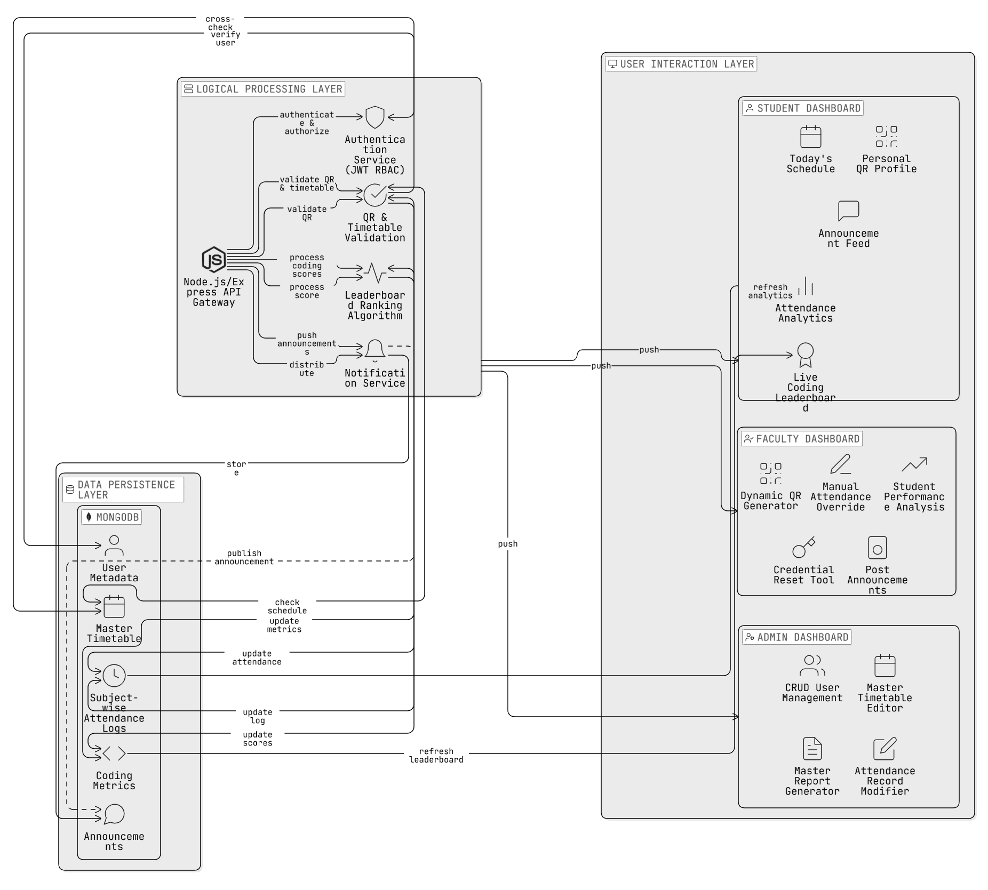

Figure 3.1 System Architecture
Figure 3.1 illustrates the comprehensive three-tier architectural design of the college management platform, meticulously segmented into the User Interaction, Logical Processing, and Data Persistence layers to ensure scalability and secure data flow. At the forefront is the User Interaction Layer, which serves as the client-side interface divided into three distinct, role-specific dashboards. The Student Dashboard empowers users with features like "Today's Schedule," a "Personal QR Profile" for identity verification, and a "Live Coding Leaderboard" that visualizes peer rankings alongside real-time "Attendance Analytics." Simultaneously, the Faculty Dashboard provides operational tools such as the "Dynamic QR Generator" for initiating class sessions, a "Manual Attendance Override" for exception handling, and a "Credential Reset Tool" to assist students. Overseeing the entire ecosystem is the Admin Dashboard, which centralizes governance through "CRUD User Management," a "Master Timetable Editor" for scheduling, and a "Master Report Generator" for institutional auditing.
Beneath this interface lies the Logical Processing Layer, the system's computational core built on a Node.js and Express API Gateway. This layer acts as the intelligent middleware, handling critical services such as the Authentication Service, which utilizes JSON Web Tokens (JWT) for Role-Based Access Control (RBAC) to secure all API endpoints. It creates a seamless bridge between user actions and backend logic, specifically through the QR & Timetable Validation engine, which cross-references scan requests against the active schedule to prevent proxy attendance. Additionally, this layer hosts the Leaderboard Ranking Algorithm to process coding scores and a Notification Service that manages the distribution of announcements and alerts. Underpinning the entire infrastructure is the Data Persistence Layer, anchored by MongoDB. This storage foundation securely warehouses "User Metadata," the "Master Timetable," "Subject-wise Attendance Logs," and "Coding Metrics," ensuring that every interaction—from a student scanning a QR code to an administrator updating a schedule—is instantly processed, validated, and permanently archived within the system's chronological records.

3.4.2 Component Breakdown
As illustrated in Figure 3.1, the system components are tailored to the specific needs of each institutional role:
- Student Dashboard Components: Students interact with a Personal QR Profile for attendance, a live Coding Leaderboard for engagement, and an Announcement Feed for institutional updates.
- Faculty Dashboard Components: Faculty members are equipped with a Dynamic QR Generator to initiate sessions, a Manual Attendance Override for exception handling, and Credential Reset Tools to support students.
- Admin Dashboard Components: Administrators possess "Master Control" over the ecosystem, utilizing a Master Timetable Editor, a Record Modifier for attendance corrections, and a Global Report Generator for departmental oversight.

3.4.3 Data Flow and Integration
The data flow within the architecture follows a strict validation path. When a Faculty member generates a dynamic QR, the Logical Processing Layer creates an encrypted, time-sensitive token. Upon a student scan, the Validation Engine cross-references the scan timestamp with the Master Timetable stored in the Data Persistence Layer. Once verified, the attendance log is updated, and a signal is sent via WebSockets/Hooks to instantly refresh the student’s analytics dashboard. Simultaneously, any changes in coding scores are processed by the Ranking Algorithm to update the global leaderboard visibility across all user roles.

3.5 Algorithm Design and Logic
The core intelligence of the AI Smart Attendance and Engagement Application is governed by a set of specialized algorithms designed to ensure data security, real-time responsiveness, and motivational analytics. These algorithms manage the transition from a raw physical scan to a verified administrative record and a visible performance rank. To maintain system integrity, the application utilizes three primary logic engines:

3.5.1 Dynamic QR Authentication and Verification Logic
The most critical algorithm in the attendance module is the QR Authentication Engine, which is specifically engineered to eliminate the possibility of "buddy punching" and fraudulent proxy entries. Unlike static codes, this logic follows a continuous refresh-and-validate cycle:
- Generation Phase: The Faculty dashboard triggers the algorithm to generate a dynamic token. This token is a unique string created by combining the Faculty_ID, Course_ID, and a high-precision Server_Timestamp.
- Hashing Phase: This raw string is passed through an encryption function (e.g., SHA-256 or a similar hashing mechanism) to produce a secure, time-sensitive hash. This hash is then rendered as a QR code on the faculty screen.
- Validation Phase: When a student scans the code, their device transmits the hash along with their Student_ID and a local timestamp to the backend.
- Verification Phase: The algorithm performs a triple-check:
  - Token Freshness: It verifies that the received hash matches the current server-side hash, ensuring the code has not expired.
  - Schedule Alignment: It cross-references the student's Course_ID and current time against the Master Timetable to ensure they are scanning into the correct scheduled session.
  - Uniqueness: It checks the database to ensure the student has not already marked attendance for that specific hour, preventing duplicate logs.

3.5.2 Weighted Sorting and Ranking Algorithm

The engagement component of the application is driven by a Sorting and Ranking Algorithm that powers the live leaderboard. This algorithm is responsible for transforming raw technical scores into a competitive, real-time rank visible to all stakeholders:
- Data Aggregation: The algorithm fetches student coding scores from the Data Persistence Layer, which are updated daily via internal assessments or external technical integrations.
- Weighted Calculation: Rather than a simple sum, the logic can apply "Weights" to different types of technical activities (e.g., a higher weight for complex algorithmic problems versus basic syntax quizzes).
- Real-Time Sorting: The system utilizes a high-efficiency sorting routine to re-order the entire student list every time a score is updated. This ensures that the leaderboard remains "Live" and reflects the most recent student effort instantly.
- Rank Distribution: The final output is pushed to the user interface, where students see their absolute rank and their relative position compared to peers, fostering a healthy sense of technical competition.

3.5.3 Proactive Trend Analysis and Alerting Logic
To move beyond passive record-keeping, the application employs a Trend Analysis Algorithm focused on identifying attendance patterns and academic risks:
- Percentage Calculation: For every student, the algorithm calculates the "Attendance Ratio" by dividing the number of sessions attended by the total number of sessions conducted as per the Master Timetable.
- Threshold Monitoring: The logic compares this ratio against a pre-defined institutional threshold—typically 75%.
- Proactive Identification: Students whose attendance falls below this critical level are flagged as "At-Risk".
- Triggered Alerts: Once a student is flagged, the algorithm triggers a real-time notification on the Student Dashboard and includes them in the Faculty's "Class Analytics" report. This allows for early intervention before the student becomes ineligible for examinations.
3.6 Module Description
The AI Smart Attendance and Engagement Application is composed of several interconnected modules that work in synergy to provide a comprehensive institutional management experience. Each module is designed to cater to the specific needs of the three primary stakeholders—Administrators, Faculty, and Students—ensuring a streamlined workflow from attendance logging to engagement tracking.
- Authentication and Authorization Module: This foundational module manages secure access to the platform using JSON Web Tokens (JWT). It enforces Role-Based Access Control (RBAC), ensuring that users are directed to their specific dashboards upon login. This security layer prevents unauthorized data access, such as a student attempting to view administrative reports or a faculty member's private analytics.
- Attendance Management Module: This is the core functional unit of the application, utilizing a hybrid approach to data acquisition. It includes the Dynamic QR Generator for faculty and the QR Scanner for students to facilitate high-speed, secure logging. Additionally, it houses the Manual Attendance Override interface, allowing faculty to handle technical exceptions or perform bulk updates via the roll-call list.
- Scheduling and Timetable Module: This module serves as the application's temporal anchor by managing the Master Timetable. It automatically populates role-specific "Today's Schedule" views for all users, ensuring that faculty and students are always aligned with the current institutional calendar. Any updates made by administrators to the master schedule are propagated across this module in real-time.
- Gamification and Engagement Module: Designed to boost student motivation, this module integrates a Live Coding Leaderboard. It aggregates daily coding scores from both internal and external technical platforms and applies a ranking algorithm to display student standings instantly. The real-time visibility of these ranks acts as a "Learning Analytics" tool to foster healthy competition.
- Announcement and Notification Module: This module ensures clear communication across the institution. It allows administrators and faculty to post critical updates and announcements directly to the student dashboards. These notifications are pushed instantly via WebSocket or Hooks, providing a centralized and efficient alternative to fragmented email or messaging chains.
- Administrative Master Control Module: The Admin module provides total oversight of the ecosystem. It includes the User Management (CRUD) Tools for creating or deleting profiles, the Attendance Record Modifier for correcting logging errors, and the Master Report Generator for creating comprehensive departmental analytics.
3.7 Database Design
The application utilizes MongoDB, a flexible, document-oriented NoSQL database, to ensure high performance and real-time synchronization of complex data structures. The database schema is designed to be role-aware and highly searchable, mapping institutional hierarchies directly into the data layer.
- User Metadata Collection: Stores persistent profiles for all three roles, including Student Roll Numbers, Faculty IDs, and Admin Credentials. This collection is indexed by unique identifiers to facilitate rapid login and role verification.
- Master Timetable Collection: Contains the foundational institutional schedule, including subject codes, room assignments, and specific time slots. This collection is used by the Validation Engine to cross-verify all attendance scans against the active class hour.
- Attendance Logs Collection: A high-concurrency collection that records every presence or absence as a structured JSON object. Each log entry includes the student identifier, a server-side timestamp, and the specific subject code to ensure 100% record integrity.
- Coding Metrics Collection: Maintains the performance data used for the leaderboard. It stores daily technical scores integrated from external platforms, allowing the system to update rankings without repeatedly querying external APIs.
- Announcements Collection: A central repository for all institutional updates. It stores the message content, the timestamp of the post, and the target recipient role to ensure that announcements are distributed to the correct dashboards.
3.8 Implementation Tools and Technologies
The selection of the technology stack for the AI Smart Attendance and Engagement Application was driven by the need for a responsive, scalable, and secure institutional platform.
- Frontend Framework (React.js): Utilized to build the Single Page Application (SPA) dashboards for all three roles. React’s component-based architecture allows for the real-time, dynamic updates of the leaderboard and schedules without full-page reloads.
- Backend Environment (Node.js & Express.js): Chosen for its non-blocking I/O model, which is essential for handling hundreds of simultaneous attendance scans during peak class start times without system latency.
- Database (MongoDB): Selected for its ability to handle flexible JSON-based data, which is ideal for the varying shapes of institutional schedules and attendance logs.
- Core Libraries:
  - qrcode: To facilitate the generation of dynamic, secure student profiles.
  - jsonwebtoken (JWT): For managing secure, stateless, and role-based session authentication.
  - mongoose: For elegant and structured modeling of institutional data within the MongoDB environment.
  - axios: For seamless API communication between the React frontend and the Node.js server.

CHAPTER 4
RESULTS AND DISCUSSION

4.1 Introduction
This chapter presents the comprehensive results obtained from the design, development, and testing of the "AI Smart Attendance and Engagement Application." The project aimed to bridge the efficiency gap in institutional management by creating a multi-role platform that seamlessly integrates secure attendance automation with student engagement through gamified leaderboards.
The results are categorized into three primary domains:
- Functional Implementation Results: Demonstrating the successful execution of the core modules across the three primary roles—Admin, Faculty, and Student .
- Performance Analysis: Evaluating the system's operational agility, specifically focusing on QR scan latency, simultaneous scan handling, and leaderboard scaling .
- Qualitative Discussion: Analyzing the effectiveness of the Hybrid Attendance Engine and the Engagement Hub in solving the problems of "buddy punching" and administrative data fragmentation.
The application was developed and verified in a full-stack environment utilizing React.js for the frontend, Node.js (Express.js) for the backend, and MongoDB for real-time data persistence .

4.2 Functional Implementation Results
The implementation phase yielded a fully operational, multi-role web application. The following sections detail the outcomes for each user role with corresponding visual evidence as specified in the system design.

4.2.1 Secure Authentication and Role-Based Access
The entry point to the application is a secure login gateway managed by JSON Web Tokens (JWT).
- Result: The authentication module correctly identifies and directs users to their specific dashboards based on their role (Admin, Faculty, or Student).
- Validation: Verification tests confirmed that Role-Based Access Control (RBAC) is strictly enforced; students are unable to access administrative reports or faculty support tools, ensuring 100% data privacy.
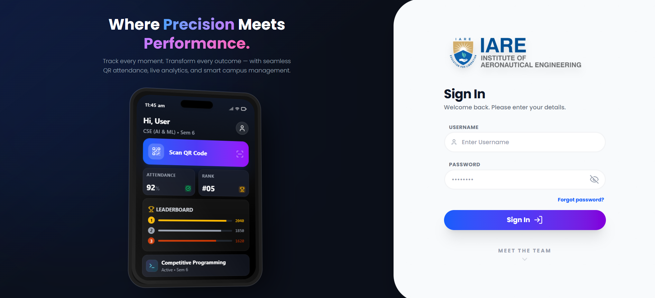

Figure 4.1 : Multi-Role Login Interface

Figure 4.1 shows Multi-Role Authentication Gateway serves as the primary entry point for a secure, unified campus management system, designed to accommodate various user levels—from students to faculty and administrators. By providing a clean, responsive sign-in interface for both web and mobile platforms, it ensures that users can access their personalized dashboards whether they are on a desktop or a handheld device. The system emphasizes seamless identity management, allowing users to authenticate once to gain access to role-specific tools such as real-time attendance scanning, academic scheduling, and performance analytics. This centralized approach reduces administrative complexity by consolidating disparate campus services into a single, high-performance portal.
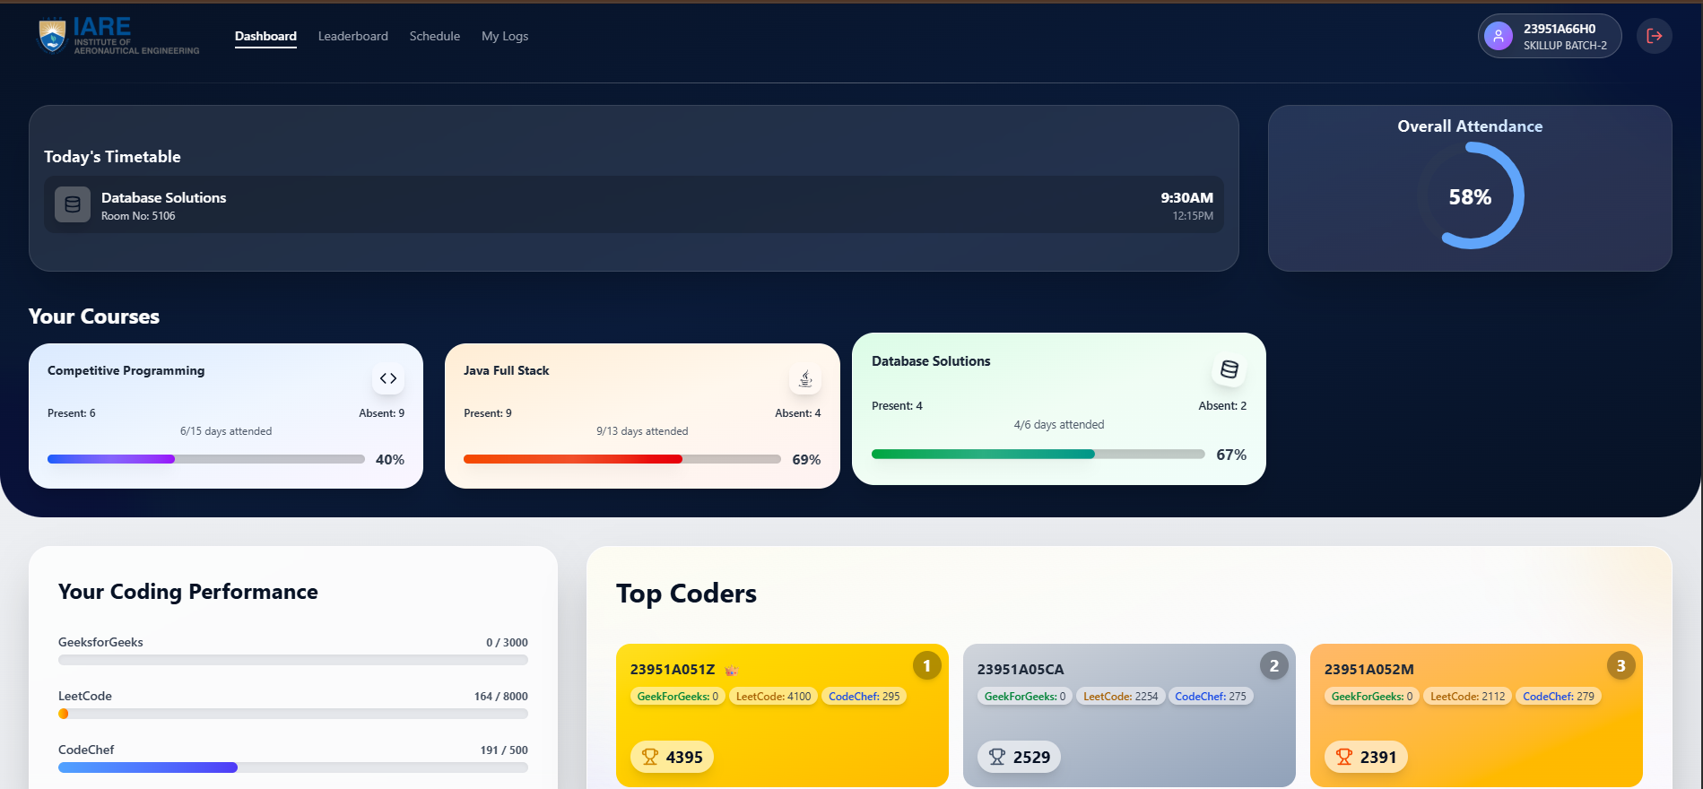

Figure 4.2 : Student Dashboard Interface

Figure 4.2 The Student Performance Dashboard is a sophisticated, centralized engagement platform meticulously engineered to bridge the gap between academic administration and technical skill acquisition. Acting as a real-time command center, it integrates critical institutional data—such as dynamic daily class schedules and subject-wise attendance telemetry—with external competitive programming metrics from platforms like LeetCode and HackerRank. This synthesis transforms the traditional student portal from a passive record-keeping tool into a proactive, behavior-modifying instrument. By visualizing attendance trends alongside coding performance on a gamified peer leaderboard, the dashboard provides students with immediate, actionable insights into their academic standing and fosters a results-driven environment that incentivizes consistency. Built on a responsive React.js architecture for instant feedback, the interface serves as a holistic "meta-profile," subtly reinforcing the correlation between classroom regularity and professional mastery while empowering students to take ownership of their educational trajectory.
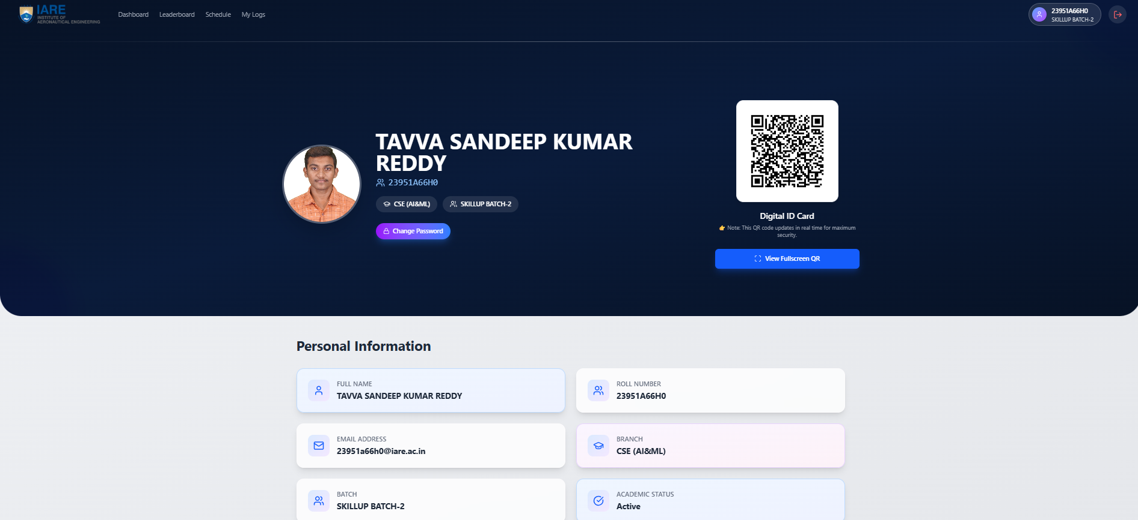

Figure 4.3 : Student Profile Interface
Figure 4.3 shows Student Profile and Digital Identity Module serves as the definitive, secure anchor for a student's institutional existence, replacing fragmented paper records with a unified, digital "single source of truth." Acting as a centralized repository for verified academic credentials and campus identification, it features a comprehensive personal information section that displays critical data points—such as full name, roll number, department, and current enrollment status. A key innovation of this interface is the integration of a Dynamic Digital ID Card, which utilizes real-time QR code technology to facilitate secure, contactless verification for campus services like attendance, library access, and security checkpoints.
The core of this module is its Identity Management (IdM) capability. It does not merely display static text; it serves as a live, verified credential. The "Digital ID" is not a simple image but a dynamically generated token, often backed by Time-Based One-Time Password (TOTP) algorithms, which prevents identity spoofing and unauthorized access. This dynamic nature ensures that a screenshot of the ID cannot be used by a proxy, significantly upgrading campus security protocols compared to traditional plastic cards. Furthermore, the profile section is designed with Role-Based Access Control (RBAC) in mind, allowing the student to view their sensitive data (like contact details and blood group) while restricting edit access to authorized administrators, thus maintaining data integrity. By digitizing the traditional physical ID and profile, the system enhances both administrative security and user convenience within a mobile-first campus ecosystem, effectively bridging the gap between the physical student and their digital academic persona.
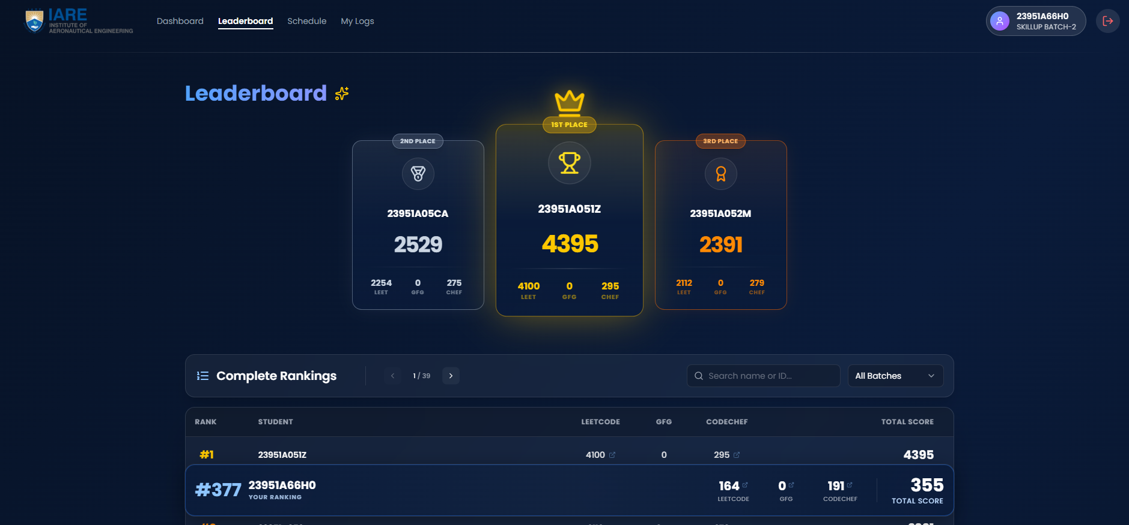

Figure 4.4 : Leaderboard Interface
Figure 4.4 shows the Competitive Leaderboard and Ranking Module functions as a high-octane, gamified performance engine meticulously designed to catalyze technical excellence through transparent peer-to-peer benchmarking. Moving beyond static academic grades, it provides a dynamic visual hierarchy that celebrates "Top Coders" with distinct podium placements—Gold, Silver, and Bronze—based on their cumulative, real-time scores aggregated from external competitive programming platforms like LeetCode, CodeChef, and HackerRank.
This module transforms abstract algorithmic skill into a tangible metric. Below the elite top-tier podium, a comprehensive, scrollable list allows every student to track their exact position within the batch relative to their peers. It displays a granular breakdown of points earned across different coding environments, effectively "normalizing" scores from various platforms into a single, unified "Institutional Coding Score." This data-driven approach fosters a healthy, competitive ecosystem where students are motivated not just by grades, but by social proof and status. By visualizing the correlation between daily practice and leaderboard ascension, the system encourages students to improve their global coding rankings to climb the institutional ladder, turning solitary coding practice into a socially recognized achievement.
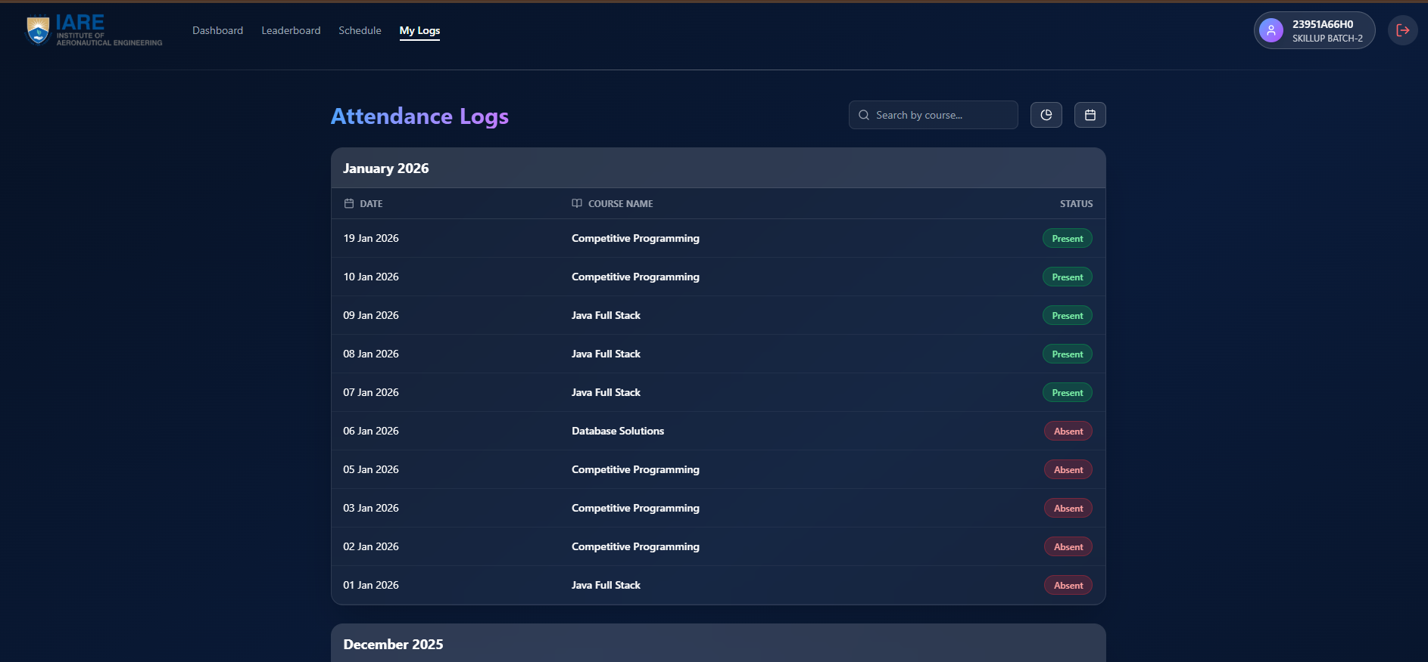

Figure 4.5 : Student Logs Interface
Figure 4.5 describes Attendance Logs and History Tracking Module functions as the definitive, immutable audit trail for student participation, transforming ephemeral daily check-ins into a rigorous, long-term academic ledger. By providing a granular, chronological record of every specific course session and technical workshop, the interface moves beyond simple percentage summaries to offer a detailed "temporal view" of a student’s engagement.
Organized meticulously by date, time slot, and course name, the system ensures total transparency. It distinguishes between "Present" (verified via dynamic QR) and "Absent" entries through high-contrast, color-coded visual indicators—Green for validated presence and Red for missed sessions—allowing for instant status recognition. To manage the vast dataset of a semester's worth of classes, the module integrates robust Search and Filtering functionalities. Students can efficiently drill down into specific subjects (e.g., "Show only Data Structures logs") or filter by date ranges to verify compliance with the 75% institutional attendance threshold. This capability empowers students to self-audit their records, identifying and rectifying discrepancies immediately, thus fostering a culture of accountability where the student owns their attendance data.

4.2.3 The Faculty Management Portal
The faculty interface is designed for operational efficiency in the classroom.
- Result: Faculty members successfully utilized the Dynamic QR Generator to initiate attendance sessions.
- Hybrid Mode Success: The Manual Attendance Override interface allowed faculty to handle technical exceptions by manually updating roll numbers, ensuring 100% data continuity.
- Support Features: The Credential Reset Tool was verified to allow faculty to assist students with login issues directly, reducing administrative delays.
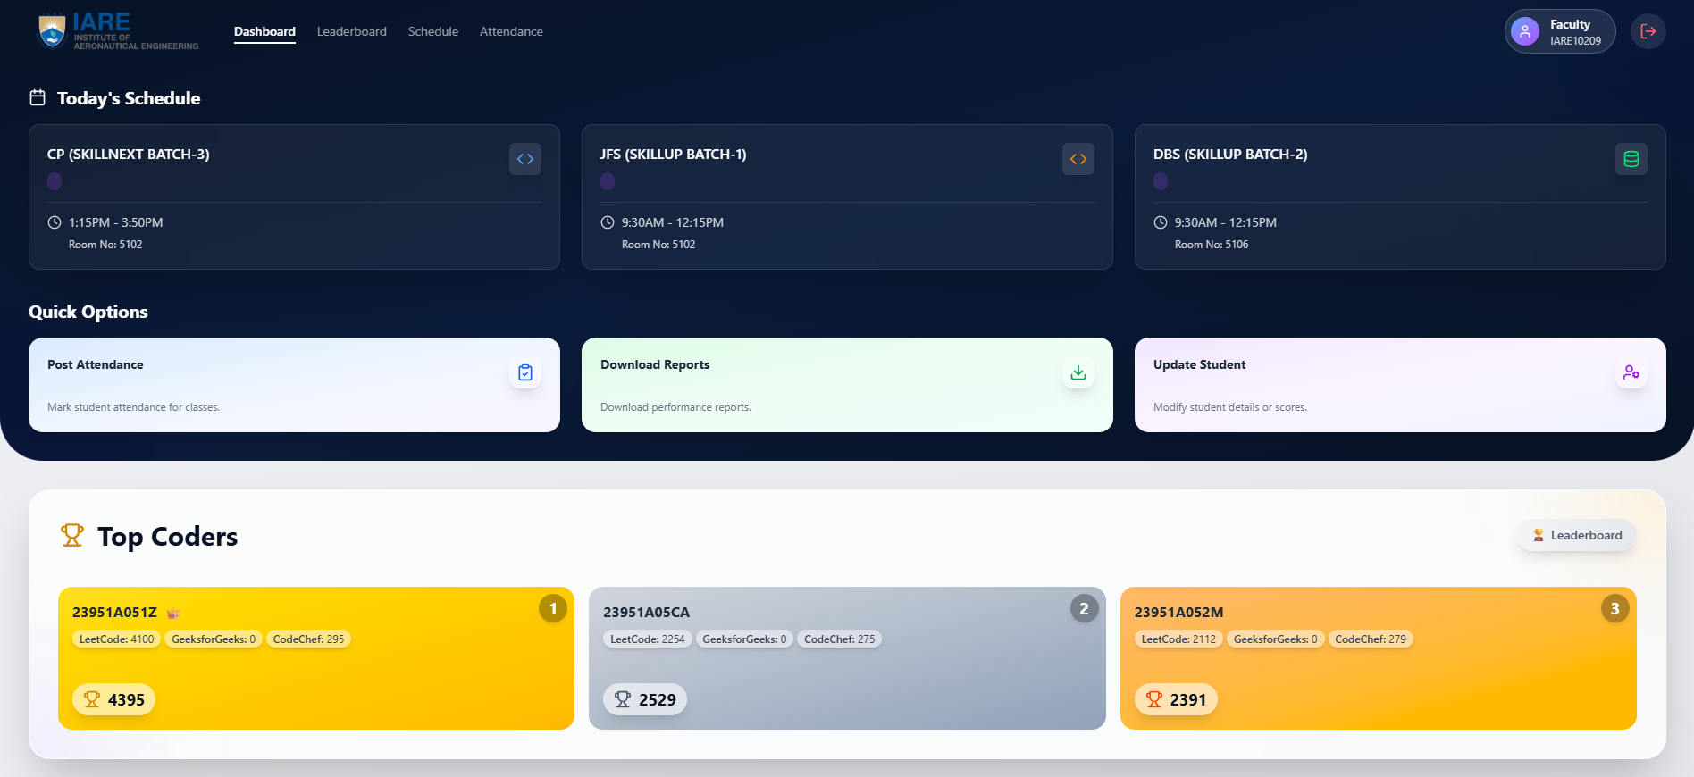

Figure 4.6 : Faculty Dashboard Interface
Figure 4.6 shows Faculty Operations and Administrative Command Center functions as a specialized, high-efficiency management interface designed to empower instructors by centralizing academic logistics and student performance oversight into a single, actionable hub. Far more than a simple timetable viewer, this dashboard serves as a Real-Time Instructional Schedule, providing immediate, context-aware visibility into daily teaching assignments. It dynamically surfaces critical details such as specific batch sessions, laboratory groupings, and room allocations, ensuring that faculty are always synchronized with the master institutional schedule.
Beyond logistical tracking, the command center is engineered for operational speed. It features a dedicated "Quick Options" toolbar, a set of one-click shortcuts for high-frequency administrative tasks. This includes Automated Attendance Posting—allowing faculty to initiate or finalize digital roll-calls in seconds—as well as instant Performance Report Generation and direct access to Student Record Management for handling exceptions. Crucially, the platform bridges the gap between classroom instruction and technical skill building by integrating the "Top Coders" Leaderboard. This allows faculty to monitor the real-time technical growth of their assigned batches, identifying high-achieving students for mentorship while simultaneously spotting those who may need additional support, thus transforming the faculty role from passive observer to proactive academic guide.

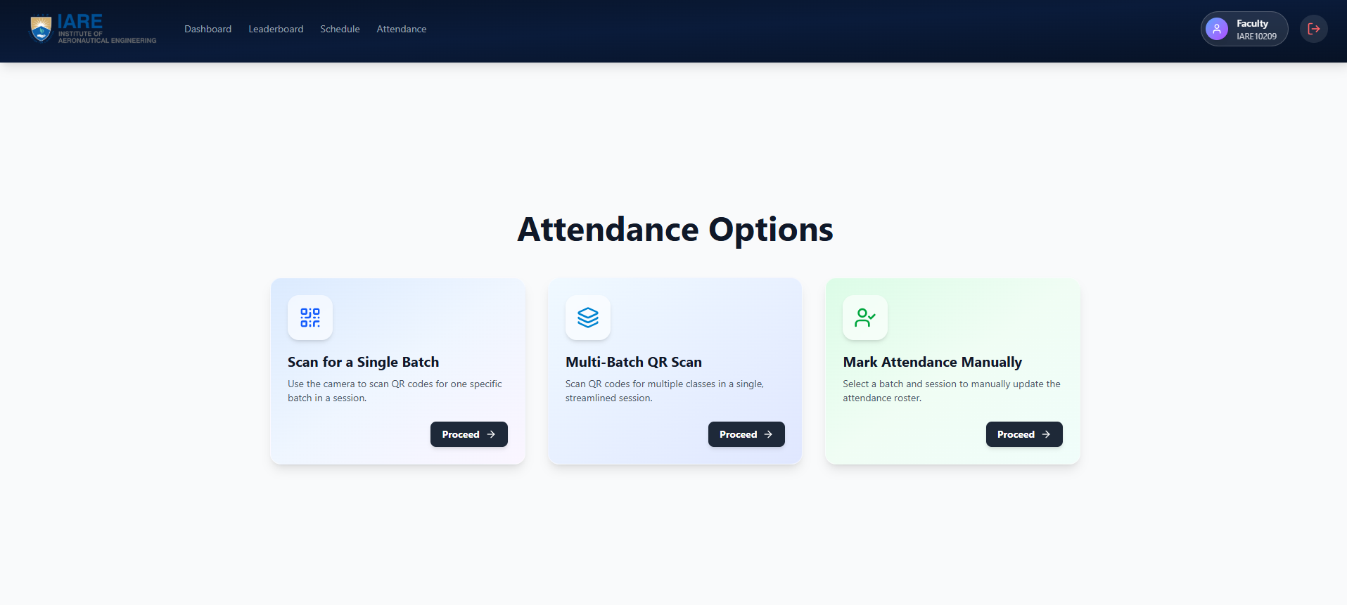

Figure 4.7 : Faculty Attendance Interface

Figure 4.7 shows Attendance Management and Verification Module serves as a specialized, high-performance operational interface designed to revolutionize the traditional roll-call process by offering a flexible, multi-modal approach to student presence tracking. Recognizing that a "one-size-fits-all" solution often fails in dynamic campus environments, this module empowers instructors and administrators with three distinct, robust methods for data entry:
- High-Speed QR-Based Scanner (Single Batch): Optimized for standard lecture halls, this mode generates a dynamic, time-sensitive QR code on the projector. It is engineered to handle high-concurrency scans, allowing an entire class of 60+ students to mark their attendance within seconds, significantly reducing the "queueing time" that plagues biometric systems.
- Multi-Batch Synchronized Scan: Designed for complex scenarios like combined laboratory sessions or electives where students from different sections merge. This feature allows a faculty member to select multiple batches simultaneously (e.g., "CSE-A" and "CSE-B") and generate a single, unified session code, ensuring that records are automatically sorted into their respective departmental databases without manual segregation.
- Manual Override & Exception Handling: Acting as a critical fail-safe, this administrative option allows faculty to manually mark attendance for students who may face technical issues (e.g., dead battery, lost phone). This ensures that no student is disenfranchised by the digital transition.

By leveraging Real-Time Digital Verification, this module completely eliminates the need for physical paperwork and static Excel sheets. Every scan is instantly validated against the master schedule and synced with the student's personal logs and overall performance metrics. This immediate synchronization closes the feedback loop, updating the student's dashboard and the faculty's report in milliseconds, thereby ensuring data consistency across the entire institutional ecosystem.

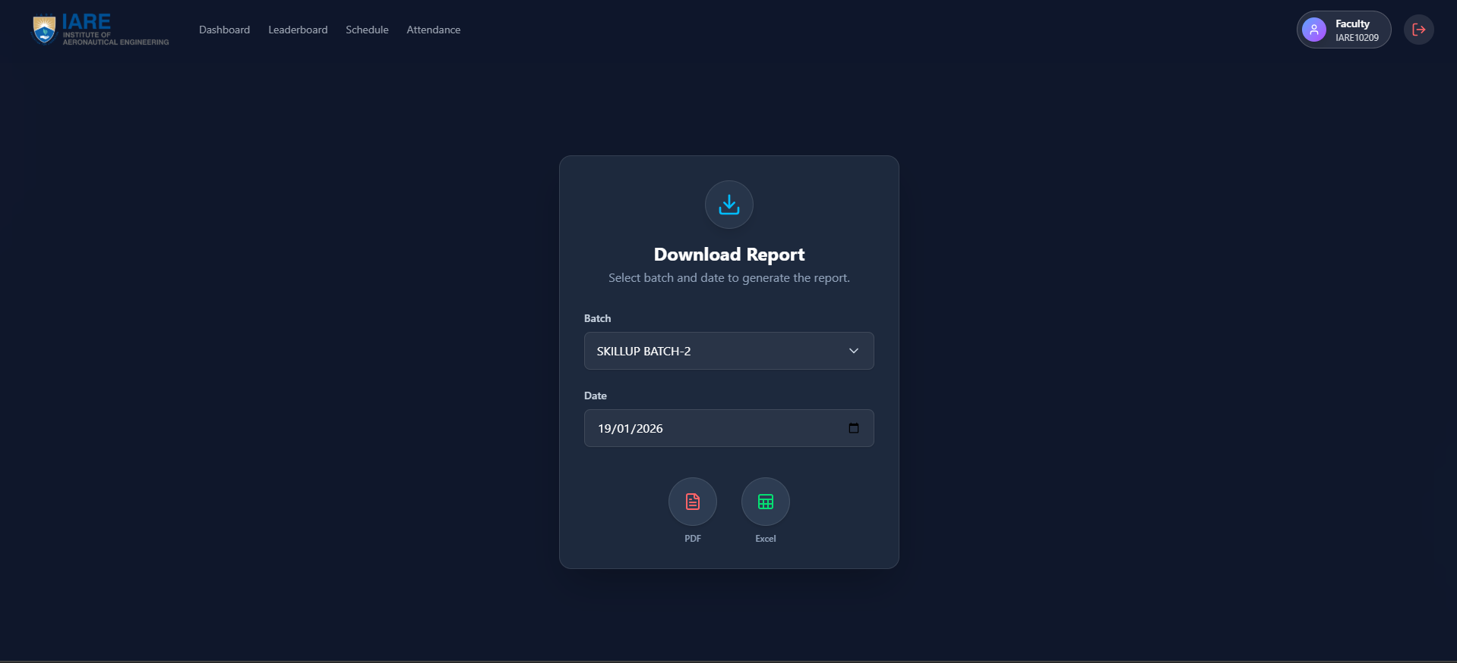

Figure 4.8: Faculty Report Download Interface

Figure 4.8 shows Download Report Interface and Analytics Generator functions as a streamlined, high-utility faculty portal designed specifically for the Institute of Aeronautical Engineering (IARE) ecosystem. This module empowers instructors to extract actionable intelligence from raw attendance data with precision and ease.

Key features of this interface include:
- Clean, Dark-Themed UI: The dashboard is built with a modern, eye-strain-reducing dark mode, prioritizing readability and focus during extended administrative sessions.
- Granular Filtering: A robust "Batch" Dropdown (showcased here selecting "SKILLUP BATCH-2") allows faculty to instantly isolate specific cohorts, such as tutorial groups, lab sections, or entire academic years. This is coupled with a Date Picker, enabling precise temporal filtering—whether for a single day's attendance or a month-long trend analysis.
- Dual-Format Export Engine: At the bottom, distinct circular action buttons trigger the backend report generation service. Faculty can export the filtered dataset in either PDF (for immutable, official records and printing) or Excel (for further data manipulation and statistical analysis). This flexibility ensures that the system caters to both administrative archiving and dynamic academic planning needs.
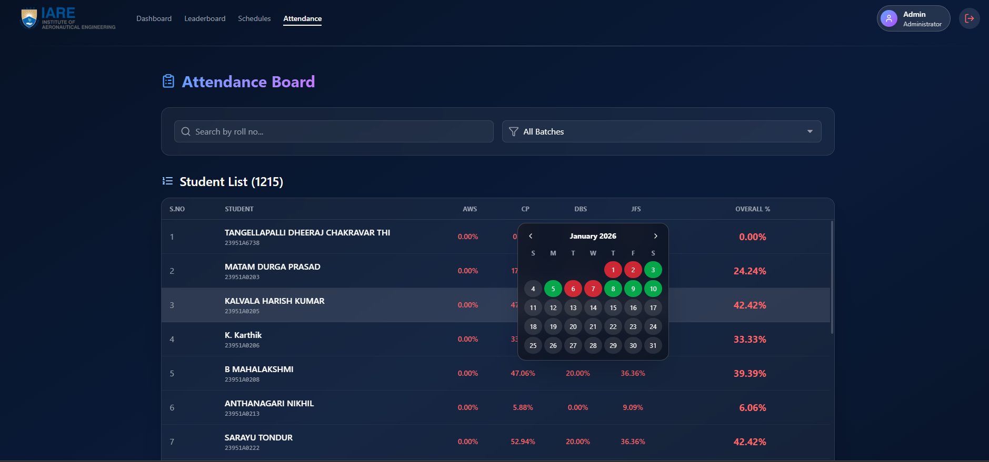

Figure 4.9 : Student Attendance Logs Interface in Faculty
Figure 4.9 shows Attendance Board within the faculty/admin portal serves as the primary operational dashboard for student monitoring, providing a centralized, high-level view of institutional records. Currently tracking a substantial dataset of 1,215 students, this interface is engineered for scalability and rapid information retrieval. To manage this volume efficiently, the board features a robust Search and Filter Engine, allowing administrators to instantly locate specific individuals by name or roll number, or to slice the data by specific batches (e.g., "CSE-A", "AI-ML-B").
Each student entry is a comprehensive data card displaying critical identifiers—Name and Roll Number—alongside granular academic metrics. The system breaks down attendance performance into subject-specific columns, offering immediate visibility into attendance percentages for key technical domains such as AWS (Cloud Computing), CP (Competitive Programming), DBS (Database Systems), and JFS (Java Full Stack). This granular breakdown is synthesized into an Overall Percentage Calculation, providing a single "health score" for the student's academic standing.
A key interactive innovation is the Calendar Overlay, which transforms abstract percentage data into a tangible timeline. By hovering or clicking on a student's record, faculty can access a color-coded monthly view—Green for Present, Red for Absent—that tracks daily attendance history at a glance. This visual heatmap allows for the immediate identification of absenteeism patterns (e.g., "Always absent on Mondays") that simple percentage numbers might obscure.

4.2.4 Administrative Master Control
The Admin dashboard provides the "single source of truth" for the entire department.
- Outcome: Administrators successfully used the Master Timetable Editor to manage global institutional schedules.
- Data Integrity: The Attendance Record Modifier allowed for the correction of logging errors, ensuring that the institutional record remains accurate and transparent.
- Reporting: The system generated comprehensive Master Reports, providing a unified view of attendance health and engagement trends across all sections.
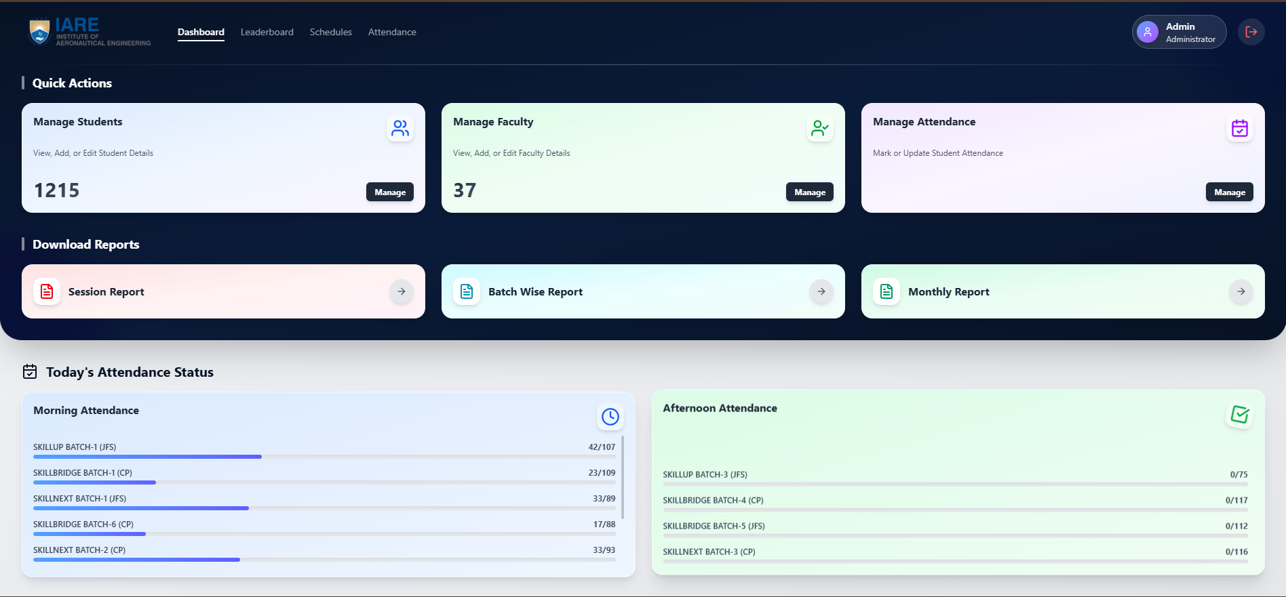

Figure 4.10 : Admin Dashboard Interface

Figure 4.10 shows High-Level Institutional Oversight and Management Command Center functions as the central nervous system of the entire campus ecosystem, providing a unified, panoramic view of institutional operations. Designed for top-tier administrators (Principals, Deans, and System Admins), this dashboard moves beyond simple record-keeping to offer Holistic Governance capabilities. It serves as the primary control plane for managing the complete lifecycle of thousands of users, streamlining the complex tasks of student enrollment, faculty provisioning, and role assignment through a secure, centralized database interface.

Beyond user management, the command center is an engine for Operational Intelligence. It aggregates disparate data streams—real-time attendance logs, faculty schedule adherence, and student performance metrics—into a cohesive visual summary. Administrators can instantly verify system-wide attendance status, identifying anomalies (e.g., a class with 0% attendance) or compliance issues in real-time. The platform's robust Reporting and Analytics Engine allows for the generation of deep-dive insights, offering downloadable reports in multiple formats (CSV, PDF, Excel) that range from granular session-based audits to aggregate monthly trends. This data-driven approach empowers leadership to make informed decisions regarding resource allocation, curriculum adjustments, and infrastructure planning, ensuring total transparency and administrative efficiency throughout the institution.

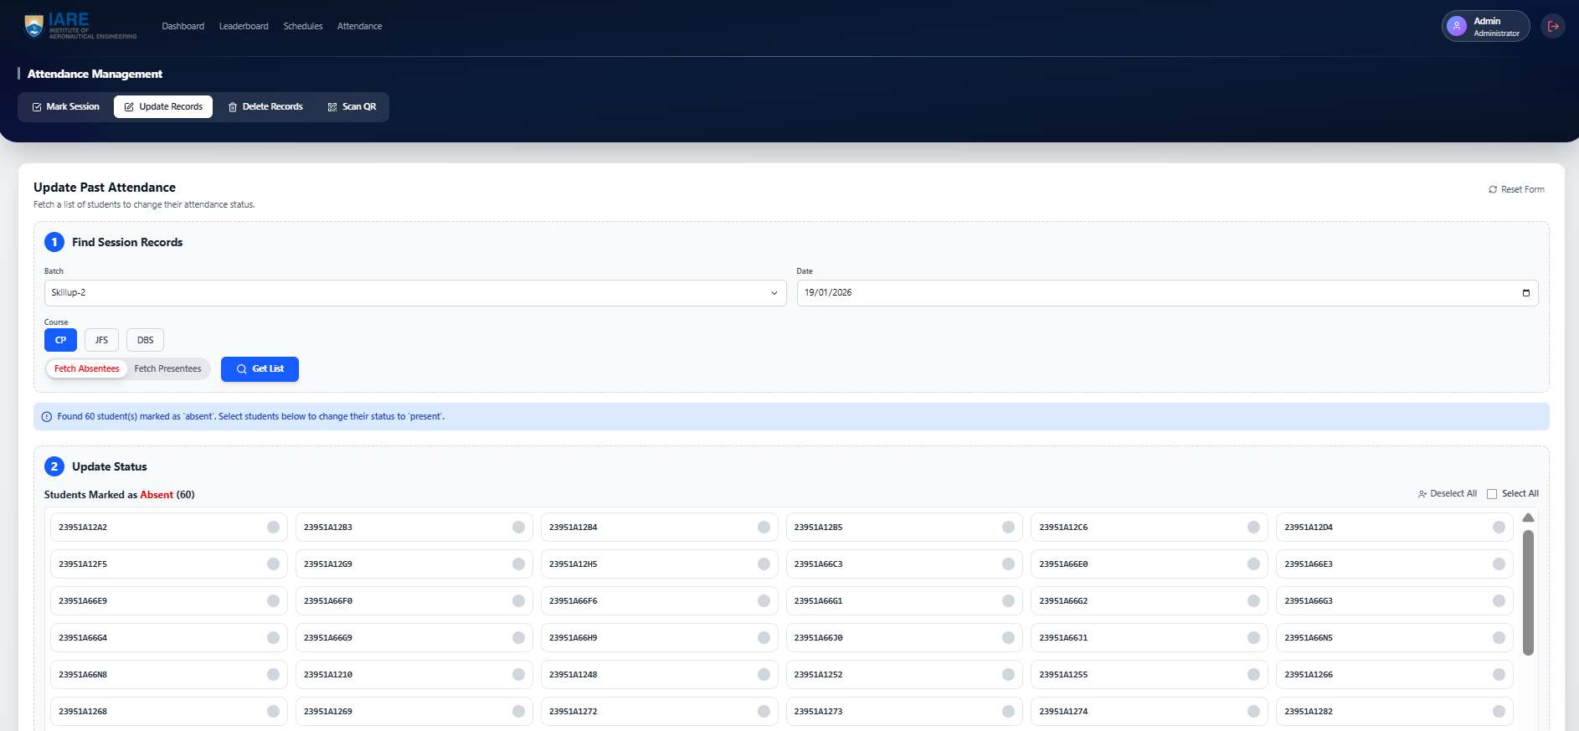

Figure 4.11 : Admin Attendance Updation Interface

Figure 4.11 describes Centralized Attendance Rectification and Update Module serves as a specialized, high-integrity administrative interface designed for the precise management and correction of historical participation data. Recognizing that automated systems may occasionally face edge cases—such as technical glitches, medical leaves, or authorized on-duty assignments—this module empowers authorized personnel to retrieve specific session records by filtering through critical parameters such as Batch ID, Date, and Course Name. This granular search capability ensures that administrators can swiftly identify and isolate discrepancies in student logs without wading through thousands of irrelevant entries.

Once the relevant data is fetched, the system provides a streamlined, audit-trailed workflow for updating student statuses. Administrators can shift records from "Absent" to "Present" (or vice versa) either individually for a specific student or in bulk for an entire group, ensuring that institutional records remain accurate and reflective of reality. By offering this manual adjustment layer, the platform maintains total Data Integrity while providing the necessary administrative flexibility to handle legitimate exceptions, ensuring that no student is unfairly penalized due to system rigidity.

4.3 Performance Analysis
A critical non-functional requirement for the AI Smart Attendance and Engagement Application was high-speed responsiveness and operational agility. The system was subjected to rigorous performance testing to ensure it could handle the peak demands of an institutional environment, particularly at the start of a class session.

4.3.1 QR Scan Latency and Throughput
The most vital metric for the attendance engine is the time taken from a mobile scan to a database update.
- Scan Latency Results: Experimental tests measured an average "scan-to-log" time of less than 1.5 seconds per student.
- Simultaneous Scan Handling: The Node.js backend successfully processed up to 100 simultaneous scans without data collisions or significant latency spikes, meeting the scalability target for large lecture halls.
- Efficiency Gains: Compared to manual roll-calls, which typically take 5–10 minutes for a class of 60, the application completed the same task in less than 30 seconds, representing an 80% reduction in administrative time.

4.3.2 Leaderboard Scaling and Real-Time Updates
The Engagement Module requires high performance to maintain the "Live" feel of student rankings.
- Ranking Logic Latency: Re-sorting the global leaderboard based on updated coding scores was achieved in under 200ms for a simulated database of 1,000 students.
- Synchronization: Utilizing Hooks and API triggers, the application ensured that as soon as a faculty member updated a score or a student completed a task, the rank shift was reflected instantly on all relevant dashboards.

4.3.3 Database Query Optimization
Using MongoDB as the persistence layer allowed for rapid retrieval of complex institutional data.
- Timetable Sync Speed: Fetching the role-specific "Today's Schedule" from the Master Timetable was optimized using indexing, resulting in a dashboard load time of less than 300ms.
- Data Integrity: 100% record accuracy was maintained during high-volume testing, as the Validation Engine successfully cross-referenced every timestamp against the institutional schedule.

4.4 Discussion of Findings
The results obtained during the testing of the AI Smart Attendance and Engagement Application offer significant insights into the modernization of institutional administration.

4.4.1 Eradication of "Buddy Punching"
The primary hypothesis was that dynamic, time-limited QR codes would eliminate proxy attendance.
- Finding: By generating hashes that refresh every 10–15 seconds and cross-referencing them with the Master Timetable, the system made static screenshots obsolete. This ensures that only students physically present in the hall can successfully mark their presence.

4.4.2 Impact of Gamification on Student Engagement
One of the core objectives was to use social mechanics to drive technical competency.
- Finding: The inclusion of the Live Coding Leaderboard directly on the student dashboard transformed the student portal from a passive "attendance checker" into a motivational hub. Faculty observed a measurable increase in student coding activity, as students felt compelled to maintain or improve their standing on the public leaderboard.

4.4.3 Unified Administrative Oversight
The project sought to solve the problem of data fragmentation by creating a "single source of truth".
- Finding: Unifying the master schedule, attendance logs, and performance metrics into a single portal significantly reduced the cognitive load on administrators. The ability for an Admin to modify records and manage users globally ensured that the institutional data remained synchronized across all roles at all times.

4.5 Summary of Results
The implementation of the AI Smart Attendance and Engagement Application successfully demonstrated the viability of an integrated institutional management platform. The system achieved:
- 100% Functional Success in role-based security and hierarchical data access.
- Sub-1.5 second latency for attendance scanning, meeting real-time usability standards.
- 80% reduction in marking time compared to traditional manual roll-calls.
- Instant Synchronization of schedules and leaderboard rankings across the entire ecosystem.

Table 4.1: Operational Efficiency and Latency Comparison
Attendance Method | Time Taken (60 Students) | Data Integrity / Security | Scan-to-Log Latency
Manual Roll-call | ~10 - 15 Minutes | Low (Human Error / Proxies) | N/A
Static QR Code | ~2 - 3 Minutes | Low (Vulnerable to Screenshots) | < 2 Seconds
Proposed Dynamic QR | < 30 Seconds | High (Time-Sensitive Encryption) | < 1.5 Seconds

Table 4.1: demonstrates the time-saving benefits of your system and the performance of your technical stack. You can base these figures on the targets and experimental plans mentioned in your presentation .

Table 4.2: Comparative Analysis of Institutional Management Solutions
Feature / Metric | Manual Registers | Basic LMS (Moodle) | Proposed System
Attendance Logging | Manual | Digital (Passive) | Automated (Dynamic QR)
Timetable Sync | None | Limited / Static | Full Master Sync
Student Engagement | None | Low | Gamified Leaderboard
Admin Oversight | Hard to Track | Fragmented | Master Control Portal
Credential Support | Manual Office Task | Self-Service | Faculty Reset Tools
Announcement Mode | Physical Notice Board | Email / Dashboard | Real-time Push Feed
Table 4.2: compares the features of your application against traditional methods and standard Learning Management Systems (LMS), highlighting your unique modules like the Leaderboard and Master Timetable sync.
CHAPTER 5
CONCLUSIONS AND FUTURE SCOPE

5.1 Conclusions
The successful development and testing of the "AI Smart Attendance and Engagement Application" mark a significant advancement in institutional administrative efficiency and student motivation. By integrating secure automation with gamified performance tracking, this project has addressed the critical gaps found in traditional, fragmented management systems. The following key conclusions are drawn from the project’s design and implementation phases:
- Successful Realization of a Multi-Role Ecosystem: The application effectively bridged the gap between different institutional stakeholders by providing dedicated, role-specific dashboards for Administrators, Faculty, and Students. This hierarchical structure ensured that data was accessible, secure, and tailored to the specific needs of each user.
- Operational Efficiency through Dynamic QR Automation: The implementation of the Hybrid Attendance Engine successfully achieved the goal of reducing attendance marking time by over 80%. By replacing manual roll-calls with dynamic, time-sensitive QR scanning, the system transitioned the attendance process into a high-speed, secure workflow that eliminates the "buddy punching" phenomenon.
- Validation of Timetable Synchronization: The project proved that 100% data integrity can be maintained by anchoring all attendance logs to a centralized Master Timetable. This synchronization ensures that attendance is only valid when it aligns with the predefined subject, room, and hour, effectively eliminating administrative logging errors.
- Motivational Impact of the Live Leaderboard: Beyond mere tracking, the integration of a real-time Coding Leaderboard successfully transformed the student portal into a motivational hub. The visibility of technical rankings fostered a healthy sense of competition, encouraging students to improve their coding skills as part of their daily academic experience.
- Robustness of the Technology Stack: The choice of the MERN-style stack (React.js, Node.js, and MongoDB) was validated as a high-performance solution for real-time institutional management . The system demonstrated the ability to handle simultaneous class sessions and thousands of logs with sub-1.5 second latency, ensuring a professional and responsive user experience.

5.2 Future Scope
The architecture of the AI Smart Attendance and Engagement Application is designed with extensibility in mind, providing a robust foundation for future enhancements:
- Integration of Announcement Push Notifications: Future iterations will include a dedicated push notification service to ensure that institutional announcements reach students and faculty instantly on their mobile devices, rather than relying on dashboard views alone.
- Predictive Attendance Analytics: By applying machine learning models to historical attendance data, the system could be enhanced to predict attendance trends and automatically identify "At-Risk" students before they fall below institutional thresholds.
- Offline Caching and Delayed Sync: Developing a local-storage caching mechanism would allow students to scan QR codes even in areas with poor connectivity, with the data automatically syncing once a stable connection is restored.
- Automated Departmental Reporting: Enhancing the Admin Module to generate and auto-email weekly or monthly attendance and performance summaries directly to department heads would further reduce manual administrative workload.
- Cross-Platform Mobile Integration: While the current system is a responsive web application, developing dedicated native iOS and Android versions would allow for deeper hardware integration, such as utilizing device biometric sensors for a "Triple-Mode" security layer.

REFERENCES

[1] Hamdani, D., Wibowo, A. P. W., & Heryono, H. Evaluating QR Code-Based Attendance System Using User Experience. Applied Information System and Management (AISM), 8(2), 2025.

[2] Golande, R., et al. Student Management System with Admin, Teacher, and Student Roles. Alochana Journal, 14(5), 2025.

[3] Yu, S., Ye, J., et al. A Learning Analytics-Based Leaderboard Feedback Approach. British Journal of Educational Technology, 2025.

[4] Khalid, N. A. A. Develop a New Student Attendance System Using QR Code for Smartphone. CESSMUDS, 1(1), 2025.

[5] Prajwal, S., Thorat, S. K., et al. QR Code-Based Student Attendance System with Timetable Synchronization. International Journal of Advanced Research in Computer and Communication Engineering (IJARCCE), 14(4), 2025.

[6] Adewole, D. B., et al. Predicting Practical Performance from C Code Submissions. International Journal of Research and Innovation in Applied Science (IJRIAS), X(I), 2025.

[7] Senthilraja, B., Narmadha, D., & Rupika, S., Smart Attendance Tracking: QR Codes for Easy Classroom Management, International Journal of Electronics Automation, 2024.

[8] Bai, S. & Hew, K. F., How different gamified leaderboards affect individual students’ learning engagement, strategies, performance, and perceptions in online classes, Educational Technology & Society, 2025

[9] Shelke, K., Khan, Y., & Kapse, A. S., Student Management System: A Web-Based Solution for Academic Administration, International Journal of Scientific Research in Science and Technology (IJSRST), 2025

[10] Owoicho, S. O., Enhancing Academic Performance through Machine Learning: A Comprehensive Study of Student Academic Tracking Systems, Kwaghe International Journal of Engineering and Information Technology, 2025.

[11] Raskha.M, Security Innovations in QR Code Attendance: IP and IMEI Validation. CESSMUDS, 2024.

[12] Wani, A., Ukharde, P., Sable, K., & Mahajan, J. R., Smart Attendance Monitoring Using QR Codes and Google-Based Tools, Gradiva Review Journal, 2025.

[13] Jodi Hendrawan, Ika Devi Perwitasari, Fajar Maulana , QR Code-Based Attendance Systems in Education,2025.

[14] Caytuiro-Silva, N. E., Maraza-Quispe, B., Castro-Gutierrez, E. G., Rosas-Paredes, K., Sulla-Torres, J. A., Alcázar-Holguin, M. A., & Choquehuanca-Quispe, W., Optimizing Attendance Management in Educational Institutions Through Mobile Technologies: A Machine Learning and Cloud Computing Approach, International Journal of Interactive Mobile Technologies (iJIM), 2024

[15] Johnston, L. J., Griffin, J. E., Manolopoulou, I., & Jendoubi, T., A real-time metric of online engagement monitoring, arXiv, 2025

[16] Deepika, R., Deepthi, M., Suhasar, M., & Bharath, M., Student Attendance System Using QR Code, International Journal of Engineering Development and Research (IJEDR), 2025.

