COLOR PICKER TOOL USING HTML5 AND JAVASCRIPT

BY SANDEEP SHARMA

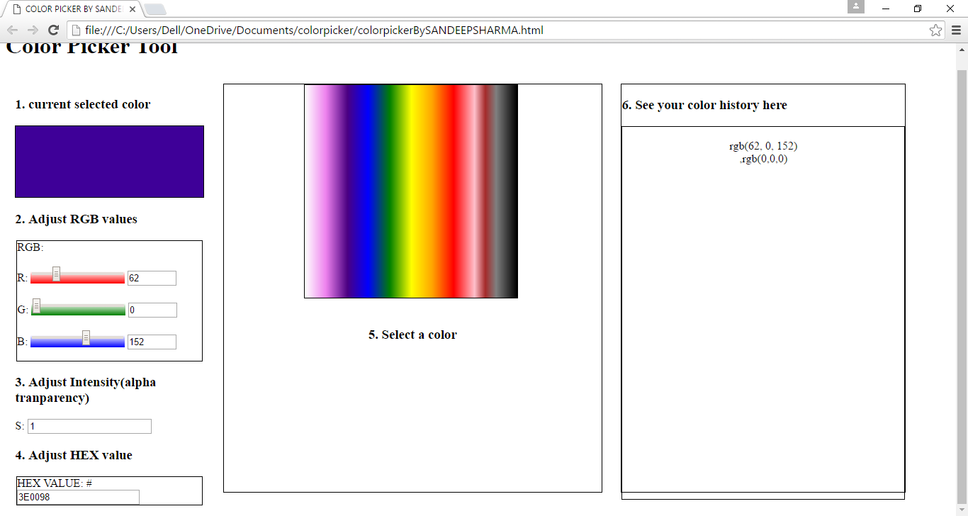

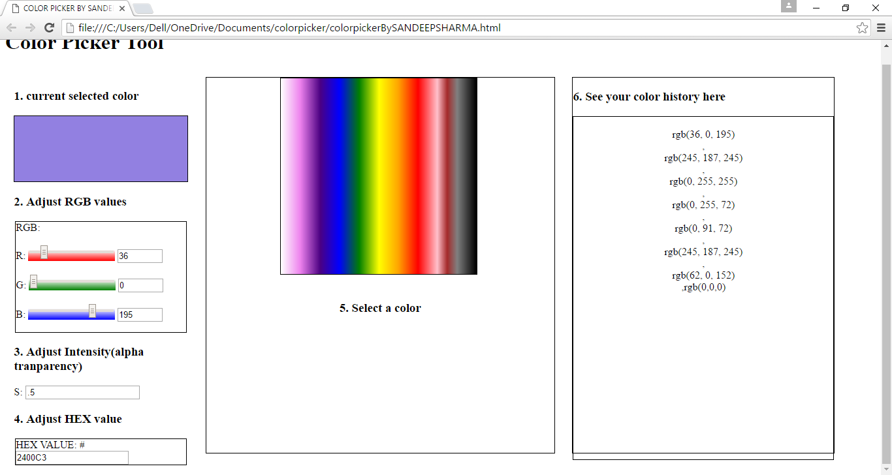

Description

1 : A Div to show the ‘current selected color’ chosen via color dial(1), RGB Slider(2), Intensity Slider(3) or Hex input(4).

2 : RGB slider to choose color with different RGB values.

3 : Sliders to adjust intensity(alpha Transparency)

It can accept value from 0.0 to 1.0 (0.0 being the total white color

and 1.0 being the full color)

4 : Color code panel: to input Color HEX Code Manually.

5 : Color Box (interactive)

Mouse Up on the color from the color box to select it

6 : Color history: It contains list of colors previously added by the user from Color Dial (5) or from Color Div (1) in rgb Format.