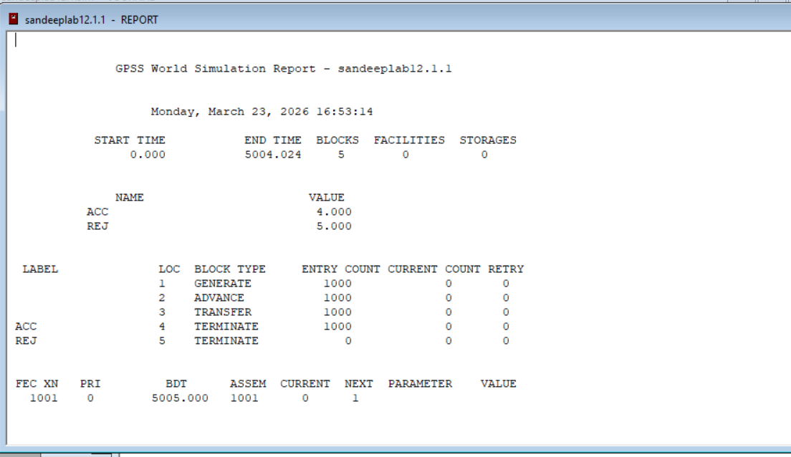
Output:

Output:

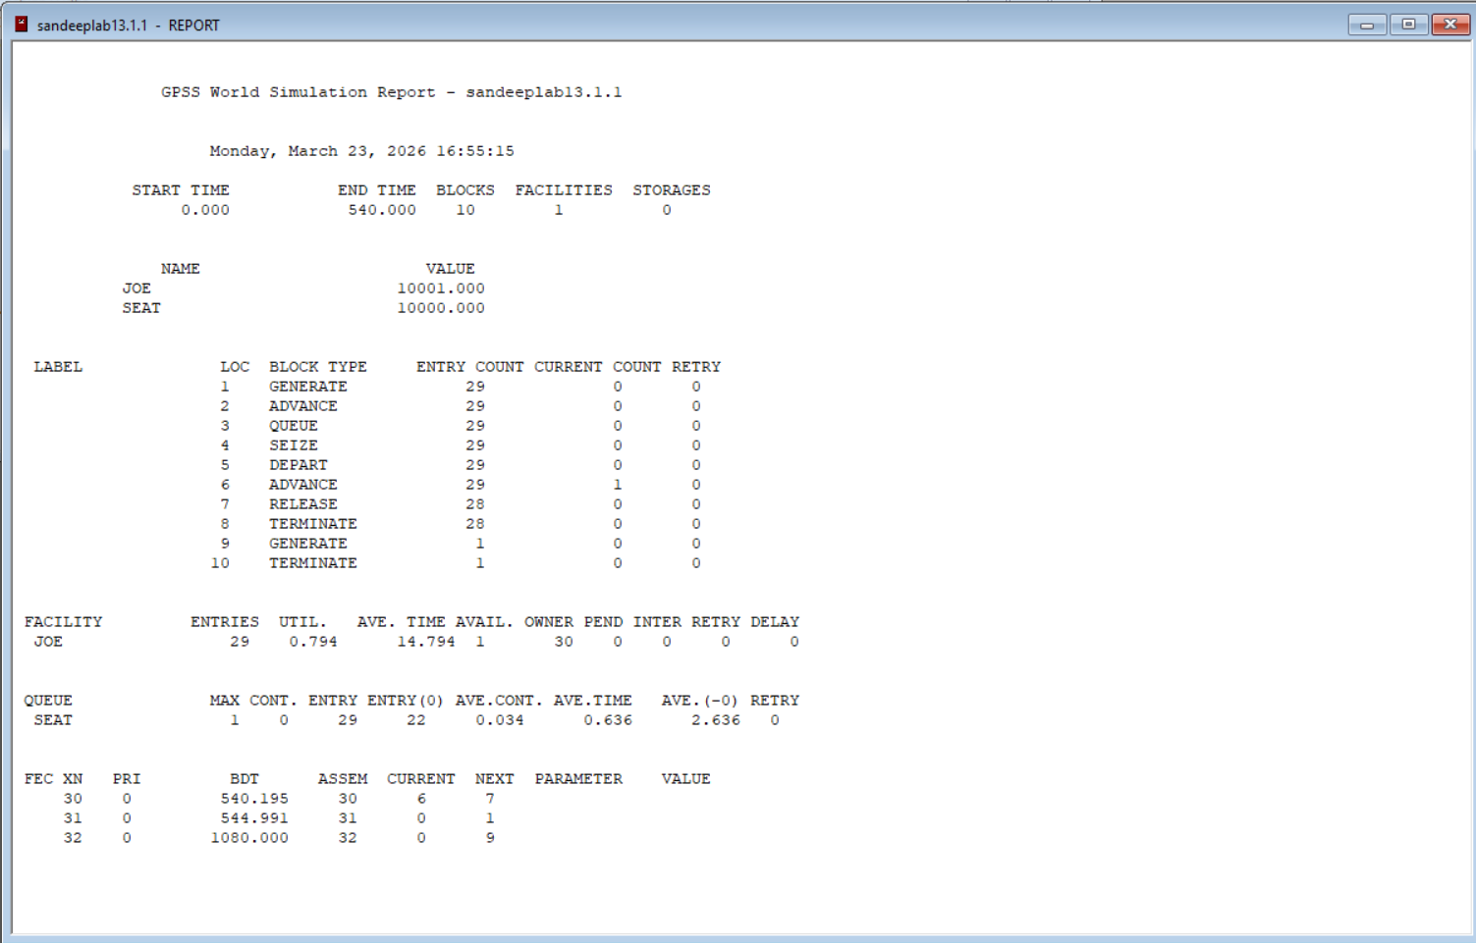

Output:

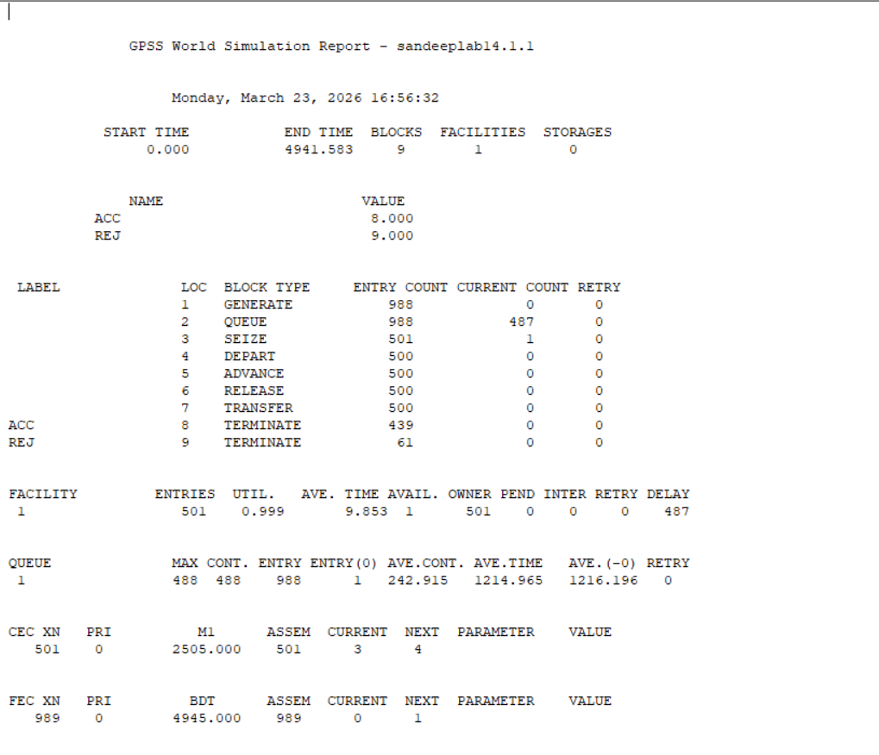

Output:
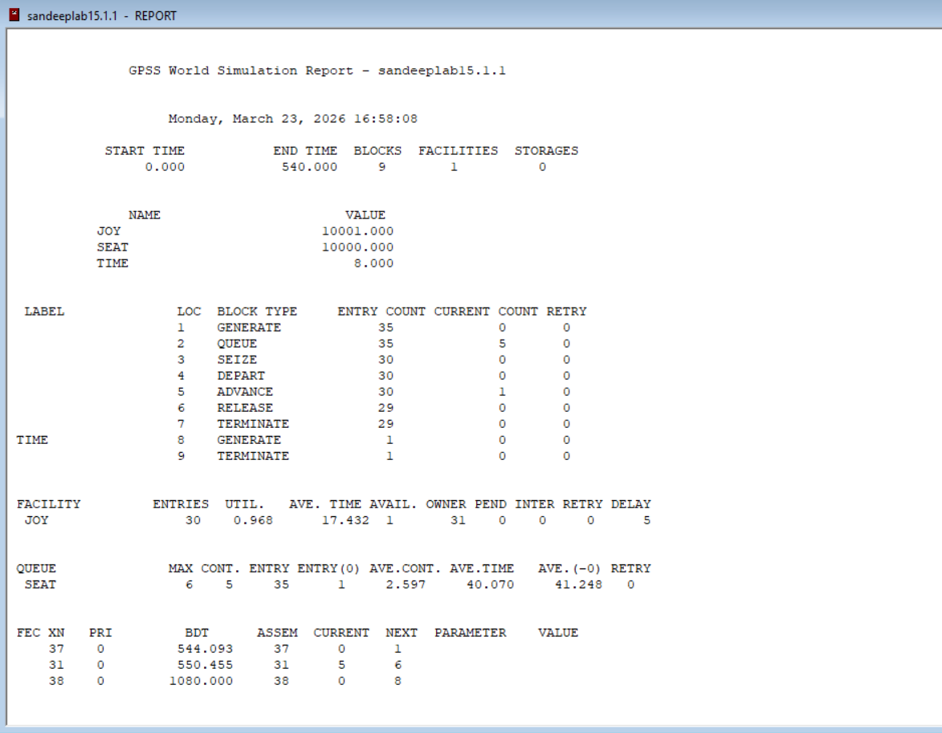

Output:

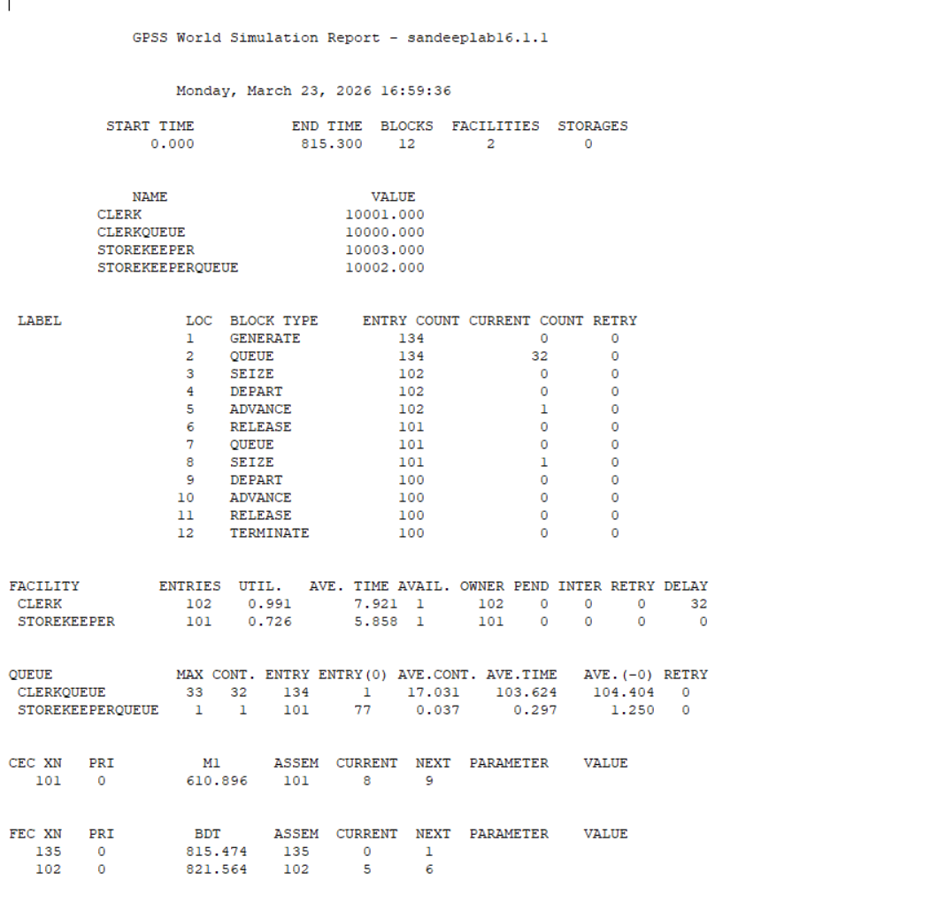

Output:

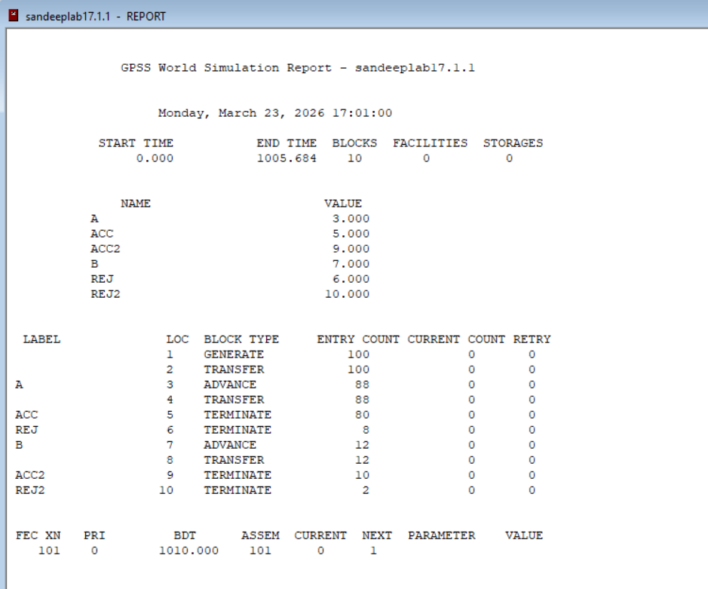

Output:
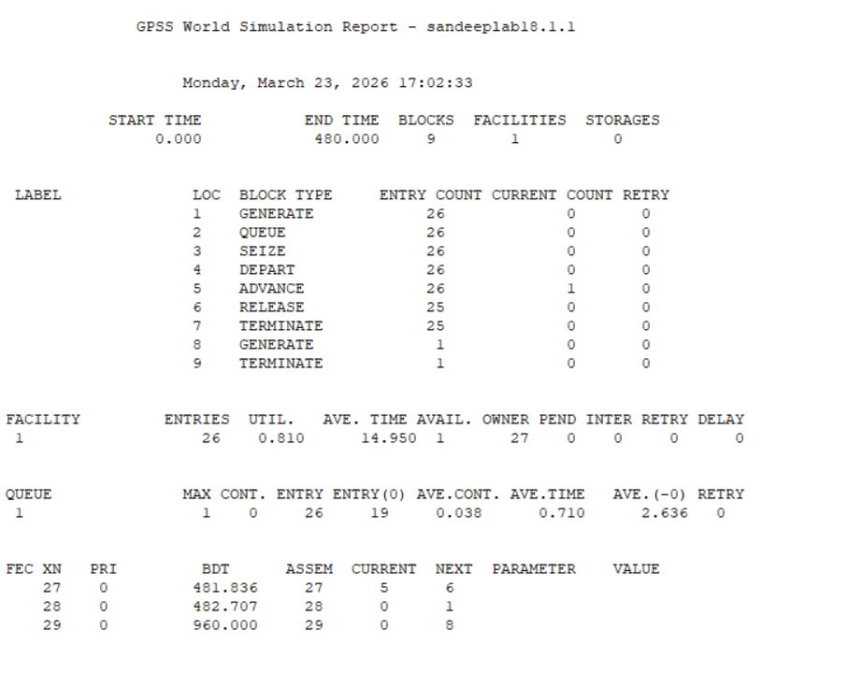

Output:

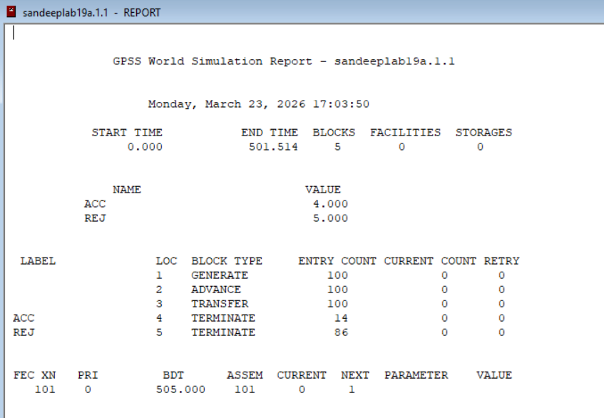

Output:

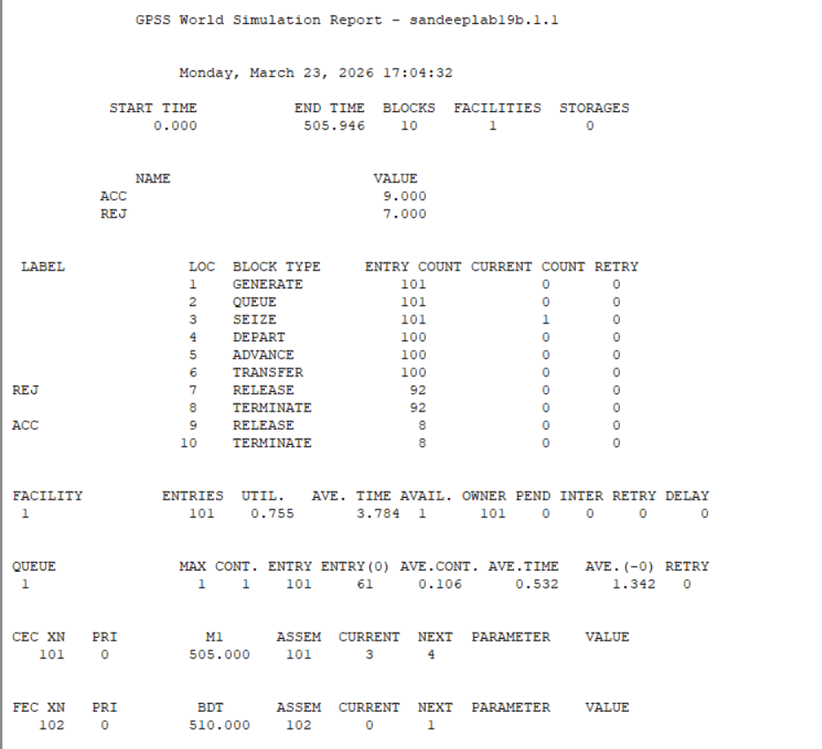

Output:

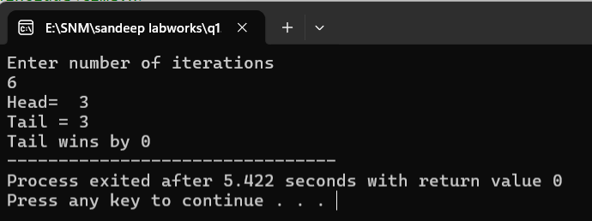

Output:

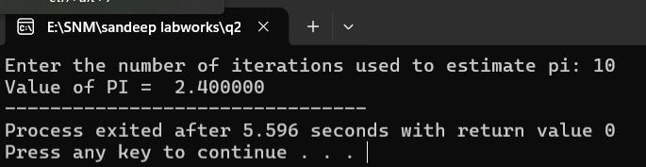

Output:

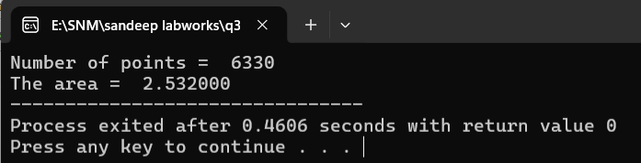

Output:

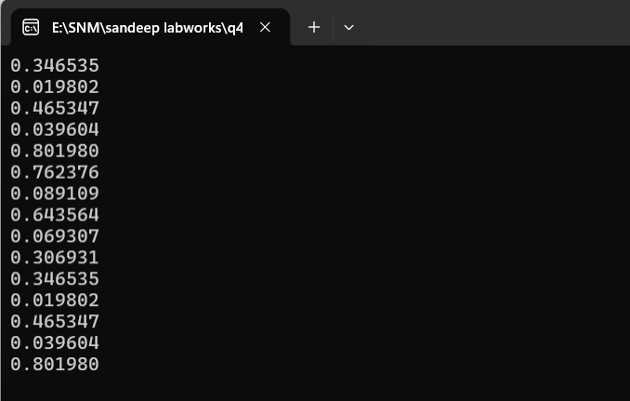

Output:

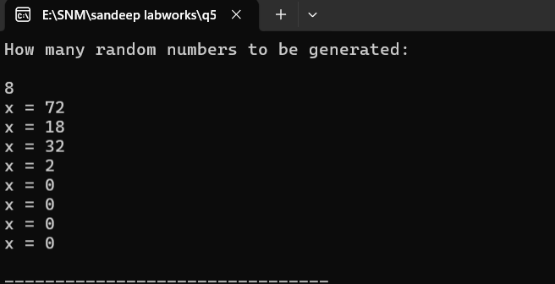

Output:

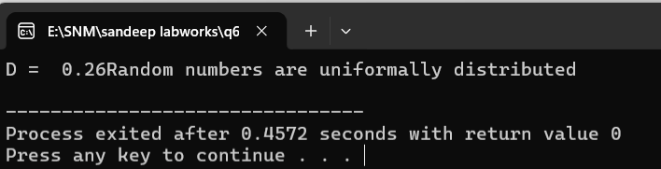

Output:

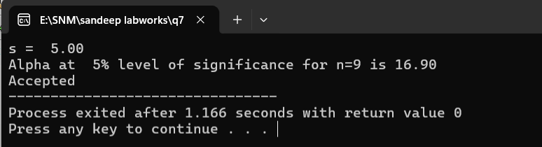

Output:

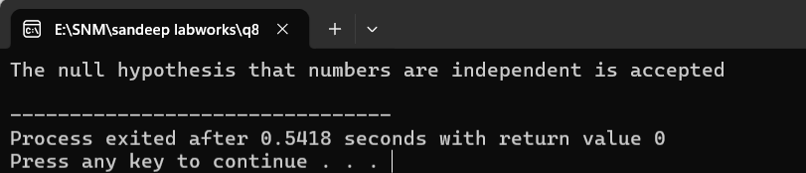

Output:
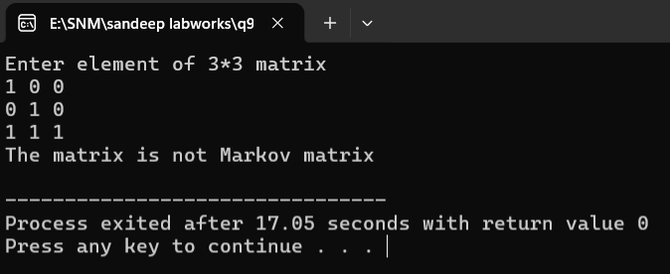

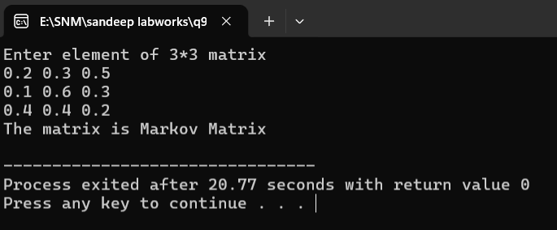

Output:

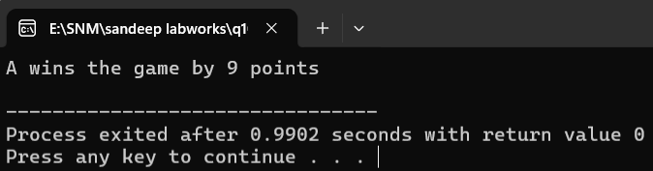

Output:

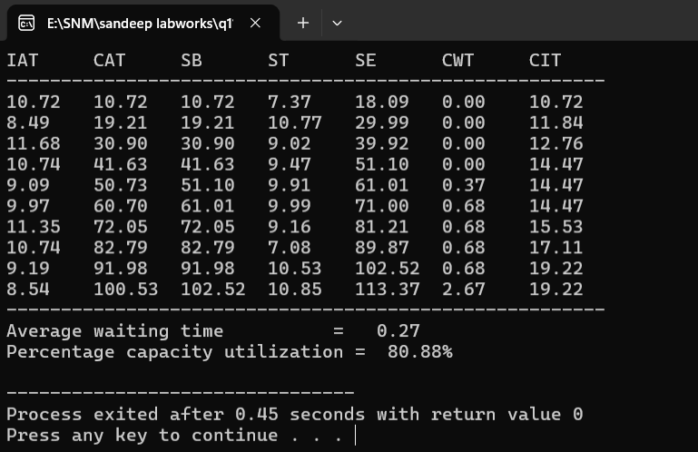

National College of Computer Studies
Tribhuvan University


Bsc.CSIT
Fifth Semester

Lab Report on: Simulation & Modeling
Submitted By
Sandeep Shrestha
Roll no: 13
Section: B

Submitted To
Teksan Gharti Magar

Simulation and Modelling
TABLE OF CONTENTS
Lab No. | Lab Topic | Date | Signature
1 | Write a program to simulate coin toss game using Monte Carlo Simulation Technique
2 | Write a C program to find out value of PI using Monte Carlo Simulation Technique
3 | Write a C program to find area between given interval of a function using Monte Carlo Simulation method
4 | Write a C program to generate 10 random numbers using Linear Congruential method
5 | Write a C program to generate 10 random numbers using mid square method
6 | Write a C program that tests random numbers for frequency using Kolmogorov S test
7 | Write a C program that tests random numbers for frequency using chi-Square test
8 | Write a program to test random numbers for independence using autocorrelation method
9 | Write a program to test whether the given matrix is Markov or not
10 | Write a program to simulate the game called DiceToss
11 | Write a C program to simulate single server queuing system
12 | Write a GPSS program to simulate a manufacturing shop inspection problem (parts every 5 min, inspector 4±3 min, 10% rejection)
13 | Write a program in GPSS to simulate barber shop problem
14 | Manufacturing shop with facility — inspector takes 10±3 min, rejects 10%, run for 500 parts
15 | Joey's Barbershop — customers every 15±3 min, haircut 18±2 min, simulate 9 hours (2079 Exam)
16 | Supply store with 2 clerks and 1 storekeeper — workers every 6±2 min, simulate 100 requisitions
17 | Two part types A and B — separate inspectors, each rejects 10%, simulate 100 parts
18 | Barber shop simulator — analyze utilization, queue length and average waiting time
19 | Manufacturing shop simulation — Model 1 (without facility) and Model 2 (with inspector facility)

