**Awk Options**

The awk command is used like this:

$ awk options program file

Awk can take the following options:

**-F fs**     To specify a file separator.

**-f file**     To specify a file that contains awk script.

**-v var=value**     To declare a variable.

We will see how to process files and print results using awk.

**Read AWK Scripts**

To define an awk script, use braces surrounded by single quotation marks like this:

$ awk '{print "Welcome to awk command tutorial "}'

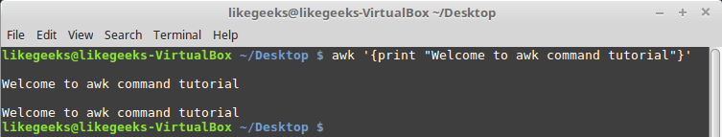

If you type anything, it returns the same welcome string we provide.

To terminate the program, press The Ctrl+D. Looks tricky, don’t panic, the best is yet to come.

**Using Variables**

With awk, you can process text files. Awk assigns some variables for each data field found:

* $0 for the whole line.
* $1 for the first field.
* $2 for the second field.
* $n for the nth field.

The whitespace character like space or tab is the default separator between fields in awk.

Check this example and see how awk processes it:

$ awk '{print $1}' myfile

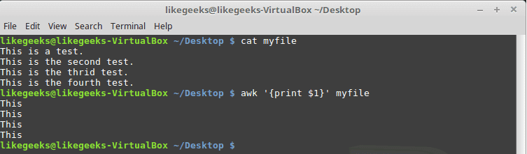

The above example prints the first word of each line.

Sometimes the separator in some files is not space nor tab but something else. You can specify it using –F option:

$ awk -F: '{print $1}' /etc/passwd

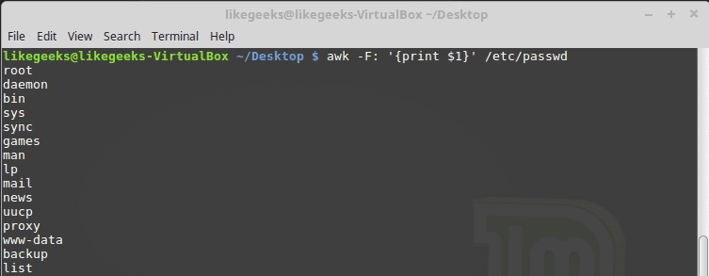

This command prints the first field in the passwd file. We use the colon as a separator because the passwd file uses it.

**Using Multiple Commands**

To run multiple commands, separate them with a semicolon like this:

$ echo "Hello Tom" | awk '{$2="Adam"; print $0}'

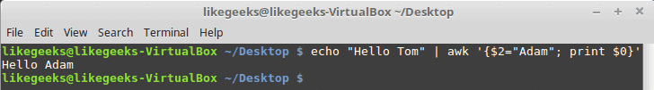

The first command makes the $2 field equals Adam. The second command prints the entire line.

**Reading The Script From a File**

You can type your awk script in a file and specify that file using the -f option.

Our file contains this script:

{print $1 " home at " $6}

$ awk -F: -f testfile /etc/passwd

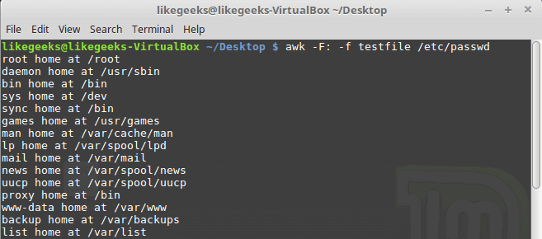

Here we print the username and his home path from /etc/passwd, and surely the separator is specified with capital -F which is the colon.

You can your awk script file like this:



|  |  |
| --- | --- |
| 1  2  3  4  5  6  7 | {  text = $1 " home at " $6  print text  } |

$ awk -F: -f testfile /etc/passwd

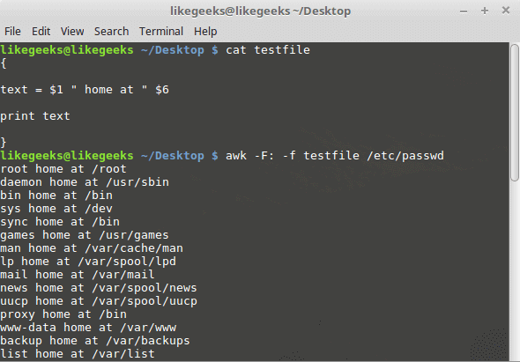

**Awk Preprocessing**

If you need to create a title or a header for your result or so. You can use the BEGIN keyword to achieve this. It runs before processing the data:

$ awk 'BEGIN {print "Report Title"}'

Let’s apply it to something we can see the result:



|  |  |
| --- | --- |
| 1  2  3 | $ awk 'BEGIN {print "The File Contents:"}    {print $0}' myfile |

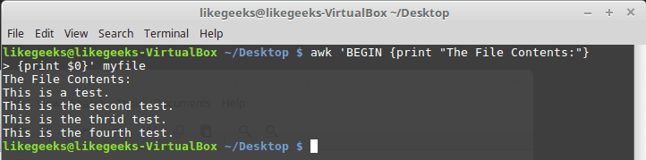

**Awk Postprocessing**

To run a script after processing the data, use the END keyword:



|  |  |
| --- | --- |
| 1  2  3  4  5 | $ awk 'BEGIN {print "The File Contents:"}    {print $0}    END {print "File footer"}' myfile |

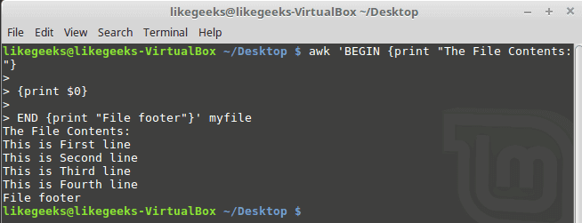

This is useful, you can use it to add a footer for example.

Let’s combine them together in a script file:



|  |  |
| --- | --- |
| 1  2  3  4  5  6  7  8  9  10  11  12  13  14  15  16  17  18  19  20  21  22  23 | BEGIN {    print "Users and thier corresponding home"    print " UserName \t HomePath"    print "___________ \t __________"    FS=":"    }    {    print $1 "  \t  " $6    }    END {    print "The end"    } |

First, the top section is created using BEGIN keyword. Then we define the FS and print the footer at the end.

$ awk -f myscript  /etc/passwd

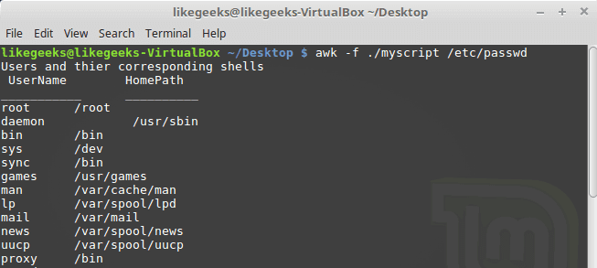

**Built-in Variables**

We saw the data field variables $1, $2 $3, etc are used to extract data fields, we also deal with the field separator FS.

But these are not the only variables, there are more built-in variables.

The following list shows some of the built-in variables:

**FIELDWIDTHS**     Specifies the field width.

**RS**     Specifies the record separator.

**FS**   Specifies the field separator.

**OFS**  Specifies the Output separator.

**ORS**  Specifies the Output separator.

By default, the OFS variable is the space, you can set the OFS variable to specify the separator you need:

$ awk 'BEGIN{FS=":"; OFS="-"} {print $1,$6,$7}' /etc/passwd

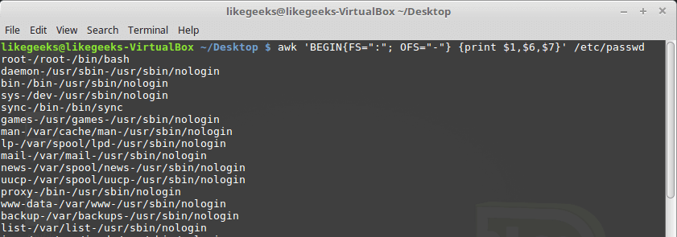

Sometimes, the fields are distributed without a fixed separator. In these cases, FIELDWIDTHS variable solves the problem.

Suppose we have this content:



|  |  |
| --- | --- |
| 1  2  3  4  5 | 1235.96521    927-8.3652    36257.8157 |

$ awk 'BEGIN{FIELDWIDTHS="3 4 3"}{print $1,$2,$3}' testfile

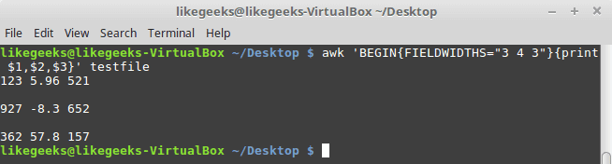

Look at the output. The output fields are 3 per line and each field length is based on what we assigned by FIELDWIDTH exactly.

Suppose that your data are distributed on different lines like the following:



|  |  |
| --- | --- |
| 1  2  3  4  5  6  7  8  9  10  11  12  13 | Person Name    123 High Street    (222) 466-1234        Another person    487 High Street    (523) 643-8754 |

In the above example, awk fails to process fields properly because the fields are separated by newlines and not spaces.

You need to set the FS to the newline (\n) and the RS to a blank text, so empty lines will be considered separators.

$ awk 'BEGIN{FS="\n"; RS=""} {print $1,$3}' addresses

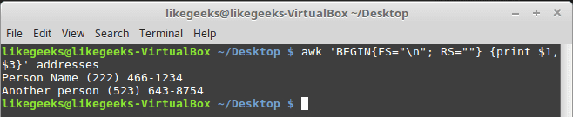

Awesome! we can read the records and fields properly.

**More Variables**

There are some other variables that help you to get more information:

**ARGC**     Retrieves the number of passed parameters.

**ARGV**   Retrieves the command line parameters.

**ENVIRON**     Array of the shell [environment variables](https://likegeeks.com/linux-environment-variables/) and corresponding values.

**FILENAME**    The file name that is processed by awk.

**NF**     Fields count of the line being processed.

**NR**    Retrieves total count of processed records.

**FNR**     The record which is processed.

**IGNORECASE**     To ignore the character case.

You can review the previous post [shell scripting](https://likegeeks.com/shell-scripting-awesome-guide-part4/) to know more about these variables.

Let’s test them.

$ awk 'BEGIN{print ARGC,ARGV[1]}' myfile

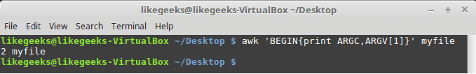

The ENVIRON variable retrieves the shell environment variables like this:



|  |  |
| --- | --- |
| 1  2  3  4  5  6  7 | $ awk '    BEGIN{    print ENVIRON["PATH"]    }' |

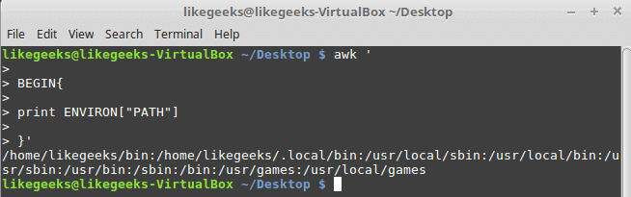

You can use bash variables without ENVIRON variables like this:

$  echo | awk -v home=$HOME '{print "My home is " home}'

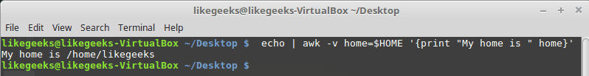

The NF variable specifies the last field in the record without knowing its position:

$ awk 'BEGIN{FS=":"; OFS=":"} {print $1,$NF}' /etc/passwd

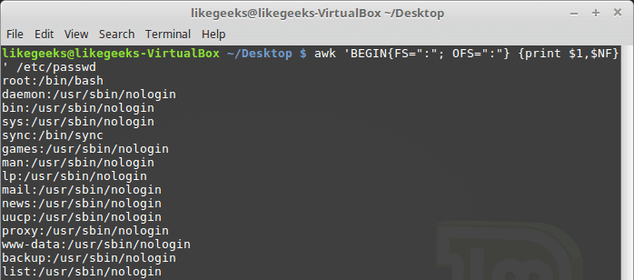

The NF variable can be used as a data field variable if you type it like this: $NF.

Let’s take a look at these two examples to know the difference between FNR and NR variables:

$ awk 'BEGIN{FS=","}{print $1,"FNR="FNR}' myfile myfile

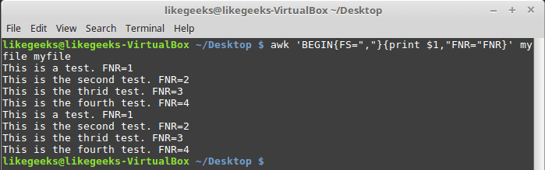

[https://go.ezoic.net/utilcave_com/img/ezoic.png](https://www.ezoic.com/what-is-ezoic/)report this adIn this example, the awk command defines two input files. The same file, but processed twice. The output is the first field value and the FNR variable.

Now, check the NR variable and see the difference:



|  |  |
| --- | --- |
| 1  2  3  4  5  6  7 | $ awk '    BEGIN {FS=","}    {print $1,"FNR="FNR,"NR="NR}    END{print "Total",NR,"processed lines"}' myfile myfile |

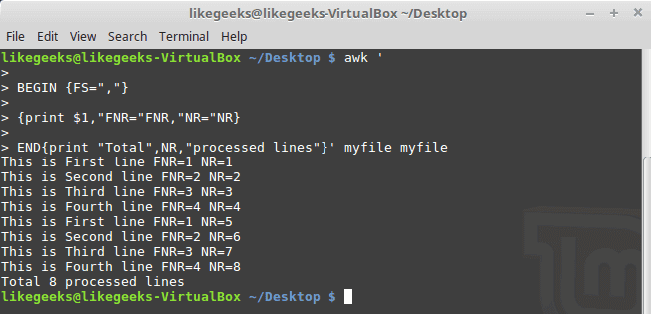

The FNR variable becomes 1 when comes to the second file, but the NR variable keeps its value.

**User Defined Variables**

Variable names could be anything, but it **can’t begin with a number.**

You can assign a variable as in shell scripting like this:



|  |  |
| --- | --- |
| 1  2  3  4  5  6  7  8  9 | $ awk '    BEGIN{    test="Welcome to LikeGeeks website"    print test    }' |

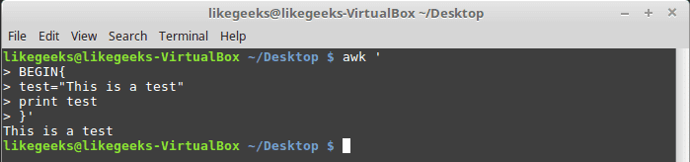

**Structured Commands**

The awk scripting language supports if conditional statement.

The testfile contains the following:

10

15

6

33

45

$ awk '{if ($1 > 30) print $1}' testfile

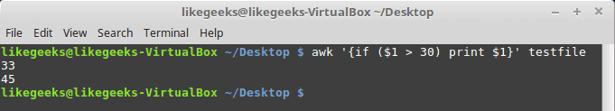

Just that simple.

You should use braces if you want to run multiple statements:



|  |  |
| --- | --- |
| 1  2  3  4  5  6  7  8  9  10  11  12  13 | $ awk '{    if ($1 > 30)    {    x = $1 * 3    print x    }    }' testfile |

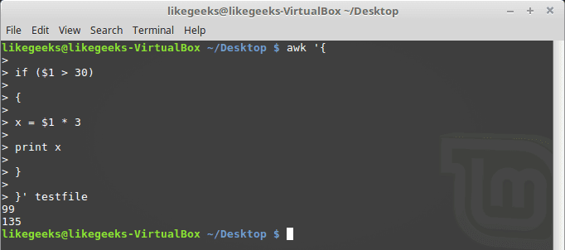

You can use else statements like this:



|  |  |
| --- | --- |
| 1  2  3  4  5  6  7  8  9  10  11  12  13  14  15  16  17  18  19 | $ awk '{    if ($1 > 30)    {    x = $1 * 3    print x    } else    {    x = $1 / 2    print x    }}' testfile |

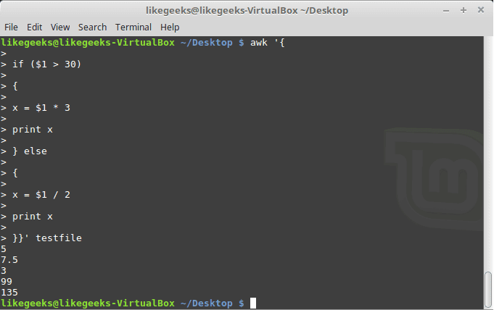

Or type them on the same line and separate the if statement with a semicolon like this:

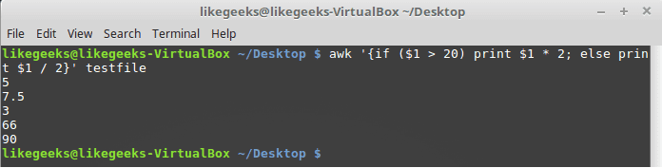

**While Loop**

You can use the while loop to iterate over data with a condition.

cat myfile

124 127 130

112 142 135

175 158 245

118 231 147



|  |  |
| --- | --- |
| 1  2  3  4  5  6  7  8  9  10  11  12  13  14  15  16  17  18  19  20  21 | $ awk '{    sum = 0    i = 1    while (i < 5)    {    sum += $i    i++    }    average = sum / 3    print "Average:",average    }' testfile |

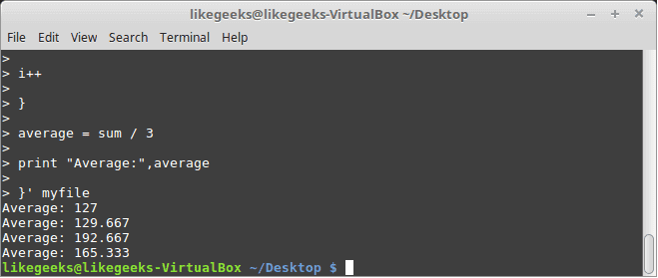

The while loop runs and every time it adds 1 to the sum variable until the i variable becomes 4.

You can exit the loop using break command like this:



|  |  |
| --- | --- |
| 1  2  3  4  5  6  7  8  9  10  11  12  13  14  15  16  17  18  19  20  21  22  23  24  25 | $ awk '{    tot = 0    i = 1    while (i < 5)    {    tot += $i    if (i == 3)    break    i++    }    average = tot / 3    print "Average is:",average    }' testfile |

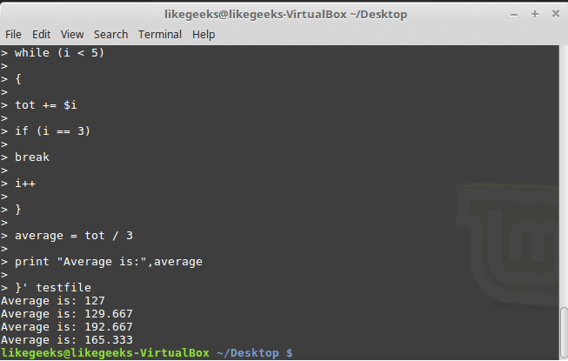

**The for Loop**

The awk scripting language supports the for loops:



|  |  |
| --- | --- |
| 1  2  3  4  5  6  7  8  9  10  11  12  13  14  15  16  17 | $ awk '{    total = 0    for (var = 1; var < 5; var++)    {    total += $var    }    avg = total / 3    print "Average:",avg    }' testfile |

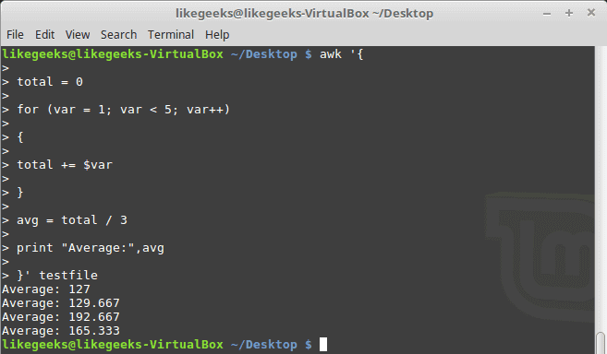

**Formatted Printing**

The printf command in awk allows you to print formatted output using format specifiers.

The format specifiers are written like this:

%[modifier]control-letter

This list shows the format specifiers you can use with printf:

c              Prints numeric output as a string.

d             Prints an integer value.

e             Prints scientific numbers.

f               Prints float values.

o             Prints an octal value.

s             Prints a text string.

Here we use printf to format our output:



|  |  |
| --- | --- |
| 1  2  3  4  5  6  7 | $ awk 'BEGIN{    x = 100 * 100    printf "The result is: %e\n", x    }' |

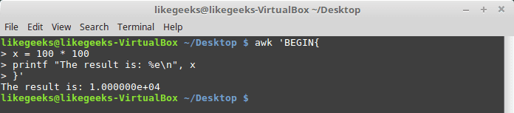

Here is an example of printing scientific numbers.

We are not going to try every format specifier. You know the concept.

**Built-In Functions**

Awk provides several built-in functions like:

**Mathematical Functions**

If you love math, you can use these functions in your awk scripts:

**sin(x) | cos(x) | sqrt(x) | exp(x) | log(x) | rand()**

And they can be used normally:

$ awk 'BEGIN{x=exp(5); print x}'

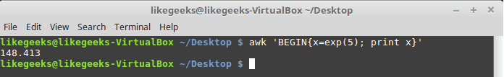

**String Functions**

There are many string functions, you can check the list, but we will examine one of them as an example and the rest is the same:

$ awk 'BEGIN{x = "likegeeks"; print toupper(x)}'

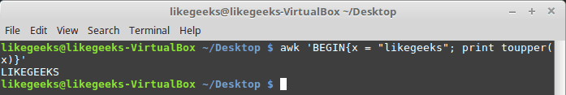

The function toupper converts character case to upper case for the passed string.

**User Defined Functions**

You can define your function and use them like this:



|  |  |
| --- | --- |
| 1  2  3  4  5  6  7  8  9  10  11  12  13  14  15  16  17 | $ awk '    function myfunc()    {    printf "The user %s has home path at %s\n", $1,$6    }    BEGIN{FS=":"}    {    myfunc()    }' /etc/passwd |

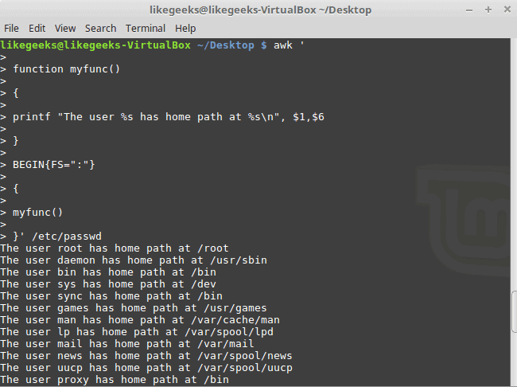

Here we define a function called myprint, then we use it in our script to print output using printf function.

I hope you like the post.

Thank you.