Business Methodology

***Step 1: Storyboarding:***

* I familiarized myself with the data by going over it and making a note of key fields.
* Created a mind map for the presentation's slides.
* Made a rudimentary template using this mind map as a guide.

***Step 2: Data Wrangling:***

* Explored all the columns in the dataset by importing it to python notebook
* Checked for the Missing values and found out the columns “name, host_name, last_review and reviews_per_month” had missing values.

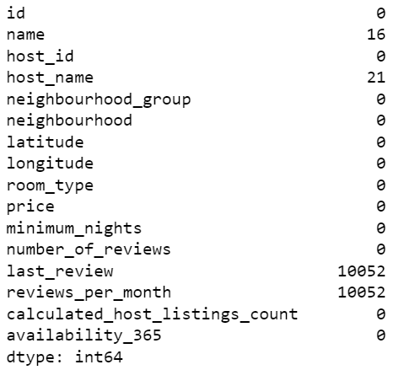

* Missing Values are treated using Python. Below are few snapshots.

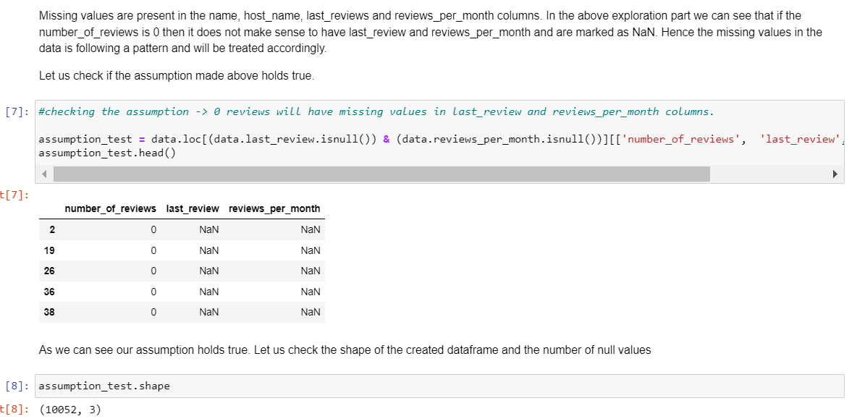

* Host Listings count is maximum for entire apartment and private room and is very small for shared room as seen below.

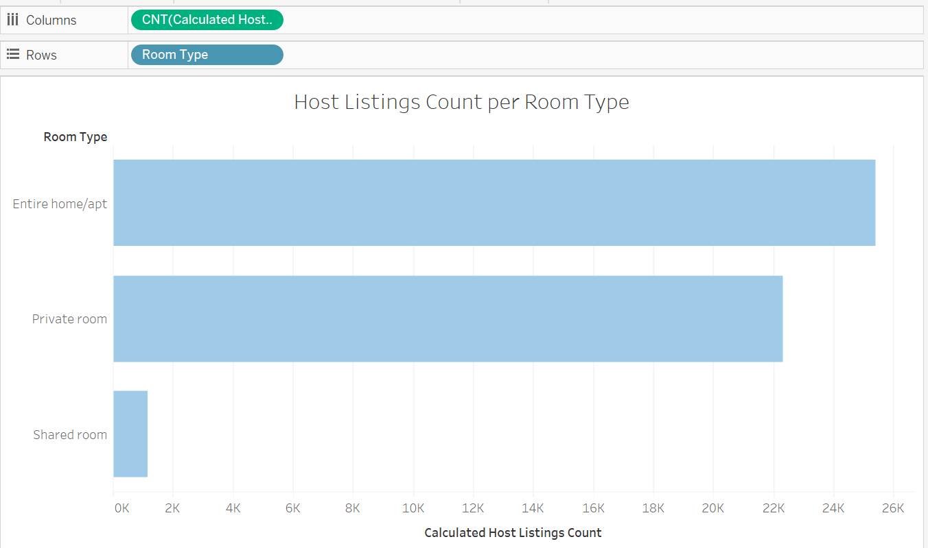

* Checked if any Outliers are present with respect to price.

* Created a grouped field for Minimum Number of Days assuming null values belonged to the category.

***Step 3: Data Analysis:***

Performed Data Analysis using Tableau with the cleaned Data file. Below are few analysis the Data Analytics team can use.

1. Neighborhood Wise Business Distribution:

* Private Rooms & Entire home/apt should be targeted in Brooklyn & Manhattan as they seem to be popular.
* Shared Rooms should be targeted as the rates are already cheap and a reasonable approach will get more customers.
* The properties in Manhattan & Brooklyn are the most expensive than any other area.

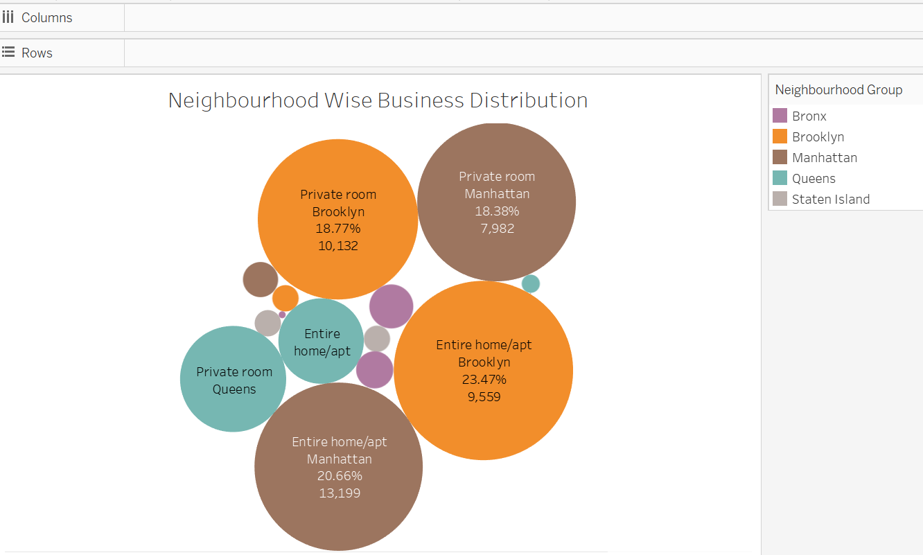

1. Insights on the price based on Neighborhood Group:

* Focus on increasing the listings in Queens, Bronx, Staten Island to increase their revenue.
* Manhattan contributes 90% of the revenue.
* As Manhattan leads the list and is quite popular, hosts can reduce the price to attract customers.

1. Popular Accommodations across NYC:

The following are popular places in each of the neighborhood group and contributes to higher income and hence target these places more for revenue generation.

* Brooklyn –Williamsburg
* Manhattan-Midtown
* Queens-Astoria
* Staten Island-Randall Manor

***Step 4: Presentation:***

* Made the presentation adhering to best practices.
* Head of Acquisitions and Operations & Head of User Experience are our audience for Presentation 2.
* Added recommendations for the respective departments.