Screenshots & GitHub link

1.Dashboard screenshot

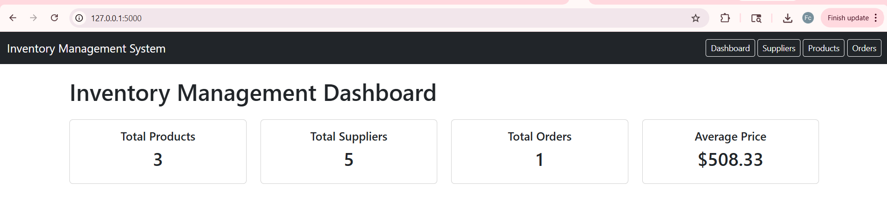

2.suppliers’ screenshot
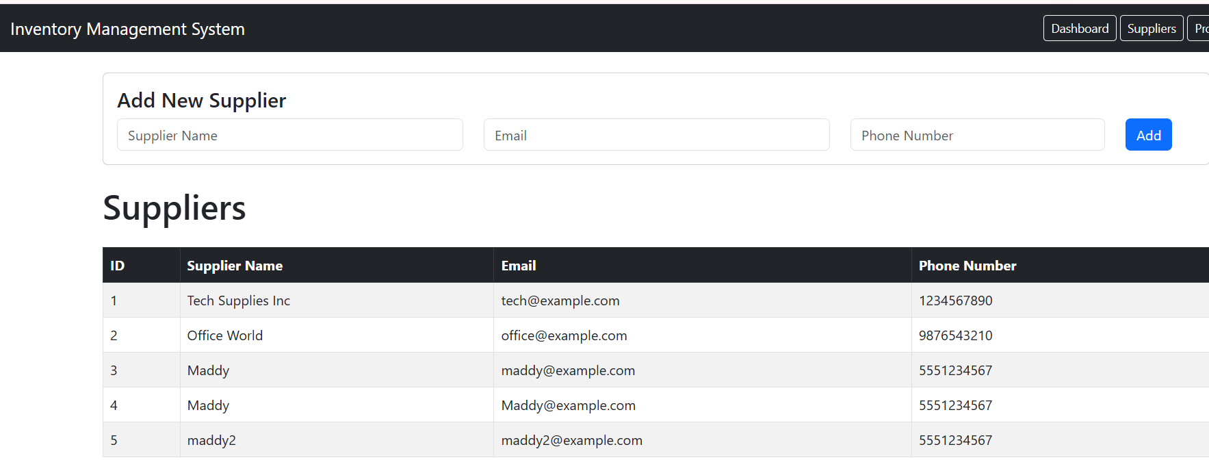

3. Products
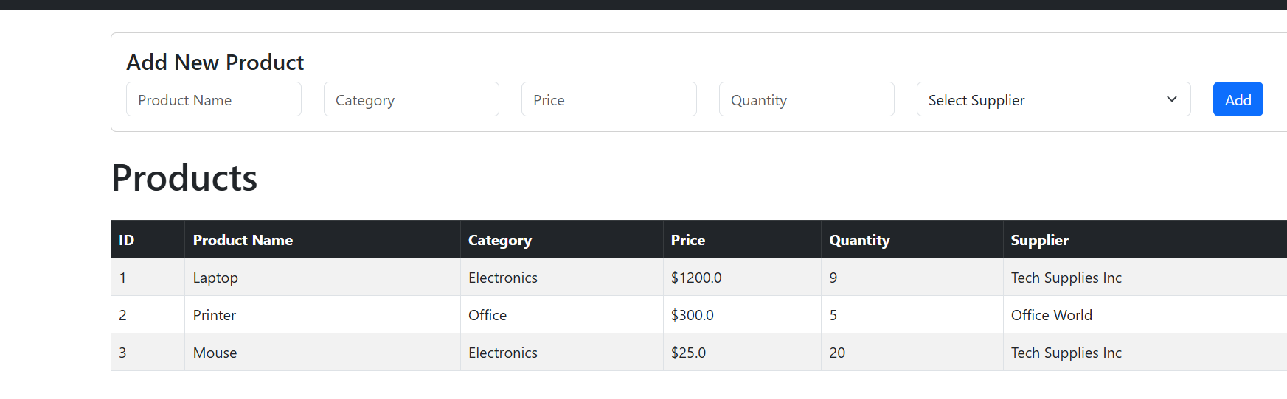
Orders

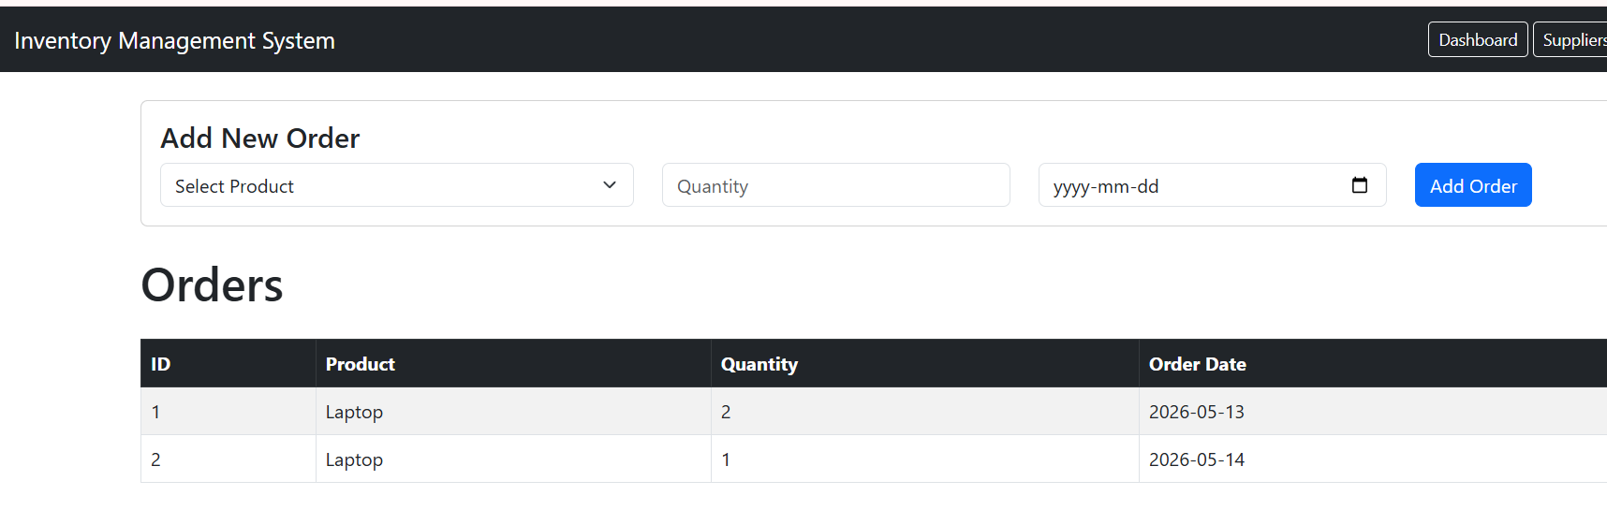

Quantity reduction proof

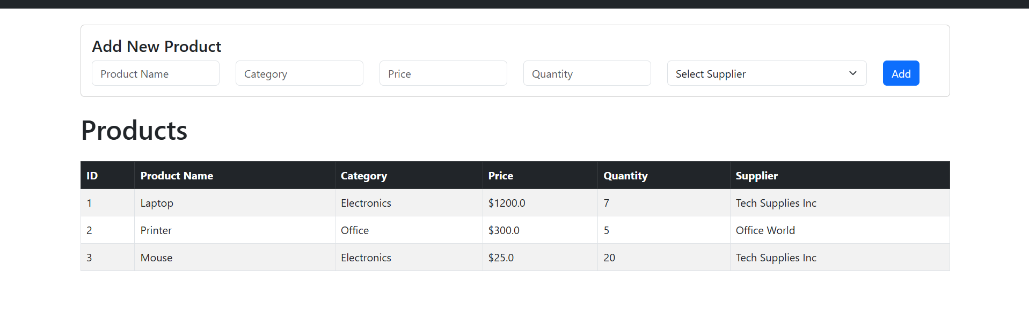
Git
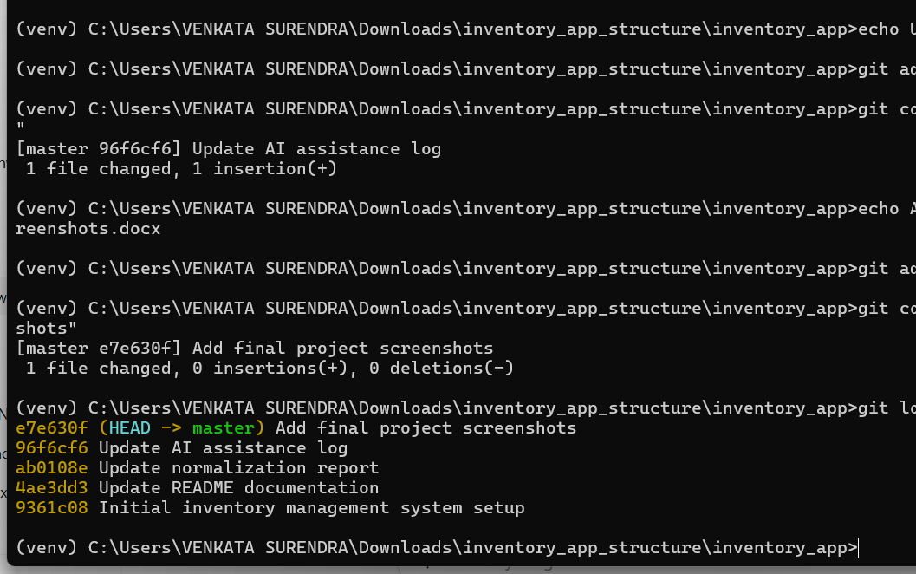

Github link: - https://github.com/SandeepYanigandla24/inventory-management-system

## Application URL

http://127.0.0.1:5000

