Linux Basic Commands Assignment

Playing with files:

1. Create a file like nano file1.txt

o Edit some data and then save the file

Ans.

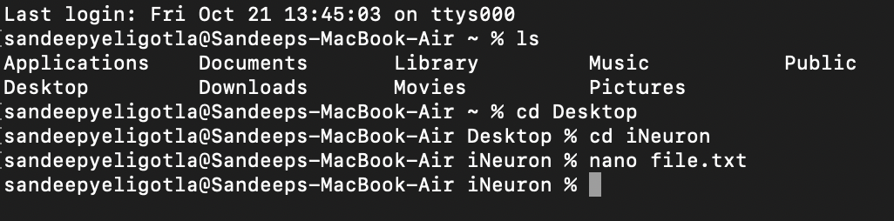

A nano text editor will open on the terminal. Entered some text and saved it using ctrl+o. Came out of the nano editor using ctrl+x.

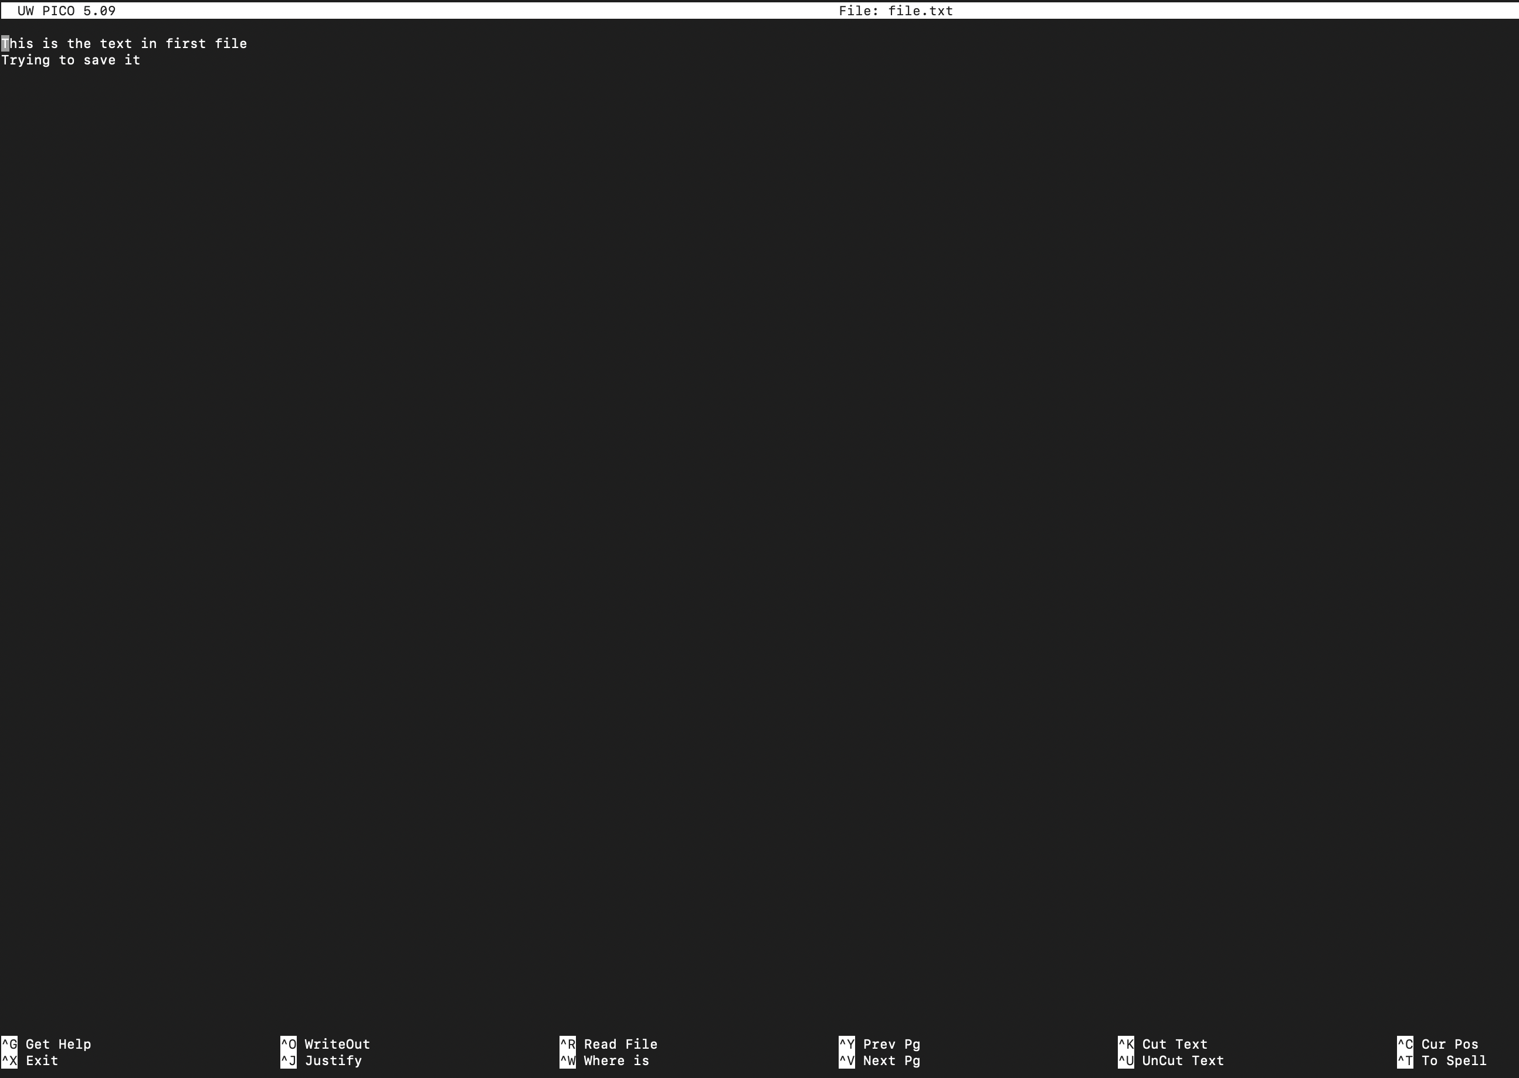

A file is saved with the written text on nano editor.

2. Now we will copy date from file1 to new file2

o cp file1.txt file2.txt

o Then see the output of file2.txt, cat file2.txt

o Give screenshot

Ans.

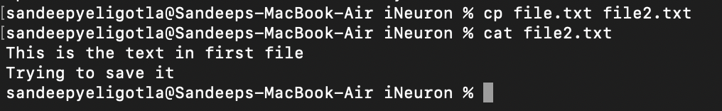

3. Now we will move the file2.txt to new folder /home

o mv file2.txt /home

o Then go to home directory and check ls, file exits or not?

o Given screenshot

Ans.

Since the home directory is not allowing to create or move a directory to home, I have created a new directory on desktop and moved file2.txt to new directory(iNeuron2).

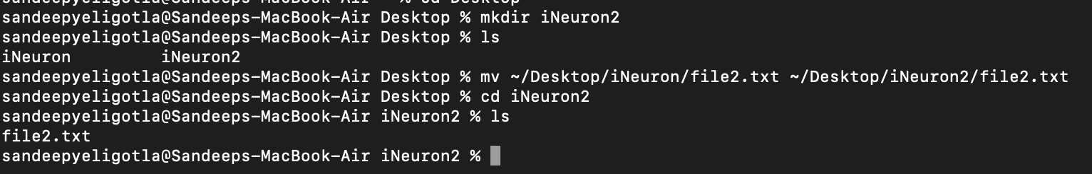

4. Then we create a new file3.txt and file4.txt in home directory and add

content in it.

o Now do echo “Hello I am newline” > file3.txt and provide the

output of file3.txt

Ans. Created 2 new files file3.txt and file4.txt under new directory iNeuron2.

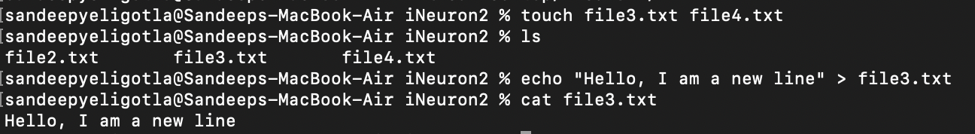

o Now do echo “Hello I am newline” >> file4.txt and provide the

output of file4.txt

Ans.



o Tell the different between both step you follow and the reason

behind it

Ans. The difference is the first command with > symbol will overwrite the existing data in file3 and the second command with >> symbol will append the new data/text to the existing data in file4.

