PROJECT REPORT

Smart Tailoring Operations Management
with Artificial Intelligence Support

CCS2360
Technology Challenge Competition
Submitted under the following degree programmers

Bachelor of Science (Hons) in Software Engineering
Bachelor of Science (Hons) in Cloud Computing
Bachelor of Science (Hons) in Data Science
Bachelor of Science (Hons) in Cyber Security


Faculty Of Computing & IT
Sri Lanka Technology Campus

PROJECT | TailorSync
ACADEMIC YEAR | 2028A | Group 09

PROJECT TEAM
CIT-24-01-0110 | A.G.S.V. Wimalasiri
CIT-24-01-0436 | W.A.E.M. Wijayarathna
CIT-24-01-0065 | N.D.H.A. Madubhashitha
CIT-24-01-0004 | D.M.J.B. Dissanayake
CIT-24-01-0090 | Manuwendra Rajapaksha
CIT-24-01-0066 | K.P.N.D. Ashokarathna

Declaration
We declare that this report titled "TailorSync: AI-Powered Tailoring Business Management System" is our own original work and has not been submitted previously, in whole or in part, for any other module or qualification. All sources of information used are duly cited and referenced. We acknowledge that the faculty's academic integrity policies apply to this submission.

Acknowledgements
We would like to express our sincere gratitude to our TCC module coordinator and supervisor for their invaluable guidance and feedback throughout this project. We also extend our thanks to the tailoring shop owners and staff in our local community who generously volunteered their time for our user evaluation sessions, providing practical insights that directly shaped the system's design.

Abstract
TailorSync is an AI-powered, cloud-hosted tailoring business management system that digitises the complete workflow of a small or medium tailoring shop: customers, body measurements, orders, staff assignments, fabric stock and business reporting. It is delivered as a cross-platform Flutter application (Android and web) backed by a FastAPI service on Microsoft Azure App Service and a managed Neon PostgreSQL database.
At its core is a dual-engine AI architecture. A custom Machine Learning engine (Scikit-Learn tree ensembles trained on ten curated tailoring datasets) gives fast, repeatable predictions of missing body measurements, together with up to five alternative values and their model support. A Microsoft Azure AI Foundry agent ("ts-ai-agent", running GPT-4.1-mini) provides contextual, tailoring-aware predictions, fabric recommendations and fabric-quantity estimates. Optimising the agent integration reduced AI response time from roughly 30 seconds to about 2-6 seconds per step.
Since the interim version the system has grown substantially. New features include an AI Virtual Try-On that dresses a customer photo in a chosen garment (including Sri Lankan styles such as the Kandyan saree) using the FLUX.2 model on Cloudflare Workers AI; garment blueprints for shirts and trousers that overlay each customer's real measurements on the pattern; an owner-only fabric inventory that is updated automatically by orders and AI recommendations; a redesigned Reports & Analytics module with trend line charts; Google reCAPTCHA protection on sign-in; a complete design-system based user interface; and a detailed Privacy Policy aligned with Sri Lanka's Personal Data Protection Act No. 9 of 2022.
Every AI output is treated as a suggestion that the tailor can review, edit or reject (Human-in-the-Loop). TailorSync therefore reduces manual effort and measurement errors, supports better material planning and gives tailoring professionals accessible AI tools within a single integrated platform.

Table of Contents
Right-click and choose "Update Field" to build the table of contents.

1 Introduction

1.1 Introduction
This chapter outlines the background and motivation for the TailorSync project. It defines the real-world problem being addressed, sets out the project's aim and measurable objectives, gives an overview of the final solution, and describes the structure of this report.

1.2 Background and Motivation
Despite the rapid digitalisation of retail and e-commerce, a large segment of small-to-medium tailoring businesses, including many in Sri Lanka, still depends on manual, notebook-based systems for capturing customer measurements and tracking orders. Research indicates that manual measurement transcription errors occur in approximately 15-20% of customer profiles, often leading to costly garment remakes and customer dissatisfaction [2]. Fabric estimation relies purely on individual tailor experience, which frequently results in material wastage or shortages, and fabric stock is rarely tracked at all. Owners also have little visibility of workload, delays and performance because the information is scattered across paper records.

1.3 Problem Statement
Small and medium tailoring businesses face persistent operational inefficiencies due to manual measurement recording, unreliable fabric estimation based on guesswork, untracked fabric stock and fragmented, informal order tracking. Customers also find it hard to imagine how a garment will look before it is made. These challenges lead directly to measurement errors, wasted fabric, missed delivery deadlines, unhappy customers and reduced profitability.

1.4 Aim
The aim of TailorSync is to develop an AI-powered tailoring business management system that improves the efficiency, accuracy and organisation of tailoring operations through integrated business management, intelligent assistance and visual decision support.
The system combines a custom Machine Learning engine for fast, structured predictions with a Microsoft Azure AI Foundry agent for contextual, expert-oriented assistance. It adds visual support through AI Virtual Try-On and measurement-driven garment blueprints, and operational support through fabric inventory management and analytics, all within a secure, privacy-aware cloud platform.

1.5 Objectives
The objectives of the TailorSync system are:
O1: Develop and integrate a custom Machine Learning model for body measurement prediction. Predict missing customer body measurements from a small set of priority inputs, returning a main prediction plus alternative values that tailoring staff can review and modify.
O2: Provide AI-assisted fabric recommendation. Recommend suitable fabrics based on garment type, occasion, weather, fit and customer preferences, showing a suitability score and current stock level.
O3: Provide AI-assisted fabric estimation. Estimate the quantity of fabric (in metres) required for a garment from the customer's measurements, supporting material planning and reducing wastage.
O4: Implement a multi-tenant, role-based tailoring business management system. Support customer management, a 9-step New Order Wizard, a 7-stage order workflow, staff assignment and notifications, with each business isolated from others and Owner/Staff permissions enforced.
O5: Provide contextual AI assistance through Azure AI Foundry. Integrate a Foundry agent as an alternative prediction and recommendation engine, optimised to respond within the 5-second target for normal requests.
O6: Provide visualisation capabilities. Generate AI Virtual Try-On images of a customer wearing a selected garment, colour and fabric, and display garment blueprints annotated with the customer's actual measurements.
O7: Provide fabric inventory management and business analytics. Track fabric stock automatically from orders, alert owners to low stock, and present orders, delivery performance, fabric usage, staff and customer insights through interactive reports and trend charts.
O8: Deliver a secure, privacy-compliant cloud deployment. Deploy the system on Microsoft Azure with CI/CD, protect accounts with hashed passwords, JWT and reCAPTCHA, and document data handling in a privacy policy aligned with the Sri Lankan PDPA.
O9: Evaluate the usability, efficiency and effectiveness of the system. Evaluate TailorSync with tailoring professionals and relevant users in terms of usability, operational efficiency, AI accuracy and overall satisfaction.

1.6 Proposed Solution
TailorSync is a mobile-first tailoring business management system with a dual-engine AI architecture. The Flutter client (Android and web) talks to a FastAPI backend hosted on Azure App Service, which stores data in Neon PostgreSQL and connects to the AI services.
- Business management: customers, measurement templates, a 9-step New Order Wizard, a 7-stage production workflow (Order Received, Cutting, Sewing, Fitting, Quality Check, Ready, Delivered), staff management and task assignment with e-mail notifications.
- Dual-engine AI: the tailor chooses either the Custom ML engine or the Azure AI Foundry agent at the start of each order to predict missing measurements; fabric recommendation and estimation follow in the same wizard.
- Visual support: AI Virtual Try-On on a customer photo, and shirt/trouser blueprints with the customer's computed values overlaid on the pattern formulas.
- Operations: fabric inventory with automatic deduction, restock history and low-stock alerts; Reports & Analytics with KPIs, trend line charts and inventory insights.
- Trust and security: reCAPTCHA-protected sign-in, JWT authentication, owner-only data such as inventory and reports, and a published privacy policy.

1.7 Structure of the Report
Chapter 2 surveys related systems. Chapter 3 details the adopted technology. Chapter 4 explains our approach, and Chapter 5 presents the analysis, requirements and design diagrams. Chapter 6 discusses the implementation of every module, including the features added after the interim report. Chapters 7 and 8 cover testing and evaluation. Chapter 9 presents conclusions and future work, followed by references and appendices.

1.8 Summary
This chapter defined the operational problems facing traditional tailoring businesses, established the aim and nine objectives of TailorSync, and gave a high-level overview of the AI-driven, cloud-hosted solution.

2 Review of Others' Work

2.1 Introduction
This chapter surveys existing commercial and academic systems that address tailoring management, measurement estimation and garment visualisation. It highlights their limitations and establishes the novelty of TailorSync.

2.2 Survey of Existing Systems
1. Tailornova [5]: a cloud-based platform offering 3D pattern-making and virtual fitting. Limitation: it is primarily a design tool for home sewists; it has no AI measurement inference from partial inputs and no order or stock management for shop owners.
2. CNN-Based Body Measurement Estimation [1]: an academic approach that uses Convolutional Neural Networks to estimate body measurements from front and side photographs. Limitation: it needs standardised, well-lit full-body photographs in tight clothing, which is impractical in busy, modest tailoring shops.
3. Smart Tailor ERP [4]: a comprehensive enterprise resource planning system. Limitation: it is designed and priced for large garment factories rather than small independent shops and has no AI-assisted estimation features.
4. General-purpose virtual try-on tools [9]: image-generation models can dress a person in new clothing. Limitation: they are stand-alone consumer tools, are not linked to measurements, orders or fabric stock, and rarely support Sri Lankan garments such as the Kandyan saree.

2.3 Feature Comparison Table
Table 2.1 Feature Comparison of Existing Systems
Feature | Tailornova [5] | CNN-Based [1] | Smart Tailor ERP [4] | TailorSync
AI measurement prediction | No | Yes (photo-based) | No | Yes (Custom ML + Foundry agent)
Fabric recommendation & estimation | No | No | No | Yes
Virtual try-on (incl. Sri Lankan garments) | Partial (3D) | No | No | Yes (FLUX.2)
Measurement-driven blueprints | Yes | No | No | Yes (shirt & trouser)
Fabric inventory with auto-deduction | No | No | Yes (factory) | Yes
Mobile-first order pipeline | No | No | Yes (factory) | Yes (9-step wizard, 7 stages)
Multi-tenant shop management | No | No | Yes | Yes
Analytics with trend charts | No | No | Yes | Yes
Target audience | Home sewers | Research | Large factories | Small/medium tailors

2.4 Novelty Statement
TailorSync's main contribution is the integration of tailoring business management with a dual-engine AI architecture and visual decision support in a single mobile-first platform aimed at small shops. Existing systems focus on garment design, photo-based measurement or factory ERP. TailorSync instead combines custom Machine Learning for structured prediction with an Azure AI Foundry agent for contextual assistance, and links both to orders, fabric stock and reports.
The system further integrates AI Virtual Try-On localised for Sri Lankan clothing, blueprints annotated with real customer measurements, and a fabric inventory that is updated automatically by AI recommendations and orders. This end-to-end combination is not available in any of the reviewed systems.

2.5 Summary
The review confirms a clear gap: there is no affordable, AI-assisted, mobile-first management system designed for bespoke tailoring shops that also offers visual try-on and stock control. TailorSync addresses this gap.

3 Technology Adopted

3.1 Introduction
This chapter describes the AI techniques, frameworks, libraries, cloud services and development tools used to build TailorSync. The system combines conventional software engineering technologies with three AI capabilities: a custom ML engine, an Azure AI Foundry agent and a generative image model.

3.2 AI/ML Techniques

3.2.1 Custom Machine Learning Engine
The custom engine is trained on curated tailoring datasets (Section 6.3) using Scikit-Learn. For shirts and trousers, tree-ensemble regression models take a small set of priority measurements (for example shoulder, chest and height for a shirt) and predict the remaining measurements. The models are serialised with Joblib and loaded once by the backend ML service when the server starts.
To give the tailor choices rather than a single number, the service collects the prediction of every individual tree, groups them with K-Means clustering and reports up to five candidate measurement sets. Each candidate shows its support (the share of trees that agree with it), is snapped to the nearest quarter inch, and must stay within 1.5 inches of the central prediction to be shown. A nearest-neighbour index over the training data is used to validate that inputs fall within realistic ranges. This approach is fast (milliseconds), works without any external service and is fully repeatable.

3.2.2 Microsoft Azure AI Foundry Agent
The second engine is an Azure AI Foundry agent named ts-ai-agent. It is called through the Foundry Responses API using an agent reference, so the model, instructions and behaviour are managed centrally in the Foundry portal rather than in code. The agent receives a compact JSON message containing the task, garment type, provided measurements, unit rules and the required reply format, and returns structured JSON. It is used for measurement prediction, fabric recommendation and fabric estimation.
During development the agent was first configured with GPT-5-mini and a File Search tool over the datasets. This produced responses of about 30 seconds, mainly because of reasoning tokens and about 4,500 extra input tokens added by retrieval. The agent was re-configured with GPT-4.1-mini, task-specific instructions and no File Search, which brought response time down to roughly 2-6 seconds per step (Section 6.5). If the agent is unavailable, the backend automatically falls back to calling the deployed model directly, with the relevant dataset rows supplied as context (Retrieval-Augmented Generation [3]).

3.2.3 Generative Image Model for Virtual Try-On
Virtual Try-On uses FLUX.2 klein 4B from Black Forest Labs, hosted on Cloudflare Workers AI [8]. The backend sends the customer photo together with a garment description built from the user's selections (garment, colour, fabric and optional details), and receives an edited image in which the person is wearing the requested outfit. Local garment names such as "Kandyan saree (Osariya)" or "Redda and hatte" are translated into descriptive English prompts so that the model can render them correctly.

3.2.4 Human-in-the-Loop
In every AI feature TailorSync follows a Human-in-the-Loop approach. Predicted measurements, recommended fabrics, estimated quantities and generated images are presented as suggestions; authorised users can accept, edit or reject them before they become part of an order.

3.3 Frameworks and Libraries
Table 3.1 Main Frameworks and Libraries
Layer | Technology | Purpose in TailorSync
Client | Flutter & Dart | Single code base for Android and web; all screens, wizard, charts and animations
Client | Riverpod | State management (orders, user, refresh triggers across screens)
Client | go_router | Navigation with a stateful bottom-navigation shell and deep routes
Client | Dio | HTTP client with JWT interceptor and structured error handling
Client | google_fonts, animations | Plus Jakarta Sans typography and Material shared-axis transitions
Client | webview_flutter / iframe | Hosting the Google reCAPTCHA widget on mobile and web
Client | image_picker | Camera and gallery photos for Virtual Try-On
Backend | Python 3.11, FastAPI, Pydantic | REST API, request validation, automatic OpenAPI docs
Backend | SQLAlchemy ORM | Database models and queries for PostgreSQL
Backend | Scikit-Learn, NumPy, Joblib | Training, clustering and serving the custom ML models
Backend | azure-ai-projects, azure-identity | Foundry agent calls authenticated with DefaultAzureCredential
Backend | bcrypt, python-jose | Password hashing and JWT authentication
Backend | Requests | Calls to Cloudflare Workers AI and Google reCAPTCHA verification

3.4 Cloud Platforms and External Services
Table 3.2 Cloud Platforms and External Services
Service | Role | Integration detail
Microsoft Azure App Service | Hosts the FastAPI backend | Deployed from GitHub Actions on every push to main
Azure AI Foundry | Contextual AI engine (ts-ai-agent, GPT-4.1-mini) | System-assigned managed identity with the Azure AI User role, so no API keys are stored for the agent
Neon (PostgreSQL) | Primary relational database | Managed, cloud-hosted PostgreSQL with TLS connections
Cloudflare Workers AI | Virtual Try-On image generation | FLUX.2 klein 4B on the free tier, with a daily usage counter shown in the app
Google reCAPTCHA v2 | Bot protection on sign-in and sign-up | Token verified server-side before authentication
GitHub & GitHub Actions | Version control and CI/CD | Builds the Python app and deploys it to App Service
SMTP e-mail | Notifications | Staff invitations, task assignments and order completion e-mails sent as background tasks

3.5 Summary
TailorSync combines a cross-platform Flutter client, a modular FastAPI backend, PostgreSQL storage and three AI capabilities: a fast custom ML engine, a contextual Azure AI Foundry agent and a generative try-on model. All are hosted on managed cloud services so that a small business can use them without any infrastructure of its own.

4 Our Approach

4.1 Introduction
This chapter describes how TailorSync was designed around its users, the inputs and outputs of the system, the AI processing approach and the main workflow followed when an order is created.

4.2 System Overview
- Users: Owners are tailoring shop proprietors with full access, including business settings, staff management, fabric inventory and reports. Staff members (tailors, cutters) see the tasks and orders assigned to them and can update production stages.
- Inputs: customer contact details, a few priority body measurements (for example height, chest and shoulder), the chosen prediction method, garment preferences (occasion, weather, fit), optional order price, and for try-on a customer photo with garment, colour and fabric choices.
- Outputs: predicted missing measurements with alternatives and support scores; the top three recommended fabrics with suitability scores and stock status; an estimated fabric quantity in metres; garment blueprints with the customer's values; try-on images; real-time order status; inventory alerts; and analytics reports.
- Process flow: the core journey is the 9-step New Order Wizard (Figure 4.1). After an order is saved, it moves through the seven production stages, stock is updated automatically and the reports refresh.
Figure 4.1 The 9-step New Order Wizard (AI-assisted steps highlighted)

4.3 Design Principles
- AI as an assistant, not a decision maker: every AI result can be edited or rejected (Human-in-the-Loop).
- Choice of engine: the tailor picks the Custom ML engine for speed and consistency, or the Foundry agent for contextual reasoning.
- Graceful degradation: if the Foundry agent is unavailable the backend falls back to the base model; if a feature fails, the app shows a clear, actionable message instead of crashing.
- Learn the shop's fabrics automatically: fabrics that the AI recommends or orders use are added to the inventory as "untracked" until the owner sets their stock, so the inventory grows without extra data entry.
- Privacy by design: AI services receive only the data they need; customer names and contact details are never sent to the AI engines, and try-on photos are not stored on TailorSync servers.

4.4 Summary
TailorSync's approach blends traditional shop management (customers, staff, production stages) with an AI-assisted wizard and visual tools, while keeping the tailor in control of every decision.

5 Analysis & Design

5.1 Introduction
This chapter presents the system architecture, the UML and database diagrams, and the functional and non-functional requirements.

5.2 High-Level Architecture
The final architecture follows a three-tier client-server model. The Flutter client communicates over HTTPS with the FastAPI backend on Azure App Service. The backend owns all business rules and connects to Neon PostgreSQL, the custom ML engine, the Foundry agent, Cloudflare Workers AI, Google reCAPTCHA and the e-mail service. GitHub Actions deploys every change automatically.
Figure 5.1 Final System Architecture
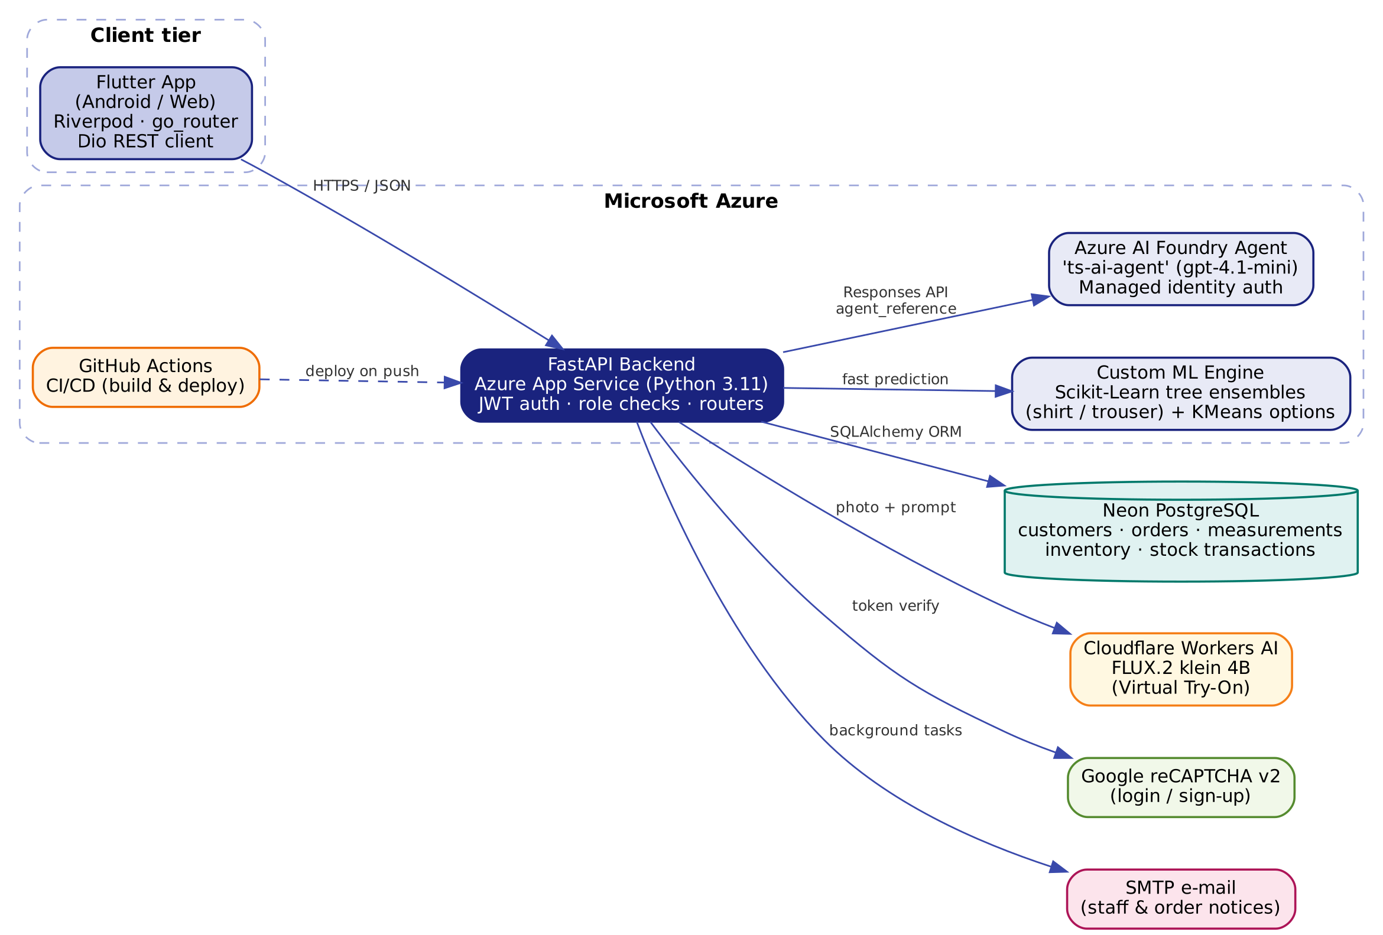
The initial architecture from the interim stage, which centred on the RAG pipeline, is retained below for comparison.
Figure 5.2 Initial (Interim) System Architecture
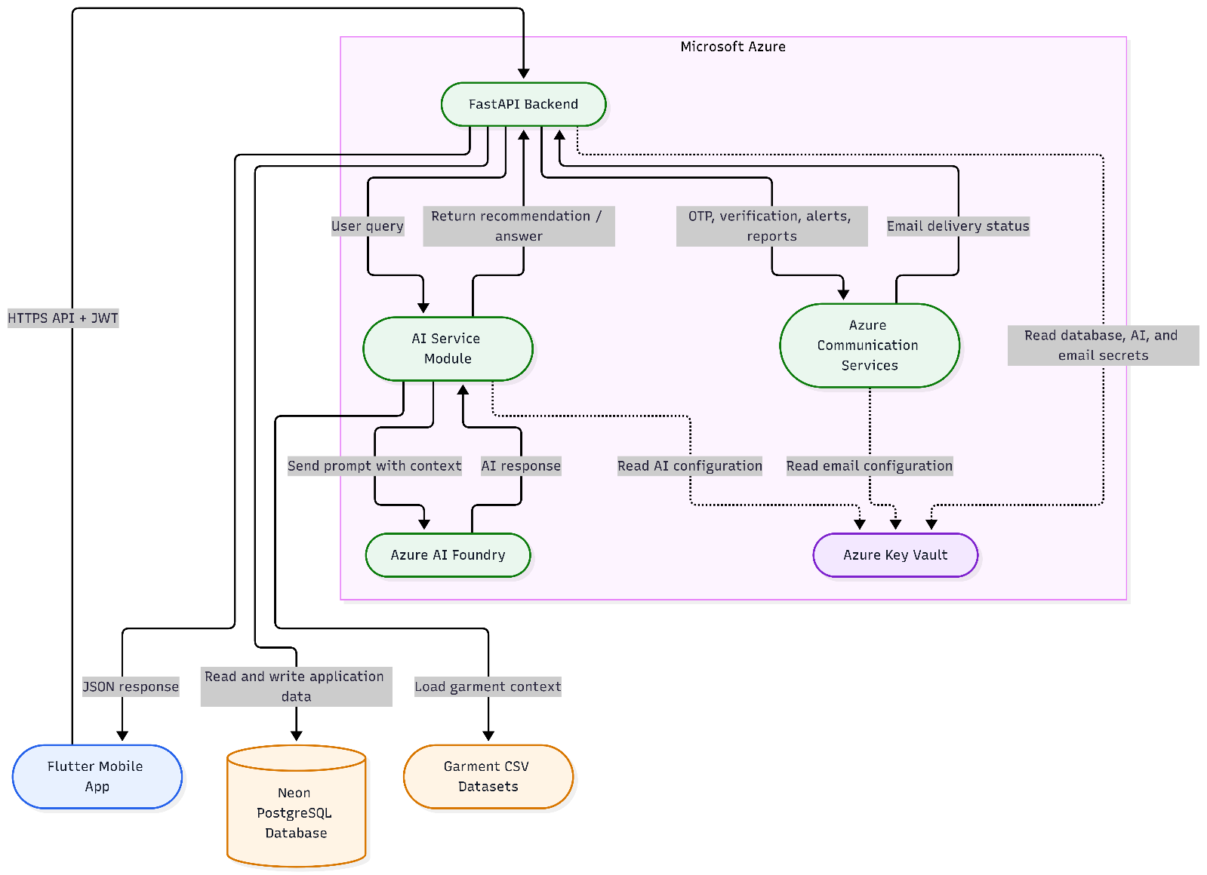

5.3 UML Diagrams
Use Case Diagram: defines the functional scope for Owners, Staff and the external AI actors.
Figure 5.3 Use Case Diagram
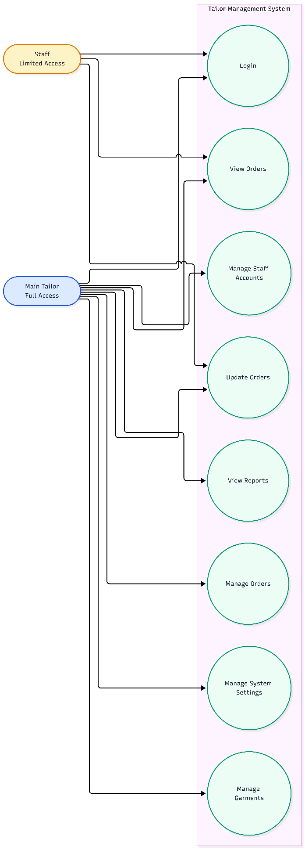
Activity Diagram (New Order Flow): illustrates the decision points in the order wizard. The final implementation adds a "Prediction Method" step in which the tailor chooses the Custom ML engine or the Foundry agent, giving nine steps in total (Figure 4.1).
Figure 5.4 Activity Diagram for the New Order Flow
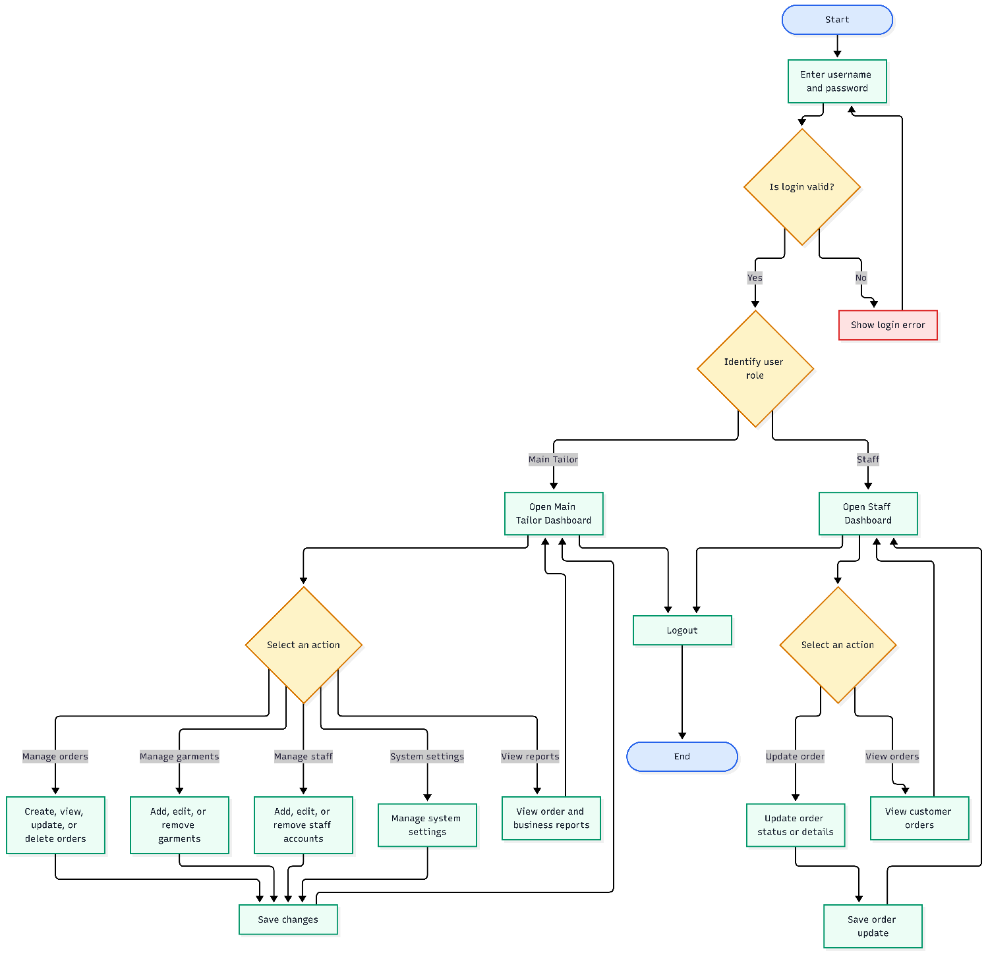
Sequence Diagram (AI Measurement Prediction): shows the synchronous flow of a prediction request across the stack.
Figure 5.5 Sequence Diagram for AI Measurement Prediction
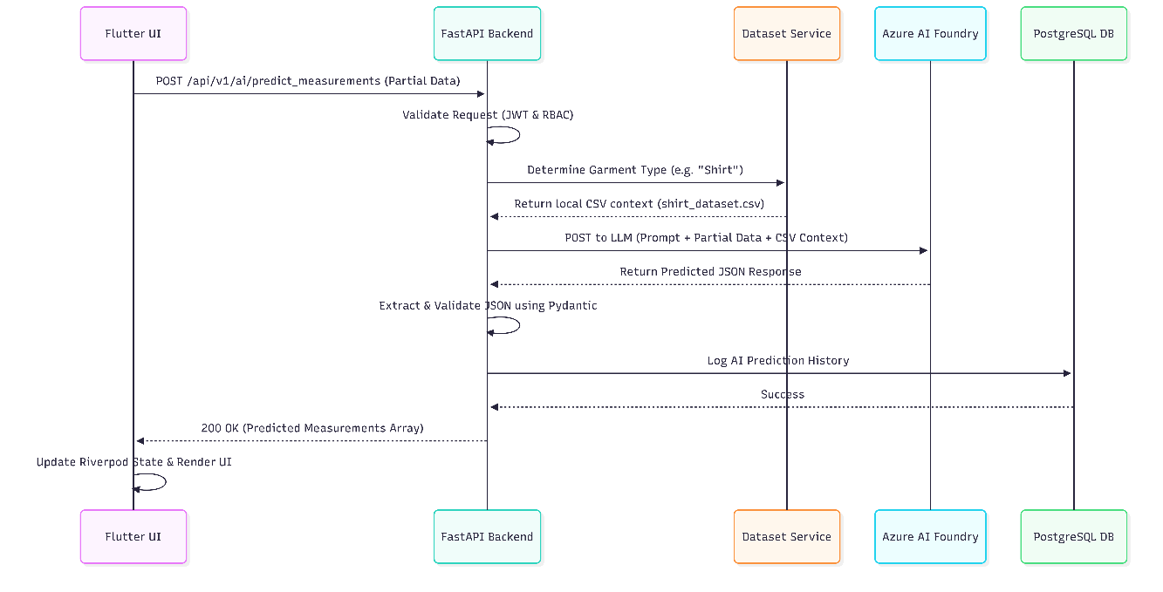

5.4 Data Design
The relational database holds the multi-tenant application. Every business-owned record carries a business identifier, so each shop can only access its own data.
Figure 5.6 Entity-Relationship Diagram (core entities)
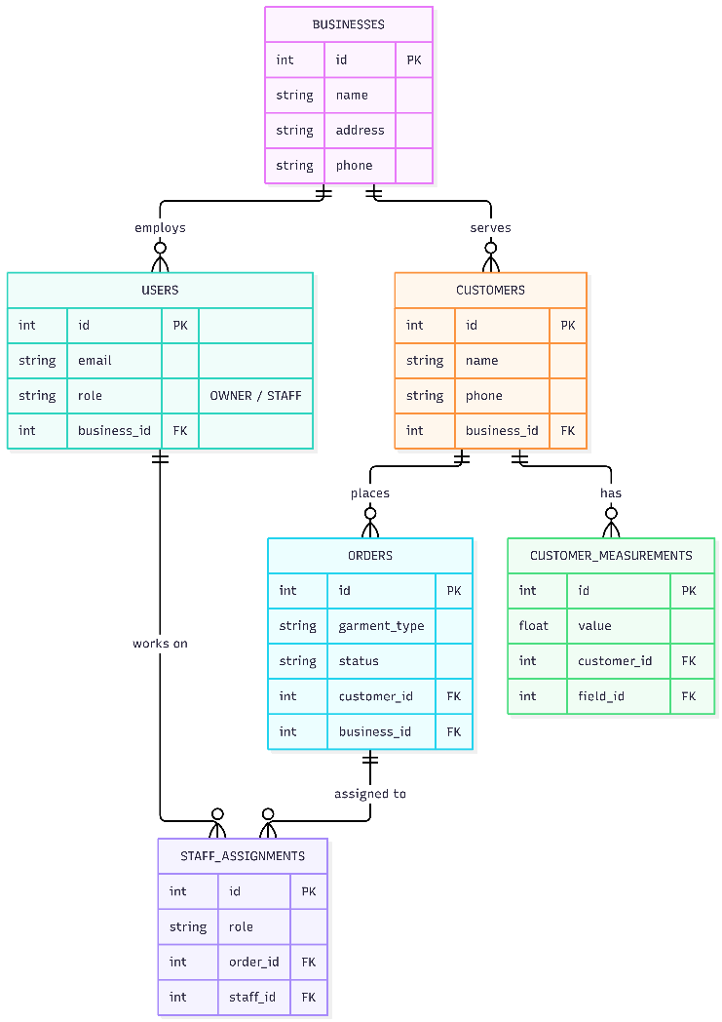
Two tables were added for the inventory module, and the order model was extended:
- inventory_items: business, fabric name, normalised name key (unique per business), quantity in metres, tracked flag and low-stock threshold.
- inventory_transactions: item, change in metres, balance after the change, type (RESTOCK, ORDER, ADJUST, REVERSAL), related order, note, user and timestamp. This gives a complete, auditable stock history.
- orders: now also store the selected fabric, fabric quantity and unit, the optional total price and the prediction method used (FOUNDRY or CUSTOM_ML), which feeds the reports.
Figure 5.7 Fabric Inventory Logic
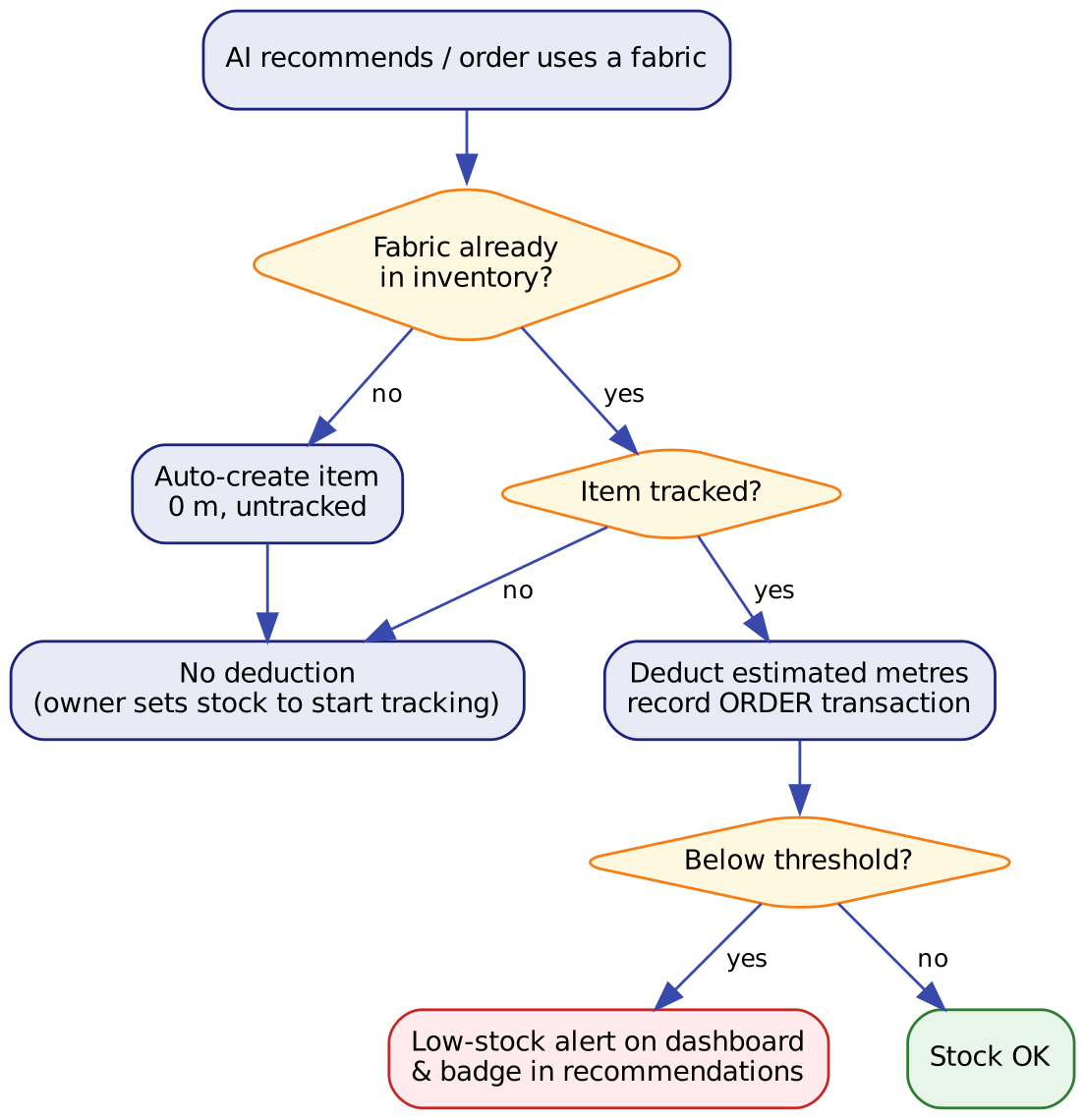

5.5 Functional Requirements
1. Customer management: add, view, search, update and delete customers.
2. Measurement management: store measurements per customer using garment-specific templates.
3. Order management: create orders through the 9-step wizard and link them to customers, staff and fabrics.
4. Order tracking: move orders through Order Received, Cutting, Sewing, Fitting, Quality Check, Ready and Delivered.
5. AI measurement prediction: predict missing measurements with either engine and allow accept, edit or reject.
6. Fabric recommendation: recommend the top fabrics with suitability scores and current stock status.
7. Fabric estimation: calculate the fabric quantity required for an order.
8. Garment blueprints: show shirt (long and short sleeve) and trouser blueprints with the customer's computed values on the last wizard step and in order details.
9. Virtual Try-On: generate an image of the customer wearing a selected garment, colour and fabric, with a visible daily usage counter.
10. Fabric inventory (Owner only): add fabrics, set and restock quantities, view history, receive low-stock alerts and see automatic deductions.
11. Reports & analytics (Owner only): KPIs, trend line charts, status breakdown, garment, customer, staff and inventory insights for selectable periods, inside the app.
12. Staff management: invite, deactivate and remove staff; assign tasks with e-mail notification.
13. Authentication and roles: secure login and sign-up with reCAPTCHA, and Owner/Staff permissions.
14. Legal information: in-app Terms & Conditions and Privacy Policy.

5.6 Non-Functional Requirements
Table 5.1 Non-Functional Requirements
Requirement | Target | Final status
Performance | Normal operations respond within 3 s | Met for standard CRUD and report requests
AI response time | AI steps respond within 5 s | Custom ML: milliseconds. Foundry agent: about 2-6 s per step after optimisation (from about 30 s)
Security | Authentication, role-based access, HTTPS/TLS | bcrypt, JWT, reCAPTCHA, owner-only endpoints, HTTPS, managed identity for AI
Privacy | Handle personal data lawfully | Privacy Policy aligned with Sri Lanka PDPA No. 9 of 2022; data minimisation to AI services
Usability | Simple and easy to use | Design-system UI, guided wizard, clear error and empty states, accessibility labels
Reliability | No data loss in normal operation | Transactional writes, inventory audit trail, AI fallback path
Scalability | At least 10 concurrent users for v1.0 | Stateless API on App Service; managed database
Maintainability | Modular and easy to update | Router/service layers, reusable UI components, CI/CD
Portability | Extendable to other platforms | Runs on Android and web; Flutter code base ready for iOS and desktop
Availability | Available during business hours | Cloud hosting; splash screen warms up the server on cold starts

5.7 Summary
The modular architecture keeps the Flutter client lightweight and responsive, while the FastAPI backend securely handles business rules, AI orchestration and database operations. The design was extended with inventory tables, richer order data and new external services without changing the core structure.

6 Implementation

6.1 Introduction
This chapter describes how each module was implemented, the datasets used, and the optimisations and new features added after the interim report.

6.2 Core Modules
- Authentication & security: passwords are hashed with bcrypt and sessions use signed JWTs (python-jose). Login and sign-up are protected by Google reCAPTCHA v2: the widget is shown inline in the form, and the backend verifies the token with Google before checking credentials. Every protected route checks the user's role and business.
- Customer & measurement management: customers and their measurements are stored per business. Measurement templates define which fields each garment needs, and the wizard generates its inputs dynamically from the selected template.
- New Order Wizard: nine steps (Customer, Prediction Method, Garment, Priority Input, AI Prediction, Preferences, Fabric Recommendation, Estimation, Review & Assign). Riverpod keeps state across steps, text controllers are created per template and disposed safely, and the last step shows the order summary, body measurements, the fabric and estimate, an optional price and the garment blueprint.
- Order workflow & staff: orders move through seven stages, staff are assigned per order, and e-mail notifications (invitations, task assignment, completion) are sent with FastAPI background tasks so they never delay the response.

6.3 Dataset Details
Ten garment datasets were curated by consulting professional tailors and standard industry charts. They are used to train the custom ML models and as context for the AI fallback path.
Table 6.1 Garment Dataset Details
Dataset | Rows | Key columns
Shirts | 40 | Shoulder, Short/Long Sleeve Length, Height, Chest, Collar Size, Sleeve Open, fabric (short/long) in metres
Trousers | 27 | Height till Knee, Height, Waist, Round Knee, Round End, Seat, Crotch, fabric (short/long) in metres
Coats, Dresses, Jackets, Suits, Waistcoats | 50 each | Shoulder, Chest, Waist, Hips, Sleeve Length, Height, fabric in metres
Office uniforms, School uniforms, Traditional wear | 50 each | Shoulder, Chest, Waist, Hips, Sleeve Length, Height, fabric in metres
Preprocessing | - | Data cleaned, missing values interpolated, fractional inches standardised; valid input ranges stored with each model

6.4 Custom ML Engine
The ML service loads the shirt and trouser models at start-up. For a request it validates every input against the range seen in training, predicts the central measurement set, then clusters the predictions of the individual trees with K-Means to produce up to five alternative sets with their support percentage. Values are snapped to the nearest quarter inch, which matches how tailors work. The predictions are returned to the wizard, where the tailor can pick an alternative or edit any value.

6.5 Azure AI Foundry Agent Integration and Optimisation
The FoundryClient creates a single, reused AIProjectClient authenticated with DefaultAzureCredential. On Azure this uses the App Service's managed identity, so no secret key is needed. Each request sends a compact JSON message and asks for JSON only; a regex-based extractor removes any markdown fences before parsing. A timing middleware and per-call statistics were added to measure latency.
Table 6.2 Foundry Agent Performance Optimisation
Configuration | Observed latency per AI step | Main reason
GPT-5-mini agent with File Search over datasets | about 30 s or more | Reasoning tokens plus about 4.5k retrieved input tokens
Request overrides (reasoning, text) sent with agent call | Rejected (HTTP 400) | Overrides are not allowed when an agent is referenced; disabled by default
GPT-4.1-mini agent, focused instructions, no File Search, compact message | about 2-6 s | No reasoning overhead; small prompt

6.6 Fabric Recommendation and Estimation
Recommendations return the top three fabrics with a suitability score and short reason. Each recommendation is matched against the shop's inventory by a normalised name key and shown with a stock badge (in stock, low, out of stock or not tracked). Fabric estimation returns metres for the chosen garment and measurements; the value is stored on the order and drives inventory deduction.

6.7 Fabric Inventory Module
The inventory service (Figure 5.7) creates untracked items at 0 m the first time a fabric is recommended or used, deducts the estimated metres when an order is created (only for tracked fabrics), and restores the stock if an order is deleted. Owners can add fabrics, set an exact stock count, restock with a note, set low-stock thresholds and view up to 100 history entries per fabric. Low-stock alerts appear on the dashboard and as a banner with a count badge. A starter set of 18 common fabrics (cotton, linen, poplin, batik cotton, silk and others) can be added in one step for new shops.

6.8 Reports & Analytics
A single overview endpoint calculates all report data for a selectable period (7 days, 30 days, 90 days or all time) and compares it with the previous period. The data is grouped into daily, weekly or monthly buckets depending on the period length. The Reports screen shows:
- KPI tiles: orders (with change from the previous period), delivered, in progress, overdue, on-time delivery rate, average turnaround in days, and fabric used.
- Line charts for new versus delivered orders and fabric usage over time, drawn with a custom painter.
- An order status donut chart, garment performance, top customers and staff performance bars, and the split between Custom ML and Foundry predictions.
- An inventory panel (owners only) with total stock, low-stock count, fabric used in the last 30 days and an estimate of days of stock left.
Following user feedback, monetary revenue figures were removed from the Reports screen so that it focuses on operational performance. The endpoint is wrapped in error handling so that a failure in one section, such as inventory, does not prevent the rest of the report from loading.

6.9 Virtual Try-On
The user takes or selects a photo, chooses a garment, colour and fabric and confirms that the person has given permission. The app sends the photo and description to the backend, which resizes the image and calls FLUX.2 klein on Cloudflare Workers AI. The result is shown with a before/after toggle. A usage counter shows how many free images remain for the day (resetting at 5:30 AM Sri Lanka time).
The garment list was localised for Sri Lanka and now includes Saree, Kandyan saree (Osariya), Bridal saree, Half saree, Lama saree, Redda and hatte, Kandyan bridal (Nilame) attire, National dress, Sarong and shirt, Batik sarong, Batik dress, Long frock and Frock, alongside South Asian (Lehenga, Kurta, Kurta pyjama, Shalwar kameez, Churidar, Anarkali) and Western or office wear. There are 21 colours and 13 fabrics, including Batik, Handloom, Organza and Brocade.

6.10 Garment Blueprints
Blueprint images for long-sleeve shirts, short-sleeve shirts and trousers were added to the app. For each order, the formulas on the blueprint (for example chest/4 + ease) are calculated from the customer's finalised measurements and the results are overlaid on the formula labels. The blueprint is shown on the final wizard step and in the order details page together with the measurements, fabric and estimate, so the cutter has everything on one screen.

6.11 User Interface and Experience
The client was rebuilt on a shared design system ("ui" package) with tokens for colour, spacing, radius and motion, and reusable components such as cards, buttons, status pills, section headers, skeleton loaders, toasts and dialogs. Key elements include:
- A brand indigo colour scheme taken from the TailorSync logo, used for the floating bottom navigation bar, hero cards and a blue-to-white page background.
- Large, faint, animated tailoring watermarks behind each main page: scissors (Home), hanger (Orders), measuring tape (Customers), thread spool and needle (Tasks) and a sewing button (Reports).
- A custom "scissor cutting" loading animation used on the splash screen and full-page loaders.
- A profile avatar with a gold ring and badge for business owners.
- A splash screen that wakes up the cloud server and shows connection progress, with retry and offline options.
- Responsive layouts for phones, tablets and web, light and dark themes, reduced-motion support and screen-reader labels.

6.12 Deployment, DevOps and Privacy
- CI/CD: GitHub Actions builds the backend with Python 3.11 and deploys it to Azure App Service on every push to the main branch.
- Configuration: secrets (database URL, Cloudflare token, reCAPTCHA keys) are stored as App Service settings, not in the app; the Foundry agent uses managed identity.
- Database migrations: new tables are created safely at start-up, so existing customer and order data is never touched when features are added.
- Support scripts: diagnostic and utility scripts were written to check the reports calculation against the live database, add sample fabrics, and benchmark the AI engines.
- Privacy: an in-app Privacy Policy (16 sections) explains what data is collected, how each AI service uses it, retention periods, security measures and user rights under the Sri Lankan PDPA. The Terms & Conditions were updated to match the actual AI providers.

6.13 Summary
The implementation connects a polished, state-managed Flutter client with a modular Python backend and three AI services. Since the interim report it has added an optimised Foundry agent, Virtual Try-On, garment blueprints, fabric inventory, richer analytics, stronger security and a full privacy policy.

7 Testing

7.1 Introduction
This chapter describes the testing strategy used to validate functionality, security and AI reliability, including the tests carried out for the features added after the interim report.

7.2 Testing Types
- Unit testing: Pytest for isolated backend functions such as password validation, JWT decoding, dataset mapping and inventory calculations.
- Integration testing: FastAPI routers with the SQLAlchemy ORM, the Foundry agent, Cloudflare Workers AI and reCAPTCHA.
- System / functional testing: end-to-end use of the Flutter app, including the full 9-step wizard and the 7-stage pipeline.
- Performance testing: benchmarking scripts that time each AI step for both engines.
- Data-safety testing: demo and sample-data scripts were run against a local SQLite copy first to prove that real customers and orders are never changed.

7.3 Test Cases
Table 7.1 shows representative cases from the 35 test cases executed for the interim build. Table 7.2 lists tests executed for the new features.
Table 7.1 Representative Test Cases (Interim Build)
Test ID | Type | Input / Action | Expected Output | Status
UT-FL-012 | Unit | Render stage bottom sheet at 320x568 | Renders without pixel overflow | Pass
IT-BE-01 | Integration | Run test_ai_connection.py against the Azure Foundry API | Connection succeeds and returns model inference | Pass
ST-FL-01 | System | Full Flutter app smoke test | App initialises and loads widgets without crashing | Pass

Table 7.2 Tests for New Features
Test ID | Type | Input / Action | Expected Output | Status
IT-AI-02 | Integration | Call ts-ai-agent through test_foundry_agent.py | Valid JSON prediction returned by the agent | Pass
PT-AI-01 | Performance | benchmark_ai.py after switching agent to GPT-4.1-mini | Each AI step below about 6 s | Pass (about 2-6 s)
IT-TO-01 | Integration | Virtual try-on test with a sample photo and dress prompt | Generated image returned from Cloudflare Workers AI | Pass
IT-SEC-01 | Integration | GET /reports/overview without a token | HTTP 401 Unauthorized | Pass
ST-SEC-02 | System | Log in with reCAPTCHA not completed, then completed | Login blocked, then allowed | Pass
UT-INV-01 | Unit | Create orders using a tracked fabric, then remove them | Stock deducted, then restored; balances match history | Pass
UT-INV-02 | Unit | Run add_sample_fabrics.py twice on a test database | First run adds 18 fabrics, second run adds 0 (no duplicates) | Pass
UT-DATA-01 | Unit | Seed and remove demo data on a SQLite copy | Existing real records unchanged after removal | Pass

7.4 Defects Found and Fixed
Table 7.3 Defect Log
Defect | Cause | Fix
Captcha widget crashed on Flutter web | webview_flutter is not supported on web | Conditional import with an HTML iframe implementation for web
Foundry agent returned HTTP 400 | reasoning/text overrides not allowed with an agent reference | Overrides disabled by default (configurable)
AI steps took about 30 s | GPT-5-mini reasoning and File Search tokens | Agent moved to GPT-4.1-mini, File Search removed, compact prompts
"Reports unavailable" message | A single failing section stopped the whole report | Section-level error handling, detailed error messages and a diagnostic script
"Method Not Allowed" when adding sample fabrics | App updated before the backend was redeployed | Deploy backend first; documented deployment order
"Floating SnackBar presented off screen" | Bottom navigation bar expanded to full screen height | Constrained the bar's height so toasts appear above it
Selected option text unreadable | Dark text on dark blue selected chips | Theme updated so selected chip labels are white

7.5 Summary
Testing across unit, integration, system and performance levels confirms that the application enforces security rules, isolates each business's data, protects existing records, and processes AI requests reliably within the target response time.

8 Evaluation

8.1 Introduction
This chapter presents the methodology and results of the user evaluation and the assessment of AI measurement accuracy.

8.2 Evaluation Strategy
The system was evaluated by four participants: one tailoring shop owner, one professional tailor and two fashion design students. Participants were given a 15-minute demonstration followed by 30 minutes of hands-on tasks (for example adding a customer and creating an order through the AI wizard). Usability and satisfaction were captured with a 10-question Likert-scale questionnaire (1 = Strongly Disagree, 5 = Strongly Agree).
Separately, AI accuracy was tested against a control set of 35 real customer measurements to calculate the Mean Absolute Error (MAE) and the percentage of predictions within ±2 cm.

8.3 Results
- AI accuracy: predicted measurements were within ±2 cm of the human-taken measurements in 90% of cases, exceeding the 85% target, with an overall MAE of 1.35 cm. Average API response time during the evaluation was 2.95 s.
- User satisfaction: 7-stage order pipeline 4.6/5.0; AI fabric estimation 4.5/5.0; overall usability and satisfaction 4.33/5.0.
- Post-evaluation performance: after the Foundry agent optimisation, contextual AI steps run in about 2-6 s, and the custom ML engine responds almost instantly.
Table 8.1 Summary of Evaluation Metrics
Metric | Target | Result
Predictions within ±2 cm | ≥ 85% | 90%
Mean Absolute Error | - | 1.35 cm
AI response time | ≤ 5 s | 2.95 s average (evaluation build); about 2-6 s per agent step (final build)
Overall satisfaction | ≥ 4.0 / 5 | 4.33 / 5

Figure 8.1 Application Screenshots Used During Evaluation
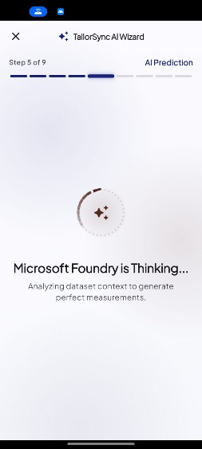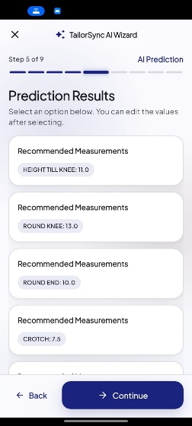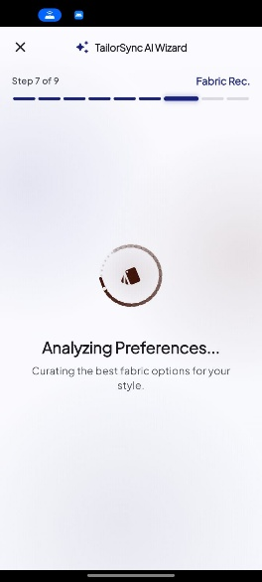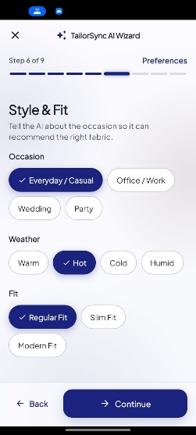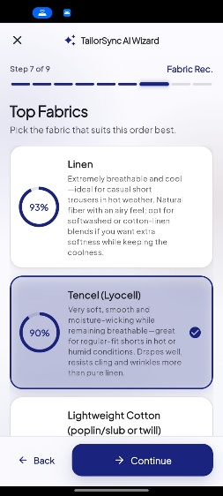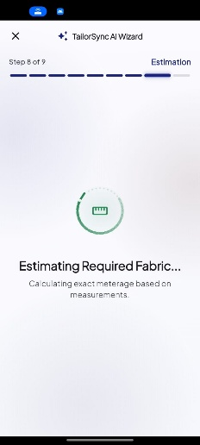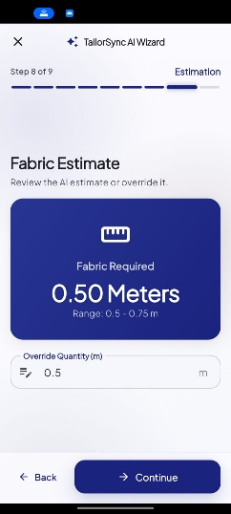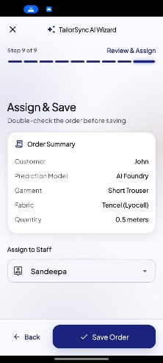

8.4 Feedback Incorporated After Evaluation
Feedback from participants and the project team led directly to several improvements in the final build: a faster AI agent, Sri Lankan garments in Virtual Try-On, blueprints with real values for the cutter, fabric stock tracking, clearer reports without revenue figures, a bolder brand-blue interface with a larger profile button, a tailoring-themed loader and better error messages.

8.5 Summary
The evaluation shows that TailorSync's predictions are accurate and that tailoring professionals value its ability to streamline daily work. The improvements made afterwards address the main feedback points and further raise performance and usability.

9 Conclusion and Further Work

9.1 Introduction
This chapter summarises the project's achievements, evaluates whether the objectives were met, discusses limitations and proposes future enhancements.

9.2 Quantitative Conclusion
TailorSync delivered a fully functional, cloud-hosted, cross-platform application. Evaluation confirmed 90% of AI measurement predictions within ±2 cm (MAE 1.35 cm), a 100% pass rate across the 35 interim test cases plus all tests executed for the new features, an overall satisfaction score of 4.33/5.0, and AI response times reduced from about 30 s to about 2-6 s per step.

9.3 Objective Achievement
Table 9.1 Objective Achievement
Objective | Status | Evidence
O1 Custom ML measurement prediction | Achieved | Tree-ensemble models with K-Means alternatives; 90% within ±2 cm
O2 Fabric recommendation | Achieved | Top-3 fabrics with suitability and live stock status; rated highly by users
O3 Fabric estimation | Achieved | Metre estimates stored on each order; 4.5/5 user rating
O4 Multi-tenant management system | Achieved | 9-step wizard, 7-stage pipeline, roles, staff assignment, e-mail notices
O5 Contextual AI (Foundry) | Achieved | ts-ai-agent integrated with managed identity; about 2-6 s per step
O6 Visualisation | Achieved | Virtual Try-On with Sri Lankan garments; measurement-annotated blueprints
O7 Inventory and analytics | Achieved | Auto-deducting inventory, alerts, history; reports with trend charts
O8 Secure, privacy-compliant deployment | Achieved | Azure App Service + CI/CD, bcrypt, JWT, reCAPTCHA, PDPA-aligned privacy policy
O9 Evaluation | Achieved | User study (4.33/5) and accuracy study (MAE 1.35 cm)

9.4 Limitations
- Dataset size: the datasets contain 27-50 rows each. They cover standard sizes well, but predictions for unusual body types are less certain, and the custom ML engine currently covers shirts and trousers only.
- Internet dependency: the app needs a connection to the cloud backend; the Foundry agent and Virtual Try-On cannot work offline.
- Free-tier limits: Virtual Try-On uses a free daily allowance, so heavy use may hit the limit, and generated images are approximate previews rather than exact garments.
- Evaluation scope: the user study involved a small number of participants and was carried out before the latest enhancements; the final features have not yet been evaluated with a larger group.
- Platforms: the app has been built and tested on Android and the web; iOS and desktop builds have not been tested.

9.5 Future Enhancements
- Extend the custom ML models to all ten garment types and retrain them with anonymised data contributed by consenting shops.
- Add on-device prediction (for example TensorFlow Lite) for basic offline use.
- Customer-facing features: order status messages via SMS or WhatsApp and a customer portal to view try-on images.
- Blueprint export to PDF and printable cutting sheets, and blueprints for more garments.
- Supplier management and automatic purchase suggestions from inventory trends.
- A larger post-release evaluation with more shops, and iOS and desktop releases.

9.6 Summary
TailorSync modernises traditional tailoring operations by combining practical business management with fast custom ML, contextual generative AI and visual tools. The project shows that these technologies can be packaged affordably and responsibly for small businesses, while keeping the tailor in control of every decision.

10 References
[1] M. Hossain and M. S. Islam, "CNN-based body measurement estimation from photographs for custom garment fitting," Proc. of ICCVIP, pp. 312-319, 2023.
[2] R. Kumar, M. Singh, and P. Gupta, "Manual measurement errors in bespoke tailoring: A systematic analysis," Int. J. of Fashion Design, vol. 15, no. 2, pp. 189-198, 2022.
[3] P. Lewis et al., "Retrieval-Augmented Generation for Knowledge-Intensive NLP Tasks," Advances in NeurIPS, vol. 33, pp. 9459-9474, 2020.
[4] Smart Tailor ERP, "Enterprise Resource Planning for Garment Factories." [Online]. Available: https://www.smartailors.com/
[5] Tailornova, "Online Pattern Making & Virtual Fitting Platform." [Online]. Available: https://tailornova.com/
[6] F. Pedregosa et al., "Scikit-learn: Machine Learning in Python," Journal of Machine Learning Research, vol. 12, pp. 2825-2830, 2011.
[7] Microsoft, "Azure AI Foundry Agent Service documentation." [Online]. Available: https://learn.microsoft.com/azure/ai-foundry/
[8] Cloudflare, "Workers AI: FLUX.2 [klein] model documentation." [Online]. Available: https://developers.cloudflare.com/workers-ai/
[9] Black Forest Labs, "FLUX.2 image generation and editing models." [Online]. Available: https://bfl.ai/
[10] Google, "reCAPTCHA v2 developer guide." [Online]. Available: https://developers.google.com/recaptcha/docs/display
[11] Parliament of the Democratic Socialist Republic of Sri Lanka, "Personal Data Protection Act, No. 9 of 2022."
[12] Google, "Flutter documentation." [Online]. Available: https://docs.flutter.dev/
[13] S. Ramírez, "FastAPI documentation." [Online]. Available: https://fastapi.tiangolo.com/
[14] Neon, "Serverless Postgres documentation." [Online]. Available: https://neon.tech/docs

11 Appendices

Appendix A: Individual's Contribution

Member 1: A.G.S.V. Wimalasiri
Contribution:
I designed and implemented the core FastAPI backend architecture of TailorSync and was responsible for the cloud deployment and backend infrastructure on Microsoft Azure. I developed the modular API architecture using separate routers and service layers to maintain a structured, maintainable, and scalable backend. My work included implementing order-related API endpoints, authentication dependencies, Pydantic-based data validation, and communication between the API, business logic, database, and AI services.
I also implemented the Azure AI Foundry integration, enabling the backend to communicate with the cloud-based generative AI service for AI-assisted tailoring recommendations. In addition, I implemented the automated email notification service using FastAPI BackgroundTasks, allowing customer notifications to be processed without unnecessarily delaying the main API response.
The backend was deployed using Microsoft Azure App Service, providing a cloud-hosted API that can be accessed by the TailorSync Flutter application.
Learnings:
Through this project, I learned how to design and implement a modular REST API using Python and FastAPI, including router-based architecture, service-layer separation, Pydantic validation, and dependency injection. I gained practical experience deploying a Python backend to Microsoft Azure App Service and configuring a cloud-based application for communication with external services.
I also learned how to integrate Azure AI Foundry with a backend application and how background processing can be used for tasks such as automated email notifications. This improved my understanding of cloud application architecture, API integration, asynchronous processing, and production-oriented backend development.
Problems:
One of the main challenges was ensuring that external operations, particularly AI communication and email delivery, did not unnecessarily delay the application's main API requests. External services can introduce network latency or temporary failures, which could negatively affect the user experience if handled directly within the main request-response cycle.
I addressed this by separating the AI and email functionality into dedicated service components and using FastAPI BackgroundTasks for automated email notifications. I also implemented appropriate input validation and error-handling mechanisms to handle invalid requests and communication failures with external AI services while keeping the backend stable and maintainable.

Member 2: W.A.E.M. Wijayarathna
Contribution:
I was responsible for the Dual-Engine AI Architecture of TailorSync. I worked on the integration of both the Custom Machine Learning engine and the Azure AI Foundry generative AI engine within the overall system architecture.
The Custom ML component uses a trained Scikit-Learn model to provide measurement predictions based on relevant customer and garment information. The trained model is serialized using Joblib and integrated with the FastAPI backend through the machine learning service.
I also worked on the Azure AI Foundry component, where contextual order information is prepared and passed to the AI service through structured prompts. This component supports AI-assisted recommendations such as fabric-related suggestions and fabric quantity estimation for more complex tailoring requirements.
The two-engine architecture separates specialized predictive machine learning from cloud-based generative AI functionality, allowing each component to perform the task for which it is designed.
Learnings:
I learned how to integrate machine learning and generative AI into a single software architecture. I gained practical experience working with Scikit-Learn models, Joblib model serialization, model prediction workflows, prompt engineering, and Azure AI Foundry integration.
I also learned how different AI technologies can be combined within one application rather than depending on a single AI model for every functionality. This helped me understand the differences between traditional predictive machine learning and generative AI.
Problems:
One of the main challenges was coordinating two different AI technologies with different input and output requirements. The Custom ML model requires structured numerical inputs, while Azure AI Foundry requires contextual information and carefully designed prompts.
I addressed this by separating the two AI engines into dedicated services and defining clear input and output structures for each component. Another challenge was that generative AI responses could occasionally contain additional formatting or markdown instead of the expected structured response. This was addressed through response processing and validation before the data was returned to the application.

Member 3: K.P.N.D. Ashokarathna
Contribution:
I was responsible for the Frontend Application using Flutter and the user interface experience of TailorSync. I worked on the application's navigation, reusable interface components, responsive layouts, and the 8-step New Order Wizard.
The New Order Wizard divides the order creation process into manageable stages, including customer selection, garment information, measurements, and order details. I also implemented dynamic measurement fields, allowing the application to display appropriate measurement inputs according to the selected garment.
I integrated the Flutter frontend with the FastAPI backend through REST API communication and worked with Riverpod state management to maintain and update application data across different screens. I also ensured that authenticated users could access the appropriate frontend functionality according to their roles.
Learnings:
I learned how to develop a structured cross-platform application using Flutter and Dart. I gained experience in responsive UI development, reusable widget design, dynamic form generation, REST API integration, and state management using Riverpod.
I also learned how to manage complex multi-step forms and maintain application state while moving between different screens and stages of the order creation process.
Problems:
The main challenge was managing application state across the eight steps of the New Order Wizard. User-entered information needed to remain available while moving between steps, while temporary controllers and resources needed to be properly managed.
I addressed this by improving the state-management structure and carefully managing the lifecycle of form controllers. I also optimized widget rebuilding and data handling to prevent unnecessary processing and maintain a responsive user interface.

Member 4: N.D.H.A. Madubhashitha
Contribution:
I was responsible for Database Architecture and Data Engineering within TailorSync. I worked on the relational PostgreSQL database structure and the representation of database entities through SQLAlchemy ORM.
I designed relationships between important entities such as customers, users, orders, and AI-related records. Foreign keys and relational relationships were used to maintain data consistency and ensure that customer information, measurements, and orders remain correctly associated.
I also contributed to the data engineering process for the Custom ML component by preparing and organizing the tailoring datasets used for machine learning. This included reviewing the dataset structure, preparing relevant data for model development, and supporting the evaluation of prediction results.
In addition, I worked with database schema management and Alembic migrations, allowing database structure changes to be tracked and applied systematically.
Learnings:
I learned how to design a normalized relational database using PostgreSQL, implement database relationships using SQLAlchemy ORM, and manage schema changes using Alembic.
I also gained practical experience in data preparation and engineering for machine learning applications. I learned how the quality and structure of training data can directly affect the performance of a prediction model.
Problems:
One challenge was ensuring that the database relationships correctly represented the real-world relationships between customers, orders, measurements, and AI predictions. Incorrect relationships could result in inconsistent or duplicated information.
I addressed this by using appropriate primary keys, foreign keys, and relational mappings through SQLAlchemy. Another challenge was ensuring that the data used for machine learning was sufficiently representative of real tailoring scenarios. I improved the dataset structure and worked with realistic tailoring information to make the data more suitable for model development and evaluation.

Member 5: Manuwendra Rajapaksha
Contribution:
I was responsible for the Order Workflow and Business Logic of TailorSync. I worked on implementing the digital workflow used to manage tailoring orders from creation through production and completion.
I implemented the order status and workflow logic so that orders move through defined stages instead of allowing arbitrary status changes. I also contributed to the Human-in-the-Loop AI approval process, where AI-generated measurements can be reviewed by a tailor before the order proceeds to production.
Another important part of my contribution was implementing the business logic for staff assignment. Owners can assign orders or tasks to appropriate staff members, while staff users can view and manage the tasks assigned to them according to their permissions.
I also contributed to the database migration and CI/CD-related workflow, ensuring that changes to the application's business and database components could be incorporated systematically.
Learnings:
I learned how to translate a real-world tailoring workflow into a structured software business process and state machine. I gained experience implementing status transitions, staff assignment, business rules, and Human-in-the-Loop workflows.
I also learned how AI systems can be incorporated into business processes while retaining human verification for important decisions. This improved my understanding of how automation and human expertise can work together within a software system.
Problems:
One challenge was preventing AI-generated information from being treated as automatically final. Measurements generated by an AI model may require verification before being used during production.
I addressed this by implementing a Human-in-the-Loop workflow, where the tailor can review and approve the AI-generated information before the order progresses to the next production stage.
Another challenge was ensuring that staff members only interact with orders relevant to their assigned responsibilities. This was addressed through appropriate business rules and integration with the system's role and permission structure.

Member 6: D.M.J.B. Disanayake
Contribution:
I was responsible for QA, Testing and DevOps activities within TailorSync. I worked on developing and organizing automated tests using PyTest to verify important backend functionality and ensure that the system handles both valid and invalid inputs correctly.
The testing process included testing API behavior, validation rules, business logic, and AI-related functionality. I also contributed to the GitHub Actions CI/CD pipeline, where automated workflows can execute tests whenever changes are pushed to the project repository.
In addition to automated testing and CI/CD, I contributed to application reliability and performance validation. I examined areas of the application where excessive state updates or rendering operations could affect responsiveness and helped optimize these areas.
Learnings:
I learned how to design and execute automated software tests using PyTest and how testing can be integrated into a development workflow.
I also learned how GitHub Actions can automate development processes such as dependency installation, testing, and deployment-related tasks. This gave me practical experience with CI/CD and software quality assurance.
Furthermore, I learned how application performance can be affected by unnecessary state rebuilds and excessive data processing, particularly in Flutter applications running on mobile devices.
Problems:
One of the main challenges was ensuring that automated tests could run reliably in the CI environment without depending unnecessarily on external production services. Database-dependent tests initially caused connection and timeout issues.
I addressed this by separating unit tests from unnecessary external dependencies and configuring an appropriate test database environment for tests that require database access.
Another challenge was frontend performance on devices with limited resources. I helped address this by reducing unnecessary state rebuilds, optimizing data handling, and caching appropriate data where necessary. These improvements contributed to better application responsiveness and reliability.

Appendix B: Main API Endpoints
Table B.1 Main REST API Endpoints (prefix /api/v1)
Area | Endpoints
Authentication | /auth/login, /auth/signup (with reCAPTCHA token), /captcha-config
Customers & measurements | /customers, /measurements, /templates
Orders | /orders (create, list, details, status updates, delete)
AI | /ai/predict-measurements (Custom ML), /ai/foundry-predict, /ai/recommend-fabric, /ai/estimate-fabric, /ai/input-ranges/{garment}
Virtual Try-On | /virtual-tryon, /virtual-tryon/usage
Inventory (Owner) | /inventory, /inventory/alerts, /inventory/samples, /inventory/{id}/restock, /inventory/{id}/history
Reports (Owner) | /reports/overview?days=, /reports/dashboard, /reports/staff-performance
Staff & business | /staff, /business, /users

Appendix C: Changes Since the Interim Report
- AI engine: connected the dedicated Foundry agent (ts-ai-agent), moved it to GPT-4.1-mini, removed File Search and added compact prompts and fallback (about 30 s to about 2-6 s).
- Prediction method step: the tailor can choose Custom ML or Foundry for each order; the method is recorded and reported.
- Virtual Try-On: new feature using FLUX.2 klein on Cloudflare Workers AI, with a usage counter and Sri Lankan garments, colours and fabrics.
- Garment blueprints: long-sleeve shirt, short-sleeve shirt and trouser blueprints with computed values, in the wizard and order details.
- Fabric inventory: auto-created items, tracked deductions, restocks, history, low-stock alerts, stock badges and a sample fabric set.
- Reports: new overview with period tabs, KPIs, trend line charts, status donut, garment/customer/staff insights and inventory panel; revenue removed.
- Order details: selected fabric, fabric quantity, optional price and blueprint shown on each order.
- Security: Google reCAPTCHA v2 on login and sign-up.
- UI/UX: new design system, brand-blue theme and navigation, page watermarks, scissor loader, owner profile ring and splash-screen server warm-up.
- Legal: detailed Privacy Policy (PDPA-aligned) and corrected Terms & Conditions.
- DevOps: managed identity for AI, timing middleware, diagnostic and benchmark scripts.

