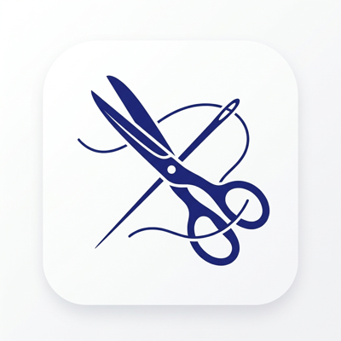
TailorSync
User Manual
AI-Powered Tailoring Business Management System

Version 1.0 | October 2026
CCS2360 Technology Challenge Competition
Faculty of Computing & IT, Sri Lanka Technology Campus
Prepared by the TailorSync Project Team
A.G.S.V. Wimalasiri
W.A.E.M. Wijayarathna
N.D.H.A. Madubhashitha
D.M.J.B. Dissanayake
Manuwendra Rajapaksha
K.P.N.D. Ashokarathna
Document Information
Item | Details
Product | TailorSync mobile app (Android) and web app
Document | User Manual
Version | 1.0
Date | October 2026
Intended readers | Tailoring shop owners and their staff (tailors, cutters, assistants)
Support | agsvwimalasiri@gmail.com (Profile & Settings > Contact Support)

Contents

1. Introduction

1.1 About this manual
This manual explains how to use TailorSync, from opening the app for the first time to managing customers, creating orders with AI assistance, tracking production, previewing garments with Virtual Try-On, controlling fabric stock and reading business reports. Every task is explained step by step and illustrated with screenshots taken from the TailorSync Android app.

1.2 What is TailorSync?
TailorSync is an AI-powered management system for tailoring shops. It keeps customers, measurements, orders and staff tasks in one secure place and helps you work faster and with fewer mistakes:
- AI measurement prediction: enter a few key measurements and TailorSync predicts the rest, using either the Microsoft Azure AI Foundry assistant or TailorSync's own Custom ML model.
- Fabric recommendation and estimation: the best fabrics for the garment, occasion and weather, and the metres of fabric required.
- Cutting blueprints: shirt and trouser pattern pieces with the customer's own measurements written on them.
- Production tracking: every order moves through seven clear stages, with due dates and staff assignment.
- Virtual Try-On: an AI image of the customer wearing the chosen garment, including Sri Lankan styles.
- Fabric inventory: stock levels that update automatically as orders are created.
- Reports & Analytics: charts and figures on orders, delivery, fabric, garments, staff and customers.

1.3 Conventions used in this manual
Convention | Meaning
Bold text | A button, tab, field or label exactly as it appears on screen, e.g. Save Customer
Profile & Settings > Manage Staff | A path: open Profile & Settings, then tap Manage Staff
Tip box (green) | A helpful shortcut or good practice
Note box (blue) | Extra information worth knowing
Important box (orange) | Something that can cause a problem or lose data if ignored

2. Getting Started

2.1 System requirements
Item | Requirement
Android device | Android 8.0 or later with about 150 MB of free storage
Web browser | Latest Google Chrome, Microsoft Edge or Firefox
Internet | Wi-Fi or mobile data. Signing in, saving data and all AI features need an internet connection
Camera (optional) | Used to take customer photos for Virtual Try-On
Account | An Owner account (created through sign-up) or a Staff account (created by the Owner)

2.2 User roles
TailorSync has two roles. The screens and options you see depend on your role.
Feature | Owner | Staff
Home dashboard with shortcuts | Yes | No (opens on Tasks)
Customers | Yes | No
Create orders (AI Wizard) | Yes | No
Orders and order details | All orders | Orders assigned to them
Tasks and stage updates | All tasks | Own tasks
Virtual Try-On | Yes | No
Fabric Inventory | Yes | No
Reports & Analytics | Yes | No
Business Profile, Measurement Templates, Manage Staff | Yes | No
Edit own name, phone and password | Yes | Yes

2.3 Launching the app
Open TailorSync. The splash screen shows the TailorSync logo and an animated pair of scissors while the app connects to the server and signs you in automatically if you were already logged in.
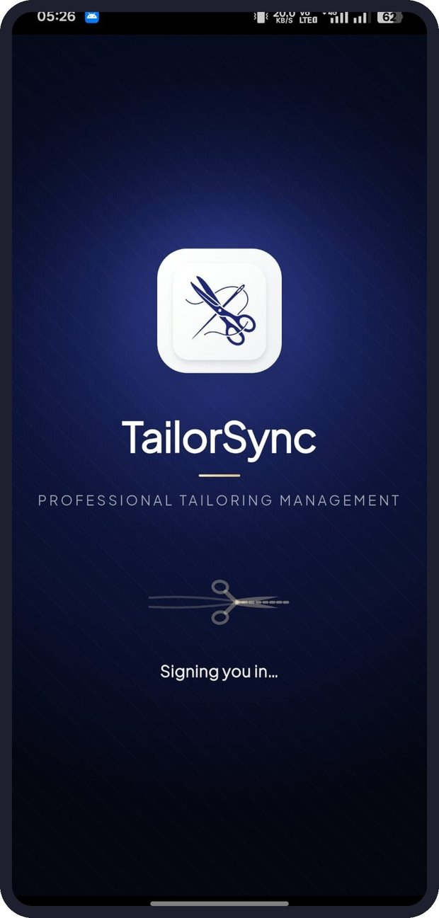
Figure 1: Splash screen

Note: The first launch of the day can take a little longer while the cloud server wakes up. If the app cannot connect, check your internet connection and tap Retry.

2.4 Creating an owner account
Business owners register their shop once. Staff do not sign up; the owner creates their accounts (see Section 10.3).
- On the welcome screen tap Create account.
- Enter your Full Name, Mobile Number, Business / Organization name, Business Registration No. and Business Contact Number.
- Enter your Email Address and create a Password (at least 8 characters, including upper-case and lower-case letters, a number and a special character).
- Open and read the Terms and Conditions, then tick the box to accept them.
- Tick I'm not a robot and tap Create Account.
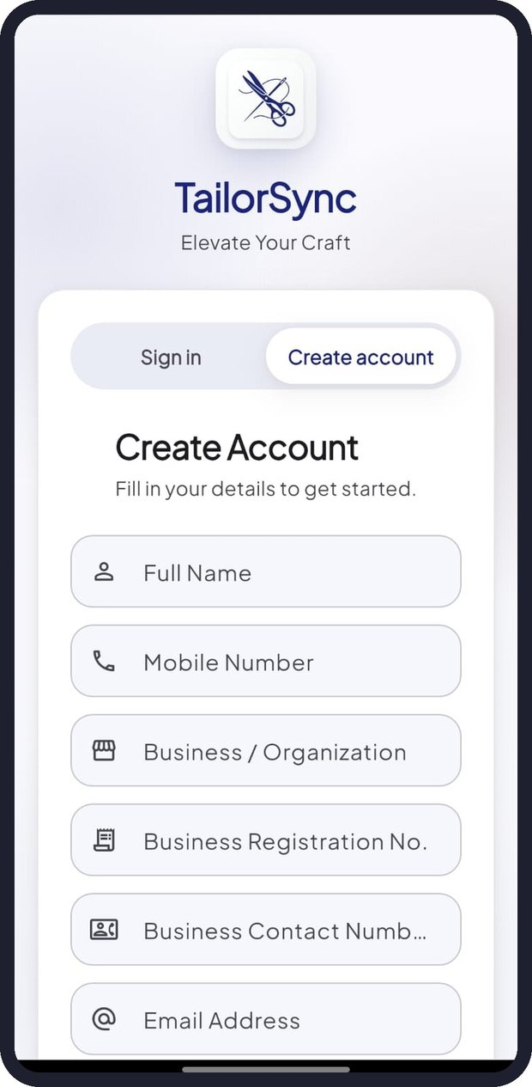  Figure 2: Create Account form | 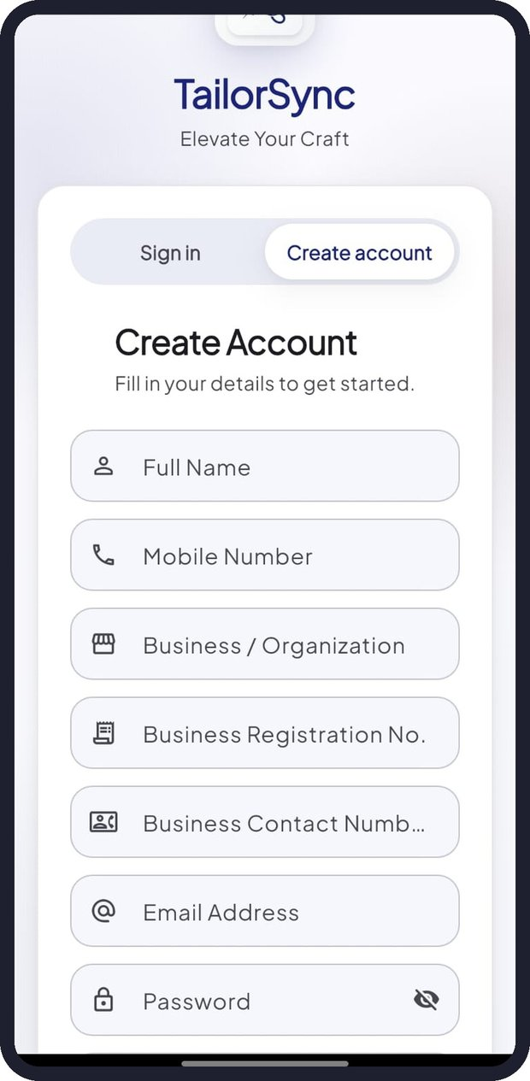  Figure 3: Create Account (continued) | 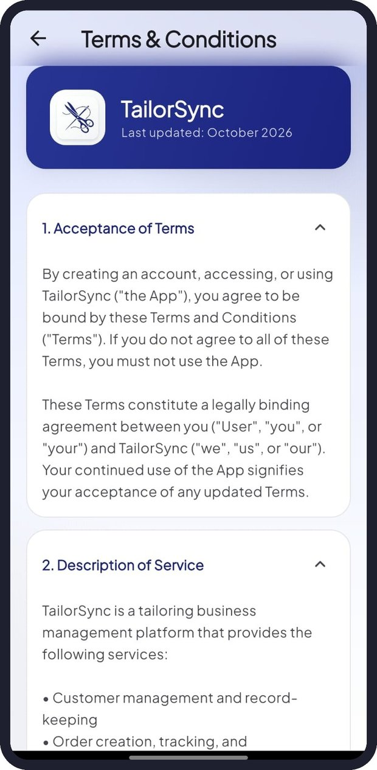  Figure 4: Terms & Conditions

2.5 Signing in
- Make sure the Sign in tab is selected.
- Enter your Email Address and Password. Tap the eye icon to show or hide the password.
- Tick I'm not a robot. If Google shows a picture check, complete it.
- Tap Sign In. Owners arrive on the Home screen; staff arrive on their Tasks screen.

2.6 Forgot password
- On the Sign in screen tap Forgot Password?.
- Enter the email address registered with TailorSync.
- Tap Send Reset Instructions and follow the link sent to your email.
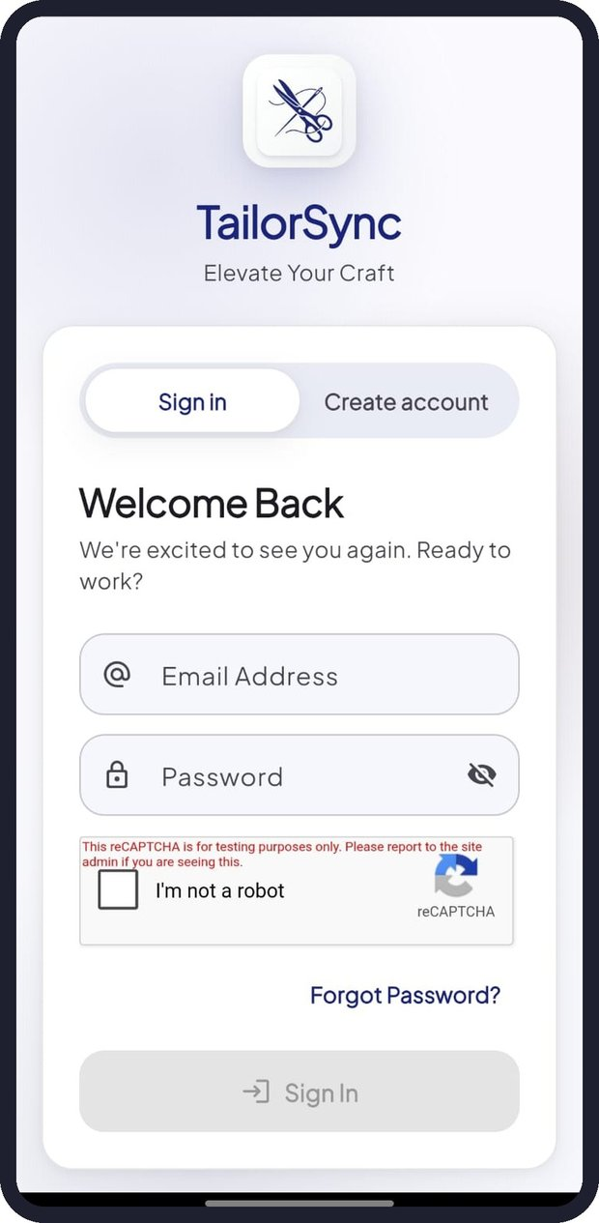  Figure 5: Sign in with reCAPTCHA | 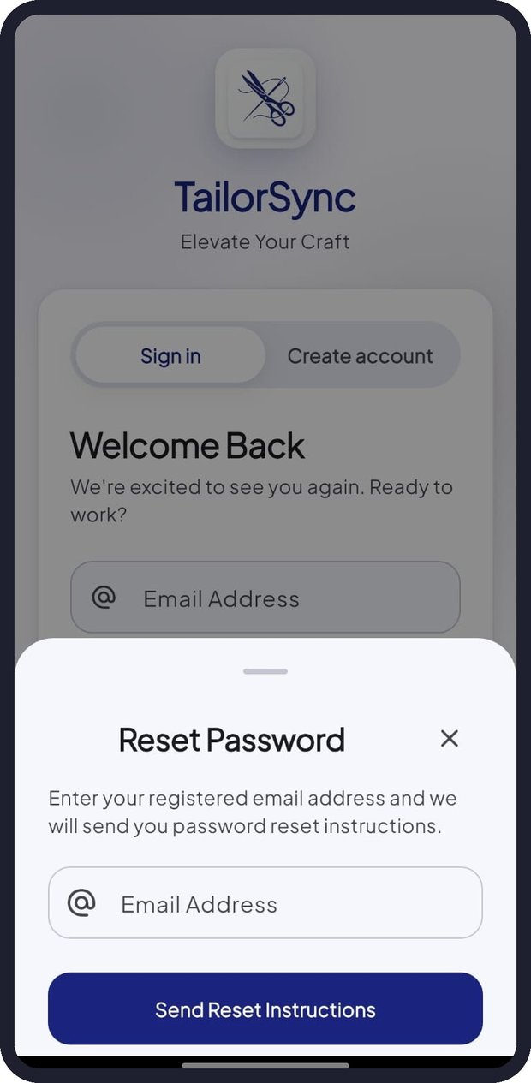  Figure 6: Reset Password

Tip: The Sign In button stays grey until both fields are filled and the "I'm not a robot" box is ticked.

3. Home Dashboard and Navigation

3.1 Home dashboard (Owner)
Home is the owner's starting point. It greets you by name and brings the most important information and actions together.
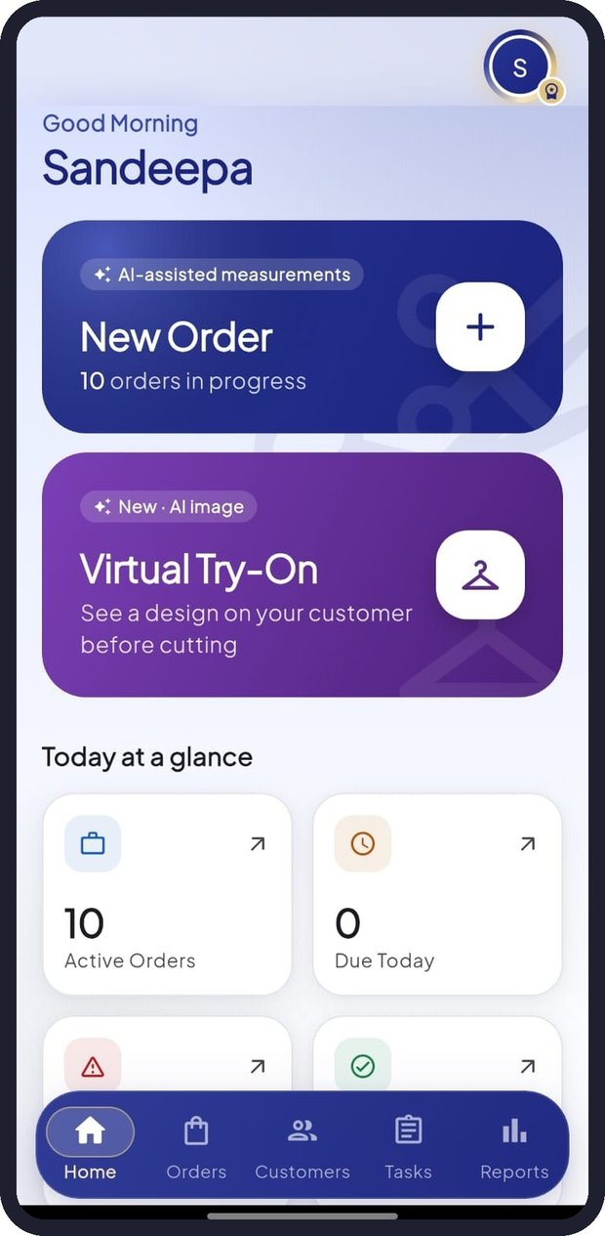  Figure 7: Home dashboard | 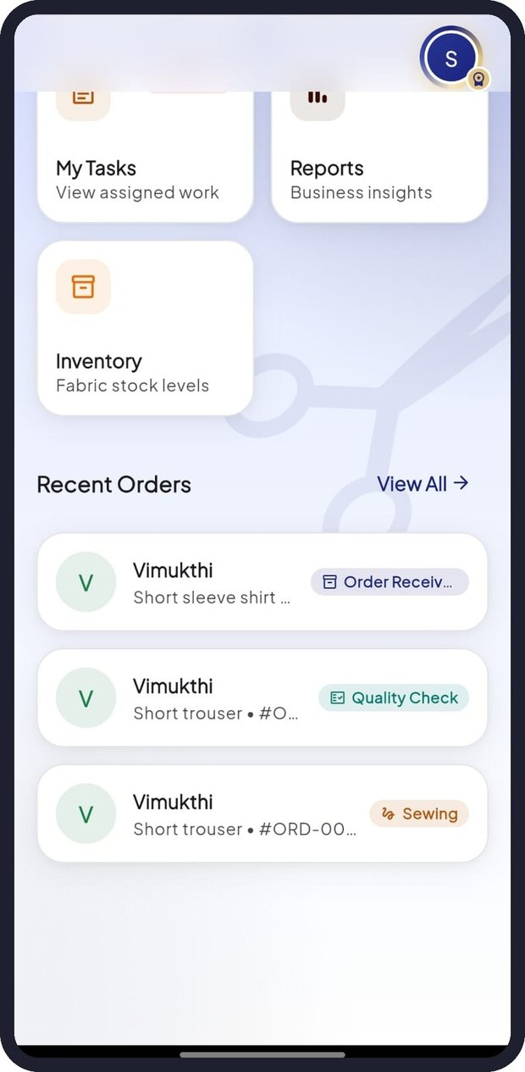  Figure 8: Shortcuts and Recent Orders

Area | What it does
Profile picture (top right) | Opens Profile & Settings. Owners have a gold ring and a small badge
New Order card | Starts the AI Order Wizard and shows how many orders are in progress
Virtual Try-On card | Opens the Try-On studio to preview a design on a customer photo
Today at a glance | Active Orders, Due Today, Overdue and Completed counts. Tap a tile to open Tasks
Shortcuts | Orders, Customers, My Tasks, Reports and Inventory
Recent Orders | The latest orders with their stage. Tap one to open it, or tap View All

3.2 Bottom navigation bar
The blue bar at the bottom of the screen moves you between the main sections. It hides when you scroll down and reappears when you scroll up. The selected tab is highlighted.
Owner tabs | Staff tabs
Home, Orders, Customers, Tasks, Reports | Tasks, Orders, Profile

Tip: Pull down on any list or report to refresh it with the latest data.

4. Managing Customers

4.1 Customer list
Tap Customers in the bottom bar. The screen shows the number of customers and a card for each one with their name, email and phone number. Use the search box to find a customer by name, phone or email.
Each card has three buttons: info (view details), pencil (edit) and bin (delete).

4.2 Adding a new customer
- Tap Add New at the top right, or Add New Customer at the bottom of the list.
- Enter the customer's Full Name, Email Address and Phone Number.
- Tap Save Customer. The customer is added to the list and can be selected when creating orders.
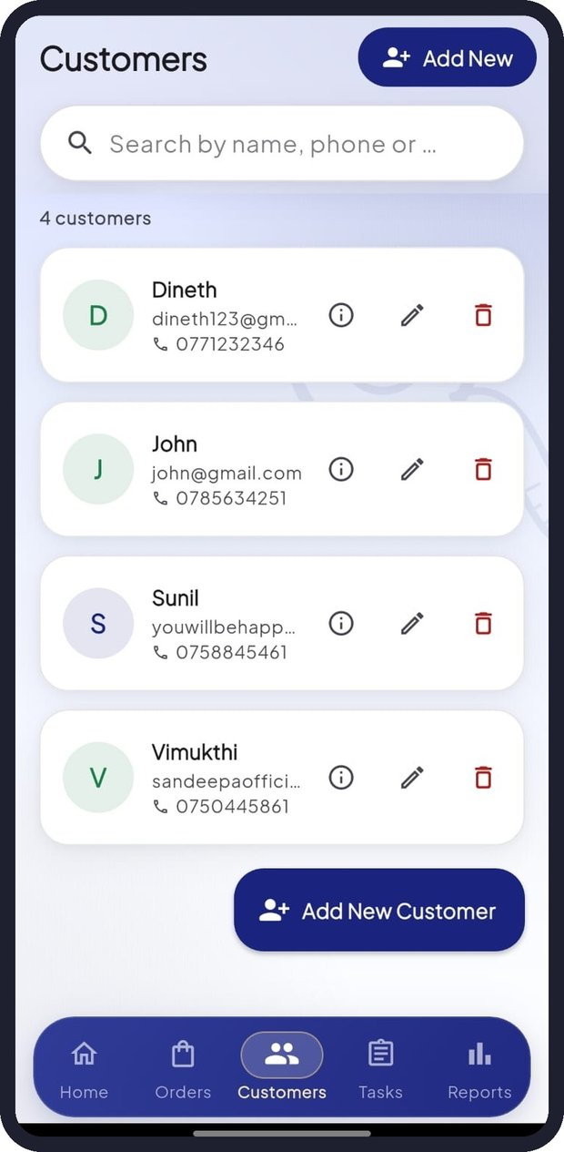  Figure 9: Customers list | 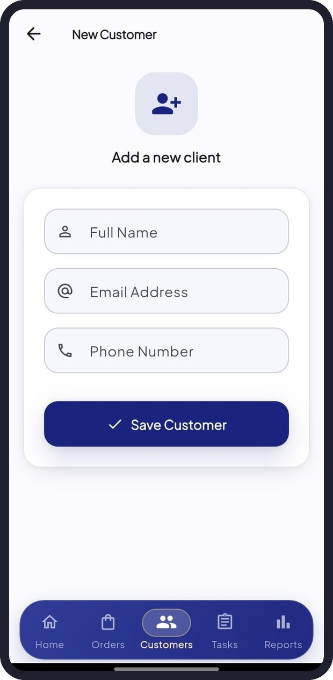  Figure 10: Add a new client | 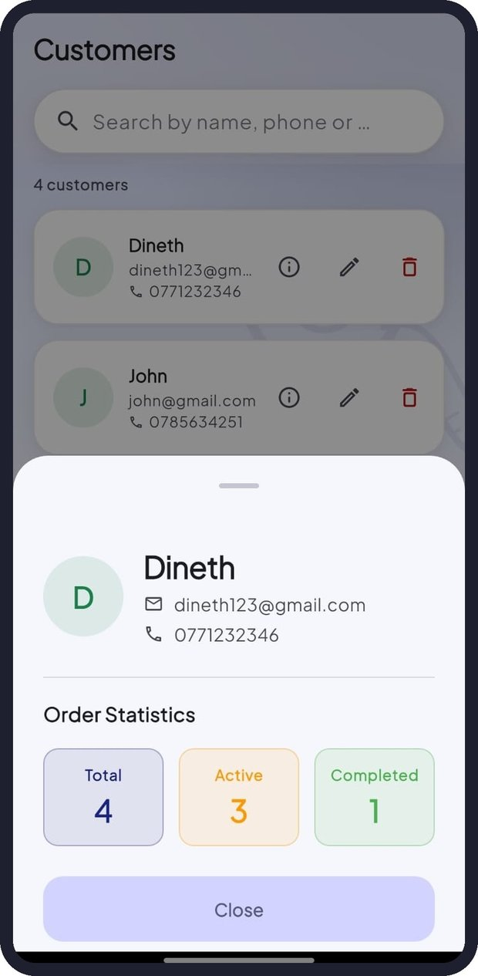  Figure 11: Customer details

4.3 Viewing customer details
Tap the info button on a customer card. A panel shows the customer's contact details and Order Statistics: Total, Active and Completed orders. Tap Close to return.

4.4 Editing or deleting a customer
- Tap the pencil icon, update the details and tap Save Customer.
- Tap the bin icon and confirm Delete to remove the customer permanently.
Important: Ask customers for permission before recording their personal details and measurements. Deleting a customer cannot be undone.

5. Creating an Order with the AI Wizard
The TailorSync AI Wizard guides you through nine steps to create an order. The bar at the top shows the current step (for example "Step 4 of 9") and its name. Tap Continue to go forward, Back to return, or the X to cancel. Nothing is saved until you tap Save Order in the last step.
Start the wizard by tapping the New Order card on Home.

Step 1 - Customer
"Who is this order for?" Search by name or phone and tap the customer. Then tap Continue.

Step 2 - Prediction Method
Choose how the AI should help with measurements:
- AI Foundry: full clothing prediction using Microsoft Azure AI Foundry. Supports all garment categories.
- Custom ML Model: TailorSync's own trained model. Very fast, but currently supports only shirts and trousers.

Step 3 - Garment
"What are we making?" Choose the garment, for example Long Sleeve Shirt, Short Sleeve Shirt, Long Trouser, Short Trouser, Jacket or Dress. The measurement fields in the next step are tailored to this choice.
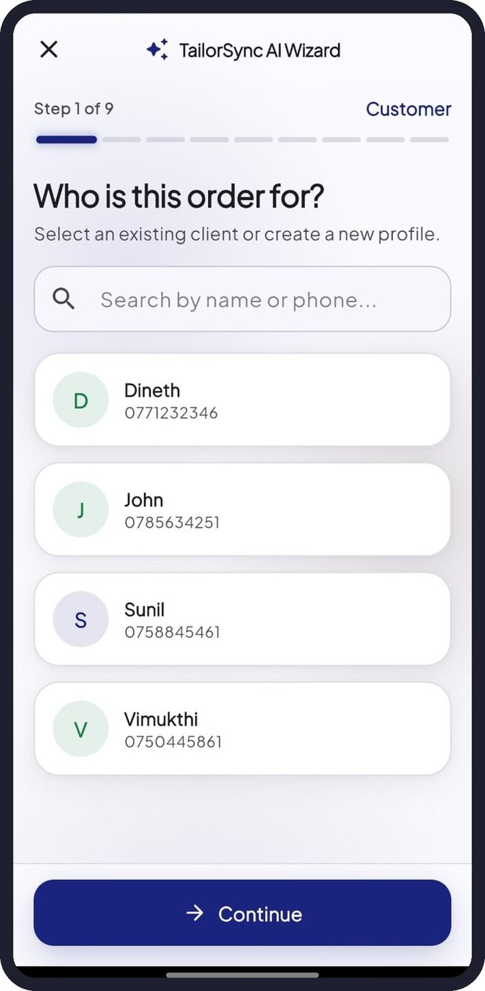  Figure 12: Step 1 - Customer | 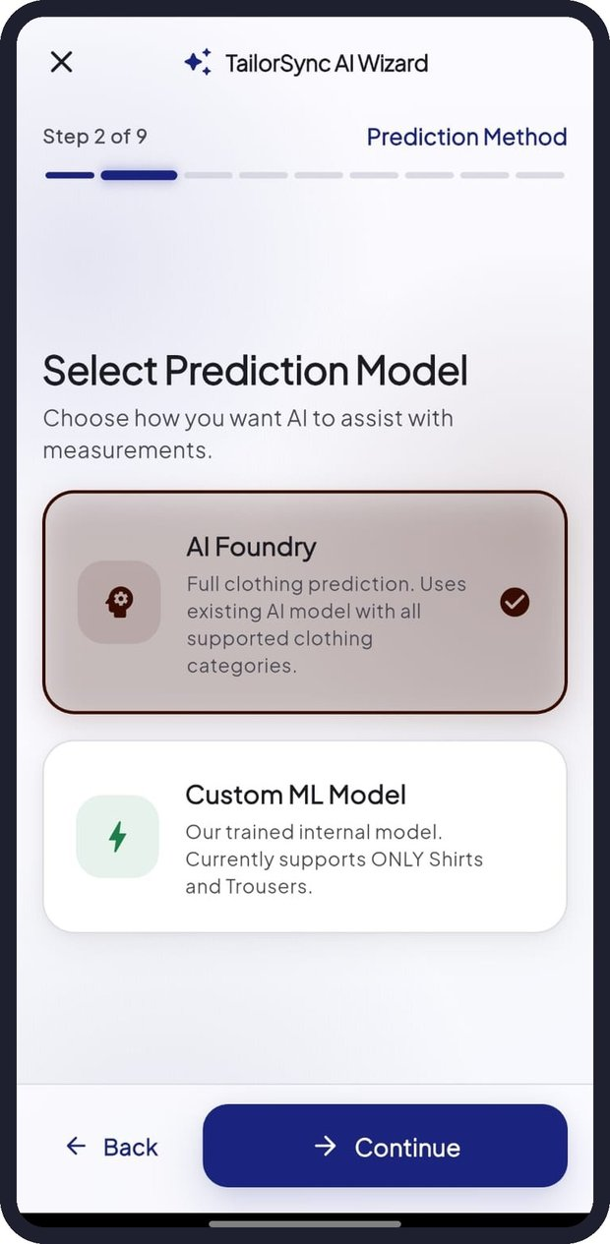  Figure 13: Step 2 - Prediction Model | 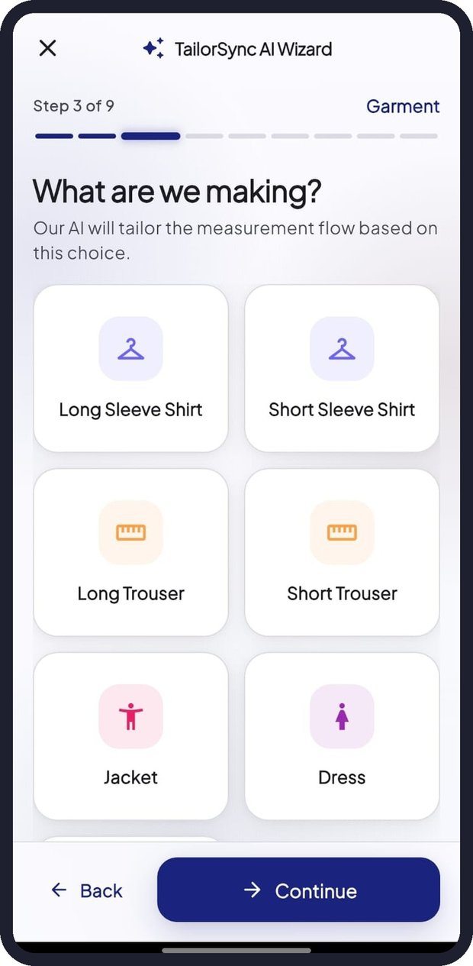  Figure 14: Step 3 - Garment

Step 4 - Priority Input
Enter the Required Measurements shown for the garment (marked with *). Each field shows a short description and the accepted range, for example "Waist - around the waist, 19.0-44.0 in". Optional measurements can be left blank for the AI to suggest. Tap Add Other Measurement to add an extra measurement you have taken.

Step 5 - AI Prediction
While the AI works you will see "Microsoft Foundry is Thinking..." (or the Custom ML equivalent). The Prediction Results then show:
- Recommended Measurements: the AI's best prediction for every measurement, including the fabric estimates.
- Alternative 1, 2...: other likely sets of measurements.
Tap the option that fits best. Tap Edit Measurements to change any value before continuing.
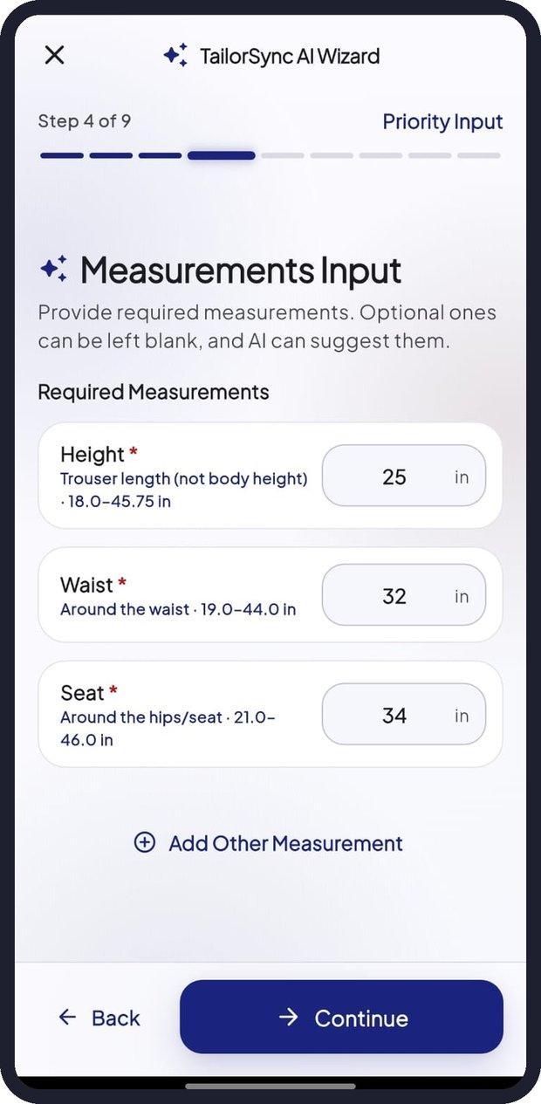  Figure 15: Step 4 - Measurements Input | 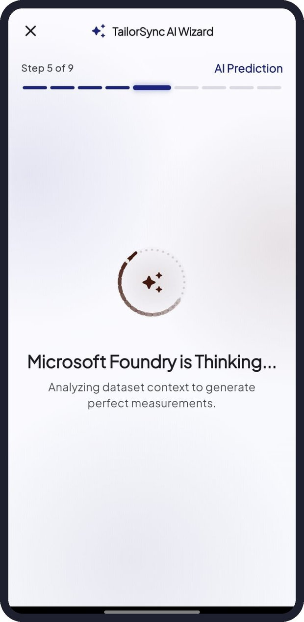  Figure 16: Step 5 - AI is thinking | 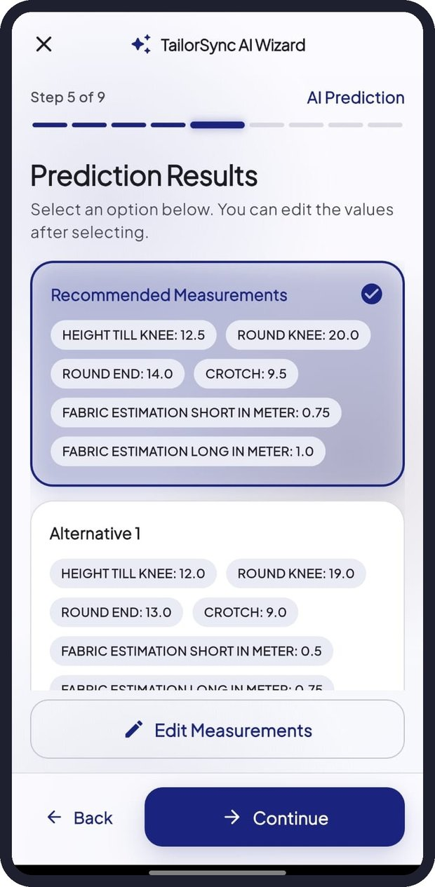  Figure 17: Step 5 - Prediction Results

Important: AI predictions are suggestions. Always check them, especially for unusual body shapes, before cutting fabric.

Step 6 - Preferences (Style & Fit)
Tell the AI about the order so it can recommend the right fabric:
- Occasion: Everyday / Casual, Office / Work, Wedding or Party.
- Weather: Warm, Hot, Cold or Humid.
- Fit: Regular Fit, Slim Fit or Modern Fit.

Step 7 - Fabric Recommendation
After "Analyzing Preferences..." the Top Fabrics list appears. Each fabric shows a match percentage, a short explanation and its stock status from your inventory (for example In stock, Low, or Stock not tracked). Tap the fabric that suits the order best.
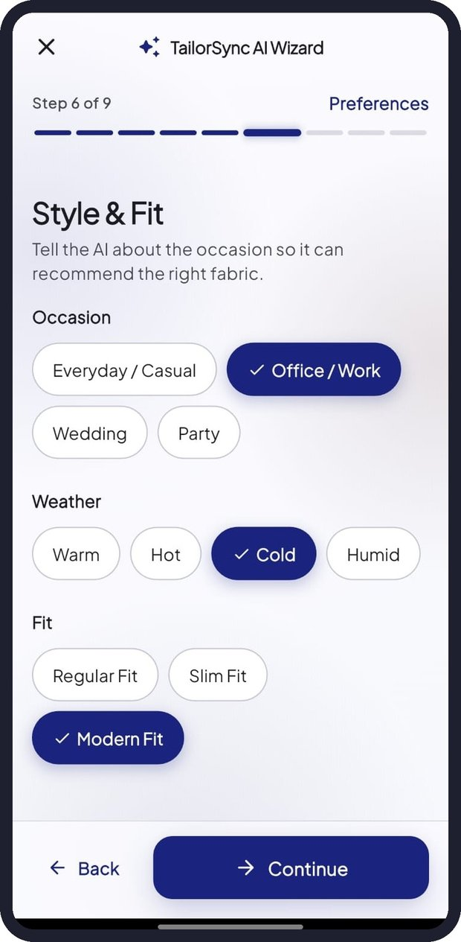  Figure 18: Step 6 - Style & Fit | 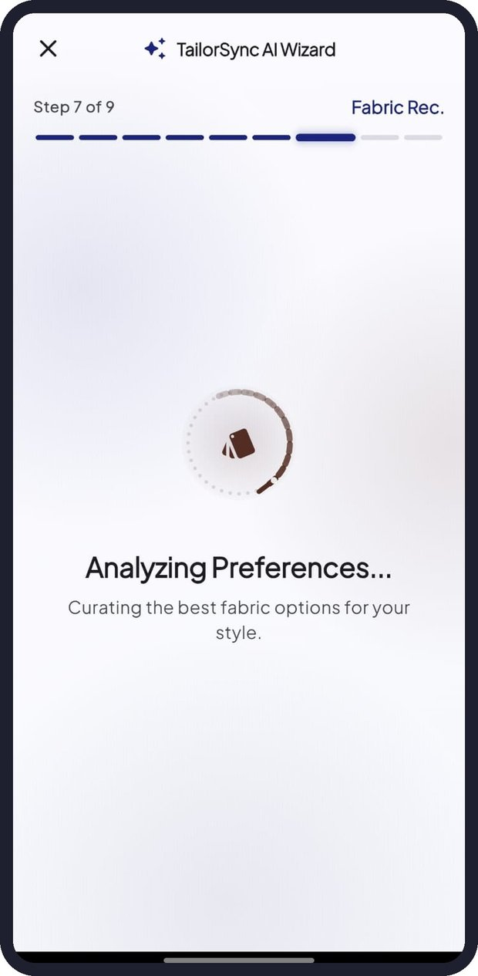  Figure 19: Step 7 - Analyzing preferences | 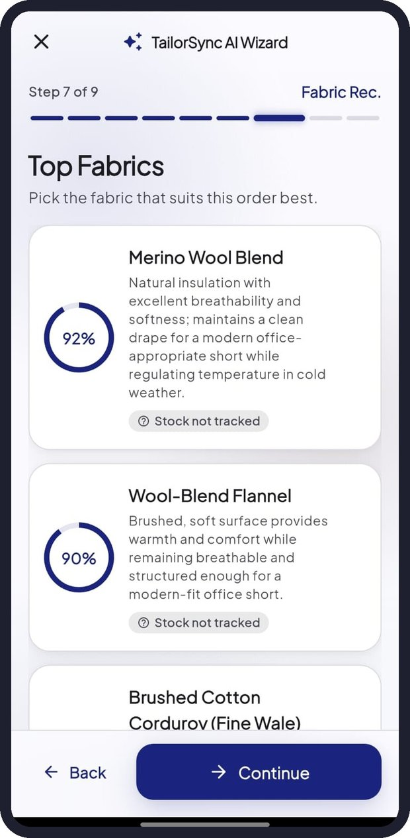  Figure 20: Step 7 - Top Fabrics

Step 8 - Fabric Estimation
TailorSync calculates the fabric required for this customer and garment, for example 0.75 Meters, with the expected range. If you want to use a different amount, type it in Override Quantity (m).

Step 9 - Review & Assign
Check the Order Summary (customer, prediction model, garment, fabric and quantity). Optionally enter the Order Price, choose the staff member in Assign to Staff, then tap Save Order.
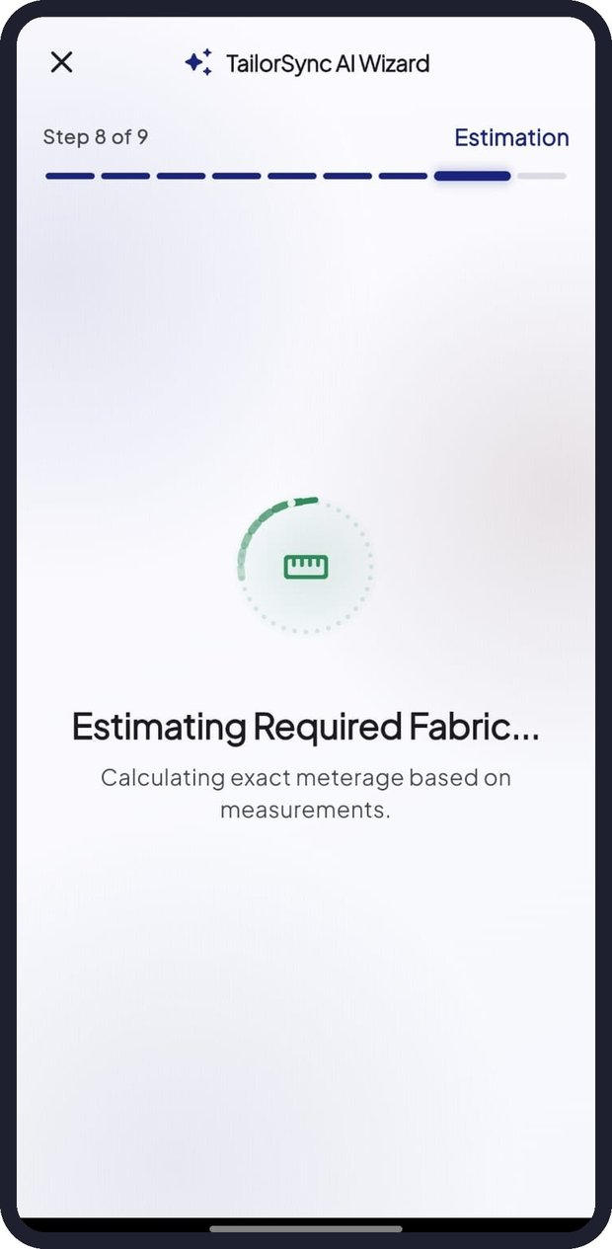  Figure 21: Step 8 - Estimating fabric | 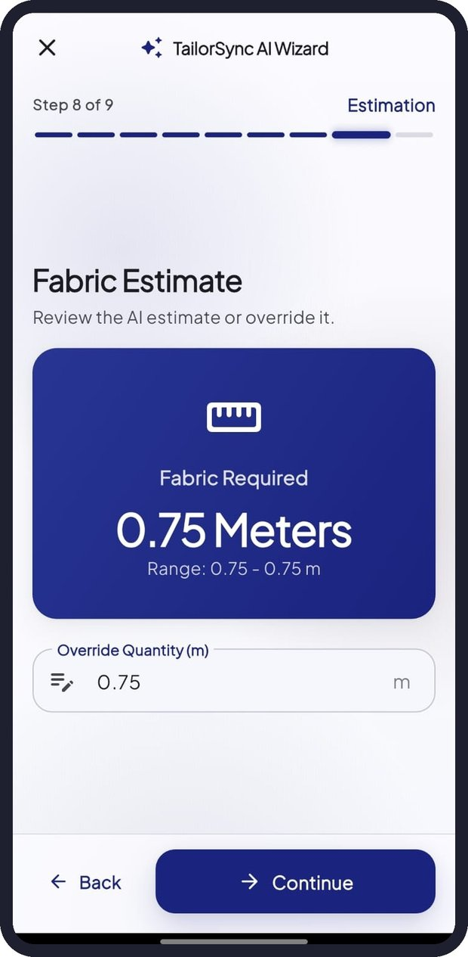  Figure 22: Step 8 - Fabric Estimate | 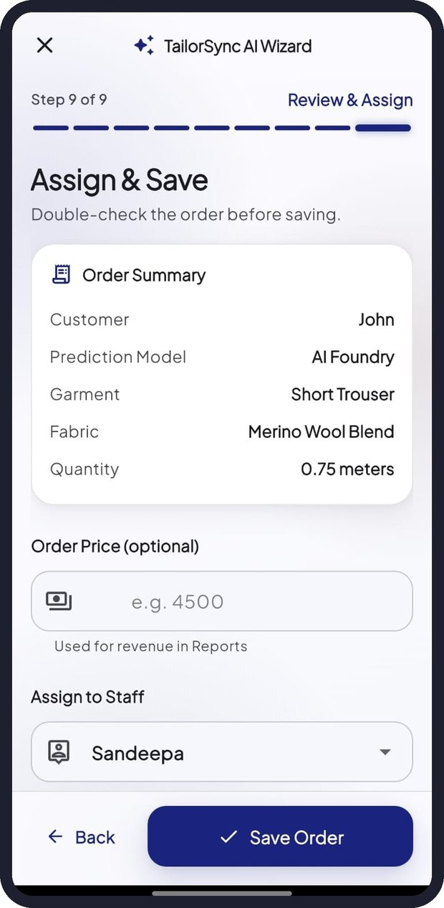  Figure 23: Step 9 - Assign & Save

When the order is saved it starts at the Order Received stage, the assigned staff member is notified, and if the fabric is tracked in your inventory the estimated metres are deducted automatically.

6. Managing Orders

6.1 Orders list
Tap Orders in the bottom bar. Each order card shows the current stage, order number (e.g. #ORD-0036), garment, customer, priority and a Stage progress bar (for example "5 of 7"). Use the search box to find an order, customer or garment, and the filter chips (All, Order Received, Cutting, Sewing...) to show orders in a particular stage. Owners can delete an order with the red bin icon.
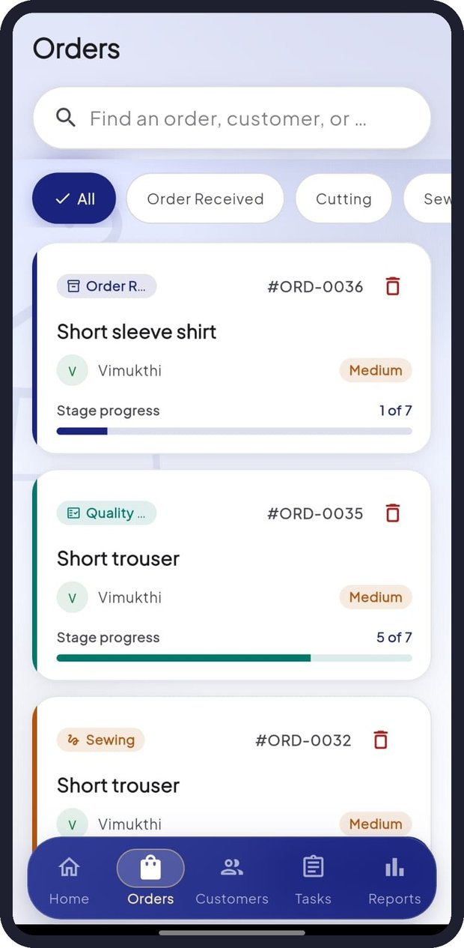  Figure 24: Orders list (Owner) | 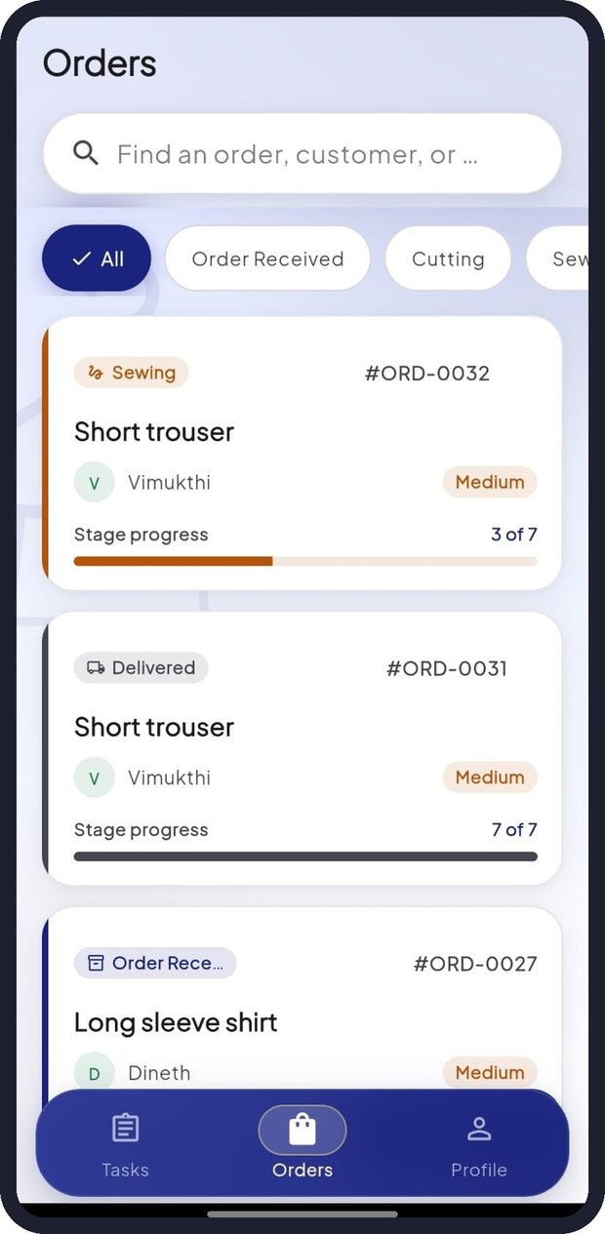  Figure 25: Orders list (Staff)

6.2 Order details
Tap an order to open its details page:
- Header: order number, current stage and garment.
- Summary: Customer, Due Date, Priority and the Prediction method used (AI Foundry or Custom ML).
- Progress: the current stage and how many of the seven stages are complete.
- Measurements: every finalised measurement; AI-predicted values are marked with a sparkle icon.
- Fabric: the selected fabric and the estimated quantity.
- Cutting Blueprint: the pattern pieces (front body, back, sleeve, collar and yoke) with this customer's values written on them. Tap the expand icon to view a piece full screen.
- Share Order Details: share the order with another app (for example WhatsApp or email) using the share button.
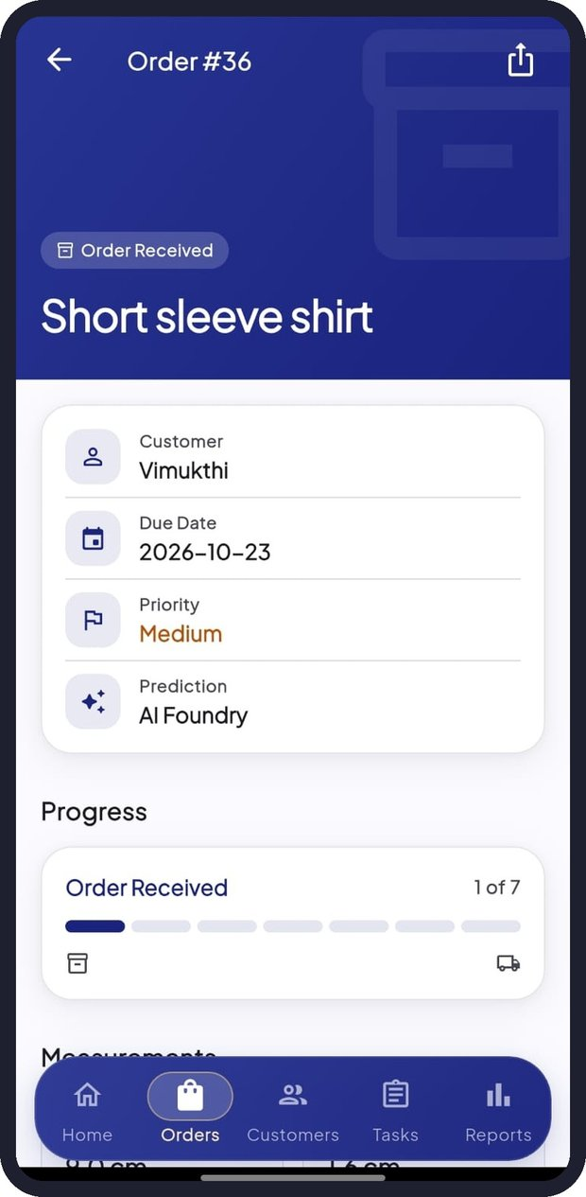  Figure 26: Order header and summary | 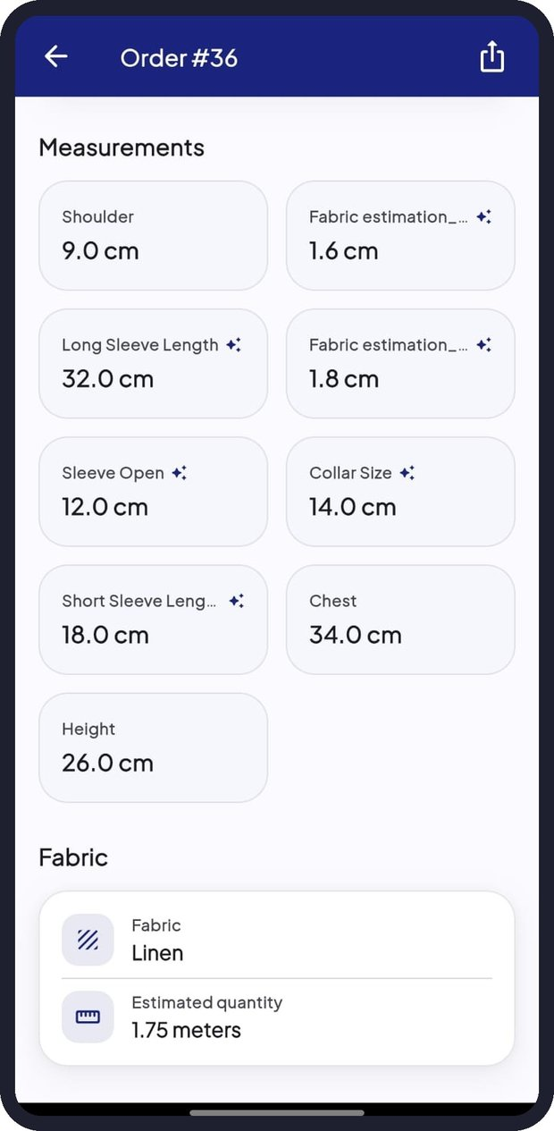  Figure 27: Measurements and fabric | 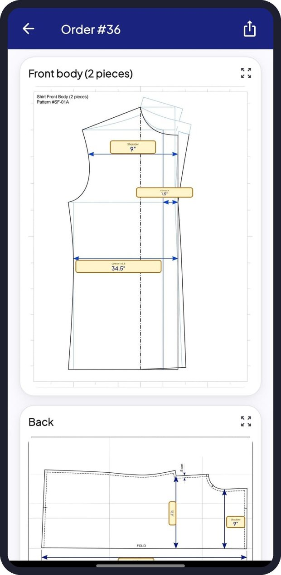  Figure 28: Blueprint - front body and back

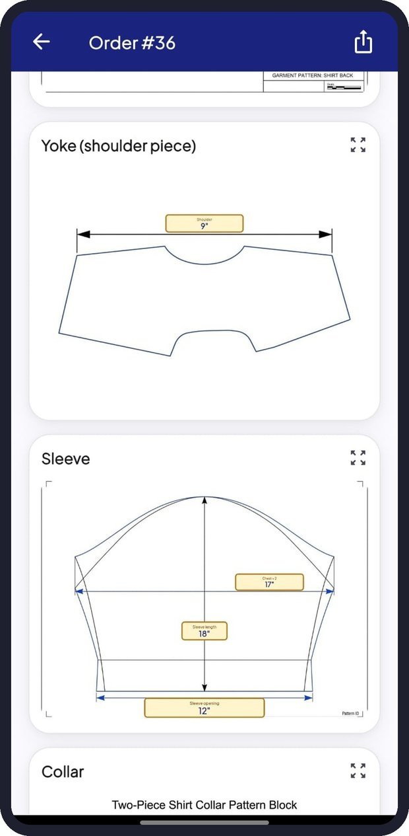  Figure 29: Blueprint - yoke and sleeve | 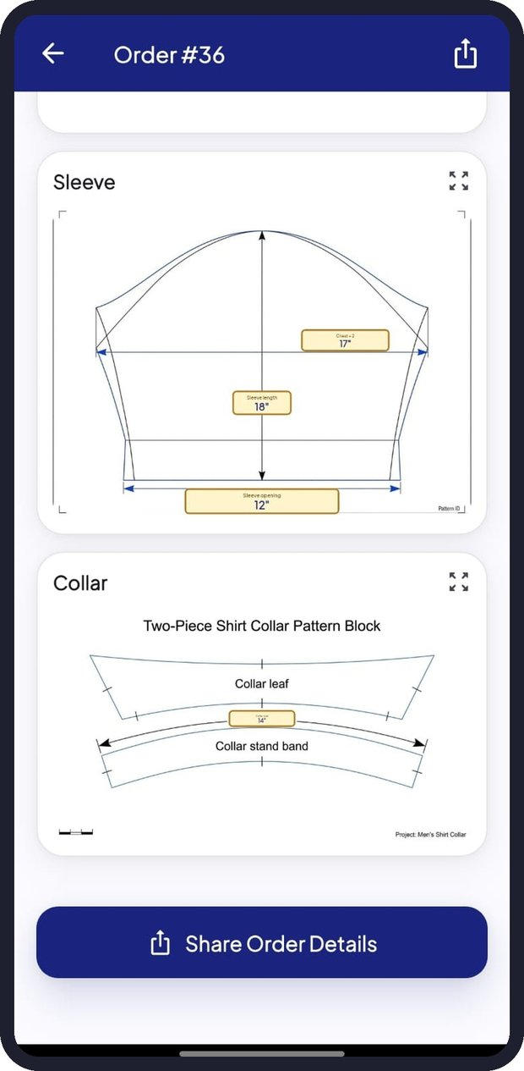  Figure 30: Blueprint - sleeve, collar and Share

6.3 Production stages
# | Stage | Meaning
1 | Order Received | Order created and waiting to start
2 | Cutting | Fabric is being cut using the blueprint
3 | Sewing | Garment is being stitched
4 | Fitting | Customer fitting and adjustments
5 | Quality Check | Final inspection of the finished garment
6 | Ready | Ready for the customer to collect
7 | Delivered | Handed over to the customer

7. Tasks and Production Updates
The Tasks screen is the production board. Owners see all tasks; staff see only the tasks assigned to them.

7.1 Tasks screen
- The summary cards show Active Tasks, Due Today and Overdue.
- Filter with All, Active, Due Today or Overdue, or search by order ID or customer.
- Each task card shows the order number, priority, customer, garment, current stage with progress, and the Due date.
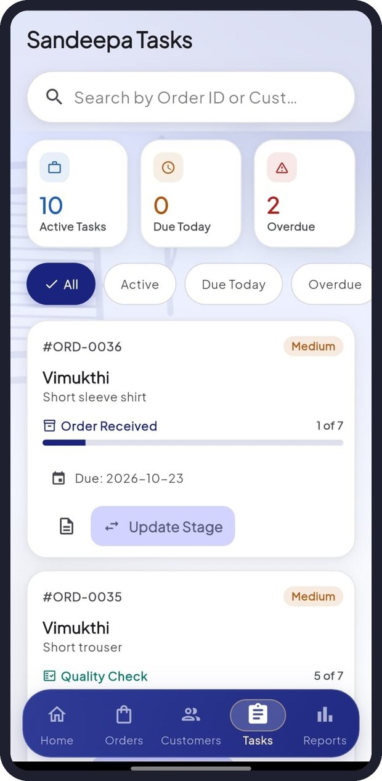  Figure 31: Tasks (Owner) | 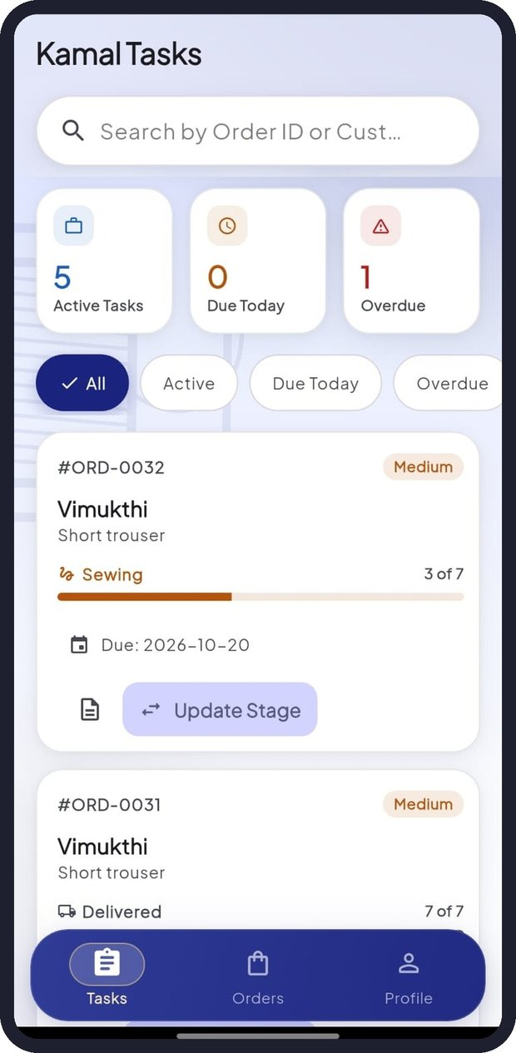  Figure 32: Tasks (Staff)

7.2 Updating the stage of a task
- On the task card tap Update Stage.
- In Update Task Stage the current stage is marked Current. Select the new stage (for example Cutting).
- Tap Update Stage. A confirmation message appears and the order, dashboard and reports update.

7.3 Changing the due date
- Tap the Due date on a task card.
- Choose the new date in the calendar.
- Tap OK to save, or Cancel to keep the current date.
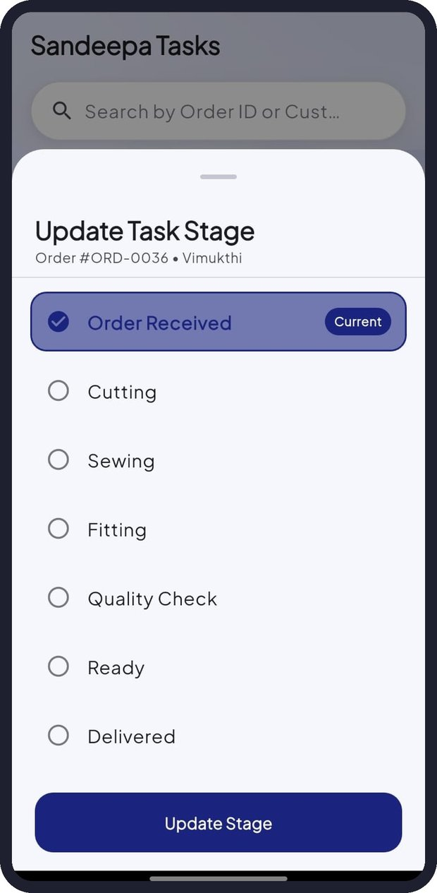  Figure 33: Update Task Stage | 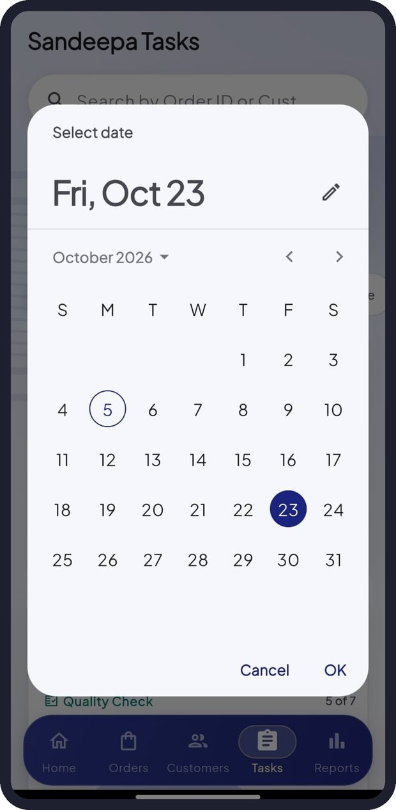  Figure 34: Change due date

Tip: Tap the document icon on a task card to open the full order with measurements and the cutting blueprint.

8. Virtual Try-On
Virtual Try-On uses AI to create an image of your customer wearing the garment you describe. It helps the customer choose style, colour and fabric before any fabric is cut.

8.1 Creating a try-on image
- On Home tap the Virtual Try-On card.
- 1. Customer photo: tap Camera to take a photo or Gallery to choose one.
- 2. Choose the dress: select a Garment, for example Saree, Kandyan saree (Osariya), Bridal saree, Half saree, Lama saree, Redda and hatte, Kandyan bridal (Nilame), National dress, Sarong and shirt, Batik sarong, Batik dress, Long frock, Frock, Lehenga, Kurta, Shalwar kameez, Churidar, Anarkali or Evening gown.
- Select a Colour (21 options, from White and Cream to Royal blue, Maroon and Black).
- Select a Fabric (Silk, Cotton, Linen, Batik, Handloom, Chiffon, Georgette, Satin, Organza, Brocade, Velvet, Lace or Denim).
- Optionally type Extra details, for example "gold zari border, puff sleeves". The line below shows the full description that will be used, such as "Dress them in a royal blue silk saree".
- Tick the box confirming that the customer agrees to their photo being processed by an AI image service.
- Tap Generate Try-On and wait a few seconds for the result.
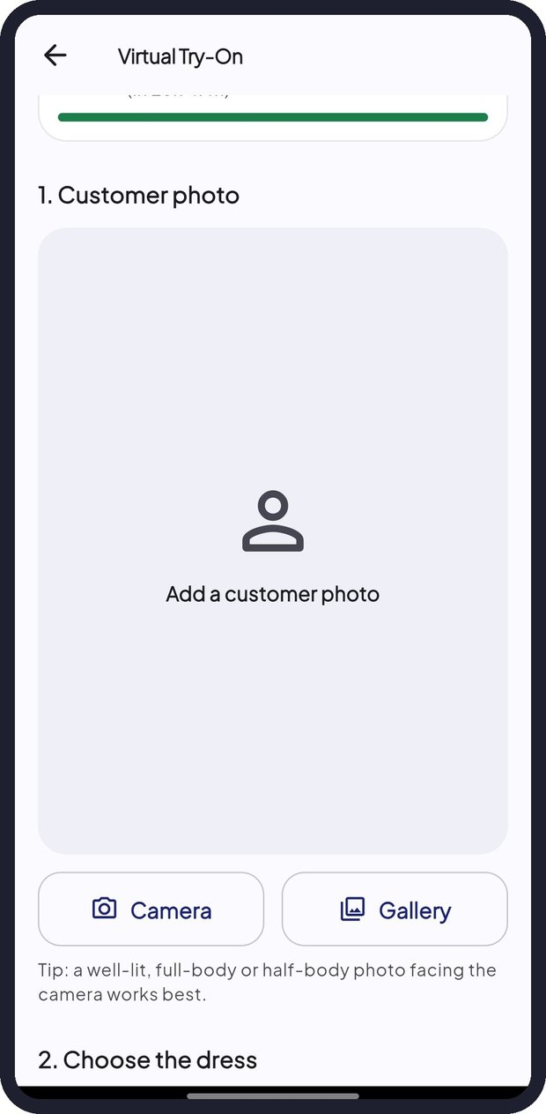  Figure 35: Add a customer photo | 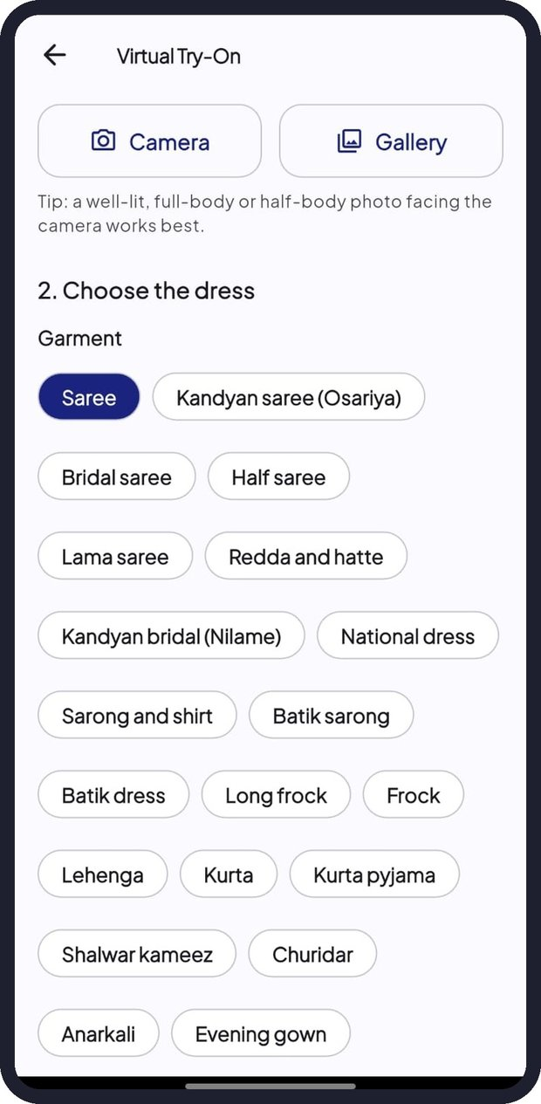  Figure 36: Choose the garment

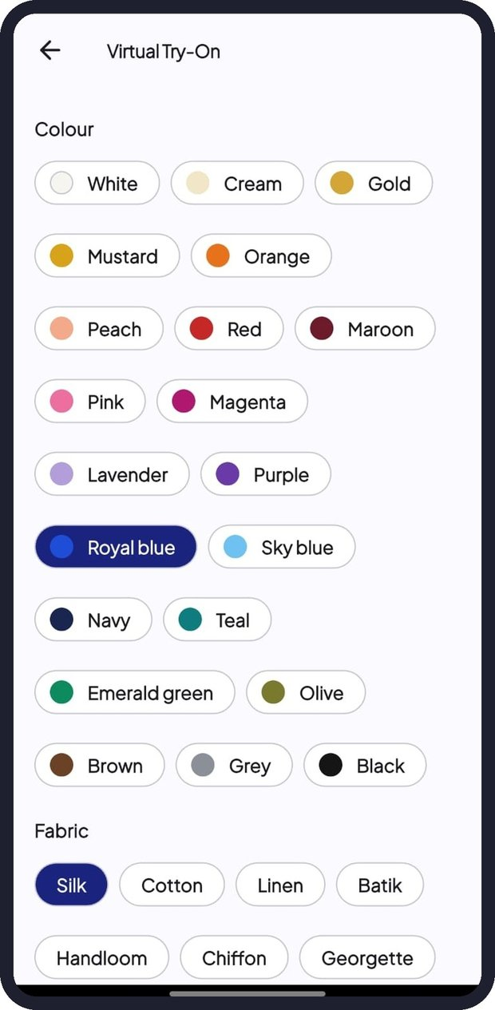  Figure 37: Choose the colour | 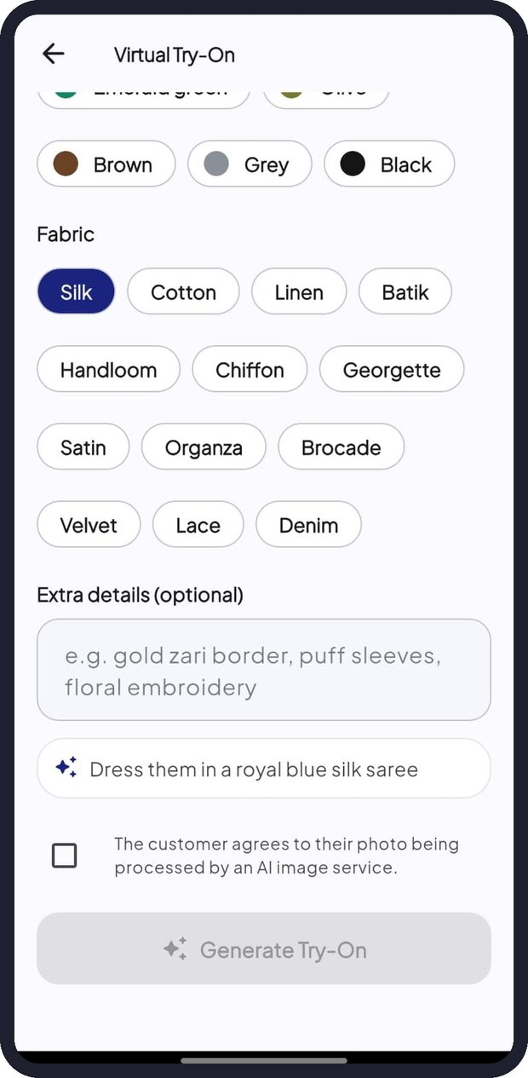  Figure 38: Fabric, details and Generate

Note: There is a free daily allowance of try-on images, which resets at 5:30 AM Sri Lanka time. Customer photos are not stored on TailorSync servers. For the best result use a bright, front-facing, full-body or half-body photo.

9. Fabric Inventory (Owner)
Fabric Inventory keeps track of how many metres of each fabric you have. Open it from the Inventory shortcut on Home.

9.1 Inventory screen
- Summary cards show the number of Fabrics, how many are Low / out and how many are Not tracked.
- Each fabric shows its quantity in metres, a stock bar and a status such as In stock.
- Fabrics recommended by the AI are added automatically as Not tracked. Set their stock to start tracking them.
- Use Search fabrics to find a fabric quickly.
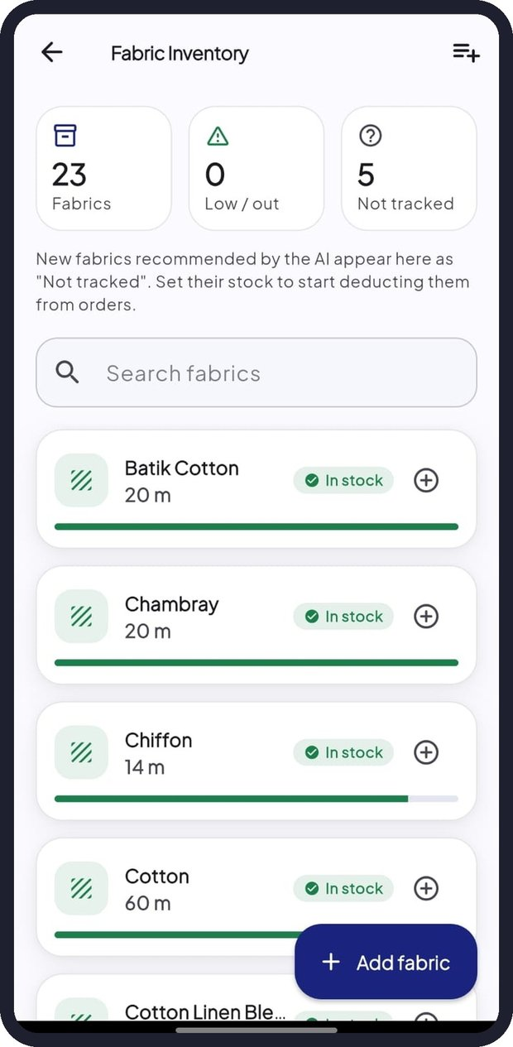
Figure 39: Fabric Inventory

9.2 Adding and restocking fabric
- To add a fabric tap Add fabric, enter the name, current metres and low-stock alert level, and save.
- To restock, tap the + button on a fabric, enter the metres received and an optional note, and save.
- Tap a fabric to see its details and full stock history.
Tip: Setting up a new shop? Tap the list icon at the top right to add a starter set of common fabrics (Cotton, Linen, Poplin, Silk, Batik Cotton and more) in one step.

9.3 Automatic stock changes
- Saving an order deducts the estimated metres from a tracked fabric.
- Deleting an order returns those metres to stock.
- When a fabric falls below its alert level, a low-stock warning appears on Home and in the fabric recommendations.

10. Reports & Analytics (Owner)
Tap Reports in the bottom bar. Choose the period with the tabs at the top: 7 Days, 30 Days, 90 Days or All Time. Scroll down to see each section, and pull down to refresh.

10.1 Overview
The Overview tiles show Orders, Delivered, In progress, Overdue (past due date and not delivered), On-time delivery percentage, Avg turnaround (days from order to delivery) and Fabric used in the selected period.

10.2 Orders Over Time and Order Status
The line chart compares New orders and Delivered orders per day, week or month. The Order Status donut shows where this period's orders are now, with the count and percentage for each stage.
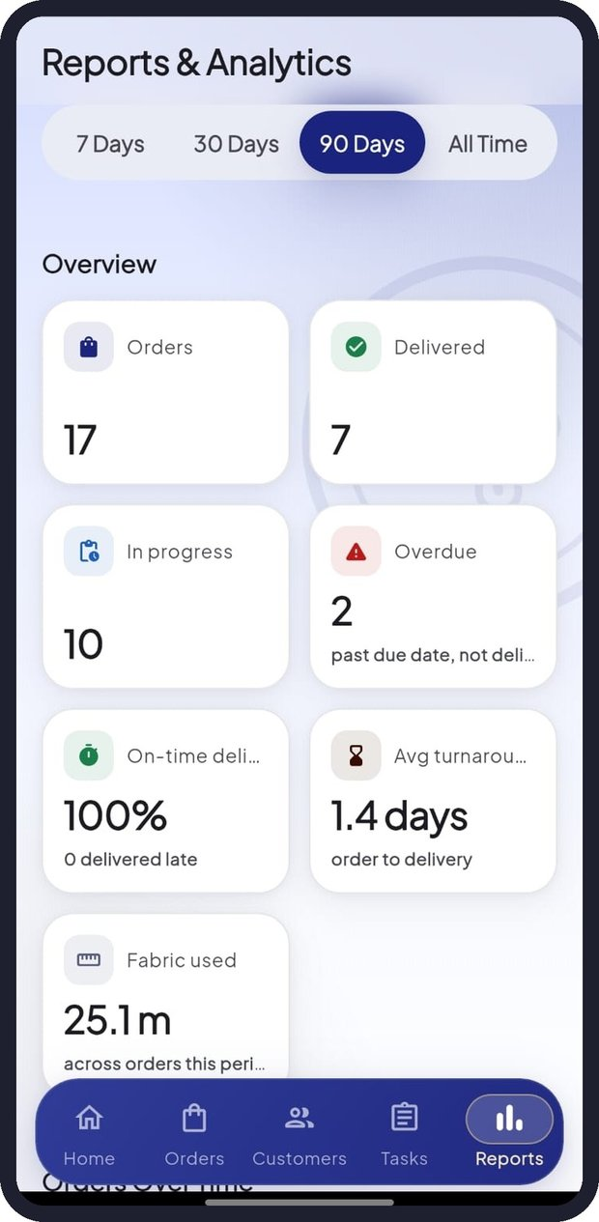  Figure 40: Overview tiles | 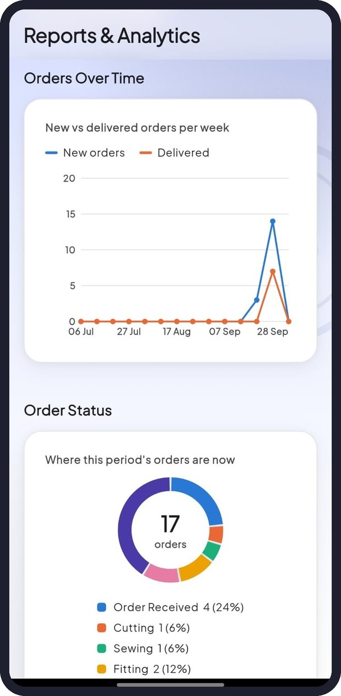  Figure 41: Orders Over Time and Order Status | 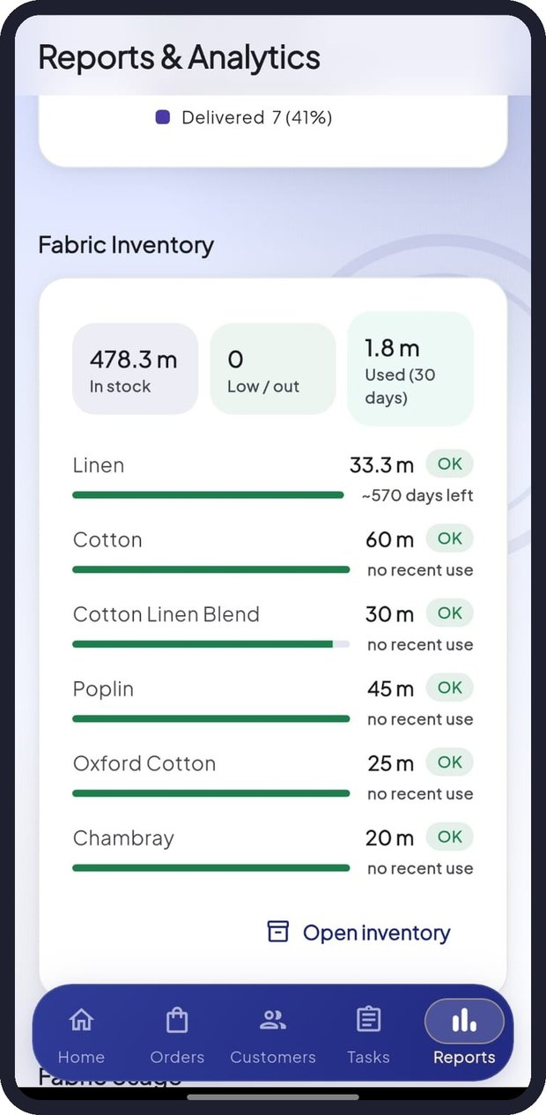  Figure 42: Fabric Inventory panel

10.3 Fabric Inventory and Fabric Usage
The Fabric Inventory panel shows the total metres in stock, the number of low or out-of-stock fabrics, and fabric used in the last 30 days, with each fabric's status and estimated days of stock left. Tap Open inventory to manage stock. Fabric Usage shows metres used per week and the fabrics used most.

10.4 Garments, AI usage, staff and customers
- Garment Performance: number of orders for each garment type.
- Measurement Prediction: how this period's measurements were produced: Manual, Custom ML or AI Foundry.
- Staff Performance: orders completed by each staff member, with on-time rate and active tasks.
- Top Customers: customers with the most orders.
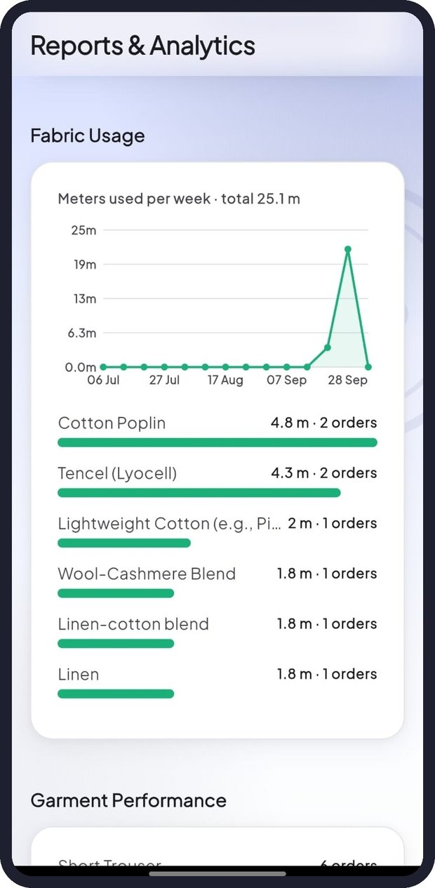  Figure 43: Fabric Usage | 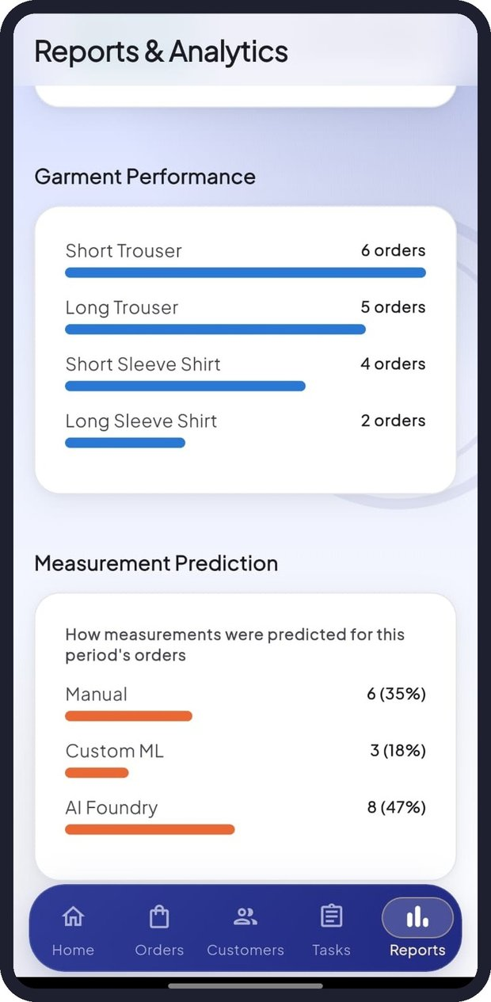  Figure 44: Garment Performance and Measurement Prediction | 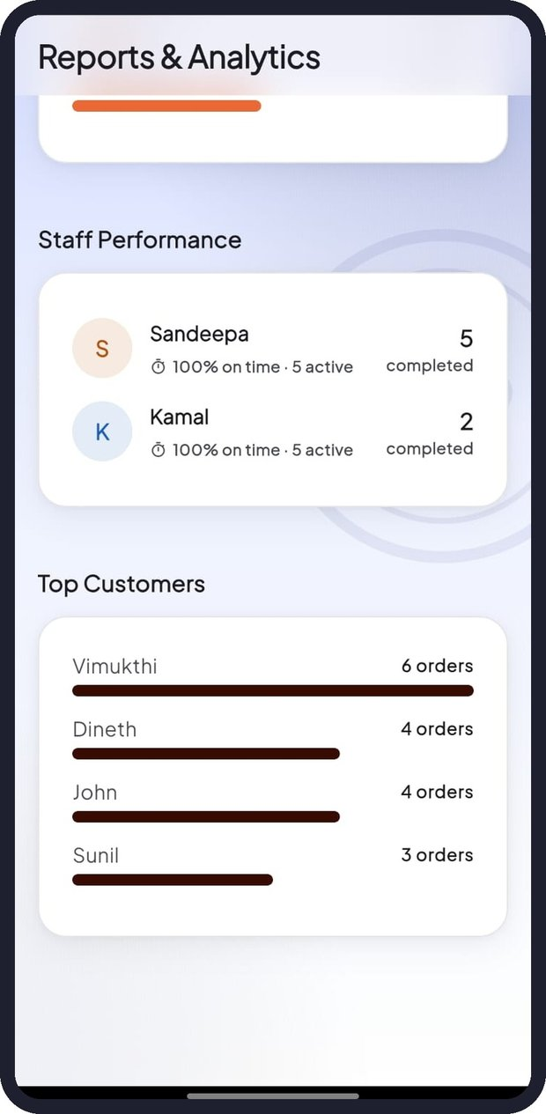  Figure 45: Staff Performance and Top Customers

11. Profile and Settings
Owners open Profile & Settings by tapping their profile picture on Home; staff use the Profile tab. The header shows your name, email and role (OWNER or STAFF).
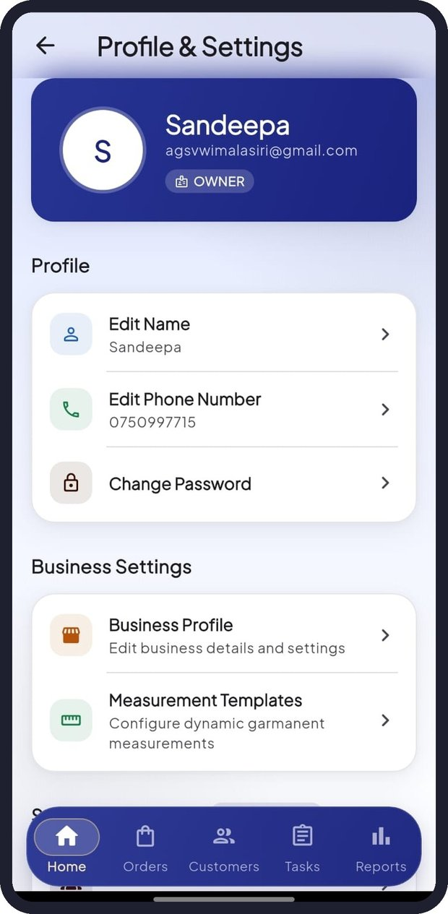  Figure 46: Profile & Settings (Owner) | 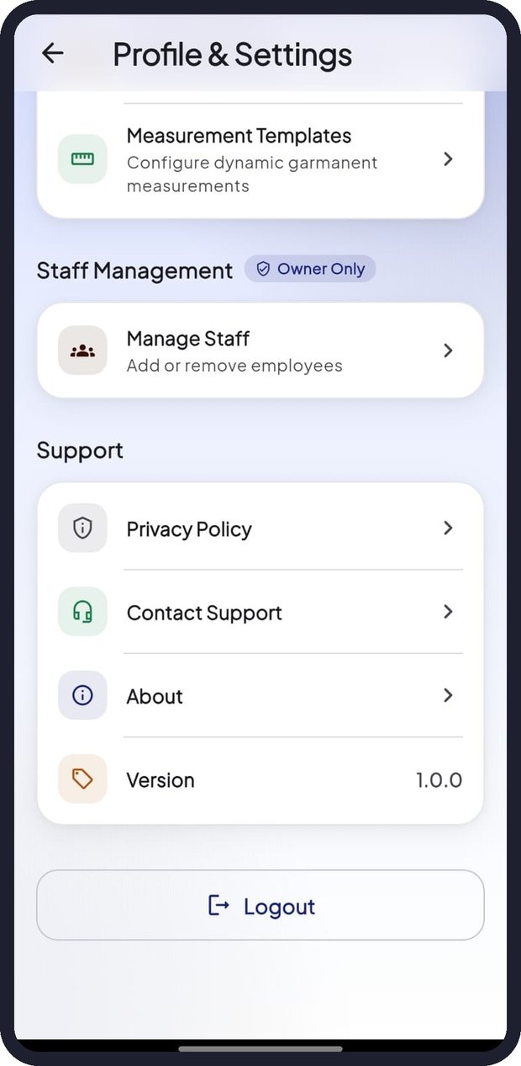  Figure 47: Business, Staff and Support options | 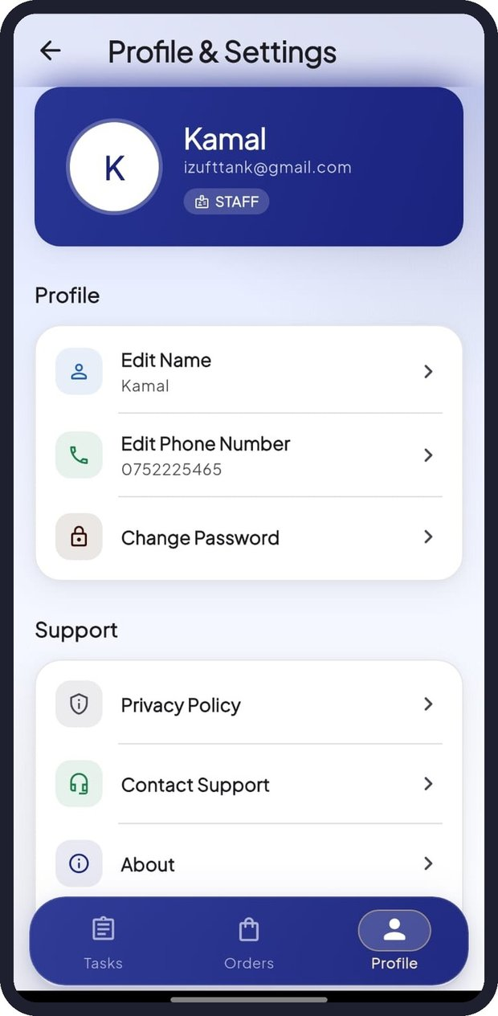  Figure 48: Profile & Settings (Staff)

11.1 Editing your name and phone number
- Tap Edit Name or Edit Phone Number.
- Type the new value.
- Tap Save.

11.2 Changing your password
- Tap Change Password.
- Enter your Current Password, then the New Password and Confirm New Password.
- The Password Requirements list shows which rules are met: minimum 8 characters, at least one upper-case letter, one lower-case letter, one number and one special character.
- Tap Update Password when all requirements are met.
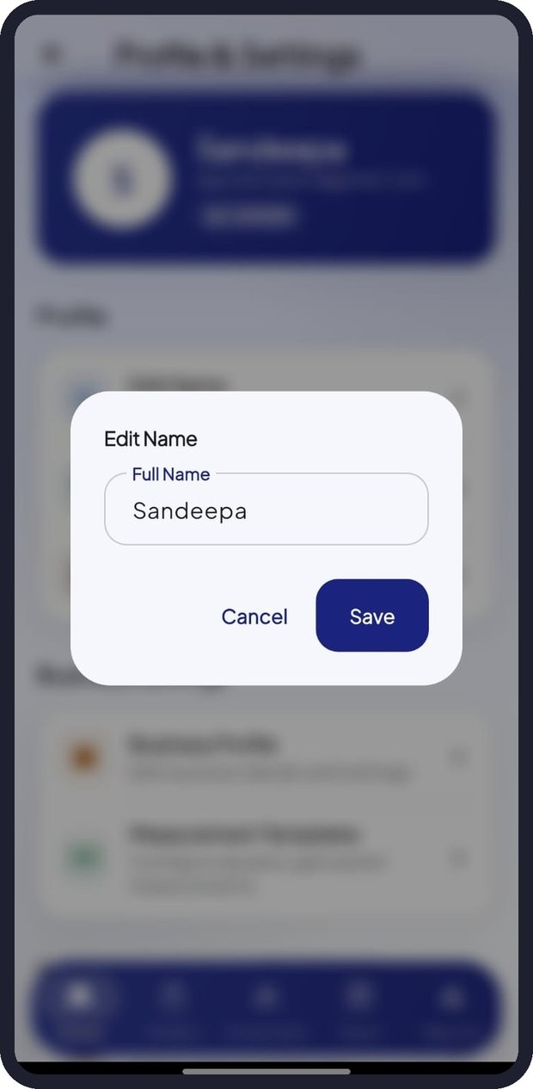  Figure 49: Edit Name | 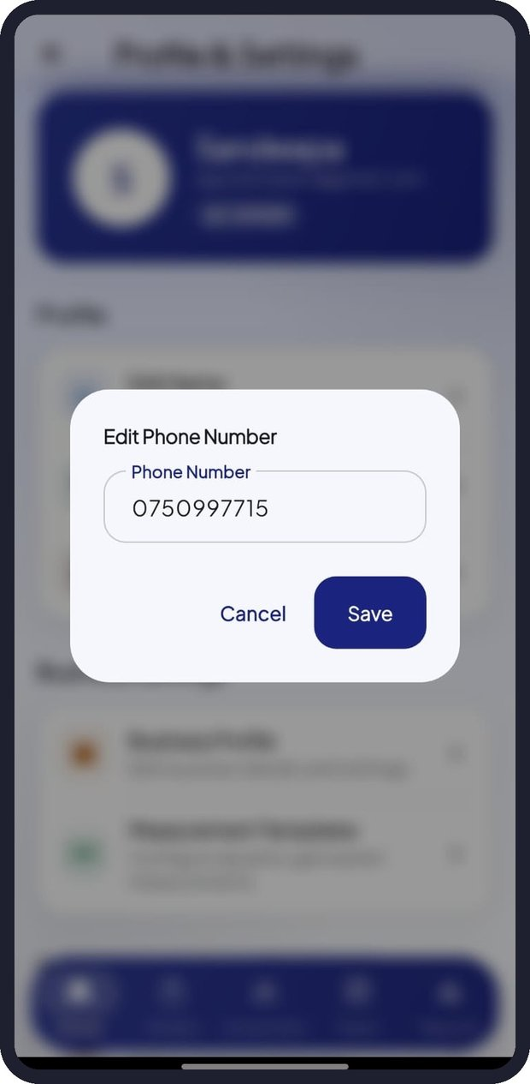  Figure 50: Edit Phone Number | 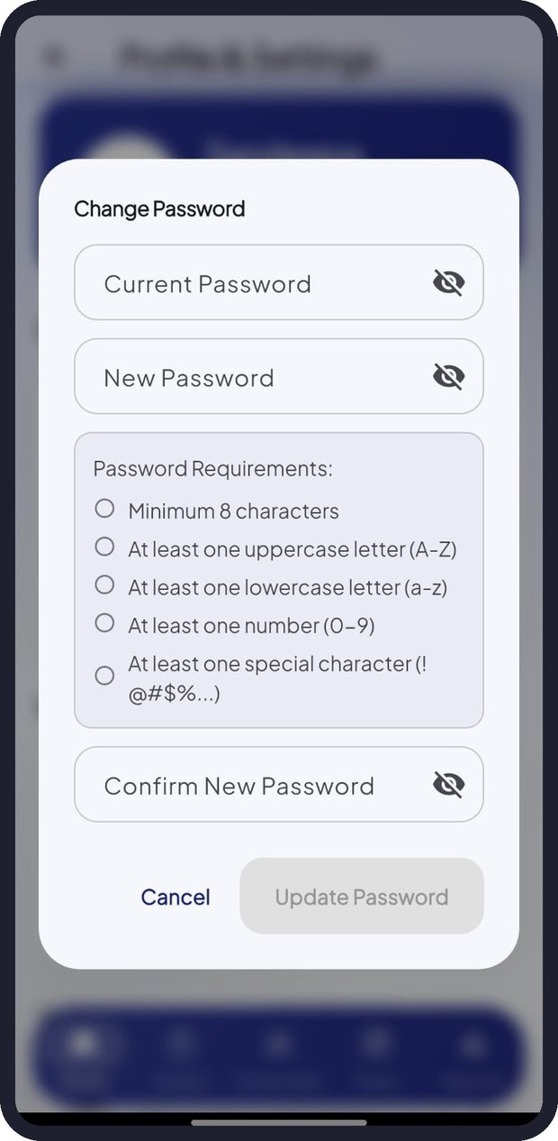  Figure 51: Change Password

11.3 Business Profile (Owner)
Profile & Settings > Business Profile. Update the Business Name (shown on orders and receipts), Business Contact Number and Business Address, then tap Save Changes.
The Danger zone lets the owner delete the account. Tap Delete Admin Account, enter your current password and tap Delete Permanently.
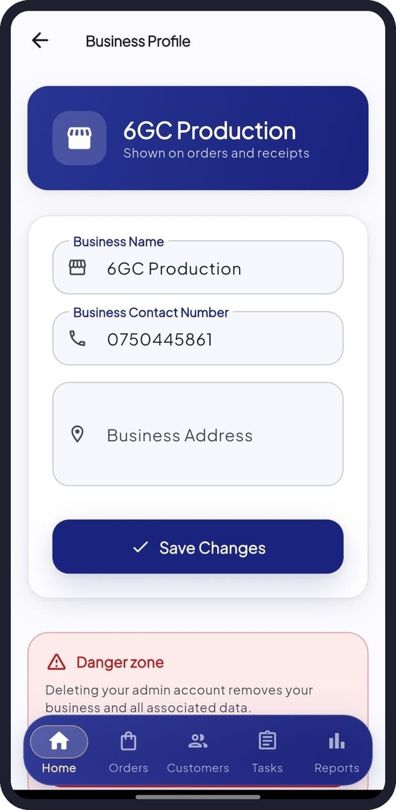  Figure 52: Business Profile | 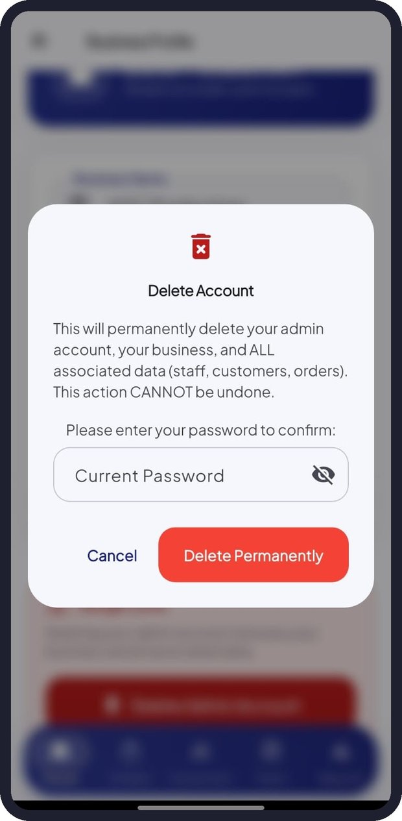  Figure 53: Delete Account confirmation

Important: Deleting the admin account permanently removes your business and ALL associated data, including staff, customers and orders. This cannot be undone.

11.4 Managing staff (Owner)
- Open Profile & Settings > Manage Staff.
- Tap Add Staff.
- Enter the staff member's Full Name, Email Address, Confirm Email Address, Phone Number and a Temporary Password.
- Tap Send Invitation. The staff member receives an email with their login details.
To change a staff member's access, tap the three-dot menu on their card and choose Deactivate Access (temporarily block sign-in), Reactivate Access, or Remove Permanently.
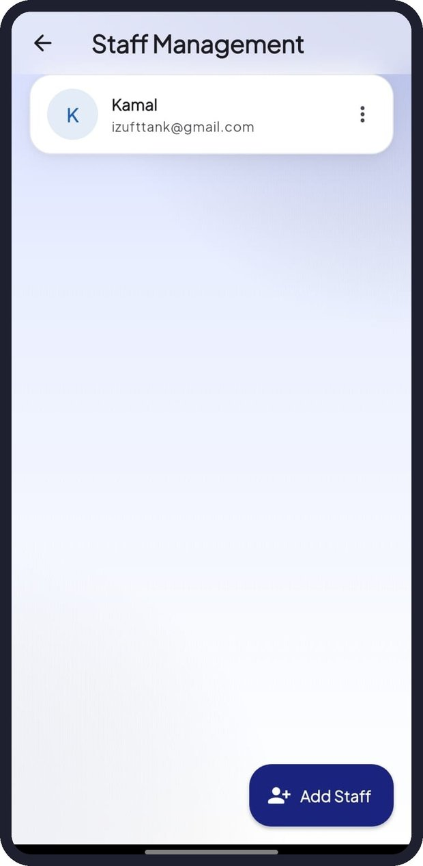  Figure 54: Staff Management | 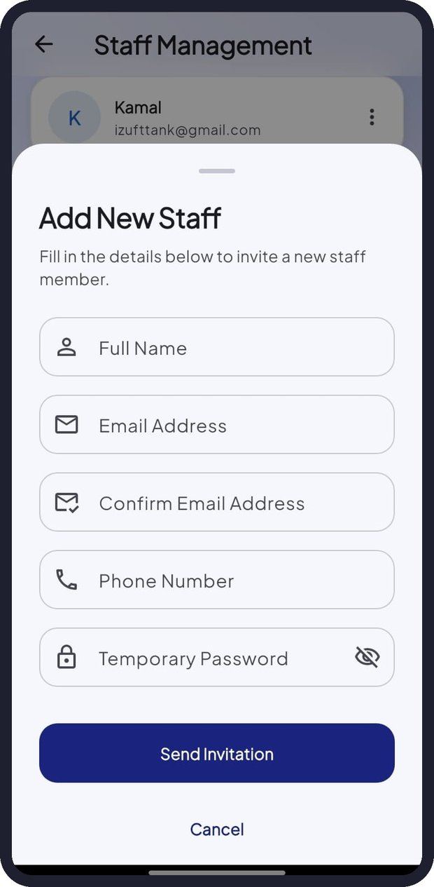  Figure 55: Add New Staff | 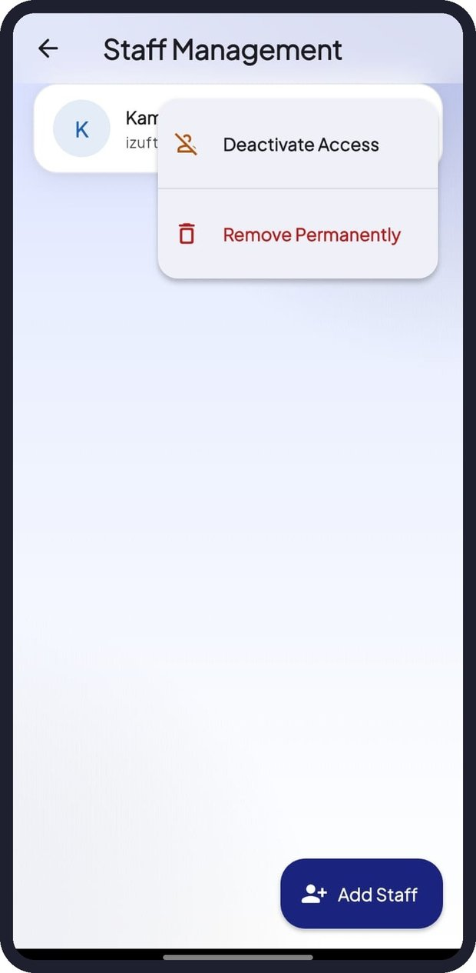  Figure 56: Staff actions

11.5 Measurement Templates (Owner)
Profile & Settings > Measurement Templates lists the measurement fields used for each garment. The AI Wizard uses these templates to show the right measurements in Step 4.

11.6 Support, About and Privacy Policy
- Privacy Policy: explains what data TailorSync collects, how it is used and protected, and your rights. It starts with an "In short" summary followed by detailed sections.
- Contact Support: shows the support email address.
- About: information about TailorSync and the development team.
- Version: the installed app version.
- Logout: signs you out of the app.
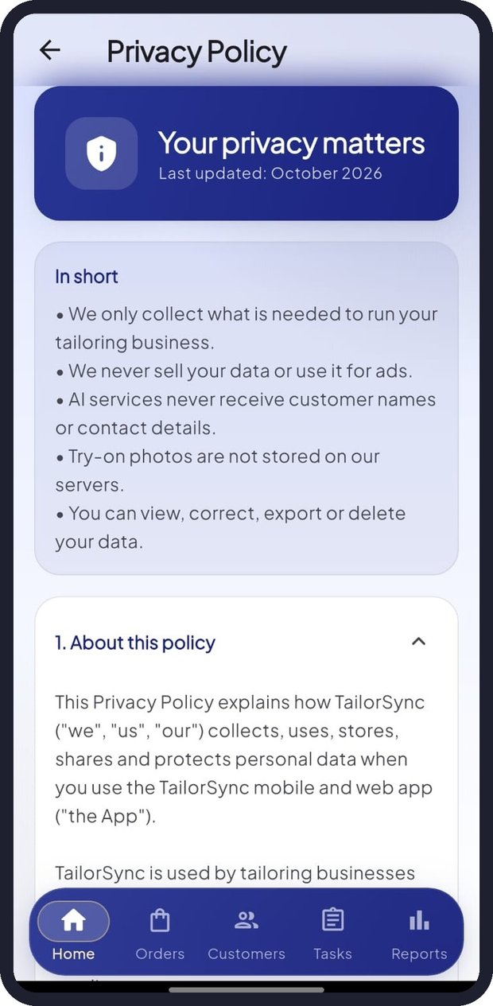  Figure 57: Privacy Policy | 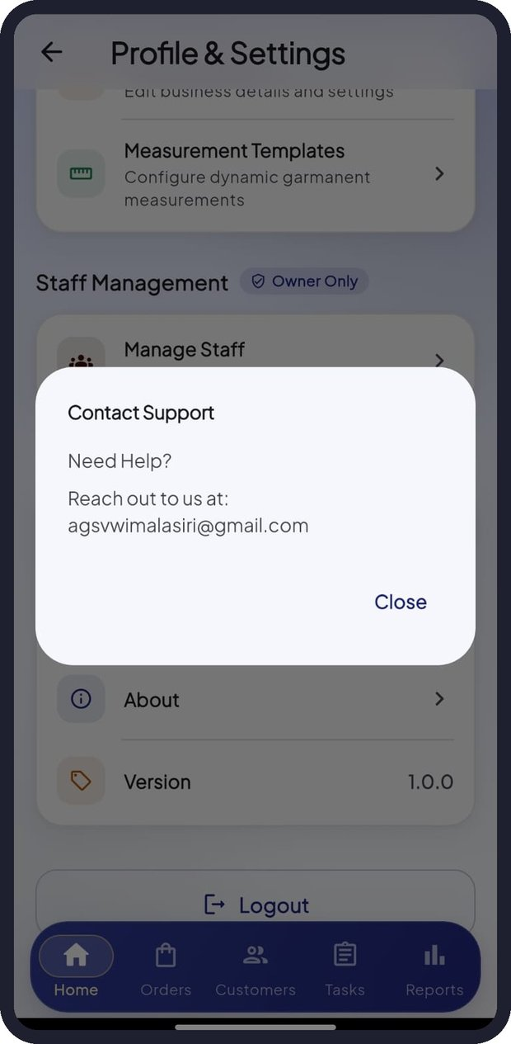  Figure 58: Contact Support | 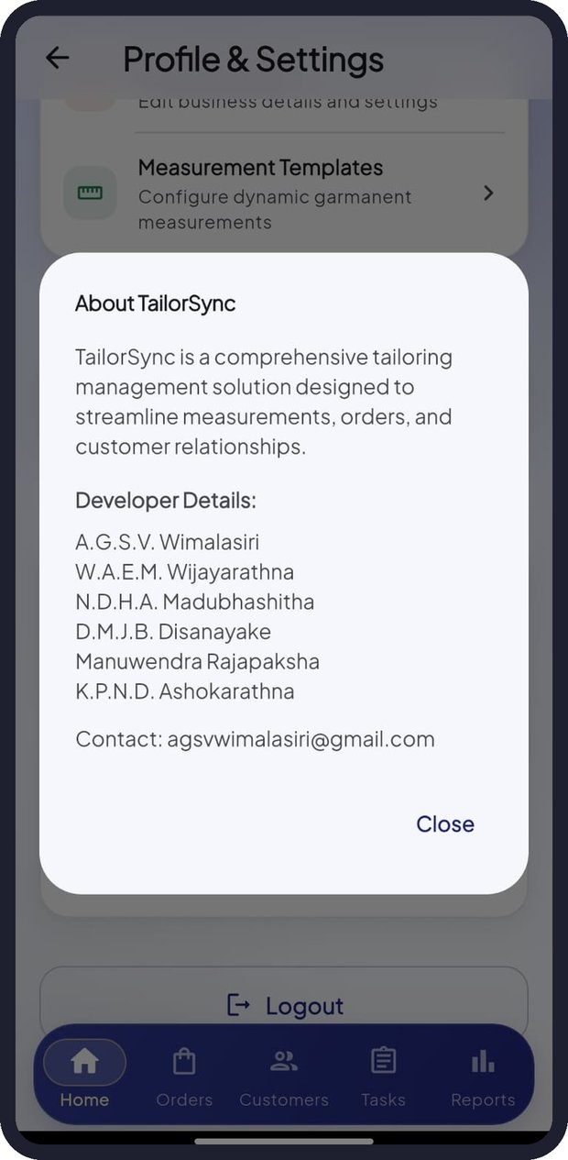  Figure 59: About TailorSync

12. Quick Guide for Staff
Staff members use a simpler version of TailorSync focused on their own work.
- Sign in with the email and temporary password sent by your employer (Section 2.5). Change the password straight away in Profile > Change Password.
- The Tasks tab opens first and shows your active, due-today and overdue tasks.
- Open a task's order to see the measurements, fabric and cutting blueprint.
- When you finish a step, tap Update Stage and select the next stage.
- Use the Orders tab to see all orders assigned to you and their progress.
Figure 60: Staff Tasks | Figure 61: Staff Orders | Figure 62: Staff Profile

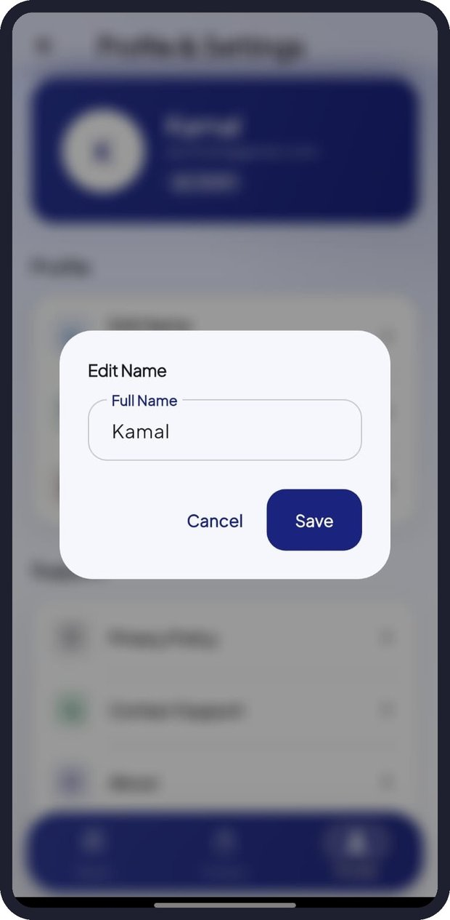  Figure 63: Staff - Edit Name | 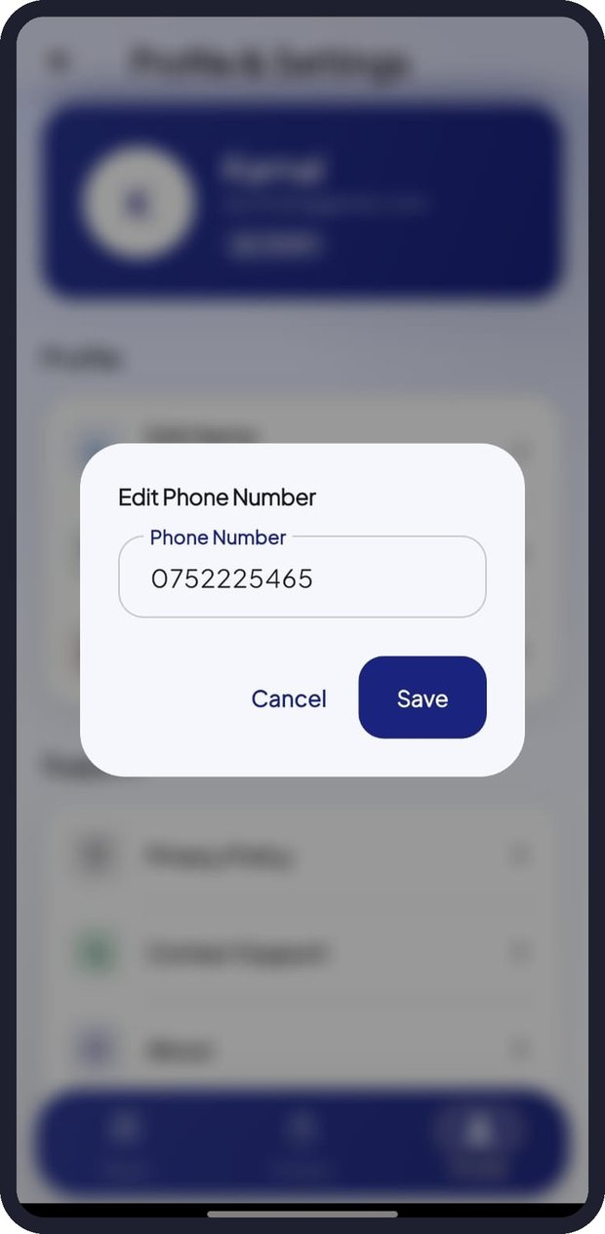  Figure 64: Staff - Edit Phone Number | 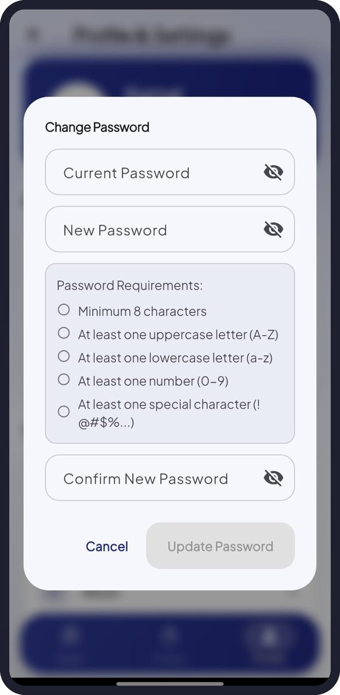  Figure 65: Staff - Change Password

13. Troubleshooting
Problem | Possible cause | What to do
App stays on the splash screen | Server is waking up or no internet | Wait up to a minute, check Wi-Fi or mobile data, then tap Retry
Sign In button is grey | A field is empty or reCAPTCHA is not ticked | Fill in both fields and tick "I'm not a robot"
"Your session has expired" | Your login has timed out | Sign in again
Forgot password | - | Tap Forgot Password? and follow the emailed instructions
Custom ML not available for a garment | Custom ML supports only shirts and trousers | Choose AI Foundry in Step 2
AI step takes long or fails | Weak connection or AI service busy | Wait a few seconds and try again, or switch prediction model
Measurement value rejected | Value is outside the allowed range | Check the range shown under the field and the units (inches)
"Today's free image limit is used up" | Daily try-on allowance reached | Try again after 5:30 AM Sri Lanka time
Try-on result looks wrong | Photo is dark, blurred or side-on | Use a bright, front-facing photo with a plain background
Fabric stock did not change after an order | The fabric is "Not tracked" | Set the fabric's stock in Fabric Inventory
Inventory, Reports or Customers missing | You are signed in as staff | These sections are for the owner only
"Reports unavailable" | Connection or server problem | Pull down to refresh; if it continues, contact support with the message shown

14. Frequently Asked Questions

Is my customers' data safe?
Yes. Data travels over encrypted connections, passwords are stored securely, and each business can only see its own data. AI services never receive customer names or contact details.

Do I have to accept the AI predictions?
No. AI values are suggestions. You can choose an alternative or edit any measurement before saving.

Which prediction model should I choose?
Custom ML is fastest for shirts and trousers. AI Foundry supports all garments and considers more context.

What units does TailorSync use?
Measurements are entered in inches in the wizard; fabric is measured in metres.

Can staff see reports or prices?
No. Reports, inventory, customers and business settings are visible only to the owner.

Are try-on photos stored?
No. The photo is used only to create the preview image and is not stored on TailorSync servers.

Can I share an order with a customer or colleague?
Yes. Open the order and tap Share Order Details or the share icon.

Can I use TailorSync on a computer?
Yes. Use the web version in Chrome, Edge or Firefox.

15. Glossary
Term | Meaning
AI | Artificial Intelligence: software that makes predictions or suggestions
AI Foundry | Microsoft Azure AI Foundry, the AI assistant TailorSync uses for full clothing prediction
Custom ML Model | TailorSync's own trained machine-learning model for shirts and trousers
Required measurement | A measurement the AI needs before it can predict the rest
Alternative | Another likely set of measurements suggested by the AI
Cutting blueprint | Pattern pieces with the customer's measurements written on them
Stage | One of the seven production steps an order passes through
Not tracked | A fabric whose stock has not been set, so it is not deducted automatically
Turnaround | Number of days from creating an order to delivering it
reCAPTCHA | Google's "I'm not a robot" check that protects sign-in

16. Support and Contact
If you need help, find a problem or have a suggestion, contact the TailorSync team:
- Email: agsvwimalasiri@gmail.com
- In the app: Profile & Settings > Contact Support
When reporting a problem, please include your business name, the screen you were using, what you tapped and the exact message shown. A screenshot helps us solve the problem faster.
© 2026 TailorSync. All rights reserved.

