Read me

-Cucumber for **BDD**

-**TestNG** for TestRunner

-Maven for dependency management

- **Maven** reporting plugin

- **Selenium** Automation Tool

- Design Patter

- Page Factory for Page Object Management

- SingletonDriver for driver management

**Project Structure**

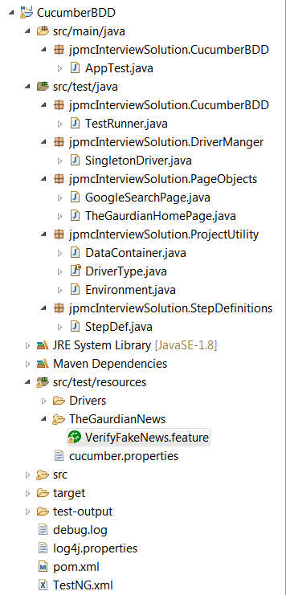

Feature File

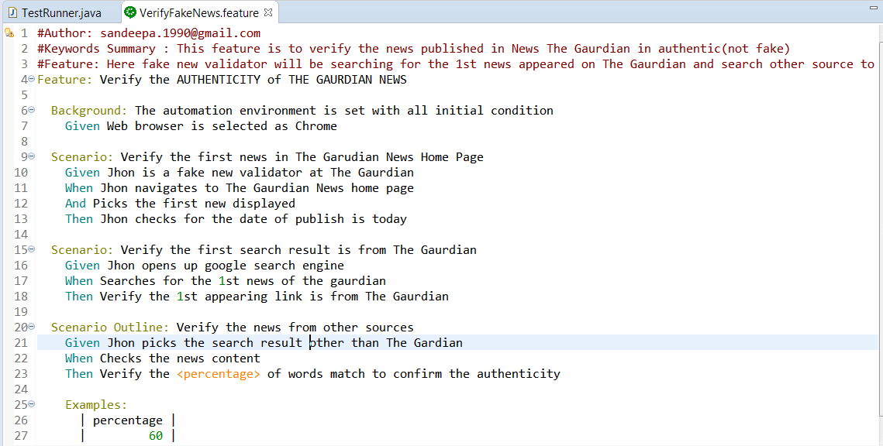

Result

