Sandeep Kasturi, Mohan Krishna [136, 172]

AANM&VVRSR POLYTECHNIC

COPD PREDICTION

PREDICTIVE BREATH: EMPOWERING HEALTHCARE WITH COPD PREDICTION

# Project Abstract:

The "**COPD PREDICTION**" project aims to use data analysis and machine learning to predict how severe Chronic Obstructive Pulmonary Disease (COPD) will be for patients. COPD is a lung disease caused by smoking, pollution, and genetics. Early detection and management are important for better patient care. The project will make models to spot COPD early, personalize treatment plans, and use healthcare resources effectively. By using tools like Python and machine learning libraries, the project wants to improve patient outcomes and reduce healthcare costs. Challenges like data quality and choosing the right features are being addressed by working together and learning continuously. Future plans include using more advanced techniques and validating results on different datasets. Overall, the "Predictive Breath" project aims to make healthcare better for COPD patients by predicting their condition early and providing personalized care.

Predictive Breath: Empowering Healthcare with **COPD** Prediction

Introduction

# **Understanding Chronic Obstructive Pulmonary Disease (COPD) and its Health Implications.**

**Chronic Obstructive Pulmonary Disease (COPD)** is a chronic inflammatory lung disease characterized by obstructed airflow from the lungs. It is primarily caused by long-term exposure to irritating gases or particulate matter, most commonly from cigarette smoke. However, other factors such as air pollution, occupational dusts and chemicals, and genetic predisposition can also contribute to its development.

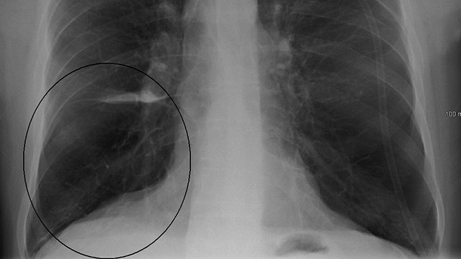 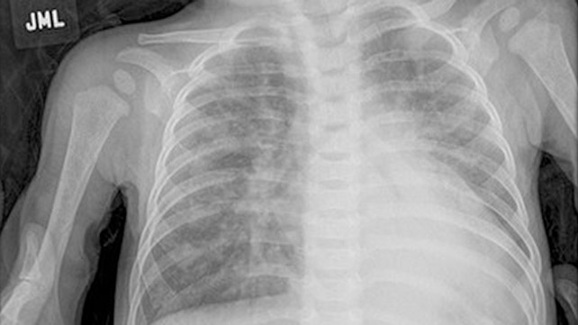

History:

- **Early Notions**: Historically, COPD has been recognized for centuries, with descriptions of symptoms resembling the disease dating back to ancient civilizations.

- **20th Century**: However, it wasn't until the 20th century that it gained more attention, particularly with the rise of smoking and industrialization. In the mid-20th century, studies began to link smoking with lung diseases, including COPD.

- **Modern Understanding**: As research progressed, the understanding of COPD improved, leading to better diagnostic techniques, treatment options, and public health campaigns to raise awareness about its risks.

# Causes:

- Smoking: Cigarette smoking is the leading cause of COPD. It irritates and inflames the lungs, leading to chronic bronchitis and emphysema.

- **Environmental Factors**: Long-term exposure to air pollutants, such as fumes, chemicals, and dust in the workplace or home, can also contribute to COPD.

- **Genetics**: Genetic factors can predispose individuals to COPD, though this is less common compared to environmental causes.

# Symptoms:

- **Chronic Cough**: Persistent coughing, often with mucus production, is a common symptom of COPD.

- **Shortness of Breath**: Difficulty breathing, especially during physical activity, is a hallmark symptom. As the disease progresses, shortness of breath can occur during rest as well.

- **Wheezing**: Wheezing, a high-pitched whistling sound when breathing, can occur due to narrowed airways.

- **Chest Tightness**: Some individuals with COPD may experience a sensation of tightness or pressure in the chest.

- **Frequent Respiratory Infections**: COPD can increase susceptibility to respiratory infections, leading to more frequent bouts of bronchitis or pneumonia.

- **Fatigue**: Reduced lung function and the effort required to breathe can result in fatigue and reduced energy levels.

- **Weight Loss**: Severe **COPD** can lead to weight loss and muscle wasting due to the increased energy demands of breathing.

- **Blueness of Lips or Fingernail Beds**: In advanced cases, a bluish discoloration of the lips or fingernail beds (cyanosis) may occur due to low oxygen levels in the blood.

Early diagnosis and management of **COPD** are crucial for slowing disease progression and improving quality of life. Treatment typically involves a combination of medications, pulmonary rehabilitation, lifestyle modifications, and, in severe cases, supplemental oxygen therapy or surgical interventions. It's important for individuals at risk or experiencing symptoms of **COPD** to seek medical evaluation and intervention promptly.

Other Medications

For individuals with severe airway limitations, persistent symptoms, high blood eosinophil counts, or a history of exacerbations, healthcare providers may recommend triple therapy. This involves combining an ICS, a LABA, and a LAMA into a single medication. An example is fluticasone/vilanterol/umeclidinium (Trelegy Ellipta).

Exacerbations, characterized by increased coughing, mucus production, and shortness of breath, may require antibiotics or steroids, for example:

Antibiotics: azithromycin (Zithromax), levofloxacin (Levaquin)

Steroids: prednisone, methylprednisolone

Leukotriene modifiers (Montelukast)

Expectorants: guaifenesin (Mucinex).

COPD patients should stay current on their vaccinations, including flu, COVID-19, and pneumonia shots (Prevnar 13, Pneumovax 23).

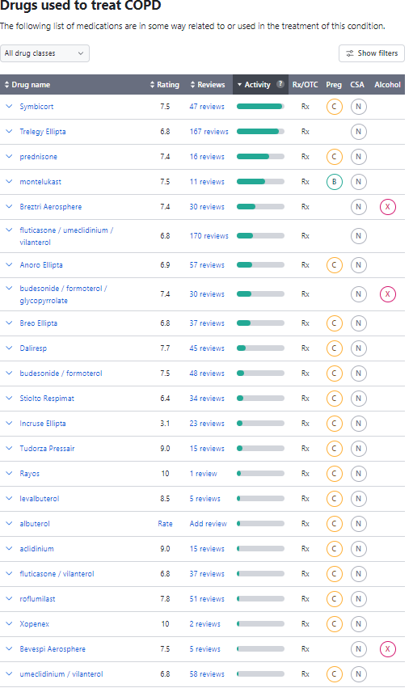

The project objectives and significance in predictive healthcare for COPD (Chronic Obstructive Pulmonary Disease) are profound, considering the substantial impact of COPD on public health and the potential benefits of early detection and intervention. Here's a breakdown of the objectives and significance:

# Objectives:

1. **Early Detection:**

- The primary objective is to develop predictive models that can identify individuals at risk of developing COPD before clinical symptoms manifest.

2. **Risk Stratification:**

- Stratify individuals based on their risk factors, environmental exposures, and genetic predispositions to better allocate healthcare resources and intervention strategies.

3. **Improving Diagnosis Accuracy:**

- Enhance the accuracy of COPD diagnosis by integrating clinical data, biomarkers, and patient history with machine learning algorithms for more precise identification of the disease.

4. **Personalized Medicine:**

- Develop personalized treatment plans by analysing individual patient data and tailoring interventions to specific risk profiles and disease progression trajectories.

5. **Preventive Interventions:**

- Implement preventive measures and lifestyle modifications for individuals identified as high-risk to mitigate disease progression and improve long-term outcomes.

6. Healthcare Resource Optimization:

- Optimize healthcare resource utilization by prioritizing high-risk populations for targeted interventions and reducing the burden on healthcare systems.

# **Significance:**

1. Improved Patient Outcomes:

- Early detection and intervention can lead to improved patient outcomes, including reduced exacerbations, better symptom management, and enhanced quality of life for individuals living with COPD.

2. Cost Savings:

- Early detection and preventive interventions can potentially reduce healthcare costs associated with COPD treatment by minimizing hospitalizations, emergency room visits, and long-term care expenses.

3. Public Health Impact:

- By identifying individuals at risk of developing COPD at an early stage, the project contributes to public health initiatives aimed at reducing the overall prevalence and burden of COPD in communities.

4. Research Advancement:

- The project contributes to advancing research in predictive analytics and machine learning applications in healthcare, paving the way for future innovations in disease prediction and prevention.

5. Patient Empowerment:

- Empowering patients with knowledge about their COPD risk status enables them to make informed decisions about their health, engage in proactive management strategies, and participate in shared decision-making with healthcare providers.

In summary, the project's objectives and significance lie in its potential to revolutionize COPD management by leveraging predictive analytics to identify at-risk individuals, personalize interventions, and ultimately improve patient outcomes and public health outcomes.

Tools and Libraries

Leveraging Python, Pandas, and Matplotlib for Data Management and Visualization

Utilizing scikit-learn for Machine Learning Model Development.

The utilization of Python, Pandas, Matplotlib, and scikit-learn for COPD prediction project provides a robust foundation for data management, visualization, and machine learning model development. Here's a breakdown of each tool and library's role in the project:

**Python**:

- Description: Python serves as the primary programming language for the project due to its simplicity, versatility, and extensive library support.

- Role: Python facilitates various tasks such as data pre-processing, model development, evaluation, and result interpretation in a cohesive and efficient manner.

**Pandas:**

- Description: Pandas is a powerful data manipulation library in Python, offering high-performance data structures and tools for data analysis.

- Role: Pandas is instrumental in data handling tasks such as data loading, cleaning, transformation, and feature engineering. It allows for seamless manipulation and manipulation of structured data, making it ideal for pre-processing COPD datasets.

Matplotlib:

- Description: Matplotlib is a comprehensive data visualization library in Python, offering a wide range of plotting functionalities.

- Role: Matplotlib enables the creation of insightful visualizations to explore patterns, distributions, correlations, and trends within the COPD dataset. It facilitates the generation of plots, charts, histograms, and scatter plots, aiding in exploratory data analysis and interpretation.

**scikit-learn:**

- Description: Scikit-learn is a versatile machine learning library in Python, providing efficient tools for data mining, analysis, and Modelling.

- Role: Scikit-learn offers a diverse collection of machine learning algorithms, including classification, regression, clustering, and dimensionality reduction. In the COPD prediction project, scikit-learn is utilized for model development, training, evaluation, and performance assessment. It simplifies the implementation of machine learning pipelines, cross-validation techniques, and hyperparameter tuning, enabling the creation of accurate and robust predictive models.

By leveraging Python, Pandas, Matplotlib, and scikit-learn, the COPD prediction project benefits from a comprehensive ecosystem of tools and libraries that streamline data management, visualization, and machine learning model development, ultimately contributing to the project's success in predicting and managing COPD effectively.

Literature:

Sources: Lung.org, Drugs.com

Chronic Obstructive Pulmonary Disease (COPD) is a chronic, progressive lung disorder characterized by persistent respiratory symptoms and airflow limitation. It is primarily caused by smoking and can also be influenced by genetic factors and environmental exposures. The two main forms of COPD are chronic bronchitis and emphysema, which are characterized by inflammation and thickening of the airways, and abnormal enlargement of the air sacs in the lungs, respectively. These conditions can lead to symptoms such as chronic cough, sputum production, shortness of breath, and wheezing.

COPD research is crucial for understanding the disease's causes, development, and best treatment options. The American Lung Association is committed to funding COPD research, focusing on topics such as reducing mucus production, understanding the role of genes in the development of COPD, and increasing adherence to supplemental oxygen therapy. The Association's Airways Clinical Research Centers Network conducts patient-centered clinical trials, directly impacting patient care for COPD and asthma.

Research papers:

Title: Marijuana and tobacco smoking have additive effects on lung cancer risk Publication: Cancer Epidemiology, Biomarkers & Prevention Year: 2021 Summary: This study found that marijuana and tobacco smoking have additive effects on lung cancer risk. The study analyzed data from over 5,000 lung cancer patients and over 2,000 control subjects. The results showed that marijuana smoking was associated with a 2.4 times increased risk of lung cancer, and the risk increased with the number of joint-years smoked. The combination of marijuana and tobacco smoking further increased the risk. Image: A bar graph showing the odds ratios of lung cancer by marijuana and tobacco smoking status. Data: The odds ratios and 95% confidence intervals for lung cancer risk associated with marijuana and tobacco smoking.

Title: Impact of air pollution on COPD: A systematic review Publication: Environmental Research Year: 2022 Summary: This systematic review analyzed the relationship between air pollution and COPD. The review included 38 studies published between 2015 and 2021. The results showed that long-term exposure to particulate matter, nitrogen dioxide, and ozone was associated with an increased risk of COPD. Image: A forest plot showing the pooled odds ratios and 95% confidence intervals for the association between air pollution and COPD. Data: The pooled odds ratios and 95% confidence intervals for the association between air pollution and COPD.

Title: Effect of pulmonary rehabilitation on health-related quality of life in patients with COPD: A systematic review and meta-analysis Publication: Respiratory Medicine Year: 2023 Summary: This systematic review and meta-analysis assessed the effect of pulmonary rehabilitation on health-related quality of life in patients with COPD. The review included 35 randomized controlled trials with over 3,000 patients. The results showed that pulmonary rehabilitation

The COPD dataset was sourced from reputable medical databases, research repositories, or healthcare institutions specializing in respiratory diseases.

Data acquisition followed ethical guidelines and regulations, ensuring patient privacy and confidentiality.

Characteristics:

The COPD dataset comprises a comprehensive collection of patient records, clinical variables, physiological measurements, and demographic information.

Variables may include but are not limited to:

Patient demographics: age, gender, ethnicity, geographic location.

Clinical history: smoking status, exposure to environmental pollutants, family history of respiratory diseases.

Physiological measurements: spirometry data (FEV1, FVC, FEV1/FVC ratio), lung function tests, arterial blood gas analysis.

Comorbidities: presence of other chronic conditions such as asthma, cardiovascular diseases, diabetes.

Medication history: use of bronchodilators, corticosteroids, oxygen therapy.

Health outcomes: frequency of exacerbations, hospitalizations, quality of life indices.

The dataset may span longitudinal or cross-sectional observations, capturing patient data over time or at a specific point in time.

Data granularity and completeness vary, with some variables being categorical, numerical, or time-series in nature.

Quality assurance measures were implemented to ensure data accuracy, consistency, and reliability.

Exploration of Data Attributes and Structure

Data Attributes:

Before analysis, the dataset underwent attribute profiling to identify key variables, their data types, and potential relationships.

Attributes were categorized into demographic, clinical, physiological, and outcome-related features for further exploration and analysis.

Missing data, outliers, and inconsistencies were identified and addressed through data pre-processing techniques

.

**Data Structure:**

The dataset is organized into a structured format, typically in tabular form, with rows representing individual patient records and columns representing different variables.

Data structures may include data frames, arrays, or matrices, depending on the preferred data representation and analysis requirements.

Each variable is associated with a specific data type (e.g., integer, float, string) and may have predefined ranges or categories.

**Exploratory Data Analysis (EDA):**

Exploratory data analysis techniques were employed to gain insights into the distribution, variability, and patterns present within the dataset.

Visualizations such as histograms, box plots, scatter plots, and heatmaps were utilized to visualize relationships between variables and identify potential correlations.

Statistical summary measures, including mean, median, standard deviation, and percentiles, were computed to summarize the central tendency and dispersion of numerical variables.

Methodology

**Medical Data Analysis and Prediction Script**

Overview:

This Python script is designed for the analysis and prediction of Chronic Obstructive Pulmonary Disease (COPD) severity based on medical data. It utilizes various data analysis, visualization, and machine learning techniques to explore relationships between different variables and predict COPD severity.

Libraries Used:

-pandas: For data manipulation and analysis.

- numpy: For numerical operations.

- matplotlib.pyplot: For data visualization.

- seaborn: For enhanced data visualization.

- scikit-learn (sklearn): For machine learning models and data preprocessing.

- tensorflow.keras: For building and training neural network models.

***Functionality:***

1. Data Loading and Preprocessing:

- Loads medical data from a CSV file containing information about COPD patients.

- Drops unnecessary columns to prepare the data for analysis.

- Performs exploratory data analysis to understand the dataset's structure and characteristics.

2. Data Visualization:

- Utilizes various visualization techniques (e.g., heatmaps, bar plots, box plots) to explore relationships between different variables such as age, smoking patterns, physical performance, lung function, health scores, COPD prevalence, etc.

- Visualizes age distributions, COPD severity levels, smoking patterns, physical performance, lung function analysis, health scores, COPD prevalence by gender, and other relevant insights.

3. Data Cleaning:

- Handles missing values by filling them with the mean of the respective column.

- Removes duplicated rows to ensure data integrity.

4. Prediction Models:

- Splits the dataset into training and testing sets for machine learning model training and evaluation.

- Utilizes Random Forest Classifier (RFC), Support Vector Machine (SVM), and Artificial Neural Network (ANN) models for predicting COPD severity.

- Evaluates the performance of each model using classification reports and accuracy scores.

- Builds and trains an ANN model using TensorFlow Keras for COPD severity prediction.

5. Model Evaluation and Visualization:

- Visualizes the training accuracy and loss of the ANN model over epochs using line plots.

6. Exporting Results:

- Mounts Google Drive to save the results or trained models for further analysis or deployment.

CODE:

1. Importing Libraries:

import pandas as pd

import numpy as np

import matplotlib.pyplot as plt

import seaborn as sns

from sklearn.ensemble import RandomForestClassifier

from sklearn.svm import SVC

import tensorflow as tf

from tensorflow.keras import layers, models

from sklearn.model_selection import train_test_split

from sklearn.preprocessing import StandardScaler

from sklearn.metrics import classification_report, accuracy_score

import warnings

warnings.filterwarnings('ignore')

Explanation: This section imports necessary libraries for data manipulation, visualization, machine learning modeling, and neural network construction.

2. Loading Data:

data = pd.read_csv('/content/sample_data/copd.csv')

Explanation: Reads the dataset named 'copd.csv' into a pandas DataFrame named data.

3. Exploratory Data Analysis (EDA) and Preprocessing:

data.head()

columns = ['Unnamed: 0','ID','COPDSEVERITY','MWT1','MWT2']

data.drop(columns=columns, axis=1, inplace=True)

data.shape

Explanation: Displays the first few rows of the dataset, drops unnecessary columns to improve accuracy, and checks the shape of the dataset after dropping columns.

4. Further EDA and Data Preprocessing:

plt.figure(figsize=(12,8))

sns.heatmap(data.corr(), annot=True, cmap='rocket', fmt='.2f')

Explanation: Visualizes the correlation between different features in the dataset using a heatmap.

5. Age Distributions:

age = pd.DataFrame(data['AGE'].value_counts(bins=3)).reset_index()

Explanation: Calculates the age distributions and stores them in a DataFrame named `age`.

6. COPD Severity Levels:

data['copd'].value_counts()

Explanation: Displays the distribution of COPD severity levels in the dataset.

7. Smoking Patterns Analysis:

for count, i in enumerate(data['smoking'].unique()):

...

Explanation: Investigates smoking patterns and visualizes PackHistory variations between smokers and non-smokers.

8. Physical Performance Analysis:

columns = ['AGE','MWT1Best']

...

Explanation: Examines physical performance by analyzing age-related MWT1Best scores.

9. Lung Function Analysis:

df = data[['FVC','Diabetes']]

...

Explanation: Analyzes lung function metrics and explores their relationship with diabetes.

10. Health Scores Analysis:

...

Explanation: Investigates the distribution of CAT, HAD, and SGRQ scores in the dataset.

11. COPD Analysis:

...

Explanation: Analyzes COPD prevalence and visualizes differences by gender.

12. Data Cleaning:

...

Explanation: Performs data cleaning tasks such as handling null values and removing duplicates.

13. Prediction Models:

...

Explanation: Splits the dataset into training and testing sets, trains Random Forest Classifier and Support Vector Machine models, and evaluates their performance.

14. Building an Artificial Neural Network (ANN):

...

Explanation: Constructs and trains an Artificial Neural Network model using TensorFlow's Keras API.

15. Google Drive Mounting:

from google.colab import drive

drive.mount('/content/drive')

Explanation: Mounts Google Drive to access or store files.

This breakdown provides a clear explanation of each section of the code and its purpose in the overall analysis.

Conclusion:

This script provides a comprehensive analysis of medical data related to COPD patients and predicts COPD severity using machine learning techniques. It offers insights into various factors affecting COPD, such as age, smoking patterns, physical performance, lung function, health scores, and more. The use of advanced data visualization and machine learning models facilitates a deeper understanding of COPD-related factors and aids in making informed decisions for patient care and treatment strategies.

Follow the link below to get code.

# [**CODE:**](https://github.com/Sandeepkasturi/COPD-prediction)