**Exercise 1: Control Structures**

**Scenario 1:** The bank wants to apply a discount to loan interest rates for customers above 60 years old.

* + **Question:** Write a PL/SQL block that loops through all customers, checks their age, and if they are above 60, apply a 1% discount to their current loan interest rates.

**Scenario 2:** A customer can be promoted to VIP status based on their balance.

* + **Question:** Write a PL/SQL block that iterates through all customers and sets a flag IsVIP to TRUE for those with a balance over $10,000.

**Scenario 3:** The bank wants to send reminders to customers whose loans are due within the next 30 days.

* + **Question:** Write a PL/SQL block that fetches all loans due in the next 30 days and prints a reminder message for each customer.

**Scenario 1: Apply 1% Interest Discount for Customers Over 60**

Since age is not directly stored, we calculate it from DOB in Customers, and then update the InterestRate in the Loans table.

**CODE:-**

BEGIN

  FOR cust_rec IN (

    SELECT C.CustomerID

    FROM Customers C

    WHERE MONTHS_BETWEEN(SYSDATE, C.DOB)/12 > 60

  ) LOOP

    UPDATE Loans

    SET InterestRate = InterestRate - 1

    WHERE CustomerID = cust_rec.CustomerID;

  END LOOP;

  COMMIT;

END;

SELECT * FROM Customers;

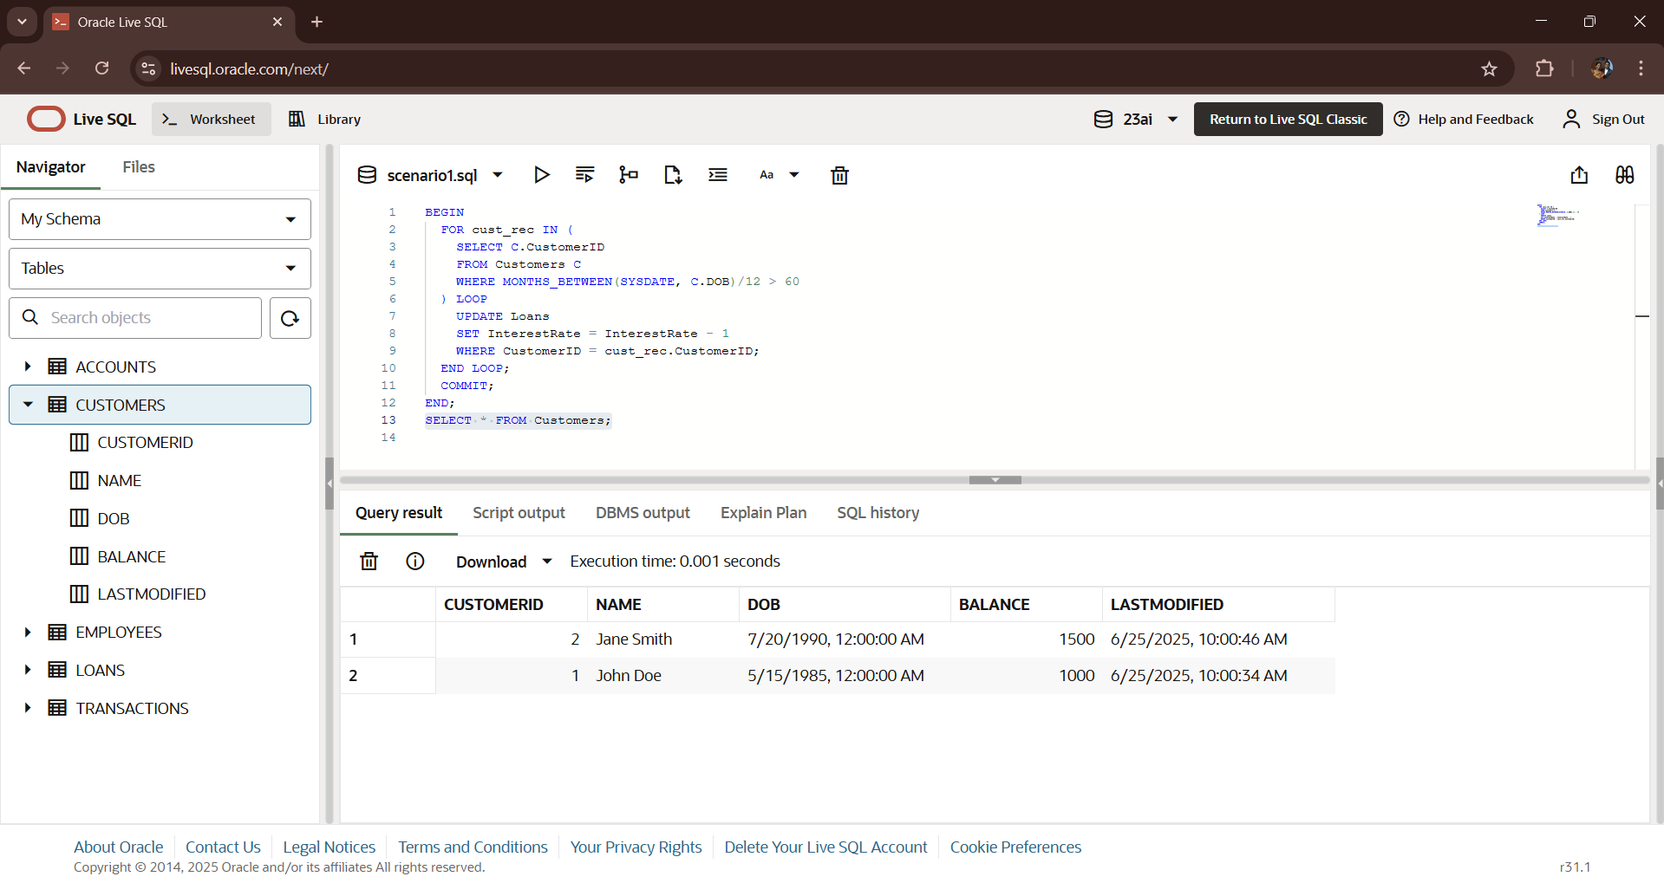**OUTPUT:-**

**Scenario 2: Promote Customers to VIP Status Based on Balance**

CODE:-

ALTER TABLE Customers ADD IsVIP VARCHAR2(5);

BEGIN

  FOR cust_rec IN (

    SELECT CustomerID, Balance FROM Customers

  ) LOOP

    IF cust_rec.Balance > 10000 THEN

      UPDATE Customers

      SET IsVIP = 'TRUE'

      WHERE CustomerID = cust_rec.CustomerID;

    ELSE

      UPDATE Customers

      SET IsVIP = 'FALSE'

      WHERE CustomerID = cust_rec.CustomerID;

    END IF;

  END LOOP;

  COMMIT;

END;

select * from CUSTOMERS;

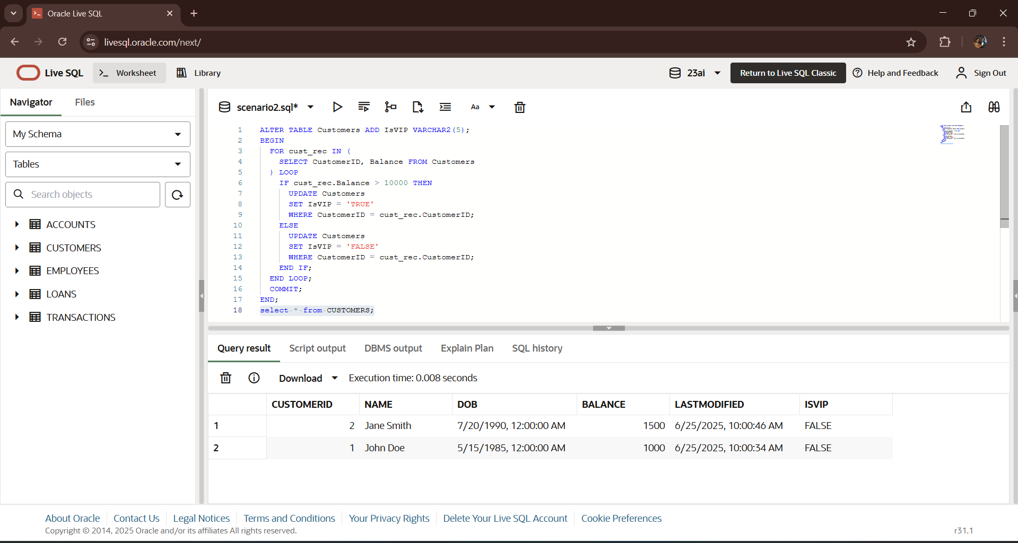**OUTPUT:-**

**Scenario 3: Remind Customers of Loans Due Within 30 Days**

This pulls from the Loans table (using EndDate) and prints a message for each due loan.

**CODE:-**

BEGIN

  FOR loan_rec IN (

    SELECT L.LoanID, L.EndDate, C.Name

    FROM Loans L

    JOIN Customers C ON L.CustomerID = C.CustomerID

    WHERE L.EndDate BETWEEN SYSDATE AND SYSDATE + 30

  ) LOOP

    DBMS_OUTPUT.PUT_LINE('Reminder: Dear ' || loan_rec.Name ||

                         ', your loan (ID: ' || loan_rec.LoanID ||

                         ') is due on ' || TO_CHAR(loan_rec.EndDate, 'DD-MON-YYYY'));

  END LOOP;

END;

SELECT * FROM LOANS;

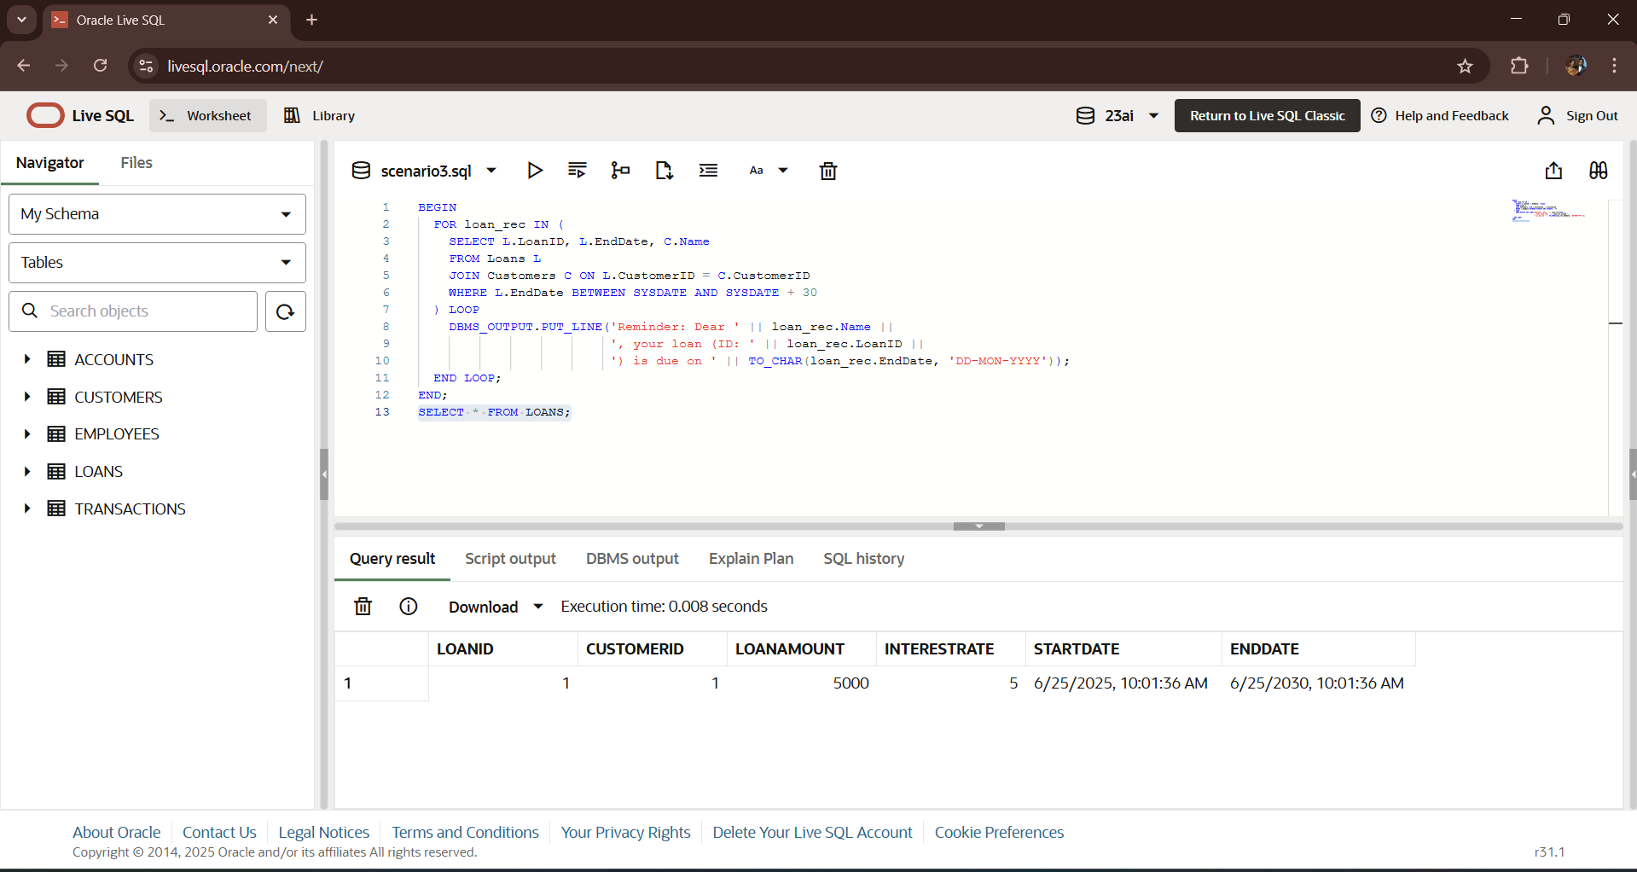**OUTPUT:-**