**Exercise 6: Cursors**

**Scenario 1:** Generate monthly statements for all customers.

* + **Question:** Write a PL/SQL block using an explicit cursor **GenerateMonthlyStatements** that retrieves all transactions for the current month and prints a statement for each customer.

**Scenario 2:** Apply annual fee to all accounts.

* + **Question:** Write a PL/SQL block using an explicit cursor **ApplyAnnualFee** that deducts an annual maintenance fee from the balance of all accounts.

**Scenario 3:** Update the interest rate for all loans based on a new policy.

* + **Question:** Write a PL/SQL block using an explicit cursor **UpdateLoanInterestRates** that fetches all loans and updates their interest rates based on the new policy.

**Scenario 1: GenerateMonthlyStatements — Print Monthly Transactions**

**CODE:-**

DECLARE

  CURSOR trans_cursor IS

    SELECT T.TransactionID, T.AccountID, T.TransactionDate, T.Amount, T.TransactionType, C.Name

    FROM Transactions T

    JOIN Accounts A ON T.AccountID = A.AccountID

    JOIN Customers C ON A.CustomerID = C.CustomerID

    WHERE EXTRACT(MONTH FROM T.TransactionDate) = EXTRACT(MONTH FROM SYSDATE)

      AND EXTRACT(YEAR FROM T.TransactionDate) = EXTRACT(YEAR FROM SYSDATE);

  v_trans trans_cursor%ROWTYPE;

BEGIN

  OPEN trans_cursor;

  LOOP

    FETCH trans_cursor INTO v_trans;

    EXIT WHEN trans_cursor%NOTFOUND;

    DBMS_OUTPUT.PUT_LINE('Customer: ' || v_trans.Name ||

                         ' | Transaction ID: ' || v_trans.TransactionID ||

                         ' | Type: ' || v_trans.TransactionType ||

                         ' | Amount: ' || v_trans.Amount ||

                         ' | Date: ' || TO_CHAR(v_trans.TransactionDate, 'DD-MON-YYYY'));

  END LOOP;

  CLOSE trans_cursor;

END;

**OUTPUT:-**

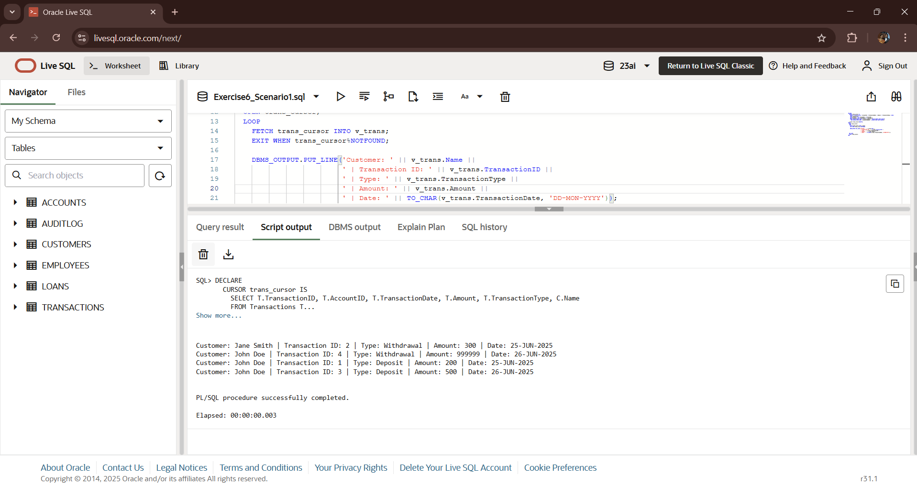

**Scenario 2: ApplyAnnualFee — Deduct Fee from All Accounts**

**CODE:-**

DECLARE

  CURSOR acc_cursor IS

    SELECT AccountID, Balance

    FROM Accounts;

  v_acc acc_cursor%ROWTYPE;

  v_fee CONSTANT NUMBER := 100; -- Annual maintenance fee

BEGIN

  OPEN acc_cursor;

  LOOP

    FETCH acc_cursor INTO v_acc;

    EXIT WHEN acc_cursor%NOTFOUND;

    UPDATE Accounts

    SET Balance = Balance - v_fee,

        LastModified = SYSDATE

    WHERE AccountID = v_acc.AccountID;

    DBMS_OUTPUT.PUT_LINE('Annual fee applied to Account ID: ' || v_acc.AccountID);

  END LOOP;

  CLOSE acc_cursor;

  COMMIT;

END;

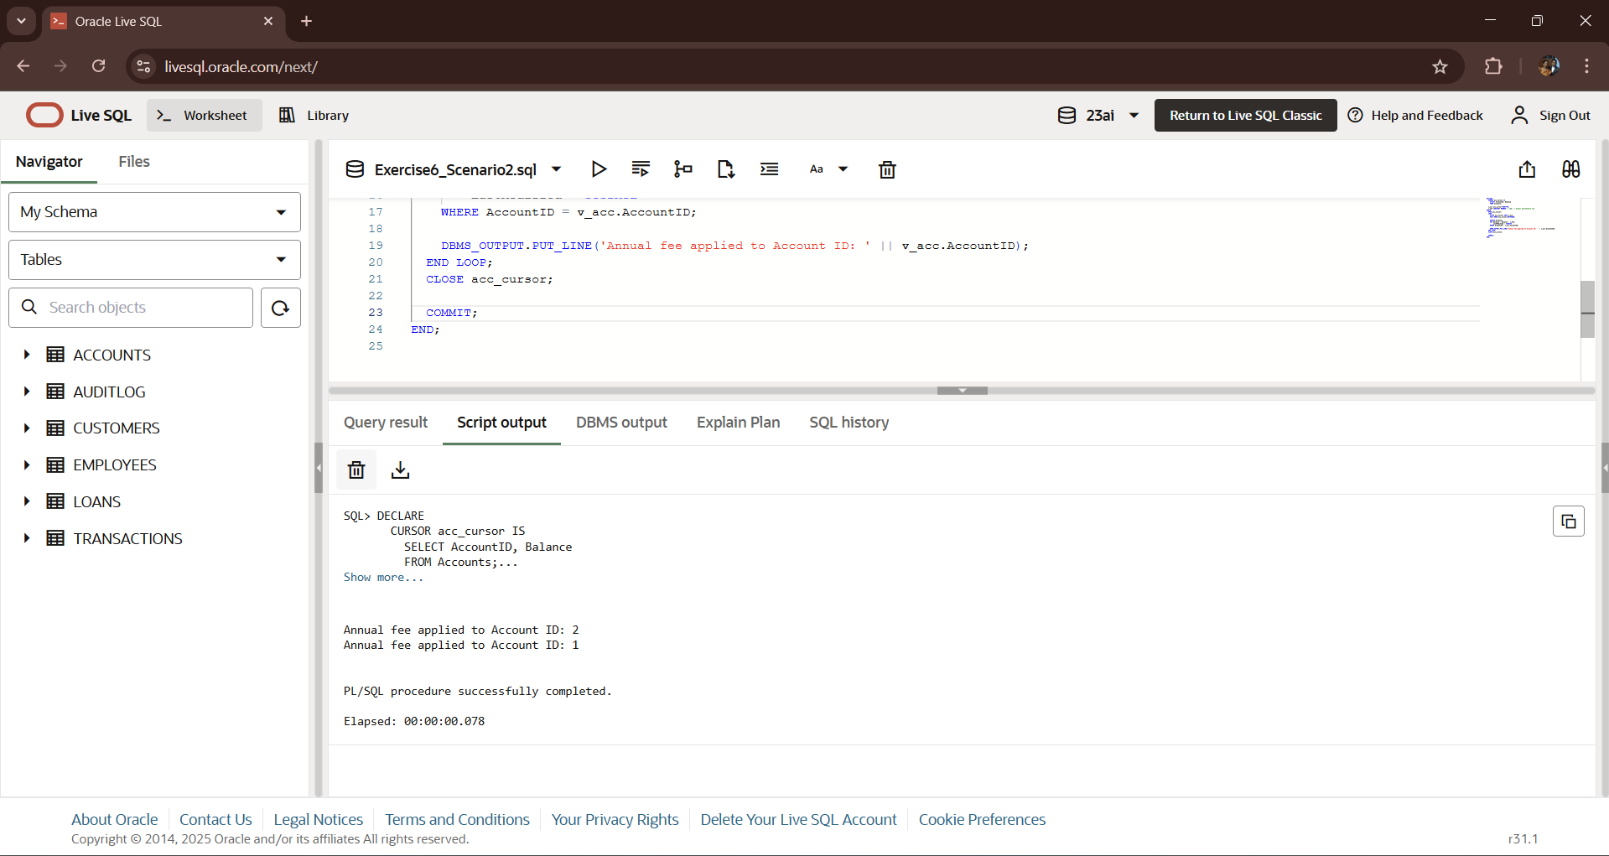**OUTPUT:-**

**Scenario 3: UpdateLoanInterestRates — Adjust Interest per Policy**

Assume a new policy like:

* If loan amount > 10000, reduce interest by 0.5%.
* Else increase by 0.25%.

**CODE:-**

DECLARE

  CURSOR loan_cursor IS

    SELECT LoanID, LoanAmount, InterestRate

    FROM Loans;

  v_loan loan_cursor%ROWTYPE;

BEGIN

  OPEN loan_cursor;

  LOOP

    FETCH loan_cursor INTO v_loan;

    EXIT WHEN loan_cursor%NOTFOUND;

    IF v_loan.LoanAmount > 10000 THEN

      UPDATE Loans

      SET InterestRate = InterestRate - 0.5

      WHERE LoanID = v_loan.LoanID;

      DBMS_OUTPUT.PUT_LINE('Reduced interest for Loan ID: ' || v_loan.LoanID);

    ELSE

      UPDATE Loans

      SET InterestRate = InterestRate + 0.25

      WHERE LoanID = v_loan.LoanID;

      DBMS_OUTPUT.PUT_LINE('Increased interest for Loan ID: ' || v_loan.LoanID);

    END IF;

  END LOOP;

  CLOSE loan_cursor;

  COMMIT;

END;

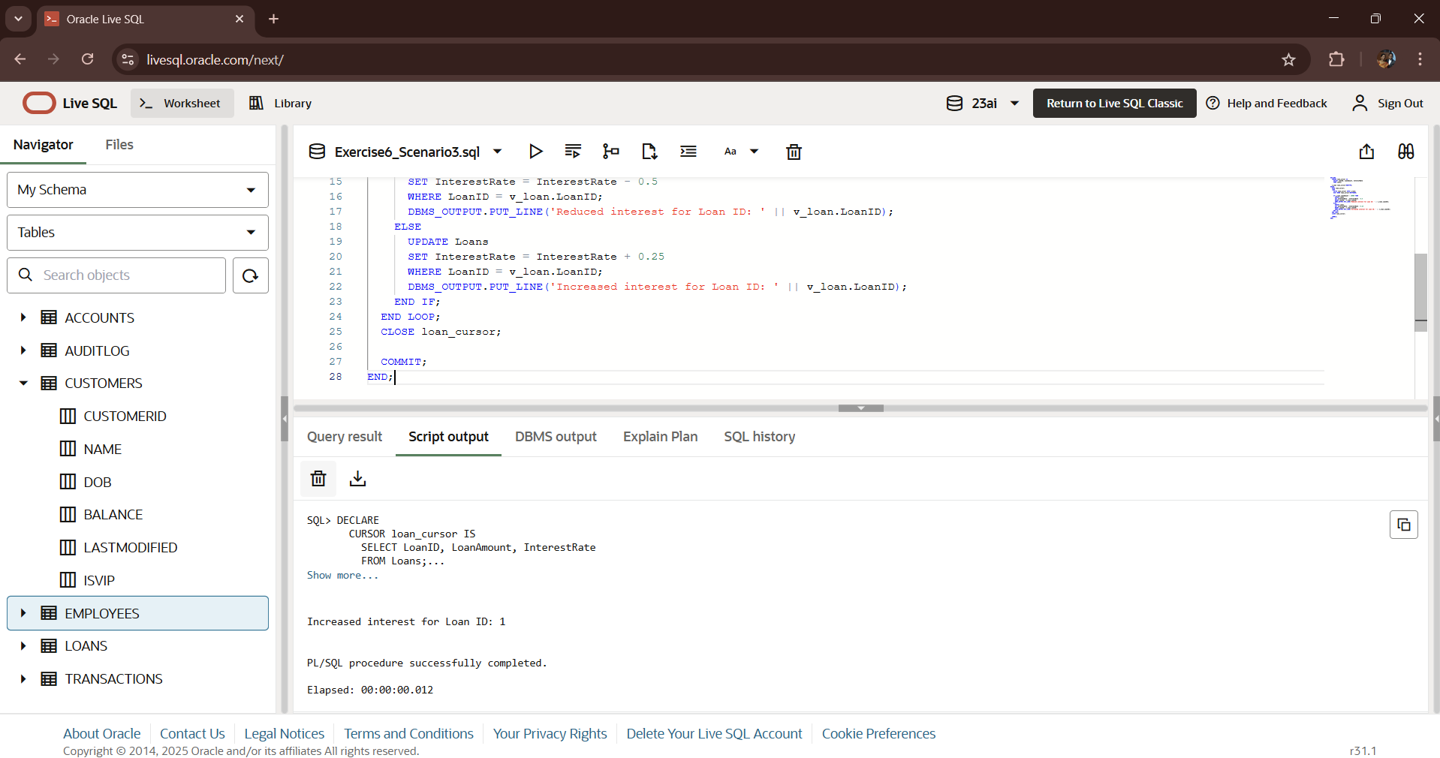**OUTPUT:-**