**Exercise 7: Packages**

**Scenario 1:** Group all customer-related procedures and functions into a package.

* + **Question:** Create a package **CustomerManagement** with procedures for adding a new customer, updating customer details, and a function to get customer balance.

**Scenario 2:** Create a package to manage employee data.

* + **Question:** Write a package **EmployeeManagement** with procedures to hire new employees, update employee details, and a function to calculate annual salary.

**Scenario 3:** Group all account-related operations into a package.

* + **Question:** Create a package **AccountOperations** with procedures for opening a new account, closing an account, and a function to get the total balance of a customer across all accounts.

**Scenario 1: Package CustomerManagement**

**Step 1: Package Specification**

**CODE:-**

CREATE OR REPLACE PACKAGE CustomerManagement AS

  PROCEDURE AddCustomer(

    p_CustomerID IN NUMBER,

    p_Name IN VARCHAR2,

    p_DOB IN DATE,

    p_Balance IN NUMBER

  );

  PROCEDURE UpdateCustomer(

    p_CustomerID IN NUMBER,

    p_Name IN VARCHAR2,

    p_Balance IN NUMBER

  );

  FUNCTION GetCustomerBalance(p_CustomerID IN NUMBER) RETURN NUMBER;

END CustomerManagement;

CREATE OR REPLACE PACKAGE BODY CustomerManagement AS

  PROCEDURE AddCustomer(

    p_CustomerID IN NUMBER,

    p_Name IN VARCHAR2,

    p_DOB IN DATE,

    p_Balance IN NUMBER

  ) IS

  BEGIN

    INSERT INTO Customers (CustomerID, Name, DOB, Balance, LastModified)

    VALUES (p_CustomerID, p_Name, p_DOB, p_Balance, SYSDATE);

    COMMIT;

  EXCEPTION

    WHEN DUP_VAL_ON_INDEX THEN

      DBMS_OUTPUT.PUT_LINE('Customer ID already exists.');

  END;

  PROCEDURE UpdateCustomer(

    p_CustomerID IN NUMBER,

    p_Name IN VARCHAR2,

    p_Balance IN NUMBER

  ) IS

  BEGIN

    UPDATE Customers

    SET Name = p_Name,

        Balance = p_Balance,

        LastModified = SYSDATE

    WHERE CustomerID = p_CustomerID;

    IF SQL%ROWCOUNT = 0 THEN

      DBMS_OUTPUT.PUT_LINE('Customer not found.');

    ELSE

      COMMIT;

    END IF;

  END;

  FUNCTION GetCustomerBalance(p_CustomerID IN NUMBER) RETURN NUMBER IS

    v_Balance NUMBER;

  BEGIN

    SELECT Balance INTO v_Balance FROM Customers WHERE CustomerID = p_CustomerID;

    RETURN v_Balance;

  EXCEPTION

    WHEN NO_DATA_FOUND THEN

      RETURN NULL;

  END;

END CustomerManagement;

EXEC CustomerManagement.AddCustomer(10, 'Asha Mehta', TO_DATE('1990-05-01', 'YYYY-MM-DD'), 2000);

SELECT CustomerManagement.GetCustomerBalance(10) FROM dual;

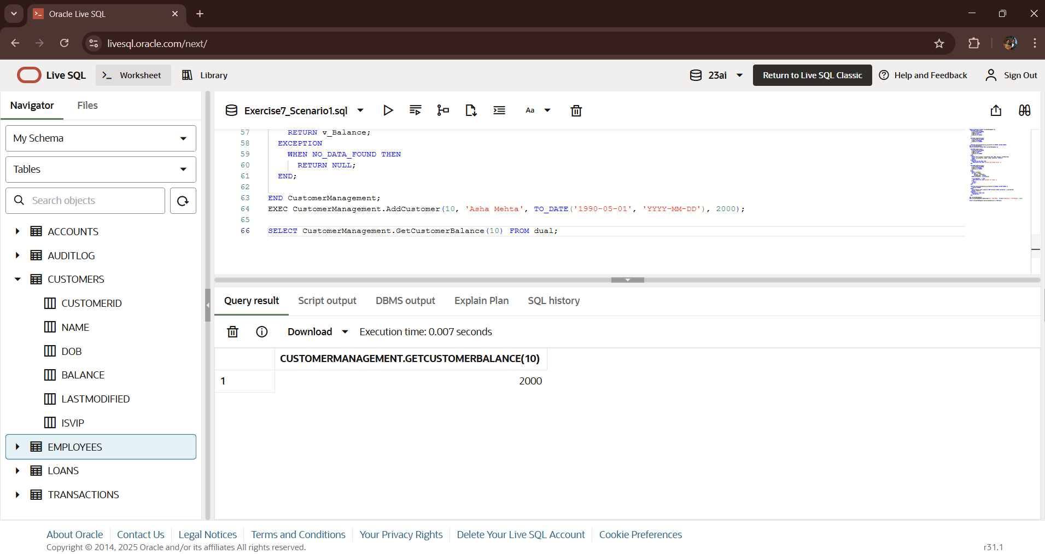**OUTPUT:**

**Scenario 2: Package EmployeeManagement**

**CODE:-**

CREATE OR REPLACE PACKAGE EmployeeManagement AS

  PROCEDURE HireEmployee(

    p_EmployeeID IN NUMBER,

    p_Name IN VARCHAR2,

    p_Position IN VARCHAR2,

    p_Salary IN NUMBER,

    p_Department IN VARCHAR2,

    p_HireDate IN DATE

  );

  PROCEDURE UpdateEmployee(

    p_EmployeeID IN NUMBER,

    p_Position IN VARCHAR2,

    p_Salary IN NUMBER

  );

  FUNCTION GetAnnualSalary(p_EmployeeID IN NUMBER) RETURN NUMBER;

END EmployeeManagement;

CREATE OR REPLACE PACKAGE BODY EmployeeManagement AS

  PROCEDURE HireEmployee(

    p_EmployeeID IN NUMBER,

    p_Name IN VARCHAR2,

    p_Position IN VARCHAR2,

    p_Salary IN NUMBER,

    p_Department IN VARCHAR2,

    p_HireDate IN DATE

  ) IS

  BEGIN

    INSERT INTO Employees (EmployeeID, Name, Position, Salary, Department, HireDate)

    VALUES (p_EmployeeID, p_Name, p_Position, p_Salary, p_Department, p_HireDate);

    COMMIT;

  EXCEPTION

    WHEN DUP_VAL_ON_INDEX THEN

      DBMS_OUTPUT.PUT_LINE('Employee ID already exists.');

  END;

  PROCEDURE UpdateEmployee(

    p_EmployeeID IN NUMBER,

    p_Position IN VARCHAR2,

    p_Salary IN NUMBER

  ) IS

  BEGIN

    UPDATE Employees

    SET Position = p_Position,

        Salary = p_Salary

    WHERE EmployeeID = p_EmployeeID;

    IF SQL%ROWCOUNT = 0 THEN

      DBMS_OUTPUT.PUT_LINE('Employee not found.');

    ELSE

      COMMIT;

    END IF;

  END;

  FUNCTION GetAnnualSalary(p_EmployeeID IN NUMBER) RETURN NUMBER IS

    v_Salary NUMBER;

  BEGIN

    SELECT Salary INTO v_Salary FROM Employees WHERE EmployeeID = p_EmployeeID;

    RETURN v_Salary * 12;

  EXCEPTION

    WHEN NO_DATA_FOUND THEN

      RETURN NULL;

  END;

END EmployeeManagement;

EXEC EmployeeManagement.HireEmployee(3, 'David', 'Analyst', 55000, 'Finance', SYSDATE);

SELECT EmployeeManagement.GetAnnualSalary(3) FROM dual;

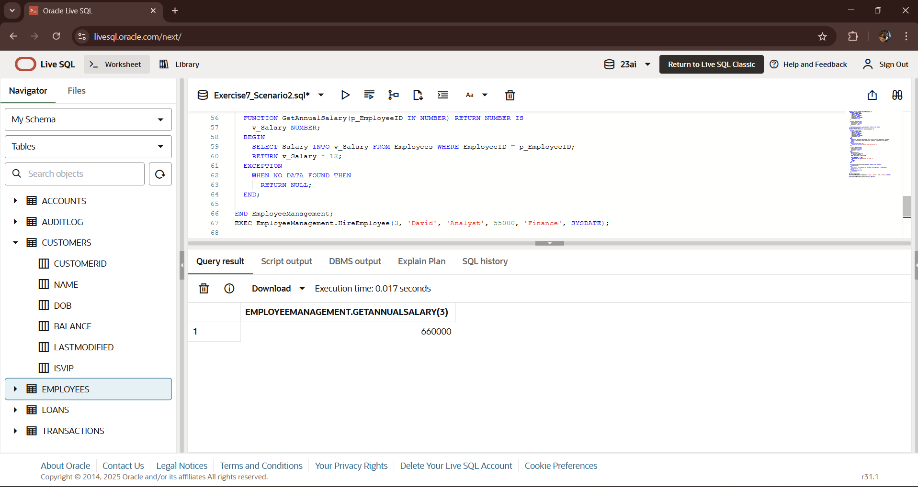**OUTPUT:-**

**Scenario 3: Package AccountOperations**

**CODE:-**

CREATE OR REPLACE PACKAGE AccountOperations AS

  PROCEDURE OpenAccount(

    p_AccountID IN NUMBER,

    p_CustomerID IN NUMBER,

    p_AccountType IN VARCHAR2,

    p_Balance IN NUMBER

  );

  PROCEDURE CloseAccount(p_AccountID IN NUMBER);

  FUNCTION GetTotalBalance(p_CustomerID IN NUMBER) RETURN NUMBER;

END AccountOperations;

CREATE OR REPLACE PACKAGE BODY AccountOperations AS

  PROCEDURE OpenAccount(

    p_AccountID IN NUMBER,

    p_CustomerID IN NUMBER,

    p_AccountType IN VARCHAR2,

    p_Balance IN NUMBER

  ) IS

  BEGIN

    INSERT INTO Accounts (AccountID, CustomerID, AccountType, Balance, LastModified)

    VALUES (p_AccountID, p_CustomerID, p_AccountType, p_Balance, SYSDATE);

    COMMIT;

  EXCEPTION

    WHEN DUP_VAL_ON_INDEX THEN

      DBMS_OUTPUT.PUT_LINE('Account ID already exists.');

  END;

  PROCEDURE CloseAccount(p_AccountID IN NUMBER) IS

  BEGIN

    DELETE FROM Accounts WHERE AccountID = p_AccountID;

    IF SQL%ROWCOUNT = 0 THEN

      DBMS_OUTPUT.PUT_LINE('Account not found.');

    ELSE

      COMMIT;

    END IF;

  END;

  FUNCTION GetTotalBalance(p_CustomerID IN NUMBER) RETURN NUMBER IS

    v_Total NUMBER;

  BEGIN

    SELECT SUM(Balance) INTO v_Total FROM Accounts WHERE CustomerID = p_CustomerID;

    RETURN NVL(v_Total, 0);

  END;

END AccountOperations;

EXEC AccountOperations.OpenAccount(5, 10, 'Savings', 1500);

SELECT AccountOperations.GetTotalBalance(10) FROM dual;

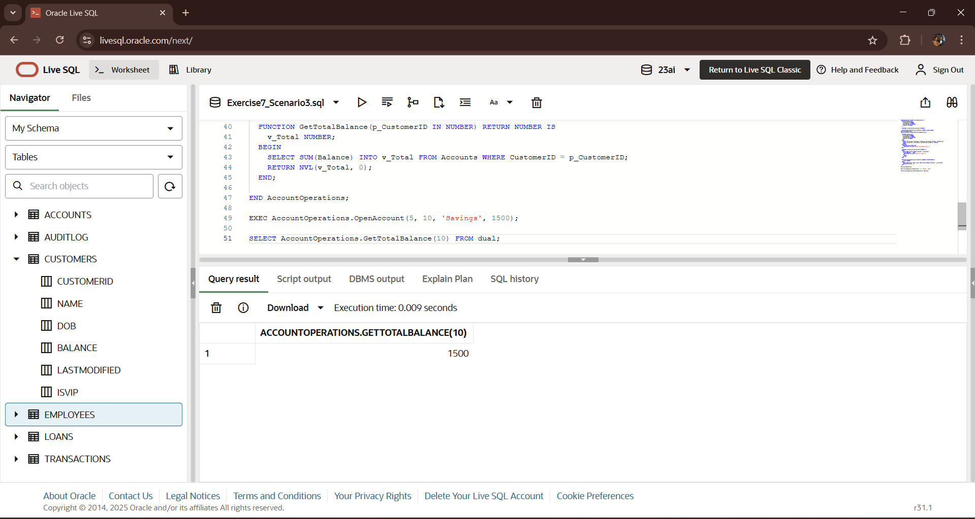**OUTPUT:-**