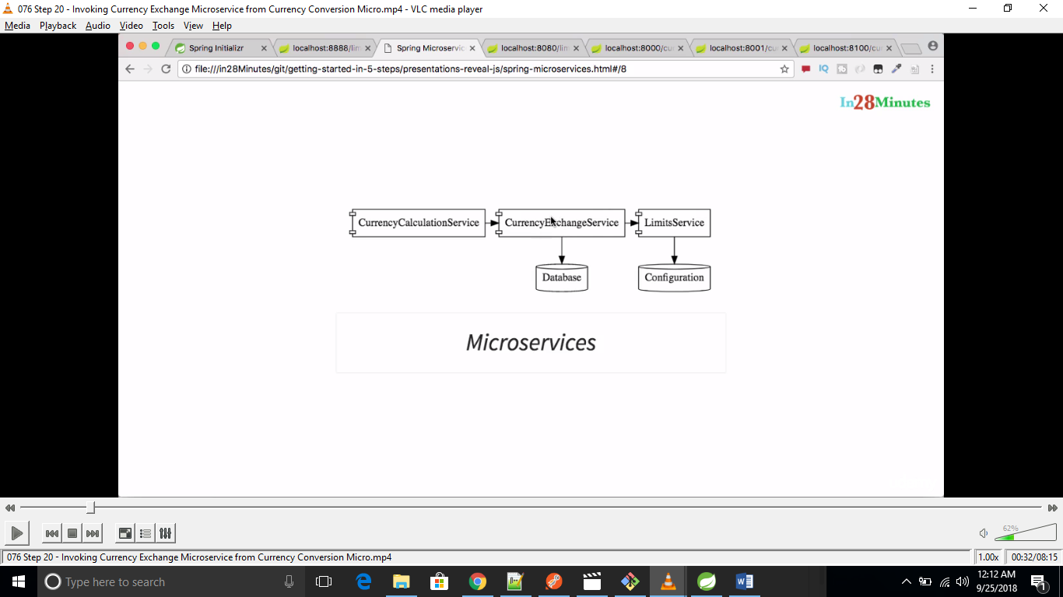

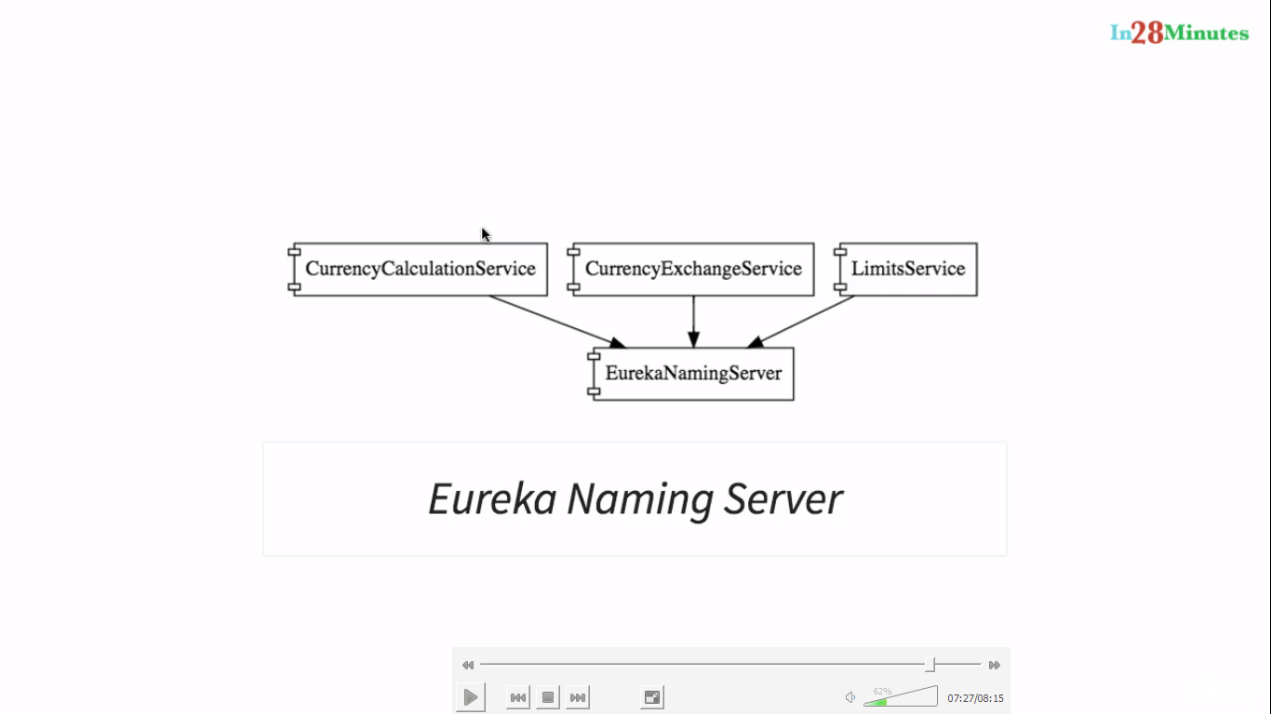

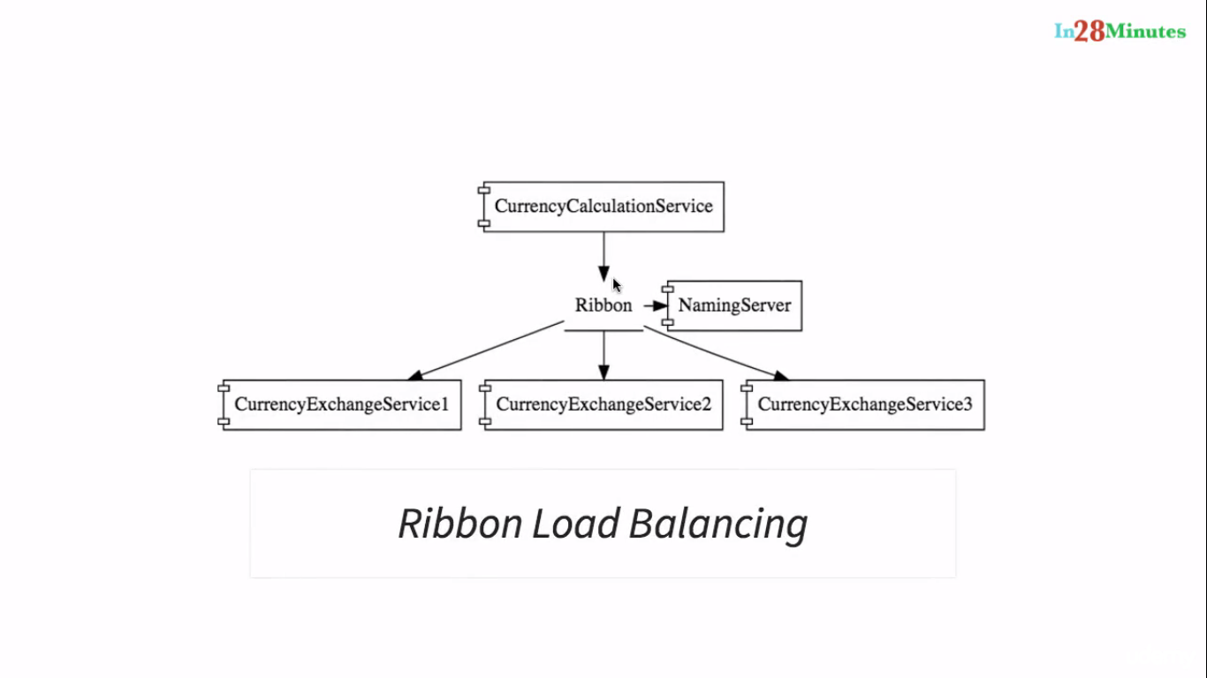

When ever there is log message The Microservice Put that in theRabbitMQ and ZipkingTracing server picking up from queue.Usually Zipking is working with db

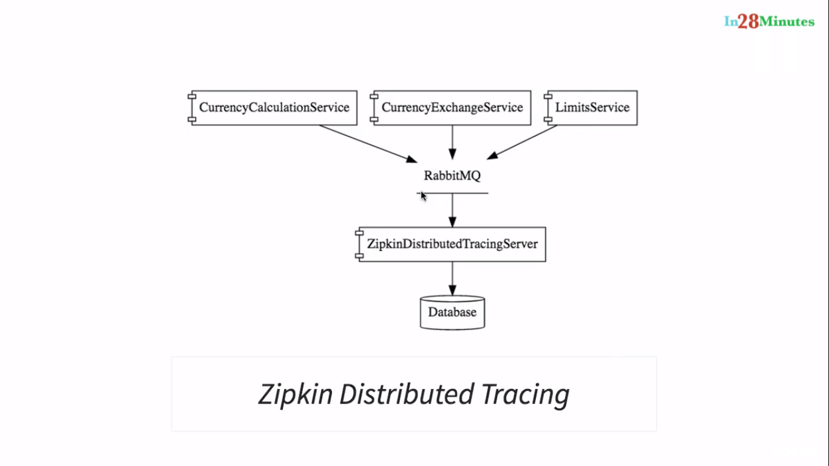

localhost:8100/currency-conversion/from/DIN/to/INR/quantity/3

localhost:8100/currency-converter -feign/from/UKD/to/INR/quantity/332

localhost:8001/currency-exchange/from/USD/to/INR

localhost:8000/currency-exchange/from/USD/to/INR

Eureka Server ->http://localhost:8761/

API GATEWAYS logging through APIGATEWAY

<http://localhost:8765/currency-exchange-service/currency-exchange/from/USD/to/INR>

vid-91

<http://localhost:8765/currency-conversion-service/currency-converter-feign/from/DIN/to/INR/quantity/3>

http://localhost:9411/ ZIPKIN

Without cloud bus-localhost:8080/actuautor/refresh

With cloud bus- localhost:8080/actuautor/bus-refresh