**Aim:** a. Write a program to raise built-in exceptions and raise them as per the requirements

**Code:**

public class pra3a

{

    public static void main(String[] args)

    {

        try

        {

            int result=divide(10,0);

            System.out.println("Result:"+result);

        }

        catch(ArithmeticException e)

        {

            System.err.println("Error:Division by zero.");

        }

    }

    public static int divide(int a, int b)

    {

        return a/b;

    }

}

**Output:**

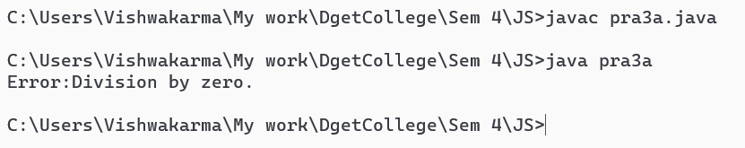

**Aim:** b. Write a program to define user defined exceptions and raise them as per the requirements

**Code:**

class CustomException extends Exception

{

    public CustomException(String message)

    {

        super(message);

    }

}

public class pra3b

{

    public static void main(String[] args)

    {

        try

        {

            int age=-20;

            if(age<0)

            {

                throw new CustomException("Age cannot be negative.");

            }

            System.out.println("Age:"+age);

        }

        catch(CustomException e)

        {

            System.err.println("Error:"+ e.getMessage());

        }

    }

}

**Output:**

