Aim: Perform the data classification using classification algorithm using R/Python.

Code:

Method 1:

> rainfall <- c(799,1174.8,865.1,1334.6,635.4,918.5,685.5,998.6,784.2,985,882.8,1071)

> rainfall.timeseries<-ts(rainfall,start=c(2012,1),frequency=12)

> print(rainfall.timeseries)

Jan Feb Mar Apr May Jun Jul Aug Sep Oct

2012 799.0 1174.8 865.1 1334.6 635.4 918.5 685.5 998.6 784.2 985.0

Nov Dec

2012 882.8 1071.0

> png(file="rainfall.png")

> plot(rainfall.timeseries)

> dev.off()

null device

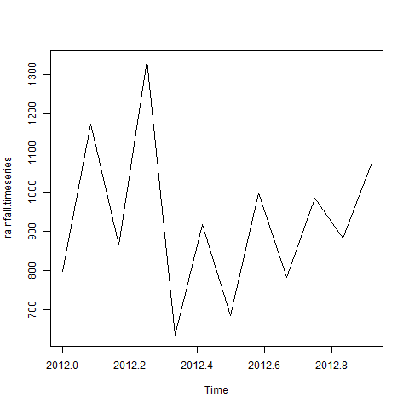

Method 2:

> studentsfail <- c(799,1174,865,1334,635,918,685,998,784,985,882,1071)

> studentsfail.timeseries <- ts (students,start = c =(799,1),frequency = 06)

> print(studentsfail.timeseries)

Time Series:

Start = c(799, 1)

End = c(800, 6)

Frequency = 6

[1] 799 1174 865 1334 635 918 685 998 784 985 882 1071

> png(file="studentsfail.png")

> plot(studentsfail.timeseries)

