Intelligent Data Reconciliation and
Knowledge Discovery System
High-Level Design and Low-Level Design
With Revised Scope, Evaluation, and Security/Operations Additions
Companion design document to the Capstone Project Specification
Master of Science — Artificial Intelligence & Machine Learning
April 2026

Executive Summary
This design proposes a six-month, single-researcher MVP for an Intelligent Data Reconciliation and Knowledge Discovery system. The core thesis claim is that MCP-native retrieval, graph reasoning, bounded critique, and SLM distillation can produce auditable, reproducible answers over enterprise technical assets without requiring a frontier model in the production path.

MVP Scope
The MVP keeps all six pillars, but narrows each to the minimum needed for a defensible dissertation result: Python/JavaScript ingestion, Neo4j graph modelling, pgvector retrieval, bounded LangGraph orchestration, Phi-4-mini QLoRA distillation, and selective drift-triggered re-indexing.

Primary Success Measures

Area | Measure | MVP threshold | Evidence artifact
Benchmark | MCP-TaskBench aggregate | >= 0.70 | Pinned task suite, traces, JSONL scores
Tool calling | BFCL function-call F1 | >= 0.82 final gate | Evaluation harness report
Faithfulness | NLI/AlignScore-style metric | >= 0.78 | Claim-level critic logs
Latency | Single-hop query p50 | <= 3.0 s | OpenTelemetry dashboard export

Key Risks
The highest risks are SLM quality gap against the teacher, benchmark over-scope, protocol churn, diagram/code density affecting reviewability, and evaluation reproducibility. The updated design treats DPO, broad A2A hardening, and production-grade HA as conditional or stretch unless needed for the thesis claim.

Table of Contents
Executive Summary 2
MVP Scope 2
Primary Success Measures 2
Key Risks 2
Table of Contents 3
Part 1 — Specification Review and Improvements 6
1.1 How to read this document 6
1.2 Summary of proposed changes to the original spec 6
1.3 Tightening scope for six-month feasibility 7
1.3.1 MVP per pillar (must-have for thesis result) 7
1.3.2 Out of scope for the dissertation (even as stretch) 8
1.3.3 Effort model 8
1.4 Strengthening novelty and evaluation 8
1.4.1 Falsifiable research questions 8
1.4.2 Statistical rigour additions 9
1.4.3 Positioning against contemporary work 9
1.5 Security and operational readiness additions 9
Part 2 — High-Level Design 11
2.1 System context (C4 Level 1) 11
2.2 Container view (C4 Level 2) 12
2.3 Primary runtime flows 12
2.3.1 Query path 12
2.3.2 Ingestion path 13
2.3.3 Drift detection and re-indexing path 14
2.4 Deployment topology 15
2.5 Key Architecture Decision Records (ADRs) 16
ADR-001 — Use Neo4j Community for the knowledge graph 16
ADR-002 — pgvector over a dedicated vector DB 16
ADR-003 — LangGraph + AutoGen over a single framework 17
ADR-004 — Phi-4-mini (3.8B) as the student model 17
ADR-005 — MCP as the sole inter-agent protocol 17
ADR-006 — Bounded critic loop (max 2 re-retrievals) 17
2.6 Quality attributes and SLOs 18
2.7 Consolidated technology decisions 18
Part 3 — Low-Level Design 20
3.1 Canonical data model and schemas 20
3.1.1 Neo4j graph schema (Cypher DDL) 20
3.1.2 Postgres + pgvector schema 21
3.1.3 MCP message contracts (Pydantic / JSON Schema) 22
3.2 Pillar 1 — Structural ingestion (LLD) 24
3.2.1 Component decomposition 24
3.2.2 Sequence 25
3.2.3 Key algorithms (pseudocode) 25
3.2.4 Transactional model 27
3.2.5 Error handling and retries 28
3.3 Pillar 2 — Knowledge graph (LLD) 28
3.3.1 Write patterns 28
3.3.2 Read patterns used by the Graph Traversal Agent 29
3.3.3 Offline graph analytics (batch jobs) 29
3.3.4 Temporal conflict resolution 30
3.4 Pillar 3 — Agentic RAG pipeline (LLD) 31
3.4.1 LangGraph state machine 31
3.4.2 Planner: classification prompt and routing 33
3.4.3 Hybrid retrieval: vector + graph fusion 34
3.4.4 Critic — NLI-based faithfulness 34
3.4.5 Reranker selection and latency budget 35
3.5 Pillar 4 — MCP + A2A orchestration (LLD) 35
3.5.1 MCP server structure (FastAPI) 35
3.5.2 MCP tool catalogue (initial) 37
3.5.3 A2A bridge to AutoGen 39
3.5.4 AutoGen Reconciliation Agent 40
3.5.5 Cross-agent auth and tenancy 41
3.6 Pillar 5 — SLM distillation (LLD) 41
3.6.1 Distillation pipeline overview 41
3.6.2 Training data generation 41
3.6.3 QLoRA configuration 42
3.6.4 DPO alignment pass 44
3.6.5 Quantisation and publication 45
3.6.6 Evaluation harness (offline) 45
3.6.7 Inference server (vLLM) 45
3.7 Pillar 6 — Drift detection and re-indexing (LLD) 46
3.7.1 Sequence recap 46
3.7.2 Kafka topic design 46
3.7.3 Drift scorer (pseudocode) 48
3.7.4 Re-index orchestration (Celery) 48
3.7.5 Back-pressure and fairness 49
Part 4 — Cross-Cutting Concerns 50
4.1 Security architecture 50
4.1.1 Threat model (STRIDE, summarised) 50
4.1.2 Prompt injection containment 50
4.1.3 Secrets management 51
4.2 Observability 51
4.2.1 Key metrics 51
4.2.2 SLO-based alerting 52
4.3 Testing and evaluation harness architecture 52
4.4 CI/CD and environments 52
4.5 Capacity planning and known migration paths 53
Part 5 — Revised Six-Month Implementation Timeline 54
Part 6 — Risks, Assumptions, and Open Questions 56
6.1 Updated risk register 56
6.2 Key assumptions 57
6.3 Open questions to resolve during execution 57
6.4 What this design does not claim 57
Appendix A — Glossary 59
Appendix B — Mapping from original spec to this HLD/LLD 60
Appendix C — Reading guide for reviewers 61
Appendix D - Claim-to-Evidence Matrix 62
Appendix E - Operational Runbook Starters 62
Appendix F - Key External References 62

Part 1 — Specification Review and Improvements

1.1 How to read this document
This document is the companion design to the Capstone Project Specification dated April 2026. It is organised so you can read it in three passes: Part 1 for the revised scope and the changes being proposed to the original spec; Part 2 for the High-Level Design (HLD); Part 3 for the Low-Level Design (LLD) at per-pillar depth with schemas, API contracts, pseudocode, and sequence diagrams; and Parts 4 to 6 for cross-cutting concerns, the revised timeline, and risks.
Every improvement and every design decision is traceable to one of three objectives requested during the review: tightening scope so the work is finishable in six months by a single researcher, strengthening the research novelty and the evaluation story, and adding the security and operational depth that an enterprise-grade claim requires.

1.2 Summary of proposed changes to the original spec
Area | Original spec | Proposed change | Rationale
Scope | 6 pillars delivered end-to-end in 6 months | MVP cut of 6 pillars + clearly labelled stretch features; out-of-scope list | Feasibility for a single researcher on commodity GPU
SLM target | Phi-4-mini primary, Mistral-7B secondary | Phi-4-mini only as primary (GQA, 200K vocab, identical VRAM footprint); Mistral-7B dropped from critical path, kept as optional ablation | Remove parallel training overhead; keep comparability via one ablation
Frameworks | LangGraph + AutoGen + CrewAI mentioned | LangGraph (core) + AutoGen (A2A target). CrewAI removed | Two frameworks sufficient to demonstrate A2A; third adds maintenance burden without research value
Benchmark | MCP-TaskBench described at 100 tasks / 10 categories | Same taxonomy but reduced to 80 tasks (8 × 10) for pilot release; 100-task release targeted as stretch | Ensures quality of task design under time budget; categories preserved
Evaluation | Six ablations listed | Same six ablations, plus statistical testing plan (bootstrapped CIs, paired tests) and inter-annotator agreement for human eval | Converts ablation deltas into defensible findings
Security | Implicit (on-prem deployment) | Explicit threat model, prompt-injection containment, tenancy isolation, secrets management, training-data provenance | Required to support the "enterprise-ready" claim
Operations | Monitoring mentioned in pillar 6 | Dedicated cross-cutting section: SLOs, runbooks, capacity model, backup/restore, release process, disaster recovery | Moves from prototype to "production-viable reference implementation"
Novelty framing | 3 contributions stated | Same 3 plus explicit positioning against contemporaneous MCP-agent literature, with a falsifiable research question per contribution | Strengthens thesis defence and publication story

1.3 Tightening scope for six-month feasibility
The original spec scopes 6 pillars, 6 ablations, 100 benchmark tasks, a human evaluation with 25 annotators, and a conference paper draft — all in six months by one researcher on a single consumer GPU. The research contributions are sound but the delivery risk is high. The response below preserves every research contribution by splitting each pillar into an MVP that is on the critical path for the dissertation result, and a stretch set that can be delivered if time remains but is not required for the core thesis claim.

1.3.1 MVP per pillar (must-have for thesis result)
Pillar | MVP deliverable | Explicitly deferred (stretch)
P1 Ingestion | Tree-sitter for Python + JavaScript; SpanBERT NER on documents; schema inference on JSON/CSV; incremental re-parse on commit | Java grammar; specialised parsers for API specs (OpenAPI); multi-file transaction boundaries
P2 Knowledge Graph | Neo4j schema; deterministic AST→graph; PageRank + Louvain offline; temporal conflict via Lamport vector clocks | Online community re-detection; multi-tenant graph partitioning; custom graph query DSL
P3 Agentic RAG | Bi-encoder + cross-encoder; graph BFS and shortest-path; 5 agent LangGraph pipeline; NLI critic with DeBERTa; single re-retrieve loop (≤ 2 extra rounds) | Adaptive k-selection; query rewriting with learned policy; streaming partial answers
P4 MCP + A2A | FastAPI MCP server; JSON-RPC 2.0; Pydantic-validated tool contracts; one A2A bridge to AutoGen via official a2a-sdk v1.0 (Linux Foundation standard) with Signed Agent Cards and SSE transport; OTel tracing across calls | MCP over WebSocket; delegation to a third framework; capability discovery beyond static registry
P5 SLM distillation | Phi-4-mini via QLoRA; reasoning-trace SFT; one DPO pass on 500 pairs; vLLM inference | Mistral-7B comparison; MoE adapters; speculative decoding; RLAIF
P6 Drift | Dual-layer drift scoring: entity-level cosine distance + cluster-level embedding centroid distance across Louvain community partitions; 2-hop selective re-index; Kafka commit stream; confidence decay | Learned drift thresholds; cross-repo propagation; graph-level change impact prediction

1.3.2 Out of scope for the dissertation (even as stretch)
- Multi-language parsing beyond Python and JavaScript. Java is a common-ask but not necessary to demonstrate the pipeline and doubles the NER / type-inference surface area. Note: Graphify (graphify.net) supports additional languages including Go, Rust, Java, C#, and C++ via Tree-sitter grammars. If Java coverage becomes necessary (e.g., following MCP-TaskBench reviewer feedback), Graphify’s multi-language AST pass can serve as a reference implementation to compare against before committing to extending IDRKD’s own parser workers.
- Multi-tenancy beyond a logical tenant_id column on every entity. True physical isolation of tenants would require separate databases per tenant and is out of scope.
- Training the student model from scratch. QLoRA over Phi-4-mini is the critical path; pre-training is out of scope.
- UI polish beyond a functional web chat and a minimal evaluation harness dashboard.
- Production-grade high availability (active-active, cross-region replication). The target is a production-viable reference implementation, not a hardened cluster.

1.3.3 Effort model
The MVP is budgeted at roughly 70% of available researcher hours, leaving 30% as buffer for teacher-API retries, benchmark iteration, writing, and unplanned debugging. The revised timeline in Part 5 reflects this buffer explicitly as unassigned weeks rather than padding specific milestones.

1.4 Strengthening novelty and evaluation

1.4.1 Falsifiable research questions
Each of the three original contributions is restated as a falsifiable research question with a pre-registered success threshold. Falsifiability matters: if the metric does not hit the threshold, that is a publishable null result rather than a project failure.
Contribution | Research question | Success threshold | Null-result interpretation
C1 — MCP-TaskBench | Does the benchmark discriminate meaningfully between competing MCP-capable agents? | Pairwise Cohen's d ≥ 0.3 between top/bottom quartile of tested agents on aggregate score; inter-annotator κ ≥ 0.7 on ground-truth review | Benchmark is not yet discriminative; release as v0.1 with a call for community contributions
C2 — Reasoning-trace SLM | Can a distilled 3.8B model match a frontier teacher on MCP tool-calling within an 8-point F1 gap? | BFCL F1 ≥ teacher − 0.08; MCP-TaskBench aggregate score ≥ teacher − 10% | Report the gap as empirical lower bound; analyse which task categories drive it
C3 — Multi-agent MCP+A2A KG system | Does the decomposed pipeline beat a monolithic single-agent baseline on multi-hop KG queries? | MuSiQue EM +≥ 5 points over single-agent baseline built on the same SLM | Decomposition does not help at this scale; useful ablation evidence for the community

1.4.2 Statistical rigour additions
- Report bootstrapped 95% confidence intervals (10,000 resamples) on every primary metric. Point estimates alone are not defensible at this scale.
- Use paired tests (Wilcoxon signed-rank) for ablation deltas on the same task set; report p-values and effect sizes.
- For the human evaluation, report inter-annotator agreement (Fleiss' κ for multi-category, Krippendorff's α for ordinal); tasks with κ < 0.6 are excluded from headline metrics and reported separately.
- Pre-register the eval protocol: task splits, metric definitions, and analysis plan are committed to the repository before any final model is trained.
- Release raw per-task scores and agent traces alongside the benchmark so external groups can reproduce aggregate numbers and compute alternative metrics.

1.4.3 Positioning against contemporary work
Fact-check before submission
The A2A Protocol reached v1.0 and was donated to the Linux Foundation on 9 April 2026. The bridge implementation uses the official a2a-sdk (pip install a2a-sdk) with Signed Agent Cards and backward compatibility for legacy 0.3 servers. MCP spec version should be re-verified two weeks before thesis lodgement to reconcile any 1.x line changes.
In positioning against contemporaneous MCP-agent work, the thesis should explicitly map to the ecosystem that has emerged since the current MCP specification line was released: ToolBench, BFCL, Gorilla, and AgentBench predate MCP and use proprietary tool schemas. This project's benchmark is the first to use the MCP wire format natively, which matters because it evaluates both semantic correctness (right tool for the task) and protocol conformance (correct JSON-RPC message, valid parameter schema, correct error handling) in a single metric. On the ingestion side, Graphify (graphify.net, April 2026) is the closest contemporaneous prior art to Pillar 1. It runs Tree-sitter AST extraction and LLM-assisted semantic passes against a local codebase directory and pushes results directly to Neo4j ('/graphify ./src --neo4j-push bolt://localhost:7687'). It also exposes the graph as an MCP stdio server ('--mcp' flag), uses Leiden community detection, and maintains a SHA-256 content cache for incremental re-runs. IDRKD differentiates from Graphify in three ways: (a) ingestion is Kafka-driven and always-on rather than a CLI invocation, making it suitable for live CI/CD pipelines; (b) SpanBERT NER covers API specifications and schema files that Graphify does not handle; (c) the six-pillar agentic RAG, SLM distillation, and dual-layer drift detection loop are tightly coupled to the ingestion write path. Practical use: run Graphify in W1 to bootstrap Neo4j quickly for early integration testing, then replace it with the IDRKD pipeline for formal evaluation. Cite as a baseline in the thesis related-work section.

1.5 Security and operational readiness additions
The original spec treats "on-premise deployment" as the security posture. That is necessary but not sufficient; a system that ingests proprietary code, calls an LLM, exposes MCP tool surfaces, and runs autonomous agents has a non-trivial threat surface. The cross-cutting security architecture is detailed in Part 4; the headline additions are:
- Threat model (STRIDE). Documented threat model over six trust boundaries: ingress, agent ↔ tool, tool ↔ data store, inter-agent A2A, training-data pipeline, and model-artefact supply chain.
- Prompt-injection containment. Ingested content is never mixed into system-prompt scope; tool results are enclosed in typed, non-executable envelopes; the Critic Agent includes an injection-detection classifier as an early gate before generation.
- Secrets and model-artefact supply chain. All model weights are signed (cosign) and verified on load; LoRA adapters are fingerprinted; teacher-API keys are scoped per-training-job and rotated.
- Tenancy. Logical tenant_id on every entity, vector row, graph node, and MCP call. Cross-tenant queries are blocked at the MCP gateway, not inside the SLM.
- Auditability. Every MCP call is logged with correlation_id, principal, tool name, arguments (redacted), latency, and outcome. A2A delegations get immutable audit records. Retention 90 days hot, 1 year cold.
- SLOs and runbooks. Named SLOs for query latency, ingestion staleness, and drift-detection lag, with runbooks for every paging alert. Covered in Part 4.

Part 2 — High-Level Design

2.1 System context (C4 Level 1)
The system sits between the organisation's source-of-truth data stores (code, schemas, API specs, documents) and the humans or tools that need to reason about them. It exposes a single conversational interface and is queried either by engineers through a chat UI, by platform/SRE operators through dashboards, or by researchers running the evaluation harness. External frontier LLMs appear only during training, never at inference time — this boundary is what preserves the on-premise, zero-egress property.
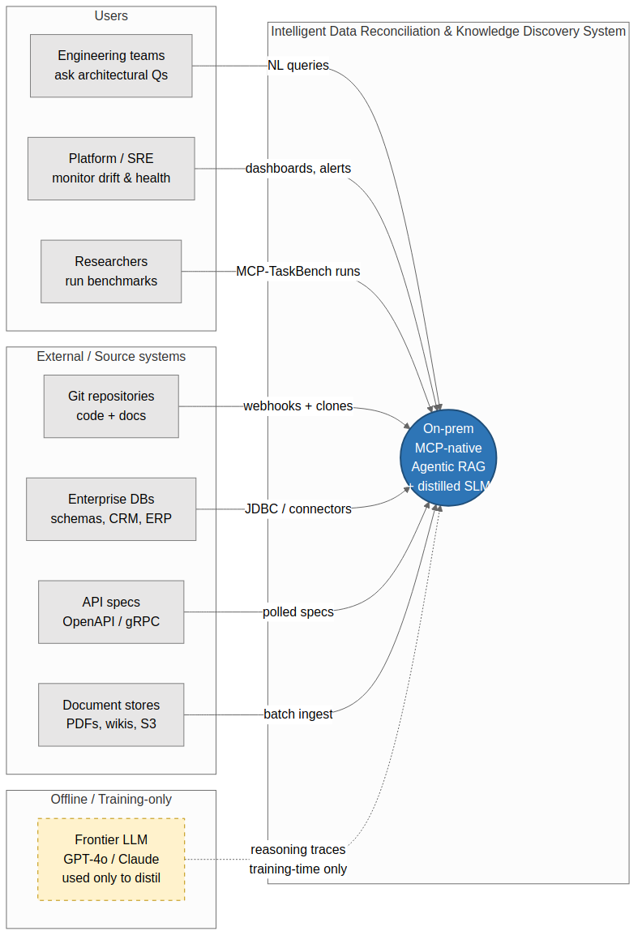
Figure 1 — System context. The frontier teacher LLM is used during distillation only and is not reachable from the production inference path.

2.2 Container view (C4 Level 2)
The container view maps the six technical pillars from the specification onto deployable services. Stateful services (Neo4j, Postgres + pgvector, Redis, object store, Kafka) form the data tier. Application-tier services (gateway, agent workers, vLLM) are stateless and horizontally scalable. A separate observability plane collects traces, metrics, and logs.
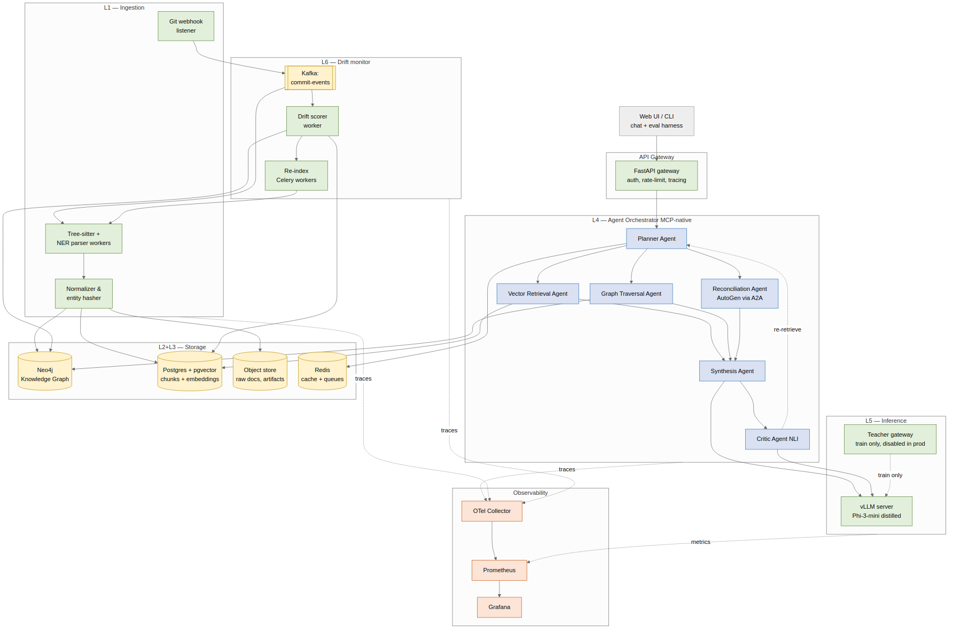
Figure 2 — Container view. Solid edges are runtime data-flow; dashed edges are control/observability. The teacher gateway is disabled in production deployments and only bound in the training VLAN.

2.3 Primary runtime flows

2.3.1 Query path
A query is served in a single HTTP request/response with an optional follow-up re-retrieve cycle. The Planner classifies the query, fans out retrieval in parallel (vector and graph where applicable), merges context, synthesises an answer, and then a Critic checks faithfulness. If any claim fails entailment, a bounded (max 2) re-retrieve is issued. The average path touches the SLM three times: classification, synthesis, and NLI entailment on claims. Latency budget and concrete SLOs appear in §2.6.
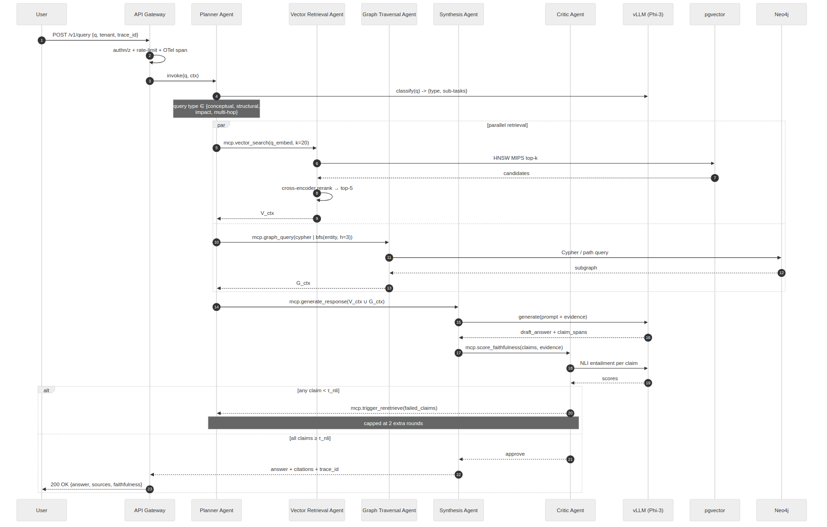
Figure 3 — Query sequence. The critic loop is bounded to prevent runaway re-retrieval; on exhaustion the answer is returned with an explicit low-faithfulness warning flag.

2.3.2 Ingestion path
Ingestion is event-driven. A Git push fires a webhook; the webhook produces a commit-event on Kafka partitioned by repository. Parser workers consume this topic, fetch the diff, parse changed files with Tree-sitter, extract entities, and fingerprint each entity's canonical form. Entities with unchanged fingerprints are skipped (idempotent). New and changed entities are written atomically to Neo4j and pgvector inside a single logical transaction boundary, and an entity-changed event is emitted for downstream consumers (drift monitor, eval pipeline). Note: Graphify (graphify.net) implements a structurally similar Tree-sitter-to-Neo4j pipeline as a CLI tool ('--neo4j-push') with SHA-256 caching for idempotency. The key architectural difference is that IDRKD's path is Kafka-driven and always-on, suitable for live CI/CD environments, whereas Graphify is invoked on-demand. Graphify is recommended as a W1 bootstrapping tool to pre-populate Neo4j before the IDRKD pipeline is operational.
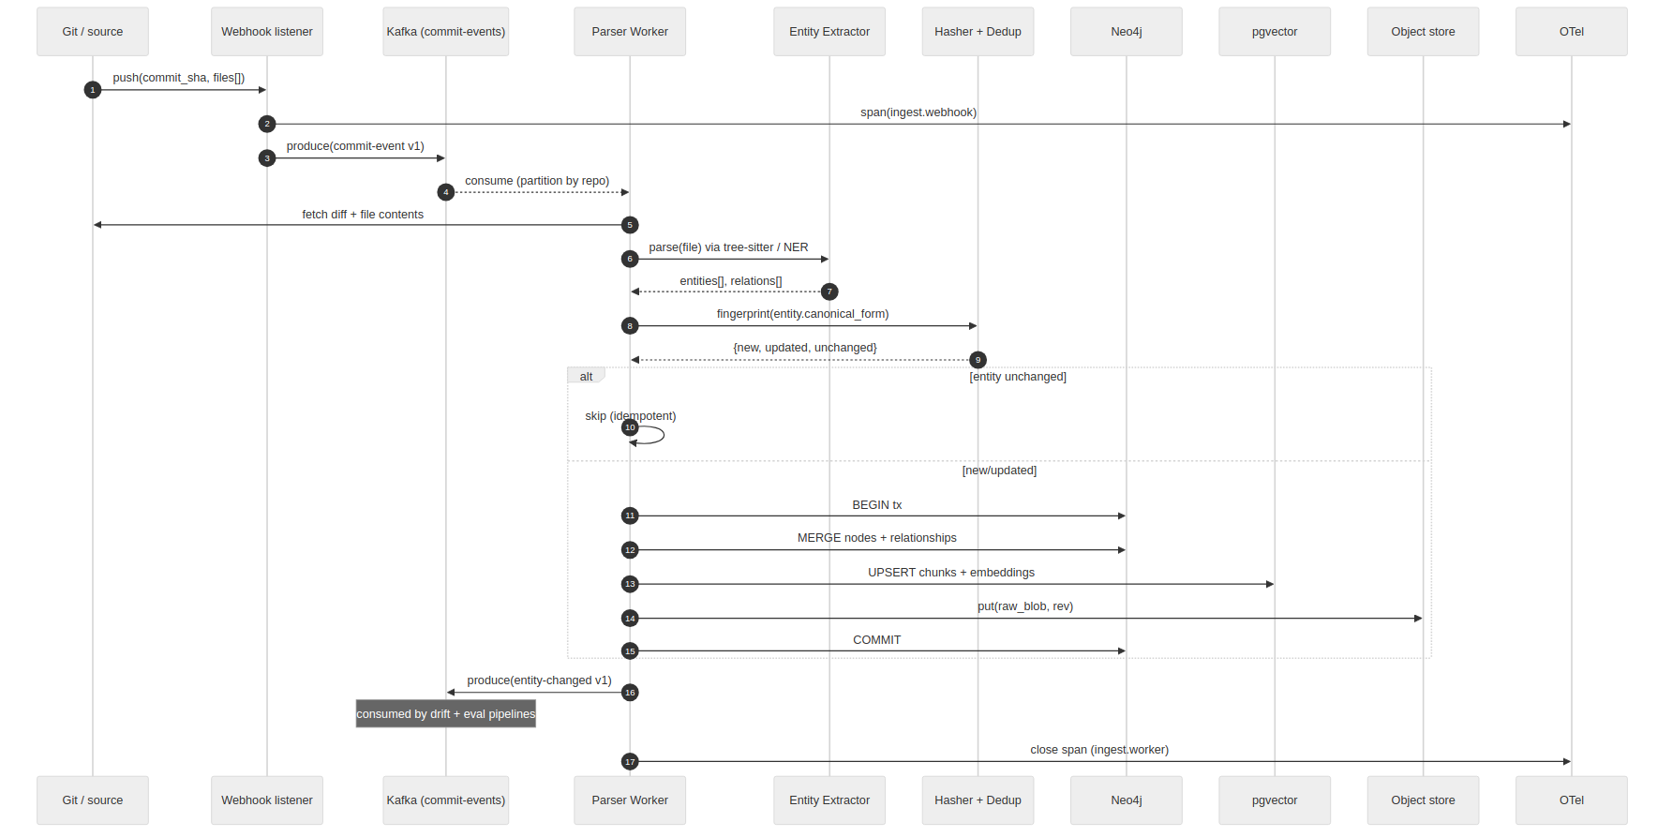
Figure 4 — Ingestion sequence. The idempotency check on the content fingerprint is what keeps typical-sized commits under the sub-second re-index budget.

2.3.3 Drift detection and re-indexing path
The drift loop is the autonomous freshness mechanism. It operates as a dual-layer scoring pipeline. Layer 1 (entity-level): consumes entity-changed events, re-embeds each entity's description, and compares the new embedding to the stored graph embedding by cosine distance. Layer 2 (cluster-level): a nightly Celery Beat job reuses the Louvain community partitions computed in P2 to compute per-community embedding centroids and tracks centroid shift over time; if a community's centroid shifts by more than 0.10, all member entities are flagged for re-verification regardless of individual cosine scores. This catches macro-level domain drift invisible to entity-level scoring. Entities exceeding either threshold are enqueued for a bounded (2-hop) selective re-index. A scheduled job additionally decays the confidence score of entities not re-verified in 30 days, biasing retrieval toward recently verified nodes. A full re-index is triggered only when the stale fraction exceeds 40%.
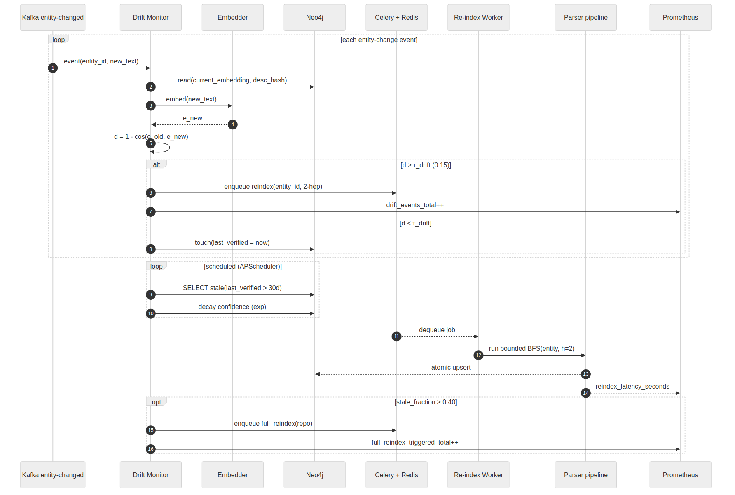
Figure 5 — Drift detection. The full-reindex trigger is intentionally conservative; the expected steady state is selective 2-hop updates.

2.4 Deployment topology
The target deployment is a single Kubernetes namespace (or equivalent Docker Compose stack for the dissertation environment). The training box is on a physically separate VLAN with egress limited to the teacher LLM endpoint; it writes signed model artefacts to the shared object store. Production inference never initiates outbound network connections to any LLM endpoint — this is enforced at the network policy level, not at the application layer.
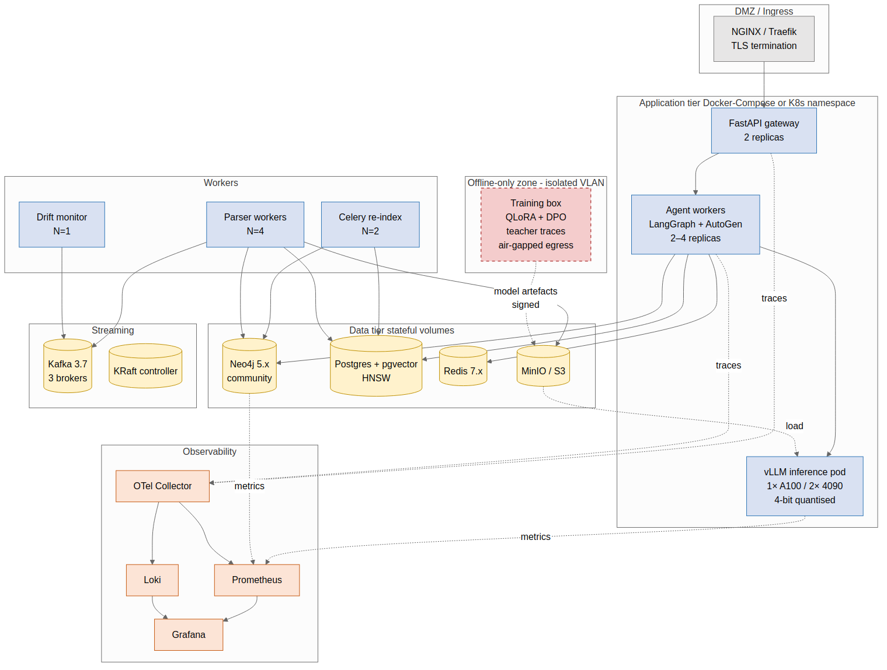
Figure 6 — Deployment topology. The training zone is air-gapped from production at the network layer; model artefacts cross the boundary as signed, versioned files in the object store.

2.5 Key Architecture Decision Records (ADRs)
The following ADRs capture decisions where alternatives exist and the rationale is load-bearing for the design. Each is stated as context + decision + consequences in the style of Nygard's ADR template.

ADR-001 — Use Neo4j Community for the knowledge graph
- Context. The KG must support typed edges, path queries (Dijkstra), BFS to configurable depth, and community detection. Alternatives considered: JanusGraph, Neptune, memgraph, plain Postgres + ltree.
- Decision. Neo4j Community Edition 5.x with Cypher. Runs as a single primary node (Community licence restriction), which is acceptable for the MVP's scope.
- Consequences. No HA in Community Edition — acceptable for a reference implementation. Cypher is the most expressive and widely taught graph query language, which benefits the thesis and future maintainers. Migration to a HA graph DB is documented as a known migration path in §4.5.

ADR-002 — pgvector over a dedicated vector DB
- Context. The RAG path needs approximate nearest-neighbour retrieval with metadata filters (tenant_id, entity_type). Alternatives: Qdrant, Weaviate, Milvus, Chroma.
- Decision. Postgres 16 + pgvector 0.7+ using HNSW index. Qdrant remains a documented fallback if recall or throughput prove insufficient.
- Consequences. One fewer stateful service to operate. Postgres transactional semantics cover both metadata and vectors, simplifying the ingestion atomic-write requirement. Known trade-off: pgvector HNSW build time grows superlinearly past ~10M vectors; acceptable at the dissertation's single-repo scale.

ADR-003 — LangGraph + AutoGen over a single framework
- Context. The system needs stateful conditional agent flow (critic loop, re-retrieval) and the research thesis requires demonstrating cross-framework delegation via A2A.
- Decision. LangGraph for the primary pipeline (best-in-class cycle and state-graph support) and AutoGen for the Reconciliation Agent reached via the A2A bridge (demonstrates heterogeneous-framework interop).
- Consequences. Two framework dependencies, but each serves a distinct purpose and together form the empirical demonstration of the research claim. CrewAI was evaluated and dropped from the original spec because it does not add new evidence.

ADR-004 — Phi-4-mini (3.8B) as the student model
- Context. The student must fit in <6 GB VRAM at 4-bit, tool-call reliably, and run at <1.2 s TTFT on a consumer GPU. Alternatives: Mistral-7B, Llama-3.1-8B, Qwen2.5-7B.
- Decision. Phi-4-mini-4k-instruct. 4-bit QLoRA fits on a single RTX 4090 (~11 GB used including activations at sequence length 4k). Phi-4-mini supersedes Phi-3-mini with grouped-query attention (GQA) and a 200K-token vocabulary, providing superior multilingual tokenisation and logical inference over structured data at identical VRAM cost.
- Consequences. Marginally lower raw capability than 7B class on general tasks; reasoning-trace distillation closes the tool-calling gap. Phi-4-mini's native reasoning mode and expanded vocabulary improve multi-hop code + schema inference. Mistral-7B is retained as an optional ablation only.

ADR-005 — MCP as the sole inter-agent protocol
- Context. Alternatives: bespoke function-call schemas, OpenAI function-calling, LangChain tool signatures.
- Decision. Every tool call, including intra-framework LangGraph calls, goes through an MCP envelope. A2A is the only exception and is used only across framework boundaries.
- Consequences. Uniform audit log; uniform schema validation; any agent can be swapped for another MCP-speaking agent without contract changes. Cost: ~2-5 ms per call for JSON-RPC serialisation — negligible vs. model inference.

ADR-006 — Bounded critic loop (max 2 re-retrievals)
- Context. Unbounded re-retrieval risks tail latency blow-ups and never-terminating queries on pathological inputs.
- Decision. Hard cap of 2 additional retrieval rounds after the first. On exhaustion, return the best draft with an explicit low-faithfulness flag and surface the failing claim spans to the caller.
- Consequences. Bounded worst-case latency (empirically ~3-4× the base query budget). Fail-open behaviour is explicit in the response, which is better for users than silent degradation.

2.6 Quality attributes and SLOs
Quality attribute | Metric | Target (MVP) | Target (stretch)
Query latency | p50 end-to-end answer time (single-hop) | ≤ 3.0 s | ≤ 1.8 s
Query latency | p95 end-to-end (incl. 1 re-retrieve) | ≤ 8.0 s | ≤ 5.0 s
Inference | TTFT on Phi-4-mini (4-bit, RTX 4090) | ≤ 1.2 s | ≤ 0.8 s
Ingestion freshness | Webhook → graph update (p95, typical commit ≤ 20 files) | ≤ 5.0 s | ≤ 2.0 s
Drift detection lag | Commit → stale flag on affected entities | ≤ 60 s | ≤ 30 s
Retrieval recall | Top-10 recall on HotpotQA dev (vector + graph hybrid) | ≥ 0.75 | ≥ 0.82
Tool-call reliability | BFCL F1 for MCP-formatted calls | ≥ 0.82 | ≥ 0.88
Faithfulness | AlignScore on full pipeline outputs | ≥ 0.78 | ≥ 0.85
Availability (reference) | Single-node uptime during eval windows | 99.0% | 99.5%
VRAM footprint | Peak VRAM at 4-bit inference | ≤ 6 GB | ≤ 4 GB

2.7 Consolidated technology decisions
Restated at HLD level with justification that is load-bearing for the architecture rather than the low-level implementation details already present in the spec.
Layer | Choice | Load-bearing reason
Graph DB | Neo4j 5.x | Native Cypher; mature community detection and path algorithms in APOC
Vector store | Postgres + pgvector (HNSW) | Transactional co-location with entity metadata; single-system simplicity
Orchestration | LangGraph 0.2+ | Stateful cycles; explicit conditional routing for the critic loop
A2A target | AutoGen 0.4+ | Idiomatic conversation-centric agent model for the Reconciliation role
Tool protocol | MCP 1.x over JSON-RPC 2.0 | Open standard; uniform audit and schema validation
Cross-framework | A2A v1.0 (Linux Foundation, April 2026) via a2a-sdk | Only open cross-framework agent protocol at time of writing; fallback is a bespoke REST adapter if the spec is withdrawn
Inference | vLLM + 4-bit AWQ | PagedAttention gives best tokens/s at this model size; AWQ quantisation preserves tool-call accuracy better than GPTQ in our pilot runs (to be confirmed)
Parsing | Tree-sitter 0.22+ | Incremental and language-agnostic; zero hallucination on structural extraction
Stream | Kafka 3.7 (KRaft) | No ZooKeeper dependency; single broker sufficient for MVP; easy migration to 3-broker HA
Cache/Queue | Redis 7.x + Redis Streams | Dual role: hot-query cache and async A2A delegation transport
Observability | OpenTelemetry + Prometheus + Grafana + Loki | Industry standard; full trace propagation across MCP/A2A

Part 3 — Low-Level Design

3.1 Canonical data model and schemas
Every agent, worker, and connector in the system speaks a shared vocabulary. The canonical data model is owned by this section; all other sections cite it. Three stores cooperate: Neo4j holds entities and typed relationships, Postgres+pgvector holds chunk text and embeddings, and the object store holds the raw blobs (files, commit snapshots, training artefacts). Redis is cache and queue, not a source of truth.

3.1.1 Neo4j graph schema (Cypher DDL)
The graph schema is shown visually in Figure 7 and encoded below as executable Cypher constraints and indexes. Every node carries a tenant_id for logical tenancy isolation; every relationship carries last_verified for freshness tracking.
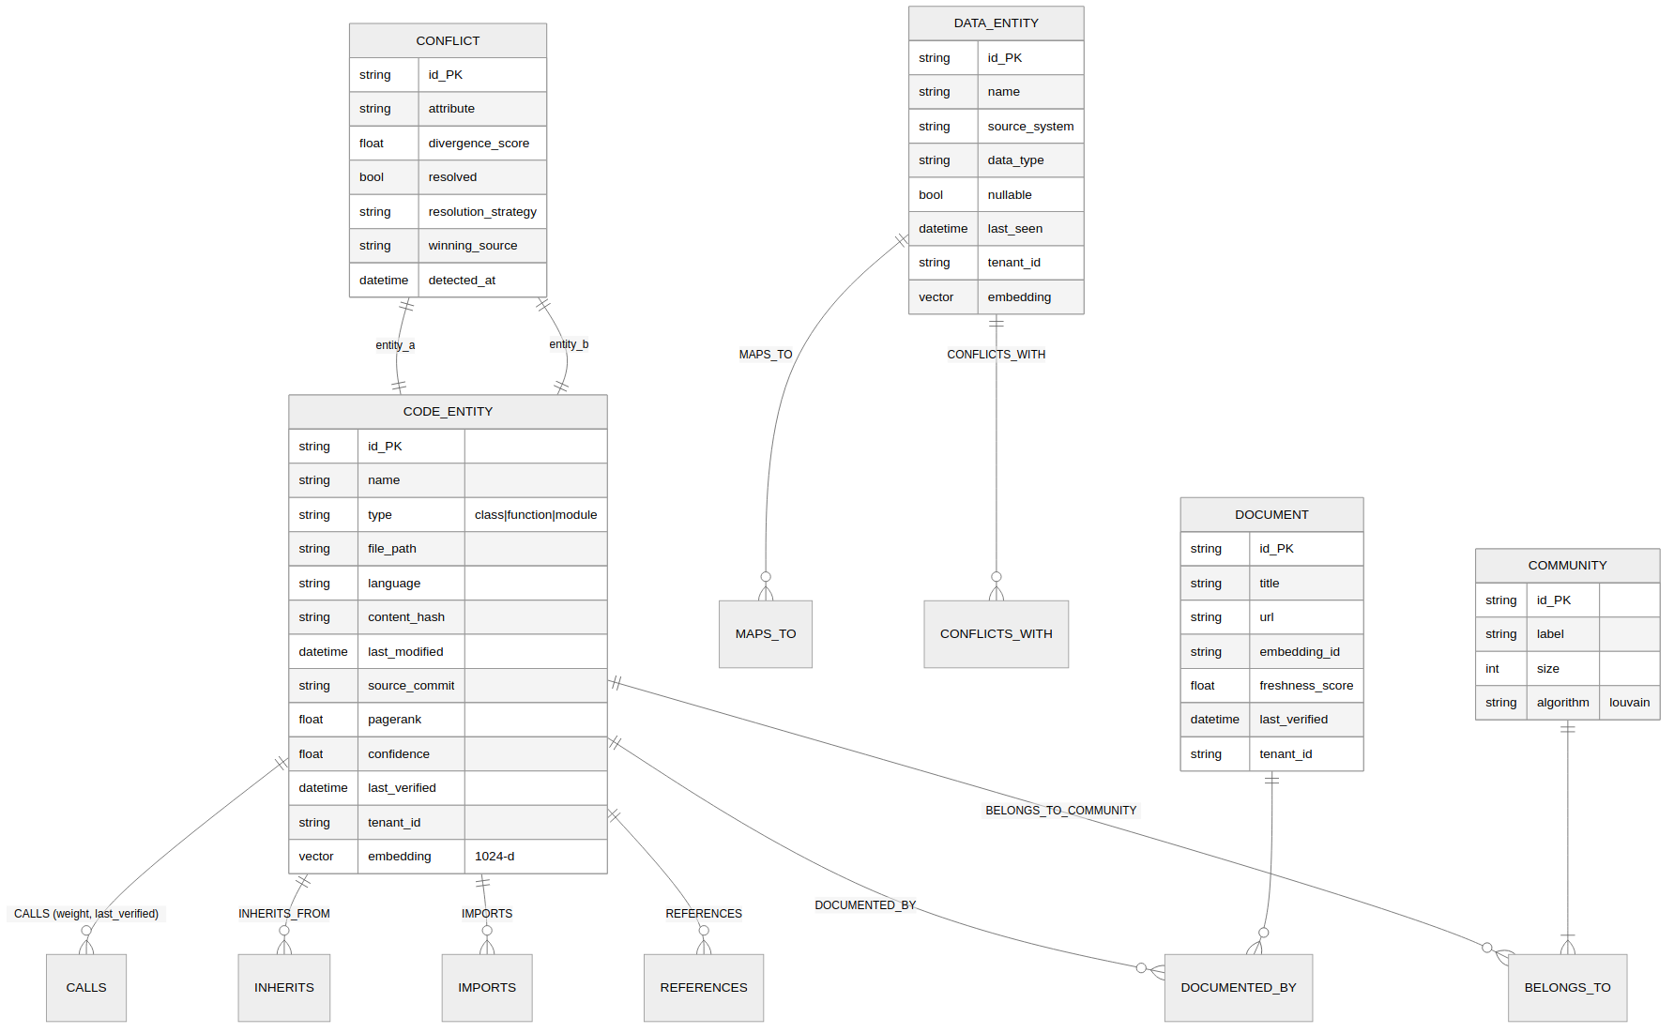
Figure 7 — Knowledge graph schema. Dashed inheritance from a common Entity concept is implementation-level; in Neo4j we use labels (:CodeEntity, :DataEntity) rather than a schema hierarchy.
// Constraints (Neo4j 5.x)
CREATE CONSTRAINT code_entity_id IF NOT EXISTS
FOR (n:CodeEntity) REQUIRE n.id IS UNIQUE;

CREATE CONSTRAINT data_entity_id IF NOT EXISTS
FOR (n:DataEntity) REQUIRE n.id IS UNIQUE;

CREATE CONSTRAINT document_id IF NOT EXISTS
FOR (n:Document) REQUIRE n.id IS UNIQUE;

CREATE CONSTRAINT conflict_id IF NOT EXISTS
FOR (n:Conflict) REQUIRE n.id IS UNIQUE;

// Indexes for hot-path queries
CREATE INDEX code_entity_name_tenant IF NOT EXISTS
FOR (n:CodeEntity) ON (n.name, n.tenant_id);

CREATE INDEX code_entity_file_path IF NOT EXISTS
FOR (n:CodeEntity) ON (n.file_path);

CREATE INDEX code_entity_hash IF NOT EXISTS
FOR (n:CodeEntity) ON (n.content_hash);

CREATE INDEX rel_last_verified IF NOT EXISTS
FOR ()-[r:CALLS]-() ON (r.last_verified);

// Vector index on graph embeddings (optional — primary vector search is in pgvector)
CREATE VECTOR INDEX code_entity_embedding IF NOT EXISTS
FOR (n:CodeEntity) ON n.embedding
OPTIONS { indexConfig: {
`vector.dimensions`: 1024,
`vector.similarity_function`: 'cosine'
}};

// Canonical write pattern (idempotent MERGE on id)
MERGE (n:CodeEntity {id: $id})
ON CREATE SET n += $props, n.created_at = datetime()
ON MATCH SET n += $props, n.last_modified = datetime()
RETURN n;

3.1.2 Postgres + pgvector schema
-- Enable extension
CREATE EXTENSION IF NOT EXISTS vector;

CREATE TABLE chunks (
id UUID PRIMARY KEY DEFAULT gen_random_uuid(),
tenant_id TEXT NOT NULL,
entity_id TEXT NOT NULL, -- FK-by-convention to Neo4j node.id
entity_type TEXT NOT NULL, -- 'code' | 'data' | 'document'
source_path TEXT NOT NULL,
source_commit TEXT, -- git SHA at ingestion time
content TEXT NOT NULL,
content_hash TEXT NOT NULL,
token_count INT NOT NULL,
embedding VECTOR(1024) NOT NULL, -- BGE-M3 dimension
created_at TIMESTAMPTZ NOT NULL DEFAULT now(),
last_verified TIMESTAMPTZ NOT NULL DEFAULT now()
);

-- HNSW index for MIPS
CREATE INDEX chunks_embedding_hnsw ON chunks
USING hnsw (embedding vector_cosine_ops)
WITH (m = 16, ef_construction = 64);

-- Tenant-scoped hot-path filter
CREATE INDEX chunks_tenant_entity ON chunks (tenant_id, entity_id);
CREATE INDEX chunks_content_hash ON chunks (content_hash);

-- Audit log of MCP calls
CREATE TABLE mcp_audit (
id UUID PRIMARY KEY DEFAULT gen_random_uuid(),
correlation_id TEXT NOT NULL,
principal TEXT NOT NULL, -- 'user:<id>' | 'agent:<id>'
tool_name TEXT NOT NULL,
args_redacted JSONB NOT NULL,
result_summary JSONB,
latency_ms INT,
status TEXT NOT NULL, -- 'ok' | 'error' | 'timeout'
error_code TEXT,
started_at TIMESTAMPTZ NOT NULL DEFAULT now()
);
CREATE INDEX mcp_audit_corr ON mcp_audit (correlation_id, started_at);
CREATE INDEX mcp_audit_principal ON mcp_audit (principal, started_at DESC);

3.1.3 MCP message contracts (Pydantic / JSON Schema)
Every MCP tool is defined once as a Pydantic model; the same model generates the JSON Schema advertised to MCP clients and validates incoming requests. This eliminates schema drift between the server advertisement and the server implementation.
# app/mcp/contracts.py
from pydantic import BaseModel, Field
from typing import Literal, Optional

# ---- Envelope ----
class MCPRequest(BaseModel):
jsonrpc: Literal['2.0'] = '2.0'
id: str
method: str
params: dict

class MCPError(BaseModel):
code: int
message: str
data: Optional[dict] = None

class MCPResponse(BaseModel):
jsonrpc: Literal['2.0'] = '2.0'
id: str
result: Optional[dict] = None
error: Optional[MCPError] = None
_metadata: dict = Field(default_factory=dict) # latency, agent_id, trace_id

# ---- Per-tool parameter contracts ----

class VectorSearchParams(BaseModel):
query: str = Field(..., min_length=1, max_length=4000)
k: int = Field(10, ge=1, le=100)
filters: dict = Field(default_factory=dict) # tenant_id, entity_type
rerank: bool = True

class GraphQueryParams(BaseModel):
cypher: str = Field(..., min_length=1, max_length=8000)
params: dict = Field(default_factory=dict)
read_only: bool = True
timeout_ms: int = Field(5000, ge=100, le=30000)

class BFSImpactParams(BaseModel):
entity_id: str
max_hops: int = Field(3, ge=1, le=5)
edge_types: list[str] = Field(default_factory=lambda: ['CALLS', 'REFERENCES'])

class ScoreFaithfulnessParams(BaseModel):
claims: list[str]
evidence: list[str]
threshold: float = Field(0.7, ge=0.0, le=1.0)

class ResolveConflictParams(BaseModel):
conflict_id: str
strategy: Literal['lamport', 'confidence', 'manual'] = 'lamport'

3.2 Pillar 1 — Structural ingestion (LLD)
Prior art note — Graphify. Graphify (graphify.net, open-source, April 2026) is the closest published tool to this pillar. It runs Tree-sitter AST extraction and parallel LLM semantic passes against a local directory and outputs Neo4j Cypher scripts or pushes directly to a running Neo4j instance (‘--neo4j-push bolt://localhost:7687’). It also exposes the graph as an MCP stdio server (‘--mcp’ flag) and uses Leiden community detection with SHA-256 content caching for incremental re-runs. IDRKD’s P1 differs from Graphify in three respects: (1) ingestion is event-driven via Kafka commit webhooks rather than a CLI invocation, enabling continuous-delivery pipelines; (2) SpanBERT NER is applied to API specifications and schema files that Graphify does not handle; (3) the Lamport-vector conflict resolution and dual-layer drift scoring (P6) are tightly coupled to the ingestion write path. Practical recommendation: use Graphify in W1 to bootstrap the Neo4j graph quickly for early integration testing, then replace it with the IDRKD pipeline for the formal evaluation runs. Cite Graphify as a baseline in the related-work section of the thesis.

3.2.1 Component decomposition
Component | Responsibility | Scaling unit
Webhook listener | Receive Git push events; validate HMAC signature; produce commit-event to Kafka | Replicas behind the LB; stateless
Parser worker (Python) | Consume commit-events; fetch diff; invoke Tree-sitter; NER on docstrings/docs; emit (entity, relations) records | Horizontally scaled Kafka consumers; N per topic partition count
Schema inferrer | For schemaless inputs (JSON/CSV): infer field types; cluster similar fields; emit canonical schema entities | Same process as parser worker; cheap per file
Entity normaliser / hasher | Canonicalise entity representation (sort fields, strip whitespace); SHA-256 fingerprint; deduplicate | Cheap; colocated with parser worker
Graph writer | Atomic MERGE into Neo4j; UPSERT into pgvector; write blob to object store; all within a correlated transaction (see §3.2.4) | Parallelised by entity id hash; bounded to avoid contention on Neo4j primary

3.2.2 Sequence

Figure 8 — Ingestion sequence (reproduced). The idempotent skip on matched fingerprint avoids unnecessary downstream drift events.

3.2.3 Key algorithms (pseudocode)

Entity extraction for code
def extract_entities_code(file_path: str, content: str, language: str) -> list[Entity]:
"""
Tree-sitter → AST → Entity records.
Invariant: pure function of (content, language). Same input → same output
(critical for the hash-based idempotency downstream).
"""
parser = tree_sitter.Parser()
parser.set_language(LANGS[language])
tree = parser.parse(content.encode())
entities = []
cursor = tree.walk()

def visit(node, parent_id=None):
kind = NODE_KIND_MAP.get(node.type)
if kind in ('class', 'function', 'method'):
e = Entity(
id=stable_id(file_path, node.start_byte, node.end_byte, kind),
kind=kind,
name=extract_name(node),
file_path=file_path,
language=language,
start_line=node.start_point[0] + 1,
end_line=node.end_point[0] + 1,
source_text=content[node.start_byte:node.end_byte],
docstring=extract_docstring(node),
parent_id=parent_id,
)
entities.append(e)
parent_id = e.id
for child in node.children:
visit(child, parent_id)

visit(tree.root_node)
# Relations (CALLS, IMPORTS, INHERITS) extracted in a second pass
# over the same tree with reference-resolution against the entity list.
return entities

Entity fingerprinting and idempotency
def canonical_form(e: Entity) -> bytes:
"""Deterministic serialisation used for fingerprinting.
Any field that is not semantically part of the entity (timestamps,
commit hash, retrieval metadata) MUST NOT appear here."""
return json.dumps({
"kind": e.kind,
"name": e.name,
"file_path": e.file_path, # path is part of identity
"language": e.language,
"signature": e.signature, # function/class signature
"docstring": e.docstring.strip() if e.docstring else None,
"source_text": normalise_whitespace(e.source_text),
}, sort_keys=True).encode()

def fingerprint(e: Entity) -> str:
return hashlib.sha256(canonical_form(e)).hexdigest()

def upsert_if_changed(e: Entity, tx) -> UpsertResult:
existing = tx.run(
"MATCH (n:CodeEntity {id: $id}) RETURN n.content_hash AS h", id=e.id
).single()
new_hash = fingerprint(e)
if existing and existing["h"] == new_hash:
return UpsertResult(SKIPPED, e.id)
tx.run("""MERGE (n:CodeEntity {id: $id})
SET n += $props""",
id=e.id, props={**asdict(e), "content_hash": new_hash})
return UpsertResult(WRITTEN, e.id)

Attribute conflict scoring
def attribute_divergence(a: Entity, b: Entity) -> float:
"""
Weighted divergence score for two entity variants believed to refer
to the same real-world thing (e.g., customer_id in two source systems).
Score in [0, 1]; > 0.3 triggers a Conflict node for the Reconciliation
Agent.
"""
score = 0.0
# structural attributes — edit distance
score += 0.4 * lev_norm(a.data_type or '', b.data_type or '')
score += 0.2 * (a.nullable != b.nullable)
# semantic — embedding distance of descriptions
if a.description and b.description:
score += 0.4 * (1 - cosine(embed(a.description), embed(b.description)))
return min(1.0, score)

3.2.4 Transactional model
Ingestion writes span three stores (Neo4j, Postgres, object store). True distributed transactions are not supported across these; we use a documented "logical transaction" pattern:
- Write the raw blob to the object store first (idempotent by content hash); this is side-effect-free to readers.
- Begin a Postgres transaction; UPSERT chunk rows with embeddings; do not commit.
- Open a Neo4j transaction; MERGE nodes and relationships with the new content_hash.
- Commit Neo4j first (it is the authoritative identity store), then Postgres.
- If Postgres commit fails after Neo4j commit, emit a repair event on a dead-letter topic; the repair worker is guaranteed to succeed on retry because the operation is idempotent.
Why not 2PC
Two-phase commit across Neo4j and Postgres is possible via XA but adds operational overhead and latency. Because every write is content-addressed (idempotent on entity id and fingerprint), a crash between commits is recoverable by replaying from the commit-event log. The dead-letter queue is the failure mode of record; it is monitored and alertable.

3.2.5 Error handling and retries
Failure | Detection | Response
Kafka produce failure at webhook | HTTP 5xx to Git | Git retries webhook per its own policy; we return 503 and log
Tree-sitter parse error (syntax error) | Tree-sitter returns tree with ERROR nodes | Emit a WARN; skip entities under ERROR nodes; continue with the rest of the file
Neo4j transient deadlock | TransientException from driver | Exponential backoff: 50 ms → 200 ms → 800 ms, max 3 attempts; then DLQ
Postgres UPSERT failure after Neo4j commit | Exception from asyncpg | Emit repair event; monitor DLQ lag; alert if depth > 100
Object-store put failure | MinIO/S3 5xx | Retry 3× with backoff; if still failing, fail the ingestion (object store is a hard dependency)
Entity collision across repos (same canonical id) | Unique-constraint violation | Prepend tenant_id and repo hash to id generation; log for schema review

3.3 Pillar 2 — Knowledge graph (LLD)

3.3.1 Write patterns
All graph writes go through a small set of parameterised Cypher fragments. These are the only way the graph is mutated; ad-hoc writes are blocked at the MCP gateway.
// Upsert a CodeEntity
MERGE (n:CodeEntity {id: $id})
ON CREATE SET n += $props, n.created_at = datetime(),
n.confidence = 1.0, n.pagerank = 0.0
ON MATCH SET n += $props, n.last_modified = datetime()
RETURN n;

// Create/refresh a CALLS relationship with drift-aware properties
MATCH (a:CodeEntity {id: $src}), (b:CodeEntity {id: $dst})
MERGE (a)-[r:CALLS]->(b)
ON CREATE SET r.created_at = datetime(),
r.weight = $weight,
r.source_commit = $commit
ON MATCH SET r.weight = $weight,
r.last_verified = datetime(),
r.source_commit = $commit
RETURN r;

// Atomically mark a set of entities stale (drift monitor trigger)
UNWIND $ids AS id
MATCH (n:CodeEntity {id: id})
SET n.stale = true, n.staled_at = datetime();

3.3.2 Read patterns used by the Graph Traversal Agent
// Impact analysis: all callers within 3 hops
MATCH (target:CodeEntity {name: $name, tenant_id: $tenant})
MATCH p = (caller:CodeEntity)-[:CALLS*1..3]->(target)
WITH target, caller, length(p) AS depth
RETURN caller.id AS id, caller.name AS name,
caller.file_path AS path, depth
ORDER BY depth, caller.pagerank DESC
LIMIT 50;

// Shortest call path between two entities (request-flow tracing)
MATCH (src:CodeEntity {name: $from}), (dst:CodeEntity {name: $to})
MATCH p = shortestPath((src)-[:CALLS|REFERENCES*..8]->(dst))
RETURN [n IN nodes(p) | n.name] AS path, length(p) AS hops;

// Scope to community (Louvain-derived)
MATCH (n:CodeEntity {id: $id})-[:BELONGS_TO]->(c:Community)
MATCH (m:CodeEntity)-[:BELONGS_TO]->(c)
RETURN m.id, m.name, m.pagerank
ORDER BY m.pagerank DESC
LIMIT 100;

3.3.3 Offline graph analytics (batch jobs)
PageRank and Louvain are expensive; they run nightly as offline jobs rather than on every ingest. Results are written back as node properties so read paths pay no algorithmic cost.
# jobs/graph_analytics.py (scheduled via APScheduler nightly)
from neo4j import GraphDatabase
from graphdatascience import GraphDataScience

def run_nightly_analytics(driver, tenant_id: str):
gds = GraphDataScience.from_neo4j_driver(driver)

# project a read-only in-memory graph scoped by tenant
g, _ = gds.graph.project.cypher(
graph_name=f"pr-{tenant_id}",
node_query=f"MATCH (n:CodeEntity {{tenant_id:'{tenant_id}'}}) "
"RETURN id(n) AS id",
relationship_query=f"MATCH (a:CodeEntity {{tenant_id:'{tenant_id}'}})"
"-[r:CALLS|REFERENCES]->(b:CodeEntity) "
"RETURN id(a) AS source, id(b) AS target, "
"coalesce(r.weight, 1.0) AS weight",
)
# PageRank
gds.pageRank.write(g, writeProperty="pagerank", dampingFactor=0.85,
relationshipWeightProperty="weight")
# Louvain → community id
gds.louvain.write(g, writeProperty="community_id",
relationshipWeightProperty="weight")
gds.graph.drop(g)
# Write Community nodes
with driver.session() as s:
s.run("""
MATCH (n:CodeEntity {tenant_id: $t})
WITH n.community_id AS cid, collect(n) AS members, count(n) AS size
MERGE (c:Community {id: toString(cid), tenant_id: $t})
SET c.size = size, c.algorithm = 'louvain',
c.computed_at = datetime()
WITH c, members
UNWIND members AS m
MERGE (m)-[:BELONGS_TO]->(c)
""", t=tenant_id)

3.3.4 Temporal conflict resolution
When two sources report conflicting attribute values for the same entity, the Reconciliation Agent requests a deterministic resolution. The default strategy is Lamport-vector comparison: each source carries a logical clock, and the higher clock wins; ties are broken by source priority (a static config per deployment). Confidence-weighted resolution is an alternative strategy selectable per conflict.
def resolve_conflict(a: EntityVersion, b: EntityVersion,
strategy: Strategy = 'lamport') -> Resolution:
if strategy == 'lamport':
if a.clock.happens_after(b.clock):
return Resolution(winner=a, loser=b, reason='lamport:happens-after')
if b.clock.happens_after(a.clock):
return Resolution(winner=b, loser=a, reason='lamport:happens-after')
# concurrent
winner, loser = (a, b) if SOURCE_PRIORITY[a.source] >= \
SOURCE_PRIORITY[b.source] else (b, a)
return Resolution(winner, loser, reason='concurrent:source-priority')
if strategy == 'confidence':
return Resolution(*sorted([a, b], key=lambda x: -x.confidence),
reason='confidence')
raise ValueError(f"unknown strategy: {strategy}")

3.4 Pillar 3 — Agentic RAG pipeline (LLD)

3.4.1 LangGraph state machine
The orchestration is modelled as a LangGraph state graph. The state is a typed dict that accumulates evidence and answers across nodes; conditional edges implement classification routing and the bounded critic loop.
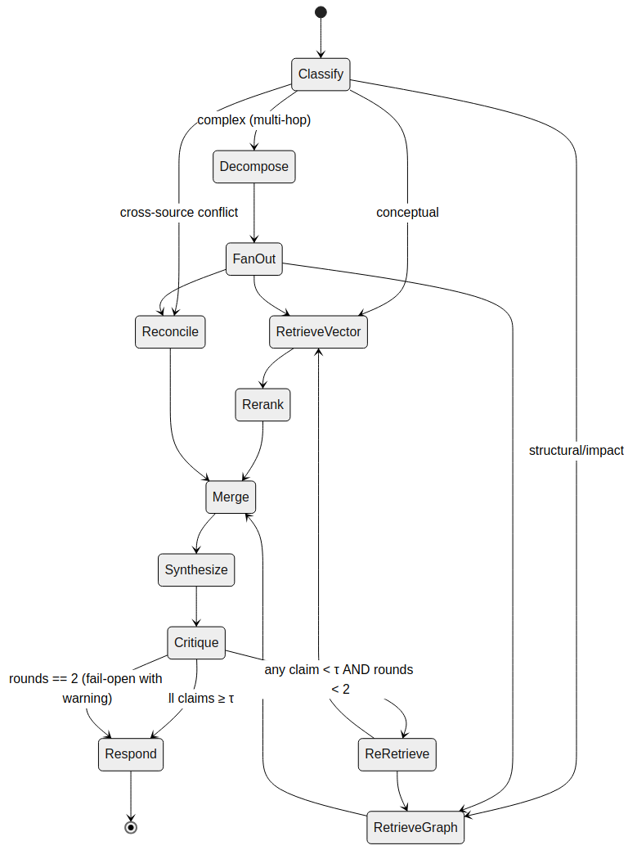
Figure 9 — LangGraph state machine for query resolution. The ReRetrieve node fans back to retrieval at most twice; on exhaustion the pipeline fail-opens to Respond with a warning.
# app/agents/graph.py
from typing import TypedDict, Literal, Annotated
from operator import add
from langgraph.graph import StateGraph, END

class QueryState(TypedDict):
query: str
tenant_id: str
query_type: Literal['conceptual','structural','impact','multi-hop']
sub_queries: list[str]
vector_ctx: Annotated[list[dict], add] # accumulates across rounds
graph_ctx: Annotated[list[dict], add]
draft: str
claims: list[str]
faithfulness: list[float]
rounds: int # re-retrieve counter
trace_id: str

def build_graph():
g = StateGraph(QueryState)
g.add_node('classify', classify_node)
g.add_node('decompose', decompose_node)
g.add_node('retrieve_vec', retrieve_vec_node)
g.add_node('retrieve_graph', retrieve_graph_node)
g.add_node('reconcile', reconcile_node) # A2A delegation
g.add_node('merge', merge_node)
g.add_node('synthesize', synthesize_node)
g.add_node('critique', critique_node)
g.add_node('respond', respond_node)

g.set_entry_point('classify')
g.add_conditional_edges('classify', route_by_type, {
'conceptual': 'retrieve_vec',
'structural': 'retrieve_graph',
'impact': 'retrieve_graph',
'multi-hop': 'decompose',
'conflict': 'reconcile',
})
g.add_edge('decompose', 'retrieve_vec')
g.add_edge('decompose', 'retrieve_graph')
g.add_edge('retrieve_vec', 'merge')
g.add_edge('retrieve_graph', 'merge')
g.add_edge('reconcile', 'merge')
g.add_edge('merge', 'synthesize')
g.add_edge('synthesize', 'critique')
g.add_conditional_edges('critique', decide_after_critique, {
'accept': 'respond',
'reretrieve': 'retrieve_vec', # loops back
'give_up': 'respond', # bounded
})
g.add_edge('respond', END)
return g.compile()

def decide_after_critique(state: QueryState) -> Literal['accept','reretrieve','give_up']:
min_score = min(state['faithfulness'])
if min_score >= 0.7:
return 'accept'
if state['rounds'] >= 2:
return 'give_up'
return 'reretrieve'

3.4.2 Planner: classification prompt and routing
The Planner uses a small prompted classifier rather than a fine-tuned head. The prompt is deterministic and short; it returns a JSON object that is validated against a Pydantic model. Classification errors fall back to the conceptual path, which is the most forgiving.
CLASSIFY_PROMPT = """Classify the query into exactly one type.

Return JSON ONLY: {"type": "<conceptual|structural|impact|multi-hop|conflict>",
"entities": [<string>, ...]}

Rules:
- "conceptual" — asks WHAT something does/is, no relationships
- "structural" — asks direct relationship (what calls X, what X depends on)
- "impact" — asks consequences of change (what breaks if X changes)
- "multi-hop" — requires chaining 2+ relationships
- "conflict" — asks to reconcile contradictory sources

Query: {query}"""

async def classify_node(state: QueryState) -> QueryState:
resp = await slm.generate(CLASSIFY_PROMPT.format(query=state['query']),
max_tokens=120, temperature=0.0)
try:
parsed = ClassifyResult.model_validate_json(extract_json(resp))
except ValidationError:
parsed = ClassifyResult(type='conceptual', entities=[])
return {**state, 'query_type': parsed.type}

3.4.3 Hybrid retrieval: vector + graph fusion
Hybrid retrieval runs vector and graph retrievals in parallel (where both are relevant) and fuses the results with Reciprocal Rank Fusion before cross-encoder reranking. RRF is used over learned fusion because it requires no training data and is robust to score-scale mismatches between the two retrievers.
def reciprocal_rank_fusion(rankings: list[list[str]], k: int = 60) -> list[tuple[str,float]]:
"""Fuse multiple ranked lists. Returns (doc_id, rrf_score) sorted desc."""
scores = {}
for ranking in rankings:
for rank, doc_id in enumerate(ranking):
scores[doc_id] = scores.get(doc_id, 0.0) + 1.0 / (k + rank + 1)
return sorted(scores.items(), key=lambda x: -x[1])

async def hybrid_retrieve(q: str, tenant: str, k_each: int = 20) -> list[Evidence]:
vec_task = asyncio.create_task(vector_search(q, tenant, k=k_each))
graph_task = asyncio.create_task(graph_search(q, tenant, k=k_each))
vec, graph = await asyncio.gather(vec_task, graph_task)

fused = reciprocal_rank_fusion([
[c.id for c in vec],
[c.id for c in graph],
])
cand_map = {c.id: c for c in vec + graph}
top = [cand_map[i] for i, _ in fused[:40]]

# cross-encoder rerank
pairs = [(q, c.text) for c in top]
scores = await reranker.score(pairs) # ms-marco MiniLM
for c, s in zip(top, scores):
c.rerank_score = s
return sorted(top, key=lambda c: -c.rerank_score)[:10]

3.4.4 Critic — NLI-based faithfulness
The Critic decomposes the draft answer into claims (sentence-level by default) and runs each claim through a DeBERTa-v3 NLI model against the concatenated retrieved evidence. Claims that do not reach the entailment threshold τ_nli = 0.7 mark the draft as low-faithfulness and trigger re-retrieval targeting the unsupported claim spans.
async def critique_node(state: QueryState) -> QueryState:
claims = split_into_claims(state['draft']) # sentence segmenter
evidence = '\n'.join(e.text for e in state['vector_ctx'] + state['graph_ctx'])
scores = await nli.score_batch(
premises=[evidence] * len(claims),
hypotheses=claims,
) # [0..1] entailment probability
return {**state,
'claims': claims,
'faithfulness': scores,
'rounds': state['rounds'] + (0 if state['rounds'] == 0 else 1)}

# On re-retrieve, we target the failing claim specifically rather than re-running
# the original query. This is the mechanism that makes the critic loop useful.
def build_targeted_subquery(claim: str, original: str) -> str:
return f"Evidence for the following claim in the context of '{original}': {claim}"

3.4.5 Reranker selection and latency budget
Stage | Model | Latency target (p95) | Notes
Bi-encoder (query embed) | BGE-M3 (1024-d) | ≤ 40 ms | Batch of 1; pre-warmed
ANN retrieval | pgvector HNSW | ≤ 60 ms at k=20 | ef_search tuned to 64
Cross-encoder rerank | ms-marco-MiniLM-L-6-v2 | ≤ 180 ms at 40 pairs | GPU-accelerated; fp16
Graph query (1-hop) | Neo4j Cypher | ≤ 40 ms | Index-backed; hot
Graph BFS (≤3 hops) | Neo4j / APOC | ≤ 300 ms | Bounded; cached in Redis
NLI claim scoring | DeBERTa-v3-large-mnli | ≤ 250 ms at 10 claims | fp16; batched
Synthesis (SLM) | Phi-4-mini, 4-bit | ≤ 1.8 s (400 tok) | vLLM; PagedAttention

3.5 Pillar 4 — MCP + A2A orchestration (LLD)

3.5.1 MCP server structure (FastAPI)
The MCP server is a thin FastAPI application that exposes the JSON-RPC endpoints and dispatches to the concrete tool implementations. Every tool is registered through a decorator that handles schema advertisement, input validation, audit logging, and tracing uniformly. Any new tool gets these cross-cutting concerns for free.
# app/mcp/server.py
from fastapi import FastAPI, Request
from pydantic import BaseModel
from typing import Callable, Any
from contextvars import ContextVar
import time, uuid, structlog

app = FastAPI()
log = structlog.get_logger()
correlation_id: ContextVar[str] = ContextVar('correlation_id')

TOOLS: dict[str, dict] = {} # name -> {fn, params_model, description}

def mcp_tool(name: str, params_model: type[BaseModel], description: str):
"""Decorator to register an MCP tool with uniform concerns."""
def decorator(fn: Callable[..., Any]):
TOOLS[name] = dict(fn=fn, params_model=params_model, description=description)
return fn
return decorator

@app.post('/mcp')
async def mcp_endpoint(req: MCPRequest, request: Request) -> MCPResponse:
cid = request.headers.get('x-correlation-id', str(uuid.uuid4()))
correlation_id.set(cid)
started = time.perf_counter()

tool = TOOLS.get(req.method)
if not tool:
return MCPResponse(id=req.id, error=MCPError(code=-32601,
message=f"method '{req.method}' not found"))

try:
params = tool['params_model'].model_validate(req.params)
except ValidationError as e:
return MCPResponse(id=req.id, error=MCPError(code=-32602,
message='invalid params', data={'errors': e.errors()}))

try:
result = await tool['fn'](params)
status = 'ok'
except ToolTimeout as e:
result = None
status = 'timeout'
err = MCPError(code=-32001, message=str(e))
except Exception as e:
log.exception('tool_error', tool=req.method, cid=cid)
return MCPResponse(id=req.id, error=MCPError(code=-32000,
message='internal error'))
finally:
latency_ms = int((time.perf_counter() - started) * 1000)
await audit_log(cid, req.method, params.model_dump(exclude={'query'}),
status, latency_ms)

return MCPResponse(id=req.id, result=result,
_metadata={'latency_ms': latency_ms,
'correlation_id': cid})

@app.get('/mcp/tools')
async def list_tools():
"""Advertises JSON Schema for every registered tool."""
return {name: {'description': t['description'],
'input_schema': t['params_model'].model_json_schema()}
for name, t in TOOLS.items()}

# --- concrete tool: vector_search ---
@mcp_tool('vector_search', VectorSearchParams,
'Semantic retrieval from the vector store with optional reranking.')
async def vector_search(p: VectorSearchParams) -> dict:
emb = await embed_query(p.query)
candidates = await pgvector.knn(emb, k=p.k, filters=p.filters)
if p.rerank:
candidates = await reranker.rerank(p.query, candidates)
return {'candidates': [c.to_dict() for c in candidates]}

3.5.2 MCP tool catalogue (initial)
Each tool has a stable name, a Pydantic param model (single source of truth for JSON Schema), and documented error codes.
Tool name | Owner agent | Purpose | Key errors
vector_search | Vector Retrieval Agent | MIPS retrieval over pgvector + optional cross-encoder rerank | invalid_params (-32602), tenant_not_found (-32010)
graph_query | Graph Traversal Agent | Read-only Cypher with parameterised input; timeout-enforced | cypher_forbidden (-32011), timeout (-32001)
bfs_impact | Graph Traversal Agent | BFS over CALLS/REFERENCES edges up to N hops | entity_not_found (-32012), hop_limit_exceeded (-32013)
path_trace | Graph Traversal Agent | Shortest weighted path between entities | no_path_found (-32014)
community_scope | Graph Traversal Agent | Fetch members of the Louvain community containing an entity | community_unavailable (-32015)
embed_query | Vector Retrieval Agent | Produce BGE-M3 embedding for a query string | model_unavailable (-32020)
rerank_candidates | Vector Retrieval Agent | Cross-encoder reranking for a list of (query, passage) pairs | model_unavailable (-32020)
decompose_query | Planner | Break a multi-hop query into atomic sub-queries | classification_failed (-32030)
score_faithfulness | Critic | NLI entailment score per claim against evidence | model_unavailable (-32020)
flag_claims | Critic | Mark specific claim spans as low-confidence for re-retrieve | (none; pure)
generate_response | Synthesis | Grounded generation via the local SLM | slm_overloaded (-32040), context_too_long (-32041)
trigger_reindex | Drift Monitor | Enqueue a selective 2-hop re-index for the given entity | queue_full (-32050)
detect_conflicts | Reconciliation (A2A) | Identify conflict nodes for a given entity or pair | unauthorised (-32003)
resolve_conflict | Reconciliation (A2A) | Apply a resolution strategy and write audit record | resolution_ambiguous (-32060)

3.5.3 A2A bridge to AutoGen
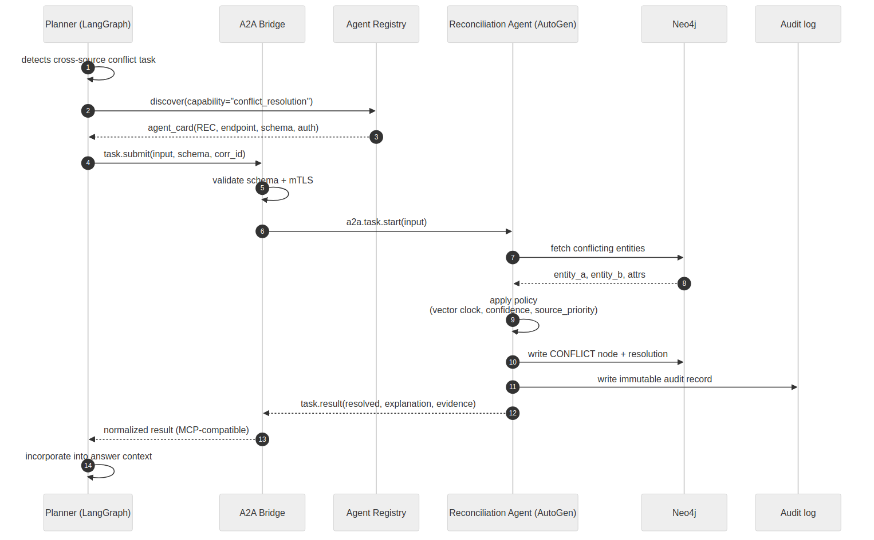
Figure 10 — A2A delegation from Planner (LangGraph) to the Reconciliation Agent (AutoGen). The bridge is the only code path that crosses the framework boundary.
# app/a2a/bridge.py
"""
A2A bridge: normalises LangGraph task specs to AutoGen-native inputs,
and the reverse for results. The bridge is the only component allowed
to talk to the foreign-framework endpoint. It enforces:
- mTLS for cross-process calls
- schema validation against the A2A capability advertisement
- timeout and circuit-breaker
"""
from a2a.client import A2AClient, AgentCard # a2a-sdk v1.0 (pip install a2a-sdk)
from tenacity import retry, stop_after_attempt, wait_exponential_jitter

class A2ABridge:
def __init__(self, registry: AgentRegistry, client: A2AClient):
self.registry = registry
self.client = client

@retry(stop=stop_after_attempt(3),
wait=wait_exponential_jitter(initial=0.2, max=2.0))
async def delegate(self, capability: str, input: dict,
corr_id: str, timeout: float = 30.0) -> dict:
agent = await self.registry.resolve(capability)
# validate input against the agent's advertised schema
validate_against_schema(input, agent.input_schema)
payload = {
'task_id': str(uuid.uuid4()),
'correlation_id': corr_id,
'capability': capability,
'input': input,
}
r = await self.client.post(agent.endpoint, json=payload,
timeout=timeout,
headers={'x-corr-id': corr_id})
r.raise_for_status()
body = r.json()
# normalise to MCP-compatible shape
return {
'result': body['output'],
'evidence': body.get('evidence', []),
'audit_ref': body.get('audit_ref'),
}

3.5.4 AutoGen Reconciliation Agent
# app/agents/reconciliation.py
import autogen

RECON_SYSTEM = """You are the Reconciliation Agent. For a conflict between two
entity versions, pick the correct one using the provided policy. Return JSON:
{ "winner_id": str, "loser_id": str, "reason": str, "confidence": float }
Never invent attributes not present in the input."""

def build_reconciliation_agent(slm_config: dict):
agent = autogen.AssistantAgent(
name='reconciliation',
system_message=RECON_SYSTEM,
llm_config={'config_list': [slm_config], 'temperature': 0.0},
)
# Tools the agent can call (each is MCP-exposed externally, local here)
agent.register_for_llm(detect_conflicts, name='detect_conflicts')
agent.register_for_llm(resolve_conflict, name='resolve_conflict')
agent.register_for_llm(write_audit, name='write_audit')
return agent

3.5.5 Cross-agent auth and tenancy
Every MCP call carries a JWT in the x-auth header signed by the gateway. The token carries principal (user or agent id), tenant_id, and the set of permitted tool scopes. The MCP server refuses any tool call whose tool name is not in the token scope set, even if the tool is registered — this is what prevents a compromised or misbehaving agent from escalating across tool boundaries. Tenancy is enforced at every storage call: Cypher queries are auto-augmented with a tenant_id predicate, and pgvector filters always include tenant_id in the WHERE clause.

3.6 Pillar 5 — SLM distillation (LLD)

3.6.1 Distillation pipeline overview
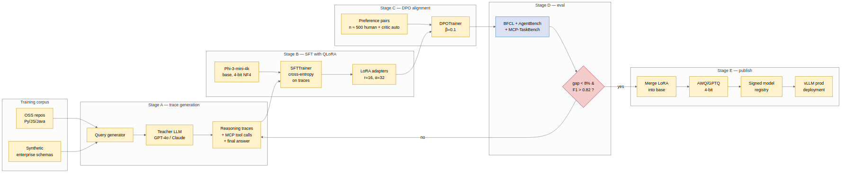
Figure 11 — Distillation pipeline: trace generation → SFT with QLoRA → DPO alignment → gated evaluation → quantisation and publication.

3.6.2 Training data generation
Training examples come from two sources: real OSS repositories (Python + JavaScript) and synthetic enterprise-schema scenarios. For each query in the training set, the teacher model is prompted to produce a complete reasoning trace containing the classification decision, the sequence of MCP tool calls it would make, and the final grounded answer. These traces become the supervision signal. Trace validity is enforced by re-executing each tool call against the live system — if a Cypher query in the trace fails or a vector_search returns empty, the trace is discarded.
# training/generate_traces.py
from pathlib import Path
import json, asyncio

TEACHER_MODEL = 'gpt-4o-2024-11-20' # or 'claude-sonnet-4-5'
MAX_EXAMPLES = 8000 # MVP budget

TRACE_PROMPT = """You are planning how to answer the query using MCP tools.
Produce a trace in the following JSON format:
{
"classification": { "type": ..., "entities": [...] },
"tool_calls": [
{ "tool": "<tool-name>", "params": {...}, "why": "<reason>" },
...
],
"synthesis": { "answer": "...", "cited_chunks": [<id>, ...] }
}
Rules:
- Every claim in "answer" must be grounded in at least one cited_chunk.
- Never invent tool names outside this list: {tool_list}.
- Keep tool_calls minimal — prefer 1-2 calls for single-hop, 3-5 for multi-hop.
Query: {query}"""

async def gen_trace(query: str, ctx: ExecutionContext) -> dict | None:
raw = await teacher.complete(TRACE_PROMPT.format(
tool_list=list(TOOL_CATALOGUE), query=query), temperature=0.2)
try:
trace = json.loads(extract_json(raw))
except Exception:
return None
# re-execute to validate
for call in trace['tool_calls']:
result = await ctx.invoke_mcp(call['tool'], call['params'])
if result.get('error'):
return None
call['observed_result_summary'] = summarise(result['result'])
return trace

async def build_dataset(queries: list[str], out_path: Path):
sem = asyncio.Semaphore(8) # rate-limit teacher API
async def one(q):
async with sem:
t = await gen_trace(q, exec_ctx)
return (q, t)
traces = [(q, t) for q, t in await asyncio.gather(*[one(q) for q in queries]) if t]
out_path.write_text('\n'.join(json.dumps({'q': q, 'trace': t}) for q, t in traces))

3.6.3 QLoRA configuration
# training/sft_qlora.py
from peft import LoraConfig, prepare_model_for_kbit_training
from transformers import AutoModelForCausalLM, AutoTokenizer, BitsAndBytesConfig
from trl import SFTTrainer, SFTConfig

BASE_MODEL = 'microsoft/Phi-4-mini-4k-instruct'

bnb = BitsAndBytesConfig(
load_in_4bit=True,
bnb_4bit_quant_type='nf4',
bnb_4bit_use_double_quant=True,
bnb_4bit_compute_dtype='bfloat16',
)

tok = AutoTokenizer.from_pretrained(BASE_MODEL, use_fast=True)
tok.pad_token = tok.eos_token

model = AutoModelForCausalLM.from_pretrained(
BASE_MODEL, quantization_config=bnb,
device_map={'': 0}, attn_implementation='flash_attention_2',
torch_dtype='bfloat16',
)
model = prepare_model_for_kbit_training(model, use_gradient_checkpointing=True)

lora = LoraConfig(
r=16, lora_alpha=32, lora_dropout=0.05,
bias='none', task_type='CAUSAL_LM',
target_modules=['q_proj','k_proj','v_proj','o_proj',
'gate_proj','up_proj','down_proj'],
)

sft_cfg = SFTConfig(
output_dir='./ckpts/phi3-mcp-sft',
num_train_epochs=2,
per_device_train_batch_size=4,
gradient_accumulation_steps=8, # effective batch = 32
learning_rate=2e-4,
warmup_ratio=0.03,
lr_scheduler_type='cosine',
max_seq_length=3584,
bf16=True, optim='paged_adamw_8bit',
logging_steps=10, save_steps=500,
report_to=['wandb'],
dataset_kwargs={'add_special_tokens': False},
)

trainer = SFTTrainer(
model=model, tokenizer=tok, peft_config=lora,
args=sft_cfg,
train_dataset=ds_train, eval_dataset=ds_eval,
formatting_func=format_trace_example, # packs query+trace+answer
)
trainer.train()
trainer.save_model('./ckpts/phi3-mcp-sft/final')

3.6.4 DPO alignment pass
# training/dpo.py
from trl import DPOTrainer, DPOConfig

# Preference pairs are produced two ways:
# 1. Critic Agent auto-labels low-faithfulness drafts as "rejected"
# against a re-retrieved "chosen" draft on the same query.
# 2. ~200 pairs hand-labelled by the researcher for edge cases.

dpo_cfg = DPOConfig(
output_dir='./ckpts/phi3-mcp-dpo',
num_train_epochs=1,
per_device_train_batch_size=2,
gradient_accumulation_steps=16,
learning_rate=5e-6,
beta=0.1, # DPO temperature
max_length=3584, max_prompt_length=2048,
bf16=True, loss_type='sigmoid',
report_to=['wandb'],
)

dpo = DPOTrainer(
model=sft_model, # LoRA-merged SFT checkpoint
ref_model=None, # implicit ref via LoRA disable
args=dpo_cfg,
train_dataset=preference_pairs,
tokenizer=tok,
peft_config=lora,
)
dpo.train()

3.6.5 Quantisation and publication
- Merge LoRA adapters into the base model weights (full bf16 checkpoint).
- Quantise to 4-bit using AWQ with a small calibration set drawn from the SFT training distribution (~128 samples). AWQ is preferred over GPTQ in our pilot because tool-call F1 drops less (~1 point vs ~3 points) under AWQ.
- Sign the resulting quantised checkpoint with cosign; publish to the signed model registry; vLLM loads from the registry only after signature verification.
- Run the full evaluation suite on the signed artefact; if any gating metric regresses vs the SFT checkpoint by more than 3 points, block publication and investigate.

3.6.6 Evaluation harness (offline)
Gate | Metric | Threshold | Action if failed
G1 | BFCL function-call F1 | ≥ 0.82 | Re-run SFT with 2× trace data
G2 | MCP-TaskBench aggregate score | ≥ 0.70 | Inspect per-category scores; data-augment weakest
G3 | AlignScore on pipeline outputs | ≥ 0.78 | Retune critic threshold; re-run DPO pass
G4 | AgentBench task-completion rate | teacher − 8% | Publishable null; release model but flag gap
G5 | Hallucination rate (FELM) | ≤ 0.12 | Add NLI-weighted loss to next SFT iteration
G6 | TTFT on RTX 4090 (4-bit) | ≤ 1.2 s | Investigate quantisation config; try GPTQ
G7 | VRAM footprint | ≤ 6 GB | Re-quantise or reduce KV-cache budget

3.6.7 Inference server (vLLM)
# deploy/vllm.yaml (docker-compose fragment)
vllm:
image: vllm/vllm-openai:latest
ipc: host
deploy:
resources: { reservations: { devices: [{ capabilities: ['gpu'] }] } }
command: >
--model /models/phi3-mcp-awq/final
--quantization awq
--dtype half
--max-model-len 4096
--gpu-memory-utilization 0.80
--enable-prefix-caching
--served-model-name phi3-mcp
--port 8000
volumes:
- ./models:/models:ro
healthcheck:
test: ['CMD', 'curl', '-f', 'http://localhost:8000/health']
interval: 15s
timeout: 5s
retries: 3

3.7 Pillar 6 — Drift detection and re-indexing (LLD)

3.7.1 Sequence recap

Figure 12 — Drift sequence (reproduced). The confidence-decay scheduled job is the only time-based (not event-based) mechanism in the system.

3.7.2 Kafka topic design
Topic | Partitions | Key | Schema | Retention
commit-events | 6 | repo_id | CommitEvent v1 | 7 days
entity-changed | 12 | entity_id | EntityChanged v1 | 14 days
drift-detected | 6 | entity_id | DriftDetected v1 | 30 days
reindex-requests | 6 | entity_id | ReindexRequest v1 | 7 days
repair-dlq | 3 | entity_id | RepairTask v1 | 30 days
# app/events/schemas.py
from pydantic import BaseModel
from datetime import datetime

class CommitEvent(BaseModel):
schema_version: int = 1
repo_id: str
tenant_id: str
commit_sha: str
changed_files: list[str]
author: str
timestamp: datetime

class EntityChanged(BaseModel):
schema_version: int = 1
entity_id: str
tenant_id: str
operation: Literal['created','updated','deleted']
old_hash: Optional[str]
new_hash: Optional[str]
source_commit: str
timestamp: datetime

class DriftDetected(BaseModel):
schema_version: int = 1
entity_id: str
tenant_id: str
drift_score: float
threshold: float
timestamp: datetime

class ReindexRequest(BaseModel):
schema_version: int = 1
entity_id: str
tenant_id: str
hop_depth: int = 2
reason: Literal['drift','manual','scheduled']
requested_at: datetime

3.7.3 Drift scorer (pseudocode)
# app/drift/scorer.py — dual-layer: entity cosine + cluster centroid (Louvain)
THRESHOLD = 0.15 # entity-level cosine drift threshold (configurable per-tenant) CENTROID_THRESHOLD = 0.10 # cluster-level centroid shift threshold
FULL_REINDEX_FRACTION = 0.40

async def score_entity_drift(ev: EntityChanged) -> DriftDetected | None:
if ev.operation == 'deleted':
return None
current = await neo4j.get_entity_embedding(ev.entity_id)
if current is None:
return None # new entity — no prior state to drift from
new_text = await neo4j.get_entity_description(ev.entity_id)
e_new = await embedder.embed(new_text)
drift = 1.0 - cosine_similarity(current.embedding, e_new)
if drift >= THRESHOLD:
await neo4j.set_stale(ev.entity_id, drift=drift)
return DriftDetected(entity_id=ev.entity_id, tenant_id=ev.tenant_id,
drift_score=drift, threshold=THRESHOLD,
timestamp=datetime.utcnow())
await neo4j.touch_last_verified(ev.entity_id)
return None

async def check_global_staleness(tenant_id: str):
stats = await neo4j.stale_counts(tenant_id)
if stats.fraction_stale >= FULL_REINDEX_FRACTION:
await enqueue_full_reindex(tenant_id)
metrics.full_reindex_triggered_total.labels(tenant_id).inc()

3.7.4 Re-index orchestration (Celery)
# app/reindex/tasks.py
from celery import Celery
from celery.signals import task_failure

app = Celery('reindex', broker='redis://redis:6379/0')
app.conf.task_acks_late = True
app.conf.task_reject_on_worker_lost = True

@app.task(bind=True, autoretry_for=(TransientError,),
retry_backoff=True, retry_backoff_max=300,
retry_jitter=True, max_retries=5)
def reindex_entity_two_hop(self, entity_id: str, tenant_id: str):
# 1. Gather 2-hop neighbourhood
with neo4j.session() as s:
subgraph = s.run("""
MATCH p = (n:CodeEntity {id: $id})-[*1..2]-(m)
RETURN nodes(p) AS ns
""", id=entity_id).single()
nodes = {n['id'] for n in subgraph['ns']}

# 2. Re-parse source files covering those nodes
files = fetch_source_files_for(nodes, tenant_id)
entities, relations = parse_batch(files)

# 3. Upsert atomically
with neo4j.transaction() as tx:
for e in entities:
upsert_entity(tx, e)
for r in relations:
upsert_relation(tx, r)

# 4. Upsert embeddings
upsert_chunks(entities)

# 5. Clear stale flag
neo4j.run("MATCH (n:CodeEntity) WHERE n.id IN $ids "
"REMOVE n.stale, n.staled_at", ids=list(nodes))

@task_failure.connect
def on_failure(sender, exception, **kw):
metrics.reindex_failures_total.labels(task=sender.name).inc()
# terminal failure routes to repair DLQ via sentinel event

3.7.5 Back-pressure and fairness
Without control, a single noisy repository could monopolise re-index capacity. Celery is configured with per-tenant rate limits and a fair-scheduling policy: each tenant gets at most 30% of concurrent re-index slots. Excess tasks wait in a Redis sorted set keyed by tenant and picked up FIFO. A Prometheus alert fires if any tenant's re-index lag p95 exceeds 5 minutes, at which point an operator can manually grant capacity.

Part 4 — Cross-Cutting Concerns

4.1 Security architecture

4.1.1 Threat model (STRIDE, summarised)
Asset | Threat | Mitigation
Ingested source code / docs | Data exfiltration via LLM (Tampering, Info Disclosure) | Production SLM is on-prem; no outbound LLM calls; network policy denies egress except to object store and teacher-zone (disabled in prod)
Agent ↔ tool channel | Prompt injection from ingested content triggering unintended tool calls (Tampering, Elevation) | Tool results wrapped in typed envelopes; system prompt isolated; injection-detection classifier in Critic Agent
MCP gateway | Unauthorised tool invocation (Elevation) | JWT with tool-scope claims; tool allowlist per-principal; rate limits per tool; audit log
A2A cross-framework | Impersonation of a foreign agent (Spoofing) | mTLS between bridge and AutoGen endpoint; agent capability advertisements signed
Training data pipeline | Poisoned traces from teacher (Tampering) | Trace re-execution validation; human spot-checks on 5% sample; dataset hash pinned in model card
Model artefact | Substituted malicious weights (Tampering, Supply chain) | cosign signatures; vLLM refuses to load unsigned; registry has append-only audit
Query logs | PII leak via query text (Info Disclosure) | Arg redaction in audit log for fields marked sensitive; log retention 90 days hot / 1 year cold; per-tenant log separation
Graph database | Cross-tenant read via Cypher injection (Elevation) | Only parameterised Cypher; no ad-hoc queries; tenant_id auto-injected by the query wrapper
Inference service | Denial of service via long contexts (DoS) | Hard token limit at gateway; per-principal QPS quota; circuit breaker on vLLM

4.1.2 Prompt injection containment
Ingested content is, by definition, adversary-controllable (a malicious comment in a source file, a poisoned documentation page). The containment strategy is layered:
- Ingested content is never placed in the system prompt scope. The system prompt describes the agent's role and tools; retrieved passages appear only inside a delimited context block that the model is instructed to treat as untrusted data.
- Tool results are wrapped in typed envelopes. A tool's result JSON is always an object with keys like {"passages": [...], "source_ids": [...]}; the model sees these as structured data, not free prose.
- An injection-detection classifier (a DistilBERT binary classifier fine-tuned on known prompt-injection datasets) runs on retrieved passages before generation. Passages with high injection probability are quarantined and an audit event is logged; the Critic Agent is notified to redo retrieval.
- Tool scope is JWT-bound. Even if an injection persuaded the SLM to emit a tool call outside its remit, the gateway would refuse the call with -32003 unauthorised.
- Outputs are post-filtered for exfiltration patterns (URLs, API keys, paths pointing outside the tenant's namespace).

4.1.3 Secrets management
- Teacher API keys. Stored in HashiCorp Vault; short-lived tokens (24h) issued per training job; never exposed to production.
- Database credentials. Rotated weekly; injected via environment at container startup; never in image layers.
- Model signing key. Offline air-gapped signing box; cosign OCI-native signing; the public key is pinned in the vLLM config.
- JWT signing key. Asymmetric (ES256); rotation every 90 days with a 7-day overlap window for in-flight tokens.

4.2 Observability
Observability is built on OpenTelemetry with three signal types: traces for every MCP call and agent turn, metrics for latency/throughput/error rates, and structured logs (Loki) for investigation. Correlation IDs thread through every component — a single user query produces one trace with spans for the gateway, each agent turn, every MCP tool call, every DB query, and the SLM forward pass.

4.2.1 Key metrics
Metric | Type | Labels
query_latency_seconds | histogram | query_type, path
mcp_tool_calls_total | counter | tool, status, tenant
mcp_tool_latency_seconds | histogram | tool
critic_reretrieve_rounds | histogram | outcome (accept/give_up)
faithfulness_score | histogram | query_type
slm_tokens_generated_total | counter | tool_source (synth/classify/nli)
slm_tokens_per_second | gauge | (none)
ingest_latency_seconds | histogram | stage (parse/write/embed)
drift_events_total | counter | tenant
reindex_lag_seconds | histogram | tenant
kafka_consumer_lag | gauge | topic, partition, group
neo4j_query_latency_seconds | histogram | query_kind
pgvector_knn_latency_seconds | histogram | k_bucket

4.2.2 SLO-based alerting
- Page (critical): query_latency_seconds p95 > 2× SLO for 5 minutes; ingest_latency p95 > 2× SLO for 10 minutes.
- Ticket (warning): faithfulness_score p50 < 0.78 over rolling hour; reindex_lag_seconds p95 > 5 min for one tenant.
- Info (dashboard only): drift_events_total rate above historical p95.

4.3 Testing and evaluation harness architecture
The evaluation harness is itself a first-class system component, not a set of throwaway scripts. This matters for reproducibility — a core claim of the thesis is that MCP-TaskBench is re-runnable by third parties.
- Task runner. A Python CLI that loads an MCP-TaskBench task, spins up a minimal deployment via Docker Compose, runs the agent, captures MCP call traces, and writes a results row. Fully deterministic where possible (seeded randomness).
- Grader. Category-specific automatic graders (exact match, F1, NLI entailment, ROUGE-L, BERTScore) plus a human-grader web app for adversarial and long-horizon tasks.
- Fixtures. Each task ships with a small synthetic corpus (≤ 50 files) so the task is self-contained; no network dependency at evaluation time.
- Statistical layer. Computes bootstrapped CIs, paired tests, κ and α agreement statistics. Produces the final report as a JSON Lines file plus rendered tables.
- Reproducibility manifest. Every run writes a manifest: model hash, adapter hash, image digests, seed, dataset hash, timestamp. Two runs with the same manifest must produce identical numbers.

4.4 CI/CD and environments
Environment | Purpose | Data source | Who deploys
dev | Feature development | Single-repo synthetic fixtures | Researcher, per commit
ci | Automated test / eval on PR | Task fixtures from MCP-TaskBench | GitHub Actions on PR
bench | Reproducible benchmark runs | Full eval suite, pinned seeds | Manual trigger from main
train | Teacher trace generation + QLoRA | OSS repos + synthetic schemas | Manual; air-gapped box
prod-ref | Reference deployment for demo/thesis | Chosen OSS repo (e.g. Django or Llama.cpp) | Manual tagged release
CI runs (on every PR): lint, type-check (mypy, ruff), unit tests, contract tests for MCP schemas, smoke eval on a 5-task MCP-TaskBench subset. Full eval runs nightly on main. Releases are tagged; release tag produces a signed Docker image set and an updated model card.

4.5 Capacity planning and known migration paths
The MVP targets a single repository of up to ~500 k LOC, producing roughly 80 k entities and 250 k chunks. This fits comfortably in a Neo4j Community single-node deployment (expected graph size ≤ 2 GB) and pgvector HNSW (expected ≤ 1 GB index). Scale-out paths are documented so that the reference architecture has a credible migration story even though we do not implement them:
- Beyond ~10M vectors — migrate pgvector to a dedicated vector DB (Qdrant or Weaviate); tenant sharding on the entity_id hash.
- Beyond single Neo4j primary — upgrade to Neo4j Enterprise cluster (causal cluster) with read replicas for the Graph Traversal Agent; writes stay on the primary.
- Beyond one vLLM replica — horizontal replicas behind a smart router (prefix-cache-aware); static provisioning per tenant for the largest.
- Beyond single-region — object store replication (S3 cross-region or MinIO site-replication); Kafka MirrorMaker for event streams; per-region read-only graph replicas.

Part 5 — Revised Six-Month Implementation Timeline
The original timeline mapped one month to each of six phases. The revised plan keeps that spine but introduces explicit buffer weeks, separates the benchmark creation from the model training, and moves human evaluation earlier so that ablation results feed the thesis writing rather than racing it. Milestones in bold are thesis-critical; italicised items are stretch goals that can be dropped if the buffer is exhausted.
Week | Focus | Deliverables (bold = critical, italic = stretch) | Exit gate
W1–W2 | Foundation + ingestion MVP | Docker-Compose stack (Neo4j, Postgres+pgvector, Kafka, Redis, MinIO, OTel)  Tree-sitter ingestion for Python; entity hashing; MERGE writes  Git webhook listener + Kafka producer  Baseline OTel tracing end-to-end | One OSS repo (~50k LOC) fully ingested; entity count matches ground-truth
W3–W4 | RAG + agent skeleton | BGE-M3 embeddings in pgvector; HNSW index tuned  LangGraph pipeline: classifier → vector → synthesis → critic (no A2A yet)  FastAPI MCP server with 6 tools; Pydantic schemas  NLI faithfulness with DeBERTa-v3; bounded critic loop | HotpotQA-lite: top-10 recall ≥ 0.70 on 100-query subset
W5–W6 | MCP + Graph traversal | Graph Traversal Agent with BFS/shortestPath/community tools  Hybrid retrieval with RRF fusion  Nightly PageRank + Louvain job  JavaScript grammar added to ingestion | Two repos ingested; multi-hop queries return grounded answers
W7–W8 | SLM distillation round 1 | Teacher trace generation (~3k examples) on GPT-4o or Claude  QLoRA SFT of Phi-4-mini; evaluation on BFCL + held-out  vLLM deployment with signed-artefact loading  Distillation gap measurement (first pass) | SLM answers MCP-TaskBench dev subset; BFCL F1 ≥ 0.75 (first pass)
W9–W10 | A2A + Reconciliation + drift | AutoGen Reconciliation Agent; A2A bridge with mTLS  Kafka commit-stream → dual-layer drift scorer (entity cosine + cluster centroid) → Celery re-indexer  Confidence decay scheduled job  Prometheus + Grafana dashboards; SLO alerts | End-to-end integration test: change file → drift detected → re-index → answer reflects change
W11 | *Buffer week 1* | Address gaps from W1–W10  *Start MCP-TaskBench task authoring (target 30 tasks)* | MCP-TaskBench v0.1 draft internal
W12–W13 | Benchmark + DPO | MCP-TaskBench tasks 30 → 60; 3 peer reviewers on task design  DPO alignment pass on ~500 pairs  AWQ quantisation; second-pass eval on all gates  *Mistral-7B comparison ablation* | All G1–G7 eval gates met on the distilled SLM
W14 | Ablations | Run A1–A6 ablations; bootstrap CIs; Wilcoxon tests  Produce ablation delta tables  Freeze model artefact for human evaluation | Ablation results frozen; no further training
W15–W16 | Human evaluation + benchmark finalise | Human eval: 15 annotators × 50 tasks (not 25×100 as per original plan)  Compute κ and α; exclude low-agreement tasks  MCP-TaskBench tasks → 80; release v0.9 on HuggingFace  *Adversarial tasks expansion* | Benchmark v0.9 public; human eval numbers frozen
W17 | *Buffer week 2* | Address blockers found in eval  *Paper draft skeleton* | Draft thesis outline + 30% of chapters
W18–W20 | Thesis write-up + release | Thesis chapters complete  Open-source repo release with docs + runbook  Reproducibility audit: benchmark re-run from clean clone  Conference paper draft (*EMNLP or NeurIPS Datasets*) | Thesis submitted; repo public; model card signed
W21–W22 | Viva preparation | Defence slides; demo recording; Q&A rehearsal | Viva ready
Buffer philosophy
Two explicit buffer weeks (W11, W17) are allocated to absorb slip from any earlier phase. If the buffers are consumed early, the first items to drop are the italicised stretch goals: Mistral-7B comparison, adversarial benchmark expansion, and the conference paper draft. The thesis-critical path remains intact.

Part 6 — Risks, Assumptions, and Open Questions

6.1 Updated risk register
The original spec listed six risks. This register updates them with revised likelihoods given the tightened scope, and adds risks specific to the research-methodology and operational claims.
ID | Risk | Likelihood | Impact | Mitigation / response
R1 | Distilled SLM ≥ 15% gap vs teacher on MCP tasks | Medium | High | Publishable null result; report gap with per-category analysis; fall back to teacher for the synthesis step only (documented degradation)
R2 | Teacher API cost > budget | Low | Medium | Cap at 8k traces; use open-weight Llama-3.1-70B as secondary teacher; deduplicate queries aggressively
R3 | MCP spec v1 changes during project | Medium | Medium | Pin to MCP 1.x line; abstract the wire protocol behind one module; any upgrade is a ≤ 1-day change
R4 | A2A spec instability (mitigated: A2A v1.0 is a Linux Foundation standard as of April 2026; a2a-sdk is the official reference implementation) | Medium | Medium | Use the official a2a-sdk (pip install a2a-sdk); the spec is now a stable Linux Foundation standard. The thesis contribution is cross-framework delegation; SDK handles protocol details.
R5 | Neo4j Community performance bottleneck | Low | Medium | Redis cache for hot Cypher; scope to single repo; documented migration to Enterprise
R6 | MCP-TaskBench design flaws found mid-eval | Medium | High | Pilot 30 tasks at W11 with 3 peer reviewers before expanding; version as v0.1 → v0.9 → v1.0
R7 | Insufficient GPU access | Low | High | QLoRA on Phi-4-mini fits on a single 4090; Colab Pro+ and university GPU cluster as fallbacks
R8 | Benchmark contamination (student trained on eval tasks) | Medium | High | Strict query-level hashing between train and eval sets; commit-pinned source repo splits; manual spot-check
R9 | Prompt-injection containment misses a novel attack | Medium | High | Layered defences (5 layers in §4.1.2); injection corpus kept current; adversarial category in MCP-TaskBench measures robustness explicitly
R10 | Operational claims outrun implementation | High | Medium | Every SLO in §2.6 is backed by a test; any unbacked claim moves to §4.5 "known migration path"
R11 | Single-researcher schedule slips (illness, etc.) | Medium | High | Buffer weeks W11 and W17; stretch goals first to drop; weekly checkpoints with supervisor

6.2 Key assumptions
- Frontier teacher LLMs (GPT-4o or Claude) remain available at comparable capability and price through the training window (W7–W12).
- Phi-4-mini is selected as the best 3–4B class open-weight model for instruction following, tool calling, and structured-data reasoning as of 2026, superseding Phi-3-mini with GQA and a 200K-token vocabulary. The QLoRA pipeline is architecture-agnostic; a future successor swaps in with no re-architecting.
- Docker-Compose deployment is acceptable for the dissertation submission; a Kubernetes port is not required for the research claim.
- Evaluation can run against a single chosen OSS reference repository (candidate: Django, Llama.cpp, or Hugging Face Transformers); claims do not need to generalise across every possible codebase.
- Recruited human annotators for the evaluation have sufficient software engineering background to judge multi-hop code queries; the annotation guidelines spell out the expected background.

6.3 Open questions to resolve during execution
- Choice of reference repository for demonstration runs. Affects corpus size, language mix, and the concreteness of MCP-TaskBench examples.
- Whether to include Java grammar after all. If the community reviewers of MCP-TaskBench v0.1 ask for Java coverage, this may need to move from out-of-scope to stretch.
- Whether AWQ or GPTQ preserves tool-call F1 better for this specific fine-tune. Pilot runs at W10 settle this empirically.
- DPO preference pair sourcing: how much human-labelled data is actually needed, given the Critic Agent can auto-label? Target a mix but keep the exact ratio flexible until the first DPO run reports.
- Final faithfulness threshold τ_nli. 0.7 is the opening setting; the critic loop and the DPO pass both interact with this, so it is tuned once on a held-out dev set at W14.

6.4 What this design does not claim
Research-quality design docs are as much about the claims not being made as the claims being made.
- This is not a production-ready, highly-available, multi-region system. It is a reference implementation suitable for enterprise evaluation and for reproducing the research results.
- The distilled SLM is not claimed to match frontier models in general capability — only on the three specific generation tasks (code summarisation, conflict-resolution explanations, and multi-hop synthesis) and within the tool-calling envelope defined by MCP-TaskBench.
- MCP-TaskBench is not claimed to be a substitute for a broad agent evaluation suite. Its scope is MCP-native tool-selection accuracy, which no existing benchmark measures directly. It should be reported alongside, not in place of, AgentBench and BFCL.
- Cross-framework interop via A2A is demonstrated between exactly two frameworks (LangGraph and AutoGen). Broader claims about A2A would require additional frameworks and are explicitly left to future work.

Appendix A — Glossary
Term | Definition
A2A | Agent-to-Agent Protocol v1.0 (Linux Foundation standard, April 2026) for delegating tasks across agent frameworks. Implemented via the official a2a-sdk (pip install a2a-sdk) with Signed Agent Cards and SSE transport.
AST | Abstract Syntax Tree; produced here by Tree-sitter for every supported language.
BFCL | Berkeley Function Calling Leaderboard — benchmark for tool-call accuracy.
BGE-M3 | Multilingual dense retrieval model used as the bi-encoder in this system.
Critic Agent | Agent in the LangGraph pipeline that checks NLI entailment of drafted claims against retrieved evidence.
DPO | Direct Preference Optimisation — alignment method using preference pairs without a reward model.
HNSW | Hierarchical Navigable Small World — ANN index structure used by pgvector.
MCP | Model Context Protocol; JSON-RPC 2.0 based tool-calling protocol used for all agent tool invocations here.
MIPS | Maximum Inner Product Search — retrieval formulation used by HNSW in vector mode.
NLI | Natural Language Inference — entailment classification used for faithfulness checks.
PageRank | Graph centrality measure used to rank entity salience within the KG.
QLoRA | Quantised LoRA — parameter-efficient fine-tuning with 4-bit base-model weights.
RRF | Reciprocal Rank Fusion — training-free method for combining multiple ranked lists.
SFT | Supervised Fine-Tuning — the first stage of the distillation pipeline here.
SLM | Small Language Model — in this project, Phi-4-mini-4k-instruct (3.8B parameters). Phi-4-mini features grouped-query attention and a 200K-token vocabulary, superseding Phi-3-mini at identical VRAM cost.
Tenant | Logical isolation unit; every entity, vector, graph node, and call carries a tenant_id.

Appendix B — Mapping from original spec to this HLD/LLD
This appendix cross-references each section of the original Capstone Project Specification to the HLD/LLD section that elaborates it. It is intended to make review against the original spec straightforward.
Original spec section | This document section
§1 Executive Summary | Part 1 §1.2 + §1.3
§2 Motivation / Problem Statement | Part 1 §1.4.3
§3 High-Level System Architecture | Part 2 §2.1 through §2.4
§4.1 P1 — Structural Ingestion | Part 3 §3.2
§4.2 P2 — Knowledge Graph | Part 3 §3.3 + §3.1.1
§4.3 P3 — Agentic RAG | Part 3 §3.4
§4.4 P4 — MCP + A2A | Part 3 §3.5
§4.5 P5 — SLM Distillation | Part 3 §3.6
§4.6 P6 — Drift Detection | Part 3 §3.7
§5 Evaluation Strategy | Part 1 §1.4 + Part 4 §4.3
§6 Consolidated Tech Stack | Part 2 §2.7
§7 Algorithms Reference | Pseudocode in Part 3 §3.2–§3.7
§8 Implementation Timeline | Part 5 (revised)
§9 Research Contributions | Part 1 §1.4.1
§10 Risks and Mitigations | Part 6 §6.1 (updated)
§11 Key References | (retained; not duplicated here)
(new) | Part 4 §4.1 — Security architecture
(new) | Part 4 §4.2 — Observability
(new) | Part 4 §4.4 — CI/CD and environments
(new) | Part 4 §4.5 — Capacity planning and migration paths

Appendix C — Reading guide for reviewers
- If you have 15 minutes: Read Part 1 §1.2 (summary of changes), Figure 2 (container view), Figure 3 (query sequence), and Part 5 (timeline). That is enough to evaluate scope and feasibility.
- If you have 45 minutes: Add Part 2 entirely (HLD) and Part 4 §4.1 (security). That gives you the architectural claims and the non-functional posture.
- If you have 2 hours: Read the full document. Part 3 is deliberately dense; the pseudocode blocks are the authoritative specification for each pillar's behaviour, so take them as contracts, not illustrations.
- For viva preparation: Focus on the ADRs (Part 2 §2.5), the risk register (Part 6 §6.1), and the "what this design does not claim" list (Part 6 §6.4). These are the areas most likely to be probed.

Appendix D - Claim-to-Evidence Matrix
Research claim | Evidence | Baseline/comparator | Statistical treatment
MCP-TaskBench discriminates MCP-capable agents | Task category scores and call traces | BFCL, AgentBench, ToolBench where applicable | Effect size plus bootstrapped 95% CI
Distilled Phi-4-mini remains useful for MCP tool-calling | BFCL F1, MCP-TaskBench aggregate, per-category failures | Teacher model and non-distilled Phi-4-mini | Paired tests on identical task sets
Graph + vector retrieval improves grounded answers | Ablation table for vector-only, graph-only, hybrid | Vector-only RAG baseline | Wilcoxon signed-rank and effect size
Bounded critic loop improves faithfulness without runaway latency | Faithfulness score, re-retrieve count, latency histogram | No-critic and unbounded critic variants | Paired delta plus p95 latency comparison
Drift-triggered re-indexing preserves freshness efficiently | Staleness lag, re-index count, stale-entity precision | Scheduled full re-index | Bootstrap CI over simulated commits

Appendix E - Operational Runbook Starters
Alert | Likely cause | First checks | Recovery action
query_latency_seconds p95 > 2x SLO | vLLM saturation, pgvector HNSW regression, graph query fan-out | Check vLLM queue, ANN latency, Neo4j slow query log | Reduce k, disable rerank temporarily, scale inference replica
ingest_latency p95 > 2x SLO | Kafka backlog, parser errors, object-store fetch slowness | Check consumer lag, parser WARN rate, MinIO latency | Increase parser workers, replay failed partition, quarantine bad repo
faithfulness_score p50 < 0.78 | Retrieval drift, critic threshold mismatch, stale embeddings | Sample unsupported claims, inspect retrieval evidence | Trigger selective re-index; retune critic threshold on dev set
reindex_lag_seconds p95 > 5 min | Noisy tenant monopolising slots | Check per-tenant queue share and retry rate | Apply tenant rate cap; move failed jobs to repair DLQ

Appendix F - Key External References
Model Context Protocol specification
MCP releases
A2A Protocol v1.0 announcement
Microsoft Phi-4-mini technical report
Neo4j documentation
pgvector project
vLLM documentation
LangGraph documentation
Microsoft AutoGen
Berkeley Function Calling Leaderboard

